SUBMITTED FOR FINAL PUBLICATION 22.9.2023
Reference: Editor: Dr. Prof. Rajamanickam Rajkumar. ID IIPER 1655445444

Title:
IMMUNIZATION – NURSING INTERVENTIONS IN IMMUNIZATION TO ENCOURAGE VACCINATION
Dr. Peula Rushmith. A¹, Dr. Rajamanickam Rajkumar^{2*}
Postgraduate¹,
Professor & Publication guide, Corresponding author^{2*}
Department of Community Medicine,
Meenakshi Medical College Hospital & Research Institute,
Meenakshi Academy of Higher Education & Research – MAHER,
Kanchipuram, Tamil Nadu, India

1. INTRODUCTION:
The immunization is safest and most least expensive public health intervention that is now available and has a significant impact on health outcomes. Immunization is a crucial component of health promotion at every stage of life. The foundation of basic healthcare is health promotion and primary illness prevention. Nurse, with their extensive experience in many contexts and sectors, a comprehensive education that involve social determinants on health, high levels of community trust, they can be an efficient change agent in the transition of the healthcare system to population-based primary care. It is obvious that vaccination needs to receive more attention as part of this change as one of the safest and most affordable health and interventions of public health with a significant influence on outcomes of health.
Although immunization is an integral part of health promotion throughout the life cycle, adult immunization is currently receiving less attention globally. There is currently less emphasis on adult immunization globally, which has led a higher burden of diseases that can be prevented by vaccinations. Access to safe immunizations may be limited or nonexistent in undeveloped countries, which affects immunization rates and raises the disease and financial burden on both children and adults.

2. NURSES' RESPONSIBILITY IN IMMUNISATION:
“Call for nurse” International Council of Nurse has long defended that nurses can do play a crucial role in vaccination around the world. The organization has called for nurses to be more involved in both health promotion and primary health care. There are many things to be done and in 2016, there were 1 in 10 infants did not receive any vaccines and adult vaccination is also not utilized in higher rate (WHO, 2018), it is clear that nurses as the health care professionals must pay more attention to immunization as a public health intervention.
Indeed, current nurses are given involvement in complete spectrum of immunization, the extensive efforts throughout the health care sectors, and confidence of high public, International Council Nurse thinks that growing and enhancing the involvement of nurses in the full spectrum of immunization activities (ICN, 2013), as part of their expanding role in primary health care, is a key strategy for improving global immunization rates.
The spectrum of immunization activities includes spreading vaccination-related awareness and public advocacy, active health education, debunking myths, helping people manage their immunization schedules, administering vaccinations, prescribing vaccinations, supervising vaccination programmes, managing other team members, and providing advice on immunization strategies and programmes. In countries all around the world, nurses participate in each of these activities to varying degrees and are essential to expanding vaccination coverage. Nursing has created a thorough immunization strategy since it can have an impact on immunization rates over the world. However, due to its appearance of simplicity, focus on prevention, and widespread coverage of adverse events, vaccination has led to a similar level of public confidence as nursing has in certain cases.
3. THE PRESENT STATE OF NURSING'S PARTICIPATION INIMMUNISATION
Finding out what role nurses are already doing in immunization is one of the first steps in increasing nursing's involvement; What exactly are the obstacles to nurses getting more involved in immunizations, and in what ways there could be possibilities for improvement. In order to realize its comprehensive immunization goal, ICN and Pfizer renewed their collaboration agreement in 2018 to accomplish so. This was done by implementing a survey to ascertain the "current state" of nursing and immunization.

OBJECTIVES:
1. To describe the part that nurses play in promoting the country's prescribed immunization schedule.
2. To identify the leadership and clinical duties that nurses have in connection with immunization.
3. Identify the role of nurses in boosting vaccination rates and influencing public attitudes towards vaccinations
4. Find out what obstacles are in the way of nursing participation in immunizations.
4. ENGAGEMENT ON IMMUNISATION INTERVENTION:
Providing vaccine information and actively educating about immunization are important aspects of the nursing position, and nurses are extensively involved in immunization programs. Issues that need addressed to help operate as effectively as possible include:
1. Immunization status
2. Educating on immunization
3. Working in a professional capacity
4. Identifying individuals for immunization actively
5. Prescribing vaccinations
5. BEING PREPARED FOR IMMUNISATION ROLES:
well-to-adequately prepared to provide vaccine advice and to prescribe immunizations. The consultative and prescription responsibilities for nurses are both developing, and it may be necessary to pay special attention to education and support to boost preparedness. level of expertise for immunization-related activities in teaching, disseminating evidence-based information about immunizations, and determining an individual's immunization status. Time constraints and legal requirements may affect how frequently nurses perform these tasks and how well-prepared they are seen to be.

6. OBSTACLES TO NURSES WHO ARE PARTICIPATING IN IMMUNISATION:
To implement several important vaccination activities, such as immunization education, vaccine administration, prescribing, and policy formulation. There is room for improvement, particularly to support tasks relating to health teaching, prescribing, and policy. The primary hurdle to nurses participating more in immunization is "required to have a prescription for immunization," while other challenges include workload, legislation, education/ knowledge/ training, personal perceptions of immunization, and beliefs about the public's willingness to immunization.
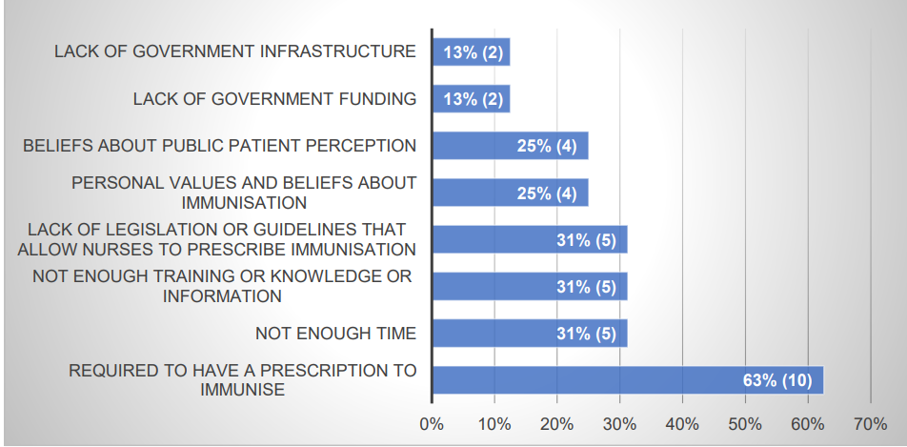
Figure: 1 Obstacles to Nurses who are participating in Immunization
7. THE ESSENTIAL ROLE OF NURSES IN VACCINE ADMINISTRATION:
Globally close 100% in all countries, Nurse provides vaccinations to a wide spectrum of patients and individuals in every field. having more of an emphasis on, or more time available for, prescribing, monitoring, and following up on vaccinations at the population level. Globally, coordinated efforts to improve nursing immunization education, guarantee enough time for immunization interventions, and approve enabling legislation could strengthen this role in nursing and have a significant impact on immunizations rates.
The basic nursing curriculum includes giving vaccinations in more than 81% of the countries that responded. However, continuing education and on-the-job skill development were frequently identified as other types of education that were necessary, perhaps as a way to stay current and competent in the intervention.

8. STRENGTHENING THE ROLE OF NURSES IN IMMUNISATION:
Immunization by participation in important events like
- Advocating for a change in the law regarding nurse prescription and vaccination administration.
- Regulation and policy making regarding nurse prescription and vaccination administration.
- The promotion of nurse prescription and immunizations administration in nursing education curriculum.
- Promotion of vaccine administration certification programmes
9. NURSE IMMUNISATION ROLE ENGAGEMENT BY COUNTRY:
In terms of the degree of nurse immunization role engagement, countries surveyed generally presented as excelling, expanding, or emerging. The nations with the highest rates of nurses participating in the full spectrum of immunization activities, such as education, immunization management, vaccine administration and prescription, and advisory roles, were those where nurses were "very" likely to support and promote immunization. They had conquered important obstacles to fully participating in immunization programs, including the need for a prescription and other internal, external, and organizational obstacles.
10. CONCLUSION AND RECOMMENDATIONS:
The need for a prescription was by far the biggest obstacle to nurses participating in immunization as a result. The statistical analysis has identified the considerable and favorable impact that removing this barrier would have on vaccination rates and the benefits to the overall health and health system that would follow. The correlation between vaccination rates and nurse readiness in both nations where nurses are licensed to prescribe. Although being prepared is crucial in and of itself, legislative actions that support and promote nurse readiness as well as allow nurses to prescribe will lead to the greatest improvements in immunization rates. Lack of time/priorities competing for nurses' attention and inadequate training were the two next-largest obstacles to their participation in immunizations, as indicated by survey results.
International Council of Nurses regularly surveys National Nursing Associations and is aware that complaints regarding nurses' workload, staffing shortages, and a lack of resources or opportunities for ongoing professional development are recurring issues. Clearly, more work and policy action are needed, but NNAs should be actively involved in the formulation, development, and evaluation of country policies as they have a key role to play.
A roadmap for access to medications and vaccinations, 2019–2023, is being created by WHO and will comprise activities, actions, and deliverable. International Council of Nurses has actively participated in this process and promoted nurse prescription, clinical participation, leadership in policy making and governance structures, and acknowledgment of those variables crucial to supporting health workforce capacity, such as education and professional development.
The strategy will be subject to Member State consultation, and International Council of Nurses will continue its lobbying efforts, highlighting the fresh and significant data in this report and the potential for policy action to support nurses' readiness to prescribe, which could lead to significant increases in vaccination rates and the wider benefits for health and health systems that would follow.
The authors declare “No Conflict of Interest”
Acknowledgments:
I convey my deep sense of thanks and gratitude to my parents Mr.S.Arokia Doss & Mrs. S. Sagayamary, to my brother Dr.A.Hancy Mourish and to my friend Dr.Altaf Ahmed who supported in my career, and the HOD and Faculties, department of Community Medicine, MMCH&RI.

REFERENCES:
- Barrows, M. A., Coddington, J. A., Richards, E. A., & Aaltonen, P. M. (2015). Parental vaccine hesitancy: Clinical implications for paediatric providers. Journal of Paediatric Health Care, 29(4), 385–394. https://doi.org/10.1016/j.pedhc.2015.04.019.
- Centre for Disease Control (1999a). Achievement in public health, 1900–1999 impact of vaccines universally recommended for children – United States, 1900–1998. Morbidity and Mortality Weekly Report, 48(12), 243–248.
- Camargo, K. & Grant, R. (2015). Public health, science and policy debate: Being right is not enough. American Journal of Public Health. 105 (2), 232-235.
- Canadian Nurses Association (CNA). (2018). Immunization and Vaccine Preventable Diseases. Retrieved from www.cna-aiic.ca/en/nursing-practice/evidence-based-practice/infectiousdiseases/immunization
- GAVI The Vaccine Alliance. (2018). About GAVI: Value of vaccination: Cost-Effective. Retrieved from Public Health's 'Best Buy': https://www.gavi.org/about/value/cost-effective
- Hampson, A., & Irving, L. (n.d.). NCBI. Retrieved from Influenza vaccination: cost-effective health care for the older adult: https://www.ncbi.nlm.nih.gov/pubmed/9107599
- Institute of Medicine. (2013). Adverse effects of vaccines: Evidence and casualty report brief. Retrieved from www.iom.edu/vdverseeffectaccine
- International Council of Nurses. (2009). ICN on mobilising nurses for health promotion. Nursing Matters. ICN: Geneva, Switzerland. Retrieved from http://www.icn.ch/images/stories/documents/publications/fact_sheets/21d_FSHealth_Promotion.pd
- International Council of Nurses. (2013). Adult and Childhood Immunisation. ICN: Geneva Switzerland. International Council of Nurses. (2016).
- Immunisation plan: Save lives, protect health, empower communities. Unpublished presentation. ICN: Geneva, Switzerland.
- International Federation on Ageing (IFA). (2017). Adult Vaccination: A Public Health Priority Expert Meeting Report 29-30 August 2017. London, United Kingdom. Retrieved from www.ifa-fiv.org/wpcontent/uploads/2017/11/Final-report-A

