Why NOMA is powered, on 5G and B5G?

C.Elayaraja^{1,2}
¹Research Scholar, Department of Electronics and Communication Engineering, SRM Valliammai Engineering College, Chennai.
²Assistant Professor, Electronics and Communication Engineering, Dhaanish Ahmed College of Engineering, Chennai. https://orcid.org/0000-0001-8063-0472
Dr.C.Amali³
³ Assistant Professor (Sel.G), Department of Electronics and Communication Engineering, SRM Valliammai Engineering College, Chennai. https://orcid.org/0000-0001-6246-1433

ABSTRACT
As technology evolves and new developments occur in 5G and beyond, it is essential to refer to the latest research and industry developments for the most up-to-date information on NOMA and its role in powering future wireless communication networks to enhance energy efficiency, spectrum efficiency, capacity improvements, and power delay profile significantly in comparison. In fact, one of the promising technologies to improve the performance of 5G and beyond (B5G) networks is non-orthogonal multiple access (NOMA). Future wireless communication technologies like 5G and B5G have undergone extensive research and evaluation as prospective possibilities, along with NOMA.
Keywords: Non-orthogonal, Power allocation, Capacity, Energy Efficiency, Spectral Efficiency
I. INTRODUCTION
The field of wireless communication has paid substantial attention to Non-Orthogonal Multiple Access (NOMA), a revolutionary multiple access approach, particularly in the context of 5G and beyond. Traditional orthogonal multiple access (OMA) [1] protocols like Frequency Division Multiple Access (FDMA), Time Division Multiple Access (TDMA), and Code Division Multiple Access (CDMA) have been replaced by NOMA. NOMA [4] uses the power domain to enable several users to share the same time-frequency resources non-orthogonally rather than distributing orthogonal resources to various users. Power domain multiplexing [5], in which users are given varying power levels to transmit their data over the same time-frequency resource, is the underlying idea of NOMA. By taking advantage of the various channel circumstances and Quality of Service (QoS) requirements of different users, this enables numerous users has been supplied at once.
II Comparison of Orthogonal Access Techniques with Non-Orthogonal Multiple Access Techniques:
Here, the review of earlier technologies and compare them to NOMA before further proceedings. Frequency Division Multiple Access, Time Division Multiple Access, and Code Division Multiple Access has considered as Orthogonal Multiple Access techniques because these techniques are sharing the resources in orthogonal manner.
- Frequency Division Multiple Access (FDMA)
The multiple access method known as Frequency Division Multiple Access (FDMA) divides the frequency band into different channels [1] and allots a different frequency band to each user as shown in Fig.1. In contrast, NOMA is a power-domain-based method that makes use of superposition coding and variable power levels to enable numerous users to share the same frequency band and time slot. NOMA has been presented as a way to increase the fifth-generation (5G) networks system spectral efficiency (SE) [2] by enabling concurrent transmissions from numerous users in the same spectrum.
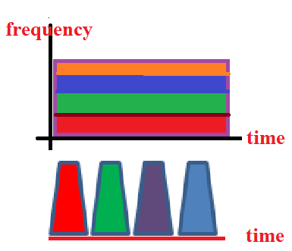
Fig.1 Frequency Division Multiple Access with Carrier frequency
However, in practice, simultaneous NOMA transmissions may also result in increased transmit and circuit energy consumption, both of which are crucial for energy-constrained IoT devices. Since FDMA is an orthogonal multiple access technique, whether the SE can be enhanced and/or the overall
- Time Division Multiple Access (TDMA)
Wireless communication systems use two separate multiple access algorithms, TDMA (Time Division Multiple Access) and NOMA. Each user is given a specific time slot for transmission when using the time-based TDMA technology as shown in Fig.2. Contrarily, NOMA is a power-domain-based technique or code domain based technique that enables many users to share the same frequency band and time slot by using superposition coding and varying power levels.
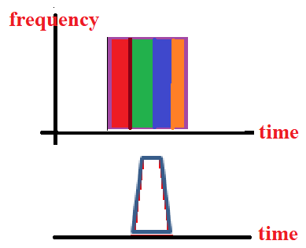

Fig.2 Time Division Multiple Access with Carrier frequency
The system spectral efficiency (SE) of fifth-generation (5G) [6] networks can be improved by using NOMA, which enables concurrent transmissions from several users within the same spectrum. Nevertheless, in practice, concurrent NOMA transmissions may also lead to increased transmit and circuit energy consumption.
- Code Division Multiple Access (CDMA)
Code Division Multiple Access, (CDMA) is a multiple access method that divides users over the same channel using codes. By using various power levels and superposition coding [7][19] as shown in Fig.3, the NOMA (Non-Orthogonal numerous Access) technology, on the other hand, enables numerous users to share the same frequency band and time slot.
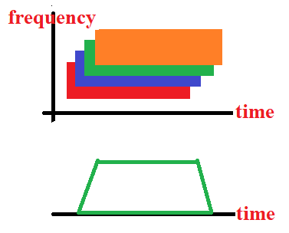
Fig.3 Code Division Multiple Access with Carrier frequency
These multiple access methods, which give users orthogonal access in terms of time, frequency, code, or space, are fundamentally distinct from NOMA as shown in Fig.4. Each user in NOMA works in the same band and at the same time, and it has identified from one another by their power output [8].
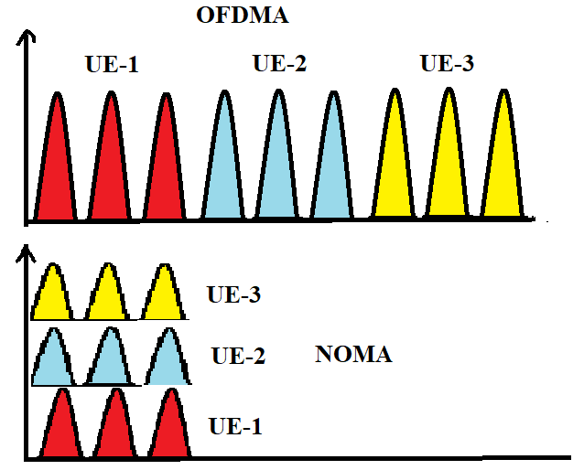
Fig.4. Comparison of OFDMA Vs NOMA
- Technical parameters of 3G, 4G and beyond
The candidate waveform, link adaption, user multiplexing, spectral Efficiency and Data bandwidth has compared in Table 2.4.1. For third generation, single carrier has required as signal waveform whereas in LTE [9], New Radio 5G and beyond 5G have been required multicarrier Orthogonal Frequency Division Multiplexing. Fast transmission power control techniques [10] have assigned in link adaptation between the transmitter and receiver modulation, in contrast adaptive Modulation and Coding with power allocation [11] [19] have positioned in 4G, 5G and B5G communication network.
Table 2.4.1.Comparision of general parameters of 3G, 4G, 5G and B5G communication:
Generation/  Parameter | 3G | 4G | 5G | B5G
Required Signal waveform | Single carrier | Multicarrier  OFDM (or DFT-s-OFDM) | Multicarrier  OFDM (or DFT-s-OFDM) | Multicarrier  OFDM (or DFT-s-OFDM)
Link adaptation | Fast Transmission Power Control | Adaptive Modulation and Coding | Adaptive Modulation and Coding + Power allocation | Adaptive Modulation and Coding + efficient Power allocation
User multiplexing | Non-orthogonal (CDMA) | Orthogonal (OFDMA) | Non-orthogonal with SIC (NOMA) | Non-orthogonal with SIC (NOMA)
Spectral Efficiency | Good | Good | Good | Good
Data Bandwidth | 2Mbps | 200Mbps | 1Gbps | >1Gbps
III. Application Specific 4th Generation Network Technology
By enabling a variety of applications that have revolutionized the way we connect with technology and the outside world, 4G (fourth generation) wireless technology has brought about a new era of mobile communication. Mobile internet surfing [12][13] and access is one of the main uses of 4G. With much faster data rates than its predecessor, 4G enables users to visit websites, do online searches, and conduct other online activities more quickly and easily. As a result, mobile e-commerce [14], social media use, and on-the-go information exchange have increased dramatically.
With 4G, streaming HD content, including movies and music have become simple. Because 4G networks offer faster data rates and lower latency, users can stream content without experiencing buffering, which has increased the appeal of services on mobile devices [15]. Along with altering the entertainment industry, this technology also made video conferencing and remote learning possible.
With the advent of 4G, online gaming has also undergone major change. The improved gaming experience provided by 4G networks' decreased latency enables gamers [16] to participate in multiplayer games with the smallest possible lag. As a result, the mobile gaming market has expanded significant advantages that 4G technology has to offer.
- Speed: Up to 1 Gbps (appro. maximum)
- Latency: Around 30 ms (typical)
- Frequency Bands: Mainly under 6 GHz
- Network Capacity: Supports up to 2000 devices per square kilometres
- Use Cases: Mobile browsing, HD streaming, online gaming
- Connection Density: Limited capacity for IoT (Internet of Things) devices
- Energy Efficiency: Limited optimization for IoT devices
- Security: Standard security features
- Infrastructure: Well-established with widespread coverage
- Applications: Apps, media consumption
Table 3.1.1 Application based comparison of 4G and 5G wireless network [17]
Features | 4G | 5G
Connection Density | Lower capacity for IoT | High capacity for IoT and M2M
Energy Efficiency | Limited optimization for IoT devices | Improved efficiency for IoT devices
Infrastructure | Well-established, widespread coverage | Still expanding, limited in some areas
Security | Standard security features | Enhanced security protocols
Applications | Apps, media consumption | AR/VR, IoT, critical communication

Based on connection density, energy efficiency, infrastructure, security, and application, Table 3.1.1 compares 4th generation LTE and 5th generation NR. Virtual and augmented reality have raised concerns in New Radio (NR). Security-based communication has improved with 5G.
IV. NOMA Powered on 5G
As an alternative technology for 5G and beyond, NOMA has studied for the following reasons as shown in Fig 4.1. Here are some reasons why NOMA has considered as a possible technology to power 5G and beyond as shown in Table 4.1.1:
- Spectral Efficiency [19]: By superimposing signals with varied power levels, NOMA [3] enables several users to share the same time-frequency resources. Compared to traditional orthogonal access techniques like Orthogonal Frequency Division Multiple Access (OFDMA), this provides improved spectral efficiency. NOMA is able to serve a greater number of users within the same bandwidth, improving throughput and spectrum efficiency.

Fig 4.1. Appropriate 5G characteristics
B. Low Latency: NOMA can serve numerous users concurrently, which can minimize latency and enhance the user experience. Low latency has needed for real-time applications like augmented reality, virtual reality, and industrial IoT, therefore this is very important.
C. Massive Connectivity: The Internet of Things (IoT) has expected to have a huge number of connected devices and objects. NOMA is an appealing option for B5G networks due to its capacity to manage huge connectivity and effectively support a large number of low-power IoT devices.
D. Enhanced Fairness: NOMA makes it possible to distribute power and resources among users in a more flexible manner, allowing for a more equitable allocation of resources dependent on user channel conditions. This helps ensure more equitable resource distribution and improves user experience for users who are using channels with less favourable conditions.
E. Greater Coverage and Reliability: NOMA's diversity gain [18] and interference management capabilities can increase communication links' coverage and dependability, particularly in difficult propagation conditions.
F. The system can adapt to changing traffic needs and channel circumstances thanks to NOMA's support for dynamic resource allocation. Through real-time network performance optimization, this dynamic allocation can increase overall effectiveness.
Table 4.1.1 Features of 4G, 5G and beyond 5G [20]:
Feature | 4G | 5G | B5G (Beyond 5G)
Speed | Up to 1 Gbps (theoretical max) | Up to 20 Gbps (theoretical max) | Expected to exceed 20 Gbps
Latency | Around 30 ms (typical) | Around 1 ms (or lower, in optimal conditions) | Aimed for ultra-low latency
Frequency Bands | Primarily under 6 GHz | Sub-6 GHz and mmWave | Expanding into higher frequencies
Network Capacity | Supports up to 2000 devices per km² | Supports up to 1 million devices per km² | Targeting even higher device density
Use Cases | Mobile browsing, HD streaming, gaming | Enhanced Mobile Broadband (eMBB), ultra-reliable Low-Latency Communication (URLLC), massive Machine-Type Communication (mMTC) | Further optimization for eMBB, URLLC, and mMTC, plus new applications
Connection Density | Lower capacity for IoT | High capacity for IoT and M2M | Focus on accommodating massive IoT
Energy Efficiency | Limited optimization for IoT devices | Improved efficiency for IoT devices | Enhanced power efficiency for all devices

G. Coexistence with Legacy Systems: Because NOMA has deployed in a way that has backward compatible; it can coexist with legacy communication systems that are already in place. The successful transfer and deployment of sophisticated communication technologies depend on this capability. Although NOMA has several benefits, it is crucial to remember that its implementation and effectiveness depend on a number of variables, including the system architecture, user density, channel conditions, interference control, and the available hardware.
V. Conclusion
By realizing, the promise of NOMA in 5G and beyond networks, extensive research, standardization efforts, and practical deployments has needed. For the most recent knowledge on NOMA and its function in powering future wireless communication networks, it is crucial to consult the most recent research and industry developments since technology continues to advance and new advancements take place. The successful deployment of NOMA in real-world scenarios requires addressing various practical challenges, including channel estimation, power allocation; SIC complexity, and multiple-user synchronization. Researchers and industry experts are continuously working on optimizing NOMA algorithms and exploring its integration with other advanced technologies to unlock its full potential in future wireless communication systems.
References
- Vaezi, M., Ding, Z., & Poor, H. V. (Eds.). (2019). Multiple access techniques for 5G wireless networks and beyond (Vol. 159). Berlin: Springer.
- Hassan, M., Singh, M., & Hamid, K. (2021, April). Survey on NOMA and spectrum sharing techniques in 5G. In 2021 IEEE International Conference on Smart Information Systems and Technologies (SIST) (pp. 1-4). IEEE.
- Hasan, M. K., Shahjalal, M., Islam, M. M., Alam, M. M., Ahmed, M. F., & Jang, Y. M. (2020, February). The role of deep learning in NOMA for 5G and beyond communications. In 2020 International Conference on Artificial Intelligence in Information and Communication (ICAIIC) (pp. 303-307). IEEE.
- Han, S., Chih-Lin, I., Xu, Z., & Sun, Q. (2014). Energy efficiency and spectrum efficiency co-design: From NOMA to network NOMA. IEEE COMSOC MMTC E-Letter, 9(5).
- Islam, S. R., Avazov, N., Dobre, O. A., & Kwak, K. S. (2016). Power-domain non-orthogonal multiple access (NOMA) in 5G systems: Potentials and challenges. IEEE Communications Surveys & Tutorials, 19(2), 721-742.
- Chinnathambi, E., Chinnappan, A., Sivabaskaran, K., & Bilvam, S. (2021). ENERGY EFFICIENT DESIGN OF EHF-5G ANTENNAS WITH ENHANCED BANDWIDTH FOR NAVIGATION SATELLITE APPLICATIONS. 3C Tecnologia, 537-551.
- Choi, J. (2015). Minimum power multicast beamforming with superposition coding for multiresolution broadcast and application to NOMA systems. IEEE Transactions on Communications, 63(3), 791-800.
- Shin, W., Vaezi, M., Lee, B., Love, D. J., Lee, J., & Poor, H. V. (2017). Non-orthogonal multiple access in multi-cell networks: Theory, performance, and practical challenges. IEEE Communications Magazine, 55(10), 176-183.
- Schaich, F., & Wild, T. (2014, May). Waveform contenders for 5G—OFDM vs. FBMC vs. UFMC. In 2014 6th international symposium on communications, control and signal processing (ISCCSP) (pp. 457-460). IEEE.
- Fu, L., Liew, S. C., & Huang, J. (2010). Fast algorithms for joint power control and scheduling in wireless networks. IEEE Transactions on Wireless Communications, 9(3), 1186-1197.
- Kim, K. S. (2005). Adaptive modulation and power allocation technique for LDPC-coded MIMO-OFDMA cellular systems. IEICE transactions on communications, 88(11), 4410-4412.
- Dangi, R., Lalwani, P., Choudhary, G., You, I., & Pau, G. (2021). Study and investigation on 5G technology: A systematic review. Sensors, 22(1), 26.
- Zhongmei, L., Yu-Che, H., & Cui, B. (2020, May). A study for application research of 5G data acquisition and testing. In 2020 5th IEEE International Conference on Big Data Analytics (ICBDA) (pp. 100-104). IEEE.
- Kshetri, N. (2018). 5G in E-Commerce Activities. IT Prof., 20(4), 73-77.
- David, K., & Berndt, H. (2018). 6G vision and requirements: Is there any need for beyond 5G?. IEEE vehicular technology magazine, 13(3), 72-80.
- Slivar, I., Vlahovic, S., Silic, M., Skorin-Kapov, L., & Suznjevic, M. (2022, June). The impact of network and social context on quality of experience for competitive multiplayer virtual reality games. In Proceedings of the 2nd Workshop on Games Systems (pp. 16-21).
- Shah, B. M., Murtaza, M., & Raza, M. (2020, November). Comparison of 4G and 5G Cellular Network Architecture and Proposing of 6G, a new era of AI. In 2020 5th International Conference on Innovative Technologies in Intelligent Systems and Industrial Applications (CITISIA) (pp. 1-10). IEEE.
- Aldababsa, M., Göztepe, C., Kurt, G. K., & Kucur, O. (2020). Bit error rate for NOMA network. IEEE Communications Letters, 24(6), 1188-1191.
- Elayaraja, C., & Amali, C. (2021). NOMA TRANSMISSION SIGNALING SCHEMES FOR INTERFERENCE MANAGEMENT IN 5G. I-Manager's Journal on Mobile Applications & Technologies, 8(2).
- Mahmood, A., Beltramelli, L., Abedin, S. F., Zeb, S., Mowla, N. I., Hassan, S. A., ... & Gidlund, M. (2021). Industrial IoT in 5G-and-beyond networks: Vision, architecture, and design trends. IEEE Transactions on Industrial Informatics, 18(6), 4122-4137.

