CHAPTER NAME – CURRENT CONCEPTS OF DIGITAL SMILE DESIGNING

AUTHORS – DR K SATHYA NARAYANAN, DR ANJANA ALEYS MATHEW, DR TINI TREESA BENNY

ORGANIZATION NAME – SATHYABAMA DENTAL COLLEGE AND HOSPITAL, CHENNAI

CHAPTER CONTENTS –
- INTRODUCTION
- DIGITAL SMILE DESIGNING (DSD)
- EVOLUTION OF DIGITAL SMILE DESIGNING
- ADVANTAGES OF DIGITAL TECHNOLOGY
- PHOTOGRAPHY PROTOCOL
- VIDEOGRAPHY PROTOCOL
- DIGITAL WORKFLOW SOFTWARE
- COMMONLY USED DSD PROGRAMS
- THE PHOTOSHOP SMILE DESIGN TECHNIQUE
- COACHMAN’S DSD APP
- CEREC - SIRONA SMILE DESIGN TOOL
- DRAWBACKS OF DIGITAL TECHNOLOGY
- CONCLUSION
- REFERENCES

INTRODUCTION
When a patient desires a perfect smile but is hesitant to undergo the treatment procedure because they are unable to see their treatment outcome, a dental practitioner may employ the Digital Smile Designing (DSD) tool. By simulating and pre-visualizing, the eventual result of the recommended treatment, digital smile design is a digital mode that aids in the creation and projection of the new smile design. (1) The natural smile of an individual is made up of a lot of factors. These include the incisal edge location, buccal corridor, labiodental relationship, upper lip curvature, smile line, smile arc, and smile design. Additionally, the position of the gingival zenith, symmetry, gingival display, and dental-facial midline all have a significant impact on how attractive a smile appears. When creating the smile makeover, each of these elements must be considered. (5) A digitally created design involves patient involvement in the design process of their own smile, which permits customization of the smile in accordance to individual requirements and preferences that complement the patient's morpho psychological characteristics, connecting with the patient on an emotional level, boosting their trust in the procedure and enhancing their acceptance of their scheduled treatment. (1)

DIGITAL SMILE DESIGN (DSD)
A versatile conceptual tool called the Digital Smile Design (DSD) may enhance diagnostic vision, facilitate communication, and improve predictability during treatment. When using the DSD, it is possible to thoroughly examine the patient's facial and dental features as well as any important details that might have gone unnoticed via clinical, photographic, or diagnostic cast-based evaluation processes. Presentation software like Keynote (iWork, Apple) or Microsoft PowerPoint (Microsoft Office) can be used to create DSD illustrations. (2)

Fig 1: Slide presentation software (Keynote, iWork, Apple)

EVOLUTION OF DIGITAL SMILE DESIGNING:
The smile designing has gradually progressed over the past 20 years from physical analogue to digital designing, which has gone from 2D to 3D. From the earlier periods of time, when hand drawings were utilised to communicate with and explain to patients what the outcome would look like on printed representations of the patient, it has advanced to comprehensive digital drawing on DSD software on the computer. To reach the final design that matches patients' functional and aesthetic needs, this is straightforward for modification and may be done at any time.
Christian Coachman in 2017 has proposed this evolution in generations as: (3)
- Generation 1. Analogue drawings over photos and no connection to the analogue model. At the time, pen sketches were made on printed images to visualise the results of treatments, but these drawings could not be matched to the study model.
- Generation 2. Digital 2D drawings and visual connection to the analogue model. With the development of the digital age, familiarity with certain programmes like PowerPoint that allowed for digital drawing increased. Although confined to two-dimensional drawings and not unique to dentistry, it was more precise and quicker than hand drawing. Visual connections between the drawing and the study model were possible, but no physical connections were made.
- Generation 3. Digital 2D drawings and analogue connection to the model. The connection between digital and analogue started at this point. The very first digital dentistry-specific drawing programme was released, connecting 2D digital smile design to 3D wax-up. At this point, facial integration into smile design was also implemented, but there was no connection to the 3D digital environment.
- Generation 4. Digital 2D drawings and digital connection to the 3D model. Now was the moment when analysis in digital dentistry moved from 2D to 3D. A face integration and preset dental aesthetic parameters could be used in a 3D digital wax-up.
- Generation 5. Complete 3D workﬂow.
- Generation 6. The 4D concept. Adding motion to the smile design process.

ADVANTAGES OF DIGITAL TECHNOLOGY:
- Esthetic diagnosis - When a dentist first assesses a new patient with aesthetic concerns, several important aspects could be missed. A dental professional can visualise and analyse problems that they might not have noticed clinically thanks to a digital photography and analysis technique. Using presentation software, reference lines and shapes can be added to intraoral and extraoral digital photos.
- Communication –
  - Dental technicians have always been in charge of designing smiles. The technician follows the instructions and guidelines provided by the dentist in writing or over the phone while doing the restorative wax-up, designing the tooth shapes, and placing the dental prosthetics.
  - To improve predictability and satisfy patient expectations in respect to aesthetics, four key factors must be managed: the horizontal reference plane, facial midline, smile design (tooth form and arrangement), and colour.
  - How precisely can this information be transferred from the face to the mouth, the cast, and the finished restoration? The DSD protocol's main objective is to make this process easier. With this crucial knowledge in hand, the dental technician can create a three-dimensional wax-up more successfully, concentrating on the development of anatomical features within the given constraints, such as the reference planes, facial and dental midlines, suggested incisal edge position, lip dynamics, fundamental tooth arrangement, and incisal plane. Through a mock-up or temporary restoration, this information is conveyed from the wax-up to the try-in phase.
  - To direct the treatment procedure, the final aesthetic restoration design should be created and tested as soon as possible.
- Feedback - The DSD enables accurate evaluation of the outcomes from each stage of treatment. On the slides, the order of the treatments is organised with images, movies, comments, graphics, and sketches. To monitor and evaluate the care given, team members can always view the PowerPoint presentation. Pre- and post-treatment photos can be easily compared using the digital ruler, sketches, and reference lines. In order to facilitate any necessary adjustments, the dental technician also receives comments concerning tooth form, arrangement, and colour.
- Patient management - The clinician can discuss the prognosis, introduce treatment plans, convey the gravity of the condition, and offer case management suggestions. By assisting patients in visualising and comprehending previous and upcoming treatments, DSD also promotes patient acceptance. The DSD can be used as a promotional strategy to entice the patient, as an educational instrument for clarifying treatment-related concerns, and an evaluation tool by contrasting before-and-after photographs.
- Education - By including slides from realistic clinical situations in a presentation, DSD might enhance its visual impact. Both the presenter and the audience will be able to comprehend the ideas being addressed more clearly. (2)
- User-friendliness - giving restorative dentists a simple form of communication with the dental lab which fabricates the restorations. (4)

PHOTOGRAPHY PROTOCOL –
BASIC ARMAMENTARIUM -
1. Digital camera: (11,12)
a. Compact point‑and‑shoot cameras
b. Digital single-lens reflex - More the pixels, the greater the detail of the image. In digital dental photography, a minimum of 10 Mega Pixels is required.
c. Intraoral cameras
2. Camera accessories:
a. Lens - Macro lens of a fixed focal length of 85–105 mm.
b. Light and electronic flash systems
• Ring flash
• Point flash
• Twin flash
c. Memory card - for storage of data
d. Filter - It serves the dual purpose of lens protection and if required changing the lighting conditions
e. Batteries: An extra battery pack with a quick charger ensures that we never run out of battery during the shoot. (11,12)
3. Clinical accessories:
a. Cheek retractors
b. Black background/contrasters
c. Intraoral mirrors (11,12)
PHOTOGRAPHIC VIEWS -
Six basic photographic views are necessary: (2)
1. Facial frontal smile with teeth apart
2. Facial frontal retracted with teeth apart
3. Facial proﬁle at rest
4. Facial proﬁle smile
5. Occlusal without mirror or from the model
6. 12 o’clock view smile
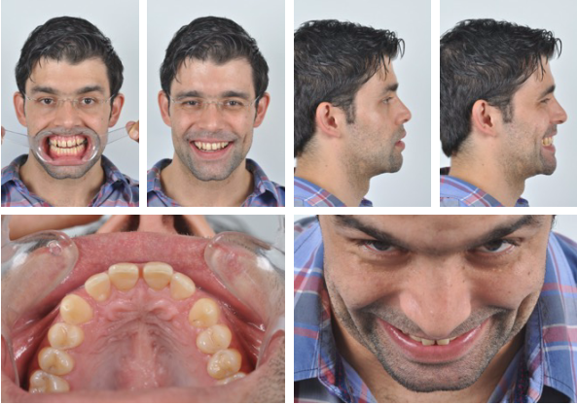
Fig 2: Six photographs

The clinicians should also record a brief video is also recommended where the patient are clarifying his or her treatment concerns and expectations in their own words. The film ought to record every achievable dental and smiling posture concurrently, including 45-degree and profile views.

VIDEOGRAPHY PROTOCOL –
According to Coachman, during videography best framing and zoom should be adjusted with suitable exposure and focus adjusted to mouth. (6)
1. A facial frontal video with a retractor and without a retractor smiling,
2. A facial proﬁle video with lips at rest and wide-E smile,
3. A 12 O'clock video above the head at the most coronal angle that still allows visualization of the incisal edge
4. An anterior occlusal video to record maxillary teeth from second premolar to second premolar with the palatine raphe as a straight line.

Four complimentary videos should also be taken for facial, phonetic, functional and structural analysis. The photographs and videos are downloaded and inserted into the slide presentation.
DIGITAL WORKFLOW SOFTWARE
The digital workflow timeline can be divided into a pre-case-acceptance phase (planning) and a post-case acceptance phase (execution). In the same way, dental software platforms are divided into pre-case-acceptance software (pre-software) and post-case acceptance software (post-software) and present the ideal features according to the phase in which they will be used. (4)
PRE-CASE ACCEPTANCE SOFTWARE
The pre-software needs to have two main characteristics:
- treatment planning guided by the face
- interdisciplinary integration.
The effects of one potential surgery relative to the other procedures must be thoroughly explored in today's interdisciplinary field of dentistry. The software should be used for diagnosing, creating the first ideal smile, and modelling various solutions for these reasons. In order to determine the appropriate combination of treatments for each patient, it should be able to execute all interdisciplinary simulations in the same programme and enable facial analysis and ideal smile design elements.
Main goals of pre-case acceptance software:
(a) data acquisition
(b) improve the process of identifying the patient's issues and diagnoses
(c) simulate, compare the options, and promote a team brainstorm of the solutions
(d) improve the decision-making process and risk assessment present
(e) explain treatment options to the patient, having the patient participate in the decision-making process with pre-software as a 3D visual communication tool. (4)
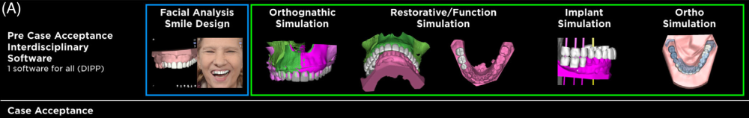
Fig 3: pre case acceptance software: “digital wax-up” software for facially driven smile designs (blue box), dentofacial interdisciplinary planning platform for interdisciplinary simulations (green box)
POST-CASE ACCEPTANCE SOFTWARE
The team can export the files from the pre-software and import them into numerous post-software after the treatment is arranged and the patient conforms to the plan. The primary objective of the post-software, which is the area-specific software, is to meticulously organise a particular disciplinary procedure while constructing any devices required to carry out the clinical procedure.
Main goals of post-case acceptance software:
(a) import files from pre-software: import the ideal design and initial speciality simulation suggestion
(b) precisely merge files from pre-software with working files to perform disciplinary tasks
(c) design the devices needed to perform specific procedures
(d) connect to manufacturing systems such as milling and 3D printing machines. (4)
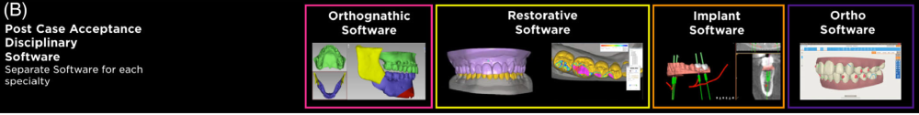
Fig 4: post case acceptance software for disciplinary planning and design (pink, yellow, orange and purple, respectively for orthognathic, restorative, implant and orthodontic)

COMMONLY USED DSD PROGRAMS:
1. Photoshop CS6 (Adobe Systems Incorporated),
2. Microsoft PowerPoint (Microsoft Oﬃce, Microsoft, Redmond, Washington, USA).
3. Smile Designer Pro (SDP) (Tasty Tech Ltd),
4. Aesthetic Digital Smile Design (ADSD - Dr Valerio Bini),
5. Cerec SW 4.2 (Sirona Dental Systems Inc.),
6. Planmeca Romexis Smile Design (PRSD) (Planmeca Romexis®),
7. VisagiSMile (Web Motion LTD),
8. DSD App by Coachman (DSDApp LLC),
9. Keynote (iWork, Apple, Cupertino, California, USA)
10. Guided Positioning System (GPS)
11. DSS (EGSolution)
12. NemoDSD (3D)
13. Exocad DentalCAD 2.3 (1)

While not designed with DSD in mind, dentists and other dental professionals have utilised Photoshop CS6 and Keynote as DSD programmes. Regarding their suitability for usage in the area of cosmetic dentistry, they are discussed in a number of literature reviews. As specialised digital design tools for the dental cosmetic industry, SDP and ADSD are marketed. Cerec SW 4.2 and PRSD are CAD/CAM programmes that can be used to build anterior restorations. Ceramic restorations may need to be designed using frontal photographs and intra-oral digital impressions. The idea of visagism, which contends that temperament may be exploited as an element in smile design, is shared by VisagiSMile and the DSD App. Coachman, who has previously published studies on the use of Keynote for digital smile design, created the DSD App. Due to their wider diversity of functions and adaptability, programmes designed for purposes other than dentistry are anticipated to have a greater scope. (7,8)
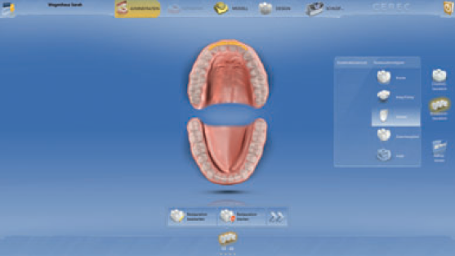
Fig 5: the smile design tool of the Cerec software
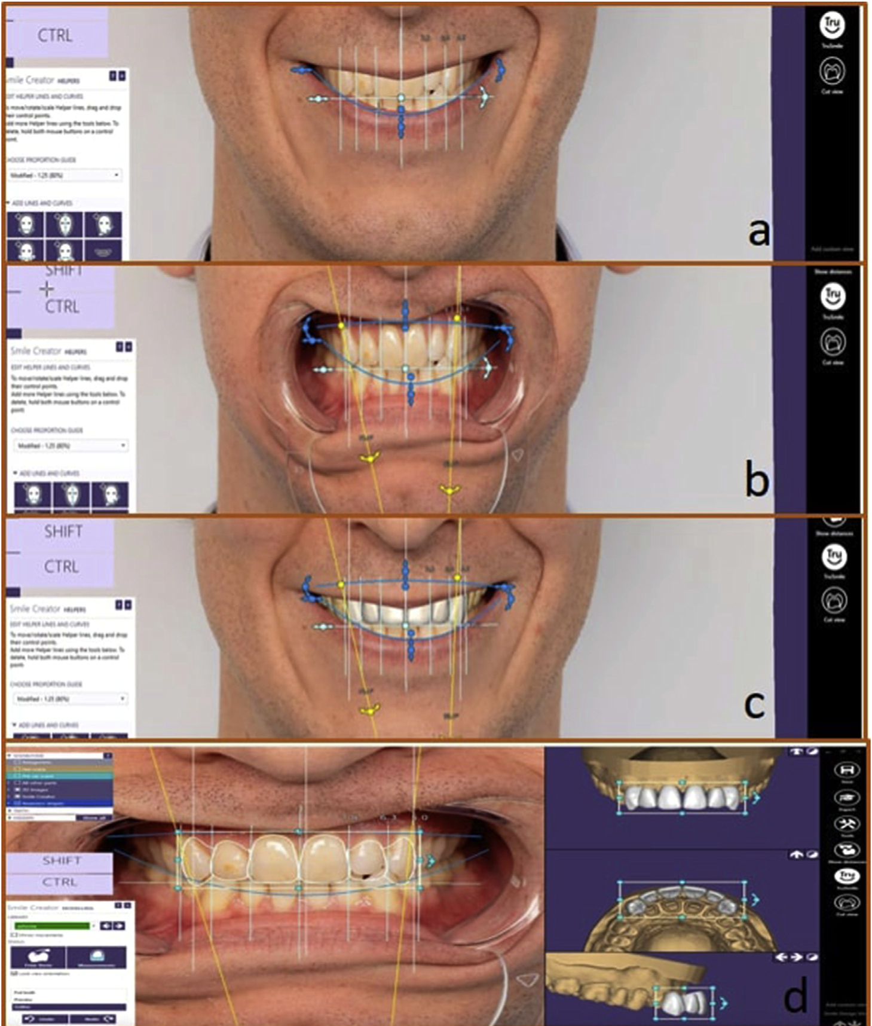
Fig 6: Digital smile designing process on Exocad 3D software

THE PHOTOSHOP SMILE DESIGN TECHNIQUE
The first step in the PSD technique is to create a digital conversion of the actual tooth length and width, and then digitally determine the proposed new length and proportion of the teeth. (10)
DETERMINING DIGITAL TOOTH SIZE
- Create a conversion factor by dividing the proposed length (developed from the smile analysis) by the existing length of the tooth.
- Open the full-arch cheek-retracted view in Photoshop, and zoom in on the central incisor.
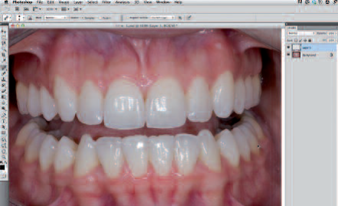
Fig 7: Open an image of an attractive smile in Photoshop and create a separate transparent layer.
- Select the eyedropper palette. A new menu will appear. Select the ruler tool
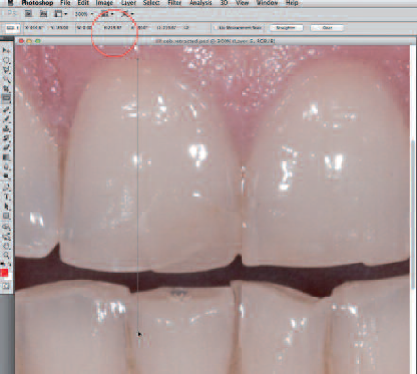
Fig 8: Measure the digital length of the central incisor using the ruler tool.
- Click and drag the ruler tool from the top to the bottom of the tooth to generate a vertical number. Multiply the number of pixels by the conversion factor. Determine the digital tooth width using the same formula.
- Create a new layer, leave it transparent, and mark the measurement with the pencil tool (10)
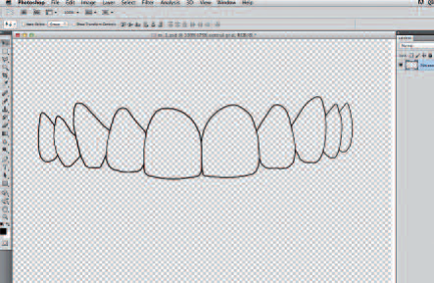
Fig 9: Click “edit > stroke,” then use a two-pixel stroke line (with the colour set to black) to trace your selection.
APPLYING A NEW PROPOSED TOOTH FORM
- After performing the smile analysis and digital measurements, choose a custom tooth grid appropriate for the patient. Select a tooth grid based on the width-to-length ratio of the planned teeth.
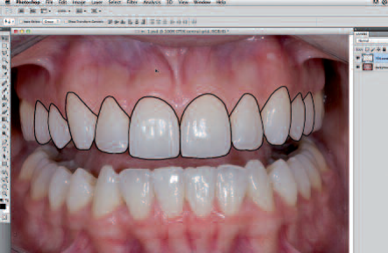
Fig 10: Image of the teeth traced up to the second premolar to create a tooth grid.

- Open the image of the chosen tooth grid in Photoshop and drag the grid onto the image of teeth to be smile-designed.
- Depending on the original image size, the tooth grid may be proportionally too big or too small. To enlarge or shrink the tooth grid created (with the layer activated), press command (or control) and “t” to bring up the free transform function. While holding the shift key (holding the shift key allows you to transform the object proportionally), click and drag a corner left or right to expand or contract the custom tooth grid.
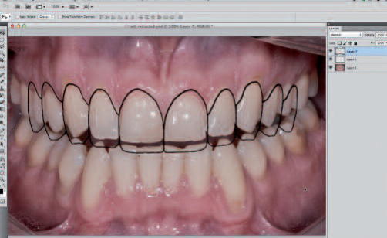
Fig 11: Adjust the grid as required while maintaining proper proportions by using the free transform tool from the edit menu.

- Adjust the size of the grid so that the outlines of the central incisors have the new proposed length. Move the grid as necessary using the move tool so that the incisal edge of the tooth grid lines up with the new proposed length.
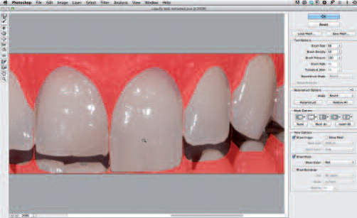
Fig 12: Shape one tooth at a time as needed by selecting “wand”.

- Areas of the grid can be individually altered using the liquify tool. (10)
DIGITALLY CREATING NEW AESTHETIC TEETH
- With the new tooth grid layer and the magic wand tool both activated, click on each tooth to select all of the teeth in the grid.
- Expand the selection by two pixels in the expanded menu; click “select > modify > expand”. Activate the layer of the teeth (cheek-retracted view) by clicking on it.
- activate the liquify filter (you will see a red mask around the shapes of the proposed teeth). The mask creates a digital limit that the teeth cannot be altered beyond. This is similar to creating a mask with tape for painting a shape.
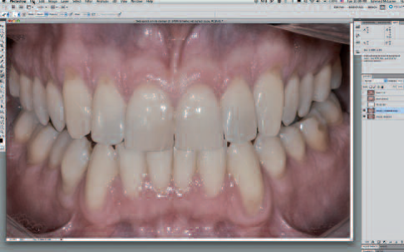
Fig 13: Once all of the teeth have been shaped, use the liquify tool.

- Use the forward warp tool by clicking on an area of the existing tooth and dragging it to mould/shape the tooth into the shape of the new proposed outline form.
- Repeat this for each tooth.
- Select the whitening tool (dodge tool) to brighten the teeth. (10)

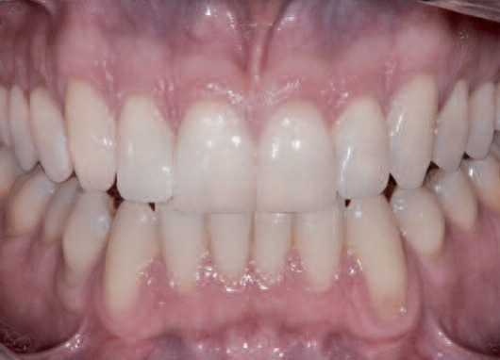
Fig 14: Image of all the teeth whitened with the dodge tool.

COACHMAN’S DSD APP
The DSD workflow by Coachman proceeds as follows: (2)
- The cross: Two lines must be placed on the centre of the slide, forming a cross. The facial photograph with the teeth apart should be positioned behind these lines.
Fig 15: crossing lines placed in the middle of the slide

- Digital facebow: Relating the full-face smile image to the horizontal reference line is the most important step in the smile design process. The interpupillary line should be the first reference line to establish the horizontal plane, but it should not be the only one. The face must be analyzed before determining the best horizontal reference to achieve harmony. After determining the horizontal reference line, the facial midline is outlined according to facial features such as the glabella, nose, and chin.
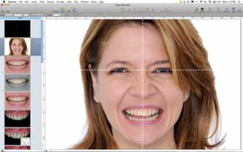
Fig 16: The facial photograph is moved behind the cross to determine the ideal horizontal plane and vertical midline

- Smile analysis: Dragging the horizontal line over the mouth will allow for initial evaluation of the relationship of the facial lines with the smile. Grouping the lines and the facial photographs will allow the clinician to zoom in on the image without losing the reference between the lines and photographs. Midline and occlusal plane shifting and canting can be easily detected.

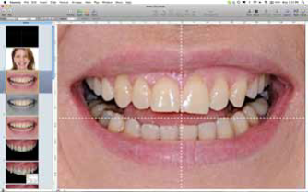
Fig 17: Transferring the cross to the smile

- Smile simulation: Simulations can be performed to fix the incisal edge position, canting, shifting, tooth proportions, and soft tissue outline.

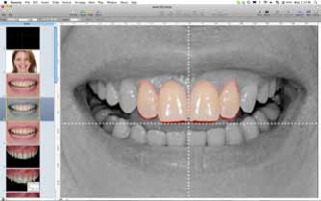
Fig 18: Basic dental simulation performed by cropping the images of the teeth and placing them over the smile photograph

- Transferring the cross to the intraoral images: To analyze the intraoral photographs in accordance with the facial references, the cross must be transferred to the retracted view using three transferring lines drawn over the smile view as follows.
  - Line 1: from the tip of one canine to the tip of the contralateral canine.
  - Line 2: from the middle of the incisal edge of one central incisor to the middle of the incisal edge of the contralateral central incisor.
  - Line 3: Over the dental midline, from the tip of the midline interdental papillae to the incisal embrasure.
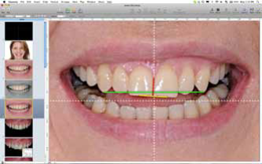
Fig 19: Drawing the three reference lines that will allow for transferring of the cross to the intraoral photograph.

- Measuring tooth proportion: Measuring the width/length proportion of the central incisors is the first step toward understanding how to best redesign the smile. A rectangle is then placed over the edges of both central incisors. The proportions of the patient’s central incisors can be compared to the ideal proportions described in the literature.

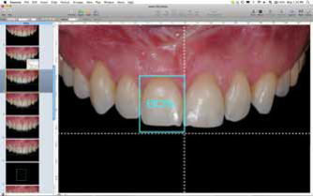
Fig 20: A rectangle with an ideal length/width proportion (80%) is placed over the central incisor

- Tooth outline: From this step on, all drawings may be performed depending on what needs to be visualized or communicated for each specific case. For example, tooth outlines can be drawn over the photograph, or premade tooth outlines can be copied and pasted. The selection of tooth shape will depend on factors such as the morpho-psychologic interview and the patient’s desires, facial features, and esthetic expectations.
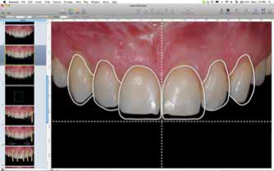
Fig 21: Final teeth outline showing the relationship between the preoperative situation and the ideal design.

- White and pink esthetic evaluation: After all reference lines and drawings have been provided, the clinician should have a clear understanding of the esthetic issues involved in the patient’s maxillary arch, including the tooth proportions, interdental relationship, the relationship between the teeth and smile line, the discrepancy between facial and dental midlines, midline and occlusal plane canting, soft tissue disharmony, the relationship between the soft tissues and teeth, papillae heights, gingival margin levels, incisal edge design, and tooth axis.

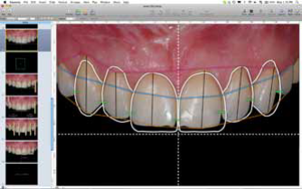
Fig 22: Other drawings and lines can be added as needed to help visualize the esthetic issues

- Digital ruler calibration: The digital ruler can be calibrated over the intraoral photograph by measuring the length of one of the central incisors on the cast and transferring this measurement to the computer. Once the digital ruler is calibrated, the clinician can make any measurements needed over the anterior area of the image.
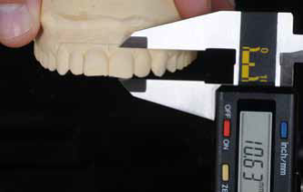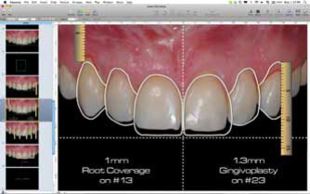
Fig 23: Measuring the length of the cast and calibrating the digital ruler on the slide

- Transferring the cross to the cast: First, the horizontal line over the intraoral photograph should be moved above the gingival margin of the six anterior teeth. The distance between the horizontal line and the gingival margin of each tooth is measured using the digital ruler, and these measurements are written down on the slide. The measurements are then transferred to the cast with the aid of a calliper. The next step is to transfer the vertical midline. Because the vertical line must be perpendicular to the horizontal line, only one point is necessary to determine its location. The distance between the dental midline and the facial midline at the incisal edge is measured on the computer, and the distance is then transferred to the cast with the calliper. (2)

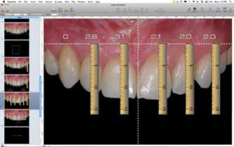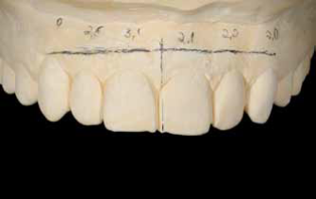
Fig 24: All the measurements are transferred to the cast, and the cross is drawn.

- Evaluate the precision: The next important step to evaluate the precision of the DSD protocol and the wax-up is to perform a clinical try-in. The clinical try-in can be carried out using a direct mock-up or a provisional restoration depending on the complexity of the case. (2)
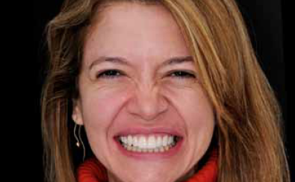
Fig 25: Try-in provisional made with bis-acrylic resin

- Tooth preparation: After patient approval, the restorative procedures can be adjusted as necessary. Tooth preparation should be minimally invasive, allowing just enough clearance to create proper space for ceramic restorations.

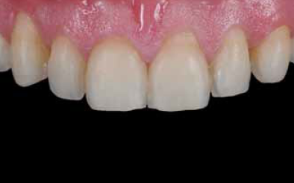
Fig 26: Final minimally invasive tooth preparation guided by the silicone indexes.

- Fabrication of the final restorations: a controlled process with minimal final adjustments. (2)

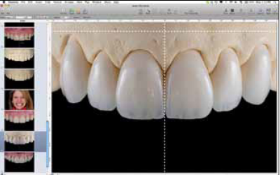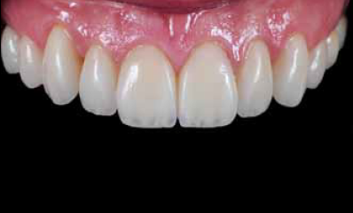
Fig 27: Final ceramic veneers

CEREC - SIRONA SMILE DESIGN TOOL

The "Smile Design" software programme was created by Sirona for the aesthetic inspection and evaluation of virtually designed restorations and is compatible with the Cerec and inLab software. (8)
- The ﬁrst step is the three-dimensional scanning of the clinical state of the patient’s dentition. This can take place via a direct optical impression using the intraoral scanner or by digitizing cast models with a laboratory scanner.
- After designing the virtual model, the Smile Design process can be initiated.
- This requires a photograph of the patient in portrait format. It is important to ensure that the patient’s teeth, and possibly also portions of the gingiva, are visible in the photograph.
- The patient’s smile should be as natural as possible, and the lips open to an average degree.
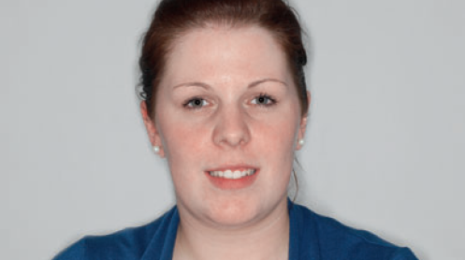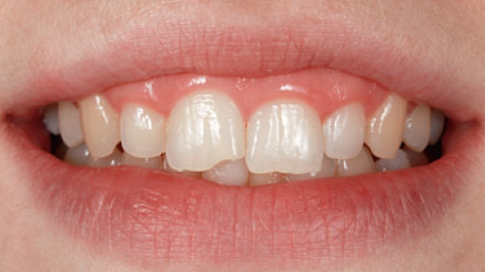
Fig 28: Portrait of the patient with the esthetic problem.

- The photograph is then selected using a ﬁle explorer and imported.
- The patient’s photograph will be displayed next to a virtual head on the monitor.
- To project the patient’s photo onto this head with the greatest accuracy of ﬁt, 16 different feature points must be marked in sequence on the patient’s photograph in the location at which they were shown analogously on the avatar by the software. These are characteristic, prominent areas of the face, such as the corners of the eyes and the tip of the nose and chin.
- In the next step, the actual distance between the two lateral corners of the eyes must be indicated. This can then be measured using a calliper.
- This measurement is important for the calculation of the real size of the head, onto which the jaw scan data are later superimposed.
- The three-dimensional model of the jaw obtained through the scanning procedure is now displayed in the mouth.
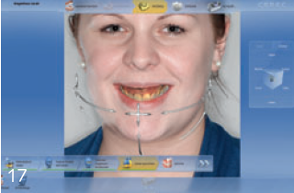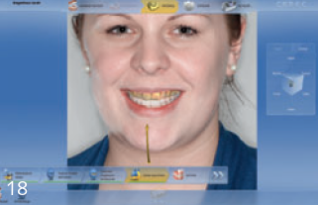
Fig 29: The face is displayed beside the so-called avatar. Characteristic feature points must be marked.
- An accurate ﬁt upon insertion of the “dentition” in the avatar is presently the weak spot of the software.
- In most cases, this needs subsequent manual adjustment. For this purpose, it is helpful to use the teeth of the scanned photograph (also displayed) as a guide.
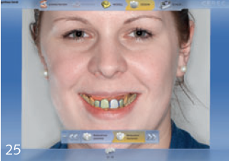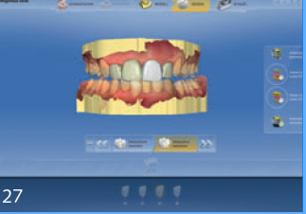
Fig 30: The face can be displayed at any time. The completed trial restoration is subsequently given a ﬁnal check in the virtual articulator.

- Once this process is completed, the Smile Design Tool is ready for use. It can be accessed via the menu item “Display Objects” at every stage of the digital design procedure.
- The current state of the virtual process is then immediately displayed together with the patient’s face.
- For this purpose, there are several applications,
  - Planning and virtual wax-up/mock-up - Digital picture from its beginning is collected. The patient can observe the procedure's outcomes on the monitor. The restoration can be made from a polymer block and fitted to the patient's teeth as a Snap-On. The patient will have a very realistic notion of the upcoming restoration as a result of this.
  - Intermediate assessment and long-term provisional restoration - After preparation, the anatomical situation is digitalized. It is also possible to mill the restoration from polymer blocks after digitally creating it. In conjunction with providing a realistic estimate of the potential outcome of treatment, the restoration that ensues from this is also ideal for use as a long-term temporary restoration.
  - Verifying the results of designing the deﬁnitive restoration - This is especially useful when determining the tooth length, sectioning, midline, and horizontal plane alignment, for instance. (8)
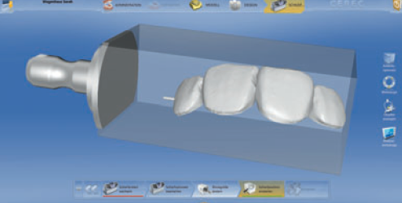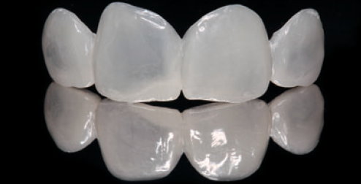
Fig 31: After completion of the design calculations, the restoration can now be milled.

Omar et al in 2017 did a systematic review comparing some of the most commonly used DSD programs in their ability to assess and digitally modify facial, dento-gingival and dental smile esthetic parameters. A set of parameters for dentofacial esthetic evaluation was used. (7)
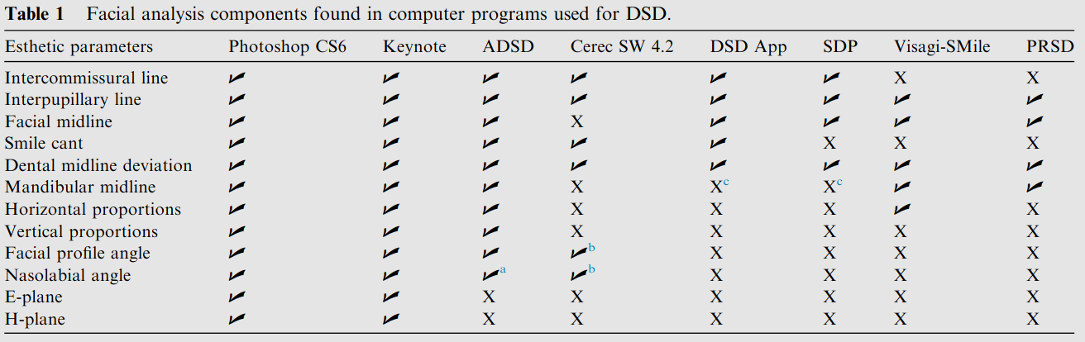
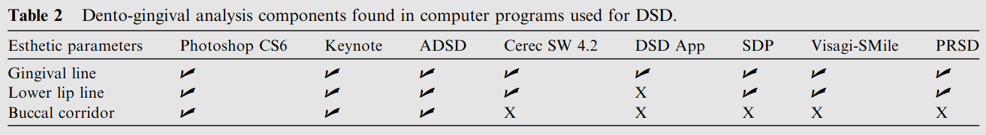
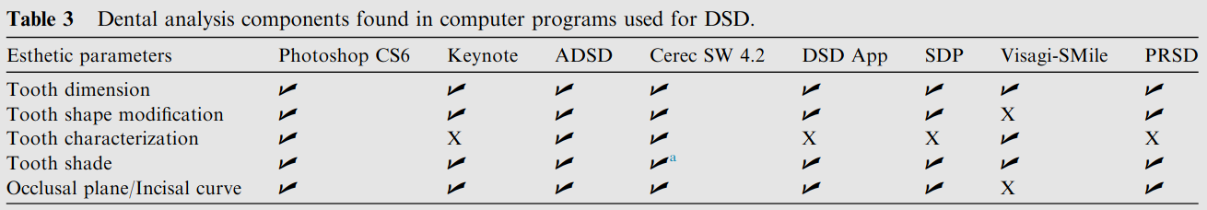
Fig 32: Comparison of DSD programs by Omar et al, 2017

DRAWBACKS OF DIGITAL TECHNOLOGY:
- Startup Costs - The price of purchasing digital dentistry equipment is still quite considerable. A platform with subscription-based licencing is used by many of the systems to operate. For instance, an annual subscription is necessary for various Digital Smile Design Apps. Similar to cloud-based data storage for backups, some intraoral scanners charge a monthly or annual fee.
- Lack of Standardized Work Flows - There are no clearly defined, universal workflows for digital dentistry that can be easily included into any practise. Interoperability is a problem since various data gathering devices from various manufacturers export various file types.
- Limited Access to Digital Partners - Finding other dental team members that use digital technology is one of the main hurdles of going digital because many of the higher-end small-scale facilities are still not totally digital.
- Intraoral Scanners and Scanning - A learning curve and adjustment for scanning, and scanning sequence and digital workflow present challenges when integrating digital impressions. There are three different digital impression systems:
  - Stand-alone systems - include Cerec Primescan, Carestream CS, iMedit 500, iTero, and Trios. Each of these scanners makes a very high-quality digital impression, and all have specific features and benefits designed to enhance the user experience.
  - Scan, design, and output to a third-party mill – include Trios by 3Shape used for scanning the patient, but also can add chair-side design software.
  - All-in-One ecosystem – include Planmeca Emerald and Sirona Cerec. These systems allow a dentist and team to make a digital impression of a patient in their office, use the internal design software to design a restoration for the patient, and mill that restoration using an integrated in-office mill. (9)

CONCLUSION
The Digital Smile Design is a versatile tool that can assist the restorative team at each phase of the procedure, enhancing the dental team's comprehension of the aesthetic concerns and boosting patient acceptance of the outcome. The placement of reference lines and other shapes over extra- and intraoral photographic images helps the dental team assess a case's restrictions, risk factors, and aesthetic principles. This broadens their field of view for diagnostic purposes. All treatment phases will see enhanced outcomes as a result of these crucial facts. The Digital Smile Design protocol's use of dynamic smile documentation will improve diagnosis accuracy and consistency of treatment regimens. Additionally, it will offer more rational and uncomplicated therapy sequences, lowering dangers and enhancing ultimate outcomes.

REFERENCES
- Jafri Z, Ahmad N, Sawai M, Sultan N, Bhardwaj A. Digital Smile Design-An innovative tool in aesthetic dentistry. J Oral Biol Craniofac Res. 2020 Apr-Jun;10(2):194-198. doi: 10.1016/j.jobcr.2020.04.010. Epub 2020 Apr 18. PMID: 32373450; PMCID: PMC7193250.
- Coachman C, Calamita M. Digital smile design: a tool for treatment planning and communication in aesthetic dentistry. Quintessence Dent Technol. 2012;35:103–111.
- Evolution of Smile Design. (Accessed on 15th February 2020) Available online:. https://media.digitalsmiledesign.com/christian-coachman-thoughts/smile-design-evolution.
- Coachman C, Blatz MB, Bohner L, Sesma N. Dental software classification and dento-facial interdisciplinary planning platform. J Esthet Restor Dent. 2021 Jan;33(1):99-106. doi: 10.1111/jerd.12713. Epub 2021 Jan 20. PMID: 33470496.
- Khan M, Kazmi SMR, Khan FR, Samejo I. Analysis of different characteristics of smile. BDJ Open. 2020 May 5;6:6. doi: 10.1038/s41405-020-0032-x. PMID: 32411387; PMCID: PMC7200793.
- Coachman C, Calamita MA, Sesma N. Dynamic documentation of the smile and the 2D/3D digital smile design process. Int J Periodontics Restor Dent. 2017;37(2):183–193.
- Omar D, Duarte C. The application of parameters for comprehensive smile esthetics by digital smile design programs: A review of literature. Saudi Dent J. 2018 Jan;30(1):7-12. doi: 10.1016/j.sdentj.2017.09.001. Epub 2017 Sep 23. PMID: 30166865; PMCID: PMC6112329.
- Kurbad A, Kurbad S. Cerec Smile Design--a software tool for the enhancement of restorations in the esthetic zone. Int J Comput Dent. 2013;16(3):255-69. English, German. PMID: 24364196.
- Fung L, Brisebois P. Implementing Digital Dentistry into Your Esthetic Dental Practice. Dent Clin North Am. 2020 Oct;64(4):645-657. doi: 10.1016/j.cden.2020.07.003. Epub 2020 Aug 12. PMID: 32888514.
- McLaren EA, Goldstein RE. The Photoshop Smile Design Technique. Compend Contin Educ Dent. 2018 May;39(5):e17-e20. PMID: 29733219.
- Kalpana D, Rao SJ, Joseph JK, Kurapati SKR. Digital dental photography. Indian J Dent Res. 2018 Jul-Aug;29(4):507-512. doi: 10.4103/ijdr.IJDR_396_17. PMID: 30127203.
- Ahmad I. Digital dental photography. Part 5: lighting. Br Dent J. 2009 Jul 11;207(1):13-8. doi: 10.1038/sj.bdj.2009.558. PMID: 19590549.

