Comparative Analysis of Various AI Techniques for Smart Cities work progress visualising
Javed Akhtar Khan
Department Computer Science & Engineering
er.javedkhan@gmail.com
Gyan Ganga College of Technology
JABALPUR MP INDIA
AISMART-0004-CRC
Abstract- This Chapter will include the various AI Techniques introduction and these comparison for visualising of Smart city work progress . This Chapter cover information about Artificial intelligence techniques its features , characteristics ,application and wide utilization of a particular application for Smart city . In this way, i try to formulate the chapter structure. AI reflecting the human intelligence here this chapter include the intelligence for the smart city work visualization the work progress through AI technique chapter include the list of Artificial Technique for Smart city to be provided the best solution for the concern problem. The another aspect of this chapter is to include the list of relevant problem in selected domain and its good solution while comparative study. AI Technique to suggest solution for concern problem of smart city domain for the proper structured a analysis is included in this chapter.
Key Word :- Smart City , AI , AI Technique , Visualization .
  - Introduction:
In the Current Era for development of the smart city or its plan AI techniques and its tools are used, Deep learning model , various models of ML for training the data set , testing thedata set , feature selection many more. Artificial intelligence (AI) techniques and method s is also used for represent the output in visual effect , this could be easy to understand by view in all aspects .
Proper planning and making the well structured policy for the smart without Artificial inelegance it little bit complex and difficult . So this is the way to archive the turst, acceptabile solution for smart city through AI .
Case Study Problem 01 - Using AI Smart Solution Proper Flood Monitoring Application :
This is o web based solution for monitoring the flood related things in smart city . The author are introduce the Semantic Web Technology under the consideration of ‘Explainable Deep LearningModel“ This is one kind of flood monitoring Application for smart city . The AI technical concept they were used misidentification of the Images such as Plastic bottles, leaves etc near by the drainage in crucial areas. As shown in the Fig mention below.
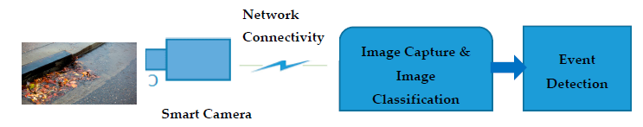

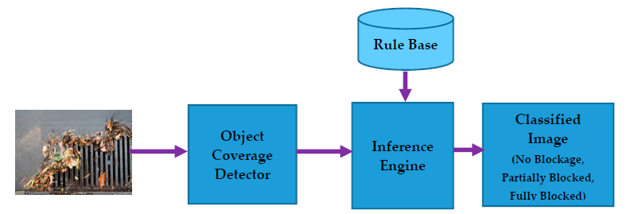
Conceptual flow diagram of Hybrid Image Classifier

Based on this authors implement the web based application using the DL- Based classifier to indentifying the above mention object . Here author capture the selected images through cameras in real time mode This work highlights the AI concept with DL and Semantic web application solution with hybrid mode classifier . The working concept of are as Hybrid classifier of DL component identifying the selected images and applying the semantic rule for the classification .This hybrid classifier able to provides the coverage relationships and image categories as well .
Experimental results from real use case evidence showed that this hybrid image classification method has an average bbetterment (F-measure) of 11% in image classification performance compared to DL-only classification. It has the distinct advantage of incorporating expert wisdom that defines decision-making rules to represent complex situations and uses such knowledge to explain outcomes.
  - THE Concept of SMART CITY
If we want to define a smart city, smart cities use technology to serve citizens. Various electronic technologies and sensors are used to collect data. Data perception helps improve the capicity of waste collection, energy supply, transportation infrastructure, environment management and environmental services management.
2.Features of the Smart Cities
Smart cities have many advanced features including smart healthcare systems, governance, transportation systems, better security, smart infrastructure, better job opportunities and all other facilities and amenities for a comfortable life.
A smart city can be considered a city with the following characteristics:
- Society needs good healthcare, smart system for education, smart and up to date housing and smart technology based infrastructure .
- Able to give some services in smart manner to near by community in a uniform and cost-effective manner.
- Good house.
- Growth of society.
- Use appropriate preventive measures.
- More career opportunities.
- For well-designed, ambitious data analysis and broad public participation
- Strengthening the local economy.
- Effective urbanization management and strategies to combat and reduce growth of population as well as maintain the change of climate using the smart technology and smart efforts .
- Use smart technologies to meet community needs
• The transport system is well maintained.
3. Steps to Make a normal city into a Smart City
Here are the steps to build a smart and smart city
Step 1: Arrange information and data relevant the city and its some effective week areas for improvement.
Step 2: Set prices for what you want, including time available and budget.
Step 3: Start with 1-2 small projects and complete them on time. Municipalities and technology may change during project completion.
Step 4: Increase all roads in the city.
Step-5: Review the observation and start working on other projects to make a normal city a smart one
- Literature survey
The concept of smart city will include the smart technology such as AI, ML IoT, best smart infrastructure, top class sensor technology for the alert system in the integrated fashion. it is also include the smart hospital, smart education system, smart vehicle management, smart vehicle parking, real time monitoring system etc . The most important is use of exiting devices like iot device is widely used for [23] collection fo the data and these data is transformed for next processing task. Data processing through IoT is much easy less time consuming while compare with human expert.
The Smart Cities apps and its applications include the real time and also use the Internet of things ,smart AI technology for the decision making towards design ,plan should be much more systematically and easy to implement for development smart city. As of now most of the existing smart city concept include the AI Technology , AI methods , IOT , Sensors to maintain and monitors the smart city [23]. Human expert decision making was the main element in all analyzes and measures [24].
Human experts often make decisions based on the data that goes into any application. This is much more complex task to take Decision for the smart cities because of the complex data , information and involvement of n number of stakeholders [25]. Various kinds of sensor and IoT-based application data are stored and processed in urban digital infrastructure to support decision making [26]. With the change in tools and techniques on digital platforms, disparate data from programs and other data sources are combined in real-time for analysis and decision making specific issues of the city [27].
Decisions to achieve certain goals require good information and value, which often leads to conflict. Therefore, all smart city applications should work better and update their work. Any modification should be based on the data used for the application and therefore the decision [28]. One of the key issues in making decisions in a smart city is how to process the information needed and how to use people's knowledge. Semantic web technology combined with data analysis has been used for expert-based recommendation systems [29,30]. Semantic systems provide the flexibility to use human knowledge and control model prediction. In another software-based system, the use of semantic representation improves the level of performance according to semantic rules defined by the use of high-level data. These all the data and information collected form the various expert side and many relvent fields. [18] in this article authors include the several types of data with high transparency that will required for the smart city development .Now here flood monitoring and its management is included with its high quality smart solution based on the AI technology . Here satellite images and rainfall data is used for to observerd the flood senorio .
In the given example , semantics is only applicable for the descriptive methods through high level information and knowledge foe the recommendation system . most of the research for flood management system is based on the public domain only and based on images only .This paper include the contextual data based classification related task . most of the analysis related work is based one the images analysis and its classification as well as decision making sense .
In this kind of analysis images and object are identified one by one and extract the most relevant information . These extracted information has been used for further classification and crate the classes of images like a cluster . Nosie data will be remove form the analysis process and images can be classified into the multiple classes this is based on the types of object present and its context images . multi class label concept is used for the classified images .
one of the classifier is used for the analysed the object and images. Now after the classifying the image and generated outputs will combined based on the probilities and again clsifiyng the images this is done in many time to improve the accuracy of result . Analysis of images and collected objects with semantic representation is some times used for the scene recognition for this segmentation approaches is used . excluding these mention methods ontology based methods is also used for fetching the particular image form the data population or sample data set [31]. To identifying the image through ontology based methods for this computer vision and some times manual annotation are preferred .
5.LIST OF AI TECHNIQUE
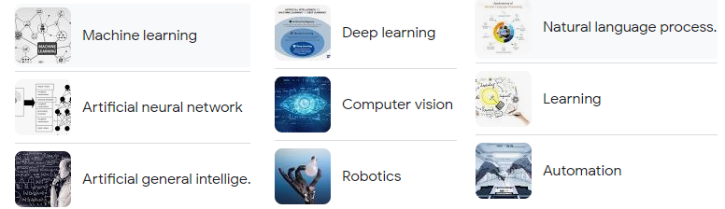
Fig List of AI Technique

6. LIST OF BENEFITS TO DEVELOPMENT OF SMART CITY
Widely use of smart technology such as AI for the development of smart city is much more beneficial for the humans and our environment. This kind of technology ready to provide the non-polluted environment, nature friendly environment and many benefits. AI technology show the multiple benefits to development of smart city some of the discussed below.

Healthy Environmental
The development of smart city also help to maintain the healthy environment .In this regard we can include many things such as vehicle pollution maintenance through AI tool and object detection , Plastic bags , E-waste management , smart dustbin etc .it is also benefited to development of energy efficient product that will able to generate the energy . Traffic management, which helps to curb pollution and makes the environment less polluted.

Water Management and reduced Energy option in Smart city
Water management and use of minimal energy is also the good benefits to development of smart city . These two factors are very important to provide the help to reduce the pollution . Using the Ai approach we can make the drinking water clean and healthy with less loss of water .Pre paid water meter , Any time water ,ATW to be develop under the smart city concept . This concept will reduce the waste of water and we save water with minimal use and smart use.

iii). Efficient Transportation system
In the smart cities, good ,clean and efficient transportation system is required for the goods delivery , services are need for all persons . These kind of Transportation system will include the smart booking counter , booking counter form home , easy pick and drop, product safety , real time tracking system of booked product etc .

iv). Public security and safety
The smart city will also benefited for the every person and able to provide the security to them . This is most important factor for the all smart city . AI cameras are able to provide the high security to public in public place . The facial recognition technique is widely used in the AI cameras . This is also used for authentication and validation like a password .
v) Smart Education
AI based smart education system as well implementation of NEP with its impact over the education system . To reduce the industries Gap AI technology is most important to implement for the smart cities .
vi) Visualization Data Representation:
This section include the some data representation that will easy the understand the result , here mention figure is show the Discrete Data representation that is include the numerical related values Visualization of various Data Types in Data Analytics :
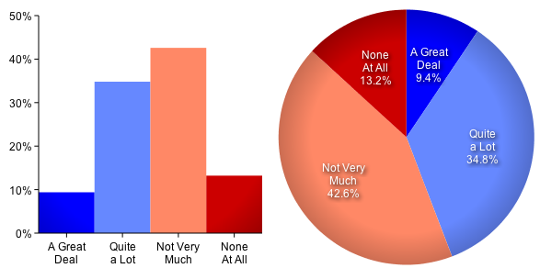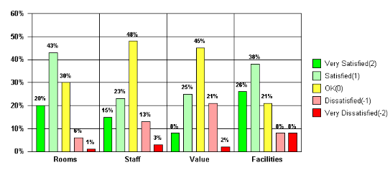
Fig. 6 Ordinal Data Representation^{[33]}

The use of AI for displaying the work progress in the form of graph ,chart etc
vii) Smart Medical Facilities:
This is also the one of the very important benefits of smart city with smart health product. Now a day’s many people are using the smart health belt to maintain the health records. it is in the secure manner the data of patient is store in the provided storage. When the patient needs this data then they will able to access these data form the storge. This is also providing the smart suggestion for early stage alert of decieses .
viii) Location Recommendation :
AI technology based smart city concept also provide help to search the location . such as near by hospital , hotel , education hubs , marts etc.
xi) Better Governance and Planning Management
While developing the cities or urban townships, AI or machine learning techniques can be used to map land use across time to generate crucial insights using the satellite imagery and aerial view 2D or 3D images of geographical areas.
xi) Parking of vehicle with smart traffic management
Now a days most of the person have car , bike , and huge number of public transports vehicle , auto etc . These all are in very high amount it is difficult to maintain the traffic and its proper parking is also very important for this AI will help .By using the smart AI smart CCTV cameras with including the per decided parking space in the selected area will help and suggest to all vehicle owner to used the present information .AI based traffic sensor system it will collect the real time data of vehicles while vehicle in the rod and these collected information send to the server centre in real time mode so it will also help .
7 AI SMART CITY CHALLENGE
AI involvement is very difficult task for Achieving then smart cities , as we all know for making the smart cities here as many challenging task , such as limited technology, limited manpower , lack of funds , some of the issue mention below section :

Costing and Infrastructure related issue
Security point of view smart cities is required the security system that is include the AI technology based cameras including the some other security system ,these all the tools are highly Costley . The maintains of these Tools is also bit of difficult. These all the tools may be damage and not working properly due to bad air quality, high pollution in the air , theft etc . Many Smart city concept include the sensor based technology for analysing the collected information thorough CCTV camera, Traffic Signals ,these all smart equipment’s are used for to provide the help for quality traffic management , make a hour cluster during high rush in traffic etc . To maintain the equipment coset as well as mention the quality of these AI equipment is difficult .
- Issue related to Security and Privacy Concerns
This is the another challenging issue to development of high security for the human begins those who are living in the Smart cities . This is difficult to arrange the good security for people. To maintain the security of people during the time slots such as night . To for monitoring the regular activity of a person is also time consuming and space consuming. This is comes under challenge of IoT and sensor technology. Now another issue with the smart cities is cyber -attack, leakage of data , hard ware security specially mobile data leakage etc.
- Socialization risk related issue
While development of smart cities for the urbanization location gives the high vulnerability of poor and persons living in slum areas. It means the development of these kind of cities what are the factor puts their influence these are also the very big challenge for smart cities such as data collection from age group, population gender , class , income group, etc .
- To Maintain the high Quality Data :
To maintain the data quality is also difficult task while colleting the data through the AI tools for maintain the sustainability of smart city. Data quality is indicate the resultant value for the smart cities related work . Data Quality is faced versatile issue and it is very challenging task to improve data quality . To improving the data quality is very time consuming and costly task generally done by Data pre-processing.
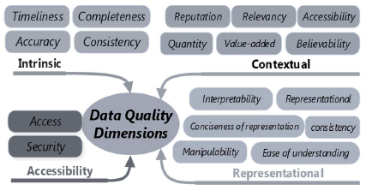
. Data Quality Various Dimensions^{[31]}

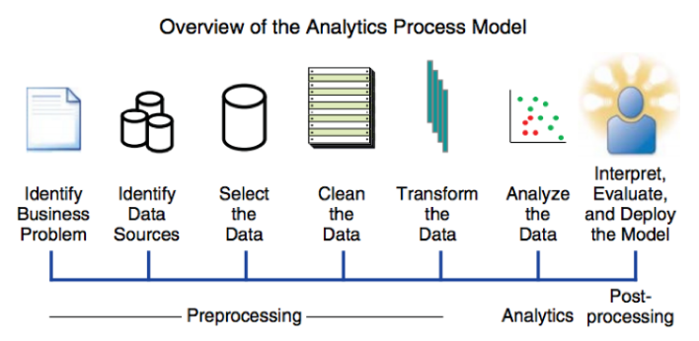
Analytics Process Model^{[32]}

Reference
1. Souza, J.T.; Francisco, A.C.; Piekarski, C.M.; Prado, G.F. Data Mining and Machine Learning to Promote Smart Cities: A Systematic Review from 2000 to 2018. Sustainability 2019, 11, 1077. [CrossRef]
2.Chakraborty,P.;AduGyamﬁ,Y.O.;Poddar,S.;Ahsani,V.;Sharma,A.;Sarkar,S.TraﬃcCongestionDetection from Camera Images using Deep Convolution Neural Networks. Transp. Res. Rec. J. Transp. Res. Board 2018, 2672, 222–231. [CrossRef]
3. Yuan, Z.; Zhou, X.; Yang, T. Hetero-ConvLSTM. In Proceedings of the 24th ACM SIGKDD International Conference on Knowledge Discovery & Data Mining, London, UK, 19–23 August 2018; Association for Computing Machinery (ACM): New York, NY, USA, 2018; pp. 984–992.
4. Shukla, U.; Verma, S.; Verma, A.K. An Algorithmic Approach for Real Time People Counting with Moving Background. J. Comput. Theor. Nanosci. 2020, 17, 499–504. [CrossRef]
5. Chen, Q.; Wang, W.; Wu, F.; De, S.; Wang, R.; Zhang, B.; Huang, X. A Survey on an Emerging Area: Deep Learning for Smart City Data. IEEE Trans. Emerg. Top. Comput. Intell. 2019, 3, 392–410. [CrossRef]
6.Simhambhatla,R.;Okiah,K.;Kuchkula,S.;Slater,R.Self-drivingcars: Evaluationofdeeplearningtechniques for object detection in diﬀerent driving conditions. SMU Data Sci. Rev. 2019, 2, 23.
7. Foody, G.M.; Mathur, A. A relative evaluation of multiclass image classiﬁcation by support vector machines. IEEE Trans. Geosci. Remote Sens. 2004, 42, 1335–1343. [CrossRef]
8. Samek, W.; Wiegand, T.; Müller, K.R. Explainable Artiﬁcial Intelligence: Understanding, Visualizing and Interpreting Deep Learning Models. arXiv 2017, arXiv:1708.08296.
9. Choo, J.; Liu, S. Visual Analytics for Explainable Deep Learning. IEEE Eng. Med. Biol. Mag. 2018, 38, 84–92. [CrossRef]
10. Shahrdar, S.; Menezes, L.; Nojoumian, M. A Survey on Trust in Autonomous Systems. In Advances in Intelligent Systems and Computing; Springer Science and Business Media LLC: Cham, Switzerland, 2018; pp. 368–386.
11. Winikoﬀ, M. Towards Trusting Autonomous Systems. In Lecture Notes in Computer Science; Springer Science and Business Media LLC: Cham, Switzerland, 2018; pp. 3–20.
12. Al Ridhawi, I.; Otoum, S.; Aloqaily, M.; Boukerche, A. Generalizing AI: Challenges and Opportunities for Plug and Play AI Solutions. IEEE Netw. 2020, 1–8. [CrossRef]
13. Holzinger, A.; Langs, G.; Denk, H.; Zatloukal, K.; Müller, H. Causability and explainability of artiﬁcial intelligence in medicine. Wiley Interdiscip. Rev. Data Min. Knowl. Discov. 2019, 9, 1312. [CrossRef]
14. Hossain, M.S.; Muhammad, G.; Guizani, N. Explainable AI and Mass Surveillance System-Based Healthcare Framework to Combat COVID-I9 Like Pandemics. IEEE Netw. 2020, 34, 126–132. [CrossRef]
15. Calvaresi, D.; Mualla, Y.; Najjar, A.; Galland, S.; Schumacher, M. Explainable Multi-Agent Systems Through Blockchain Technology. In Biometric Recognition; Springer Science and Business Media LLC: Cham, Switzerland, 2019; pp. 41–58.
16. Marino, D.L.; Wickramasinghe, C.S.; Manic, M. An Adversarial Approach for Explainable AI in Intrusion Detection Systems. In Proceedings of the IECON 2018—44th Annual Conferen.
17.Abdullatif,A.;Masulli,F.;Rovetta,S.TrackingTimeEvolvingDataStreamsforShortTermTraﬃcForecasting. Data Sci. Eng. 2017, 2, 210–223. [CrossRef]
18. Fong,R.C.;Vedaldi,A.InterpretableExplanationsofBlackBoxesbyMeaningfulPerturbation. InProceedings of the 2017 IEEE International Conference on Computer Vision (ICCV), Venice, Italy, 22–29 October 2017; pp. 3449–3457.
19. Gao, J.; Wang, X.; Wang, Y.; Xie, X. Explainable Recommendation through Attentive Multi-View Learning. In Proceedings of the Thirty-Third AAAI Conference on Artiﬁcial Intelligence, Honolulu, HI, USA, 27 January–1 February 2019; Volume 3, pp. 3622–3629.
20. Papernot, N.; McDaniel, P. Deep k-Nearest Neighbors: Towards Conﬁdent, Interpretable and Robust Deep Learning. arXiv 2018, arXiv:1803.04765.
21. Berners-Lee, T.; Hendler, J.; Lassila, O. The Semantic Web. Sci. Am. 2001, 284, 34–43. [CrossRef]
22. Dhavalkumar, T.; Fan, Y.-T.; Dimoklis, D. User Interaction with Linked Data: An Exploratory Search Approach. Int. J. Distrib. Syst. Technol. IJDST 2016, 7, 79–91.
23. Escolar, S.; Villanueva, F.J.; Santoﬁmia, M.J.; Villa, D.; Del Toro, X.; Lopez, J.C. A Multiple-Attribute Decision Making-based approach for smart city rankings design. Technol. Forecast. Soc. Chang. 2019, 142, 42–55. [CrossRef]
24. Tobey, M.B.; Binder, R.B.; Chang, S.; Yoshida, T.; Yamagata, Y.; Yang, P.P.-J. Urban Systems Design: A Conceptual Framework for Planning Smart Communities. Smart Cities 2019, 2, 522–537. [CrossRef]
25. Hoang, G.T.T.; Dupont, L.; Camargo, M. Application of Decision-Making Methods in Smart City Projects: A Systematic Literature Review. Smart Cities 2019, 2, 433–452. [CrossRef]
26. Gupta, K.; Hall, R.P. Understanding the What, Why, and How of Becoming a Smart City: Experiences from Kakinada and Kanpur. Smart Cities 2020, 3, 232–247. [CrossRef]
27. Browne, N.J.W. Regarding Smart Cities in China, the North and Emerging Economies—One Size Does Not Fit All. Smart Cities 2020, 3, 186–201. [CrossRef] 28. Komninos, N.; Bratsas, C.; Kakderi, C.; Tsarchopoulos, P. Smart City Ontologies: Improving the eﬀectiveness of smart city applications. J. Smart Cities 2016, 1, 31–46. [CrossRef]
29. Subramaniyaswamy, V.; Manogaran, G.; Logesh, R.; Vijayakumar, V.; Chilamkurti, N.; Malathi, D.; Senthilselvan, N. An ontology-driven personalized food recommendation in IoT-based healthcare system. J. Supercomput. 2019, 75, 3184–3216. [CrossRef]
30.Alkahtani,M.;Choudhary,A.;De,A.;Harding,J.A.;Harding,J.Adecisionsupportsystembasedonontology anddataminingtoimprovedesignusingwarrantydata. Comput. Ind. Eng. 2019,128, 1027–1039. [CrossRef]
31 Ikbal taleb and Mohamed Adel Serhani "Big Data Quality: Survey" In: IEEE International Congress in Big Data pp 166 -173 IEEE Honolulu, HI, USA 2018
32. https://blogs.sas.com/content/sgf/2019
33 https://www.google.com/imgres

