UVTG Based Dynamic Voltage Restorer For Mitigation of Voltage Sag
Vijay S. Karale¹  Dept. of Electrical Engineering  S.S.G.M. College of Engineering  Shegaon.  vijayskarale@gmail.com | Dr. Saurabh S.Jadhao²  Associate. Prof. Dept. Electrical Engineering S.S.G.M. College of Engineering Shegaon.  ssjadhao@gmail.com | Dr. S. R. Paraskar ^{3.}  Prof.& Head Dept. Electrical Engineering S.S.G.M. College of Engineering Shegaon.  srparaskar@gmail.com

Abstract— Voltage dips or sag creates useless conflict at the customer side as well as utility side. In this paper, dynamic voltage restorer device based on voltage source converter (VSC) topology is used to compensate voltage sag. Dynamic Voltage Restorer (DVR) is a modified power apparatus that is utilized to improve voltage stability i.e. to minimize the power quality problems in electrical power system network. Usually DVR is installed between load feeder and source in the distribution system. In this paper approach to compensate voltage sag by using dynamic voltage restorer base on unit vector template generation (UVTG) is discussed. Simulation is done in MATLAB software and results are obtained.
Keywords— Dynamic voltage restorer, voltage sag, sensitive load

Introduction
Power quality is the most important term of Power delivery system today. Poor power quality affects electricity consumer in many ways poor power quality result into loss of production, damage of equipment appliances increase in the power losses, interference with communication line etc. The main objective of electrical utility companies is to supply their customers with uninterrupted sinusoidal voltage of constant magnitude [1,2]. To improve power quality, custom power devices are used. In 1995 the concept of custom power is first explained by Hingorani [16]. The thought of custom power (CP) identifies with the utilization of electronic controllers for power system network. There are number of custom power units which are given below, Distribution Statcom (D-STATCOM), Dynamic Voltage Restorer (DVR), Unified power quality conditioner (UPQC), Active Power Filters, Battery Systems (BESS),Distribution Series Capacitors (DSC), Surge Arresters (SA),Uninterruptible Power Supplies (UPS), Solid State Fault Current Limiter (SSFCL), Solid-State Transfer Switches (SSTS), and Static Electronic Tap Changers (SETC) [2]. The CPD devices are either connected in series or in shunt or combination of both. Power system make sure good quality of electrical power supply which means voltage and current wave form should be balance and sinusoidal. moreover, the voltage level torque on the system should be within dependable limit, generally within 100+ -5% of their rated value if the voltage is more or less than this pre-specified value, performance of equipments is sacrificed. In case of low voltages, picture on television starts rolling, the of induction motor reduces to the square of voltage and therefore there is need for voltage compensation. Nowadays, power quality is a very important topic in the electric utility grid. The presence of voltage disturbances at the point of common coupling (PCC) results in failure of sensitive industrial equipment, which produces grid component failures, such as transformers, and economical losses[5,6]. Dynamic voltage restores are a adequate solution to mitigate the voltage sag and protect sensitive loads against the most important voltage disturbances voltage sag. A Dynamic voltage restorer is the voltage source converter that injects a series voltage in the line. The dynamic voltage restorer is able to work like series active powers filter. The paper deals with compensation of voltage sag by using DVR based unit vector template generation (UVTG) control strategy. Currently they are based on converters and connect to low and medium voltage distribution system in shunt or in the series. Series active power filters must operate in conjunction with shunt passive filters in order to compensate load voltage and current harmonics. DVR operates as a controllable voltage source power. Both schemes are implement preferable which voltage source inverters with a dc bus having a reactive element such as a battery. One of the most common power quality problems today is voltage dips. Voltage sag is a small time (10 ms to 1 minute) event for the duration of which is diction in r.m.s. voltage magnitude occurs. It is often set only by two parameters, magnitude and duration. The voltage sag magnitude is ranged from 10% to 90% of nominal voltage (which corresponds to 90% to10% remaining voltage) and with a duration from half a cycle to 1 min .In a three-phase system a voltage sag is by nature a three-phase phenomenon, which affects both the phase-to-ground and phase to- phase voltage the voltage sag is cause by the sag.

configuration of dvr
The main components of dynamic voltage restorer are injection transformer, harmonic filter, voltage source converter and energy storage control [9].
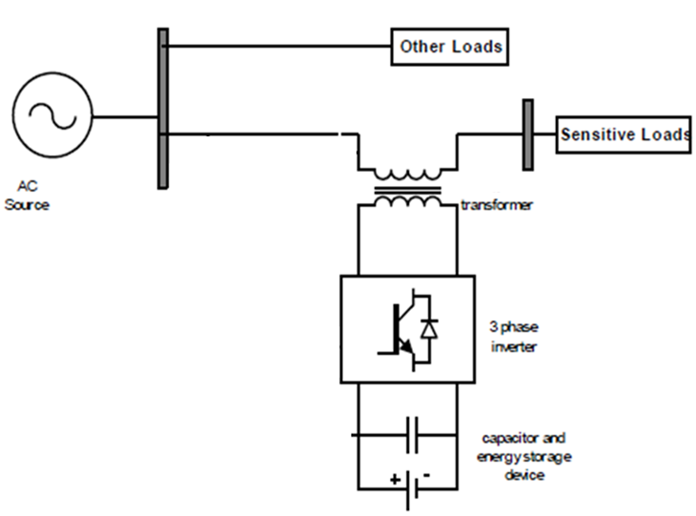
Fig.1 Basic block diagram of DVR

The dynamic voltage restorer (DVR) is a series connected device for mitigating voltage sag. The dynamic voltage restorer compensate the supply voltage related problem by injecting voltage series with the line to achieve distortion free voltage at the load terminal the series converter can be represented by following equation.
V_{inj}(ωt) = V_{L}(ωt) – V_{S}(ωt) (1)
Where, V_{inj}(ωt) , V_{L}(ωt) and V_{S}(ωt) represent the series converter injected voltage load voltage and actual source voltage respectively.
The schematic diagram of DVR system is shown in “Fig.1”, The DVR has mainly two parts, a) Power circuit b) Control circuit and PI controllers. Power circuit consists of voltage source converter (VSC), series connected injection transformer, passive filter and energy storage device. In DVR, control circuit is used to derive the parameters like magnitude, frequency and phase shift of the control signal that has to be injected through DVR. As per this control signal, an injected voltage is generated by the power circuit. The DVR corrects voltage sag for conditions to maintain the load voltage to sensitive loads within acceptable tolerances. The DVR is designed to mitigate voltage sag of a various magnitude for various durations. As the connection of transformer in distribution network is of delta-star type, zero sequence voltage will not propagate through transformer; hence only restoration of positive sequence and compensation of negative sequence voltage is required The VSC utilizes insulated gate bipolar transistors (IGBTs). It is supplied from an energy source, and provides compensated AC voltage with the help of inverter. A passive filter is used to suppress the switching harmonics and corrects the shape of voltage to be injected. Connection of DVR with the distribution line is made through an injection transformer that is connected in series with the line. The three single phase injection transformer is used to inject the missing voltage at the PCC.
The main objective of this paper is to compensate the symmetrical voltage sag as well as unsymmetrical voltage sag.

SELECTION OF DC CAPACITOR
The selection of dc bus capacitance is selected based on transient energy required during changed in the load Considering that energy store in the capacitor is for meeting the energy demand of the load for fraction of power cycle.[18]
(½){C_{DC}(V²_{DC} –V²_{DC1})}=3V_{f}I_{f} ∆t (4)
Where,
V_{DC} is rated voltage, V_{DC1} is the drop in voltage allowed during the transient, ∆t is the time for which support is required and C_{DC} is the DC bus capacitance.

CONTROL STRATEGY AND PRAPOSED METHDOLOGY
This section is described by the proposed control strategy of dynamic voltage restorer. The unit vector template generation (UVTG) technique is used to control the dynamic voltage restorer the controlled block diagram DVR for generating reference voltage signal is as shown in fig.2.[2][3][4]

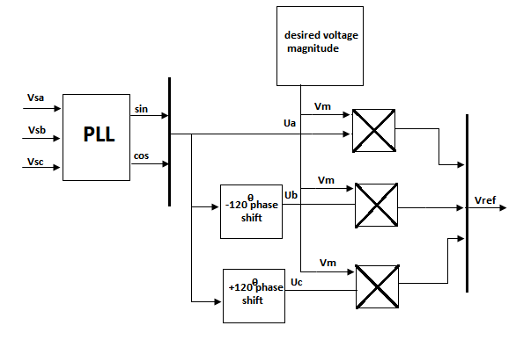
Fig.2 Control block diagram of series APF based on UVTG technique.

The component of series APF (DVR) is controlled to appropriate voltage between the point of common coupling and load so that voltage become balance and distortion free and maintain desire magnitude.[2] [3]
The three phase input voltage may be distorted or any power quality problems are present at point of common coupling (PCC). To get unit vector template signal the input source voltage sensed and multiplied by gain equal to 1/Vm (Vm is the peak amplitude of fundamental voltage)[3]. The phase lock loop (PLL) is used to achieve synchronization with supply voltage. The extraction of three-phase voltage reference signal for series APF is based on unit vector template generation (UVTG) is achieve by phase lock loop (PLL) is given by following equation. Three-phase distorted supply voltages are sensed and given to PLL which generates two quadrature unit vectors (sinwt,coswt). The in-phase sine and cosine outputs from the PLL are used to compute the supply in phase, 120^{ο} displaced three unit vectors (Ua ,Ub Uc) using eqn.(2) as:

(2)

The computed three in-phase unit vectors then multiplied with the desired peak value of the PCC phase voltage (Vm), which becomes the three-phase reference PCC voltages as:

(3)

The desired peak value of the PCC voltage under Consideration is 338V (=415sqrt (2)/sqrt(3)).The Computed voltages from reference voltages from eqn.(2) are then given to the comparator along with the sensed three phase PCC voltages(V_{La}, V_{Lb} and V_{Lc}).[3]
For getting the distortion free load voltage this load voltage must be equal to the reference load voltage.
Now this reference voltage is compare with load voltage which gives the error signal as shows in fig.(3)
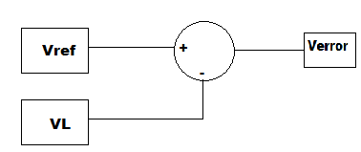
Fig.3 Generation of error signal.
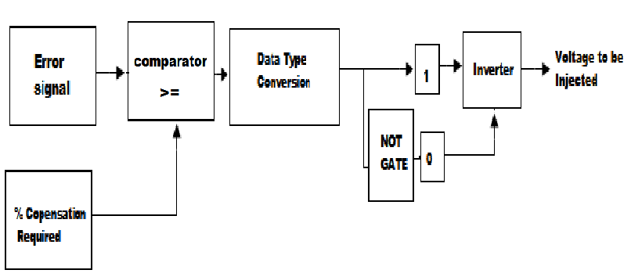
Fig.4 Generation of triggering pulses
Fig.4 shows generation of triggering pulses from error signal and % compensation required. Error signal and required % compensation are compared and data type of the output is changed to Boolean. Logical operation with the Boolean signal generates the required triggering pulses to the inverter that generates the voltage to be injected.
Simulation of control algorithm
The basic functions of a controller in a DVR are the detection of voltage sag, distortion, and harmonic events in the system; computation of the correcting voltage, generation of trigger pulses to the sinusoidal PWM based DC-AC inverter, correction of any anomalies in the series voltage injection and termination of the trigger pulses when the event has passed. The controller may also be used to shift the DC-AC inverter into rectifier mode to charge the capacitors in the DC energy link in the absence of voltage sags. The control scheme for the proposed system is based on the comparison of a voltage reference and the measured terminal voltage (Va, Vb, Vc).The voltage sags is detected when the supply drops below value 20% of the reference voltage. The error signal is used as a modulation signal that allows to generate a commutation pattern for the power switches (IGBT‘s) constituting the voltage source converter. The commutation pattern is generated by means of the sinusoidal pulse width modulation technique (SPWM); voltages are controlled through the modulation. The PLL circuit issued to generate a unit sinusoidal wave in phase with mains voltage.
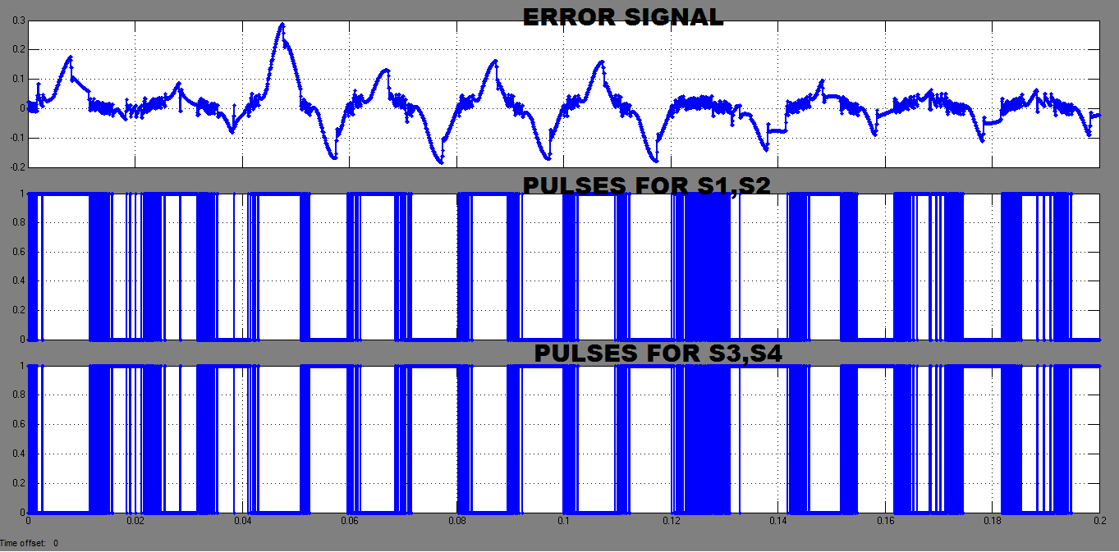
Fig.5 triggering pulses
The output of the comparator is switching signals to the twelve switches of the VSI of Series APF. It will generate the switching signals such that the voltage at PCC becomes the desired sinusoidal reference voltage. Therefore, the injected voltage across the series transformer through the ripple filter cancel out both balance and unbalance voltage sag present in the supply voltage.
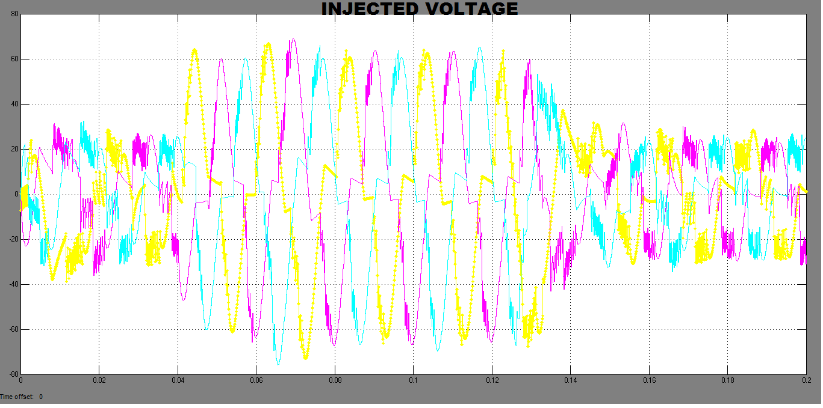
Fig.6 Injection transformer output

Fig. 6 shows voltage to be injected in series with the load voltage. Injected voltage is the approximate sine wave voltage due to transformer winding inductance.

IV. SIMULATION AND RESULTS

In this section the MATLAB simulation and result are presented dynamic voltage restorer (DVR) voltage sag mitigation based on unit vector template generation technique there are two cases analyzed for the DVR based on UVTG control technique which are given below.
CASE I: 20% Balance voltage sag compensation.
Generally in case of power system this sag comes about due to faults or beginning of sudden large load. Following figure shows generalized power system.

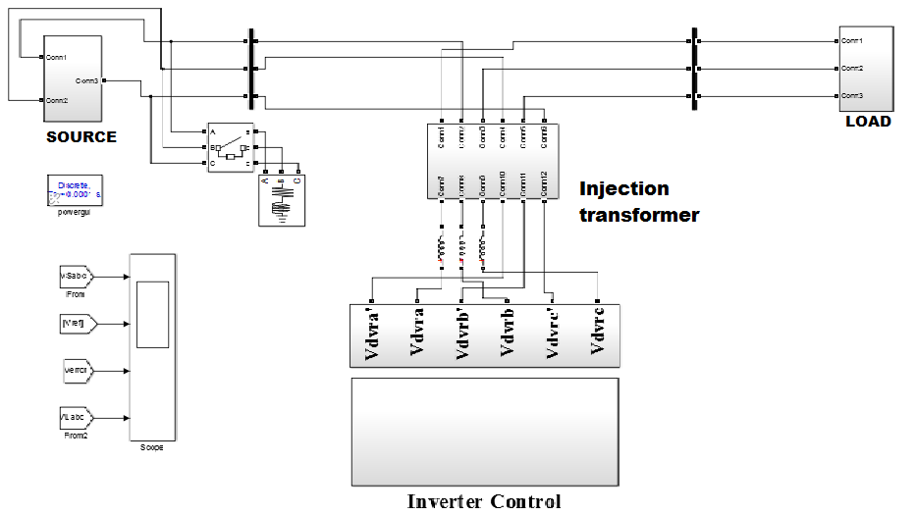

Fig.7 Shows Simulation of system when sudden load increase on source side

The simulation result of 20% supply balance voltage sag created in all three phase to sudden increase in the large load at 0.04s and cleared at 0.12sis shown in fig. when the supply voltage sag is created at 0.04s the dynamic voltage restorer comes into operation and inject the missing voltage during the sag.

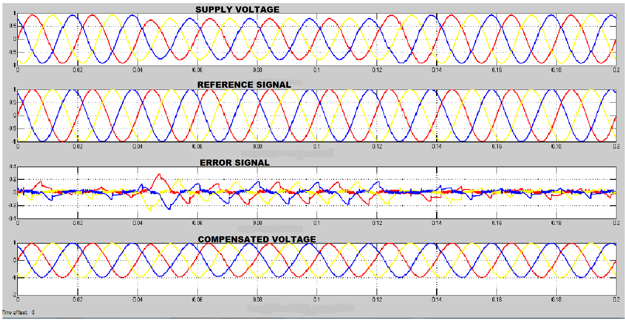

Fig.8 Simulation and results of Case I

System voltage | Voltage sag | Injected  voltage | Mitigated voltage
415V | 0.2pu | 0.10*2 | 1pu
Table 1. Observed Output of Case I

CASE II: 25% balance voltage sag compensation.

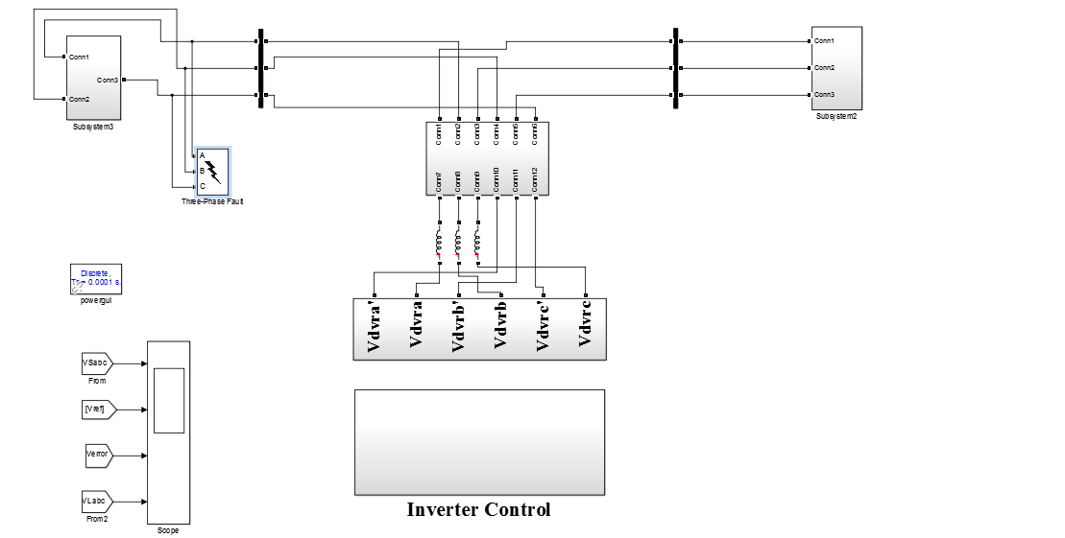

Fig.9 Shows Simulation of system with balanced voltage sag

The simulation result of 25% supply balance voltage sag created due to three phase to ground fault for duration 0.04s and cleared at 0.12s is shown in fig. when the supply voltage sag is created at 0.04s the dynamic voltage restorer comes into operation and inject the missing voltage during the sag.

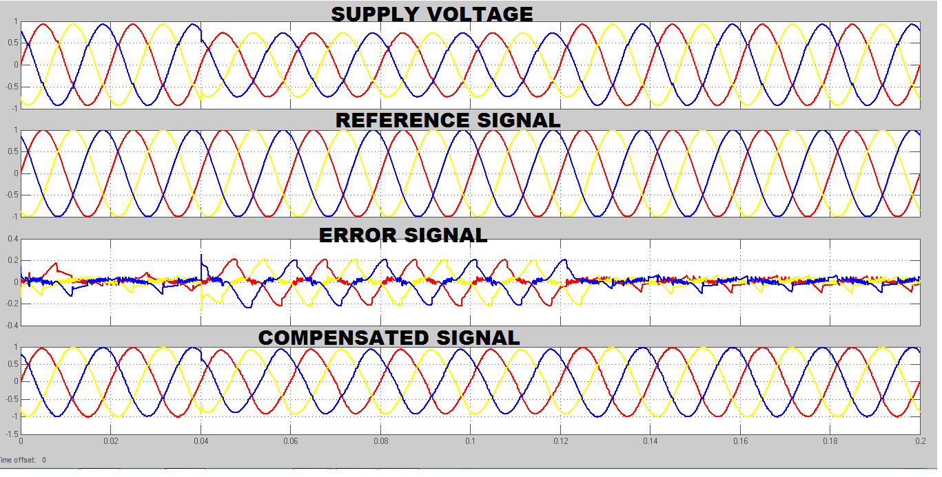

Fig.11 simulation and result for voltage in case II

System voltage | Voltage sag | Injected  voltage | Mitigated voltage
415V | 0.25pu | 0.125*2 | 1pu
Table 2. Observed Output of Case II

Case III: 25%unbalance sag compensation

The simulation result of 25% supply unbalance voltage sag created due to single phase to ground fault for duration 0.04s and cleared at 0.12s is shown in fig. when the supply voltage sag is created at 0.04s the dynamic voltage restorer comes into operation and inject the missing voltage during the sag.

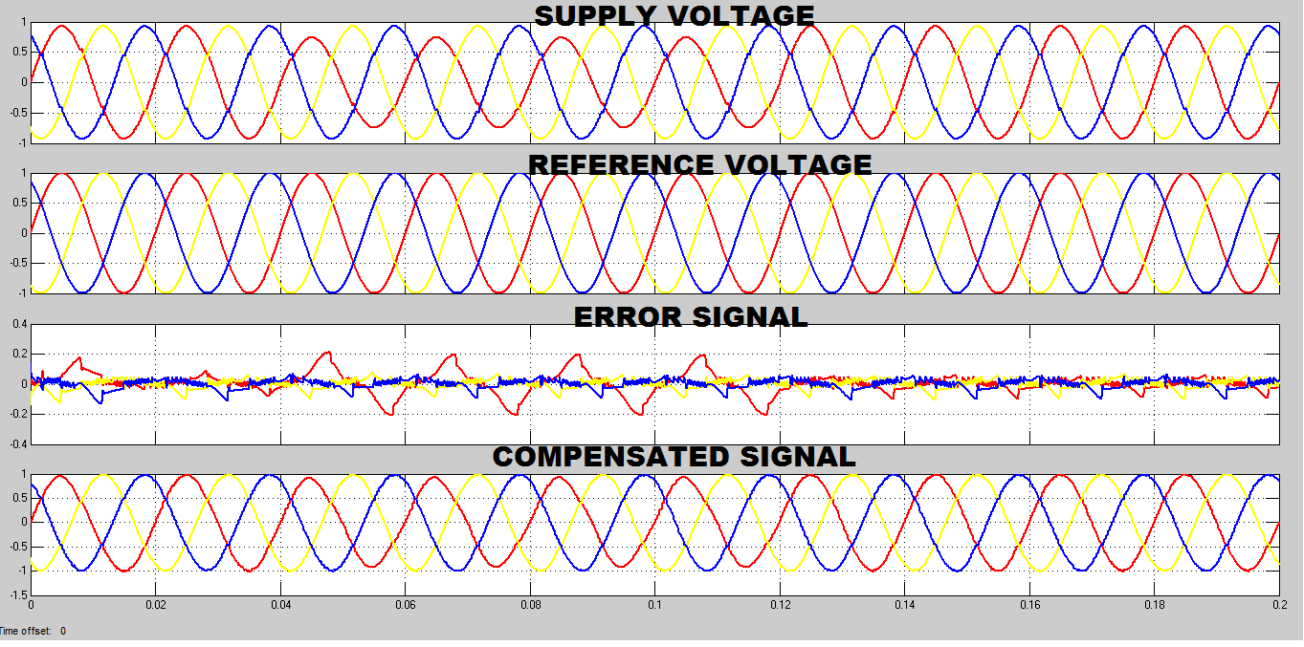
Fig.12 simulation and result for voltage in case III
System voltage | Voltage sag | Injected  voltage | Mitigated voltage
415V | 0.25pu | 0.125*2 | 1pu

Table 3. Observed Output of Case III

From both the cases, it is verified that, voltage injected by inverter = 1–Sag Voltage (pu) (5)

V.CONCLUSION
The modeling and simulation of a DVR using MATLAB has been presented in this paper. A proposed control system based on unit vector template generation (UVTG) for DVR. The MATLAB simulink models have been simulated to verify effectiveness of proposed control technique The simulation shows that the DVR performance is Satisfactory in mitigating voltage sag. Simulation results also show that the DVR compensates the sags quickly and provides excellent voltage regulation. The DVR can handles both balanced and unbalanced situations without any difficulties and injects the appropriate voltage component to correct rapidly any anomaly in the supply voltage to keep the load voltage balanced and constant at the nominal value.

References

- Rosli Omar and Nasrudin Abd Rahim “Mitigation of voltage sag/swell by using DVR” ARPN Journal of Engineering and Applied Sciences, vol. no 4, June 2009.

- Bhim Singh and venkateswarlu.P “A simplified control algorithm for three-phase , four wire unified power quality conditioner” Presented at journal of power electronics ,vol no.1, January 2010

- S. N. Gohil, M.V.Makwana, K.T. Kadivar,G.J.Tetar “Three phase unified power quality conditioner(UPQC) for power quality improvement using UVTG Technique” 2013 International conference on renewable energy and sustainable energy [ICRESE’13].
- B.Singh, a chandra and k al haddad “review of active filters for power quality improvement” IEEE trans. Industrialelectronics,vol 46, No 5,pp.960-97, oct. 1999
- IEEE Std. 1159 – 1995, “Recommended Practice for Monitoring Electric Power Quality”.
- Vijay Karale and Saurabh jadhao “voltage sag mitigation using dynamic voltage restorer” proceeding of 2nd international conference on innovative in electrical & electronics engineering (ICIEE)., No.184, Aug 2015.
- P.Boonchiam and N. Mithulananthan, Thammasat “Understanding of Dynamic Voltage Restorers through MATLAB Simulation,” Int. J. Sc. Tech., Vol. 11, No. 3, July-Sept 2006.
- J. G. Nielsen, M. Newman, H. Nielsen,and F. Blaabjerg, “Control and testing of a dynamic voltage restorer (DVR) at medium voltage level,” IEEE Trans.Power Electron., vol. 19, no. 3,p.806, May 2004.
- Ghosh and G. Ledwich, “Power Quality Aamir Hanif, Mohommad Ahmed Choudhary,and Tahir Mehmood “Feed-Forward Control Strategy for the VSC of DVR for Smooth and Clean Power Flow to Load”.
- Hideaki Fujita and Hirofumi Akagi, “The Unified Power Quality Conditioner”, IEEE transaction on power electronics, VOL. 13, NO. 2, MARCH 1998
- H. Awad, J.Svensson, M. Bollen, “Mitigation of Unbalanced Voltage Dips Using Static Series Compensator”, IEEE Trans. On Power Elec., Vol. 19, No. 13, May 2004
- Hochgraf, R. Lasseter, “Statcom controls for Operation with Unbalanced Voltages”, IEEE Trans. On Power delivery, Vol. 13, No. 2, April 1998.
- Gunther, E.W., Mehta, H.: A survey of distribution system power quality. In: IEEE Trans. on PowerDelivery, vol.10 (1995), No.1, Jan.1995, pp.322-329.
- IEEE recommended Practices and Recommendations for harmonics Control in Electric Power Systems. In:IEEE std.519, 1992.
- Kotwal, C., Pillai, G. N., Gupta, H. O.: Modeling and Simulation of Different Topologies for VSI Based Static Synchronous Series Compensator. In: JEE, Vol.10(2010), Edition-4.
- H. Hingorani “Introducing custom power” IEEE spectrum, vol.32 no.6,June 1995 p 41- 48.
- Bhim Singh ,Amrish Chandra And Kamal AL-Haddad “Power quality problems and mitigation techniques” Published by 2015 John Wiley & Sons,Ltd

