Role and Regulation of Plants Phenolics in heat Stress Tolerance: An Overview
Ragini Bhardwaj¹, Jafar K. Lone¹, Sapna Lngyan¹
¹Division of Germplasm Evaluation, ICAR-National Bureau of Plant Genetic Resources, New Delhi-110012, India.
1. Introduction
Plants routinely confront an array of unfavorable environmental conditions, collectively known as abiotic stresses. These challenges arise from the ever-changing and inhospitable atmospheric conditions that impact the growth and development of plants (Zhu et al., 2016). These stressors encompass a wide spectrum of difficulties, including issues related to water availability, such as drought and flooding, exposure to heavy metals, salinity-related problems, nutrient imbalances, extreme temperature fluctuations, ranging from chilling cold to scorching heat, varying light intensities, spanning from intense brightness to dimness, exposure to radiation, including both UV-B and UV-A rays, encounters with ozone and sulfur dioxide, encounters with mechanical forces, and a range of other less common stress factors (Pereira, 2016). Since plants are securely rooted in their growth surroundings, they need to constantly adapt to the perpetually changing conditions brought about by abiotic stresses. Among these challenges, temperature fluctuations are particularly detrimental to plant growth and development. In response to these abiotic stressors, plants synthesize a range of defensive compounds, with plant phenolic compounds playing a pivotal role (Parvaiz & Satyawati, 2008; Akula & Ravishankar, 2011). An adaptive mechanism employed by plants in the face of these unfavorable conditions involves the accumulation of phenolic compounds in their tissues (Pereira, 2016; Lattanzio, 2013). These phenolic compounds significantly increase in plants under stress, contributing to their survival (Lattanzio, 2013; Sharma et al., 2019).
Plants produce an extensive array of chemical compounds, which can be classified into two primary categories: primary metabolites and secondary metabolites. Primary metabolites, including substances like sugars, fatty acids, amino acids, and nucleic acids, are essential for the basic growth and development of plants and are found universally in all plant species (Fiehn, 2002; Wu and Chappell, 2008). In contrast, secondary metabolites exhibit greater structural and functional diversity. While they are not directly involved in fundamental plant metabolic processes, these compounds play a crucial role in ensuring the plants' survival within their specific environments. Plant phenolics, also referred to as polyphenols, represent a prominent category of secondary metabolites with significant physiological and morphological importance. hese aromatic compounds, distinguished by the presence of one or more hydroxyl groups, have their origins in pathways like the shikimate/phenylpropanoid or polyketide acetate/malonate pathways, leading to the formation of both single-unit and multi-unit phenols and polyphenols (Randhir et al., 2004). Plant phenolics exert a significant influence on various aspects of plant life, including growth, development, and reproduction. Moreover, they function as protective barriers against abiotic stressors such as intense light, cold temperatures, UV-B radiation, heavy metal exposure, and nutrient deficiencies (Lattanzio, 2013). Beyond their protective roles, they act as guardians against diseases and predators (Bravo, 1998), contribute to the vibrant color and sensory characteristics of fruits and vegetables (Alasalvar et al., 2001), and possess valuable properties like anti-allergenic, antimicrobial, and antioxidant activities (Balasundram et al., 2006).
As the demand for food continues to rise and the pressing issue of crop losses attributed to climate change, notably global warming, becomes more pronounced, it becomes absolutely essential to develop strategies aimed at improving crop yield (Ainsworth & Ort, 2010). During times of stress, plants curtail their growth and shift their primary metabolic focus towards synthesizing secondary metabolites. This entails precise regulation of gene expression levels, influenced by factors like ontogeny and the circadian clock mechanism.
Transcription factors are responsible for coordinating these regulatory mechanisms that govern the growth and accrual of diverse secondary metabolites within plants (Ornston & Yeh, 1979; Wink, 1999; Lehfeldt et al., 2000; Tauber et al., 2000; Broun, 2005; Nascimento & Fett-Neto, 2010). The conveyance and aggregation of secondary metabolites are crucial for governing both defensive and developmental processes in plants. The control of this process is intricately affected by multiple factors, such as the stage of development, the nature of the tissue or organ, and the occurrence of particular stress conditions. In the expansive realm of plant metabolites, phenolic compounds emerge as noteworthy natural secondary metabolites originating from pathways like the shikimate, pentose phosphate, and phenylpropanoid pathways (Balasundram et al., 2006; Cheynier et al., 2013; Heleno et al., 2015). These metabolic routes give rise to either individual phenolic compounds like flavonoids, phenolic acids, and phenylpropanoids or complex phenolic compounds such as tannins, lignins, lignans, and melanins. Due to their unique roles in plant growth and defense, phenolic compounds exhibit significant diversity in their molecular structures. While certain phenolic compounds are common across various plant species, others are specific to particular plant types. These phenolic compounds not only contribute to regulating diverse physiological functions during plant growth and development but also play a pivotal role in plant defense mechanisms (Kumar et al., 2020).
2. Biosynthesis of plant phenols
Transcription factors take on the vital role of coordinating the intricate regulatory mechanisms governing the growth and accumulation of various secondary metabolites within plants (Ornston & Yeh, 1979; Wink, 1999; Lehfeldt et al., 2000; Tauber et al., 2000; Broun, 2005; Nascimento & Fett-Neto, 2010). The transport and storage of these secondary metabolites hold a pivotal position in controlling both defensive and developmental processes in plants, with this regulation intricately influenced by factors such as the plant's developmental stage, the specific type of tissue or organ involved, and the presence of specific stress conditions. Within the vast spectrum of plant metabolites, phenolic compounds emerge as natural secondary metabolites synthesized through pathways like the pentose phosphate, shikimate, and phenylpropanoid pathways (Balasundram et al., 2006; Cheynier et al., 2013; Heleno et al., 2015). These pathways yield a diverse array of phenolic compounds, ranging from individual ones like flavonoids, phenolic acids, and phenylpropanoids, to more complex structures like tannins, lignins, lignans, and melanins. Due to their unique roles in plant growth and defense, phenolic compounds exhibit remarkable diversity in their molecular structures. This conversion leads to the production of ribulose-5-phosphate. Simultaneously, glycolysis generates phosphoenolpyruvate, which then combines with erythrose-4-phosphate. This integrated pathway guides these metabolites through both the phenylpropanoid pathway and, eventually, the shikimic acid pathway, resulting in the synthesis of phenolic compounds. One pivotal step in this process is the conversion of phenylalanine, a critical event illustrated in Figure 1.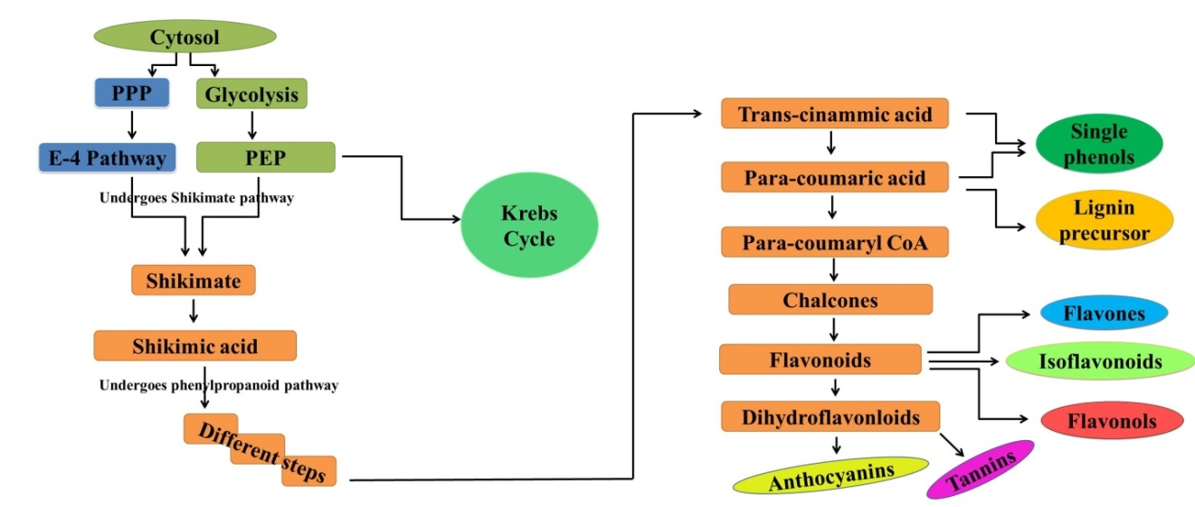
Fig.1: Integration of all three major pathways in the biosynthesis of Phenols includes: phenyl propanoid pathway, Pentose phosphate pathway, and Shikimate pathway in plants/crops

3. Classification of plant phenolics
Phenolic compounds are characterized by a structural framework that includes an aromatic ring adorned with one or more hydroxyl groups, leading to a wide array of structural variations, often categorizing them as polyphenols (Bravo, 1998). Many phenolic compounds naturally exist in combinations with both mono- and polysaccharides, incorporating one or multiple phenolic units. Additionally, they can undergo functional modifications, such as the formation of esters and methyl esters (Harborne, 1989; Harborne et al., 1999; Shahidi and Naczk, 1995). While phenolics constitute a vast and diverse array of chemical compounds, they can be classified based on various criteria. For instance, Al-Mamari (2021) briefly outlined a classification based on the carbon count within the molecule (as shown in Table 1), which can be summarized as follows:
Table 1: classification of plant phenolics (Al-Mamari, 2021)

Structure | Class | No. of atoms
C6 | Simple Phenols, benzoquinones6 | 6
C6-C1 | Phenolic acids and related compounds | 7
C6-C2 | Acethophenones, phenyl acetic acids | 8
C6-C3 | HCAs, phenylpropanoids (coumarin, isocoumarin, chromones, chromenes) | 9
C6-C4 | Napthoquinones | 10
C6-C1-C6 | Xanthones | 13
C6-C2-C6 | Stilbenes, anthroquinones | 14
C6-C3-C6 | Flavonoids, isoflavonoids | 15
 | Betacyanins | 18
(C6-C3)2 | Lignans, neolignans | 18
(C6-C3-C6)3 | Biflavonloids | 30
(C6-C3)n | Lignin
(C6)n | Melanin | N
(C6-C3-C6)n | Condensed tannins (proanthocyanins falvolans)

Plant phenolic compounds are classified based on a variety of factors, including the number of hydroxyl groups they contain, their chemical composition, and their structural characteristics. Firstly, the number of hydroxyl groups distinguishes phenolic compounds as 1-, 2-, or polyatomic phenols, with polyphenols having multiple OH groups within their aromatic ring. Secondly, their chemical composition categorizes phenolics as mono-, di-, oligo-, or polyphenols. Furthermore, the classification of phenolic compounds can be based on the presence of substituents in the carbon skeleton, the number of aromatic rings, and the carbon atoms in the side chain. Following this approach, phenolic compounds can be categorized into four primary groups: those with a single aromatic ring, those with two aromatic rings (including benzoquinones, xanthones, stilbenes, and flavonoids), quinones, and polymers formed by connecting phenolic compounds. Within the intricate realm of polyphenolics, which comprises more than 8,000 unique compounds, there are two primary classes: flavonoids and non-flavonoids like tannins, each displaying unique structural variations that set them apart.

4. Phenolics and plant growth
Plants employ secondary metabolites to interact with their environment, and within this group, polyphenols assume essential functions. These compounds contribute to diverse processes, including the transmission of signals from roots to shoots and the mobilization of nutrients. Phenolic compounds, found abundantly across the plant kingdom, hold pivotal significance in metabolic and physiological processes (Boudet et al., 2007; Kumar et al., 2019). These compounds exert their influence on various physiological functions related to growth, encompassing processes like seed germination, cell division, and the synthesis of photosynthetic pigments (Tanase et al., 2019). The versatility of phenolic compounds extends to applications such as bioremediation, allelopathy, promotion of plant growth, and their role as antioxidants in food additives (Bujor et al., 2015). In response to stress, plants consistently accumulate phenolic compounds, which serve as a defense mechanism against a wide range of abiotic stressors (Cheynier et al., 2013). These compounds are instrumental in enhancing plant tolerance and adaptability under less-than-optimal conditions (Andersen et al., 2003), with many of them possessing antioxidant properties (Hasanuzzaman et al., 2013) that bolster plant performance during stressful periods.
The interaction between plants and their environment, facilitated by secondary metabolites, including polyphenols, holds significant implications for vital processes like signal transduction from roots to shoots and the mobilization of nutrients. Phenolic compounds found in root exudates actively alter the characteristics of the rhizosphere, with soil microbes playing a role in transforming these compounds, which in turn contributes to processes like nitrogen (N) mineralization and the formation of humus (Sakamoto et al., 2000). Additionally, phenolics are instrumental in enhancing nutrient uptake through various mechanisms, including chelation of metallic ions, creating favorable absorption sites, improving soil porosity, and expediting the mobilization of essential elements such as calcium (Ca), magnesium (Mg), potassium (K), zinc (Zn), iron (Fe), and manganese (Mn) (Balla et al., 2009). Recent investigations conducted by Rehman and colleagues have shed light on the elevation of phenolic and organic acid concentrations in wheat root exudates following the application of zinc (Zn) and treatment with plant growth-promoting rhizobacteria (PGPR). This augmentation has led to a noteworthy enhancement in the mobilization and absorption of nutrients, as corroborated by studies by Hoque et al. (2020) and Oh et al. (2009).
In the context of legumes, phenolic compounds serve as facilitators of nitrogen fixation by releasing secondary metabolites that inhibit auxin transport, thereby promoting cell division during nodulation (Lo-Piero et al., 2005). Operating as physiological regulators and chemical messengers, plant phenolics impact the breakdown or synthesis of indole-3-acetic acid (IAA), subsequently influencing growth and development (Christie et al., 1994). Notably, flavonoids play a crucial role in pollen development, with even small amounts of flavonolaglycones restoring mature pollen fertility during pollination (Rivero et al., 2001; Kasuga et al., 2008). However, an excess accumulation of certain phenolics like trans-cinnamic acid, coumarin, p-hydroxybenzoic acid, and benzoic acid can hinder germination and seedling growth by disrupting enzymes and impeding cell division (Weidner et al., 2009). Conversely, elevated levels of phenolic acids can positively impact seed germination, as demonstrated in a recent study (Isshiki et al., 2014). Extracts rich in polyphenols obtained from spruce bark enhance germination rates in Lycopersicon esculentum while simultaneously inhibiting root elongation (Rana et al., 2016). Phenolics influence seed tegument porosity, facilitating water absorption and germination (Commisso et al., 2016). They also enhance photosynthetic activity and pigment synthesis in maize and sunflower (Chalker-Scott & Fuchigami, 2018). Polyphenols are generated by plants in response to a variety of environmental circumstances, encompassing both favorable and demanding situations. They play crucial roles in various aspects of plant development, encompassing processes like hormonal regulation, cell division, photosynthetic activity, signal transduction, germination, and reproduction. The increased production of polyphenols as a response to abiotic stress conditions bolsters plants' ability to adapt to demanding and adverse environments.
5. Plant defense against temperature stress
Plants employ sophisticated strategies to defend against temperature stress, involving a complex sequence of responses. Both elevated and reduced temperatures disrupt the normal functioning of photosynthetic metabolism and trigger the production of reactive oxygen species, which can lead to cellular damage (Asada, 2006; Hasanuzzaman et al., 2013). In response to these challenges, plants employ several protective mechanisms. They amass osmoprotective substances like soluble sugars, proline, and glycine betaine, serving as a shield against oxidative harm. (Sakamoto & Murata, 2000). Additionally, plants synthesize antioxidant enzymes and molecules to counteract oxidative stress (Balla et al., 2009). The buildup of antioxidant metabolites, including phenolics, terpenes, and alkaloids, during temperature stress enhances the plant's capacity to cope with these adversities (Hoque et al., 2020; Oh et al., 2009; Lo-Piero et al., 2005; Christie et al., 1994). The enzyme phenylalanine ammonia lyase becomes more active during temperature stress, leading to the accumulation of phenolic compounds within plant cells. Remarkably, Rivero et al. (2001) observed significant increases in soluble phenolics in watermelon and tomato under both heat and cold stress conditions. Kasuga et al. (2008) proposed that the accumulation of phenolics induced by cold stress contributes to lowering the freezing point, maintaining water potential, and protecting against cell damage.In the study conducted by Weidner et al. (2009), exposure to cold treatment was found to lead to elevated levels of tannins and soluble phenolics in grapevine roots. Similarly, Amarowicz et al. (2010) reported increased concentrations of specific phenolic acids such as gallic acid, ferulic acid, and caffeic acid in grapevines subjected to cold stress. When examining freezing cold stress, Isshiki et al. (2014) documented the accumulation of farinose flavonoids in the above-ground parts of primula plants. Rana and Bhushan (2016) suggested that temperature stress triggers the synthesis of phenolic compounds, thereby enhancing plants' ability to withstand cold stress.
Commisso et al. (2016) proposed the idea that phenolic compounds serve a protective role against reactive oxygen species, helping to safeguard the microfilament cytoskeleton. Additionally, Chalker-Scott and Fuchigami (2018) emphasized the significance of accumulating phenolic compounds in reinforcing cellular resilience and stress tolerance. These compounds can become integrated into cell walls as suberin or lignin, contributing to enhanced plant resilience against temperature stress. The primary phenolic compounds expressed during defense against temperature stress are depicted in Figure 2..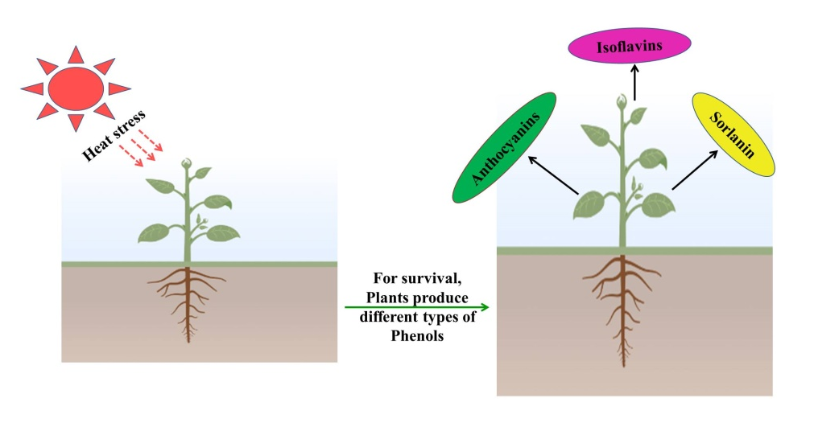
Fig. 2: High temperature stress induces synthesis of phenolic compounds in plants
Each plant species has a specific temperature range critical for its optimal growth and development. Even minor deviations from this ideal range can profoundly affect a plant's growth potential. Such temperature fluctuations trigger a wide range of physiological, biochemical, and molecular changes within plants, compelling them to adapt and maintain cellular equilibrium in challenging environments. Both high and low temperatures impose stressful conditions on plants, collectively referred to as temperature stress. It's worth noting that what may constitute an ideal temperature range for one plant species could be considered stressful for another. Hence, a temperature range below which a plant's regular growth and development processes are hindered is categorized as low-temperature stress.
When temperatures exceed the optimal range, it creates stressful conditions that can severely impact plant survival and growth.
It has been approximated that with each one-degree rise in temperature beyond the typical growing season average, there is an anticipated reduction of roughly 17% in crop yield (Lobell and Asner, 2003). Heat stress imposes various detrimental effects on plants, including reduced seed germination, diminished photosynthesis, alterations in plant phenology, oxidative stress, compromised seed quality, and ultimately a decrease in crop yield. Elevated temperatures lead to decreased enzyme activity and the production of less functional proteins. At higher temperatures, the plant's photosynthetic process is hindered, resulting in the generation of reactive oxygen species (ROS) that can cause damage to various plant structures. Both high and low temperatures can trigger the production of cellular ROS, leading to damage to components like the photosynthetic machinery (Asada, 2006; Hasanuzzaman et al., 2013). Moreover, temperature stress disrupts the water potential gradients within plants, potentially leading to dehydration stress. In response to temperature fluctuations, plants employ a strategy of accumulating primary metabolites such as proline, glycine betaine, and soluble sugars as osmoprotectants. These compounds play a critical role in preserving cell water balance and acting as a buffer against fluctuations in the cell's redox potential, as depicted in Figure 3 (Sakamoto and Murata, 2000). Additionally, plants activate antioxidative defense mechanisms in response to temperature stress to combat the harmful effects of reactive oxygen species (ROS). This defense system involves a variety of antioxidative enzymes and antioxidants that scavenge ROS, offering protection to plant structures (Balla et al., 2009). In reaction to stress conditions, plants also undergo a metabolic shift, redirecting their primary metabolism toward secondary metabolism.
This shift in response to temperature stress leads to the production of complex secondary plant compounds referred to as secondary metabolites (Selmar and Kleinwächter, 2013). These secondary metabolites include phenolics, alkaloids, and terpenes. The accumulation of these secondary metabolites during temperature stress greatly augments the plant's capacity to endure and adapt to challenging conditions, as outlined in Table 2.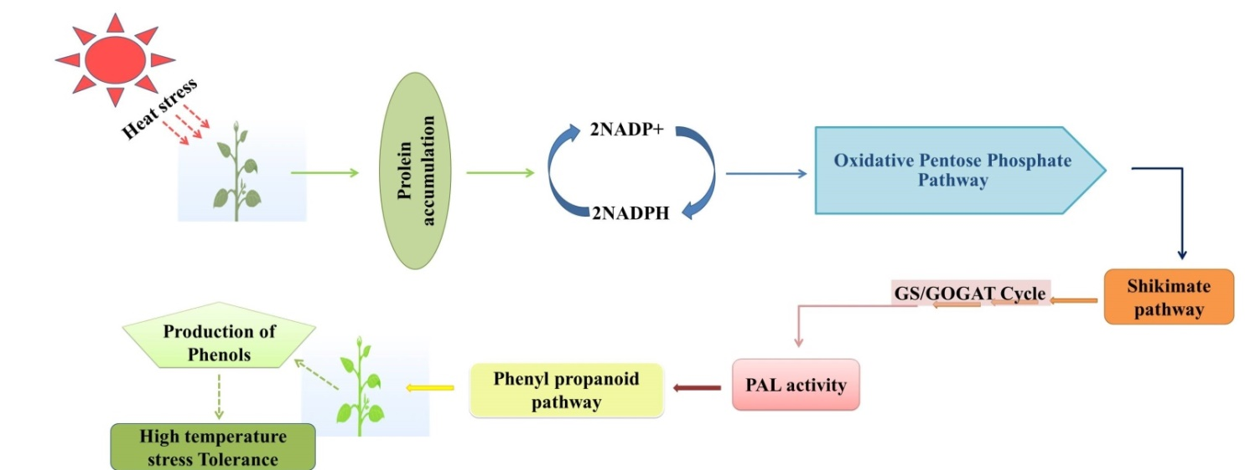
Fig. 3: Mechanism of heats stress tolerance through phenolic production in plants/crops

Table 2: Phenolics as plant protective companion against high temperature stress
Phenoliccompound | Plant/crop | Modeofaction/signalling | Reference
Total solublephenols | Tomato(Lycopersiconesculentum) and watermelon (Citrulluslanatus) | Soluble phenolic compounds accumulate significantly under temperature stress conditions due to the stimulation of their biosynthesis and the concurrent reduction in their oxidation | Rivero et al.(2001)
Kaempferol, 3-O-  glucoside, naringenin,  naringeninchalcone, quercetin-  3-hexoside | Tomato  (Solanum  lycopersicon) | Under heat stress, plants accumulate phenolic compounds to protect themselves from oxidative damage. | Martinez  et al. (2016)
Coumaric acid,caffeic acid and  anthocyanins | Carrot (Daucus  carota L.) | Phenolic metabolites acted as protective agents for the microfilament cytoskeleton in carrot cell cultures, shielding them from the harmful effects of reactive oxygen species generated during episodes of high heat. This protection resulted in reduced heat damage to the plants. | Commisso  et al. (2016)
Chicoric acid and  chlorogenic acid,  quercetin-3-O-  glucoside and  luteolin-7-O-  glucoside | Lettuce  (Lactuca  sativa L.) | Mild heat stress led to an increase in the phenolic content of lettuce. In contrast, chilling stress induced the synthesis of PAL (phenylalanine ammonia lyase), L-GalDH (L-galactose dehydrogenase), and g-TMT (gamma-tocopherol methyltransferase), but these responses were not observed under heat stress. However, the enzyme GalDH (galactose dehydrogenase) consistently increased in response to both heat and chilling stresses. | Oh et al.  (2009)

6. Significance and a way forward

Plant phenolics represent a prominent and ubiquitous group of secondary metabolites, constituting a vast reservoir of natural chemical diversity encompassing a wide range of compounds and enzymes. These compounds exert their effects through a diverse array of mechanisms, including gene regulation, metabolite transport, and interactions with enzymes. When faced with adverse environmental stresses such as physical damage, pathogen attacks, mineral deficiencies, and fluctuations in temperature, plants respond by accumulating phenolic compounds within their tissues as an adaptive strategy. Among the secondary metabolic pathways in plants, the phenylpropanoid pathway stands out as one of the most extensively studied.
Under challenging growth conditions, the accumulation of phenolic compounds often corresponds with increased plant tolerance, as illustrated in Figure 4. Abiotic stresses also trigger cellular signaling pathways that result in the transcriptional up-regulation of the phenylpropanoid pathway. This heightened resistance aligns with the diverse functions of polyphenols in plants, primarily including their capacity to neutralize reactive oxygen species (ROS) and the ability of certain polyphenol classes to shield plants from excessive light. For instance, flavonoids can counter the effects of UV light, while anthocyanins provide protection against visible light. Moreover, polyphenols may assume additional ecological roles during abiotic stress, potentially serving as chemical signals, or infochemicals, for neighboring plants, as illustrated in Figure 4.

Fig. 4: Significance of phenolic compound in plants/crops
Despite the extensive body of research in this area, further exploration is imperative. For instance, delving into the specialized roles of polyphenols in response to specific abiotic stresses remains a priority. Moreover, elucidating the intricate mechanisms that orchestrate the transition from primary metabolism to the heightened expression of the phenylpropanoid pathway is an avenue that requires further investigation.
7. References
Ainsworth, E. A., & Ort, D. R. (2010). How do we improve crop production in a warming world?. Plant physiology, 154(2), 526-530.
Akula, R., & Ravishankar, G. A. (2011). Influence of abiotic stress signals on secondary metabolites in plants. Plant signaling & behavior, 6(11), 1720-1731.
Alasalvar, C., Grigor, J. M., Zhang, D., Quantick, P. C., & Shahidi, F. (2001). Comparison of volatiles, phenolics, sugars, antioxidant vitamins, and sensory quality of different colored carrot varieties. Journal of agricultural and food chemistry, 49(3), 1410-1416.
Al Mamari, H. H. (2021). Phenolic compounds: Classification, chemistry, and updated techniques of analysis and synthesis. Phenolic Compounds: Chemistry, Synthesis, Diversity, Non-Conventional Industrial, Pharmaceutical and Therapeutic Applications, 73-94.
Amarowicz, R., Weidner, S., Wójtowicz, I., Karmac, M., Kosinska, A., & Rybarczyk, A. (2010). Influence of low-temperature stress on changes in the composition of grapevine leaf phenolic compounds and their antioxidant properties. Functional Plant Science and Biotechnology, 4, 90-96.
Andersen, C. P. (2003). Source–sink balance and carbon allocation below ground in plants exposed to ozone. New phytologist, 157(2), 213-228.
Asada, K. (2006). Production and scavenging of reactive oxygen species in chloroplasts and their functions. Plant physiology, 141(2), 391-396.
Balasundram, N., Sundram, K. and Samman, S. (2006). Phenolic compounds in plants and agriindustrial by-products: Antioxidant activity, occurrence, and potential uses. Food Chemistry 99, 191-203.
Balla, K., Bencze, S., Janda, T., & Veisz, O. (2009). Analysis of heat stress tolerance in winter wheat. Acta Agronomica Hungarica, 57(4), 437-444.
Boudet, A. M. (2007). Evolution and current status of research in phenolic compounds. Phytochemistry, 68(22-24), 2722-2735.
Bravo, L. (1998). Polyphenols: chemistry, dietary sources, metabolism, and nutritional significance. Nutrition reviews, 56(11), 317-333.
Broun, P. (2005). Transcriptional control of flavonoid biosynthesis: a complex network of conserved regulators involved in multiple aspects of differentiation in Arabidopsis. Current opinion in plant biology, 8(3), 272-279
Bujor, O. C., Talmaciu, I. A., Volf, I., & Popa, V. I. (2015). Biorefining to recover aromatic compounds with biological properties. TAPPI J, 14(3), 187-193.
Chalker-Scott, L., & Fuchigami, L. H. (2018). The role of phenolic compounds in plant stress responses. In Low temperature stress physiology in crops (67-80). CRC press.
Cheynier, V., Comte, G., Davies, K. M., Lattanzio, V., & Martens, S. (2013). Plant: recent advances on their biosynthesis, genetics, and ecophysiology. Plant physiology and biochemistry, 72, 1-20
Christie, P. J., Alfenito, M. R., & Walbot, V. (1994). Impact of low-temperature stress on general phenylpropanoid and anthocyanin pathways: enhancement of transcript abundance and anthocyanin pigmentation in maize seedlings. Planta, 194, 541-549.
Commisso, M., Toffali, K., Strazzer, P., Stocchero, M., Ceoldo, S., Baldan, B., ... & Guzzo, F. (2016). Impact of phenylpropanoid compounds on heat stress tolerance in carrot cell cultures. Frontiers in Plant Science, 7, 1439.
Fiehn, O. (2002). Metabolomics –the link between genotypes and phenotypes. Plant Molecular Biology 48, 155–171.
Harborne, J.B. (1989). General procedures and measurement of total phenolics. In: Methods in Plant Biochemistry: Volume 1 Plant Phenolics. Academic Press, London, pp. 128.
Harborne, J.B., Baxter, H., Moss, G.P. (Eds.) (1999). Phytochemical Dictionary: Handbook of Bioactive Compounds from Plants. seconded Taylor & Francis, London.
Hasanuzzaman, M., Nahar, K., Alam, M. M., Roychowdhury, R., & Fujita, M. (2013). Physiological, biochemical, and molecular mechanisms of heat stress tolerance in plants. International journal of molecular sciences, 14(5), 9643-9684.
Heleno, S. A., Martins, A., Queiroz, M. J. R., & Ferreira, I. C. (2015). Bioactivity of phenolic acids: Metabolites versus parent compounds: A review. Food chemistry, 173501-513
Hoque, T. S., Sohag, A. A. M., Burritt, D. J., & Hossain, M. A. (2020). Salicylic acid-mediated salt stress tolerance in plants. Plant Phenolics in Sustainable Agriculture: Volume 1, 1-38.
Isshiki R, Galis I, Tanakamaru S. Farinose flavonoids are associated with high freezing tolerance in fairy primrose (Primulamalacoides) plants. Journal of Integrative Plant Biology. 2014;56(2):181-188
Kasuga, J., Hashidoko, Y., Nishioka, A., Yoshiba, M., Arakawa, K., & Fujikawa, S. (2008). Deep supercooling xylem parenchyma cells of katsura tree (Cercidiphyllum japonicum) contain flavonol glycosides exhibiting high anti‐ice nucleation activity. Plant, cell & environment, 31(9), 1335-1348
Kumar, S., Abedin, M. M., Singh, A. K., & Das, S. (2020). Role of phenolic compounds in plant-defensive mechanisms. Plant Phenolics in Sustainable Agriculture: Volume 1, 517-532.
Kumar, V., Sharma, A., Kohli, S. K., Bali, S., Sharma, M., Kumar, R., ... & Thukral, A. K. (2019). Differential distribution of polyphenols in plants using multivariate techniques. Biotechnology Research and Innovation, 3(1), 1-21.
Lattanzio V. (2013). Phenolic compounds: Introduction In: Ramawat K.G., Mérillon J.M. editors. Natural Products: Phytochemistry, Botany and Metabolism of Akaloids, Phenolics and Terpenes. (Berlin/Heidelberg, Germany: Springer; ) pp. 1543–1580. doi: 10.1007/978-3-642-22144-6_57
Lattanzio, V. (2013). Phenolic compounds: introduction 50. Nat. Prod, 1543-1580
Lehfeldt, C., Shirley, A. M., Meyer, K., Ruegger, M. O., Cusumano, J. C., Viitanen, P. V., ... & Chapple, C. (2000). Cloning of the SNG1 gene of Arabidopsis reveals a role for a serine carboxypeptidase-like protein as an acyltransferase in secondary metabolism. The Plant Cell, 12(8), 1295-1306.
Lo Piero, A. R., Puglisi, I., Rapisarda, P., & Petrone, G. (2005). Anthocyanins accumulation and related gene expression in red orange fruit induced by low temperature storage. Journal of agricultural and food chemistry, 53(23), 9083-9088.
Lobell and Asner 2003 Lobell, D. B., & Asner, G. P. (2003). Climate and management contributions to recent trends in US agricultural yields. Science, 299 (5609), 1032-1032.
Martinez, V., Mestre, T. C., Rubio, F., Girones-Vilaplana, A., Moreno, D. A., Mittler, R., & Rivero, R. M. (2016). Accumulation of flavonols over hydroxycinnamic acids favors oxidative damage protection under abiotic stress. Frontiers in plant science, 7, 838.
Nascimento, N. C. D., & Fett-Neto, A. G. (2010). Plant secondary metabolism and challenges in modifying its operation: an overview. Plant secondary metabolism engineering: methods and applications, 1-13
Oh, M. M., Carey, E. E., & Rajashekar, C. B. (2009). Environmental stresses induce health-promoting phytochemicals in lettuce. Plant Physiology and Biochemistry, 47(7), 578-583.
Ornston, L. N., & Yeh, W. K. (1979). Origins of metabolic diversity: evolutionary divergence by sequence repetition. Proceedings of the National Academy of Sciences, 76(8), 3996-4000
Parvaiz, A., & Satyawati, S. (2008). Salt stress and phyto-biochemical responses of plants-a review. Plant soil and environment, 54(3), 89.
Pereira, A. (2016). Plant abiotic stress challenges from the changing environment. Frontiers in plant science, 7, 1123
Rana, S., & Bhushan, S. (2016). Apple phenolics as nutraceuticals: Assessment, analysis and application. Journal of food science and technology, 53, 1727-1738.
Randhir, R., & Shetty, K. (2004). Microwave-induced stimulation of L-DOPA, phenolics and antioxidant activity in fava bean (Vicia faba) for Parkinson’s diet. Process Biochemistry, 39(11), 1775-1784.
Rivero, R. M., Ruiz, J. M., Garcıa, P. C., Lopez-Lefebre, L. R., Sánchez, E., & Romero, L. (2001). Resistance to cold and heat stress: accumulation of phenolic compounds in tomato and watermelon plants. Plant science, 160(2), 315-321
Sakamoto, A., & Murata, N. (2000). Genetic engineering of glycinebetaine synthesis in plants: current status and implications for enhancement of stress tolerance. Journal of Experimental Botany, 51(342), 81-88
Selmar and Kleinwächter 2013 Selmar, D., & Kleinwächter, M. (2013). Stress enhances the synthesis of secondary plant products: the impact of stress-related over-reduction on the accumulation of natural products. Plant and Cell Physiology, 54(6), 817-826.
Shahidi, F., &Naczk, M. (1995). Food phenolics.Technomic Pub. Co. Inc. Lancaster, PA. 31-38
Sharma, A., Shahzad, B., Rehman, A., Bhardwaj, R., Landi, M., & Zheng, B. (2019). Response of phenylpropanoid pathway and the role of polyphenols in plants under abiotic stress. Molecules, 24(13), 2452.
Tanase, C., Bujor, O. C., & Popa, V. I. (2019). Phenolic natural compounds and their influence on physiological processes in plants. In Polyphenols in plants (45-58). Academic Press.
Tauber, E., Last, K. S., Olive, P. J., & Kyriacou, C. P. (2004). Clock gene evolution and functional divergence. Journal of Biological Rhythms, 19(5), 445-458.
Weidner, S., Karolak, M., Karamac, M., Kosinska, A., & Amarowicz, R. (2009) . Phenolic compounds and properties of antioxidants in grapevine roots [Vitis vinifera L.] under drought stress followed by recovery. Acta Societatis Botanicorum Poloniae, 78(2), , 97-103
Wink, M. (Ed.). (1999). Biochemistry of plant secondary metabolism (Vol. 2). CRC Press
Wu, S., & Chappell, J. (2008). Metabolic engineering of natural products in plants; tools of the trade and challenges for the future. Current Opinion in Biotechnology, 19(2), 145-152.
Zhu, J. K. (2016). Abiotic stress signaling and responses in plants. Cell, 167(2), 313-324

