RECENT ADVANCES IN LAPAROSCOPY
DR TANYA GROVER (Post Graduate), DR ZEBA KHANAM (Assistant Professor),
DR NIDHI GUPTA (Associate Professor)
HAMDARD INSTITUTE OF MEDICAL SCIENCES AND RESEARCH

INTRODUCTION
Minimally invasive surgery is now the standard of care for most surgical procedures and continues to transform the field of operative gynaecology. Because of the numerous benefits, technological advances in laparoscopy are being implemented rapidly, allowing the most complicated procedures to be performed in the least invasive way and with minimal complications.
The first use of laparoscopy in humans was described in the early 20th century by a Swedish surgeon, Hans Christian Jacobaeus, who gave the term “laparoscopy (laparothorakoskopie)”.¹ Gynaecological laparoscopy was introduced four decades later. In the 1970s, it was used to perform simple operative procedures like tubal ligation. It was Kurt Semm who developed sophisticated laparoscopic instruments that enabled surgeons to perform complex pelvic procedures.
Currently, minimally invasive surgery is used in the treatment of many gynecological diseases. Proven benefits of such an approach include reduced blood loss, reduced postoperative pain and complications, faster recovery, and shorter hospital stays.
Recent developments in minimally invasive surgical techniques have significantly influenced the development of laparoscopy in gynecology at various levels. These can be broadly categorized into the following subheadings:
- Advances in Surgical approach
- Advances in devices and techniques
- Advances in postoperative management

ADVANCES IN SURGICAL APPROACH
Single-incision laparoscopic surgery (SILS)/ Laparoendoscopic single site surgery(LESS)
Single incision laparoscopic surgery (SILS) is the technique of laparoscopic access to the abdomen through a single incision well concealed in the umbilicus. It utilised the Tripot system and an Air seal device to allow passage of multiple instruments and smoke while maintaining pneumoperitoneum through the same port.
The first single incision tubal ligation was performed in 1969 and the first total hysterectomy with bilateral salpingo-oophorectomy using the single incision technique was performed in 1991.
Advantages of SILS over conventional laparoscopy include better cosmetics, shorter hospital stay, and reduced postoperative pain. However, there were numerous technical pitfalls that prevented it from gaining widespread popularity. These included extra-abdominal hand collisions, intra-abdominal instrument collisions, the need for specialized instruments, the risk of umbilical hernia due to a large umbilical incision, and longer operative times. Additionally, SILS allowed in-line viewing because it did not follow the triangulation principles used in standard laparoscopies. This not only limited the surgical view and the workspace, but also hampered the training of residents and colleagues. Besides, SILS itself is a challenging procedure and has a long learning curve.²
Vaginal Natural Orifice Transluminal Endoscopic Surgery (vNOTES)
NOTES is a scar free procedure that takes advantages of natural orifices to perform complex surgical procedures. It is usually performed vaginally (vNOTES), although other routes such as the gastrointestinal route may be used.
vNOTES is a single-access procedure that has shown promise in adnexectomy, hysterectomy, and sacrocolpopexy procedures.^{3,4} Benefits of vNOTES include the absence of a visible abdominal scar, reduced pain perception, shorter hospital stay, and an improved surgical view. Most importantly, it eliminates the need for adhesiolysis to expose deep pelvic structures.
It has been argued that SILS is preferred over vNOTES. Reasons include the easier transition from SILS to conventional laparoscopy without having to change the patient's position, shorter operating times, early recovery, less blood loss, better tissue collection, lower instrumentation costs, and higher patient acceptance. Disadvantages of SILS over NOTES include a long learning curve, the need for experienced surgeons, and fewer cosmetic benefits.⁵
Robotic surgery using the DA VINCI surgical system
The first use of robotic surgery dates back to 1985 when the PUMA 560 was used to take a brain biopsy under computed tomography guidance. The Probot was used in urology in 1988, Robodoc in orthopedics in 1992 and Zeus in gynecology in 1999.
- The following robotic surgery system are available:
  - The robotic camera holder (AESOP) and ViKY systems- The AESOP (Automated Endoscopic System for Optimal Positioning) was the first FDA-approved robotic device used for intra-abdominal procedures. ViKY was the first voice-controlled robot to be used in the single-port procedures.
  - An immersive telerobotic surgical system (Eg da Vinci)
  - Open remote-control stations (Eg Senhance or Versius)- Versius is available in the UK and is undergoing FDA trail in the US.
Immersive telerobotic surgical system: Robot telepresence means that the robot is controlled from a remote location. The first such robot was da Vinci, developed in 2000 by the Stanford Research Institute and the National Aeronautics and Space Administration to operate soldiers on the battlefield from a remote location. The system consists of a surgeons’ console, a surgical cart holding 3 to 4 robotic arms and an equipment cart for monitors and other components. The surgeon sits at the surgical console remote from the surgical field. (Figure.1) The da Vinci Surgical System produces two distinct images that enable depth perception and a three-dimensional experience that standard laparoscopy lacks.
Advantages and disadvantages of robotic surgeries
- Some advantages of robotic surgery over standard laparoscopy are:
  - Better visualization and the function of the abdominal wall as a fulcrum, allowing efficient inversion of movement to the working end of the instrument.
  - Instruments are less likely to break in obese patients. This is because the force is carried by the robotic arms and large-bore (8 to 10 mm) trocars. In contrast, in standard laparoscopy, the instruments are passed through smaller trocars (3-5mm) that are not strong enough.
  - Another great advantage of robotic surgery is the Endowrist movement. This allows for seven degrees of movement, or wrist-like movement. In comparison, a standard rigid laparoscope allows four degrees of motion.
  - Robotic arms also minimize surgeon tremors as the arms are docked in one location and the instrument is stabilized.
  - In addition, the robotic systems prevent surgeon fatigue and ensure excellent ergonomics.
The American Association of Gynecologic Laparoscopists (AAGL) recommends that robotic laparoscopy is not a substitute for traditional laparoscopic or vaginal procedures for benign gynecological procedures such as endometriosis or myomectomy.⁶
- The disadvantages of Robotic-assisted surgery include:
  - Robotic surgery is associated with a higher rate of bladder and ureteral injury, delayed thermal injury, and vaginal cuff dehiscence compared to laparotomy, which is also seen with conventional laparoscopy.
  - Unique complications of robotic surgery include:
    - The lack of tactile feedback, which can lead to pressure injuries
    - Mechanical failure of the robotic equipment
    - Erroneous movements of robotic arms and controls
    - Loss of direct view of instruments when zooming in.
    - The robot is very bulky and occupies a large area.
    - The da Vinci system cannot cover more than two abdominal quadrants at a time. Therefore, re-docking of the robotic arms is required if that quadrant is not covered. However, some newer and more expensive systems such as the da Vinci Xi models do not require re-docking and provide wide intra-abdominal access.
  - Other disadvantages of robotic surgery include the need for specialized surgical training, increased instrument costs, and operating time. In addition, the robot is very bulky and occupies a large area.
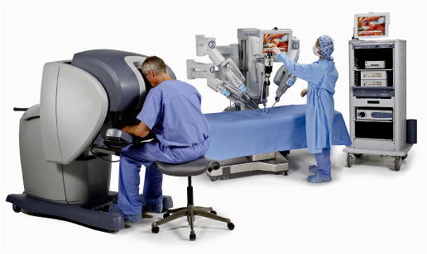
Figure.1 The da Vinci surgical system.

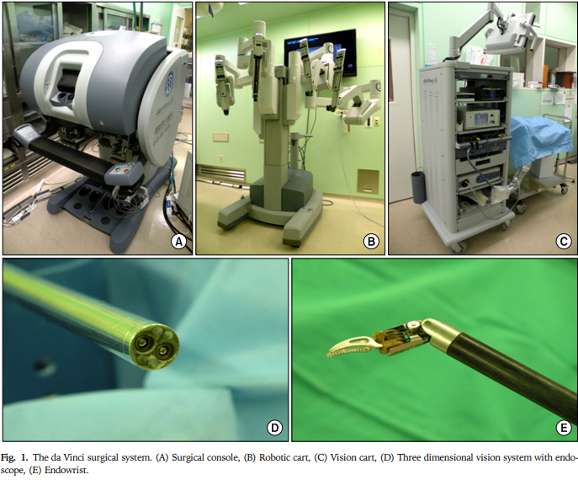
ADVANCES IN DEVICES AND TECHNIQUES
Morcellation
Morcellation involves cutting the uterus or fibroid into smaller pieces to allow removal through small incisions, usually through the laparoscopic port site or through the vagina. Electromechanical devices for shaving or cutting tissue were first used in the 1990s. These devices are still referred to today as power morcellators.
The FDA issued a Safety Communication in 2014 regarding the risk of possible spread of unsuspected leiomyosarcoma when performing open or uncontained morcellation with a power morcellator.⁷ Immediately thereafter, the use of morcellators decreased and with it the number of laparoscopic hysterectomies and myomectomies. However, the number of abdominal hysterectomies and myomectomies increased, and with it the rate of postoperative complications.
In 2020 the FDA allowed the use of power morcellators, however, only with a legally marketed tissue containment system and in appropriately selected patients. The latter criteria exclude postmenopausal women or women aged 50 years or older, as well as women who were candidates for en bloc tissue removal through the vagina or a mini-laparatomy incision. Since then, the technique of morcellation has gained momentum again, but this time with a bag in use.^{8,9}
The American College of Obstetricians and Gynecologists (ACOG) recommends the use of minimally invasive techniques whenever possible for benign gynecological diseases. ACOG says that the evidence regarding the use of power morcellators and the risk of spreading benign and malignant gynecological diseases is limited. Another disadvantage of the technique is the risk of endo-bag leakage, particularly when using a scalpel or power morcellator. In addition, the procedure itself is complicated and time-consuming. Finally, one theoretical problem with the use of morcellators is limited visibility and the risk of injury to other internal organs such as the bladder, intestines and major blood vessels.¹⁰
Alternatives to morcellation for removal of an enlarged uterus and leiomyoma include hand-assisted morcellation through a mini-laparotomy and vaginal manual morcellation. However, the evidence on these approaches and the risk of cancer spread is again limited. Therefore, new studies are needed to find methods that can eliminate the risk of cancer spreading into the abdominal cavity.
Barbed sutures
A knotless suture or barbed suture is a self-anchoring suture with barbs spaced 1 mm apart. They were developed in the mid and late 1990s and were originally inspired by a porcupine’s quill. It was John Alcamo who is credited with developing the first barbed suture material. He applied for its patency in 1964. However, these unidirectional barbed sutures required ‘double-backing’ for complete wound closure. Three years later, Alan McKenzie developed the bidirectional barbed sutures made of nylon, silver, stainless steel or tantalum. These sutures completely obliviated the need for double backing. Since then, numerous modifications of barbed- sutures have been introduced.
At the beginning of their development, barbed sutures were primarily used for lifting procedures in cosmetic surgeries. In 2005, the FDA approved the first barbed suture material for soft tissue approximation as a wound closure device. Since then, barbed sutures have been used in a multitude of operations. Nevertheless, they continue to dominate the field of plastic and cosmetic reconstructive surgery.¹¹
Due to its unique design, the barbed suture material allows wound tension to be distributed evenly across the suture line rather than at the points of suture knots as with standard sutures. Today barbed sutures are available as mono- or polyfilaments, or absorbable or non-absorbable suture materials. The bidirectional sutures feature laser-etched barbs that point in opposite directions on either side of the midline. They can be made up PDO, polyglycolate, nylon, or polypropylene. It has been argued that the barbed sutures are associated with fewer suture knot failures and a lower wound dehiscence rate compared to traditional smooth sutures. They are also said to be more cost effective as the same procedure can be performed with fewer barbed sutures compared to smooth sutures. Other advantages of barbed sutures include less time to operate and less intraoperative blood loss.
There are now two barbed sutures available in the Indian market, namely the Quill SRS bidirectional suture and the V-Loc absorbable suture.
ADVANCES IN POSTOPERATIVE MANAGEMENT AND REDUCTION OF COMPLICATIONS
Enhanced recovery after surgery in minimally invasive gynaecological surgery (ERAS)
ERAS is a multimodal bundled pathway based on evidence based practices. The goal of the ERAS approach is faster patient recovery after any surgical procedure. The key components of the ERAS protocol are:
- Comprehensive preoperative counselling
- Provision of optimal nutrition
- Optimal anaesthesia and analgesia using standardized medicines and doses
- Early ambulation or mobilisation
It is worth noting that until recently, the ERAS protocol was mainly applied to open gynecological procedures. Nowadays it is recommended for all types of laparoscopic procedures and is not just limited to laparoscopic hysterectomies. This is because it helps reduce hospital stays, increase same day discharge rates, increases patient satisfaction and outcomes. In addition, it improves patient compliance, reduces hospital costs and reduces postoperative complication and readmission rates.
CONCLUSION
Over the last two decades, minimally invasive surgical techniques have revolutionized the field of gynecological surgery. However, despite the advantages of minimally invasive surgery over traditional laparotomy, there are still some major barriers to its adoption in both Western and developing countries and overcoming these barriers is an ever-growing challenge.
REFERENCES
- Vecchio R, MacFayden BV, Palazzo F. History of laparoscopic surgery. Panminerva Med. 2000 Mar;42(1):87-90. PMID: 11019611.
- Greaves N and Nicholson J. Single incision laparoscopic surgery in general surgery: a review. Ann R Coll Surg Engl. 2011 Sep;93(6):437-440. doi: 10.1308/003588411X590358
- Housmans S, Noori N, Kapurubandara S, Bosteels JJA, Cattani L, Alkatout I, Deprest J, Baekelandt J. Systematic Review and Meta-Analysis on Hysterectomy by Vaginal Natural Orifice Transluminal Endoscopic Surgery (vNOTES) Compared to Laparoscopic Hysterectomy for Benign Indications. J Clin Med. 2020 Dec 7;9(12):3959. doi: 10.3390/jcm9123959. PMID: 33297354; PMCID: PMC7762322.
- Li CB, Hua KQ. Transvaginal natural orifice transluminal endoscopic surgery (vNOTES) in gynecologic surgeries: A systematic review. Asian J Surg. 2020 Jan;43(1):44-51. doi: 10.1016/j.asjsur.2019.07.014. Epub 2019 Aug 20. PMID: 31444108.
- Jayasingh SC. Comparison of Advantages and Disadvantages between SILS and NOTES. World Journal of Laparoscopic Surgery. 2011;4(1):67-72.
- AAGL Advancing Minimally Invasive Gynecology Worldwide. AAGL position statement: Robotic-assisted laparoscopic surgery in benign gynecology. J Minim Invasive Gynecol 2013; 20:2.
- Multinu F , Casarin J , Hanson KT , Angioni S , Mariani A , Habermann EB , et al . Practice patterns and complications of benign hysterectomy following the FDA statement warning against the use of power morcellation . JAMA Surg 2018 ; 153 : e180141 .
- U.S. Food and Drug Administration . UPDATE: The FDA recommends performing contained morcellation in women when laparoscopic power morcellation is appropriate . Silver Spring, MD : FDA ; 2020 . Available at: https://www.fda.gov/medical-devices/safety-communications/update-fda-recommends-performing-contained-morcellation-women-when-laparoscopic-power-morcellation .Retrieved August 7, 2020.
- U.S. Food and Drug Administration . Update: perform only contained morcellation when laparoscopic power morcellation is appropriate. FDA Safety Communication . Silver Spring, MD : FDA ; 2020 . Available at: https://www.fda.gov/medical-devices/safety-communications/update-perform-only-contained-morcellation-when-laparoscopic-power-morcellation-appropriate-fda .Retrieved January 4, 2021.
- Uterine morcellation for presumed leiomyomas. ACOG Committee Opinion No. 822. American College of Obstetricians and Gynecologists. Obstet Gynecol 2021;137:e63–74. doi: 10.1097/AOG.0000000000004291.
- Nambi Gowri K, King MW. A Review of Barbed Sutures-Evolution, Applications and Clinical Significance. Bioengineering (Basel). 2023 Mar 27;10(4):419. doi: 10.3390/bioengineering10040419. PMID: 37106607; PMCID: PMC10135495.

