MICROSURGERY : PRECISION IN ACTION

Authors: Dr. Swati Jha, Dr. Sheena Jain, Dr. Aishwarya Jolly, Dr. Anisha Deb

Introduction: Faster healing and better patient response are encouraged by the least invasive procedure of microsurgery. The critical aspect of microsurgery is close investigation, which is rapidly replacing earlier surgical techniques by adhering to a rigid microsurgical procedure and carefully selecting patients. Almost all endodontic injuries can be effectively treated.

Procedures for microsurgery:-

- Design of the flap
- Osteotomy
- Resection of the root
- Root end resection bevels : Long vs Short
- Isthmus management
- Preparation of root end
- Filling of root end

Design of the flap

Semilunar incision was the most favoured design in the previous surgical operations, especially in the maxillary area. Due to inadequate access to the surgical area and its association with persistent inflammation and scar formation during recovery, this incision is no longer appropriate.⁽¹⁾ Modern management employs a triangular flap with a single vertical incision, the Luebke-Ochsenbein submarginal flap, and the papilla base incision to preserve the papillae. In the maxillary anterior region, it is the most favoured aesthetic design. It is carried out enclosing the attached gingiva region and causes no postoperative recession of the gum margin or interdental papilla.⁽²⁾ As a result, creation of a black triangle and crown margin exposure in anterior region, as well as food impaction in posterior region, are avoided. In order to keep the flap away from the light path of microscope, the vertical incision should be 1.5 to 2 times extended than traditional teeth, so that the range of vision is not obscured.⁽³⁾

Osteotomy

Due to improved illumination and magnification, it is more conservative.
Diameter should be 3 to 4 millimetres, just enough to allow 3 millimetres ultrasonic tip to vibrate freely into the cavity. Identification of the exact position of root apex has to be done in order to prepare small size osteotomy.⁽⁴⁾

Guidelines: ⁽⁵⁾

- Cortical plate can be penetrated and it can be identified with micro explorer below dental operating microscope. Beneath the lesion, micro explorer can penetrate through the thin layer of cortical bone.

- Sound cortical bone estimation of tooth length by CBCT or radiovisiography can give accurate assessment of root apex portion.

- If there is a presence of periodontal lesion between the 2 roots, osteotomy from the centre of the lesion securely leads to both mesial and distal apex.

- If it doesn’t bevel root apex at 2 to 3 millimetres depth, the placement of radiographic material cortical bone, for eg; Gutta Percha, aluminium foil

- If it doesn’t reveal root apex at 2 to 3 millimetres depth, the positioning of radiopaque substance on the cortical bone for example, resilon, aluminium foil, gutta percha, and the acquisition of a periapical radiograph is a clinical technique for root apex recognition.

- The Small size of osteotomy is directly related to faster healing, less patient discomfort, less post-operative pain.
3 millimetres of root tip resected
Visible Root apex
Resection of the root

Granulation tissue removed
At right angle to long axis of the root
Lindemann Bur at 45 degrees angle handpiece + water spray

3 millimetres root resection = around twice the width of Lindemann bur

- Complete removal of granulation tissue is done after resecting the root end.

- Root resection of apical part is indicated in:-

- Pathologic process removal.
- Elimination of Endodontic alterations like apical delta, accessory canal, severe curve and apical ramifications.
- Enhanced removal of granulation tissue.
- Revelation of iatrogenic mishap like ledge, blockage, perforation, separated instrument and strip perforation.
- Creation and evaluation of apical seal
- Evaluation of complete or incomplete Vertical root fracture
- When coronal access is blocked or non surgical re-treatment is not possible, considered time consuming and invasive

A study of root apex revealed that in order to reduce 98% of apical ramification and 93% lateral canals, at least 3 millimetres of root end must be removed.⁽⁴⁾ The root surface has to be stained with methylene blue and inspected under magnification for the presence of PDL in order to to verify complete resection of root tip. The PDL appears as uninterrupted circular line in complete root end resection.⁽⁶⁾

Root end resection bevels: Long vs Short

The previously advised angle of the root end resection was between 45 and 60 degrees from the long axis of the root facing the buccal or facial portion of the root.⁽⁷⁾ The steeper the bevel, the more potential for one of the following complication to occur such as unnecessary removal or damage to buccal supporting bone, incomplete resection of root; mainly on roots that lengthen rather deep lingually, such as mandibular molar, missed anatomy on lingual/ palatal wall, long bevels can be caused by spatial disorientation in relation to the long axis. As a result, there is a greater risk of perforation of the lingual or palatal dentinal wall.⁽⁸⁾

Microsurgery recommends 0 degree bevel at right angle to long axis of the tooth. A critical step in microsurgery that was lacking in conventional techniques is high magnification examination. Magnification range is X14 to X25. ⁽⁴⁾

The reflected image of the root reveals every anatomical detail by utilising a micromirror at a 45-degree angle to the resected surface end. The most prevalent micro finding is the presence of a gap in the filling. That area is primarily stained with methylene blue between the root canal filling material and dentinal wall. When a lateral peri-radicular lesion is seen on a radiograph, a complete examination is performed, which includes an examination of the cut root surface as well as the entire root surface. A vertical root fracture, a lateral exit, a perforation or an accessory canal can also be discovered. ⁽⁴⁾

Isthmus management

The two root canals are connected by the isthmus which is a small ribbon shaped structure containing pulp and pulp derived tissue. It is a component of the canal system, not an independent entity. ⁽⁹⁾ Whenever an apical surgery is being done, premolars and molars carry isthmus at 3 millimetres from the apex in 80 to 90% instances. ⁽¹⁰⁾

It is considered as ‘Achilles Heel’ of traditional endodontic procedure. ⁽¹¹⁾ Therefore, not performing the root end preparation and isthmus filling could also be the reason of frequent apical root resection failures. Identifying un-negotiated canals and isthmus should be the primary step after root end resection. It is crucial to prepare the canals and isthmus entirely to a depth of 3 millimetres. ⁽¹²⁾

Preparation of the root end

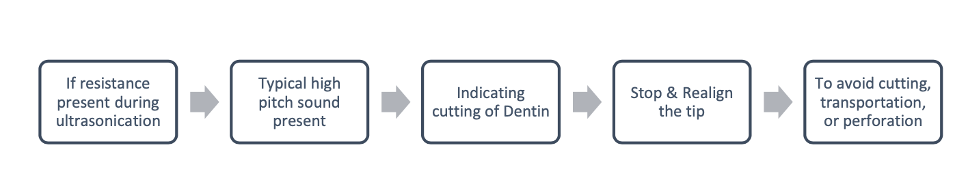
In order to generate a cavity that can be filled, it removes the restoration, foreign bodies, necrosed tissue, and remains from the canal and isthmus. For an ideal root end preparation, the walls of class I cavity must be parallel to and inside the anatomical shape of the root canal space at least 3 millimetres into the root dentin. Using ultrasonic is the pressure during preparation that is feather light touch repeatedly for effective cleaning of canals. A gentle touch improves cutting efficiency, whereas constant pressure like a handpiece reduces it. This is because ultrasonics operates on the vibration, not the pressure, principle. ⁽¹³⁾

- Clinical concepts:-

- The root end preparation is initiated with the alignment of a preferred ultrasonic tip adjacent to the prominence of root on the buccal plate under low magnification.

- 4x-8x magnification to ensure long axis preparation.

- After the ultrasonic tip has been positioned, the preparation is carried out under medium magnification (10–12).

- Light, sweeping motions are employed when applying ultrasonic tips; quick forward/backward and upward/downward strokes, in order to produce cutting movement efficiently.

- Interrupted strokes provide more efficiency than ones that are applied continuously to the dentin surface.

- After completing the apical end preparation, the gutta percha must be compressed by a micro-condenser, dried, and examined with a micro-mirror.

Filling of the root end

Final step of the surgery is root-end filling, and it is crucial that there is sufficient hemostasis in the bone crypt and that the root-end cavity is dry. An epinephrine-impregnated cotton pellet is left at the depth of the osteotomy so as to maintain hemeostasis and prevention of particles of the root-end filling material from falling at the peri-radicular bone or PDL.

Materials used for root end filling ⁽¹⁴⁾:-

- Mineral trioxide aggregate (MTA)
- Amalgam
- Gold foil
- Zinc oxide eugenol (ZnO)
- Glass ionomer cement (GIC)
- Composite
- Intermediate restorative material
- Endosequence repair material
- Biodentine
- Bioaggregate
- Super Ethoxy benzoic acid (EBA)
- Diaket
- Root repair putty

MTA is a potential material for root end filling. It was originated in 1990’s in Loma Linda University for Endo surgery and now for clinical setting. It demonstrates superior biocompatibility and encourages regeneration of the tissue whenever placed in contact with peri-radicular tissues. ⁽¹⁴⁾ Root end filling, root repair putty and material are produced as homogenous premixed consistent material. They are dimensionally stable and have high pH and mechanical strength; radiopacity and are hydrophilic. They have similar cytotoxicity as MTA; also similar antibacterial and sealing ability. ⁽¹⁵⁾

Differences between Traditional vs Modern microsurgery ⁽¹⁶⁾ :-

 | Traditional Surgery | Microsurgery
Removal of the suture | 7 days postoperative | 2–3 days postoperative
Sutures | Silk 4 -0 | Monofilament 5 - 0, 6 - 0
Degree of bevel angle | 45 to 65 degrees | 0 to 10 degrees
Size of osteotomy | 8–10 millimetres | 3–4 millimetres
Resected surface inspection | None | Always
Preparation of root-end | Seldom inside canal | Always within canal
Filling material of root-end | Amalgam | Mineral trioxide triacetate
Preparation of the root end instrument | Bur | Ultrasonic tips
Identification and treatment of isthmus | Impossible | Always
Healing success and 1-y follow-up | 40% to 90% | 85% to 97%

Microsurgical technique-prognosis/outcome

Due to insufficient knowledge it was not practical and reported limited clinical success. ⁽¹⁶⁾ Modern microsurgery consisting certain technical advancements such as dental operating microscope, modern microsurgery instruments, ultrasonics, biocompatible material, better illumination and inspection of surgical site and precise preparation of root end with micro instrument has increased the success rate of the treatment.⁽¹⁷⁾ The clinical success of microsurgery cases are reported as 96.8% and 91.5% at 1 and 7 years respectively. ⁽¹⁸⁾

According to Kim and Kratchman, Case selection classification starts from A - F (Figure 1) :-

- Classes A - C are primary lesions of endodontic origin
- Classes D - F are lesions related to PDL involvement

Successful outcome in A to C was reported as 95.2% and 77.5% in D to F. ⁽¹⁶⁾ Regenerative method consisting collagen membrane and calcium sulphate were used in pathology involving PDL. ⁽¹⁹⁾

FIGURE 1: Diagrammatic Representation of Case Selection Classification Starts From A - F

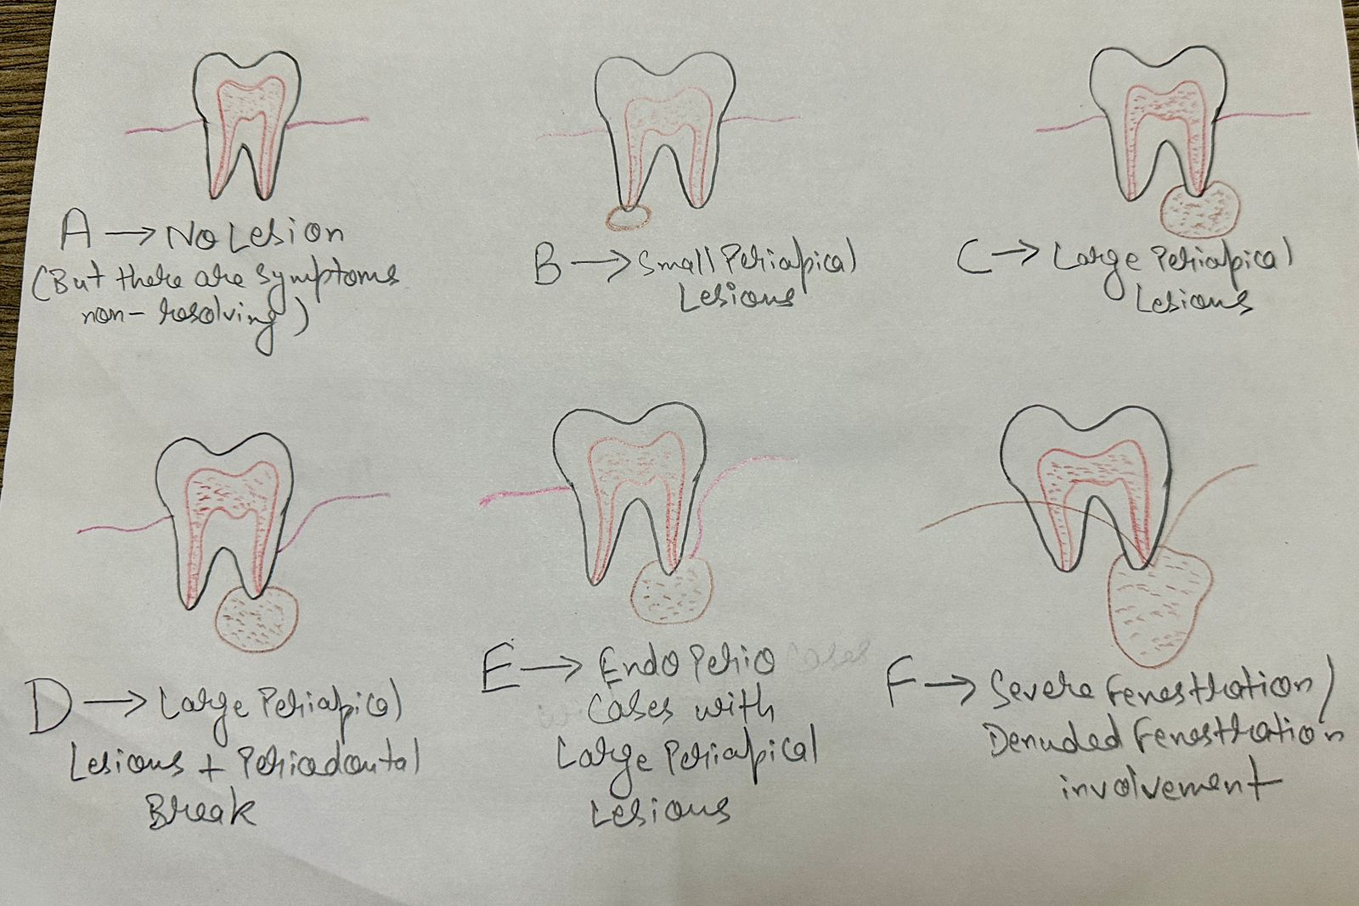

Conclusion: According to the current evidence, when applicable, microsurgery along with the regenerative techniques should be provided to the patient as a treatment option in the cases of extraction and implant installation. MTA remains the preferred material for microsurgery, although emerging bioactive materials like bioceramic appear to be similarly reliable.

References:
- Kramper BJ, Kaminski EJ, Osetek EM, et al. A comparative study of the wound healing of three types of flap design used in periapical surgery. J Endod 1984; 10(1):17–25.

- Velvart P. Papilla base incision: a new approach to recession-free healing of the interdental papilla after endodontic surgery. Int Endod J 2002;35(5):453–60.

- Rubinstein R. Magnification and illumination in apical surgery. Endod Top 2005; 11(1):56–77.

- Kim S, Pecora G, Rubinstein R, editors. Color atlas of microsurgery in endodontics. Philadelphia: W.B. Saunders; 2001.

- Gutmann JL, Pitt Ford TR. Management of the resected root end: a clinical review. Int Endod J 1993;26(5):273-83.

- Carr GB. Microscope in endodontics. J Calif Dent Assoc 1992;20:55–61.Rud J, Andreasen JO. A study of failures after endodontic surgery by radiographic,histologic and stereomicroscopic methods. Int J Oral Surg 1972;1(6);311–28.

- Cohen S, Burns R, editors. Pathways of the pulp. 8th edition. St Louis (MO):Mosby; 2002. p. 683–721.

- Weller RN, Niemczyk SP, Kim S. Incidence and position of the canal isthmus: part-I Mesiobuccal root of the maxillary first molar. J Endod 1995;21(7):380–3.

- Hsu YY, Kim S. The resected root surface. The issue of canal isthmuses. Dent Clin North Am 1997;41(3):529–40.

- Nair PN, Henry S, Cano V, et al. Microbial status of apical root canal system of human mandibular first molars with primary apical periodontitis after ‘‘one-visit’’ endodontic treatment. Oral Surg Oral Med Oral Pathol Oral Radiol Endod 2005;99(2):231–52.

- Kim S. Principles of endodontic microsurgery. Dent Clin North Am 1997;41(3): 481–97.

- Carr GB. Ultrasonic root end preparation. Dent Clin North Am 1997;41(3):541–4.

- Torabinejad M, Pitt Ford TR. Root end filling materials: a review. Endod Dent Traumatol 1996;12(4):161–78.

- Damas BA, Wheater MA, Bringas JS, et al. Cytotoxicity comparison of mineral trioxide aggregates and Endosequence bioceramic root repair materials. J Endod 2011;37(3):372–5.

- Kim S, Kratchman S. Modern endodontic surgery concepts and practice: a review. J Endod 2006;32(7):601–23.

- Zuolo ML, Ferreira MO, Gutmann JL. Prognosis in periradicular surgery: a clinical prospective study. Int Endod J 2000;33(2):91–8.

- Rubinstein RA, Kim S. Long-term follow-up of cases considered healed one year after apical microsurgery. J Endod 2002;28(5):378–83.

- Rubinstein RA, Kim S. Long-term follow-up of cases considered healed one year after apical microsurgery. J Endod 2002;28(5):378–83.

- Kim E, Song JS, Jung IY, et al. Prospective clinical study evaluating endodontic microsurgery outcomes for cases with lesions of endodontic origin compared with cases with lesions of combined periodontal-endodontic origin. J Endod. 2008;34(5):546–51.

