**Abstract:** ***Energy content in an image pixel plays a very vital role in achieving optimized compression. By reduction in zeros in the pixel values of the image, one can achieve a higher compression ratio. By using wavelet transform at different levels we can reduce the number of zeros in the image pixels. By reducing the zeros in pixel values the amount of information content per pixel increases. This result can be achieved by minimizing the interpixel redundancy. In our proposed work we have designed a mapper to minimize the interpixel redundancy. We also applied Huffman coding to optimize the code length per pixel. Using wavelet transform we optimized the energy levels per pixel.***

**Amit Kumar Tewari**

(Associate Professor)

Department of CSE

Arya College of Engineering & IT, Jaipur-302028

amitteawri.cs@aryacollege.in

**Mohit Mishra**

(Associate Professor)

Department of CSE

Arya College of Engineering & IT, Jaipur-302028

mohit28sep@gmail.com

**Differential Division Mapper Model for Optimization of Retained Energy in Images Post Compression**

**Keywords:** Huffman, Coding, Compressed Image, Mapper

# **Introduction**

Image compression plays a vital role in today’s life. It has applications in video calling, data transfer, Weather reporting, direct-to-home services and also in military purposes, etc. In compression, we can omit unwanted or repeated data to get relevant information. Image or data compression can be of two types lossless compression and lossy compression. In lossless compression, a loss of information is cannot be tolerated such as in medical imaging. In lossy compression loss in information can be tolerated such as in newspaper images.[3]

In digital images, the presence of repeated data or redundancy is highly possible. The image pixels can be predicted from their adjacent pixels. [7][11]

**1.1 Compression Ratio**

 (1.1.1)

 is for representation of original image

 is units required to represent compressed image

and  and  shows same information.

So relative data redundancy of n

 (1.1.2)

**Ram Babu Buri**

(Assistant Professor)

Department of CSE

Arya College of Engineering & IT, Jaipur-302028

burirambabuapex2009@gmail.com

 (1.1.3)

RD become 1, CR goes to ∞. This means the n1 >> n2 and data is highly redundant. [2]

RD become - ∞, CR goes to 0. This means the n2 >> n1 and data is highly redundant. [2]

For example, if CR=8, then RD=1-1/8=0.875. It means that %12.5 percent of the data is used, and the rest of it is unnecessarily repeated. [5][7]

**1.2 Process of Image Compression**

Image compression is needed because people have started transporting more and more images over networks and collection of image has increased.[1]

First, we will take the image and will do the DWT (Discrete Wavelet Transform) over RGB coefficients separately. Then we will apply thresholding methods over wavelet coefficients as shown in figure 1. Now, we will make the probability distribution of the threshold wavelet coefficients. If uniform quantization is selected, we will just replace the middle value of the class in which the coefficients lie, for each coefficient occurring in that class.

If nonuniform quantization is selected, we will do the classification again, in such a manner that in the middle portion class length will be more while at the ends of a probability distribution, more characteristics are preserved and we will keep it as it is. If nonuniform quantization is selected, we will do the classification again, in such a manner that in the middle portion class length will be more while at the ends of a probability distribution, more characteristics are preserved and we will keep it as it is.[2]

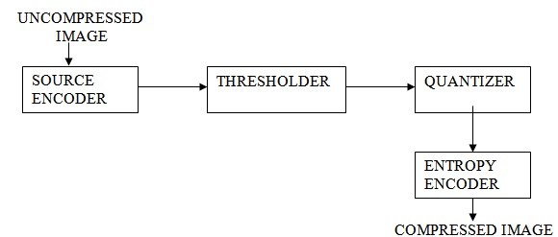

**Figure 1.1** Basic Steps for Image Compression

**1.3** **Fidelity Criterion for Image Compression System**

Psycho-visual redundancy based on a human perception. If we remove psycho-visual redundancy more than a certain loss of information must occur. For minimizing the possibility of the loss of real information there two criterion are decided to follow .[5]

a. An Objective Fidelity Criteria  
b. A Subjective Fidelity Criteria

When the degree of information loss can be expressed as a function of the original or input image and the compressed latterly decompressed produce image, it's said to be predicated on an objective fidelity criterion. Although objective fidelity criteria offer a simple and accessible medium for assessing information loss, utmost decompressed images eventually are viewed by humans. Accordingly, measuring image quality by the private evaluations of a mortal bystander frequently is more applicable. This can be done by showing a “ typical ” decompressed image to an applicable sampling of observers and comprising their evaluations. The evaluations may be made using an absolute rank scale.[10]

# **2. MATHEMATICAL RELEVANCE**

To achieve optimal Compression in images we reduce three types redundancy such as coding redundancy, psycho-visual redundancy, and Interpixel Redundancy. We use coding techniques like Huffman coding for reducing Coding redundancy. We use predictive coding models to reduce interpixel redundancy and for reducing psycho-visual redundancy we use transforms such as Wavelet Transform. [2]

**2.1 Wavelet Analysis**

The wavelet transform has an important role in real-life scenarios in data communication. The wavelet transform can be applied to any digital signal like image, sound, or any discrete sequence. To calculate these parameters we can use HAAR Transform at different levels. These types of transform use the convolution function in association with the wavelet which is scaled.

It is an efficient approach to calculating the internal components of any image and signal. In the image we take the below steps to find out this transform:

1. Covert the image into a grayscale image.

2. By using the scaling signal and wavelet final signal can be obtained.

 (2.1)

**Figure 1.2** The Standard Image Wavelet Transform and Decomposition

**2.2 Huffman Tree [2]**

Huffman tree can be made by using the Huffman coding algorithms. The Huffman tree is type of binay tree. The nodes of the tree can be represented as the sourse symbols.

The procedure of designing the Huffman tree follows the steps below:

1. By transverse the tree from its root node, we can obtain the Huffman code for any symbol. The Huffman code for any symbol can be obtained by traversing the tree from the root node.
2. Provide 0 to upper branch after tranversing and provide 1 to lower branch after transversing the lower branch.
3. Codeword for two symbols with smallest probability must be similar.
4. Sorting of the nodes can be done by reduced alphabet. 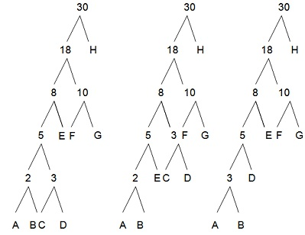

**Figure 2.1:** Huffman Tree Design

**3 DIFFERENTIAL DIVISION MAPPER PROPOSED**

Compression removal model are used to reduce inter-pixel redundancy to optimize the image compression. In this section we develop a mapper to reduce the interpixel redundancy.

**Mapper**

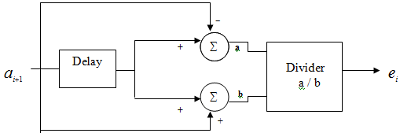

**Figure 3.1** Differential Division Mapper Proposed Model

**The mapped value is evaluated as:**

 (3.1)

**De-Mapper**

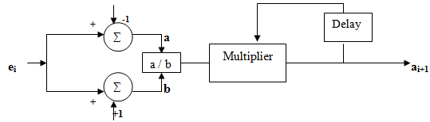

**Figure 3.** Differential Division De-Mapper Proposed Model

**The de-mapped value is evaluated as**

 (3.2)

**4 RESULTS**

Here we compare our proposed work (Differential Division Mapper Proposed Model) values with the original image values:

**4.1 Analysis of Original Image with Mapped Image**

**Default Analysis**

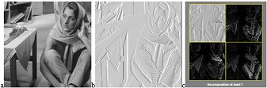

**Figure 4.1:** p) Barbara Image q)Mapped Image Normally r) Decomposion at wavelet

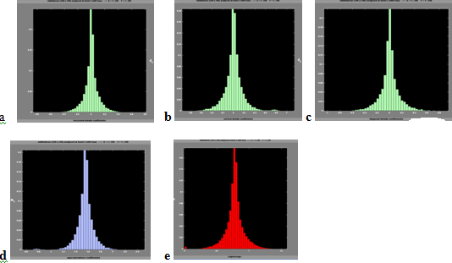

**Figure 4.2:** Histograms of Original Image

**Differential Division Mapper**

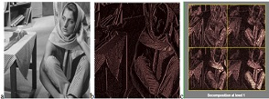

**Figure 4.3:** p) Barbara Image q)Mapped ImageDifferential Division Mapper r) Decomposion at wavelet

### 

**Figure 4.3:** Histograms of Differential Division Mapped Image

**4.2 Comparison of Number of Zeros & Retained Energy for Differential Division Mapper Proposed Model**

**Default Analysis**

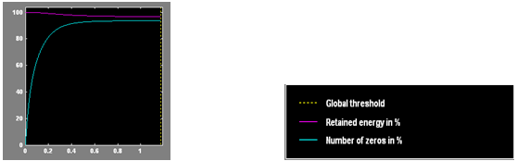

**Figure 4.4** Analysis of baboon Differential Division Error Model

**Table 1** Different set of values for Barbara image default analysis

|  |  |  |  |
| --- | --- | --- | --- |
| S.no | A1 | A2 | A3 |
| 1 | 0.2481 | 97.68 | 85.23 |
| 2 | 0.5181 | 98.42 | 91.62 |
| 3 | 0.8212 | 97.84 | 94.66 |
| 4 | 1.011 | 97.69 | 92.14 |
| 5 | 1.164 | 97.68 | 94.55 |

Where A1 **=**  Global Threshold

A2 = Retained Energy (%)

A3 = No of Zeros (%)

**Differential Division Mapper Proposed Model**

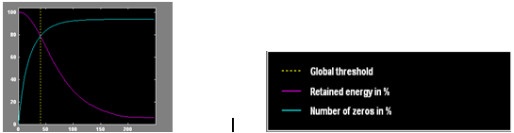

**Figure 4.5** Analysis of Differential Division Mapper Proposed Model

**Table 2** Different set of values for barbara Differential Division Mapper Proposed Model

|  |  |  |  |
| --- | --- | --- | --- |
| S.no | A1 | A2 | A3 |
| 1 | 0.24 | 99 | 1.16 |
| 2 | 0.518 | 99 | 3.35 |
| 3 | 0.821 | 99 | 3.16 |
| 4 | 1.15 | 99 | 5.34 |
| 5 | 1.4 | 99 | 6.46 |

Where A1 **=**  Global Threshold

A2 = Retained Energy (%)

A3 = No of Zeros (%)

# **5. CONCLUSION**

The proposed Differential Division Mapper Model gives tremendous result-related compression. A newly designed mapper ( proposed Differential Division Mapper) produces an image that is free from inter-pixel redundancy. If we analyze the output image from the mapper in the frequency domain the pixel values are very compact as compared with the original image. The relation between closely spaced pixels in terms of standard deviation and the average mean value is reduced drastically. Because of this more compression in images can be achieved. After this mapper result, the energy values at the image pixels are limited to only a few pixel values and the other pixel values have negligible energy components. So pixels with low energy components are removed or suppressed by this method to gain optimal results. To achieve more compressed wavelet analysis at different levels was also done and the results are very encouraging after this analysis.

**REFERENCES**

1. R.C.Gonzales & R.E.Wood*, Digital Image Processing,* 2nd Low Price Ed., Prentice Hall, 2007.
2. K Sayood*, Data Compression,* 2nd Ed., Morgan Kaufmann, 2005.
3. D Salomon*, Data compression”The Complete Reference”*, 3rd Ed., Springer, 2004.
4. Myung-Sin Song*”Entropy encoding in Wavelet Image compression”,* 2006.
5. G.E.Blelloch*”Introduction to data compression*”, 2001.
6. Wei-Wei Lu & M.P.Gough*”A Fast adaptive Huffman coding algorithm”*IEEE Trans.Commun. vol.41, 1993.
7. K Sayood,”*Loseless Compression Handbook”,* 2nd Ed., Academic Press,2003.
8. Steve Mann*,”Intelligent Image Processing”*,2nd Ed.,A John Wiley & Sons,Inc.,2002
9. Roberto De Prisco & Alfredo De Sntis*”On the Redundancy and data expansion of Huffman Codes”*IEEE Trans.Commun., 1998.
10. Matlab 7.4.0.287(R2007a)Help*.*