“Food Fabrication by 3D Printer-Present Scenario and Future Prospects”
Dr.UdaykumarNidoniª, Er. Jambamma^{b}* and Dr.PramodKatti^{c}
ªProfessor and Head, Department of Processing and Food Engineering, University of Agricultural Science(UAS), Raichur, KA.
^{c}Professor, Department of Agricultural Entomology, University of Agricultural Science(UAS), Raichur, KA.
^{b}In-service PhD Scholar and Assistant Professor, Department of Agricultural Engineering, Agricultural College-Aswaraopet,
BadhradriKothagudem(District), Professor JayashankarTelangana State Agricultural University(PJTSAU)-Hyderabad, TS.
Communication email: *jammu2011@gmail.com
1.0. Introduction
3D printing is a process of joining materials via printing, layer-by-layer, to make a designated object using a variety of 3D model data either from computer or microprocessor designs. Moreover, it’s also called additive manufacturing/industry 4.0/rapid prototyping unlike the subtractive manufacturing -objects create by removing material from a solid block (Sun et al., 2015).
Researchers from Cornell University invented an extrusion-based 3D printer, solid free-form food fabrication, to print innovative, customized, reliable, and speedy delivery products (Lipton et al., 2010).
1.1. Subtractive Manufacturing V/S Additive Manufacturing
Traditionally any manufacturing processes of creating objects by disintegration/taking away from raw material.
Subtractive Manufacturing(SM)  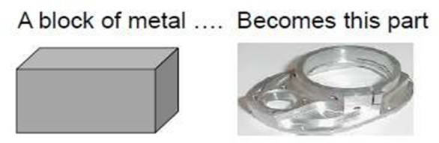  Producing a part by removing raw material via: boring, drilling, milling, sawing, shaping, planning, reaming etc. | Additive Manufacturing(AM)  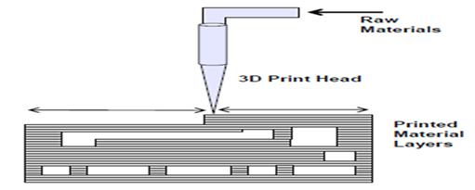  Additive manufacturing recreates an object layer-by-layer from scratch by adding materials.
^{(https://get-it-made.co.uk )}
1.2. Advantages and Disadvantages of food 3D Printing (3DP)
- 3DP of food is an advanced and niche technology in the food industry revolution. The customized food is printed spontaneously and faster in a hygienic, clean, and safe environment. Various types of food capsule containers are prepared either directly from raw food material or partially cooked food material to form paste such as cream, or mashed potatoes. The major advantages and disadvantages of the 3DP are
Advantages:-  - Food waste will be reduced  - Food preparation time will be minimised  - Easy for additionof vitamins and minerals  - Accurate tracking of printing calories  - 3DP food resembles traditional food product  - Food printing can be customized  - Creativity of food fabrication | Disadvantages:-  - 3D food printers are relatively expansive  - Risk of failure due to power off and technical voids  - Mostly printing requires pastes, cream and partial cooked food material  - Not possible to print most of the food material  - Lower acceptability rate due to less popular
2.0. Evolution of Food Printers and various printed products(https://3dfoodprintingconference.com )

2.1. History of 3DP Technologies around Globe.
1993:
MIT’s inkjet print head technology was commercialised
1981:
Hideo Kodama of Japan documented first photo-polymer rapid prototyping fabrication process
1990:
EOS GmbH builds the first Industrial-grade 3D printer

1992:
Stratasys patents its own version of FDM
1995:
Fraunhofer Institute developed Selective Laser melting 3D printer
1984:
French Charles Hull deve-loped the first SLA stereo -lithography 3D printer

2000:
Object Geometries develops the first Inkjet 3D printer
1999:
3D printing in used in biomedicine
2000:
Z Corporation builds the first multicolor 3D printer

2001:
Solid dimension introduces the first desktop 3D printer
2001:
Solidimension introduces the first desktop 3D printer
2002:
The first 3D printed human kidney was invented by the Wake Forest Institute for Regenerative Medicine

2008:
The first 3D printed prosthetic leg is printed
2005:
The RepRap Project creates open-source 3D printers
2009:
The first 3D printed blood vessel by Organovo

2011:
Urbee develops the first 3D printed car
2014:
The first 3D printed house is completed in China
2012:
The first 3d printable gun is released, sparking safety concerns

2017:
Software is developed for mass production in 3D printing,
2016:
The first human bones are 3D printed

3.0. Ten years challenge in 3D printing and marketing trend(https://mms.businesswire.com/).
- Professional 3D Printers have undergone a remarkable evolutionfrom 2009 to 2018 in two dimensions of sales of 3D printers and revenue from its sales and service. For the last one decade, the growth of 3D printer and revenue generation was exponential level which may is due to the sedimentary life style, health conscious, nutritional awareness, and faster printing, easy customized recipe, cleanliness and food safety.
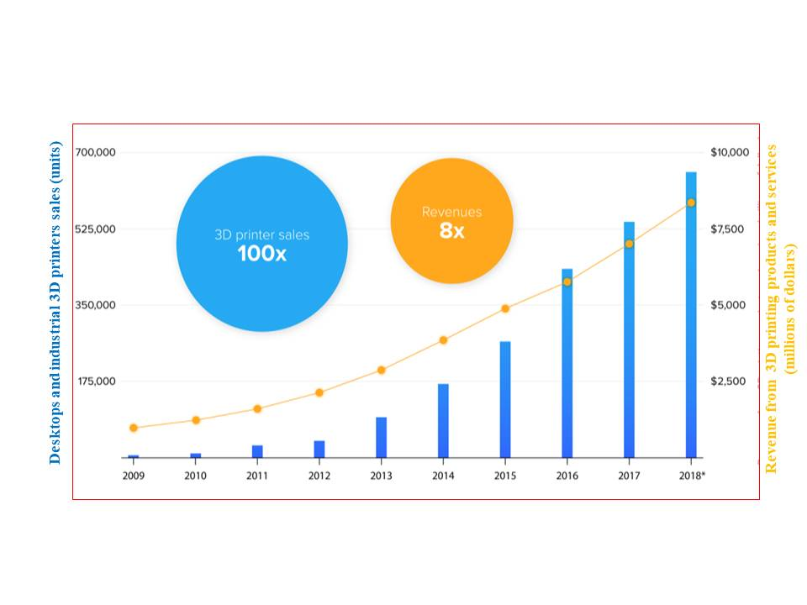
3.1. Major Key Players:
- Fab@Home, Philips, NASA, Barilla, ZMorph, Choc Edge, Modern Meadow, 3D Systems, Electrolux, Nestle, Hershey's, and Natural Machines are among the companies in the fast-moving consumer goods (FMCG) market.
- Market Segmentation: By Ingredients:
- Proteins  - Carbohydrates  - Dairy Products  - Dough | - Sugar  - Sauce  - Yard  - Fruits & Vegetable
- Many companies in developed countries are foray into 3D food printers for printing of chocolate, pastes, pizza, gels, sugary products and cookeries given below Table 1.
Figure1:3D printers sale and revenue generation from 2007-18

Table 1. List of popular 3D food printer companies and printed products.
Printer | Printing Products | Uses | Print Volume (mm) | Price
Print2Taste Mycusini | Chocolate | Home | 105 x 105 x 70 | ~$440
ZMorph VX + Thick Paste Extruder | Pastes | Home | 250 x 235 x 165 | $4,399
Createbot 3D Food Printer | Pastes | Home, Catering | 150 x 150 x 100 | $2,115
Structur3D Discov3ry | Pastes | Home, Catering | Printer-dependent | $1,299
byFlow Focus | Thick pastes | Catering | 208 x 228 x 150 | $4,30
Choc Edge Choc Creator V2 Plus | Chocolate | Catering | 180 x 180 x 40 | $2,299
Print2Taste Procusini 4.0 | Pasta, Chocolate, Marzipan, Cassis, Fondant | Catering | 250 x 150 x 100 | $2,625
WiibooxSweetin | Pastes | Catering | 95 x 80 x 90 | $1,999
MMuse Touchscreen | Chocolate | Catering | 160 x 120 x 150 | $5,700
Natural Machines Foodini | Pastes | Catering | 257 (diameter) x 110 (height) | $4,000
(https:marketresearchposts.com)
3. Procedure of 3DP Technology for Food Materials
Material
The selection of 3D printing materials is based on a thorough study of their chemical, physical, and rheological properties.
3DP Technique
Based on the material qualities, application, and post-processing requirements, an appropriate 3DP approach is chosen.
3D Design and Path Planning
To begin utilizing 3DP, a variety of software programs, including SketchUp, Tinkercad, OnShape, and others, are required for the creation of 3D content.
.stlFile Creation and Slicing
Following design planning, the file is transformed into a.stl format and is then "sliced" using slicing tools like Cura, Repetier, Simplify3D, and so on.
G-Coding
To guide the print head at predefined material flow, speed, and temperature settings, a G-code instruction is generated.
Assessment of Printing and Printed Object Parameters
It is possible to evaluate the shape fidelity and mechanical properties of printed materials in relation to their original design by comparing them with the printing parameters.
Figure 2. Flow Chart of 3D Printing Process
4.0. How to Print the 3D Foods?
- Additive manufacturing process of food preparation carries simultaneous operation of extrusion/inkjetting/heating of pastes or powder or fluid material through print head nozzle issubjected to pressure, heat, and temperature to form structure. 3D food is printed after scanning, modelling, .stl, slicing and G-code signalling of printer. Most of the food printing methods followed by post production operations such as sintering, surface cleaning, heating, infiltration to make strength product. Free online software are available for beginner to advanced learners to use 3D food modelling and G-code language as given in table 2 below.

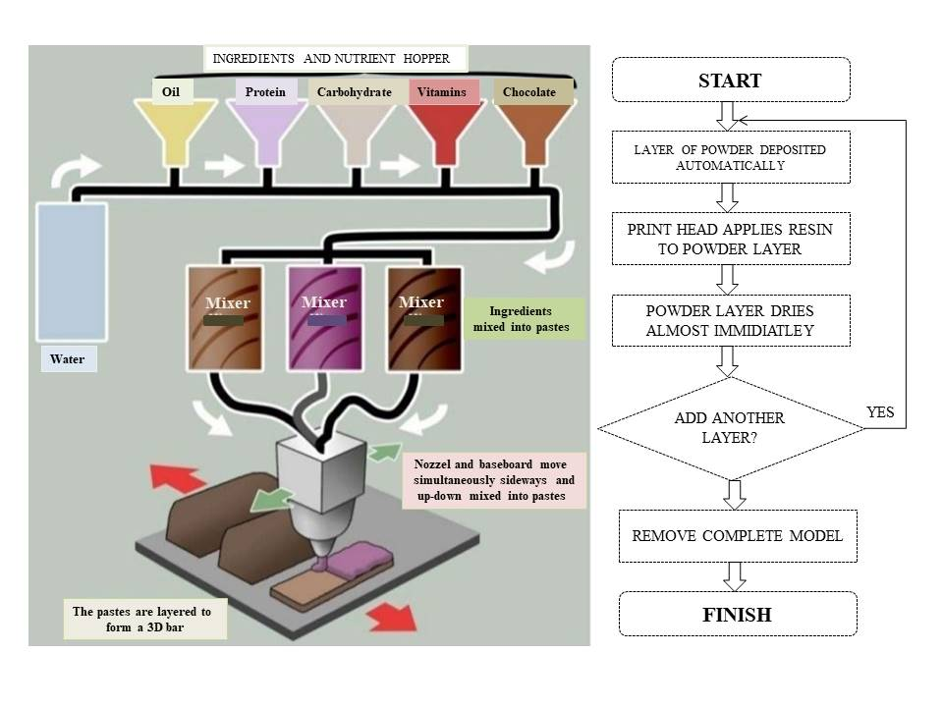
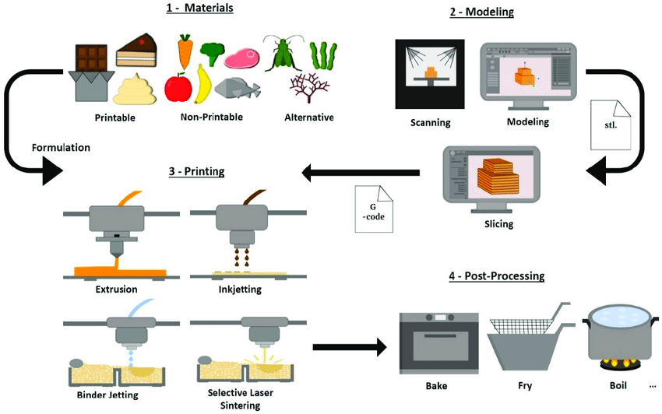

^{(Pereira, et al., 2021)}

Figure3. Computer-aided design systems to create 3D virtual models of food

Table 2. Main properties of free CAD software to use for 3D Food Modeling(Derossi, et al., 2019)
Name | Level of  user | Operating  system | Type | Files formats
3D Builder | Beginner | Windows Mobile, Xbox One & Windows, HoloLens | 3D | 3mf, obj, ply, vrml, stl
Tinkercad | Beginner | Browser | 3DCAD | 123dx, 3ds, c4d, mb,obj, svg, stl
Sculptris | Intermediate | Windows, Mac | 3D CAD | obj, GoZ
Onshape | Advanced | Windows, Mac,  Linux and browser | 2D/  3D-CAD | sat, step, igs, iges, sldprt, stl, 3dm, dae,dfx, dwg, dwt, pdf, x_t, x_b,xxm_txt
OpenSCAD(L) | Advanced | Windows, Mac and Linux | 3D/CAD | dxf, off, st
G-CODE: The Language to Drive Printers and to Optimize Printing Quality
- G28 e Move to Origin,
- G90 and G91 - Set positioning mode and
- G1 to Linear movements
4.1. Customisation of Food for 3D printing process
The 3D food can be designed in different form, size and shapes are customised by carbohydrate, protein, fats and other essential nutritional compositions as per the age, gender, life styles recommended by standard dietary guidelines. National institute of nutrition recommends essentially a balance diet which provide blend of appropriate proportions of four basic food groups, that is carbohydrate (50-60%), protein(10-15%), visible and non-visible fats (20-30%) and minerals (calcium and iron). This balanced diet quantity varies with individuals by their gender, age, working nature and physiological status as given in table below.
Table3. Recommended Dietary Allowances(RDA) for Indians (Macronutrients and Minerals) (NIN, 2011)
Group | Particulars | Body  weight,kg | Net Energy  Kcal/d | Protein  g/d | VisibleFat  g/d | Calcium,  mg/d | Iron  mg/d | 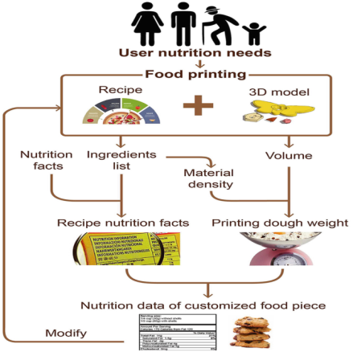
Man | Sedentarywork | 60 | 2320 | 60 | 25 | 25 | 25
Woman | Sedentarywork | 55 | 1900 | 55 | 20 | 20 | 20
 | Pregnant woman | +55 | +350 | +23 | 30 | 30 | 30
Children | 1-3years | 12.9 | 1060 | 16.7 | 27 | 600 | 09
 | 4-6years | 18 | 1350 | 20.1 | 25 |  | 13
 | 7-9years | 25.1 | 1690 | 29.5 | 30 |  | 16
Boys | 10-12years | 34.3 | 34.3 | 2190 | 39.9 | 800 | 21
Girls | 10-12years | 35.0 | 35.0 | 2010 | 40.4 | 800 | 27
Boys | 13-15years | 47.6 | 47.6 | 2750 | 54.3 | 800 | 32
Girls | 13-15years | 46.6 | 46.6 | 2330 | 51.9 | 800 | 27
Boys | 16-17years | 55.4 | 55.4 | 3020 | 61.5 | 800 | 28
Girls | 16-17years | 52.1 | 52.1 | 2440 | 55.5 | 800 | 26
5.0. Structural Configuration of 3D Printers
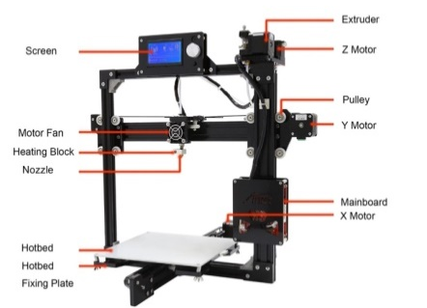
- The movement of the print head and print bed in the X-Y-Z direction, which enables the printer to deposit material layer by layer along the paths created based on the 3D virtual design, is the basis for classifying 3D printers. Moreover, there are four distinct structural configurations for 3D printers: Cartesian, Polar, Delta, and Scara, which are described below (Stephanie and Jonathan, 2018).
- Figure4. Structural configuration of the 3D printer and its components
5.1. CartesianConfiguration
-  Cartesian configuration 3D printers are simple designs of the first generation developed by ByFlowCompany. Cartesian printer moves in any of two directions of the Cartesian axes X, Y, and Z with different sub-configuration flexibility.
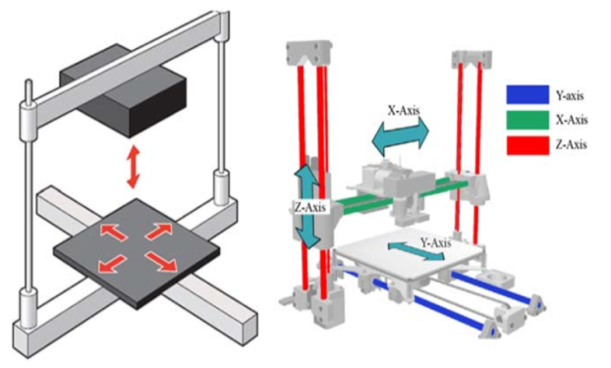
- The Cartesian 3D printers are designated as ‘XY Head’ printers in which the print-head may move on the X-Y plane while the print-bed moves along the Z axis, alternatively if the print-head moves on the X-Z axis while the print-bed moves along the Y plane is called ‘XZ Head’ printer. Further, the X-axis represents moving horizontally from left to right, Y-axis represents moving horizontally from front to back and Z-axis represents vertical movement from up and down to build layers.
A
B
- These XY Head/ XZ Head printers are filled with consumer-own recipe food material in plastic syringes on the printer overhead position for printing customized 3D food according to consumer age, gender, and physicalmovement’s etcetera.
- Some of the popular Cartesian 3DPs are Creality, Prusa Research, Anycubic, FlashForge, Ultimaker, LulzBot, Monoprice, MakerBot, Raise3D, and BCN3D.
Figure5. Schematic Representation of Cartesian 3DP; (A) XY Head 3D printer (B) XZ Head 3D printer

5.2. Delta Configuration
- The delta configuration designs are the most popular and commercially used printers next to Cartesian. In this configuration, printing is carried out by moving the printer head in three directions at the same time, i.e., X, Y, and Z, forming a right-angled triangle—a Pythagorean Theorem.
- These three pairs of arms of the delta printer are connected to a vertically moving carriage by single moving printer heads. An arm length is defined as the length of the connecting rod from the printer head to the carriage connecting point. It is important to form a diagonal of the triangle while printing to form various complex designs.
- During delta 3DP, positioning of the printer head along the X-axis and Z-axis results in a diagonal of the triangle by its arm length, such that movements in X or Z directions are consequences of arm up-down directions movements.
- This 3DP is relatively lightweight since its printer head is suspended by three vertical arms connected to the carriage. Thus, this configuration is more suitable for tall and big object printing as well as rapid prototyping than Cartesian printers. However, these printers lack precision positioning and calibration for printing smaller objects. Some of the top brands forayed into popular delta 3D printers include Kossel, Rostock, and DeltaWASP.
Figure 6. Typical structure of the delta 3D printer(He, et al., 2018)
5.3. Polar Configuration
- This type of printer uses polar coordinates for pivoting a circular printing bed around 360 degrees and along radial distance while another stepper motor directs the printer head to move up and down.
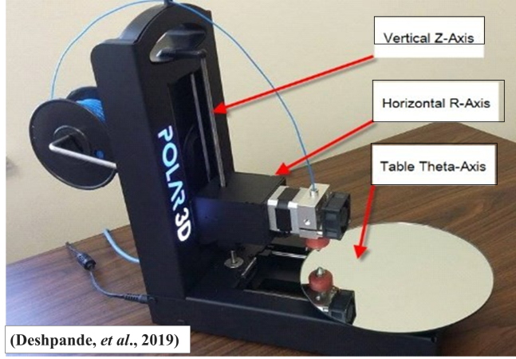
- Polar configuration 3D printers are different from the Cartesian and delta printers, which use the rectangular and triangle fixed beds and Cartesian axis. The polar printer bed moves in angular and linear directions on its polar planes and the printer head moves vertically to enable faster printing of complex curved and circular shape objects to small and bigger sizes.
- The polar configuration printer has three times the printing efficiency of a cartesian printer. For instance, with a constant printing length of 4 cm, the maximum square print bed size for a polar configuration is 50.24 cm2, whereas a surface area of 16 cm2 is possible for a cartesian configuration.
- Commercially these printers are limited due to their complex calibration, relatively new and niche technology.Some of company manufacturing polar 3D printers are Ultimaker Delta Series, SeeMeCNC Rostock Series, FLUX Delta+ 3D Printer, Folgertech FT-5 R2, Anycubic Kossel Series, Ultimaker Delta Series, SeeMeCNC Rostock Series, FLUX Delta+ 3D Printer, Folgertech FT-5 R2, Anycubic Kossel Series, FLSUN Delta 3D Printers, Tevo Little Monster.

Figure7.The Polar3Dprinter and its components. 5.4. SCARA Configuration:-
- Selective Compliance Articulated Robot Arm, or SCARA configuration, is a popular industrial tool for assembly and production processes. The robotic arm can move in the XY plane, and a separate motor ensures accurate and controlled movement in the vertical direction.
- In the current situation application of this configuration in 3D food printing is a novel concept at the budding stage.
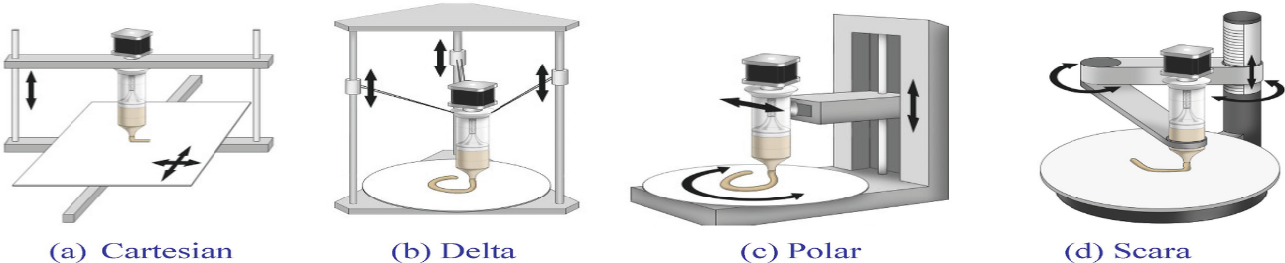

Figure 8. Various Structural Configurations of 3D Printers

6.0. 3D Printing Techniques (Fernanda et al., 2019)
The 3D printers are classified according to the Driving mechanisms of printing techniques as;
Table 4. Classification of various 3D food printing techniques.
Inkjet | Extrusion | Heating Mode
- Continues  - Drop on demand  - Drop on drop  - Drop on powder | - Non-phase change extrusion  - Melting extrusion  - Gel formation extrusion | - Powder Bed Fusion (PBF) 3D Printing
6.1. INKJET PRINTING
- The Inkjet printing (IJP) technique extensively used for printing of 2D and 3D food objects by process of deposit liquid droplets on the substrate as per the computer design coordination. This technique also used for decoration o foods like pizza, cookies and cake or create surface filling in cheese, jam or sugar icing and meat paste.
- IJP can be conducted using the drop-on-demand (DoD-IJP) approach or continuously (C-IJP). The Naviere Stokes principle of fluid dynamics, which states that the velocity, temperature, pressure, and density of the moving fluid determine the ejection of fluid droplets from orifices, is followed by both printing techniques. In contrast, a computerized 3D mode by binder procedure developed a sliced 2D profile, which was then used to expel binder solution onto a thin layer of powder using drop-on-powder IJP.
- The process of printing in IJP occurs by forcing fluid ink through print-head orifices will breaks channel of fluid stream into small droplets typically 20-50µm. further, ejection of same fluid volume in C-IJP and DoD-IJP method, whereas lesser surface area in DoD-IJP than C-IJP.
6.1.1. Three main parameters are adopted to predict the droplet jetting behavior
- The relationship between the Reynolds number (Re) and the Weber number (We) is known as the "Re/We" ratio, and it represents trends in surface tension, viscous, and inertial forces on fluid flow. The fluid's characteristic length, density, surface tension, and viscosity are represented by the terms a, rho-ρ, gamma-γ, and eta-η in Equation 1.

$\frac{Re}{We}=\frac{{\left(γρa\right)}^{1}/2}{η}$---------------- (1)
- If droplet spreading in absence of solidification (ε): Equation 2, derived by Bhola and Chandra: r_{max}and r are The equilibrium contact angle that the droplet makes with the substrate is represented by ʸ, which is also the maximum splat radius and starting drop radius, respectively.

𝛆=$\frac{rmax}{r}$= ${\left\{\frac{We^{2}+ 12}{3\left(1-cosθ\right)+4\frac{We^{2}}{Re^{1}/2}}\right\}}^{1/2}$----------------- (2)
Liquid droplet splashing (K): The droplets' splashes during jetting lead to dimensional instability and irregularities. When the parameter K surpasses a critical value, Kc, splashing happens (Equation
3K=We*Re^{1/4} ----------------- (3)

Table5: Difference between the Continuous and Drop-on-Demand Inkjet Printing Methods
Continuously (C-IJP) | Drop-on-demand (DoD-IJP)
Printing fluid is forced through an nozzle | Printing fluid is forcedthrough an nozzle
Print head ejects high-pressure fluiddroplets between 50 -80µm diameter | Print head is embedded with multiple heads range 100-1000 no.  70-0 dots per square inch (dpi)
To maintain desired flowability, the printingmaterial added with electrical conducting fluid | The printing material is subjected to thermal or piezoelectric heating
Most desired viscosity of inks in range of 2.8 to about 6 mPas | Under the force of a valve, ink is released from heads.
Printing process is faster and high volume production | The printing process is sluggish, but the images that are created have better quality and precision.
- Athermal IJP used to ejects the drops from nozzle due to pressure generated from the electrically heated printpulses.
- A Piezoelectric IJP used to discharge the drops from printhead nozzledue to piezoelectric crystalacoustic wave effects to breaks the liquid line at even intervals.
6.1.3. Application of Inkjet Printing Food Creation
- Generally, these printers were used with low-viscosity materials. As a result, IJP is mostly utilized in the fields of surface filling and image decoration on edible substrates like cake, biscuits, and crackers, as well as in nanoencapsulation and nanoprinted 3D structures (typically for bioprinting applications).
- lacks application in the production of intricate food structures since it uses low-viscosity materials.
Table 6: Some of popular graphical decoration and filling 3D food printers
i. FoodJet printing | Discharges a liquid onto layers a moving object.
ii. Mars Inc., | Printing of high resolution (100-300dpi) images using fat or edible substrate of non-polar and hydrophobic surfaces by Piezoelectric printhead.
iii. Procter and Gamble Co | Application of flavouron ediblesubstrates.
iv. Microencapsulation; | A printhead produces highly mono-disperse droplets converted into highly mono-disperse powders after drying invented by Netherlands Organization for Applied Scientific Research (TNO).
v. ChefJet printer | A broad range of confectionary recipes like sugar, fondant and sweet and sour candy in a variety of shapes and flavours are produced using Z-Corp inkjet process.
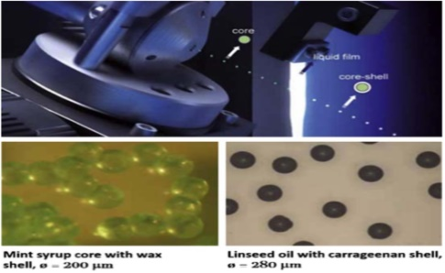
Figure 9. Encapsulation of core shell structures: mint syrup wax and linseed oil carrageenan (TNO, 2017).
6.2. Extrusion-Based 3D Printing
- The extrusion-based technique depends on the flow of a continuous ink onto a layer-by-layer fashion unlike the DoD-IJP methods. The printing material used was highly concentrated colloidal inks, of TSS 5%-50%, are capable of forming gel or achieving paste consistency.
- During extrusion printing, ink flows out a small orifices on application of pressure along the length (l) of printer head channel. The applied pressure develops variable pressure gradient across extrusion barrel leads toa radially varying shear stress (tau,ζ) as per Equation 4, where r is the radial position within the nozzle. At the nozzle wall center (r =R), there is zero velocity, and in the center (r =0), the velocity is at a maximum (Lewis, 2002).
ζ=rΔP/2l ----------------(4)
- In accordance with computer-based design integration, mechanical instruments based on screws or pistons are used to accomplish 3D extrusion food printing. While screw-driven printing may favor longitudinal control and make it easier to mix and disperse highly viscous materials, piston-driven printing often offers better direct control over the flow of viscous materials via the print head orifices.
- A rheological property of food material plays crucial role in binding mechanism of layer-by-layer deposition process. An Extrusion printing can be processed by with temperature control or without temperature control. Non phased change extrusion printing applied to high viscous material such as dough and meat paste and is defined as printing of 3D objects without control in process temperature. In melting or gel-forming extrusion 3D printing there is temperature control and also solidifies upon cooling, but the quality of final printed object depends on phase transitions took place during extrusion.
In general, the material's viscosity during extrusion printing is lower than the material's viscosity after deposition or printing to sustain the structure. In order to meet food safety regulations and provide the appropriate rheological characteristics, thickening agents, also known as additives, may be utilized.
6.2.1. Melting Extrusion/ Fusion Deposition Modeling(FDM)
- Fused Deposition Modeling (FDM) 3D printing has traditionally been employed for the production of 3D chocolate items, and this technology has been utilized by leading players in the market such as Fab@home, Choc Edge's Choc Creator, 3D System's ChefJet, Hershey's CocoJet, and Chocabyte. The materials employed in the fusion deposition process include paste, powder, solid pieces, and, though less common in food applications, filaments. When printing pastes that are rich in fat or sugar, it is crucial to carefully control the temperature to ensure the printability of the 3D object. The melting point of these compositions varies depending on the types of fats and their bonding. Fatty acids with a higher number of carbon atoms exhibit a higher melting point, whereas a higher number of double bonds results in a lower melting point.
6.2.1.1. Mechanism of Formation of Self-Supporting Layers
- It should be possible for the chocolate ink to maintain its structure both during and after the layer-by-layer deposition procedure.
⁮ ⁮The glass transition temperature (Tg) and melting point, which are crucial for the post-deposition solidification of the deposited layer, are factors that determine a system's "self-supporting" ability. Six primary crystal polymorphisms are found in cocoa butter; form V, which is the most significant and gives the finished chocolate more stable properties, a superior texture, and a glossy finish, with a melting temperature (Tm) ranging from 33.8 to 35 0C.
6.2.2. Gel-Forming Extrusion
- Ingel-forming extrusion printing gels can be formed according to the fraction or colloidal forces.
Equation 5 describes the attrition of particle to particle bonds inside the gel, which causes the gel to exhibit shear thinning flow behavior if it is stretched beyond the gel yield point (tau-τ).
τ=τy+kγ^{n} --------- (5)
  - Where
    - τis shear stress, n is the shear thinning exponent (<1),
    - K is the viscosity parameter and
    - γ-gamma is the shear rate.
- -The ink flows with a three zone velocity profile:
- -A thin slip layer free of colloidal particles at the nozzle wall,
- -A yielded fluid (shell) experiencing laminar flow, and -The un-yielded gel (core) flows at a constant velocity.
- ✓The mechanical equilibrium of colloidal gels, represented by the ratio, can be correlated with the elastic parameter y (which can be shear YS or elastic modulus) using Equation 6. Ɵ/Ɵ_{gel}, where Ɵ is proportional to the bond density, and Ɵ_{gel} scales inversely with bond strength. In Eq.6, k is constant and x is the scaling exponent.
Y=k($\frac{ϕ}{ϕgel}-1)^x$ ------------ (6)
The minimum elasticity required to produce self-supporting 3D construct.
G’_{min} ≥1.4 s⁴ D --------------- (7)
To avoid premature gelation of the material inside the nozzle, 3DP should consider both the elastic properties and the temporal control of the gelation mechanisms.
There are five groups into which the gelation mechanisms can be divided:
- Thermal gelation,
- Chemical cross-linking,
- Ionotropic cross-linking,
- Complex coacervate formation, and
- Enzymatic cross-linking.
Table7. Type of gelation mechanism and its printable materials
1 | Thermal-gelation |  | Gelatin is a classic printing material.  Gelation is induced upon cooling due the formation of junction by small segments of polypeptide chains reverting to the collagen triple helix-like structure (within 15-20ºC).  It depends on adjust printing speed and temperature.
2 | Chemical cross-linking |  | This is a typical tactic used to increase the temperature stability of gels, such gelatin. Methacrylation of gelatin, which is subsequently cross-linked by UV radiation, is one example used in bioprinting applications.
3 | Complex coacervate formation |  | Gelatin and xanthan gum have been printed to mimic a variety of mouthfeels.  The combination of a polycation (xanthan) and an amphoteric polymer (gelatin) hydrogel-forming process.
4 | Enzymatic cross linking |  | has raised the sodium caseinate's gelation temperature (20% w/w, at 15OC) by using trans-glutaminase as a cross-linking agent. This has allowed low-concentration sodium caseinate dispersions to be printed.
5 |  | Ionotropic cross-linking | has been used extensively in the food sector, particularly for procedures involving microencapsulation.  Applying low methoxylated (LM) pectin gel as a potentially useful edible ink for confectionery.
• The gel-like layers were cross-linked using the calcium chloride solution using the two methods illustrated in figure 10:
(1) Post-immersion of the 3D construct in CaCl₂ solution (concentration 300 mM) and
(2) Concurrent crosslink by coaxial extrusion (CaCl₂ ) of the outer flow ranging from 30 to 150 mM .
- • Coaxial extrusion did not require any post-printing treatment since it allowed the pectin to gel during printing.

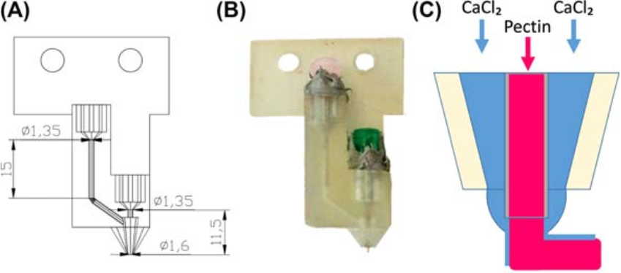

- Figure 10: Coaxial extrusion schematic representation (A) and coaxial extruder apparatus schematic representation (B), A cross-sectional view of the extrusion of pectin within the nozzle with a collateral flow of CaCl2 solution is displayed in (C).
- Further, low viscous food materials is extruded using pressurized extrusion mechanisms via piston or syringe extrusion, air compression extrusion and screw based extrusion is shown in figure 11.

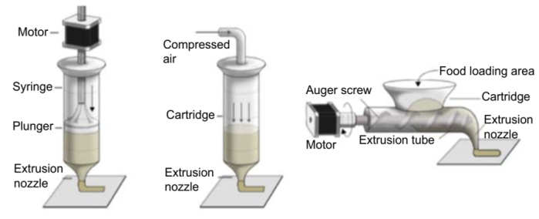

Figure11. According to Sun et al. (2015), there are three types of extrusion mechanisms used in the 3D food printing process: syringe-based extrusion, air-compressed extrusion, and screw-based extrusion.
6.2.3. Soft Materials Extrusion
- Food slurry was the printing material used in soft material extrusion; it was constantly extruded from a moving nozzle and solidified to the layer above upon cooling. Dough, mashed potatoes, cheese, and meat paste were the food ingredients employed in the soft extrusion process.
- Table 8 illustrates the three extrusion mechanisms used in 3D food printing.
Table 8.Methods of extrusion based on printing materialsproperty
Screw-based extrusion | Air pressure-based extrusion | Syringe-based extrusion
Food slurries with high viscosities and mechanical strengths shouldn't use it. | Air pressure forces the food ingredients into the nozzle, making it possible to print liquid or low viscosity materials. | Suitable for printing food ingredients with high mechanical and viscosity strengths. able to create intricate, highly-resolution 3D structures.
6.2.4. Mechanism of Formation of Self-Supporting Layers
- In this printing process a separate support structural object is used till final stage during fabricate delicate and complex shapes. This is a time consuming process.
6.2.5. Pre and Post Treatment Methods
- Literally, the 3D food structure has to resistant post-processing such as cooking, baking,frying, etc.
- The inclusion of additives and recipe control are techniques used to keep items stable during post-processing.
- Because a new protein matrix forms over time, adding 0.5% of transglutaminase by weight greatly improved the structure stability of meat cookies and confections after cooking.
Paste Extrusion  - Medium to high viscosity  - No support needed  - Solidification upon cooling or gel forming before or during printing | Inkjet Extrusion  - Low viscosity  - Support needed

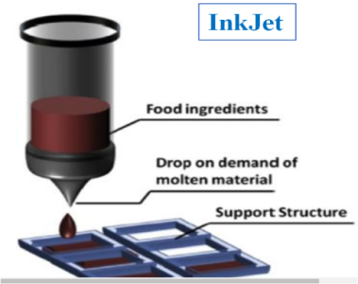
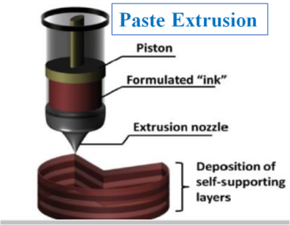
Figure 12. Structure representation Paste extrusion and InkJet Printer.
6.3. Heating Mode: Powder Bed Fusion (PBF) 3D Printing
- Powder bed fusion (PBF) printing has become a more popular and versatile additive manufacturing method in recent years.It is rapid and simple way of printingwhich uses layer-by-layer powderwas fused by various source of heat such as laser beam, electron beam or heat.
- In PBF, the mechanism of powder fusion occurs wassintering the material, a powder coalesces into a solid without liquefying;others melt the powder, heating it above its phase transition point. However, on broader spectra of PBF 3D printing systems are classified based on plastic material, commonly refer to selective laser sintering (SLS), selective heat sintering (SHS), and metal based, such asdirect metal laser sintering (DMLS) or selective laser melting (SLM).
- • In the field of food 3D printing, 3D items made of sugar were printed using selective spatial hot air sintering and melting technologies.
- Sintering is known to produce solid mass material by compacting with the help of heat or pressure without melting it to the point of liquefaction. This method of printing was coined byCandyFab machines, a project by Evil Mad Scientist Laboratories (California, US).
After the 3D object is completed, the bed is returned to its original position, causing the created model to become disoriented.
i. Selective Laser Sintering (SLS) –an 3D Food Printing Technology
- This process is also known as additive manufacturing (AM) for 3D printing of powdered structures. Selective Laser Sintering (SLS) enables the creation of intricate, high-resolution, free-standing 3D structures, although it is primarily applicable to materials such as sugar, fat, or starch granules. The sintering duration between the hot air gun and sugar powder ranged from 1 to 3 seconds. Typically, the melting temperature (Tm) or glass transition temperature (Tg) of the binder component falls within the range of 10 to 200 degrees Celsius. It is essential for the binder to undergo Tm and Tg in less than 5 seconds..
6.3.1Application of Laser-Based Printing in Food Creation
- SLS has been used to create intricate structures out of powdered sugar or sugar-rich materials. Using sugars and esQuikpowders, TNO researchers have produced delicate and intricate 3D structures.
The CandyFab Project has effectively built a variety of eye-catching complex structures out of sugar granules that could not be made in a traditional manner.
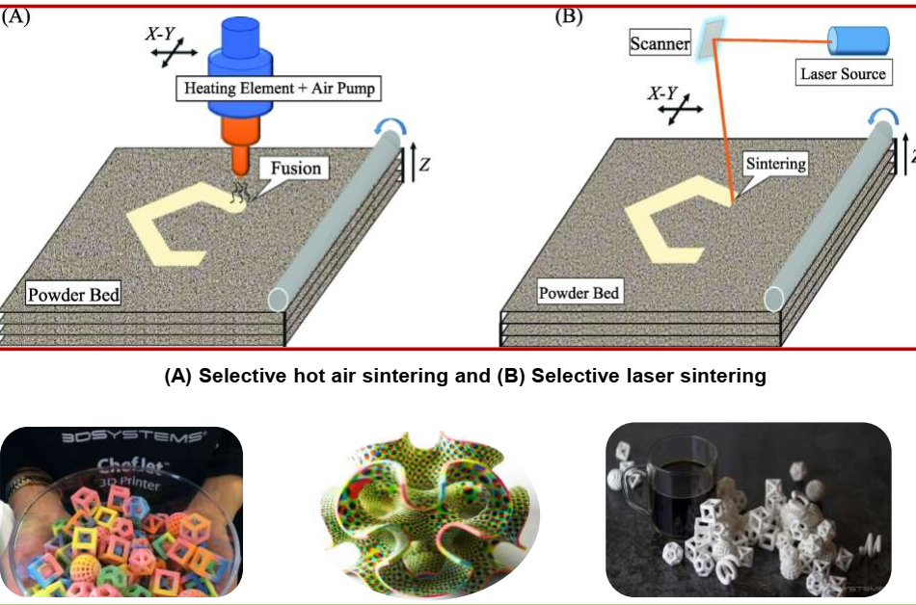

Figure 13. Representation of A-Selective hot air sintering B-Selective laser sintering(Sun et al., 2015)
6.3.2. Binder Jetting
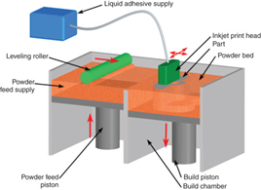
- This is traditional method of non-beam-based additive manufacturing(AM) also called as inkjet 3D printing. During printing adhesive film liquid is jetted throughprinter head at low temperature onto the thin layers of powder. To print complex and delicate 3D structure powdered, with angle of repose<30 degrees, was deposited layer by layer and the binder was selectively injected upon each material layer at certain regions based on the data file.
- During the fabrication process, non-binder powder supported the fused pieces, enabling the creation of delicate and complicated structures. The binder fuses the in-situ cross-sections to earlier and later fused cross-sections. In the end, the unbound powder is taken out and recycled for additional usage.Finished objects are removed from the printer, then structures are subjected to a post-process such as sintering (process of heating without liquefaction) or infiltration (process of surface coating/treatment) to achieve desirable mechanical properties.
- For food printing, building of complex structures low material of edible used aresugars and starch mixtures.Figure14. Binder jet printing process
7.0. Computer-aided design (CAD) systems to create 3D virtual models of food
- CAD is a way to digitally create 3D food models of real-world products that seems to not possible to manufacture by traditional way of food making. Also, CAD used in various industries to create detailed 3D virtual models of objects, structures, and products. There are different techniques and software used to create 3D models is listed inabove table2.
Table10.Comparison of significant 3D food printing technologies(Liu and Zhang, et al., 2019)
Factors affecting printing | Extrusion-Based Printing | Selective Laser Sintering | Binder Jetting | Inkjet Printing
Available  material | Chocolate, soft material  such as dough, cheese, meat puree. | Powdered materials such as sugar, chocolate, fat. | Liquid binder & powder material like starch, sugar, protein. | Low-viscosity material such as pizza sauce.
Material  properties | Rheological properties,  mechanical strength, Tg. | Melting temperature,flowability, particle size, wettability, Tg. | Flowability, particle size, wettability & binder’s viscosity & surface tension. | Compatibility, ink  rheological properties,  surface properties.
Processing  factors | Printing height, nozzlediameter, printing rate,nozzle movement rate | Laser types, power, thickness, spot diameter,energy density, scan speed | Head types, printing rate, nozzle dimeter, layer thickness | Temperature, printing rate, nozzle diameter, printing height
Postprocessing | Additive, recipe control | Removal of excess parts | Heating, baking, surface coating,rem- oval of excess part | No
Advantages | More material choices,  simple device | Complex 3D food  fabrication, varying textures | Complex 3D food fabrication, full colour,varyingflavours, textures | More material choices, better printing quality, fast fabrication
Limitations | Incapable of fabricating ofcomplex food designs,  difficult to hold 3D  structures in post process | Limited materials, less  nutritious products | Limited material, less  nutritious products | Simple food design, only for surface filling or image decoration
Products | 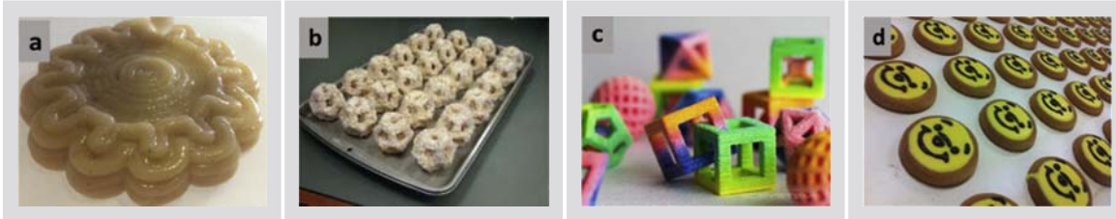
8.0. 3D Printing Technologies for Cereal-based Formulations
- Two primary technologies that have been extensively used in the cereal industry are powder bed fusion and material extrusion.
- During the extrusion process, a food filament that is molten or semisolid is forced out of a moving nozzle by an auger screw, a hydraulic piston, or compressor pressure (Figure 11).
- The platform descends in a z direction, while the nozzle tip travels in x and y directions.
- The process of creating a three-dimensional object involves the binding mechanisms between layers, which are influenced by the rheological properties of the materials, solidification upon cooling, and hydrogel-forming extrusion. These techniques are well suited to producing multiple layers of food matrix, each containing distinct food ingredients.
8.1. Use of Binding Agents to Improve the Printability of Dough
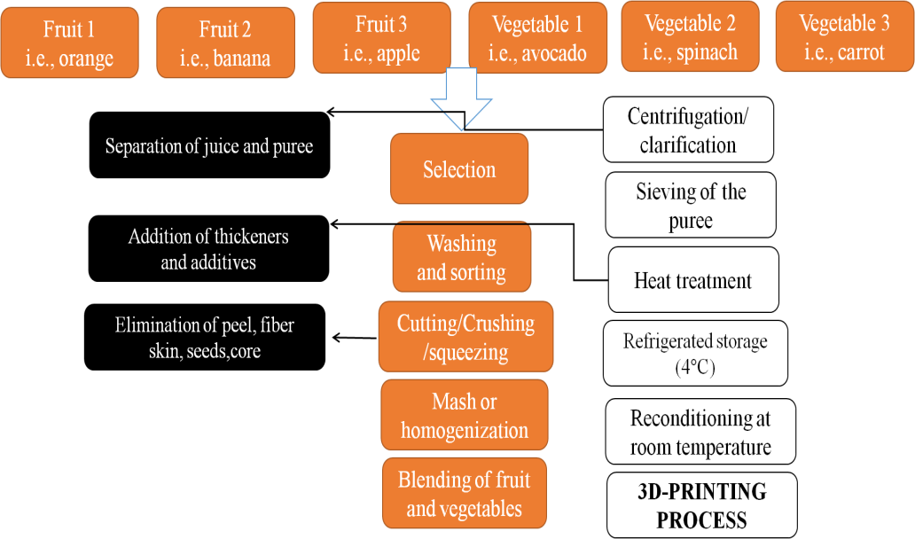
- Hydrocolloids are blended within food safety limits (Liu et al., 2018) to modify the rheological of printing material. They are frequently added to naturally nonprintable materials including grains, meat, fruits, and vegetables (Sun et al., 2015).
- The hydrophilic polymers known as hydrocolloids, which include xanthan gum, gelatine, and agar, are authorized for use as thickening and gelling agents in solutions containing water..
Figure 15. Diagram showing the steps involved in making a fruit and vegetable paste for 3D printing (Ricci, et al., 2019)

9.0. 3D Food Printing Research in India
In India, there are some research institutions and startups are working on making 3D food printing affordable and suitable for the Indian market. The global market for 3D food printing is expected to grow rapidly in the next decade. Here is the list of initiative and outcomes of various research works on 3D food printing in indiarespresenting in table

Table 11. Indian 3D printing initiative at various institutions on different food materials
Autor, Year, Place | Title | Result | Publisher
Cinu Varghese et al., 2020, IIT-Kharagpur | The microstructure, rheological properties, and textural properties of cookies produced through 3D printing are influenced by certain product and process parameters. | Extruding at 27 and 30 ◦C with fill density values of 50%, 70%, 90%, and 100% and water butter ratios of 3:10 and 6:5 produced the 3D printed cookies. | Foods
PrithvikaKrishnarajet al., 2019, IIFPT-Thanjavur | Using Indigenous Composite Flour, 3D Extrusion Printing and Post-Processing to Create Fiber-Rich Snacks | The nozzle diameter of 0.84 mm, nozzle height of 0.63 mm, printing speed of 2400 mm/min, extruder motor speed of 300 rpm, and movement speed of X/Y and Z axis of 6000 mm/min and 1000 mm/min, respectively, are the optimized process parameters that provided the best resolution and stability. | Food and Bioprocess Technology
K. Keerthanaetal., 2020, IIFPT-Thanjavur | Creating fiber-rich 3D printed snacks using non-traditional foods: a button mushroom research | Enhancement of alternative food's extrusion printability (Agaricus bisporus). correlation between the printability of the material supply and its rheology. | Journal of Food Engineering
RadhikaTheagarajanetal., 2020, IIFPT-Thanjavur | Rice starch's 3D extrusion printability and process variable optimization | Better printability was obtained by printing rice starch at lower printing speeds (800–1500 mm/min) and higher motor speeds (180–240 rpm). | Food and Bioprocess Technology
T.Anukiruthikaetal., 2020IIFPT-Thanjavur | 3D printing of egg yolk and white with rice flour blends | The stability and strength of printed EY and EW were significantly improved by the addition of filler agent (rice flour at 1:1 and 1:2 w/w). Using a 0.84 mm nozzle at 0.005 cm3/s extrusion rate, EY at 1:2 (EY: rice flour) could be 3D printed with fine precision and higher layer definition at 60 0 and 800 mm/min printing speeds at 180 rpm motor speed. | Journal of Food Engineering
Conclusion 10.
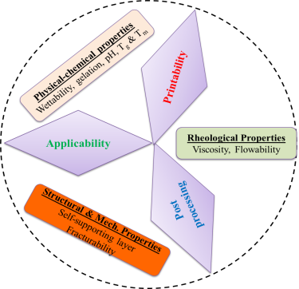
- The future of 3D food printing holds a lot of promise and potential for transforming various aspects of the food industry. It reduces food waste, creating personalized and nutritious food, designing innovative shapes and textures, and facilitating social interaction.
- The global market for 3D food printing is expected to grow rapidly in the next decade.
- Some of the challenges and opportunities for 3D food printing include developing suitable food inks, optimizing printing parameters, post printing treatments, understanding preference, ensuring food safety and quality.
- India is not only fastest growing economy, but also second largest youth population country should involve in design, development and formulation of 3D food printing technologies.
- Therefore, it is right situation to carry research, explore varies properties of feed materials and establish master roadmap in the 3D food printing market is ahead as shown in figure 15. Figure 15. Future prospects of 3D food printing

11. References:
Derossi, A., Caporizzi, R., Ricci, I. and Severini, C., 2019. Critical variables in 3D food printing. In Fundamentals of 3D food printing and applications (pp. 41-91). Academic Press.
Deshpande, S.P., Kulkarni, S., Shah, S. and Irwin, J., 2019. Developing an Open Source, Inexpensive, Large-Scale Polar Configuration 3d Printer. International Journal of Engineering Research & Innovation, p.13.
Fernanda C. G., Bhesh R. Bhandari, SangeetaPrakash and Min Zhang, 2019, Fundamentals of 3D Food Printing and Applications. London, United Kingdom: Academic Press.
He, K., Yang, Z., Bai, Y., Long, J. and Li, C., 2018. Intelligent fault diagnosis of delta 3D printers using attitude sensors based on support vector machines. Sensors, 18(4), p.1298.
Lipton, J.I., Cutler, M., Nigl, F., Cohen, D., Lipson, H., 2015, Additive manufacturing for the food industry. Trends in Food Science and Technology: 43 (1), 114-123.
Liu, Z. and Zhang, M., 2019. 3D food printing technologies and factors affecting printing precision. In Fundamentals of 3D food printing and applications (pp. 19-40). Academic Press.
Manual, A., 2011. Dietary guidelines for Indians. Nat Institute of Nutrition, 2, pp.89-117.
Stephanie Torta and Jonathan Torta, 2018, 3D Printing: An Introduction. Dulles, VA: Mercury Learning & Information.
Sun, J., Peng, Z., Yan, L., Fuh, J., Hong, G.S., 2015a, 3D food printing–An innovative way of mass customization in food fabrication. Int. J. Bioprint. 1:27–38.
Pereira, Tatiana, SóniaBarroso, and Maria M. Gil. "Food texture design by 3D printing: A review." Foods 10, no. 2 (2021): 320.
Ricci, I., Derossi, A. and Severini, C., 2019. 3D printed food from fruits and vegetables. In Fundamentals of 3D food printing and applications (pp. 117-149). Academic Press.
https://3dfoodprintingconference.com/wp-content/uploads/2017/07/Nesli-Sozer-3D-Food-Printing-Conference_Sozer28062017.pdf
https://mms.businesswire.com/media/20170418005579/en/581191/5/Global_3D_Printers_Market.jpg?download=1
https://marketresearchposts.com/2020/07/28/3d-food-printing-market-key-players-size-trends-growth-opportunities-analysis-and-forecast-to-2028-nasa-nestle-natural-machines-philips-3d-systems-hersheys/
https://get-it-made.co.uk/blog/additive-vs-subtractive-manufacturing

