“DESIGN AND DEVELOPMENT OF FUSED DEPOSITION MODELLING (FDM) 3D BASED FOLDABLE PRINTER”
Nagesh D¹, Channa Keshava Naik N², Shubha A³, Vidhyadhara D¹
¹Department of Aeronautical Engineering, SJC Institute of Technology, Chickballapur, Karnataka, India, (Affiliated to Visvesvaraya Technological University, Belgaum).
²Department of Mechanical Engineering, BGS College of Engineering and Technology, Bangalore, Karnataka, India, (Affiliated to Visvesvaraya Technological University, Belgaum).
³Department of Physics, BGS College of Engineering and Technology, Bangalore, Karnataka, India, (Affiliated to Visvesvaraya Technological University, Belgaum).

Email id: *channakeshava.mech@bgscet.ac.in, nageme417@gmail.com

Abstract
3D Printing or Additive assembling is an original technique for assembling parts straightforwardly from computerized model by utilizing layer by layer material development approach. This apparatus less assembling technique can deliver completely thick strong aspects in brief time frame, with high accuracy. Elements of added substance producing like opportunity of part plan, part intricacy, light weighting, part union and plan for work are gathering specific interest's metal added substance fabricating for aviation, oil and gas, marine and car applications.3D printing is a course of prototyping where by a construction is blended from a 3d model. The 3d model is put away in as a STL design and after that Forwarded to a 3D printer. It can utilize a wide scope of materials, for example, ABS; PLA.3D printing is a quickly creating and cost improved type of fast Prototyping. The 3D printer prints the CAD configuration layer by layer shaping a genuine article. 3D Printing measure is gotten from inkjet work area printers in which various store jets and the Printing material, layer by layer got from the CAD 3D information. There are numerous 3D Printer accessible in market which can't be put away in little space since 3D printer has 3-hub to print 3D model which is one of its detriment, additionally there some interest in market like a real size 3D printer that can be collapsed and put away in little spot. In our task we will plan fundamental foldable 3D printer model in CAD programming and foster the foldable 3D printer and do some presentation test on the created 3D printer.
Key words: 3D Printer, FDM, Dual Head, Foldable.
- Introduction
The term 3D printing originally referred to a process that deposited a binder material onto a powder bed with inkjet printer heads layer by layer. The phrase "3D printing" is now being used more frequently in everyday speech to refer to a wider range of additive manufacturing processes. The phrase "additive manufacturing" is still more widely used among experts due to its broader definition and longer history. Additionally, other terminology are used, including desktop manufacturing, quick manufacturing, direct digital manufacturing, and rapid prototyping. Charles Hull created and built the first 3D printer in 1984 while working for Hideo Kodama of the Nagoya Municipal Industrial Research Institute. He founded, 3D Systems Corp. Charles Hull was a pioneer of the stereo lithography solid imaging technique and the STL (stereo lithographic) file format, which is still the most popular 3D printing file type in use today. Along with the discovery of 3D printing, he is also credited with launching commercial fast prototyping.
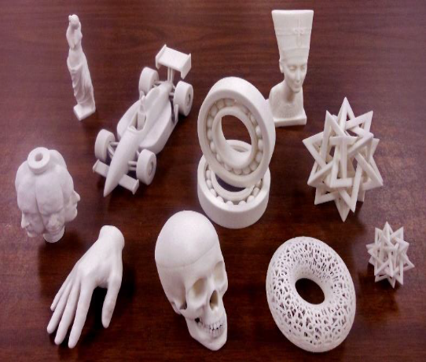
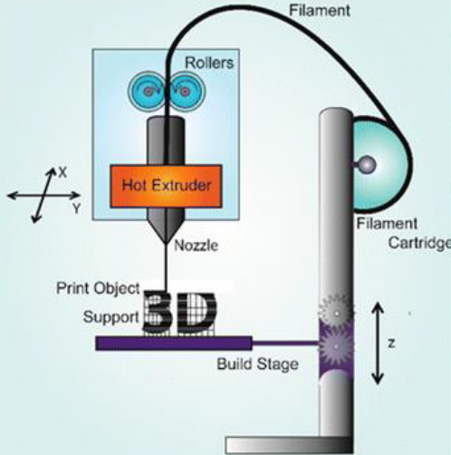
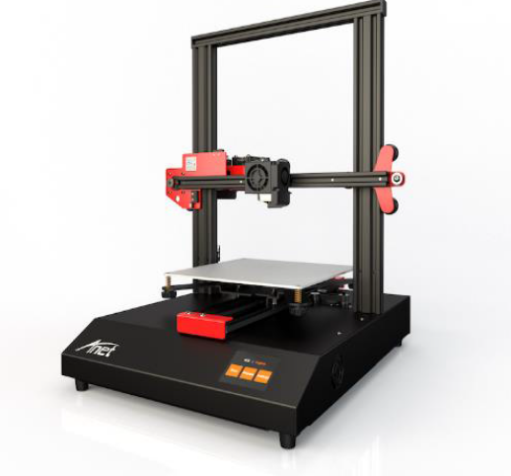

Fig.1.1: 3D Printer Fig.1.2: 3D-Printed object Fig.1.3: FDM Printer
Fused deposition modelling (FDM) is a common desktop 3D printing technology for plastic parts. An FDM printer functions by extruding a plastic filament layer-by-layer onto the build platform. It’s a cost-effective and quick method for producing physical models. There are some instances when FDM can be used for functional testing but the technology is limited due to parts having relatively rough surface finishes and lacking strength. Fused deposition modeling (FDM) is a common desktop 3D printing technology for plastic parts. An FDM printer functions by extruding a plastic filament layer-by-layer onto the build platform. It’s a cost-effective and quick method for producing physical models. There are some instances when FDM can be used for functional testing but the technology is limited due to parts having relatively rough surface finishes and lacking strength. There are four types of FDM 3D printer, 1. Cartesian coordinate FDM 3D Printers 2. Delta FDM Printers, 3. Polar 3D FDM Printers and 4. Robotic Arms. 3D printer has 3 Dimensional axis movements. Hence, the 3D printer acquires total storage volume of minimum 500mm X 500mm 600mm frame of 220mm * 220mm * 400mm printing area. After printing of 3D model in the 3D printer the printer cannot be folded and stored in safe place. Normal 3D printer moving mechanical parts are in open format, were manual dragging of printer bed or extruder in axial movement lead to damage of stepper motor or controlling system. 3D Printing of a model with its supportive structure in single plastic material might lead to damage in finished model while removing supportive material. The major objective of our work are A) To Design and develop FDM based dual head and portable 3D printer for plastic material. B) To check the specification of 3D printer.
Cartesian Co-ordinate FDM 3D Printers
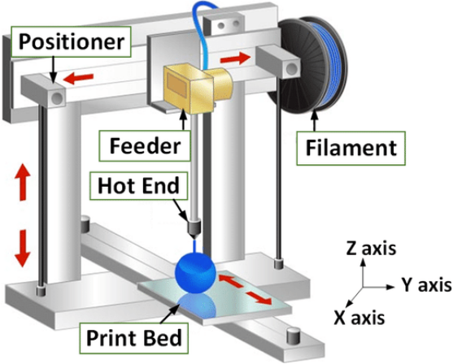

Fig 1.4: Cartesian co-ordinate FDM 3D-Printer
The most prevalent FDM 3D printer on the market is a cartesian model. This technology uses three-axis: X, Y, and Z to establish the proper placements and direction of the print head. It is based on the Cartesian coordinate system used in mathematics. In this kind of printer, the print head operates in two dimensions on the X-Y plane while the printing bed typically moves solely along the Z axis. MakerBot and Ultimate are two well-known companies in the Fused Deposition Modeling industry that produce FDM 3D printers with Cartesian technology. It should be noted that the printing bed can move in a variety of ways; for instance, with the gMax 3D printer, it can move along the Y-axis. There are many 3D Printer available in market which cannot be stored in small space since 3D printer has 3-axis to print 3D model which is one of its disadvantage, also there some demand in market like an actual size 3D printer that can be folded and stored in small place. In our project we are going to design basic foldable 3D printer model in CAD software and develop the foldable 3D printer and do some performance test on the developed 3D printer. A prominent issue in technological areas, 3D printing and the many materials used in it were presented by Vinod G. Gokhare et al. in their article [1]. In order to choose the best materials among them that are compatible with cutting-edge 3D printing equipment, the author investigated the history of 3D printing, its technique, and the materials used to produce 3D printed products. Additionally, briefly outline the benefits of 3D printing over additive manufacturing. In this article by Krisztian Kuna et al., [2], the author outlined the precise constructional materials needed for a 3D printer that uses FDM technology. The author described the key moments in the printer's reconstruction, the recovery of the technical documentation (Reverse Engineering), and finally the calibrations and measurement results. Rushabh S. Mole et al [3] Robots are becoming an essential part of all aspects of modern life, including industrial needs. Precision and speed are key components of today's industrial manufacturing processes. A robotic system requires human intervention to carry out a variety of tasks, including setup, programming, troubleshooting, maintenance, and error handling. When humans enter the work zones where robots are operating, dangerous situations result. It is important to research human perception, decision-making, and action techniques to stop accidents involving robots. When planning the layout of a robotic system, system designers and technology managers must take into account the constraints of the operator's perceptual process. Suraj Takle and others [4] The major goal of the research presented in this paper is to create and evaluate a low-cost 3D printer that can produce items that fit within a 200 x 200 x 200 (in mm) printing area utilizing easily available materials and fabrication techniques. A thorough market analysis has revealed that the price range for 3D printers on the Indian market is between Rs. 50k and Rs. 60k, depending on the type of supporting material employed. Asif Angadi et al [5] this paper deals with Development of low-cost 3D printing machine with integrated CD drives and Floppy drives. Here high cost stepper motors are avoided in assembly and then the CD drives are manipulated such that only guide ways and motor arrangements are used. Author used aluminium composite panel for base (floor), Acrylic plate used for bed, L-frame used for making structure of machine. To make machine fully atomize author used Arduino AT mega 2560 Microcontroller with 1.4 Ramps for drive the motors and other accessories of machine.
2. Methodology
1. Literature survey on design and development of FDM based portable 3D printer in reference of research paper.
2. By analyzing research paper and other resource identifying the problems and describing objectives to solving problem evolved.
3. Designing the model using CAM software in 3-dimensional view and estimating cost required for the project.
4. Purchasing the available parts in market and other parts as to be developed.
5. After all the required parts are ready, next we have to construct the fordable type main frame the 3D printer and next we have to assemble first the mechanical parts and then electrical components into the frame at desired position. Next wiring connection as to be done between controlling system and electronic component.
6. Operating software as to be installed in controlling system to control electrical component.
7. Developed 3D printer as to be tested, if any modification is required well be modified and performance analysis will be made on curtain parameters of 3D printer.

Fig 2.1: Methodology of the Proposed Model

- Experimental work
In our project we built a frame for 3D printer in z axis direction which can be unfolded before printing process or folded after the printing process. We built a frame which is made of Stainless steel rod. The frame made by steel rod has frame size 550mm height x 500mm width and the frame is attached linear telescopic guides at either side with a roller bearing mounted on telescopic guide to actuate the frame like an arm. Stainless steel rod frame is also used as linear rail guide in Z-direction.200N pneumatic suspension is used in either side frame and between frame and telescopic guide rail.
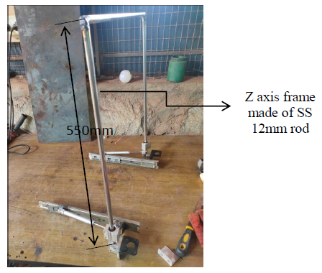
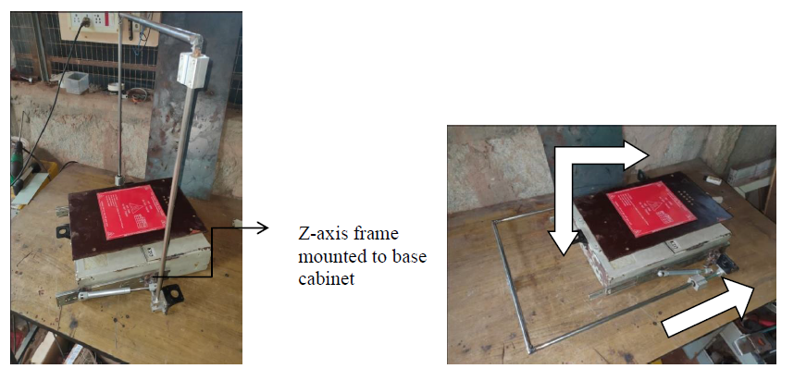

Fig 3.1: Z-axis with folding frame Fig 3.2: Folding of the frame-Y axis frame and carriage

The folding frame and telescopic guide probe are joined by rotational joint with help of 12mm roller bearing. Frame is restricted to 90-degree deviation in upwards direction with respect to telescopic guide. A pneumatic suspension helps foldable frame to stand in 90 degrees and to resist the fall of frame due to gravity and load applied by components lifted in z direction and each suspension has 200N load capacity to hold frame in 90 degree. In our project we built a supportive structure for y axis carriage, here linear guide is mounted under print bed which is moved front and backwards, hence linear bearing is fixed into supportive structure, Supportive structure is built using CPVC ¾ inch / 20mm inner diameter T-bonds and pipes. We selected T-bend since the linear bearing outer diameter is also 20mm and supportive structure CPVC has good strength and cost effective. Supportive structure is mounted rigidly in printer base cabinet using fasteners.
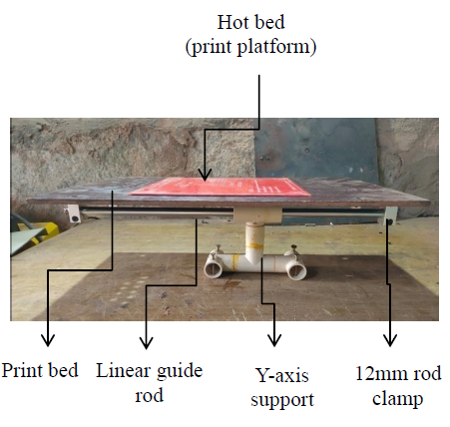

Fig 3.3: Y-axis frame construction
3.1 X- axis frame and carriage
We built X-axis frame using metal plate and stainless steel rods. The overall dimension of X-axis frame is 530mm length 100mm width and 110mm height. Slots are made to mount lead screw nut and 3 stepper motor clamps are mounted on the X-axis frame.2 stainless steel rods are mounted parallel to each other of 12mm diameter in between 2 joints as shown in figure. The rods are mounted as linear guide rod for x-axis movement of nozzle in x-direction. Linear guide rods are inserted with carriage which moves in path of guide rods. The carriage is made of CPVCT bend as structure and inner diameter 12mm linear bearing to slide on rails/rods. Then 2nozzlesare attached to this carriage.
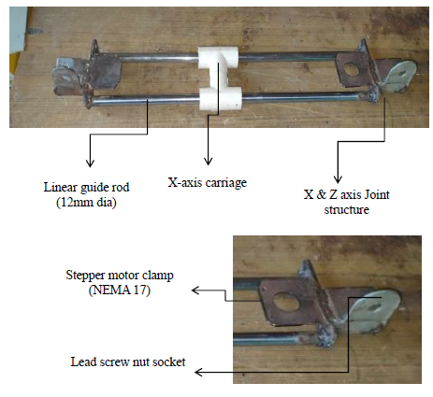

Fig 3.4: Both images show the construction of X-axis frame

3.2 Assembly of three axis:
3D Printer is 3-Dimensional printing printer. In 3D-printer a nozzle is used to print, the filament is melted and extruded through the hot nozzle and to develop a 3D model a robotic frame / computer controlled robot is required. Since requirement of CNC frame a Co-ordinate robot is developed. Co-ordinate robot has three axis and the three axis frame are constructed as design of our project. Now, the three axis frames are assembled as in the schematic figure shown above. First, Z-axis frame is inserted to guide rail mounted either side of base cabinet. Here Z-axis frame cannot be mounted rigidly, because in our project Z-axis frame is foldable. Second, Y-axis frame base structure is mounted in the base cabinet using fasteners. Next, X-axis frame is mounted to linear bearing using fasteners, were linear bearing moves in Z-direction. Also an carriage is inserted in X-direction for nozzle movement in X-direction.

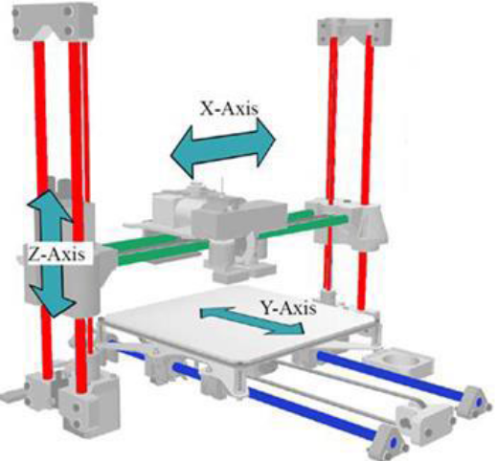

Fig 3.5: Schematic assembly of 3D printer frame

3.3 Assembly of Developed Three Axis Foldable Printer.
3D Printer is 3-Dimensional printing printer. In 3D-printer a nozzle is used to print, the filament is melted and extruded through the hot nozzle and to develop a 3D model a robotic frame / computer controlled robot is required. Since requirement of CNC frame a Co-ordinate robot is developed. Co-ordinate robot has three axis and the three axis frame are constructed as design of our project. Now, the three axis frames are assembled as in the schematic figure shown above. First, Z-axis frame is inserted to guide rail mounted either side of base cabinet. Here Z-axis frame cannot be mounted rigidly, because in our project Z-axis frame is foldable. Second, Y-axis frame base structure is mounted in the base cabinet using fasteners. Next, X-axis frame is mounted to linear bearing using fasteners, were linear bearing moves in Z-direction. Also an carriage is inserted in X-direction for nozzle movement in X-direction.
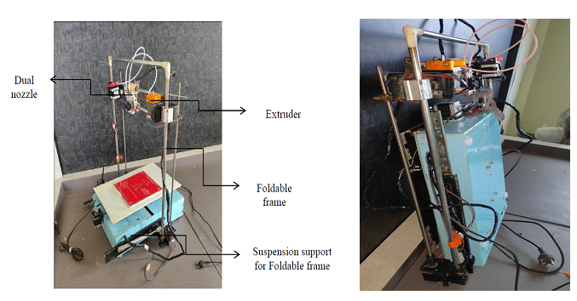

Fig.3.6: Complete Assembly of foldable 3D-Printer

3.4 Assembly of Electronic circuit
Every 3D printer has a small computer and control circuitry to amplify and direct the signals that perform all the functions the printer needs to operate. Some printer suppliers put all these functions on a single circuit board and use proprietary chips to control their printers. First, Arduino mega 2560 controller board is attached with RAMP 1.4 Circuit board. Next, stepper motor drives are mounted on the RAMP 1.4 controller board. Next, stepper motors, End stop switches, thermistor, cooling fan, Nozzle heating coils, hot bed is connected to RAMP 1.4 Board through wires. Finally, Power supply module SMPS (switch mode power supply) is connected to RAMP board through connector for 12volt, 15 Amps to the electric circuit.
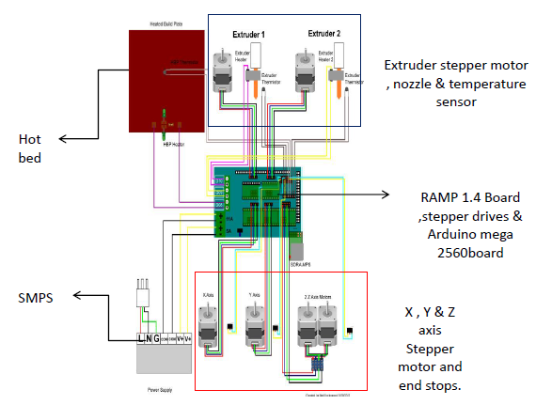
Fig 3.7: Electronic Circuit

3.5 Complete assembly of foldable 3D – printer
After, completion of design 3D printer, construction of parts, Assembly of parts to frames now the foldable 3D printer is ready. Here all electrical parts are mounted on the 3D Printer frame where it as to be mounted. Next, stepper motors, End stop switches, thermistor, cooling fan, Nozzle heating coils, hot bed is connected to RAMP 1.4 Board through long wires In this complete assembly, X-axis probe & Y-axis probe is derived by timing belt and pulley, then the Z-axis probe is derived by a 4-start lead screw. The foldable frame can be folded for 0°degree with reference to Y-axis. None each Stepper motor is mounted for each axis to actuate probe. The 3D-printer folded frame is given below image.

    - Foldable 3D-Printer specification

Table 1: Detailed Specification of Foldable 3D Printer

SL.No | SPECIFICATION (figure
01 | Overall dimension Printer | 600mm (L) X 600mm (W) X 650mm (H)
02 | Printing volume | 300mm (L) X 300mm (W) X 450mm (H)
03 | Filament used | PLA , ABS
04 | Number of nozzle | 2
05 | Max nozzle temperature | 260°C
06 | Nozzle diameter | 0.4mm
07 | Weight of the printer | 15Kg
08 | Type of technology used | FDM

- Result and Conclusion

4.1 Model printed by our foldable 3D – printer

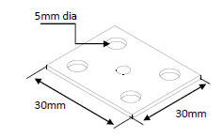
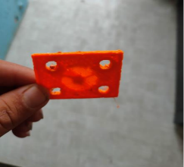
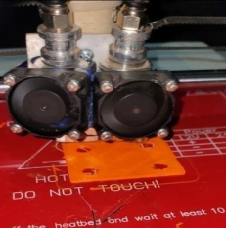

Fig 4.1: 3D-model by CAD Software Fig 4.2: 3D-Model Printing Fig 4.3: Printed 3D-model
Since, we have designed and developed 3D-printer and for testing the 3D-printer we wanted to print a 3D-object by our printer. So here we created a CAD model 30mm square shaped plate of thickness 2mm and the plate has 4 holes of 5mm diameter at corner of the plate as shown in above image. Then the 3D-Model file is saved in (.stl) file format. After, creating CAD model and saved the file in stereo lithographic file format, the file is then transferred to slicing software to slice the CAD model into G-Code format layer by layer with heating temperature of filament, bed temperature, flow of filament is given in this software. Then this G-code file is imported to an SD-card where the input file to 3D-printer is given by SD-card. After, slicing we inserted the SD-card into the 3D-printer, using smart controller display module the file is selected form SD-card and start printing.

The 3D-printed model is shown in the above image.
Filament specification
- PLA (Polylactic acid)
01 | Melting temperature | 220°C
02 | Tensile strength | 61.5MPa
03 | Heat resistance | 110°C
04 | Filament dia | 1.75mm
05 | Print temperature | 205°C - 215°C
06 | Flexural strength | 88.8MPa

01 | Melting temperature | 200°C
02 | Tensile strength | 54MPa
03 | Heat resistance | 100°C
04 | Filament dia | 1.75mm
05 | Print temperature | 205°C - 215°C
06 | Flexural strength | 80MPa
2. ABS (Acrylonitrile Butadiene Styrene)

4.2 Conclusion
- The FDM based dual head and Foldable 3D printer which is developed by use can be stored in small space by folding the Z-axis.
- This printer does not require dismantle of parts after printing process for boxing and caring to another place.
- In our printer there no disturbance of foldable frame during printing process and suspension used in foldable frame also act as damper to absorb vibration of printer.

References
[1] A Review paper on 3D-Printing Aspects and Various Processes Used in the 3D-Printingby Vinod G. Gokhare, Dr. D. N. Raut, Dr. D. K. Shinde Department of Production Engineering, Veermata Jijabai Technological Institute, Mumbai - 400019, India.
[2] International Conference on Manufacturing Engineering and Materials, ICMEM 2016, 6-10 June 2016, Nový Smokovec, Slovakia Reconstruction and development of a 3D printer using FDM technology Krisztián Kuna.
[3] A Literature Review on Structural Properties of Different Types of Robots Rushabh S. Mole UG Student Department of Mechanical Engineering Suman Ramesh Tulsiani Technical Campus, Faculty of Engineering, Khamshet, Pune-410405.
[4] An Overview on 3D Printing Technology: Technological, Materials, and Applications N. Shahrubudina , T.C. Leea,*, R. Ramlana .
[5] Review Paper On 3 Dimensional Printing Technology Mr. Akash M. Patil*1, Miss. Neha U. Deshpande2 & Prof. V. A. Patil3 *1,2&3Mechanical Engineering Department, Ashokrao Mane Polytechnic ,VathartarfVadgaon, Kolhapur.(India).
[6] Websites - Wikipedia “3D-Printing” https://en.wikipedia.org/wiki/3D_printing/
[7] Gosselin &Dubollet& Roux & Morel, 2016, ―Large Scale 3D Printing Of Ultra -High Performance Concrete – A New Processing Route For Architects & Builder‖, Elsevier Journal Of Material &Design ,100 pp102-109.
[8]Weng& Wang &Senthil&wu ,2016, ―Mechanical and Thermal Properties Of ABS /Montmorillonite Nanocomposites For Fused Deposition Modelling 3D Printing‖, Elsevier Journal Of Material Design ,16 pp-519-526.

