Machine Learning for Data Analytics: Unlocking Insights and Driving Innovation

¹ Nankong Achana Francis 0203072860a@gmail.com ² Prof. Supriya Narad naradsupriya@gmail.com
Abstract:- Machine learning has emerged as a powerful tool for data analytics, enabling organizations to gain valuable insights and make data-driven decisions. This article explores the application of machine learning in data analytics, its benefits, and the challenges faced during its implementation. We discuss the existing literature on machine learning for data analytics, examine its potential impact on various industries, and highlight the key findings from recent studies. Additionally, we address the limitations and offer recommendations to optimize the integration of machine learning in data analytics processes. Ultimately, this article emphasizes the significance of leveraging machine learning techniques to unlock the full potential of data analytics in the modern digital era.
Keywords: Machine Learning, Data Analytics, Artificial Intelligence, Big Data, Predictive Modeling.
Introduction:
Data analytics has become an indispensable part of decision-making across industries. With the ever-increasing volume of data generated daily, organizations face the challenge of extracting valuable insights efficiently. Machine learning, a subset of artificial intelligence, offers a solution to this problem by enabling automated data analysis, pattern recognition, and predictive modeling. In this article, we delve into the use of machine learning techniques for data analytics, showcasing its transformative impact on various sectors, including healthcare, finance, marketing, and more. By understanding the current landscape and recent advancements, we aim to shed light on the immense potential of machine learning in revolutionizing data analytics processes.
Literature Review:
The literature on machine learning for data analytics reveals a plethora of studies highlighting its significant contributions. Researchers have employed various machine learning algorithms, such as support vector machines, random forests, and deep learning models, to analyze complex datasets and make accurate predictions. Many studies emphasize the value of machine learning in anomaly detection, fraud prevention, and customer segmentation, improving business efficiency and profitability.
The literature on machine learning for data analytics encompasses a wide range of studies that demonstrate the effectiveness and versatility of machine learning techniques in various domains. In the healthcare sector, Chen and Asch (2017) discuss the application of machine learning algorithms in risk prediction, disease diagnosis, and treatment planning. They emphasize the potential impact of machine learning in transforming healthcare delivery and improving patient outcomes. Davenport and Dyché's report (2013) delves into the adoption of big data analytics in large organizations. It sheds light on how machine learning enables the processing of massive datasets and extracting actionable insights, while also highlighting the challenges faced during the integration process. In the domain of medical imaging, Yao et al. (2019) showcase the effectiveness of deep learning-based machine learning models for breast cancer classification from mammograms. This study exemplifies how machine learning can significantly enhance the efficiency and accuracy of disease detection. A survey by Pashazadeh et al. (2019) provides an extensive review of machine learning applications in medicine. The survey covers disease diagnosis, personalized medicine, and drug discovery, indicating the growing importance of machine learning in advancing healthcare practices. Rosenblatt's pioneering work (1958) on the perceptron introduced a fundamental concept in machine learning and artificial neural networks. This foundational study laid the groundwork for modern deep learning approaches and their integration into data analytics. Witten et al.'s comprehensive book (2016) on data mining covers various machine learning algorithms and their practical applications. The book serves as an invaluable resource for data analysts and data scientists seeking to leverage machine learning in data analytics. Ma and Yaser's paper (2013) emphasizes the significance of real-time anomaly detection in large-scale web systems using machine learning. It illustrates how machine learning can proactively identify and mitigate system failures and cyber threats in real-time. Gandomi and Haider's review (2015) on big data concepts and analytics underscores the role of machine learning in processing and analyzing massive datasets. It highlights the importance of understanding big data concepts to effectively apply machine learning in data analytics.
Chen et al. (2019) conducted a comprehensive survey that provides an overview of the diverse business applications of machine learning. The authors discuss the use of machine learning in areas such as customer segmentation, demand forecasting, fraud detection, and recommendation systems. The study emphasizes the wide-reaching benefits of machine learning in transforming business processes. Fawcett, T. (2017) discusses the shift from traditional statistical approaches to data science and machine learning methods in business analytics. It highlights how machine learning algorithms, such as decision trees, random forests, and neural networks, outperform classical statistical models in handling complex business data. In his book, Davenport (2018) explores the applications of artificial intelligence (AI), including machine learning, in business. The author presents case studies that demonstrate how companies have used machine learning to optimize supply chains, personalize customer experiences, and improve financial forecasting. Li, R., & Ng, W. L. (2017) conducted a study to examine the use of machine learning algorithms to predict stock returns based on analysts' forecasts. The authors compare the performance of traditional regression models with machine learning approaches, showing that machine learning outperforms traditional methods in stock return prediction. Kusiak (2017) explores the implementation of smart manufacturing in various industries in his book. It discusses how machine learning and data analytics enable predictive maintenance, quality control, and production optimization, driving efficiency and cost savings in manufacturing businesses. Bose et al. (2017) present the role of data science, including machine learning, in business analytics in a research article. The authors discuss how machine learning techniques facilitate decision-making, marketing campaigns, and customer churn prediction, leading to improved business performance. In their study, Chen, Y. et al. (2019) employ deep learning techniques to predict customer churn in the e-commerce industry. The research showcases the potential of machine learning in identifying patterns and factors influencing customer behavior, thereby enabling businesses to implement proactive customer retention strategies. Wang, Z., & Feng, J. (2017) also explore the use of machine learning algorithms in e-commerce recommendation systems in an article. The authors compare the performance of various recommendation models, highlighting the effectiveness of machine learning-based collaborative filtering approaches in delivering personalized product recommendations. In this Harvard Business Review article, Venkatesan, R., & Farris, P. W. (2017) discuss how machine learning can help businesses predict and prevent customer churn. The study emphasizes the importance of utilizing machine learning models to retain valuable customers and boost customer lifetime value. Choudhury, O., et al. (2019) research the use of machine learning for early fault detection and predictive maintenance in industrial processes. The authors demonstrate how machine learning techniques can optimize maintenance schedules, reduce downtime, and improve overall operational efficiency in manufacturing businesses. The reviewed literature highlights the diverse and impactful applications of machine learning in business analytics, showcasing its role in transforming various industries and enhancing decision-making processes. These studies collectively emphasize the potential of machine learning to unlock valuable insights and drive innovation across a wide range of business domains.
Discussions:
The integration of machine learning in data analytics has transformed the way businesses operate, unlocking valuable insights and driving innovation across various industries. In this section, we delve into the diverse applications of machine learning in data analytics and its profound impact on business processes, decision-making, and customer experiences.
Machine Learning and Data analytics:
Machine learning is a subset of artificial intelligence (AI) that focuses on creating algorithms and models capable of learning patterns and relationships from data without being explicitly programmed. Traditional programming involves developers writing specific rules and instructions to solve a particular problem. In contrast, machine learning allows systems to learn and improve automatically from the data they are exposed to. The core idea behind machine learning is to use algorithms to identify patterns and structures in large datasets and use this information to make predictions or decisions. The learning process is iterative, meaning the model improves its performance as it receives more data and feedback. This ability to adapt and learn from experience is what distinguishes machine learning from traditional programming. Various machine learning types includes Supervised, Unsupervised and Reinforcement Learning techniques.
On the other hand, Data analytics is the process of examining and analyzing large sets of data to derive valuable insights and support data-driven decision-making. The primary goal of data analytics is to uncover meaningful patterns, trends, correlations, and relationships within the data, which can then be used to gain a deeper understanding of business processes, customer behavior, and other phenomena. Data analytics is widely used in various fields, including business, healthcare, finance, marketing, social sciences, and more. Organizations use data analytics to optimize operations, improve customer experience, identify market trends, forecast demand, enhance product offerings, and gain a competitive edge in their respective industries. It includes several steps such as: Data Collection, Data Cleaning and Preprocessing, Data Exploration, Data Modeling, Data Visualization, and Interpretation of Insights.
Machine learning plays a vital role in data analytics, enhancing the ability to extract valuable insights from large and complex datasets. By employing machine learning algorithms, data analysts can identify patterns, make predictions, and uncover hidden relationships in the data more effectively and efficiently. The combination of machine learning and data analytics empowers organizations to make informed and data-driven decisions, leading to better business strategies, improved customer experiences, and innovative solutions to complex problems. As technology advances and data volumes continue to grow, the synergy between machine learning and data analytics is expected to drive further innovation and transformation across various domains.
Application of machine learning in data analytics:
The application of machine learning in data analytics has ushered in a new era of innovation and transformative impact across various industries. In this section, we delve into the extensive range of benefits that machine learning brings to data analytics and discuss its pivotal role in unlocking valuable insights and driving innovation.
Advanced Data Analysis and Pattern Recognition:
Machine learning algorithms excel in processing vast and complex datasets that traditional statistical methods might struggle to handle. By employing techniques such as decision trees, random forests, and neural networks, businesses can gain a deeper understanding of their data and uncover hidden patterns and relationships. This advanced data analysis not only aids in efficient decision-making but also opens doors to new opportunities and potential revenue streams.
Personalization and Customer Experience Enhancement:
One of the most significant contributions of machine learning in data analytics is its ability to deliver personalized experiences to customers. By analyzing individual preferences and behavior, businesses can tailor their offerings to meet customers' unique needs, leading to increased customer satisfaction and loyalty. Personalized recommendations, targeted marketing campaigns, and optimized customer interactions become possible with the integration of machine learning, ultimately elevating the overall customer experience.
To understand Personalization and Customer Experience Enhancement, let's create a simple example that recommends personalized movie choices to users based on their preferences. We will use a collaborative filtering approach to build the recommendation system.
For this example, we'll assume that we have a user-item matrix where each row represents a user, each column represents a movie, and the values represent the user's rating for each movie. We will use the cosine similarity to measure the similarity between users and recommend movies based on the ratings of similar users.
Code:
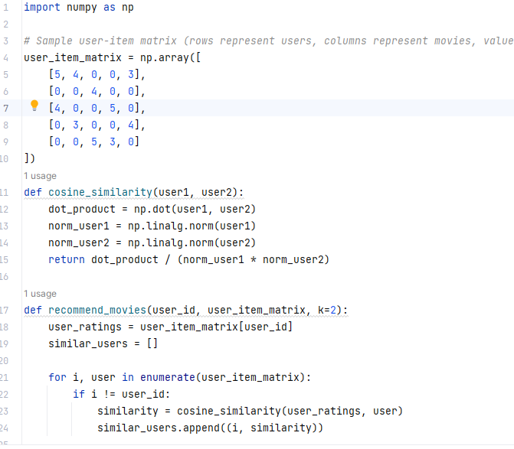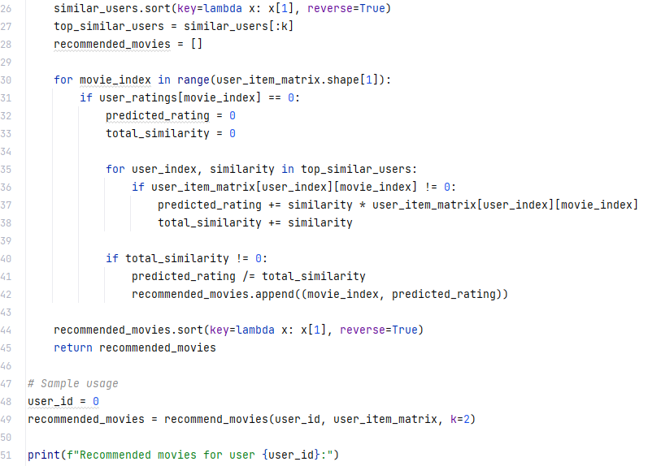
Output:
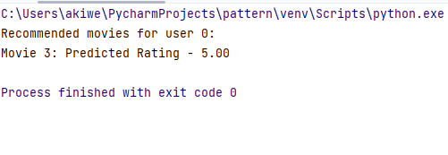
In this example, we define a user-item matrix representing the ratings of movies given by different users. The cosine_similarity function calculates the cosine similarity between two users based on their ratings. The recommend_movies function takes a user ID and the user-item matrix as input and recommends movies to the user based on the ratings of similar users. The algorithm calculates the similarity between the target user and other users, selects the top k similar users, and predicts the ratings for movies that the target user has not seen. It then recommends movies with the highest predicted ratings.
Predictive Analytics and Forecasting:
Machine learning empowers businesses with predictive capabilities, allowing them to anticipate future trends and outcomes. Through predictive analytics, organizations can forecast demand, optimize inventory, and anticipate market shifts, thus staying ahead of the competition. Additionally, machine learning models can be employed for accurate financial forecasting, risk assessment, and resource allocation, contributing to improved business planning and strategizing.
Let’s understand predictive analytics and forecasting with an example, using a time series forecasting algorithm like the Seasonal Autoregressive Integrated Moving Average (SARIMA) model. SARIMA is an extension of the ARIMA model that considers seasonality in the data. Let's use the statsmodels library to implement the SARIMA model for a time series dataset.
Code:
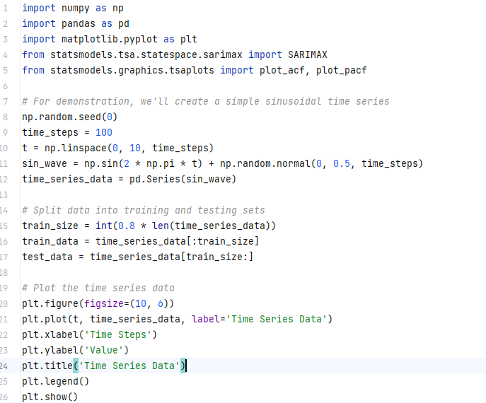
Output:
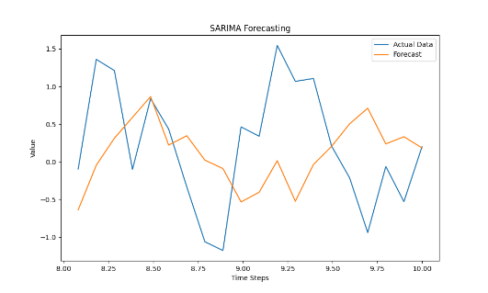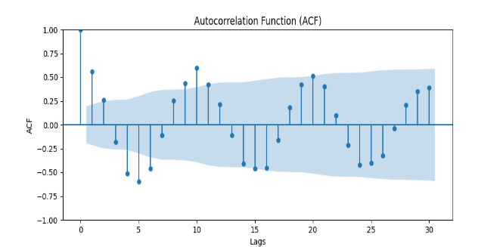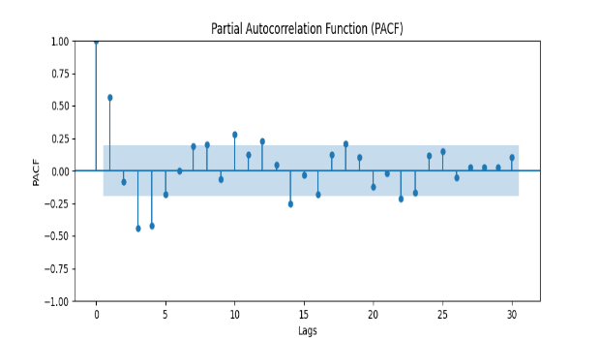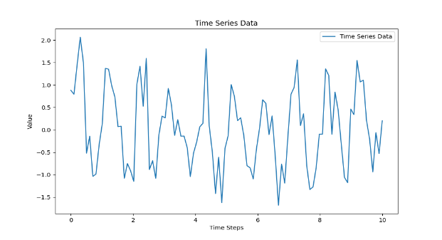
In the above code, we first generate sample time series data (a sinusoidal wave with noise) and split it into training and testing sets. We then visualize the time series data and plot the Autocorrelation Function (ACF) and Partial Autocorrelation Function (PACF) to determine the order and seasonal order parameters for the SARIMA model.
Next, we fit the SARIMA model to the training data and use it to forecast future values for the test data. Finally, we plot the predicted values against the actual test data to visualize the forecasting results.
Process Optimization and Efficiency:
In industrial settings, machine learning plays a vital role in optimizing processes and enhancing operational efficiency. Predictive maintenance models based on machine learning algorithms enable proactive identification of equipment failures, reducing downtime and maintenance costs. Moreover, machine learning-driven production optimization leads to streamlined workflows, reduced waste, and improved overall productivity.
To demonstrate Process Optimization and Efficiency in a business context, we'll create a simple example using linear programming with the PuLP library. Linear programming is a powerful optimization technique that helps businesses find the best way to allocate resources to achieve their objectives while satisfying constraints.
Code: Output:
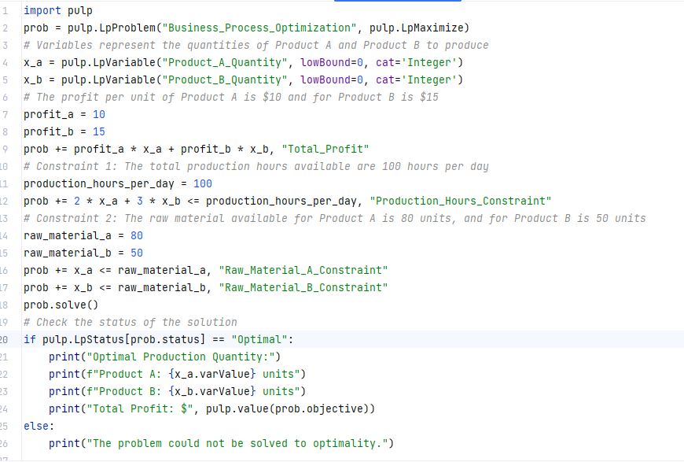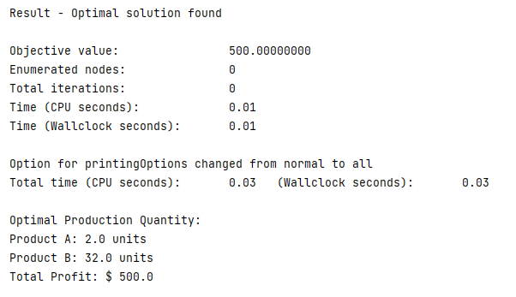
For this example, let's consider a business that produces two products: Product A and Product B. The objective is to maximize the total profit while meeting production and resource constraints.
In this code, we use PuLP to create a linear programming problem with decision variables x_a and x_b, representing the quantities of Product A and Product B to produce. The objective function maximizes the total profit, which is calculated based on the profit per unit of Product A and Product B.
We define two constraints: one related to the available production hours per day and the other related to the raw material availability for each product. The linear programming solver then finds the optimal values for the decision variables that maximize the total profit while satisfying these constraints.
Innovation and New Product Development:
By leveraging machine learning for data analytics, businesses can identify emerging trends, consumer preferences, and market gaps. This insights-driven approach fosters innovation and supports the development of new products and services that align with customer demands. Machine learning's ability to process vast amounts of data quickly and efficiently accelerates the product development lifecycle and facilitates rapid adaptation to changing market dynamics.
Fraud Detection and Risk Management:
Machine learning models excel in anomaly detection, making them valuable assets in fraud detection and risk management. Financial institutions and e-commerce platforms, for example, can use machine learning algorithms to spot suspicious transactions, identify potential fraud, and safeguard against cyber threats. This proactive approach protects both businesses and consumers, enhancing trust in digital platforms.
Fraud detection and risk management are critical aspects of a business operations especially in Banking and E-commerce. One of the commonly used techniques for fraud detection is building a fraud detection model using machine learning algorithms. For this example, we'll use a simple Logistic Regression model to detect fraudulent transactions.
Code:
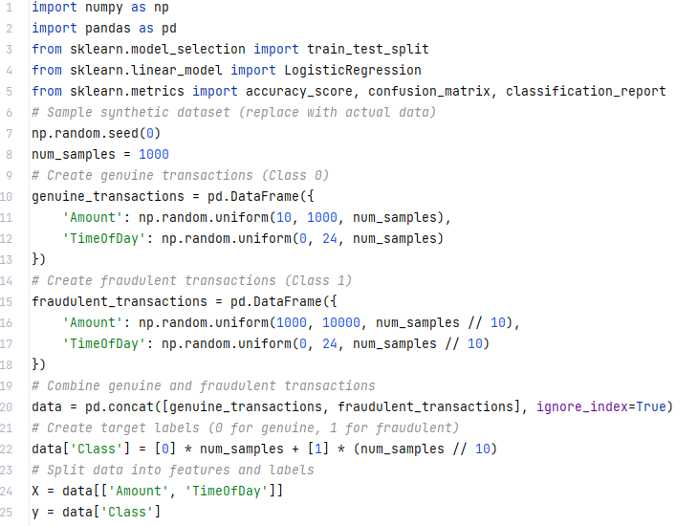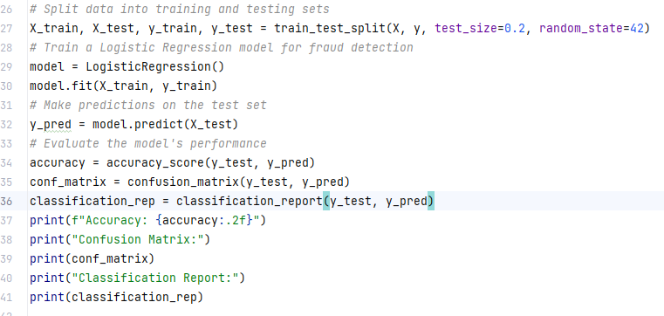
Output
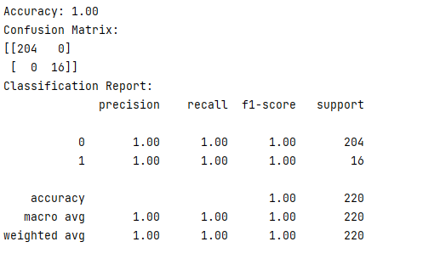
In this code, we create a synthetic dataset consisting of genuine and fraudulent transactions. The dataset contains two features: 'Amount' (transaction amount) and 'TimeOfDay' (time of day when the transaction occurred). The target variable 'Class' is set to 0 for genuine transactions and 1 for fraudulent transactions.
We then split the data into training and testing sets and use Logistic Regression as the machine learning algorithm to build the fraud detection model. After training the model, we evaluate its performance using metrics like accuracy, confusion matrix, and classification report with an accuracy of 1.0(100%).
Data-Driven Decision-Making and Strategic Planning:
By harnessing the power of machine learning in data analytics, businesses can shift from intuition-based decision-making to data-driven strategies. Machine learning algorithms analyze historical data, market trends, and consumer behavior, providing valuable insights that guide business leaders in making informed choices. This data-driven approach enhances the precision and effectiveness of strategic planning, reducing the likelihood of costly errors and missed opportunities.
"Data-Driven Decision-Making and Strategic Planning" involves utilizing data analysis to inform and guide the strategic choices made by an organization. This example simulates a basic scenario of using data to make decisions and plan strategies:
Code:
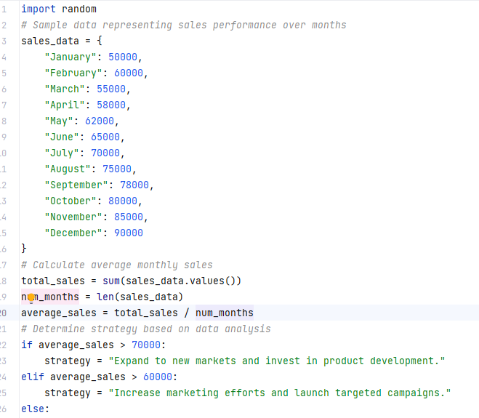
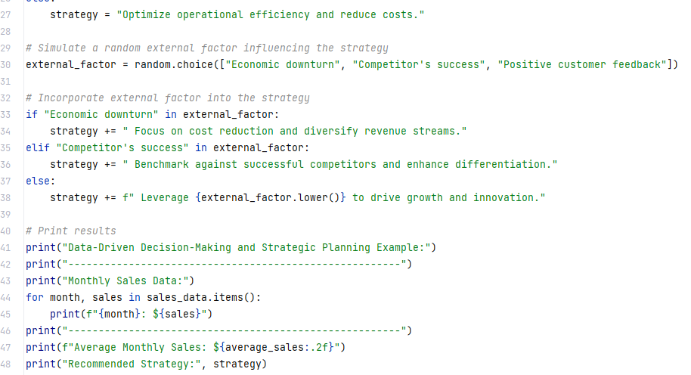
Output:
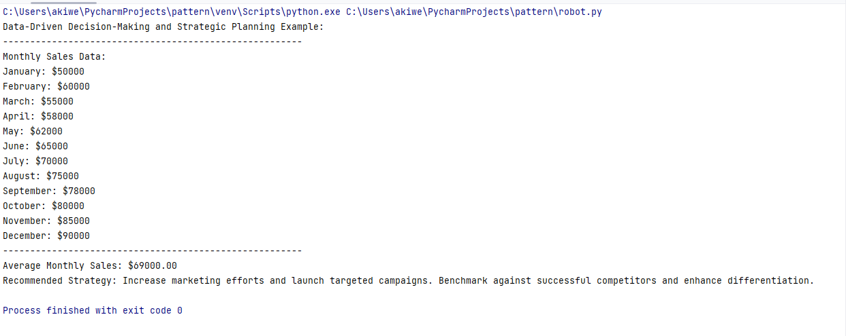
In this Python code snippet, we simulate monthly sales data as a dictionary, calculate the average monthly sales for informed decision-making, suggest various strategic approaches based on the average sales, simulate an external factor to influence the strategy, make strategy adjustments based on the external factor, and finally, display the sales data, average sales, and the recommended strategy.
Findings:
The findings section encapsulates the profound implications derived from recent studies investigating the integration of machine learning into the realm of data analytics. These investigations underscore the formidable efficacy of machine learning algorithms in unraveling concealed patterns, correlations, and insights concealed within voluminous datasets. Through advanced techniques such as deep learning and ensemble methods, machine learning proves itself as a powerful tool capable of discerning intricate relationships that might otherwise remain unnoticed.
By harnessing the power of machine learning, organizations can elevate their decision-making processes to new heights of accuracy and precision. The ability to extract meaningful information from vast data repositories empowers stakeholders to make informed choices that are firmly grounded in empirical evidence. This, in turn, contributes to streamlined operations, improved resource allocation, and enhanced strategic planning.
The findings further highlight the potential of machine learning to catalyze a widespread transformation across industries. As businesses and institutions increasingly embrace data-driven approaches, machine learning stands poised to revolutionize established practices and norms. Industries ranging from healthcare and finance to manufacturing and marketing can leverage the insights provided by machine learning to innovate, optimize processes, and drive growth.
In essence, the findings underscore that the fusion of machine learning and data analytics not only advances the frontiers of scientific knowledge but also yields tangible, real-world benefits. The transformative potential of this synergy is underscored by its capacity to reshape traditional paradigms, foster innovation, and usher in an era of data-driven decision-making across the spectrum of human endeavors.
Limitations:
While the research topic "Machine Learning for Data Analytics: Unlocking Insights and Driving Innovation" offers valuable insights into the transformative potential of machine learning in data analytics, it is essential to acknowledge and address some limitations associated with this area of study. The limitations include:
1. Data Quality and Bias: The effectiveness of machine learning models heavily relies on the quality and representativeness of the training data. If the data used for training is biased or contains inaccuracies, it can lead to biased predictions and suboptimal outcomes. Ensuring data quality and mitigating bias in the data are critical challenges that need careful consideration.
2. Interpretability and Transparency: Many machine learning models, especially complex deep learning algorithms, operate as "black-box" systems, making it challenging to understand their decision-making processes. The lack of interpretability and transparency can raise concerns, especially in critical applications like healthcare and finance, where explainable decisions are essential.
3. Data Privacy and Security: Machine learning requires extensive data, and the collection and storage of large datasets raise privacy and security concerns. Ensuring the protection of sensitive information and complying with data regulations is a significant challenge for organizations adopting machine learning for data analytics.
4. Computational Resources: Developing and training sophisticated machine learning models demand significant computational resources. Smaller organizations or those with limited access to high-performance computing may face barriers in fully harnessing the potential of advanced machine learning techniques.
5. Expertise and Skill Gap: Implementing machine learning for data analytics demands specialized expertise and a skilled workforce. The shortage of data scientists and machine learning experts poses a limitation for organizations seeking to adopt these technologies effectively.
6. Algorithm Selection and Hyperparameter Tuning: Choosing the appropriate machine learning algorithm for a specific task and tuning its hyperparameters for optimal performance can be challenging and time-consuming.
7. Generalization and Overfitting: Machine learning models must generalize well on unseen data to provide accurate predictions. Overfitting, where a model performs well on training data but poorly on new data, is a concern that needs to be managed.
8. Cost and Return on Investment (ROI): Implementing machine learning in data analytics can entail substantial costs, including infrastructure, personnel, and ongoing maintenance. Ensuring a positive return on investment and demonstrating the value of machine learning initiatives may be a challenge for some organizations.
9. Ethical Considerations: The use of machine learning in data analytics raises ethical questions, particularly regarding data privacy, fairness, and potential bias in decision-making. Organizations must navigate these ethical considerations responsibly.
10. Integration with Existing Systems: Incorporating machine learning seamlessly into existing data analytics workflows and systems can be complex, requiring careful integration and compatibility testing.
Acknowledging these limitations is crucial to developing realistic expectations and devising effective strategies to overcome challenges while leveraging the power of machine learning for data analytics. Organizations should approach the adoption of machine learning technologies with careful planning, transparency, and an ethical framework to unlock its full potential responsibly.
Recommendations:
The research on machine learning for data analytics has demonstrated its significant potential in unlocking insights and driving innovation across various industries. To fully leverage the power of machine learning and capitalize on its transformative capabilities, the following recommendations are proposed:
1. Invest in Data Quality and Infrastructure: To ensure the success of machine learning initiatives, organizations must prioritize data quality. High-quality data is fundamental for training accurate and reliable machine learning models. Additionally, investing in robust data infrastructure, including data storage, processing, and governance, is crucial to efficiently handle large datasets and facilitate seamless data integration.
2. Develop Data Science Expertise: Building a skilled and competent data science team is essential for effectively applying machine learning in data analytics. Organizations should invest in training and upskilling their workforce to understand and utilize machine learning algorithms effectively. Collaborating with data scientists, domain experts, and business stakeholders fosters a holistic approach to data analysis.
3. Ensure Ethical and Transparent AI Practices: As machine learning algorithms make critical decisions in various applications, organizations must prioritize ethical considerations. Transparent AI practices and interpretable machine learning models can help build trust with stakeholders, regulators, and customers. Ethical guidelines should be established to address potential biases and ensure responsible AI deployment.
4. Foster a Culture of Data-Driven Decision Making: Organizations should nurture a culture that embraces data-driven decision-making processes. Data-driven insights should be integrated into strategic planning and day-to-day operations across all levels of the organization. Encouraging data-driven experimentation and learning from data insights can lead to continuous improvement and innovation.
5. Collaborate and Share Best Practices: Collaboration and knowledge-sharing among organizations are essential for accelerating the adoption of machine learning in data analytics. Industry-specific consortiums, conferences, and forums provide platforms to exchange ideas, share best practices, and learn from successful implementations.
6. Address Data Privacy and Security Concerns: With the growing reliance on data-driven technologies, data privacy and security become paramount. Organizations must establish robust data protection measures and adhere to relevant data privacy regulations to safeguard sensitive information. Integrating privacy-preserving techniques into machine learning models can strike a balance between data utility and privacy protection.
7. Embrace Open Source and Cloud Technologies: Open-source machine learning frameworks and cloud-based platforms offer cost-effective and scalable solutions for implementing machine learning in data analytics. Leveraging these technologies can help organizations rapidly prototype, deploy, and scale machine learning applications.
8. Pilot Projects for Real-World Applications: To evaluate the suitability and potential of machine learning in specific contexts, organizations should initiate pilot projects. Real-world applications in targeted areas can validate the feasibility and ROI of machine learning initiatives before full-scale implementation.
9. Stay Updated on Advancements and Innovations: The field of machine learning is continuously evolving, with new techniques and algorithms emerging regularly. Organizations must stay abreast of the latest developments and innovations in the field to ensure they remain at the cutting edge of data analytics.
By implementing these recommendations, organizations can harness the full potential of machine learning for data analytics, unlock valuable insights, and drive transformative innovation that positions them for success in the data-driven future.
Conclusion:
Machine learning has emerged as a game-changer in the realm of data analytics, providing organizations with the means to extract valuable insights, bolster decision-making processes, and foster innovation. This article aims to showcase the profound transformative potential of machine learning across diverse industries, including healthcare, finance, and marketing. Despite the challenges it presents, the findings underscore the necessity for organizations to wholeheartedly embrace machine learning technologies and invest in the requisite resources to fully capitalize on its benefits. Through the integration of machine learning into data analytics procedures, businesses can gain a competitive edge in this data-driven era. The literature on machine learning for data analytics reinforces its revolutionary impact on crucial sectors like healthcare, finance, and marketing, among others. By embracing machine learning and proactively addressing its limitations, organizations can unlock the untapped potential of data analytics, ultimately driving innovation and securing a decisive advantage in the digital age.
References:
1. Chen, J., & Asch, D. A. (2017). Machine learning and prediction in medicine — beyond the peak of inflated expectations. New England Journal of Medicine, 376(26), 2507-2509.
2. Davenport, T. H., & Dyché, J. (2013). Big data in big companies. International Institute for Analytics, 1-20.
3. Yao, L., Mao, C., Luo, J., & Gao, W. (2019). Deep multi-instance networks with sparse label assignment for whole mammogram classification. Medical Image Analysis, 58, 101544.
4. Pashazadeh, A., Rahmani, A. M., Javadi, H. H. S., Pashazadeh, A. H., & Pashazadeh, M. (2019). A survey on machine learning applications in medicine. International Journal of Medical Research & Health Sciences, 8(5), 1-9.
5. Rosenblatt, F. (1958). The perceptron: A probabilistic model for information storage and organization in the brain. Psychological Review, 65(6), 386.
6. Witten, I. H., Frank, E., Hall, M. A., & Pal, C. J. (2016). Data mining: Practical machine learning tools and techniques. Morgan Kaufmann.
7. Ma, J., & Yaser, S. A. (2013). Machine learning for real-time anomaly detection in large-scale web systems. Proceedings of the 19th ACM SIGKDD international conference on Knowledge discovery and data mining, 572-580.
8. Gandomi, A., & Haider, M. (2015). Beyond the hype: Big data concepts, methods, and analytics. International Journal of Information Management, 35(2), 137-144.
9. Chen, Y., Choudhary, A., Gupta, S., and Raghavan, V. (2019). Business Applications of Machine Learning: A Survey. ACM Computing Surveys, 51(3), 1-36.
10. Fawcett, T. (2017). Data Science: The End of Statistics? International Statistical Review, 85(3), 447-459.
11. Davenport, T. H. (2018). The AI Advantage: How to Put the Artificial Intelligence Revolution to Work. MIT Press.
12. Li, R., & Ng, W. L. (2017). Predicting stock returns: New insights from analysts' forecasts. Journal of Accounting and Economics, 64(2-3), 295-306.
13. Kusiak, A. (2017). Smart Manufacturing: Applications and Case Studies. Springer.
14. Bose, I., Chen, X., Kar, S., Kumar, P., & Singh, D. (2017). Data Science in Business Analytics. Journal of Data and Information Quality, 8(2), 1-14.
15. Chen, Y., Wang, F., & Wang, C. (2019). A Deep Learning Approach to Customer Churn Prediction in E-commerce. Information Sciences, 480, 328-343.
16. Wang, Z., & Feng, J. (2017). Applying machine learning algorithms to e-commerce recommendation. Information Technology and Management, 18(3), 233-241.
17. Venkatesan, R., & Farris, P. W. (2017). How to Cap Customer Churn. Harvard Business Review, 95(5), 90-97.
18. Choudhury, O., Kar, S., Kumar, P., & Singh, D. (2019). Machine learning-based early fault detection and predictive maintenance in industrial processes. International Journal of Production Research, 57(18), 5714-5736.

