Biotechnology Trends and Innovations: Shaping the Future
Dr. Praveen Garg
Assistant Professor, Vindhya Institute of Management and Science, Satna (M.P.)
Email: praveengarg1983@gmail.com

ABSTRACT
Biotechnology is a rapidly evolving field that holds immense promise for shaping the future of medicine, agriculture, environmental sustainability, and more. This chapter explores the latest trends and innovations in biotechnology, highlighting their potential impact on various sectors. From gene editing and synthetic biology to personalized medicine and sustainable biofuels, biotechnology is driving unprecedented advancements that are poised to revolutionize industries and improve quality of life. This chapter delves into key trends such as CRISPR-based technologies, 3D bioprinting, bioinformatics, and the ethical considerations surrounding these innovations. By examining the current landscape and future possibilities, we gain insights into how biotechnology is reshaping the world as we know it.
Keywords- Biotechnology, Recent trends of Biotechnology, Gene Editing, Bioinformatics

- INTRODUCTION
Biotechnology is one of the world's most dynamic and innovative sectors, with scientific and technological advancements transforming the healthcare, agriculture, energy, and environmental sustainability industries. According to Smith, 1996 biotech play an important role in Genetic Engineering and its defined as in very simple manner as “the formation of new combinations of heritable material by the insertion of nucleic acid molecules produced by whatever means outside the cell, into any virus, bacterial plasmid or other vector system so as to allow their incorporation into a host organism in which they do not naturally occur but in which they are capable of continued propagation”. Biotechnology is at the forefront of scientific and technological progress, enabling humanity to harness the power of living organisms for a multitude of applications. From the modification of genes to the engineering of entire biological systems, biotechnology innovations are rapidly transforming industries and pushing the boundaries of what is possible. This chapter delves into the trends and innovations that are shaping the future of biotechnology and the implications these advancements have for various sectors.
- DEVELOPMENT OF BIOTECHNOLOGY:
If we trace the origin of biotechnology, it is as old as human civilization. Development of biotechnology can be studied considering its growth that occurred in two phases-
- The Traditional (Old) Biotechnology
- The New (Modern) Biotechnology
Traditional Biotechnology: The traditional biotechnology refers to the conventional technologies which have been used for many centuries. Beer, Wine, Cheese and many foods have been produced using traditional biotechnology. The traditional biotechnology was an art rather than a Science. The traditional biotechnology associated with fermentation was gradually industrialized.
Modern Biotechnology:
The two major features of technology differentiate the modern biotechnology from the classical biotechnology:
- Capability of science to change the genetic material for getting new products for specific requirement through recombinant DNA technology
- Ownership of technology and its socio-political impact.
The new or modern biotechnology embraces all methods of genetic modification by recombinant DNA and cell fusion technologies.
Currently there are about 35 biotechnology-derived therapeutics and vaccines approved by the USFDA alone for medical use, and more than 500 drugs and vaccines to reach in markets. Similarly, about 600 biotechnology diagnostics are worldwide available in clinical practices. About 130 gene therapy protocols have been approved by the US authorities. India relies on imports of many immunodiagnostic kits.

- NEEDS FOR FUTURE DEVELOPMENT:
The future development of few developing countries like India required Scientist and technologists related to biotechnology field, where implementation of biotechnology could be done for development of national strategies. The aim to produce expertise in biotechnology is to be scientific and technical manpower shifted towards new area of biotechnology.
- GLOBAL SCENARIO
Looking at it from a global standpoint, data from Vision Research Reports shows that the international biotech market is expected to surpass $3.44 trillion in 2030, driven by the rapid development and adoption of new technologies, products, and services that address major challenges and opportunities worldwide.
Biotech is dealing how we access health, medicine, and agriculture. Several trends in biotechnology have impelled rapid innovation without the impact of COVID-19. The expansion of industry has followed such type of innovation. The market of global biotechnology is currently valued at 752.8 Billion and growing. The development of advanced health initiatives in the field of biotechnology will transform our future and we can challenges various global problems including disease, food management and environmental pollution.
Understanding the concept of biotechnology trend can help companies and industries, and obtain the rapid growth potential. But before you can utilize the potential of these new technologies and practices, it is necessary to understand the context and challenges around biotech. It is essential for biotechnology companies to stay up-to-date with the latest developments and their needs. In this article, we will explore trends and innovations of the topmost biotechnology industry that shaping the future and set to change the world.

- SCOPE OF BIOTECHNOLOGY
- To produce more food for the growing population by using the available land.
- To Produce disease-resistant, high-yielding varieties of crops,
- To introduce nontoxic bio fertilizers as a substitute of harmful chemical fertilizers,
- To introduce biopesticides in agriculture for control Pest.
- To preserve germplasm (plants, animals and microbes)
- To produce pharmaceutical products to treat severe diseases in all living things.
- To produce biofuels for reducing the felling of forest trees for fuel wood.

- TRENDS IN BIOTECH
Biotechnological innovations are already a part of our daily lives and it’s developed in pharmacies and supermarkets by us, along with many other places. In addition, in present months biotechnology has become one of the spearhead in the fight against the COVID-19 pandemic, since it helps to decode the virus' genome and understand how our body's defense mechanism works alongside infectious agents.
Biotechnology will therefore play a major role in our society in future to preventing and containing probable pathogens. But this is just one its have many applications.
Below, we reviewed some of the most applicable in different fields:
- In Medicine:- In medicine biotechnology continuously grow for the development of insulin, different growth hormone, molecular identity and diagnostics, gene therapies and vaccines such as hepatitis B are some of the milestones of biotechnology and its association with genetic engineering.
- In Industry:- In industry biotechnology play very advanced role. The revolt of the new smart materials hand-in-hand with biotechnology has only just begun. Presently we could have self-healing material, plants that change color when they detect an explosive, clothing and footwear which made with synthetic spider web, etc.
- In Food:- In the field of food, biotechnology play advanced role like hybrid products, genetically modified foods. Thanks to biotechnology products such as WEMA have been created, a type of resistant crop to droughts and certain insects that may prove essential in fighting hunger in Africa.
- In Environment:- All the way through bioremediation processes, very useful for ecological recovery, the catabolic properties of microorganisms like fungi, plants and also enzymes are used to restore contaminated ecosystems.

- TRENDS IN BIOTECHNOLOGY IN YEAR 2021-2022
Biotech is undergoing a global evolution. The most notable innovations in biotech involve personalized medicine, drug research, artificial intelligence, big data, and synthetic biology.

- Gene Editing: - It is known as genetic engineering which is a modern technology. This technique is responsible for eliminates faulty gene and placed it with desired gene. The development of engineered nucleases has increased gene editing effectiveness, and CRISPR is now being used as a molecular scissors in the healthcare industry. This editing technology has enabled different applications in the field of gene therapy to treat genetic disorders and include complex editing techniques for adding, replacing, or silencing specific genes.

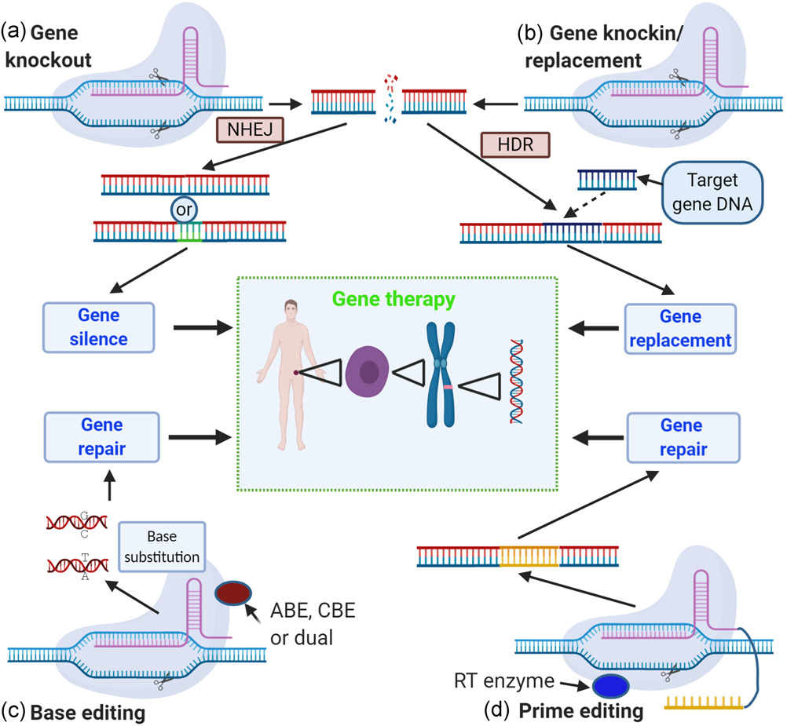

- Bio-printing: - Bioprinting can be defined as the computer-aided manufacturing of cells and tissues to create organs. It produces 3D structure of tissue by printing cells and biomaterials one layer over the other. This technique is used in develop building tissue and organ structure bio-printers that work with accessible bio-inks made from biomaterials. These cells will act as substrates which allowing the development of various body parts from the patient's cells, such as bone skin, etc.
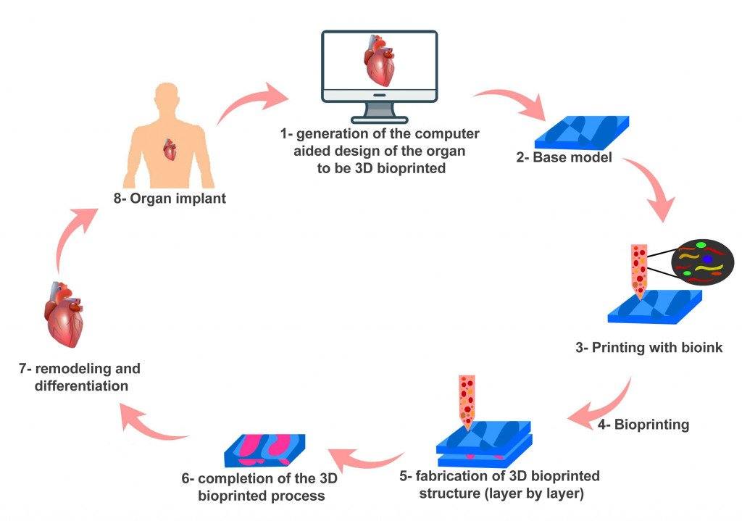

- Telemedicine: - Telemedicine technology is very useful technology in the future health and care industry prospects. It is defined as medical people treating and diagnosing by keeping their distance from the patients. There is no. of telemedicine software like Doxy.me, OhMD, Whereby, Mend, Updox, etc.

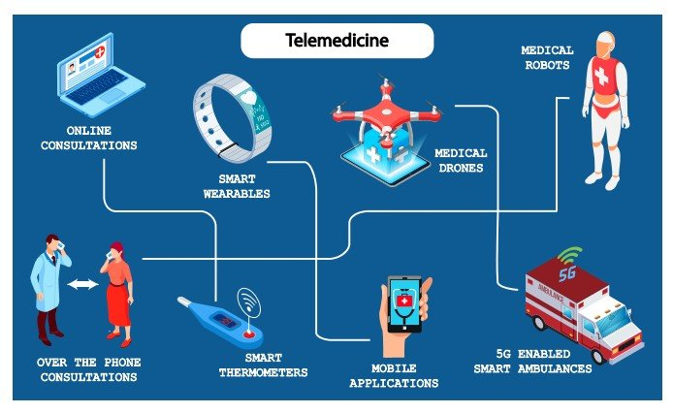

- Precision Medicine:- The falling costs of gene editing process and gene sequencing both are routinely applied in clinical practices. Its enable precision medicine, an advance that allows physicians to determine many prevention strategies will work for a particular group. Furthermore, it enables personalized treatment for the treatment of the several diseases, like cancers. Biotechnology startups are leveraging accuracy medicine to identify a new drug targets, novel drugs discover, provide gene therapies, and also develop new drug delivery technologies.
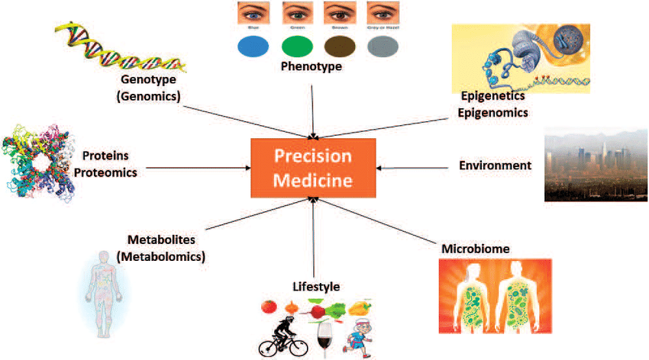

- Big Data:- There is an unique quantity of data available in Biotechnology today, from the ever-growing omics technologies, incorporation of sensors and the Internet of Things (IoT) devices. Big data and analytics solutions both allow startup Biotechnology startups to tap into this wealth of data to create innovation. Its allow biopharma companies to recruit patients for the clinical trials with more effectively. Startups and companies both initiate bioinformatics branch for the solutions of many problems and to develop better feed also for crop improvement, produce livestock varieties, and explore undiscovered microbes.
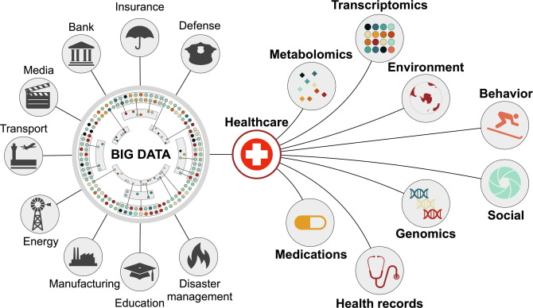

- Synthetic Biology:- An extraordinary biology which able to read and write genomes. Its allows biotechnology startups and companies to develop many products faster than ever before. Furthermore, synthetic biology increased standardization and reproducibility, that allowing manipulating organisms at the level of gene networks. Synthetic biology startups work on many challenges ranging from computational designing of range and cellular agriculture to microbiome-based solutions.

- Drug Research:- Now a day drug research is one of the most promising biotech trends to advancements in smart technology. Usually, drug research faced many challenges with receiving enough participants for trials, and long production timelines that can run into years. Machine learning technology presents huge possibilities in the field of drug research, as well as improve assess diagnosis and treatment with medications.

- 4D printing and Tissue Engineering:- 4D printing is very useful to gaining popularity in the creation of self-healing substances for engineering in tissue and different manufacturing applications, but it has seen limited use in agriculture and farming applications. When 4D materials are exposed to certain environments change their shape but recently available materials are of low compatibility with cells. However, created new 4D materials based on gelatin-like hydrogels by the research team of Eben Alsberg and also led by them. Tissue engineering enhances cell compatibility and 4D printing provides 4D structures.

Development of Vaccines:- As we know, that how coronavirus was once related to milder infections for example common cold, however, three variants such as Severe Acute Respiratory Syndrome Coronavirus (SARS-CoV), Middle East Respiratory Syndrome Coronavirus (MERS-CoV), and SARS-CoV-2 are now linked to significant illness and humanity in infected people, resulting create global pandemics around the world. It is critical to formulate new and long-term strategies for stopping the spreading of virus’s in global. Therefore, with the help of biotechnology, many researchers and scientists have been capable to formulate reliable vaccines.

SIX EMERGING BIOTECH TRENDS

1. CRISPR-Cas and Gene Editing:
One of the most groundbreaking innovations in biotechnology is the development of the CRISPR-Cas gene-editing technology. This revolutionary tool allows scientists to precisely modify DNA sequences in a wide range of organisms, from microbes to plants and animals. The potential applications of CRISPR-Cas are vast, including the treatment of genetic diseases, the creation of genetically modified organisms for agriculture, and advancements in drug discovery. However, ethical concerns surrounding gene editing, such as the potential for unintended consequences and designer babies, raise important ethical questions that society must address.

2. Personalized Medicine:
The era of personalized medicine is upon us, thanks to advancements in genomics, proteomics, and bioinformatics. Biotechnology allows for the analysis of an individual's genetic makeup, enabling tailored medical treatments and therapies. Precision medicine holds promise for more effective disease prevention, diagnosis, and treatment. However, challenges related to data privacy, regulatory frameworks, and equitable accesses to personalized treatments need to be addressed to fully realize the potential of this approach.
3. Synthetic Biology:
Synthetic biology involves designing and engineering biological components to create novel biological systems with desired functions. This field has the potential to revolutionize industries such as pharmaceuticals, agriculture, and energy production. From designing microorganisms that produce biofuels to engineering bacteria that can sense and clean up pollutants, synthetic biology offers innovative solutions to pressing global challenges. As with any emerging technology, careful consideration of ethical, safety, and environmental implications is essential.
4. 3D Bioprinting and Tissue Engineering:
Advancements in 3D bioprinting are poised to transform the field of regenerative medicine. Researchers can now create intricate three-dimensional structures of tissues and organs using bioinks composed of living cells. This technology holds promise for organ transplantation, drug testing, and disease modeling. However, challenges such as vascularization of printed tissues and the mimicking of complex organ structures remain to be addressed for clinical applications.
5. Agricultural Biotechnology:
Biotechnology is revolutionizing agriculture through genetically modified crops that offer increased yields, enhanced nutritional profiles, and improved resistance to pests and diseases. These innovations have the potential to address food security challenges and reduce the environmental impact of agriculture. Public acceptance, regulatory frameworks, and coexistence with conventional farming practices are critical factors in the successful adoption of agricultural biotechnology.
6. Ethical and Societal Considerations:
As biotechnology advancements continue to accelerate, ethical considerations become paramount. Balancing the benefits of innovation with potential risks and unintended consequences is a complex challenge. Issues such as biosecurity, intellectual property rights, and equitable access to biotechnological advancements require global collaboration and thoughtful policymaking.

Artificial Intelligence (AI) in Biotechnology
On the one hand, AI offers solutions like smart manufacturing and augmented analytics, while on the other; it can identify biomarkers for developing drugs.
Here are some AI trends in biotech that are gradually shaping the modern world:
- Fast analysis of healthcare information
- Bioinformatics for genome sequencing
- Eliminating manual data entry and analysis tasks
- Farmland data
- Recognizing accurate molecules for particular drugs
AI technologies are transforming biotech by optimizing data, analysis, and improving the accuracy of scientific models. This trend in biotechnology has a massive potential to change the medicine and agriculture sector.
In addition, the recent utility of AI in biotech research for detecting cancer cells can prove remarkable. Scientists and health experts can identify the presence of tumors right from the onset, thanks to AI.

CONCLUSION
Biotechnology's transformative potential is reshaping industries and societies, offering solutions to pressing challenges and unlocking new possibilities. From healthcare to agriculture, the innovations discussed in this chapter represent just a glimpse into the future of biotechnology. As we navigate this rapidly evolving landscape, interdisciplinary collaboration, ethical foresight, and responsible innovation will be crucial in harnessing the power of biotechnology for the betterment of humanity.

- Srivastava, M., (2007). Biotechnology Tools and Techniques. Shree Publishers and Distributers: New Delhi; 2–81.

- https://www.hult.edu/blog/biotech-innovation-6-exciting-developments

- https://www.cell.com/trends/biotechnology/fulltext/S0167-7799(22)00005-1

- https://www.cell.com/trends/biotechnology/home

- https://www.sciencedirect.com/journal/trends-in-biotechnology

- Charlotte, V. T., Thierry, V., Jeroen L., Dragana, S., (2023). Imaging the unimaginable: leveraging signal generation of CRISPR-Cas for sensitive genome imaging. Trends in Biotechnology. Volume 41, Issue 6, Pages 769-784https://doi.org/10.1016/j.tibtech.2022.10.003

