Overview of Biomedical Instrumentation and Its various Applications
Neeta A. Ukirade
Assistant Professor, KES’ Pratibha College of Commerce and Computer Studies,
Chinchwad, Pune - 411019 (M.S.) India.
*Corresponding Author: Neeta A. Ukirade , Email: nitugatkal@gmail.com.

ABSTRACT
Biomedical instrumentation is a multidisciplinary field that focuses on the development of devices and methods for measuring, evaluating, and treating biological systems in the healthcare domain. It plays a crucial role in bridging the gap between medicine and engineering, enabling accurate diagnostics, effective treatments, and improved patient care. Biomedical instrumentation relies on various types of sensors to monitor physiological signals and detect critical biomarkers in healthcare and biomedical applications. Biomedical instrumentation offers numerous opportunities driven by increasing awareness of healthcare quality and patient safety. The rise of wearable health technologies, powered by biomedical instrumentation, is transforming healthcare with innovations such as smartwatches, biosensors, and implantable devices. The application of biomedical instrumentation has opened new opportunities in the medical industry, allowing patients with terminal diseases to live longer and enhancing disease management. This chapter covers basic principles and components of Biomedical instrumentation followed by applications of biomedical instrumentation and Future Opportunities of Biomedical instrumentation
1. Introduction
Biomedical Instrumentation is a topic of research that focuses on the knowledge and implementation of medical technology in patient care. It involves the design, development and use of equipment and instruments for monitoring, diagnosing, and treating biological systems and prevention of disease in humans. This field is continuously evolving, keeping pace with advancements in healthcare, technology, and standards. The fundamental principles of Biomedical Instrumentation involve understanding the interaction between medical devices and the human body. This includes the measurement and evaluation of physiological parameters, such as bio potentials (e.g., electrocardiography, electroencephalography), pressure, flow, temperature, and chemical concentrations . By accurately capturing and analyzing these parameters, healthcare professionals can make informed decisions regarding patient diagnosis, treatment, and monitoring.
Biomedical Instrumentation also encompasses the development of sensors, which play a vital role in detecting and converting physical inputs into electrical signals. These sensors can range from simple devices to sophisticated systems capable of monitoring and recording various physiological signals. An understanding of electronics and measurement principles and procedures is essential to measure biological signals and design medical equipment[1]. Signal processing techniques are employed to amplify, filter, and analyze the electrical signals obtained from sensors [2]. Signal processing helps extract meaningful information from the acquired data, removing noise and enhancing the quality and reliability of the measurements. The output of biomedical instrumentation systems is typically presented through an output display, which provides a visual representation of the processed data. This display allows healthcare professionals to interpret and analyze the information in real-time, aiding in diagnosis, treatment, and patient monitoring
Overall, the field of Biomedical Instrumentation combines engineering principles and medical knowledge to improve patient care through the development and application of medical technology. It encompasses various aspects such as device classification, sensor technology, signal processing, and output display, with the ultimate goal of enhancing healthcare outcomes.
India holds immense potential in the field of biomedical instrumentation due to its growing population, increasing healthcare needs, and thriving technology sector. Biomedical instrumentation's significance and advancements have transformed healthcare delivery, enhancing precise diagnostics, continuous monitoring, and effective therapies. The field's continuous evolution presents vast opportunities in India and abroad, with biomedical engineers and healthcare professionals collaborating to shape a future where advanced medical technologies improve global healthcare and lead to longer, healthier lives.

2. Basic components of biomedical Instrumentation
Biomedical Instrumentation is a field that involves the measurement and analysis of current or voltage signals from various parts of the human body. It plays a crucial role in aiding medical professionals to diagnose health issues accurately and provide appropriate treatment. A biomedical instrumentation system typically consists of the following key components:
Measurand: The measurand refers to the physical quantity or condition that the biomedical instrumentation system measures. In the context of biomedical instrumentation, the human body serves as the source of the measurand, generating a variety of signals. Examples of measurands include electrocardiogram (ECG) potential on the surface of the body or blood pressure in the chambers of the heart.
Transducer/Sensor: The transducer, sometimes referred to as a sensor, is a device that converts one form of energy into another. In the context of biomedical instrumentation, the transducer converts the physical signal from the measurand into an electrical output. For instance, a piezoelectric transducer can convert mechanical vibrations into an electrical signal. The primary function of the transducer is to provide a usable output in response to the measurand.
Signal Conditioner: The signal conditioner is a critical component that processes the output from the transducer to create an electrical quantity suitable for operation with the display or recording system. Signal conditioning involves various functions, such as amplification, filtering, analog-to-digital conversions, and digital-to-analog conversions. This process helps to enhance the sensitivity of the instruments by amplifying the original signal or its transduced form, especially when the original signal is extremely small.
Display System: The display system presents a visible representation of the measured quantity. It can be in the form of a displacement on a scale, a chart recorder, a cathode-ray oscilloscope (CRO), or a numerical readout. In addition to the display unit, the processed signal from the signal conditioner may be utilized for various purposes:
Alarm System: Some biomedical instrumentation systems incorporate alarm systems with adjustable upper and lower thresholds to indicate when the measurand's physical variable goes beyond the preset limits, alerting medical professionals of critical conditions.
Data Storage: Biomedical instrumentation systems may include data storage options to retain data for future reference. This data can be stored in hard copies on paper or in digital formats using magnetic or semiconductor memories.
Data Transmission: Biomedical instrumentation systems may also have interfaces for data transmission, allowing information obtained from the system to be carried to other parts of an integrated system or transmitted from one location to another, often useful in telemedicine or remote monitoring setups[3].
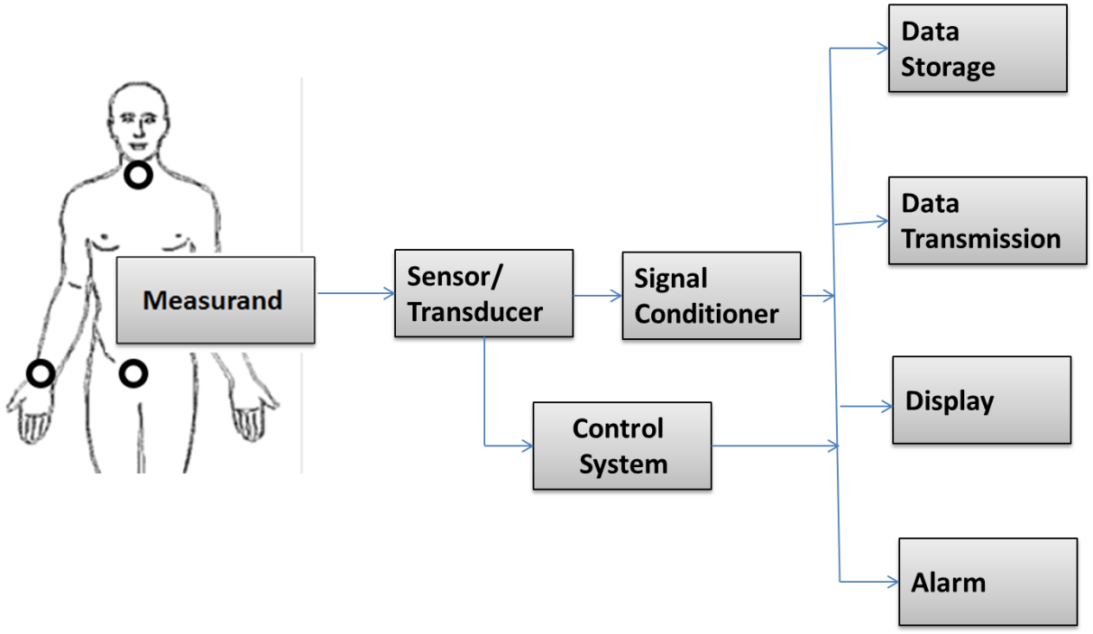
Fig 1. Block Diagram of a Biomedical Instrumentation System

3. Biosignals and bioelectrodes
Biosignals
Biosignals, also known as biological signals, are signals found in living organisms that can be continuously measured and monitored. These signals serve as a means of communication between various biosystems and provide essential information about their behavior. Biosignals can be broadly categorized into electrical and non-electrical signals, both of which play a crucial role in understanding physiological processes and diagnosing medical conditions[4].
Electrical biosignals, such as electroencephalogram (EEG), electrocardiogram (ECG), and electromyogram (EMG), are obtained through the measurement of electrical activity in specialized tissues, organs, or cell systems like the brain, heart, and muscles. These signals provide insights into the functioning of the nervous system, cardiac activity, and muscle contractions, respectively. For instance, EEG is used to study brain activity and diagnose neurological disorders, while ECG helps in detecting heart abnormalities and diagnosing cardiac conditions.
Non-electrical biosignals encompass a diverse range of signals, including mechanical signals (e.g., mechanomyogram or MMG), acoustic signals (e.g., breathing sounds), chemical signals (e.g., pH and oxygenation levels), and optical signals (e.g., movements). These signals are equally important in understanding various physiological processes and diagnosing medical conditions. For instance, MMG is used to monitor muscle vibrations and study muscle function, while acoustic signals aid in respiratory assessments.
Biosignal processing involves various techniques and algorithms to extract relevant information from these signals. Signal processing methods, such as filtering, feature extraction, and pattern recognition, are applied to clean the data, identify relevant features, and classify different biosignal patterns. Machine learning and artificial intelligence techniques are also employed to develop advanced algorithms for biosignal analysis, which can improve the accuracy of diagnosis and monitoring[5].

Bioelectrodes

Bioelectrodes are electronic devices that can either monitor or stimulate biological activity by transmitting signals to and from living biological systems. These devices play a crucial role in various biomedical applications, such as neuromuscular diseases, neurological disorders, and other medical conditions where the monitoring and interaction with biological systems are necessary[6]. Bioelectrodes play a significant role in biomedical instrumentation, particularly in the field of biosensors and wearable technology for biomedical applications. The electrode material can affect the electron transfer between the biocatalyst and the surface, the stability and immobilisation of the enzymes, the mass transport of fuel, and the conductivity and surface area of the electrodes, all of which contribute to the development of efficient bioelectrodes[7]. Advancements in biomedical instrumentation have been made possible through the integration of bioelectrodes with various nanomaterial-based technologies. Nanomaterials, such as carbon nanotubes, graphene, and metallic compounds, have enabled the development of stretchable self-powered technologies for wearable biosensors [3]. These nanomaterial-based devices allow for improved flexibility, stretchability, and lightness, making them suitable for integration into wearable biomedical devices. One significant advantage of self-powered biosensors is the elimination of the need for traditional external power sources, enhancing the portability and usability of these devices.
Types of bioelectrodes commonly used in medical measurements can be classified based on their application and location on or within the body. Here are the main types of bioelectrodes:
Surface Electrodes: These electrodes are placed on the surface of the body to pick up bioelectric potentials. They are used for in vitro measurements, where potential differences are measured outside the body. Surface electrodes are commonly used in electrocardiography (ECG) and electromyography (EMG) to monitor heart and muscle activity, respectively.
Deep Seated Electrodes: These electrodes are inserted inside live tissues or cells for in vivo measurements. They are used to measure bioelectric potentials from within the body. Two subtypes of deep-seated electrodes are:
a. Depth Electrodes: These electrodes are used to study the electrical activity of neurons on the surface of the brain. They consist of bundles of Teflon-insulated platinum and iridium alloy wires, which allow for easy insertion into the brain to record electrical signals.
b. Needle Electrodes: Needle electrodes are used to record peripheral nerve action potentials. They resemble a medicinal syringe, with a short insulated wire bent at one end. The bent wire is inserted into the muscle, and the needle is withdrawn, leaving the wire inside the muscle for measurement. Needle electrodes can be either mono-polar (with a single reference electrode placed on the skin) or bi-polar (with one reference electrode and one active electrode).
Microelectrodes: These electrodes are designed to measure bioelectric potentials near or within a single cell. They have small diameter tips to penetrate the cell without causing damage. Microelectrodes are used for potential recording and injecting medicines into cells. They can be further classified into two types:
a. Metal Microelectrodes: Made from materials like tungsten or stainless steel, these electrodes have insulating material covering most of the electrode for safety. They are used to measure potentials between the metal electrode and the electrolyte.
b. Non-Metal Microelectrodes (Micropipette): These electrodes use non-metallic materials, typically glass micropipettes filled with an electrolyte solution compatible with cellular fluids. They are used to measure potentials between the electrolyte-filled micropipette and the reference electrode, providing information about the potential within the cell..
4. Advances in Biosensor Technology
Biosensors are currently widely used in biomedical diagnostics, as well as point-of-care monitoring of treatment and illness progression, environmental monitoring, food control, drug discovery, forensics, and biomedical research. A wide range of techniques can be used for the development of biosensors. A biosensor is a device that detects biological or chemical processes by generating signals proportional to an analyte concentration in the reaction[9]. A typical biosensor is shown in Fig. 2 .The basic structure of a biosensor typically consists of three main components:
Biological Recognition Element: This is the biological component of the biosensor, which is specific to the target analyte. It can be an enzyme, an antibody, a DNA strand, or other biomolecules that can bind to the target analyte with high selectivity.
Transducer: The transducer is responsible for converting the biological interaction between the recognition element and the analyte into a measurable signal. Common transducers include electrochemical, optical, piezoelectric, and thermal sensors.
Signal Processor: The signal processor amplifies, processes, and converts the signal generated by the transducer into a quantitative measurement. This step allows the biosensor to provide real-time and accurate readings of the analyte concentration.
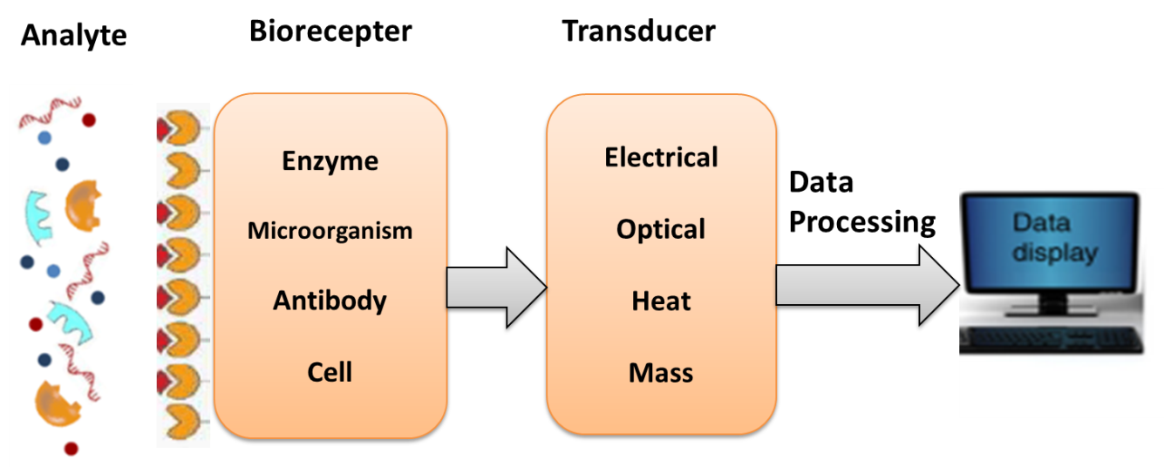
Fig 2. Schematic of a biosensor.
Biosensors are categorised based on the manner of physicochemical transduction or the type of biorecognition element. Biosensors are divided as electrochemical, optical, thermal, and piezoelectric biosensors based on their transducer[10].
Electrochemical biosensors are further subdivided into amperometric biosensors (which measure the current produced during the oxidation or reduction of an electroactive product or reactant), potentiometric biosensors (which measure the potential of the biosensor electrode in relation to a reference electrode), and conductometric biosensors (which measure the change in conductance caused by the biochemical reaction).
Optical Biosensors: Optical biosensors use light-based detection methods to measure changes in optical properties caused by the binding of the analyte to the biological recognition element. The transducer in optical biosensors converts the optical changes into measurable signals. Surface Plasmon Resonance (SPR) and Fiber Optic biosensors are examples of optical biosensor technologies. They find applications in label-free biomolecular interaction analysis, drug discovery, and medical diagnostics.
Thermal Biosensors: Thermal biosensors work based on the principle that the binding of the analyte to the biological recognition element causes a change in heat release or absorption. The transducer in thermal biosensors measures this change in temperature and converts it into a detectable signal. These biosensors are used in applications such as DNA hybridization detection and monitoring enzymatic reactions.
Piezoelectric Biosensors: Piezoelectric biosensors use a piezoelectric material that generates an electrical signal when subjected to mechanical stress. The binding of the analyte to the biological recognition element causes a change in mass on the surface of the piezoelectric material, leading to a measurable change in the electrical signal. Quartz Crystal Microbalance (QCM) biosensors are an example of piezoelectric biosensors. They are employed in applications like real-time monitoring of biomolecular interactions and food quality control.
Biosensors find applications in various fields, including medical diagnostics, environmental monitoring, food safety, and biotechnology. They have several advantages, such as high specificity, sensitivity, and rapid response times, making them valuable tools in many industries.
Recent advancements in biosensor technology have led to the development of nanomaterial-based biosensors, which enhance sensitivity and detection capabilities. Additionally, the integration of biosensors with advanced technologies like artificial intelligence and machine learning has enabled improved data analysis and enhanced diagnostic accuracy.

5. APPLICATIONS IN BIOMEDICAL INSTRUMENTATION
Biomedical instrumentation finds diverse applications in the field of healthcare and medical sciences. It involves the use of various instruments and devices that combine principles from engineering and medical sciences to aid in the diagnosis, monitoring, and treatment of medical conditions. Here are some applications of biomedical instrumentation:
Medical Device Development: Biomedical instrumentation plays a crucial role in the development of medical devices and equipment. Engineers in this field design and create instruments such as medical imaging machines (X-ray, MRI, CT scanners), electrocardiograms (ECGs), ultrasound machines, and more. These devices help healthcare professionals to visualize internal body structures and diagnose medical conditions accurately.
Patient Monitoring: Biomedical instruments are used for continuous monitoring of patients in hospitals and critical care units. Devices like heart rate monitors, blood pressure monitors, pulse oximeters, and respiratory rate monitors assist medical professionals in monitoring patients' vital signs and providing timely interventions.
Clinical Laboratory Equipment: Biomedical instrumentation is essential in clinical laboratories for conducting various diagnostic tests. Instruments like blood analyzers, DNA sequencers, and biochemical analyzers help in analyzing patient samples to diagnose diseases and monitor treatment effectiveness.
Prosthetics and Implants: Biomedical instrumentation contributes to the development of advanced prosthetics and implants. Prosthetic limbs with integrated sensors and implants such as pacemakers, defibrillators, and cochlear implants enhance the quality of life for individuals with disabilities or chronic conditions.

Rehabilitation and Physiotherapy: Biomedical instrumentation is used in physiotherapy equipment for therapeutic purposes. Devices like ultrasound machines, traction units, and electrical stimulation equipment aid in rehabilitation and promoting tissue healing.
Research and Development: Biomedical instrumentation is essential for conducting research in various medical fields. Researchers utilize sophisticated instruments to study human physiology, drug effects, and medical interventions.
Telemedicine: With advancements in technology, biomedical instrumentation has enabled the integration of medical devices with telecommunication systems. This allows remote patient monitoring and consultations, making healthcare accessible to remote and underserved areas.
Healthcare Informatics: Biomedical instrumentation is closely related to healthcare informatics, where data from medical devices are collected, processed, and analyzed to improve patient outcomes and optimize healthcare practices.

6. Future Opportunities of Biomedical instrumentation
Global opportunities in biomedical instrumentation are significant and offer a wide range of prospects for professionals in the healthcare and medical technology industry worldwide. Biomedical instrumentation plays a critical role in revolutionizing healthcare by providing precise diagnostics, continuous monitoring, and therapeutic interventions.
Wearable Health Technologies: The popularity of wearable devices for health monitoring and disease management is a global trend. Biomedical instrumentation experts are involved in developing innovative wearable health technologies, such as smartwatches, biosensors, and implantable devices, that revolutionize healthcare delivery.
Artificial Intelligence (AI) and Machine Learning : The combination of AI and machine learning algorithms with biomedical instruments has the potential to significantly improve diagnosis, treatment planning, and patient outcomes. AI-powered tools can assess massive volumes of data, resulting in more precise and personalised healthcare interventions.
Telemedicine and Remote Monitoring: The growing popularity of telemedicine and remote monitoring presents significant global opportunities for biomedical instrumentation experts. These professionals contribute to the development of instruments that enable remote diagnosis, monitoring, and treatment, bridging the gap between urban and rural healthcare and ensuring access to quality care for all.

Conclusion
Biomedical instrumentation is a rapidly advancing field that plays a vital role in revolutionizing healthcare delivery and improving patient outcomes. It involves the design, development, and application of various instruments and devices used in healthcare settings to diagnose diseases, monitor vital signs, deliver therapies, and conduct research. It focuses on using many sensors to monitor a person's or an animal's physiological features. Sensors can range from simple devices to complex systems capable of monitoring and recording a variety of physiological signals. To monitor biological signals and design medical tools, an expertise of electronics and measurement principles and methodologies is essential. Biomedical transducers and electrodes are essential components in the development of a wide range of biomedical equipment. Bioelectrodes can interact with either faradaic or nonfaradaic frame fluids (electrolytes). An electrode can also make ohmic contact with its surroundings, allowing electrons to move via the electrode-electrolyte interface via oxidation or reduction reactions. Biomedical instrumentation presents significant opportunities due to the country's growing population, increasing healthcare needs, and flourishing technology sector. The field holds great promise in providing affordable healthcare solutions tailored to the specific needs. The integration of artificial intelligence (AI) and machine learning algorithms with biomedical instrumentation holds immense potential for improving diagnostics, treatment planning, and patient outcomes through more accurate and personalized healthcare interventions. Furthermore, there is a growing need for portable, rapid, and easy-to-use diagnostic devices for point-of-care testing, where biomedical instrumentation can address this demand by developing handheld devices for quick and accurate diagnoses, especially in resource-limited settings and remote areas.

References
- Ilker Ozsahin, Dilber Uzun Ozsahin, Mustapha Taiwo Mubarak, Chapter One Introduction to biomedical instrumentation, Editor(s): Dilber Uzun Ozsahin, Ilker Ozsahin, Modern Practical Healthcare Issues in Biomedical Instrumentation, Academic Press, 2022, Pages 1-2, ISBN 9780323854139, https://doi.org/10.1016/B978-0-323-85413-9.00005-0.
- Sudip Paul, Angana Saikia, Vinayak Majhi, Vinay Kumar Pandey, Chapter 1 - Overview of biomedical instrumentation, Editor(s): Sudip Paul, Angana Saikia, Vinayak Majhi, Vinay Kumar Pandey, Introduction to Biomedical Instrumentation and Its Applications, Academic Press, 2022, Pages 1-43, ISBN 9780128216743, https://doi.org/10.1016/B978-0-12-821674-3.00010-3.
- Antony, Allwyn. (2014). Review on Biomedical Instrumentation / Biomedical Engineering and its Various Applications. 3.
- Vasileios C. Pezoulas, Themis P. Exarchos, Dimitrios I. Fotiadis, Chapter 2 - Types and sources of medical and other related data, Editor(s): Vasileios C. Pezoulas, Themis P. Exarchos, Dimitrios I. Fotiadis, Medical Data Sharing, Harmonization and Analytics, Academic Press, 2020, Pages 19-65, ISBN 9780128165072, https://doi.org/10.1016/B978-0-12-816507-2.00002-5.
- Monty Escabí, Chapter 11 - Biosignal Processing, Editor(s): John D. Enderle, Joseph D. Bronzino, In Biomedical Engineering, Introduction to Biomedical Engineering (Third Edition), Academic Press, 2012, Pages 667-746, ISBN 9780123749796, https://doi.org/10.1016/B978-0-12-374979-6.00011-3.
- Min Wang, Bin Duan, Materials and Their Biomedical Applications, Editor(s): Roger Narayan, Encyclopedia of Biomedical Engineering, Elsevier, 2019, Pages 135-152, ISBN 9780128051443, https://doi.org/10.1016/B978-0-12-801238-3.99860-X.
- G.C. Sedenho, A.R. Pereira, K.C. Pagnoncelli, J.C.P. de Souza, F.N. Crespilho, Implantable Enzyme-Based Biofuel Cells, Editor(s): Klaus Wandelt, Encyclopedia of Interfacial Chemistry, Elsevier, 2018, Pages 248-260, ISBN 9780128098943, https://doi.org/10.1016/B978-0-12-409547-2.13709-6 .
- Wang Qianqian, Sun Xu, Liu Chen, Wang Chunge, Zhao Wenjie, Zhu Zehui, Ma Sainan, Zhang Sheng Current development of stretchable self-powered technology based on nanomaterials toward wearable biosensors in biomedical applications Frontiers in Bioengineering and Biotechnology ISSN=2296-4185 https://doi.org/10.3389/fbioe.2023.1164805.
- Bhalla N, Jolly P, Formisano N, Estrela P. Introduction to biosensors. Essays Biochem. 2016 Jun 30;60(1):1-8. doi: https://doi.org/10.1042/EBC20150001. PMID: 27365030; PMCID: PMC4986445.
- S.N. Sawant, 13 - Development of Biosensors From Biopolymer Composites, Editor(s): K.K. Sadasivuni, D. Ponnamma, J. Kim, J.-J. Cabibihan, M.A. AlMaadeed, Biopolymer Composites in Electronics, Elsevier, 2017, Pages 353-383,ISBN 9780128092613,
https://doi.org/10.1016/B978-0-12-809261-3.00013-9.

