RECOMBINANT DNA TECHNOLOGY

ABSTRACT
Recombinant DNA technology is a method depending on the realization of genetic recombination events artificially. It became possible to obtain any ordered gene or its product with this method. Before the production step, the ordered gene is derived from the original chromosome by an endonuclease enzyme and integrated into a vector as a plasmid or a phage. After, that this vector is transformed into a bacterium or a yeast. Then ordered gene or protein is produced in desired amounts by culturing these microorganisms. Recombinant DNA Technology is the name given to the process of creating artificial DNA by fusing DNA from various sources with various genetic components. Recombinant DNA technology has been widely used to improve strains. For example, in brewing yeast, it has been advantageous in the improvement in Fermentation.

Authors
R.Vidhyasri,
II M.Sc. Microbiology,
Department of Microbiology,
Bharathidasan University.
K.Shrika,
II M.Sc. Microbiology,
Department of Microbiology,
Bharathidasan University.
G. Narmadha,
II M.Sc. Microbiology,
Department of Microbiology,
Shrimati Indira Gandhi College.
A.Vinodha,
II M.Sc. Microbiology,
Department of Microbiology,
Shrimati Indira Gandhi College.
K.Chitra Devi,
Assistant Professor,
Department of Microbiology,
Shrimati Indira Gandhi College.

INTRODUCTION:
Recombinant DNA or chimeric DNA is the combination of DNA molecules in vitro, from two different species and subsequently inserting the hybrid DNA into a host cell, often a bacterium to produce new genetic combinations that are of value to research and practical application in science, medicine, agriculture, and industry. Recombinant DNA technology is a subset of biotechnology, which has recently experienced significant growth. This technology makes it possible to generate essential proteins required for dietary purposes and health issues which can be produced safety, sufficiently and affordably.A unified definition of genetic engineering has been given by Smith (1996) “as the formation of new combinations of heritable material by the insertion of nucleic acid molecules produced by whatever means outside the cell, into any virus, bacterial plasmid or other vector system so as to allow their incorporation into a host organism in which they do not naturally occur but in which they are capable of continued propagation.”With the increasing world’s population, human’s requirement for a healthy and safe food at reasonable price is also increasing. Also human associated health issues throughout the globe cause massive range of deaths year around.
Approximately 36 million people die each year from several non- communicable and communicable diseases, such as cardiovascular diseases, cancer, diabetes, AIDS/HIV, tuberculosis, malaria, and several others according to .Therefore, it is imperative that these problems be solved using modern technologies.Molecular cloning and transformation, which take less time and produce more reliable results, are the modern approaches used in genetic engineering, as opposed to traditional approaches that address agricultural and health issues through conventional techniques like breeding and traditional medicines. For instance, genetic engineering uses various techniques, such as biolistic and Agrobacterium-mediated transformation, to only transfer a small block of desired genes to the target, as opposed to conventional breeding, which transfers a large number of both specific and nonspecific genes to the recipient.[3]
Recombinant DNA technology is playing a vital role in improving health conditions by creating novel vaccinations and medications .One of the most prominent instances of genetic engineering in health is the development of new varieties of experimental mutant mice for research purposes and the synthesis of synthetic human insulin and erythropoietin by genetically engineered bacteria [4]. It provided new prospects for innovations to produce a wide range of therapeutic products with immediate effect in medical genetics and biomedicine by modifying microbes, animals, and plants to yield medically useful substances [5, 6]
A BRIEF HISTORY OF RDNA:
Scientists already knew about “plasmids in addition to chromosomal DNA in bacteria, since 1959. In general, bacteria containing plasmid can transfer beneficial genes like those that code for antibiotic resistance to other bacteria.[1] By the early 1970s, investigators had isolated several plasmids as well as special enzymes known as “restriction endonucleases” that work like molecular scissors to cut open the loops of plasmids. After meeting at a conference in 1972, the two scientists, Stanley Cohen and Herbert Boyer who already had expertise with restriction endonuclease and plasmids, decided to combine their research efforts and conducted many experiments. One such experiment conducted by Stanley Cohen and Herbert Boyer in 1973 served as the foundation for modern DNA technology. [2]They successfully recombined two plasmids namely pSC101 (which possesses a gene resistant to antibiotic tetracycline) and pSC102 (which possesses a gene resistant to antibiotic kanamycin). The newly developed recombinant plasmid when incorporated into a host bacterium like E.coli, exhibited resistance to both antibiotics.
The second set of experiments was conducted by Cohen and Boyer, in which a gene encoding a Protein (required to form rRNA) was isolated from cells of the African clawed frog Xenopus laevis, by using restriction enzyEcoRICoRI). The same enzyme was used to cut open the vector pSC101 and a recombinant plasmid DNA developed with the help of DNA ligase. When this recombinant plasmid DNA is incorporated into E.coli, it resulted in the production of a new Protein (i.e. frog protein). Thus Cohen and Boyer used the previous technique to insert a gene from a frog into bacteria, proving that it was possible to transfer genes between two very different organisms.

AN OUTLINE OF RDNA TECHNOLOGY:
The basic principles of recombinant DNA technology are simple and involves the following steps:
- A desired gene of interest can be isolated from its normal location by biochemical methods in vitro. Moreover, a gene can be synthesized by using gene machine.
- Insertion of this desired gene into cloning vectors (like plasmids, bacteriophage lambda) to create chimeric DNA or rDNA.
- Introduction of rDNA into host cells
The transferred gene replicates normally and is handed over to the next progeny over generations. After confirmation of its presence through biochemical procedures clone of the same cell is produced.
This chapter describes recombinant DNA technology with particular emphasis on the following notions:
- Molecular tools of rDNA technology
- Cloning vectors (plasmids, bacteriophage-based vectors, phagemid, high capacity vectors: cosmids, YAC, BAC, TA, animal viral vectors, shuttle vectors.
- Gene transfer methods
- Cloning strategies
- Future trends in rDNA
- Applications and limitations.
Molecular tools:
The enzymes useful for cutting DNAs into small fragments and joining together of DNA fragments are called tailoring enzymes or enzyme tools of genetic engineering. These enzymes were isolated from bacteria, which plays an important role in providing defense against the entry of foreign DNA (E.g. from a virus) into the cell.
Enzymes:
Lysing enzymes and Cleaving enzymes are major tools in genomic research. Lysing enzymes are used to open up the cell to obtain DNA along with other macromolecules for genetic experiments. Bacterial cells are treated with lysozyme, plant cells are treated with cellulase, and fungal cells are treated with chitinase for lysing. Cleaving enzymes are used to break the DNA molecules at specific recognition sites.
They are classified as Exonuclease, Endonuclease, and Restriction Endonuclease. A) Exonuclease
They remove nucleotides at the Terminal ends, either 5’ end or 3’ end, producing sticky ends. They are found in both prokaryotes and eukaryotes. Exonuclease do not cut RNA molecules.
B) Endonuclease
They make cuts at specific position within the DNA. These enzymes do not cleave the ends and involves only one strand of the DNA duplex. They cut RNA.
Restriction enzymes:
Restriction enzymes or molecular scissors were first discovered in E.coli restricting the phages replication, by cutting the phage DNA (and the host bacterial DNA is protected from restriction digestion by the addition of methyl groups) .Bacteria have a variety of restriction endonucleases that cleave DNA at more than a hundred distinct recognition sites, which consists of a specific sequence of four to eight base pairs. The enzymes breaks two phosphodiester bonds, one in either strand of the duplex DNA to cut the DNA. The 3’ cut end has free OH group and 5’ cut end has phosphate group.

c) Restriction Endonuclease
They cut DNA duplex at specific points. Their single strands free ends are called Sticky ends or cohesive ends which can be joined end to end by DNA ligases. They are known as Molecular scissors.Restriction Endonuclease was isolated for the first time by Wemer Arber in 1962 in bacteria. In 1978, Arber, Smith, Nathan awarded the Nobel Prize for the discovery of Restriction Endonuclease. They recognixe the base sequence at Palindromic sites in dna duplex and cut at its strands.They act as a defence mechanisms in bacteria.
Types of Restriction endonucleases
Type 1 Restriction Endonuclease
Enzyme structure is made of 3 different subunits. Type 1 RE requires Mg2+ ions, S-adenyl-methionine for Restriction.Type 1 RE cut the DNA away from the Restriction.
Type 2 Restriction Endonuclease
Enzyme structure is simple and made by family of unrelated proteins. They are made of Mg2+ ions only for restriction. Type 2 RE used to cut within the DNA simultaneously at the recognize the sites. Type 2 RE produces sticky ends & blunt ends.
Type 3 Restriction endonuclease
Type 3 RE has an enzyme structure made of two different subunits (Ros and Mod units). They require Mg2+ ions and S-adenosine methionine for restriction. Type 3 RE recognizes specific restriction sites, but does not cut at these sites,
Nomenclature of Restriction Enzymes:
- The first letter of the bacterium should be the Genus name in Italics.
- Then, the first two letters of the species should be written in italic.
- The Fourth letter of the enzyme is the 1st letter of the strain.
- The end of the name indicates the order in which the enzyme was isolated order written in Roman Number
Eg; EcoR1
Examples for Type 2 RE:
S.No | Restriction  enzymes | Source | Site of cleavage | Product
1. | Alu I | Arthrobacter luteus | 5’-A-G-C-T-3’  3’-T-C-G-A-5’ | Blunt ends
2. | EcoR1 | Escherichia coli | 5’-G-A-A-T-T-C-3’  3’-C-T-T-A-A-G-5’ | Sticky ends
3. | Sma I | Serratia marcescens | 5’-C-C-C-G-G-G-3’  3’-G-G-G-C-C-C-3’ | Blunt ends
4. | Bam H | Bacillus amyloliquefaciens | 5’-G-G-A-T-C-C-3’  3’-C-C-T-A-G-G-5’ | Sticky ends

CLONING VECTORS
A DNA fragment can be carried by a vector into a host cell where the DNA fragment can replicate. It is referred to as a cloning vector if it is simply employed for replicating the DNA fragment. An expression vector is something that is utilized to express a foreign gene.
Properties of cloning vector:
(1) It must have an ori region and be capable of self-replication.
(2) At least one selectable marker, such as an antibiotic-resistance gene, should be present.
(3) There should only be one restriction enzyme site per various REs
(4) It should be as compact as possible to make handling it easier.

Vectors are of different types depending on the host. These are as follows:
Bacterial vectors
E.coli is the most commonly used bacterium for gene cloning though other bacteria such as Bacillus are also used. Vectors for cloning in E.coli are categorized as plasmids, phages, cosmids, phagemids and bacterial artificial chromosomes.
a)Plasmid vectors
Plasmid vectors are the first bacterial circular, double-stranded DNA molecules known as plasmids replicate on their own. They are capable of independent replication from the host chromosome and have their own origin of replication (ori region). Plasmids can be as small as a few kb or as large as 200 kb. It is common practice to clone short DNA segments (up to 10 kilobases) using plasmid vectors.
Eg; pBR322, pUC

i) pBR322
The first intentionally created plasmid vector is called pBR322. It bears the names of the two scientists who built it in 1977, Bolivar and Rodriguiz. Its size is 4362 bp. Its origin of replication is a plasmid (ColE1) with colicin resistance. This origin allows for roughly 100 copies of the plasmid per cell, which is a rather high copy number. Ampicillin (Apr) and tetracycline (Tc r) resistance genes are carried by the plasmid pBR322, which also carries two other selectable markers. These genes contain numerous distinctive RE sites for the insertion of non-human DNA. Any of these genes lose their ability to withstand antibiotics when a foreign DNA sequence is added into them. Insertional inactivation is the term used for this. For instance, the Tcr gene is rendered inactive when a restriction fragment is inserted into the SalI site. One can still choose colonies that are in Apr and then check to see if they have lost Tcr.

YEAST vectors
The development of cloning vectors in yeast was sparked by the identification of a 2 m plasmid in the majority of strains of Saccharomyces cerevisiae. The size of the 2m plasmid is 6 kb. Each cell has 50–100 copies of it. Numerous shuttle vectors that can replicate in yeast or E. coli have been created using 2 m plasmids and bacterial plasmids. There are four different forms of yeast plasmid vectors: yeast centromeric plasmids (Ycps), yeast integrative plasmids (YIps), yeast episomal plasmids (YEps), and yeast replicative plasmids (YRps). Large chunks of DNA can also be cloned using yeast artificial chromosomes (YACs), in addition to plasmid vectors.
Eg: Yeast episomal plasmids (YEps)
I) Yeast episomal plasmids (YEps):
Some YEps only comprise the 2m origin of replication, while other YEps contain the whole 2m plasmid. YEp13 is an illustration of the latter type (Fig. 5). It is a shuttle vector that can replicate in yeast and E. coli. It includes the complete sequence of pBR322, the yeast gene leu2 as a selectable marker, and the 2 m origin of replication. An enzyme necessary for the production of the amino acid leucine is encoded by the leu2 gene.
YEps can carry out independent replication or homologous recombination-based integration into one of the yeast chromosomes. 10,000 to 100,000 transformants per g of DNA are produced often by them [10].
Plant vectors like Ti Plasmid and Animal vectors are also used in biotechnology.
CLONING STRATEGIES:
DNA cloning is the process of making multiple, identical copies of a particular piece of DNA. In a typical DNA cloning procedure, the gene or other DNA fragment of interest (perhaps a gene for a medically important human protein) is first inserted into a circular piece of DNA called a plasmid. The insertion is done using enzymes that “cut and paste” DNA, and it produces a molecule of recombinant DNA, or DNA assembled out of fragments from multiple sources.Next, the recombinant plasmid is introduced into bacteria. Bacteria carrying the plasmid are selected and grown up. As they reproduce, they replicate the plasmid and pass it on to their offspring, making copies of the DNA it contains [7].
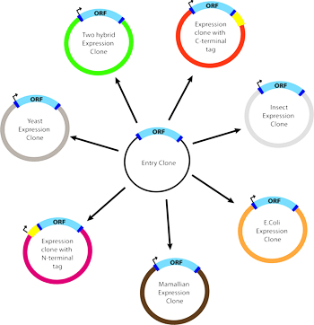

STEPS OF DNA CLONING:
Step 1: Cutting and Pasting of DNA
A restriction enzyme is a DNA-cutting enzyme that recognizes a specific target sequence and cuts DNA into two pieces at or near that site. Many restriction enzymes produce cut ends with short, single-stranded overhangs. If two molecules have matching overhangs, they can base-pair and stick together. However, they won't combine to form an unbroken DNA molecule until they are joined by DNA ligase, which seals gaps in the DNA backbone. We combine the fragments with DNA ligase, which links them to make a recombinant plasmid containing the gene.
Step 2: Bacterial Transformation:
Plasmids and other DNA can be introduced into bacteria, such as the harmless E. coli used in labs, in a process called transformation. During transformation, specially prepared bacterial cells are given a shock (such as high temperature) that encourages them to take up foreign DNA. Plasmids and other DNA can be introduced into bacteria, such as the harmless E. coli used in labs, in a process called transformation. During transformation, specially prepared bacterial cells are given a shock (such as high temperature) that encourages them to take up foreign DNA. acid typically contains an antibiotic resistance gene, which allows bacteria to survive in the presence of a specific antibiotic. Thus, bacteria that took up the plasmid can be selected on nutrient plates containing the antibiotic. Bacteria without a plasmid will die, while bacteria carrying a plasmid can live and reproduce. Each surviving bacterium will give rise to a small, dot-like group, or colony, of identical bacteria that all carry the same plasmid.

Step3: Protein production
Once we have found a bacterial colony with the right plasmid, we can grow a large culture of plasmid-bearing bacteria. Then, we give the bacteria a chemical signal that instructs them to make the target protein.
The bacteria serve as miniature “factories," churning out large amounts of protein. For instance, if our plasmid contained the human insulin gene, the bacteria would start transcribing the gene and translating the mRNA to produce many molecules of human insulin protein.
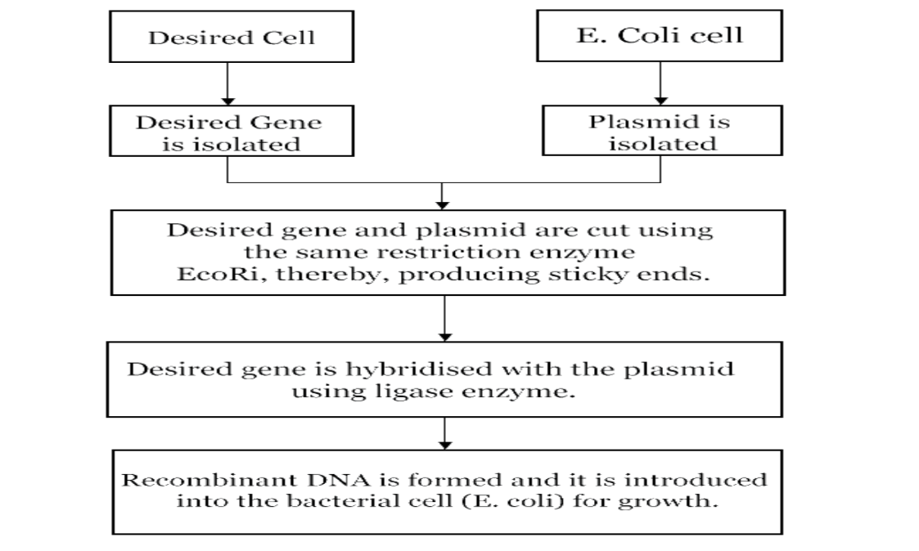
Once the protein has been produced, the bacterial cells can be split open to release it. There are many other proteins and macromolecules floating around in bacteria besides the target protein (e.g., insulin). Because of this, the target protein must be purified, or separated from the other contents of the cells by biochemical techniques. The purified protein can be used for experiments or, in the case of insulin, administered to patients [8].
GENE TRANSFER METHODS:
GENE TRANSFER: The process of introducing a new DNA into a living host cell, by vectors such as plasmids and modified viruses. Cells may be altered ex vivo for subsequent administration to humans, or may be changed in vivo by gene therapy methods.
METHODS OF GENE TRANSFER:
- Electroporation
- Electroporation is a technique mixture containing cells and DNA is exposed to very high voltage electrical pulses for very brief time. It is a method of transformation direct gene transfer.
- Temporary micro pores are formed in cell membranes which allow cells to take up plasmid DNA leading to stable or transient DNA expression.
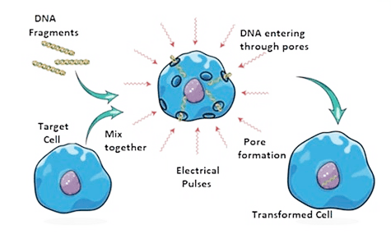

- Microinjection
- Microinjection is a direct mechanical introduce of DNA into the nucleus by using a glass micropaillary injection pipette.
- The process of using a glass micropipette to manually injected transgene at microscopic or borderline macroscopic level is known as microinjection.
- Transformation
- The process of introducing foreign DNA into bacterial cells is known as transformation (e.g., E. coli)
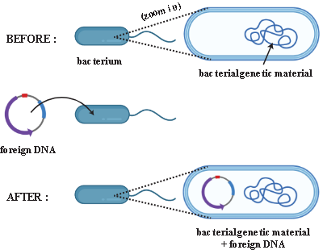

- Transfection
- Transfection is the process by which the foreign DNA is deliberately introduced into a eukaryotic cell through non-viral methods including both chemical and physical methods in the lab.
- Transfection is only done in eukaryotic cell only.

- Transduction
- The transduction process involves inserting genes into the genome of a host cell utilising viruses, as carriers.
- The viruses are used in gene transfer because Viruses’ ability to transfer their nucleic acid into cells. Replication and gene expression at a high level.
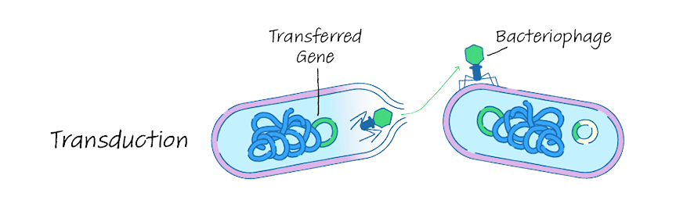

- Bacterial conjugation
- Two living bacteria (a donor and a recipient) come together during conjugation, connect through cytoplasmic bridges, and transmit single-stranded DNA (from donor to recipient).

- Gene gun
- It is usually used to insert the genetic material into the cells by the particles coated into small DNA sequences.
- The gene gun method can also be used to transform cell organelles into the cells such as chloroplast and mitochondria

- Transfer DNA
- Vector

FUTURE TRENDS IN BIOTECHNOLOGY:
The majority of recombinant pharmaceuticals are produced in microbial cells, which means that there are a number of barriers that prevent them from manufacturing functional proteins effectively. These barriers are overcome by making changes to the cellular processes. Posttranslational changes, activated cell stress responses, instability of proteolytic activities, limited solubility, and resistance to the expression of additional genes are typical challenges that must be overcome. Human genetic mutations lead to shortages in the production of proteins, which can be corrected by adding foreign genes to close the gaps and restore levels to normal. Escherichia coli serves as a biological framework for the recombinant DNA technology, enabling the producers to work in controlled ways to technically generate the necessary molecules.By enabling the investigation and manipulation of yeast genes not only in the test tube but also in living yeast cells, recombinant DNA research holds considerable promise for advancing our understanding of yeast biology.
Most notably, it is now possible to get back to yeast through DNA transformation and gene cloning using a number of specially created selectable marker systems. Because of these developments in technology, it is now possible to manipulate and analyze yeast genetic material at the molecular level as well as the traditional genetic level. Recombinant DNA technology has been most successful in solving biological issues whose core difficulty is the structure and organization of individual genes. Recent advancements in recombinant DNA technology have resulted in significant modifications.[11]
Applications
• Recombinant DNA is widely used in biotechnology, medicine and research. The most common use of recombinant DNA is in basic research, and this technology is important for the latest research in bioscience and biomedicine.
• Recombinant DNA is used for gene identification, mapping, sequencing, and determination of their function.
• Recombinant proteins are widely used as reagents for laboratory experiments and for producing antibody probes for studying protein synthesis in cells and organisms.
• Many other practical applications of recombinant DNA can be found in industry, food production, human medicine and veterinary medicine, agriculture and biotechnology. DNA technology is also used to detect the presence of HIV in humans.
• Application of recombinant DNA technology in agriculture- For example the production of Bt Cotton to protect plants from roundworms.

• Drug applications-Insulin production with recombinant DNA technology is a classic example.
• Gene therapy-An attempt to correct a genetic defect that leads to a hereditary disease.
• Clinical diagnosis-ELISA is an example where recombinant DNA can be applied.

Limitations
• Destruction of native species in an environment where genetically modified species have been introduced.
• Elastic plants can lead to elastic weeds that are theoretically difficult to control.
• Mutual contamination and transfer of unique DNA between organisms. Recombinant organisms that pollute the natural environment.
• Recombinants are a population of clones that are just as susceptible.
• A single disease or pest can quickly wipe out the entire population.
• The appearance of super bugs is expected.
• It is exaggerated by fear of the unknown about what technology makes and how it affects civilization. Such systems can result in people having their genetic information stolen and used without permission.
• Many people are concerned about the safety of modifying foods and medicines with recombinant DNA technology.

CONCLUSION:
- Crop and animal biotechnology have advanced thanks to recombinant DNA (rDNA) technologies.
- The potency of rDNA technology stems from our ability to manipulate genes and introduce them into plant and animal cells in order to research and alter gene function.

REFERENCE:
1. Helinski DR. EcoSal Plus. 2022. A Brief History of Plasmids. PMID: 35373578 free article. Review.
Helinski DR. A Brief History of Plasmids. EcoSal Plus. 2022 Dec 15; 10(1):eESP00282021. Doi: 10.1128/ecosalplus.esp-0028-2021. Epub 2022 Apr 4. PMID: 35373578.
2. Cohen S.N., Chang A.C., Boyer H.W., Helling R.B. Construction of biologically functional bacterial plasmids in vitro. Proc Natl Acad Sci, 70(11):3240-4. 1973. [PubMed]
3. Kumar S., Kumar A. Role of genetic engineering in agriculture. Plant Archives. 2015;15:1–6. [Google Scholar]
4. Lomedico P. T. Use of recombinant DNA technology to program eukaryotic cells to synthesize rat proinsulin: a rapid expression assay for cloned genes. Proceedings of the National Academy of Sciences of the United States of America. 1982;79(19):5798–5802. Doi: 10.1073/pnas.79.19.5798. [PMC free article] [PubMed] [CrossRef] [Google Scholar]
5. Galambos L., Sturchio J. L. Pharmaceutical firms and the transition to biotechnology: a study in strategic innovation. Business History Review. 1998;72(2):250–278. Doi: 10.2307/3116278. [CrossRef] [Google Scholar]
6. Steinberg F. M., Raso J. Biotech pharmaceuticals and biotherapy: an overview. Journal of Pharmacy and Pharmaceutical Science. 1998;1(2):48–59. [PubMed] [Google Scholar]
7. Dhillon, Santosh, A. K. Chhabra, and Pushpa Kharb. "Cloning Strategies and Screening of Recombinant DNA Clones." 2007.[GOOGLE SCHOLAR]
8. Maheshwari, Neeraj, et al. "Overview of Gene Cloning Strategies." A Complete Guide to Gene Cloning: From Basic to Advanced. Cham: Springer International Publishing, 2022. 69-78.[Google scholar]
9. Wil A. M. Loenen and others, Type I restriction enzymes and their relatives, Nucleic Acids Research, Volume 42, Issue 1, 1 January 2014[Google scholar]
10. Bhatnagar, Rakesh, Amulya K. Panda, Sonika Bhatnagar, A. K. Chhabra, Santosh Dhillon, A. K. Dubey, and Pushpa Kharb. "Recombinant DNA Technology and Biotechnology." (2017).
11. Suliman Khan, Muhammad Wajid Ullah, Rabeea Siddique, Ghulam Nabi, Sehrish Manan, Muhammad Yousaf, Hongwei Hou, "Role of Recombinant DNA Technology to Improve Life", International Journal of Genomics, vol. 2016, Article ID 2405954, 14 pages, 2016.

