Internet of Things

Practical and Innovative things of IoT and IoT Networks.

Ms.Valluri. Padmapriya
Assistant Professor
Dept. of Computer Science
Bhavan’s Vivekananda College,
Secunderabad, Telangana, India, padmapriya1bvc@gmail.com

Ms. V.Sreeprada
Assistant Professor
Dept. of Computer Science
Bhavan’s Vivekananda College,
Secunderabad, Telangana, India, vsreeprada21@gmail.com

Ms. Bhavana Chintalapudi
Dept. of Computer Science
Bhavan’s Vivekananda College,
Secunderabad, Telangana, India
bhavana2004.ch@gmail.com

ABSTRACT
The Internet of Things (IoT) has evolved from a theoretical concept to a reality that is changing the way we live. The practical and innovative aspects of IoT applications are explored in this abstract.The world of IoT, or Internet of Things, brings both practical convenience and exciting innovation to our lives. On the practical side, everyday items like thermostats and lights can be controlled with a tap on our phones, making homes smarter and more comfortable. But IoT doesn't stop there – it's also about thinking big and creating new things. Imagine cities becoming super smart, managing traffic and energy in clever ways. Or think about wearable gadgets that track your heart rate and sleep, helping you stay healthy. So, IoT is all about making life easier in simple ways and dreaming up amazing new possibilities for the future.
We also discussed the Overviews of all the applications of Practical and Innovative things of IoT and IoT Networks.

IOT (INTERNET OF THINGS)
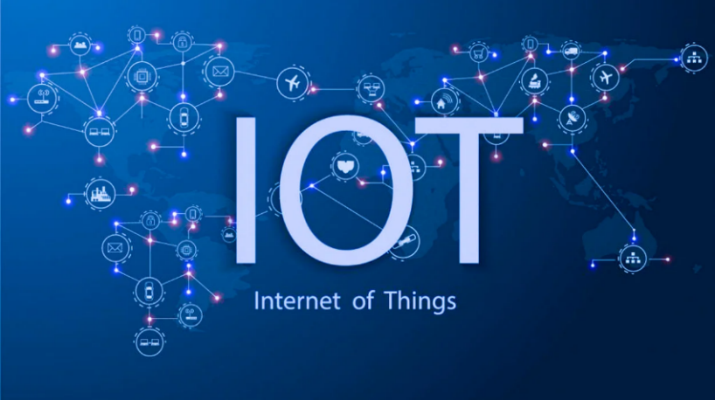
The "Internet of Things" or IoT, is a concept in which commonplace items are connected to the internet and are capable of communicating with one another. These things, which can include wearable fitness trackers, smart thermostats, and even home appliances, collect and exchange data to improve the comfort and effectiveness of our lives.
IoT, to put it simply, is the process of fusing the physical and digital worlds to create a smarter, more interconnected world.
For Example: A wearable fitness tracker can monitor your activities and communicate the data to your smartphone, while a smart thermostat can adjust the temperature in your home based on your preferences and the outside temperature.
Characteristics of IoT
- Sensing and Information Gathering
Sensors on IoT devices collect a variety of data, including temperature, humidity, location, motion, and more. Devices may gather information about their environment in real time thanks to these sensors.
- Remote Administration and Control
Through the internet, IoT devices may be remotely managed and seen. This implies that you can use a smartphone, computer, or other connected device to make settings changes, get updates, and gather data from these devices.
- Analytical Processing of Data
IoT devices frequently send the data they collect to cloud servers for processing and analysis. This makes it possible to glean important trends, patterns, and insights from the gathered data, which may subsequently be applied to decision-making.
- Security and Privacy
Because IoT devices frequently handle sensitive data, security and privacy must be prioritized. Protecting both the devices and the data they collect and transmit requires the implementation of robust security mechanisms.

IOT NETWORKS
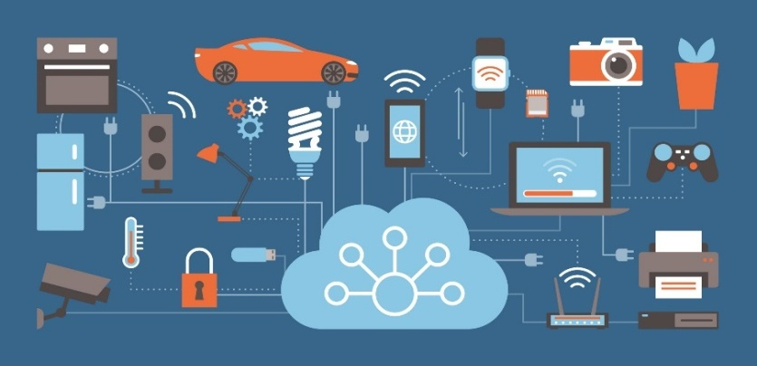
Connecting the Future with IoT Networks
IoT networks resemble a large collection of connected devices that communicate with one another online. They have a unique method of communicating, and they assist these gadgets in exchanging crucial information to improve operations and simplify our lives.
To enable smooth interaction, these networks make use of a variety of communication technologies, including Wi-Fi, Bluetooth, and specialized low-power choices. This network is made up of objects with tiny radios that enable them to communicate, receive commands, and collaborate intelligently.
Comprehensive overview of IoT networks:
{1} Diversity of Network Technologies:
IoT networks are made up of a variety of wireless communication technologies, many of which were created to address certain use cases, ranges, data speeds, and power needs. Wi-Fi, cellular (4G/5G), Bluetoothand other popular IoT network technologies are only a few examples.

{2} Wireless Connectivity:
IoT networks do not require physical connected connections, allowing for the placement of devices in a variety of locations. For scenarios including mobility, remote monitoring, and dynamic sensor placements, wireless communication is essential.

{3} Range and Coverage:
The coverage areas provided by various IoT network technologies differ. While Lora WAN and Zigbee are useful for building local area networks that cover a narrow area, cellular networks can offer extensive global coverage.
{4} Power Efficiency:
To ensure long-lasting performance, many IoT devices are battery-powered or require energy-efficient operation.

{5} Data Throughput:
To support varied applications, IoT networks provide a range ofdata rates. Low-power networks like Sigfox are made for sporadic, low-data-rate applications, but cellular networks offer high data throughput appropriate for video streaming and real-time communication.

Their significance stems from their capacity to harness connectivity's power, enabling the information interchange that fosters productivity, creativity, and a higher standard of living. IoT networks give businesses the ability to remotely monitor and manage operations, anticipate maintenance requirements, and maximize resource use. By utilizing networked infrastructure, efficient energy use, and responsive services, they enable smart cities to improve urban living.
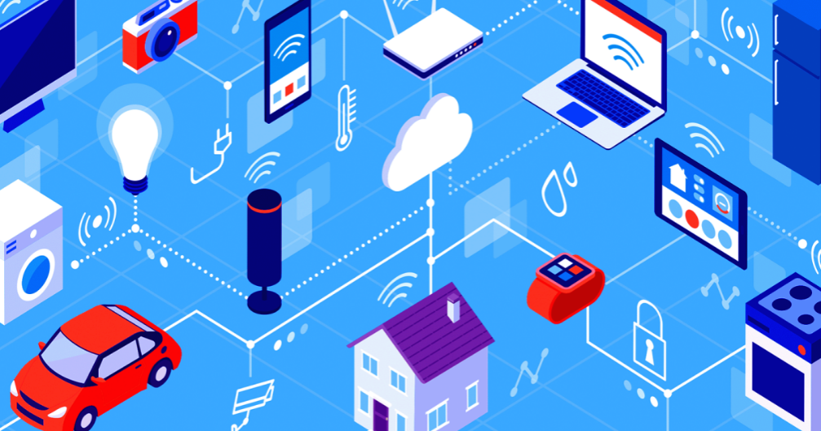

In a word, IoT networks enable our devices to cooperate, improving the convenience and effectiveness of our lives.
PRACTICAL AND INNOVATIVE APPLICATIONS OF IoT
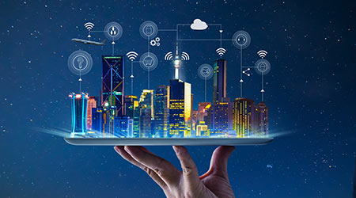
Internet of Things (IoT) Practical Applications are real-world uses and applications of IoT technology that provide concrete benefits and address common issues. In numerous industries and facets of daily life, these applications concentrate on enhancing efficiency, ease, and effectiveness. Optimizing current processes, improving user experiences, and streamlining operations are frequent components of practical IoT applications. Wearable health monitors, industrial automation, smart homes, and energy management systems are a few examples.
Internet of Things (IoT) Innovative IoT applications: Creative applications for the IoT make use of Internet of Things technology in fresh and inventive ways to solve new problems or open up brand-new opportunities. These applications introduce novel ideas that could have never been considered before, pushing the limits of what the IoT can accomplish. Innovative IoT applications can result in ground-breaking breakthroughs in a variety of industries and frequently call for innovative problem-solving. Examples include deploying IoT-driven solutions for environmental monitoring and sustainability, creating smart cities with cutting-edge urban planning, and leveraging IoT for animal conservation.
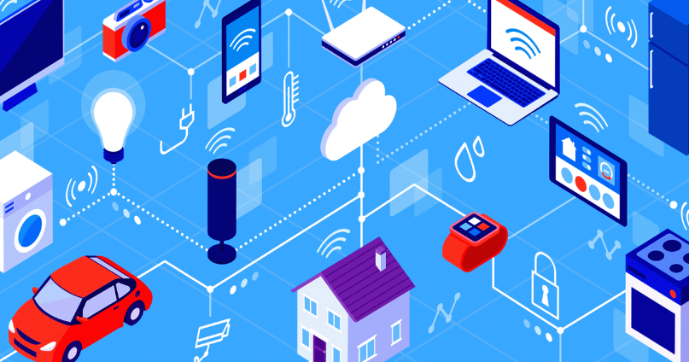
Applications which are PRACTICAL and INNOVATIVE contribute to the IoT's ever-expanding ecosystem by reshaping industries, improving quality of life, and advancing technology.
SMART CITITES
Smart cities represent a transformative application of Internet of Things (IoT) technology that aims to enhance urban living through data-driven solutions and improved infrastructure. In a smart city, various aspects of urban life are interconnected and optimized using IoT devices and data analytics.
An overview of smart cities within the IoT is provided below:
- Infrastructure and utilities:
IoT-enabled sensors and devices keep an eye on and manage vital infrastructure, including waste management, energy use, and water supply. In order to maximize resource efficiency and minimize environmental effect, smart grids distribute energy more efficiently, water sensors find leaks, and garbage bins alert users when they need to be emptied
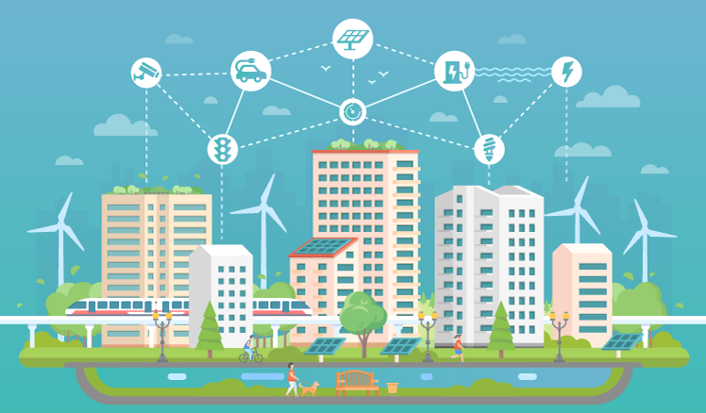

- Mobility & Transportation:
IoT makes linked vehicles and traffic infrastructure more efficient by giving real-time traffic data, streamlining the routes of public transportation, managing parking spaces with the use of smart sensors, and managing parking spots.

- Urban Planning and Management:
IoT sensor data may provide city planners with information on usage trends, population density, and other elements that affect urban growth. This knowledge supports the creation of more functional and habitable spaces, which supports sustainable development.

- Sustainability and environmental monitoring:
IoT devices keep an eye on noise levels, air quality, and other environmental aspects to promote a healthier and more sustainable urban environment. Better resource management and pollution prevention may result from data-driven insights.

- Public Safety and Security:
IoT technologies enable smart surveillance cameras, emergency response systems, and criminal prediction algorithms, enhancing public safety and security. Connected sensors can identify unexpected occurrences or patterns, allowing emergency services to react more quickly.

- Economic growth:
Smart cities encourage innovation and commercial growth by providing a friendly environment for IT firms and startups. IoT infrastructure's accessibility promotes the development of new products and services.

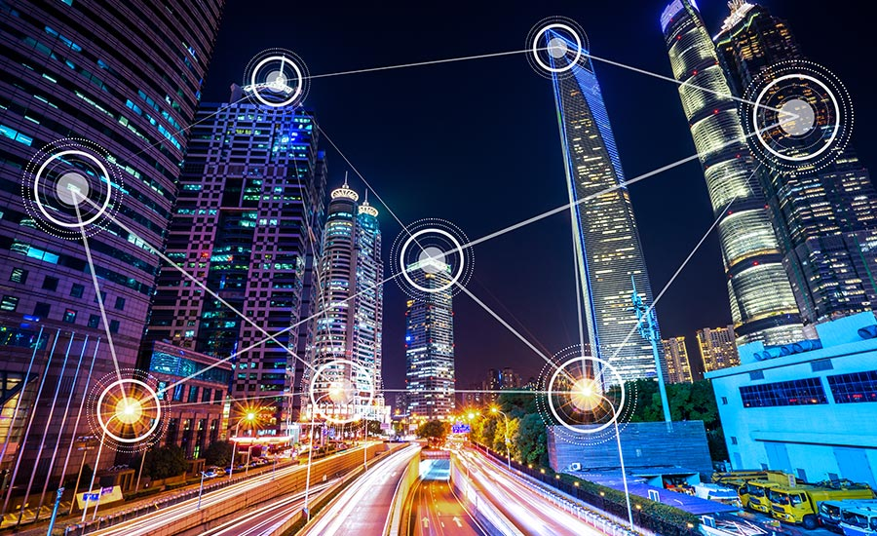

In conclusion, the idea of "smart cities" shows how Internet of Things (IoT) technology may enhance urban life by building more effective, sustainable, and interconnected urban environments. In order to address urban concerns, improve citizen experiences, and build the groundwork for future urban development, it makes use of data and technology.

SMART MOBILITY
The term "smart mobility" refers to a concept within the Internet of Things (IoT) that focuses on leveraging technology to make urban mobility and transit more pleasant, efficient, and sustainable. In order to enhance many aspects of transportation systems, IoT devices, data analytics, and connectivity are used.

An overview of smart mobility within the IoT is provided below:
- Sustainability and reduced emissions:
Smart mobility solutions promote the use of electric vehicles and other forms of alternate transportation, which helps to lower emissions and improve air quality in metropolitan areas.

- Accessibility and Inclusivity:
IoT systems can give people with disabilities access to real-time information on accessible routes and transport options, enabling a more inclusive and fair mobility experience.

- Real-time traffic management:
It involves gathering information on traffic flow, congestion, and road conditions in real time using IoT-enabled sensors and cameras. In order to reduce travel times and congestion, this data is analyzed to improvetraffic signals, redirect cars, and give drivers precise navigational information.

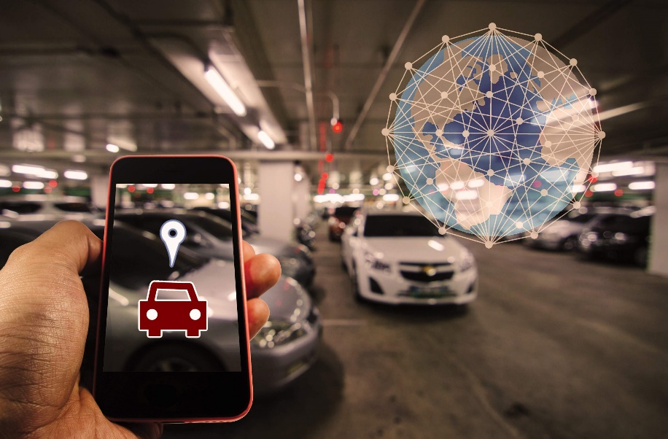

- Public Transportation Optimization:
IoT devices track the movement of buses, trains, and other types of public transportation as part of public transportation optimization. This data can be utilized to optimize routes, give passengers precise arrival times, and raise the general effectiveness of public transportation systems.

- Last-Mile Solutions:
Micro-mobility solutions driven by the Internet of Things, such as e-scooters and bike-sharing programs, offer practical substitutes for short distances, decreasing the need for personal vehicles for such excursions.

- Connected Vehicles:
Vehicles that are connected to the internet of things (IoT) can exchange data about position, speed, and road conditions with other vehicles and infrastructure. This makes it possible for features like coordinated traffic flow, adaptive cruise control, and collision avoidance.

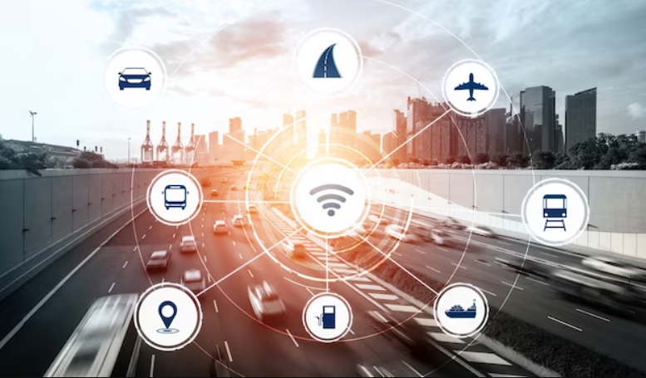
In essenceIoT technology is essentially used by smart mobility to build a more connected and effective transportation ecosystem. While tackling issues like traffic congestion, air pollution, and the overall sustainability of urban transportation systems, it seeks to improve how people move around cities.

SMART HOME
A smart home is a place of residence that has Internet of Things (IoT) technology installed, enabling various appliances and gadgets to interact and communicate with one another online. A smart home aims to improve comfort, security, efficiency, and convenience by providing control and automation through linked devices.

An overview of smart home within the IoT is provided below:
- Home automation:
Smart homes have automation features that let you plan chores or set off events based on predetermined circumstances. For instance, you could arrange your thermostat to change the temperature while you're away or set your lights to switch on and off at predetermined intervals.

- Connectivity:
Internet-enabled IoT gadgets in a smart home communicate with one another and with you. Using smartphones, tablets, or PCs, you may use this connectivity to remotely operate and monitor your house from any location.

- Voice Assistants:
Many smart homes feature voice assistants like Apple Siri, Google Assistant, or Amazon Alexa. You may provide commands and control devices with these helpers by speaking naturally.

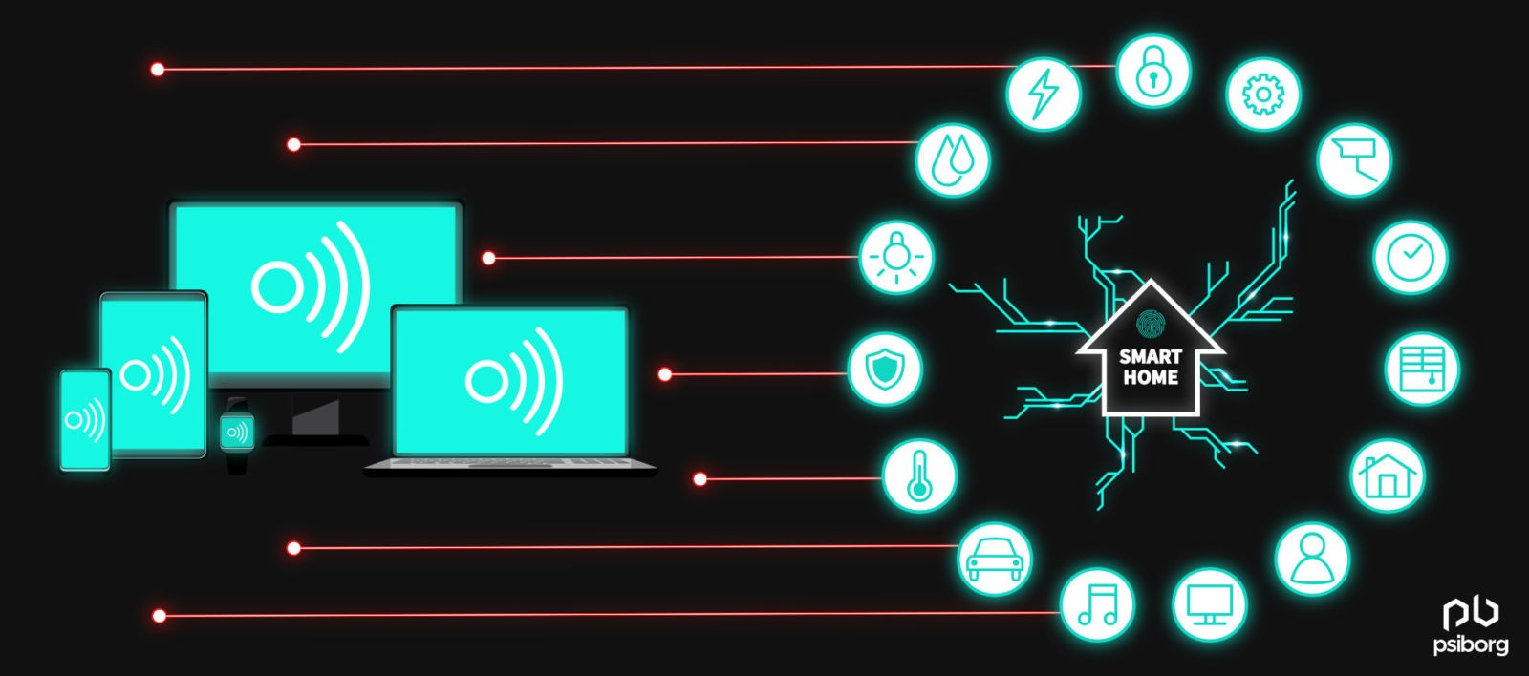

- Lighting Control:
With the help of smart lighting systems, you may alter the brightness, color, and timing of your lights. To accommodate diverse activities and times of the day, you can design numerous moods and scenarios.

- Energy Efficiency:
Smart homes put a strong emphasis on energy efficiency by providing features like programmable thermostats that change temperatures according to your preferences and occupancy patterns. You may check your usage with the aid of energy monitoring tools and pinpoint areas that need improvement.

- ComfortandConvenience:
Smart homes put an emphasis on comfort by enabling you to operate equipment with a single tap or voice command. Before you come home, you can set your bathtub to fill with a certain degree of water, adjust your blinds, start your coffee machine, and more.

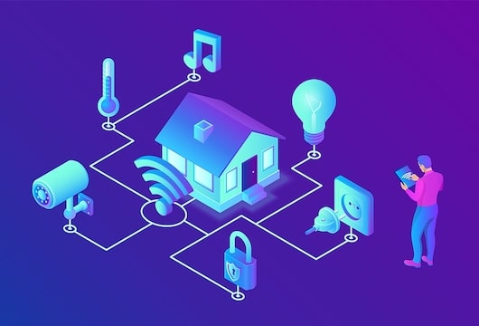
In conclusion, a smart home employs IoT technology to build a linked ecosystem of gadgets that improve daily life. Through your smartphone or other connected devices, these technologies cooperate to offer automation, security, energy savings, and personalized experiences.
SMART HEALTH
A Smart health in the context of the Internet of Things (IoT) refers to the integration of technology and connected devices into healthcare and wellness practices. It involves using IoT devices to gather health-related data, monitor patients remotely, and provide personalized insights and interventions.
An overview of smart health within the IoT is provided below:
- Wearable Technology:
IoT-powered wearable technology can track vital indications like heart rate, activity levels, sleep patterns, and more. Examples include smartwatches, fitness trackers, and health monitors. Users can receive real-time feedback on their health via these devices, and they can also exchange data with medical specialists for more thorough monitoring.

- Remote Patient Monitoring:
IoT technology enables the remote monitoring of patients with chronic conditions or those recovering from surgeries. Patients can use connected devices to track their health status at home, and healthcare providers can receive real-time updates to intervene if needed.

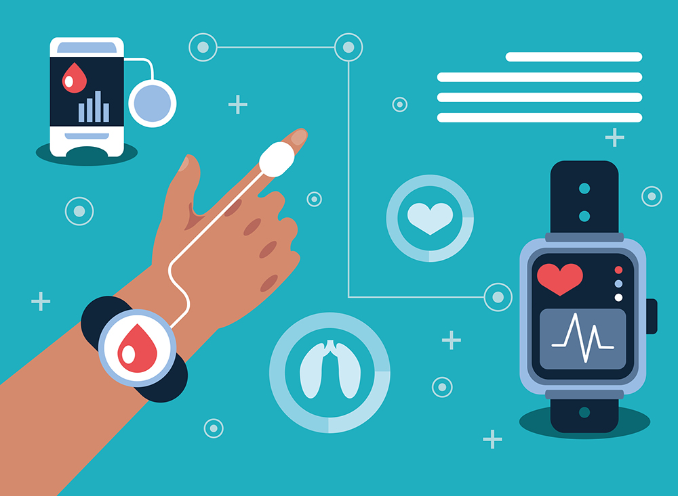

- Fitness and Wellness Coaching:
Based on specific goals and medical circumstances, smart health applications can provide individualized fitness and wellness coaching. These apps direct users through workout regimens, diet plans, and stress reduction strategies.

- Telemedicine and Virtual Consultations:
Telehealth appointments are made possible by IoT-enabled gadgets, enabling patients to consult with medical professionals virtually. During these virtual visits, connected equipment can communicate real-time medical data, such as digital stethoscopes and otoscopes.

- Data Sharing with Healthcare Professionals:
Patients can give their healthcare practitioners access to the health information they have obtained via IoT devices. Doctors can use this information to make more informed diagnosis and treatment choices.

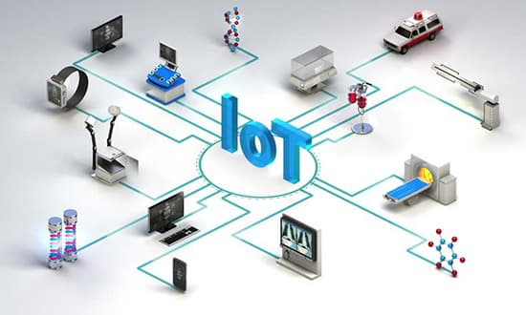
In essence, smart health makes use of IoT to improve accessibility, effectiveness, and patient-centeredness in healthcare. Smart health solutions have the potential to promote patient participation, improve health outcomes, and change the way healthcare is provided because they allow for continuous monitoring, individualized insights, and remote treatments.
SMART GRID
An upgraded electrical distribution system known as a "smart grid" uses Internet of Things (IoT) technology to modernize and optimize the production, transmission, and use of electricity. It makes use of data analytics and digital communication to boost the effectiveness, dependability, and sustainability of electrical power systems.
An overview of smart grid within the IoT is provided below:
- Two-Way Communication:
IoT devices make it possible for the electrical grid's various parts to communicate with each other in both directions. This makes it possible for power producing sources, substations, distribution networks, and end-user devices to all communicate information in real time.

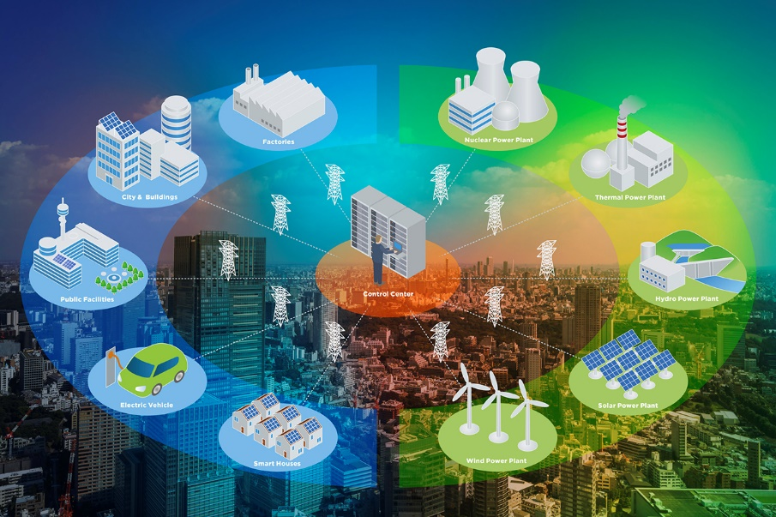

- Distributed Energy Resources (DERs):
To manage energy from diverse distributed sources including solar panels, wind turbines, and battery storage, smart grids utilize IoT technologies. Coordination of these resources can improve grid stability and effectiveness.

- Grid Resilience and Reliability:
IoT devices continuously monitor grid conditions, spotting faults, outages, and possible disruptions. This improves grid resilience and reliability. This facilitates a shorter response time and speedier service restoration, improving grid resilience.

- Grid Modernization:
Modernizing the grid involves replacing outdated analogue systems with digital ones that are more flexible, scalable, and adaptable to shifting energy needs and technology improvements.

- Load balancing and optimization:
IoT technology makes it possible to balance load in real time across several grid segments. Demand-based electricity distribution can be changed, relieving pressure on particular grid segments.
- Predictive Maintenance:
IoT sensors are used by smart grids to monitor the state of grid components and forecast when repair is required. Downtime and maintenance expenses are decreased by this proactive strategy.

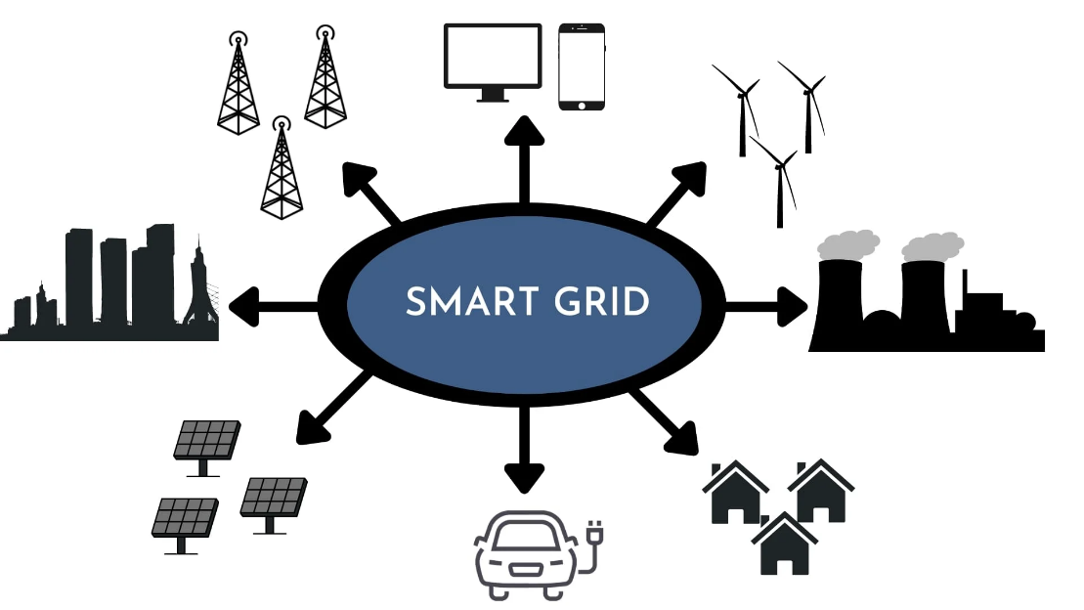
In essence, by incorporating IoT devices and data analytics, a smart grid reflects the progression of conventional power distribution systems. It improves the efficiency, sustainability, and dependability of energy delivery, laying the groundwork for a more adaptable and reliable electrical infrastructure.

CONCLUSION:
In conclusion, the practical and innovative applications of IoT have ushered in a transformative era, redefining the way we interact with technology and the world around us. Through practical applications, IoT has seamlessly integrated into our daily lives, enhancing convenience, efficiency, and comfort. From smart homes that adapt to our preferences to healthcare devices that monitor our well-being, IoT has become an integral part of modern living.

REFERENCES:
[1].Harvard University: https://hbsp.harvard.edu/product/I0052E-HTM-ENG
[2].Science Soft site [Online] https://www.scnsoft.com/blog/iot-for-smart-city-use-cases-approaches-outcomes
[3].https://www.simplilearn.com/internet-of-things-iot-projects-article.
[4].https://www.fracttal.com/en/blog/the-9-most-important-applications-of-the-internet-of-things
[5].S. B. Bakerand I. Atkinson, “Internet of things for smart healthcare: Technologies, challenges, and opportunities”
[6]. Precision: Principles, Practices and Solutions for the Internet of Things By Timothy Chou

