Application of Polyethylene glycol (PEG) as an additive in Drilling Fluids in oil and gas industries
Ananya Dutta ¹, Leema Deori ¹, Supriya Deori ¹, Barkha Saikia ², Gargi Ananya Boruah ²,
Chayanika Bora ^{2*}, Borkha Mech¹

¹ Department of Petroleum Technology, Dibrugarh University, Dibrugarh, Assam, India
² Department of Petroleum Engineering, Dibrugarh University, Dibrugarh, Assam, India

Abstract
The purpose of this study is to develop an experimental method by adding polyethylene glycol (PEG) in drilling mud to form an environment friendly drilling fluid, to measure the rheological properties, filtration properties and density of a drilling mud by using Fann VG Meter, Dead Weight Filter Press and Mud Balance respectively and finally to prepare an optimum drilling fluid by analysing different samples made with different molecular weight of PEG. The results show that PEG can reduce the filtration loss and also reduce the maintenance cost of the drilling fluid.

Keywords- Polyethylene Glycol (PEG), Rheology, Environment Friendly Drilling Fluid Additive, Lubrication Performance, Sloughing, Oil-Based Drilling Mud, Environmental Pollution
- Introduction
In order to reduce the negative impact, environment friendly drilling fluid additives are used in drilling operations. The oil-based drilling mud has strong inhibition and high lubricity, which can effectively prevent sloughing and sticking. However, environmental pollution, affecting logging quality, and high cost are also its disadvantages. The water-based drilling mud does not have these problems, but the poor lubrication performance and high friction have restricted its development. Therefore, improving the lubrication performance of the water drilling mud has great significance in solving the above problems.

  - Introduction on Drilling fluid and its application in oil industry

Drilling fluid helps stabilize the wellbore by exerting hydrostatic pressure against the formation walls. This prevents the collapse of the wellbore and maintains its integrity during drilling. Drilled cuttings produced during drilling are transported to the surface by drilling fluid. The drill bit and the bottom hole assembly are cooled with the aid of drilling fluid. Additionally, it lubricates, which lessens damage to the drilling machinery.
In order to help stop fluid loss into the formation, drilling fluid creates a filter cake on the wellbore wall. Geologists and petrophysicists can examine formation cuttings brought to the surface by drilling fluid to learn more about the subsurface formations, including their rock type, porosity, permeability, and hydrocarbon content. Drilling fluid may occasionally be used during hydraulic fracturing procedures to move proppants (such as sand) into the fractures and preserve wellbore stability while fracturing. For well control and kick prevention, drilling fluid is necessary. Kicks, or influxes of formation fluids, can happen during drilling and can be detected and controlled with the right monitoring and management of drilling fluid parameters, such as density and pressure.

1.2. Polyethylene Glycol and its importance as an additive:
PEG is a polyol and its molecular diversity dictates the variety of compounds it can produce. It is extremely helpful in oil drilling because it has strong lubricating performance in addition to good shale inhibition performance. It has basic drilling mud buffer capacity in addition to lubricating and antifriction capabilities.
PEGs are prepared by polymerization of ethylene oxide and are commercially available over a wide range of molecular weights from 300 g/mol to 20,000 g/mol. PEGs are liquids or low melting solids, depending on their molecular weights. Ethylene oxide macromolecule with molecular weights less than 20,000 g/mol are called PEG, and those having values above 20,000 g/mol are named PEO(refers to an oligomer).
PEG, as a treatment agent is found to be environmentally safe and biodegradable and fully complies with the development idea of water-based drilling mud. PEG being a water-soluble polymer has set foot as a promising hydrate-inhibitive water-based drilling fluids. PEG is found to be a good thermodynamic hydrate inhibitor, and are less toxic and easily biodegradable[13][14][15]. It has been found that PEG reduces filtration loss and also reduce the maintenance cost. Apart from the filtrate loss reduction, the addition of PEG also helps in improving the viscosity and density a bit. An ideal drilling fluid is the one which shows less filtrate loss and forms a thin and tough mud cake [3]. In a study, the effect of PEG has been determined by analysing the rheological and filtration properties of drilling fluid with varied concentrations of PEG, and they have found that with the addition of varying concentrations of PEG it shows almost negligible effects in the change in mud density. PEG results in improving the viscosity of the drilling fluid. They have proved in their experiment that PEG4000 can be used as an active fluid loss–reducing agent and it can contribute to wellbore stability by forming thin and tough mud cakes which will also prevent pipe sticking.
1.3. Objective of the work
The aim of the project work is to devise an experimental method by adding polyethylene glycol in bentonite based mud to form an environment friendly drilling fluid, to measure the rheological properties, filtration properties and density of an environment friendly drilling mud by using Fann VG Meter, Dead Weight Filter Press and Mud Balance respectively and finally to prepare an optimum drilling fluid by analysing different samples made with different molecular weight of poly ethylene glycol.

2. Experimental Analysis
2.1. Apparatus and Chemicals used:
The following apparatus and chemicals are employed in the experimental procedure.
2.1.1. Hamilton Beach Mixer
The Hamilton beach mixer was used in this study for drilling fluid mixing. It was used to shear water and other mud additives mechanically to produce a consistent drilling mud. The Hamilton beach mixer are of two types namely, single and three-Speed Models. The three-speed model was used in this study. The low speed is 10,000rpm. The medium speed is 14,000rpm while the high speed is 17,000rpm. [6]
2.1.2. Mud balance
Mud balance is a measuring device used to determine the density of drilling fluid. It consists of a constant volume balance cup and lid connected to balance arm that has four graduated scales. On one side scales for measuring density in pound/gallon (LB/GAL) and specific gravity in gm/cc. on the other side are scales for measuring pounds per cubic feet (LBS/CU.FT) and pounds per square inch per 1000feet of depth(LBS/SQ.IN/1000FT). [6]
2.1.3. Fann VG meter
It is an instrument used to measure viscosity and gel strength of drilling mud. The direct-indicating viscometer is a rotational cylinder and bob instrument. It is a type of rheometer, which runs at much speed, which can be selectable. A rheometer is a laboratory device used to measure the way in which a liquid, suspension or slurry flows in response to applied force. It is used for those fluids which cannot be defined by a single value of viscosity and therefore required more parameter to be set and measured than in case of the viscometer. It measures the rheological properties of the fluid.
2.1.4. Scientific Weighing Scale
One of the most crucial tools in the lab are scientific weight scales. They are employed to calculate the mass and weight of a wide variety of solids, liquids, and powders. Weight is determined by the force applied to the load cell of weighing scales and balances. They then translate the outcome into mass and present it in several mass units.
2.1.5. pH Meter
In order to determine whether a solution is acidic or alkaline and express that information as pH, a pH metre detects the hydrogen-ion activity in water-based solutions. The pH metre is frequently referred to as a "potentiometric pH metre" since it detects the difference in electrical potential between a pH electrode and a reference electrode.
2.1.6. Calcium Carbonate
Calcium carbonate is the inorganic chemical substance with a chemical formula CaCO₃. It is present in the earth's crust.. The crust of the earth contains it. There are numerous other types of it as well, such as marbles, limestone, etc. A well-known non-toxic and odourless chemical is calcium carbonate, a white mineral that occurs naturally in limestones, chalks, marbles, and pearls. Calcium carbonate serves as a weighing component in this drilling mud.
2.1.7. Sodium Hydroxide
At room temperature, sodium oxide is typically found as a white solid and is one of the inorganic substances. Sodium Na+ cations and hydroxide OH anions make up this chemical combination. It functions in the drilling mud as a pH-controlling substance. As a result of the addition of a pH-regulating agent (NaOH) to the mud, we then evaluated the pH of each sample and discovered that it was kept between the range of 7-8.
2.1.8. Xanthan Gum
In the oil industry, xanthan gum is used in large quantities to thicken drilling mud. These fluids carry the solids cut by the drilling bit to the surface. Xanthan gum provides great "low end" rheology. When circulation stops, the solids remain suspended in the drilling fluid. The widespread use of horizontal drilling and the demand for good control of drilled solids has led to its expanded use. It has been added to concrete poured underwater, to increase its viscosity and prevent washout.[20]
2.1.9. Bentonite
Bentonite is naturally occurring industrial rock, characterized by the property of absorbing water and by capacity for base exchange; both properties are significantly greater than that of plastic clays and kaolin; in certain bentonites water absorption is accompanied by a considerable increase in volume and formation of gelatinous mass. [20] Montmorillonite group of clays have great power to absorb moisture, especially the sodium bentonite.
2.1.10. Polyethylene Glycol (PEG)
Polyethylene glycol (PEG) is a polyether compound derived from petroleum with many applications, from industrial manufacturing to medicine. PEG is also known as polyethylene oxide (PEO) or polyoxyethylene (POE), depending on its molecular weight. The structure of PEG is commonly expressed as H−(O−CH2−CH2)n−OH. Poly ethylene glycol (PEG), a water-soluble polymer, has been widely used as the most promising polymer for designing hydrate inhibitive water-based drilling fluids.

2.2. Methods employed
2.2.1. Formulation of drilling fluid:
In this study, samples of base muds with bentonite were prepared. To the base muds calcium carbonate, xanthan gum, sodium hydroxide and different concentrations of polyethylene glycol (PEG) was added. The amounts of PEG used in this experiment were 0 gm (base muds), 1 gm, 2.5gm, 4 gm and 5gm. Also PEG of three different molecular weight, which are 200, 600 and 4000 were used. So, a total of 13 samples were prepared.
Firstly, the base mud is prepared by adding 10 gm of bentonite in 500ml of distilled water. The distilled water was poured into a beaker and the bentonite was mixed in the distilled water with the help of a stirrer. Then 10 gm of calcium carbonate, 1 gm of xanthan gum, 1 gm of sodium hydroxide was added to the prepared base mud. After that the mud was firmly mixed by the stand mixer, that is, Hamilton beach mixer for about 10 to 15 min. Then a minimum soaking time of about 8 hours was given to the mud with hand stirring from time to time.
2.2.2. Study on Density Behaviour:
After formulation of the mud, it is followed by measuring the density of the mud in mud balance.
Firstly, the base stand or carrying case is placed on a flat, level surface. After measuring and recording the temperature of the collected sample, it is transferred to the mud balance cup. Tapping the side of the mud balance cup gently with the cup’s lid will break out any trapped air or gas. Placing the lid on the mud balance cup with a twisting motion and making sure some of the test sample is expelled through the lid’s vent hole. Sealing the vent hole with a finger and cleaning the balance with water, base oil, or solvent. After that any excess water, base oil, or solvent is wiped off. The knife edge of the balance into the fulcrum is fitted and the assembly is balanced by moving the rider along the arm. The balance is level when the line on the sight glass is centred across the bubble. The density from the side of the rider nearest the balance cup (the arrow on the rider points to this side) is recorded. Measurement to the nearest 0.1 lb/gal, 1 lb/ft3, 0.01 g/cm3, or 10.0 lb/in2/1,000 ft is reported.
2.2.3. Rheological analysis:
Rheological properties (plastic viscosity, yield point and gel strength) are measured in a Fann VG meter.
Firstly, the given fluid is placed in the cup followed by agitation. Then the housing is lowered to its normal position once the cup is located underneath the sleeves (the pin in the bottom of the cup fits into the holes in the base of the plate).The cup is then elevated using the nearby support and secured to the scribe line while it is immersed in the rotating cylinder in the sample. Then the desired rpm, time, and temperature is set before turning on the machine. The sample is then stirred and watched for a stable dial reading. Dial readings for both 300 and 600 rpm are then recorded.
2.2.4. Filtration analysis
A dead-weight filter press is used to determine the mud cake thickness, initial or the spurt loss and the filtration loss. The nut is taken out from the top and the piston from the cylinder is removed. The piston is then placed into the weight's bottom so that the threads stick out from the top hole. The nut is tightened onto the piston to hold it in place. Any wear or damage is checked for on the o-ring in the top of the cylinder. If necessary, it is replaced with a fresh o-ring. Piston is positioned at the bottom of the cylinder by sliding it downward. O-ring at the top of the cylinder needs to be lubricated on occasion. When using the device for the first time and on a regular basis after that, some instructions need to be followed. The cell should be clean and dry, before beginning a test, particularly the screen. The gaskets are examined for distortion and wear. The water reservoir is filled to the top with clean, fresh water. The bleed-off valve is opened. The weight to the top of the cylinder is raised and released, allowing it to travel a full stroke. The reservoir is refilled with clean, fresh water. The bleed-off valve is closed. The unit is now ready for operation. Before beginning a test, the mud sample’s first temperature data is recorded for further examination. It is started by turning the base cap inside-out and inserting a rubber gasket to assemble the test cell. After that, the screen, one sheet of filter paper, and one more gasket is added. The cell body should then be inserted and tightened into the base cap. The freshly stirred sample fluid should be poured into the cell, leaving a 0.5" (13 mm) space at the top. The top cap should have a rubber gasket inside it. Ensuring that it is completely seated around the cap. After that, the cell's body is covered with the top cap and the entire thing is inserted into the frame. Utilise the T-screw for securing the cell. Place a clean, dry graduated cylinder below the filtrate tube, connecting the line going from the dead-weight hydraulic pressure source to the inlet valve on the top cap. The reservoir is filled on the dead-weight hydraulic assembly with clean, fresh water. Caution must be observed to close the bleeder valve before pressurising the cell. The dead weight should be raised about a foot, then left to rest. In nearly two-thirds of a stroke, the pressure gauge will register 100 PSI (689.5 kPa). The dead weight is brought back to the stroke's top. The test's timing should get underway straight now. One piston stroke will allow for a maximum filtration loss of around 30 mL. The amount of filtrate that has accumulated after 30 minutes is measured. The flow from the pressure source is shut off. To the closest centimetre, the filtrate volume is recorded that was gathered 1 cm3. "API Filtrate" for this value is indicate. The duration and the mud's initial temperature is noted. For chemical analysis, the filtrate is saved. The bleed-off valve is opened to release the pressure on the filter press cell at the conclusion of the test. Verify that the cell has completely lost all pressure. The cell is disassembled by removing it from the frame. Away any leftover muck is thrown. The cake that was dropped and the filter paper is carefully stored. With a soft stream of water, the surplus filter cake on the paper is rinsed. Instead of using water to clean the filter cake when testing oil mud, diesel oil is used. The filter cake's thickness to the nearest 1/32" (0.8 mm) is calculated and noted. Typically, cakes with a thickness of no more than 2/32" are appropriate. The cake's characteristics, such as its firmness, flexibility, sponginess, slickness, rubberiness, and toughness is kept track of. The test cell after each test is disassembled, then all surfaces is scrubbed with soap and water. Before storing the device, it is ensured that all of the parts are dry and clean.

- Results and Discussions
After conducting all the experiments for checking parameters like rheological properties, filtration properties and density, the following results were obtained:

BENTONITE BASE MUD PROPERTIES
Density | 8.4 ppg
Plastic Viscosity | 2.544 cP
Yield point | 3.523
Gel 0 | 1.957
Gel 10 | 2.74
Filtration Properties:

Initial loss | 3 ml
Filtrate loss | 21.8 ml
Mud Cake thickness | 0.19 m

BENTONITE BASE MUD FOR PEG 200 MOLECULAR WEIGHT

PEG Concentration | Density (ppg) | Plastic  Viscosity  (cP) | Yield Point | Gel 0 | Gel 10 | Filtration Property
 |  |  |  |  |  | Initial loss (mL) | Filtration (mL) | Mud cake thickness (mm)
1 gm | 8.4 | 2.86 | 3.76 | 2.23 | 2.86 | 1.3 | 20.4 | 0.18
2.5gm | 8.4 | 3.12 | 3.98 | 2.43 | 2.96 | 0.7 | 18.8 | 0.18
4gm | 8.5 | 3.21 | 4.23 | 2.65 | 3.131 | 1.4 | 16.5 | 0.18
5 gm | 8.5 | 3.327 | 4.46 | 2.87 | 3.323 | 2.6 | 15 | 0.17
Table 1: Various properties of Bentonite mud with increasing concentration of PEG (Molecular weight 200) as an additive.

BENTONITE BASE MUD FOR PEG 600 MOLECULAR WEIGHT

PEG Concentration | Density (ppg) | Plastic Viscosity (cP) | Yield Point | Gel 0 | Gel 10 | Filtration Property
 |  |  |  |  |  | Initial loss (mL) | Filtration (mL) | Mud cake thickness (mm)
1 gm | 8.4 | 3.584 | 3.80 | 2.56 | 2.73 | 1.6 | 19.8 | 0.17
2.5gm | 8.4 | 3.635 | 4.24 | 2.74 | 2.948 | 2.2 | 17.6 | 0.17
4gm | 8.5 | 4.57 | 4.40 | 2.74 | 3.131 | 0 | 15.8 | 0.16
5 gm | 8.5 | 5.678 | 4.87 | 2.98 | 3.23 | 1.4 | 14.4 | 0.15
Table 2: Various properties of Bentonite mud with increasing concentration of PEG (Molecular weight 600) as an additive.

BENTONITE BASE MUD FOR PEG 4000 MOLECULAR WEIGHT

PEG Concentration | Density (ppg) | Plastic Viscosity (cP) | Yield Point | Gel 0 | Gel 10 | Filtration Property
 |  |  |  |  |  | Initial loss (mL) | Filtration (mL) | Mud cake thickness (mm)
1 gm | 8.4 | 4.305 | 3.98 | 3.327 | 3.914 | 1.8 | 18.8 | 0.19
2.5gm | 8.4 | 4.967 | 4.33 | 3.652 | 4.305 | 1.8 | 16.5 | 0.17
4gm | 8.5 | 5.088 | 4.64 | 4.214 | 4.546 | 1.2 | 15 | 0.15
5 gm | 8.5 | 5.87 | 5.12 | 5.301 | 6.125 | 1 | 12.2 | 0.14

Table 3: Various properties of Bentonite mud with increasing concentration of PEG (Molecular weight 4000) as an additive.

  - Study on Density behaviour:

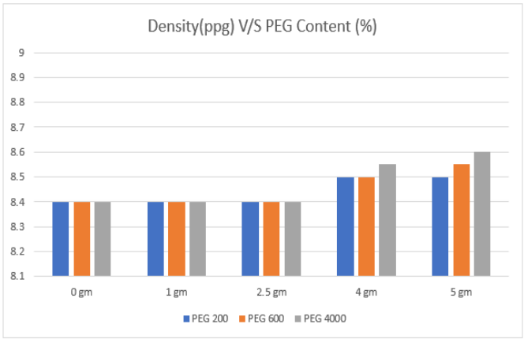
Figure 1: Variation in density with PEG concentration

Fig. 1 illustrates the effect of PEG (200, 600, 4000 Molecular Weight) concentration on density of the bentonite-based drilling mud. With the increase in the concentration of PEG, the density values of the bentonite-based mud increases slightly. When the concentration of PEG is 1 gm, density of the mud is 8.4ppg and it increases to 8.5 ppg as we go on increasing the concentration of PEG as shown in the fig. 1. Thus, it can be derived that there is slight increase in density of the bentonite-based drilling mud with the increase in concentration of PEG.

  - Rheological analysis:

The rheological properties of the drilling fluid are a very important factor regarding the property enhancement of the drilling mud. The variation and comparison of plastic viscosity, YP and gel strength (GS) are in Figs. 2,3,4,5 and 6.

Plastic viscosity (PV) and Yield Point(YP): With the increase in the concentration of PEG, the Plastic Viscosity and Yield Point values of the bentonite-based drilling mud slightly increases. Fig 2. illustrates the effect of PEG concentration on PV. When the concentration of PEG increases from 1 gm to 5 gm, the plastic viscosity shows better result. In case of YP, fig 3. illustrates the effect of PEG concentration on YP. When the concentration of PEG increases from 1gm to 5gm the YP increases. Therefore, it can be seen that the addition of PEG concentration shows better improvement in PV and YP.

Gel strength: Fig 4-6 illustrates the effect of PEG concentration of MW 200,600 and 4000 on gel strength. With the increase in PEG concentration gel strength increases. Thus, it has been found from the figures that the there is an increasing trend in the rheological properties i.e. PV, YP and gel strength of the bentonite based drilling mud with the increase in concentration of PEG.

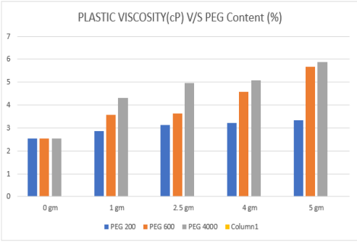
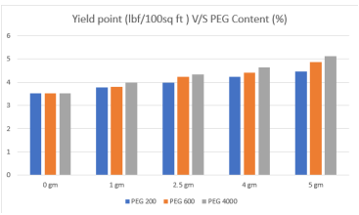

Figure 2: Variation in Plastic viscosity with PEG concentration Figure 3: Variation in Yield Point with PEG concentration

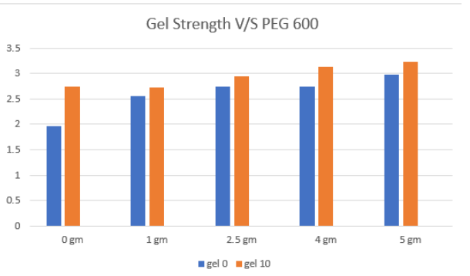
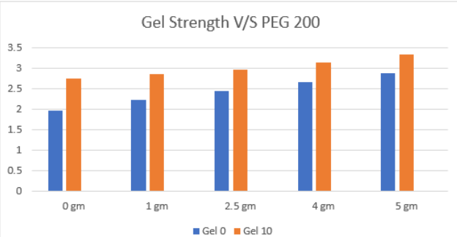
Figure 4: Variation in Gel 0 and Gel 10 with PEG 200 Figure 5: Variation in Gel 0 and Gel 10 with PEG 600

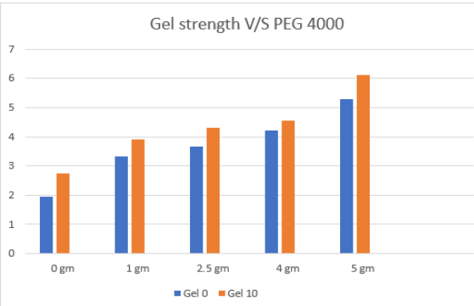
Figure 6: Variation in Gel 0 and Gel 10 with PEG 4000

  - Filtration analysis:
A highly important property of drilling fluids is the ability to form an impervious filter cake upon the permeable walls of the bore hole to prevent filtrate loss, which can be obtained by the filter press method. In Fig. 7, the filtrate loss of bentonite-based drilling mud vs PEG concentration is shown, followed by the thickness of the mud cake in Fig. 8. From the figures it can be seen that the amount of filtrate loss reduces with different PEG concentration and different molecular weights and different concentrations of PEG. As the concentration of PEG increases, the filtrate loss volume shows a decreasing trend. Also, as the molecular weight of PEG increases, the fluid loss volume gradually decreases. This result shows that PEG can reduce the filtrate volume of bentonite-based drilling mud to a certain extent. This is because PEG is a long chain molecule with polar groups (hydroxyl group) at the end chain. The hydroxyl groups were adsorbed on the surface of the clay and mud cake, which can effectively block the micropores and achieve the effect of reducing the filtrate volume. Small molecular-weight PEG can only block smaller pores, while larger molecular-weight PEG can also block larger micropores through cross-linking adsorption. Fig. 8 illustrates the effect of PEG concentration on mud cake thickness. With the increase in concentration of PEG, the thickness of mud cake decreases.

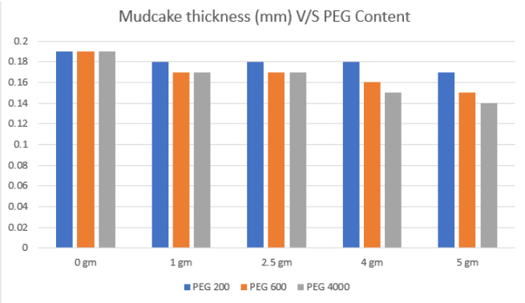
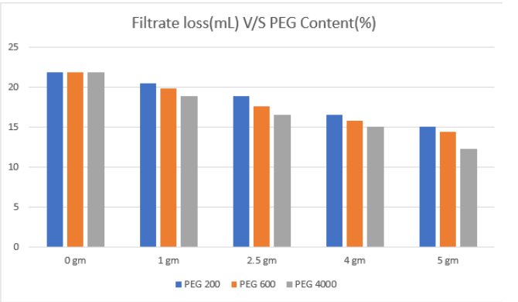

Figure 7 : Variation of Filtrate loss with PEG concentration Figure8: Variation in mud cake thickness with PEG concentration

After analysing all the experimental results it was obtained that the PEG 600 molecular weight 5gm gives an optimum result, due to the reasons that - Higher the molecular weight, better are it’s filtration properties (less filtrate loss and optimum mud cake thickness). But taking into consideration, the economic factors, PEG 600 is a better choice than PEG 200 and PEG 4000. The plastic viscosity is also showing values which are within the desired range and the prerequisite is a plastic viscosity which is not high enough to provide too much resistance to flow and neither too low that is does not take cuttings along with it to the surface. Moreover, as the molecular weight increases, the coefficient of friction decreases; a higher molecular weight PEG provides more lubricity which is an acceptable phenomenon in case of substituting oil-based mud. So, PEG 600 is better than PEG 200. Along with that, lower the molecular weight, better is the defoaming properties. So, PEG 600 is better than PEG 4000. As it can be obtained from the results that the gel strength has an increasing weight with both molecular weight and concentration so, an optimum value of gel strength is needed.

- Conclusion
PEG is non-volatile, inert, colourless, and non-toxic. It is also very soluble in organic solvents like benzene, carbon tetrachloride, and chloroform as well as water. Poly(ethylene glycol) in drilling mud underwent "phase separation" and changed into an oil-soluble material as a result of the cloud point effect. A lubricating layer was created by the molecular chain's hydroxyl groups adhering to the metal and mud cake's surfaces. Additionally, the lubricating film rapidly thickens and the drilling mud's ability to lubricate declines as PEG's molecular weight rises. Strong shale inhibition, high lubricity, and water miscibility in any ratio are all benefits of PEG, making it ideal for the creation of water-based drilling mud for very water-sensitive formation. PEG’s diversity in its molecular weight, determines the diversity of the products, moreover it provides antifriction property and is cost effective.

References:
1. Salam, M., Al-Zubaidi, N.S. and Al-Wasiti, A.A., 2019. Lubricating Properties of Water-Based Drilling Fluid Improvement Using Lignite NPs as well as Their Effect on Rheological and Filtration Properties. Association of Arab Universities Journal of Engineering Sciences, 26(1), pp.81-88.
2. ASME Shale Shaker Committee, 2011. Drilling fluids processing handbook. Elsevier.
3. Borah, B., Das, B. M., (2022),"A review on applications of bio-products employed in drilling fluids to minimize environmental footprint", Environmental Challenges Vol.6, 100411
4. Huang, D., Xie, G., Peng, N., Zou, J., Xu, Y., Deng, M., Du, W., Xiao, Y., Huang, J., Luo, P., (2021),“Synergistic inhibition of polyethylene glycol and potassium chloride in water-based drilling fluids”, Petroleum Science 18, 827-838
5. Qin,G., Xu , M., He, M. and Chen, K.,(2021), “Synergistic Effect of Polyaspartate and Polyethylene Glycol on Lubrication Performance of the Water-Based Drilling Mud” ,ACS Omega, 6, 21, 13817–13830
6. Rabia, H. (2002), “Well Engineering & Construction.” Entrac Consulting Limited, London
7. Akpan, E. A.,(2019) "Water-Based Drilling Fluids for High Temperature and Dispersible Shale Formation Applications" Ph.D. Thesis, Petroleum and gas Engineering Division, School of Computing, Science and Engineering, University of Salford, United Kingdom.
8. Nagre, R., Zhao, L., Frimpong, I., & Owusu, P. (2015). “EVALUATION OF SULFONATED ACRYLAMIDE-BASED TETRAPOLYMER AS A RHEOLOGY MODIFIER IN WATERBASED DRILLING FLUID”. Petroleum & Coal, 57(2), 93-100
9. Adekomaya, O. A., Olafuyi, O., (2011), “An Experimental Study of the Effect of Contaminants on the Flow Properties of Oil based Drilling Mud. Petroleum & Coal”, 53(4), 315-319.
10. Bland R., (1992) “Water-based glycol systems acceptable substitute for oil-based muds.” Oil Gas Journal .90(26):5.
11. Bland R, et al., (1996), “Low salinity polyglycol water based drilling fluids as alternatives to oil-based muds” Asia Pacific Drill Technology Society of Petroleum Engineers.
12. Twynam AJ, Caldwell PA, Meads K., (1994), “Glycol-enhanced water-based muds: case history to demonstrate improved drilling efficiency in tectonically stressed shales”, SPE/IADC Drilling Conference. Society of Petroleum Engineers.
13. Jiang, G.; Lin, T.; Ning, F.; Tu, Y.; Zhang, L.; Yu, Y.; Kuang, L.(2011), “Polyethylene Glycol Drilling Fluid for Drilling in Marine Gas Hydrates-Bearing Sediments: An Experimental Study”, Energies 2011, 4, 140−150 DOI: 10.3390/en4010
14. J. Ulbricht et al., (2014), “On the biodegradability of polyethylene glycol, polypeptoids and poly(2-oxazoline)s”, Biomaterials, Volume 35, Issue 17, June 2014, Pages 4848-4861
15. Kawai, F., Yamanaka, H., (1986),” Biodegradation of polyethylene glycol by symbiotic mixed culture (obligate mutualism)”, Arch. Microbiology 146, 125–129
16. Lopes, B.D.M., Lessa, V.L., Silva, B.M. and La Cerda, L.G., 2015. Xanthan gum: properties, production conditions, quality and economic perspective. J. Food Nutr. Res, 54(3), pp.185-194.
17. Akinade, A.E., Wilfred, O.C. and Akin-Taylor, A.M., 2018. Improving the rheological properties of drilling mud using local based materials. Am. J. Eng. Res.(AJER), 7, pp.58-63.
18. Alemdar, A., Güngör, N., Ece, O.I. and Atici, O., 2005. The rheological properties and characterization of bentonite dispersions in the presence of non-ionic polymer PEG. Journal of Materials Science, 40, pp.171-177.
19. Pietrelli, L. Effect of MW and pH on poly(ethylene glycol) adsorption onto carbon. Adsorption 19, 897–902 (2013).
20. Liu, L., Javed, H.U. and Xiao, J., 2022. Engineering emulsion gels as functional colloids emphasizing food applications: A review. Frontiers in Nutrition, 9, p.890188.

