Cyclodextrin and their Imminent Applications: A Sophisticated Pharmaceutical Ingredient for Drug Delivery

Niku Ahmed
Department of Chemical Scienes
Tezpur University, Napaam, Tezpur, Assam 784028
nahmed@tezu.ernet.in

Dabasish Deka
Department of Chemical Scienes
Tezpur University, Napaam, Tezpur, Assam 784028
dabasish@tezu.ernet.in

ABSTRACT
Cyclodextrin signifies an important class of supramolecular chemistry. In this book chapter; fundamental ideas of structure, synthesis and application of this class of supramolecular chemistry is explored. Focus has been given to medicinal application like drug delivery and encapsulation with potential impact.

Keywords- Cyclodextrin, supramolecular, medicinal, drug delivery,

INTRODUCTION

Cyclodextrins are a family of cyclic oligosaccharides which are consist of macrocyclic ring of glucose subunits connected by α-1,4 glycosidic bonds. They are primarily obtained from starch or starch derivatives through a enzymatic conversion. Cyclodextrins belongs to a family of caged shaped molecules and due to their unique structure with cavity, they can encapsulate other molecules [1].
Cyclodextrin was called "cellulosine" by A. Villiers in 1891. In between 1911 and 1935, Pringsheim in Germany did significant research in this field, demonstrating the possibility of formation of stable aqueous complexes of cyclodextrin with many other substances. In between 1935 and 1950, cyclodextrin were investigated by structural outcomes on the “Schardinger dextrins. In the year 1949, Cramer first introduced the concept of nomenclature to cyclodextrin-based compounds. In the last 50 years, cyclodextrins have attained ground in many industrial applications, mostly in the pharmaceutical formulation, chemical industries, environmental engineering and food sectors. In this chapter, we present an overview and applications of cyclodextrins [1,2].

STRUCTURE OF CYCLODEXTRIN
Chemically cyclodextrins are comprises of five or more α-D-glucopyranoside units joined by α-1,4 glycosidic bonds. These glycosidic bonds form a cyclic structures and it consist of a lipophilic central cavity. The outer surface have a hydrophilic property. The primary hydroxyl groups can rotate and decrease the diameter of cyclodextrin while secondary hydroxyl groups form strong hydrogen bonds, providing rigidity to cyclodextrin structure. Replacement of the hydroxyl groups by other lipophilic methoxy functional group leads to the decrease of hydrogen bond forming capacity and thus results in theatrical improvement in water solubility. Due to this distinctive structure, cyclodextrin can encapsulate guest molecules leading to the formation of inclusion complexes. This encapsulation characteristic is very exclusive and significant, leading to application in different industries such as agricultural products or medicine goods [2,3].
Figure 1: Anatomy of cyclodextrins

FAMILY OF CYCLODEXTRINS
Three important type of cyclodextrin family are α-cyclodextrin, β-cyclodextrin and γ-cyclodextrin. In addition to this, several minor cyclodextrin are also known like δ-cyclodextrin and ε-cyclodextrin. α, β, δ nomenclature are used to distinguishes the cyclodextrin with different ring size in a homologous series. (Table 1)
Table 1: Properties of different Cyclodextrins
Family | Number of glucose units | Ring size |  | Internal cavity (Å) |  | Water solubility at 25°C (g/L)
α | 6 |  | 30 |  | 5.0 | 145
β | 7 |  | 35 |  | 6.2 | 18.5
δ | 8 |  | 40 |  | 8.0 | 232

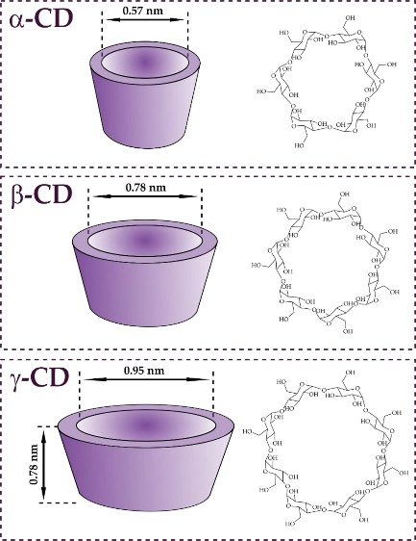
Figure 2: Sizes of different cyclodextrins (α-CD, β-CD and γ-CD respectively).

IV: PREPARATION AND CHARACTERIZATION
Photosynthetic plants produce starch and cellulose. Degradation process of starch with a variety of enzymes in aqueous solution results in dextrins. The degradation of dextrins by glucosyltransferase enzyme in absence of water results in cyclodextrins.
There are number of synthetic approach can be adopted to prepare cyclodextrins-guest complexes. Important approaches includes co-precipitation, kneading, microwave treatment and spray drying like techniques. Scanning electron microscopy (SEM), Fourier-transform infrared spectroscopy (FT-IR), powder X-ray diffraction (PXRD), thermogravimetric analysis (TGA) and differential scanning calorimetry (DSC) are few analytical techniques which are employed to characterize Guest-Cyclodextrin complex formation in solid phase. In solution phase, the main characterization techniques generally employed are nuclear magnetic resonance (NMR) spectroscopy, UV-visible spectroscopy, high-performance liquid chromatography (HPLC) and fluorescence spectroscopy [2].

V: APPLICATION IN SUPRAMOLECULAR CHEMISTRY

Overview
Cyclodextrin molecule have exclusive structural feature with a hydrophobic void and a hydrophilic exterior in which a guest molecule can be captured. A polar guest molecule interact with cyclodextrins in aqueous medium to form 1:1 molecular inclusion compounds. In general, the guest molecule is incorporated within the cyclodextrin cavity of the complex [5].
Figure 3: Formation of a host-guest complex between cyclodextrin molecule and guest
The key factor for formation of inclusion complex of the cyclodextrins involves the following important factors:
i. Steric flexibility and fitness
ii. Hydrophobic effects
iii. Van der Waals interactions
iv. Dipole-dipole interactions
v. Hydrogen bonding
vi. Electrostatic interactions
Cyclodextrins are well established and well-studied in the field of supramolecular chemistry. Applications of inclusion systems have gained considerable interest of cyclodextrin due availability in high purity, solubility, biocompatible nature and possibility of functionalization using different synthetic methods is also significant. Due to significant inclusion capability, α-CD and β-CD are employed in the design and construction of supramolecular structures. Different strategies are adopted to manipulate CDs in host-guest delivery systems. They are used in medicinal example in pills, aqueous parenteral solutions, nasal sprays and eye drops. Aqueous solutions of cyclodextrins forms host-guest complexes with many drug molecules or lipophilic part of the molecule inside the available central cavity. In general, no covalent bonds are formed or broken during the complexation process. Drug molecules in the complex are in very fast equilibrium with unrestricted molecules in the solution phase. Cyclodextrins as well as their derivatives are used to synthesize unique nano-materials of cyclodextrin-containing materials with multipurpose supramolecular topologies [1,3]. For pharmaceutical and medical applications, nanosubstances may be formulated as oral, parenteral, topical forms. Cyclodextrins and as well as their derivatives have also important real life applications in aroma and fragrances industry, oils, analytical chemistry, organic chemistry, click chemistry, macromolecular chemistry, environmental chemistry, food chemistry and nanotechnology [4].
Cyclodextrins are potential candidate for various modern day purposes in daily life. Nowadays, it is hard to think of a modern world that does not have cyclodextrins. Unintentionally, every individual routinely uses CDs in their daily lives foodstuffs as well as a significant amount of cosmetics, textiles and toiletries as unseen ingredients and numerous kinds of medically used chemicals. So the application of cyclodextrins contains area such as pharmaceuticals, food industry, agriculture industry, chemical industry, beauty products and toiletries, textile industry. The vast applicability of the cyclodextrins are due to the fascinating properties because of a cavity filled of glucoside oxygen and methylene hydrogen [6-7].

Application in Pharmaceutical

Comparatively low miscibility of native cyclodextrins in common organic solvent as well as water makes them less beneficial in the pharmaceutical product. However there are some added advantage which make the cyclodextrin as active ingredient in pharmaceutical products. They are manufactured from the natural starch through a simple enzymatic transformation. Moreover any cytotoxic effect of cyclodextrin can be avoided by making proper derivatives. This motivates the scientist to synthesized different varieties of cyclodextrin which can be used to enhance the bioavailability, miscibility and stability of different drugs molecule by triggering formation of the ‟Inclusion complex” [8] (figure 5). To improve the crystallization rates of insufficient water-soluble medicines, hydroxyalkylated-β-cyclodextrins derivatives are used. This also help in inhibition of polymorphic formation during storage [9, 10].
Thiolated α-cyclodextrin are known to be the tiniest drug carrier [11]. Thiolation process of α-CD is showed in the figure 4. Cellular uptake experiment demonstrated that the thiolated α-CD can enter the HEK-293, Caco-2, and MC3T3 cells more simply compared to the native-CD. These thiolated α-CD carry the hydrophobic drug in its cavity and convey to the target cells. The drug delivery of molecule can be explained in Figure 5.
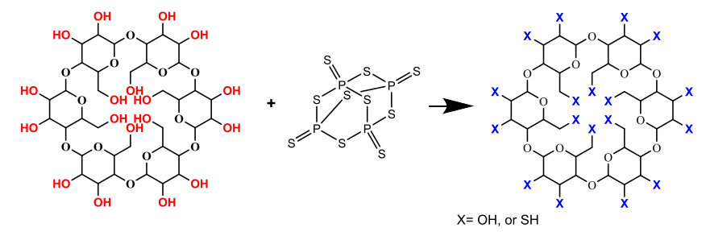
Figure 4: Schematic reaction for the synthesis thiolated α-cyclodextrines
Figure 5: The mechanism of formation of Inclusion compound with the drug molecule.
The drug delivery mechanism for the cyclodextrin is shown in the figure 6. CDs have no title role in the increasing penetrability of drug across biological membrane. It only helps in the improvement of the water solubility of the drugs. The composition of the drug determine the rate of movement of the drugs across the membrane. [12].The main driving force for irreversible binding is simple dilution. Moreover, other well studied mechanism like protein–drug molecule binding, viable drug partition from the complex to competitive binding which also help in swift drug release from the complexes [13,14]
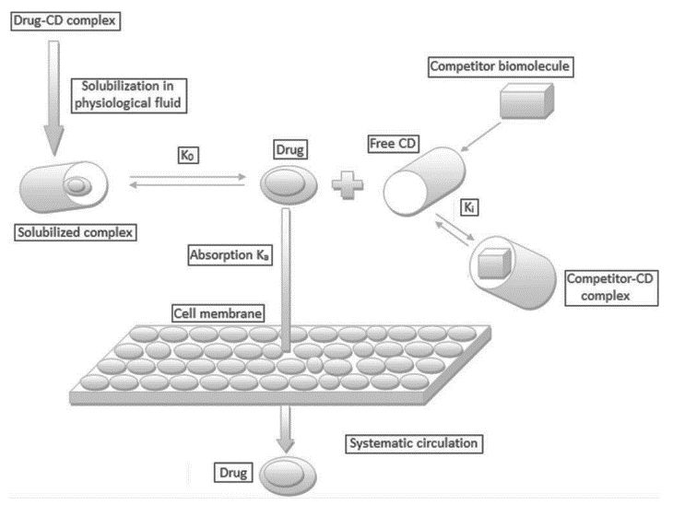
Figure 6: The mechanism and drug binding and releasing mode of cyclodextrin molecule
In recent times, the usage of CD-containing polymers for drug release seems to have been seriously investigated. Some of them have reached upto clinical trial also. For example application of clycodextrin use in drug enablement are explained in short in the following-
(a)Piroxicam:
Piroxicam represents a water insoluble non-steroidal and anti-inflammatory drug (figure 7).For the purpose of increment in the solubility, piroxicam is treated with β−CD with molar ratio 1: 2.5 in aqueous NH₄OH solution followed by spray drying resulting in white precipitate. [15]. Complex formation increases water solubility of the drug from ~ 0.02 mg/ml to ~ 0.15 mg/ml at pH value 5 and 37°C temperature. Moreover, it increase the wettability, boosting the drug dissolution ratio [16].
Figure 7: Chemical structure of drug piroxicam.
(b)Ziprasidone:
Another low water soluble drug is Ziprasidone which used as an antipsychotic agent (figure 8) [17]. It has a solubility of 0.003 milligram per milliliter of solution. On the other hand the solubility of hydrochloride salt of ziprasidone is 0.08 mg/ml. Further, synthesis of mesylate salt increase the inherent solubility of the drug molecule (Table 2). However, in case of this drug, it is impossible to increase the solubility through simple CD complexation. The complexation with negatively charged HPβ−CD and SBEβ−CD can provide alternate pathway to increase the solubility by formation of ion-pair. So, ziprasidone mesylate and SBEβ−CD are also used to formulate the drug as an aqueous solution for injection [18, 19].
Table 2: The solubility of ziprasidone in pure water and aqueous solution with 40% (w/v) HPβ−CD and 40% (w/v) SBEβ−CD
Salt | Solubility percentage (mg/ml)
 | Pure Water | 40% (w/v) | 40% (w/v)
 |  | HPβ−CD | SBEβ−CD
Free base | 0.0003 | 0.26 | 0.35
Hydrochloride | 0.08 | 2.4 | 4.0
Aspartate | 0.17 | 1.3 | 9.3
Tartrate | 0.18 | 12.4 | 26
Esylate | 0.36 | 13.7 | 15
Mesylate | 1.0 | 17.3 | 44

Figure 8: Chemical structure of free drug Ziprasidone.
(c) Itraconazole:
Itraconazole is a widely used antifungal medication which offered as oral and solution for injection (figure 9). The miscibility of the drug in water at room temperature is very less. It has a solubility of about 1 mg/ml at pH value of 7 and ~ 4 mg/ml in aqueous 0.1 N hydrochloric acid solution. Likewise the crystalline itraconazole has solubility of 3 mg/ml in aqueous 40% (w/v) solution. The interaction of the drug molecule with the HPβ−CD enhance the solubility of the drug by transforming crystalline form into amorphous form [20,21]

Figure 9: Chemical structure of Itraconazole drug.

VI: CONCLUSION
Normal cyclodextrin and its derivatives have emerged as very essential ingredient for the formulation of drug in the pharmaceutical industry. The main attractive features of the cyclodextrines are host-guest type of interaction between the CDs and drug molecule. This makes the
binding reversible and it is one of the key reason of cyclodextrines to be used for drug delivery. Apart from pharmaceutical filed, CDs are useful in other branches like food industry, textile industry etc [22]. This signifies the emerging demand of CDs and its important requirement for mankind in upcoming time.

REFERENCES

- Szejtli, J., Introduction and general overview of cyclodextrin chemistry, Chemical reviews, 98(5), 1743-1754, 1998.
- Przybyla, M. A., Yilmaz, G., & Becer, C. R., Natural cyclodextrins and their derivatives for polymer synthesis. Polymer Chemistry, 11(48), 7582-7602, 2020.
- Gregório, C., Review: a history of cyclodextrins. Chem. Rev, 114(21), 10940-10975, 2014.
- Cid-Samamed, A., Rakmai, J., Mejuto, J. C., Simal-Gandara, J., & Astray, G., Cyclodextrins inclusion complex: Preparation methods, analytical techniques and food industry applications. Food Chemistry, 132467, 2022.
- Hu, Q. D., Tang, G. P., & Chu, P. K., Cyclodextrin-based host–guest supramolecular nanoparticles for delivery: from design to applications. Accounts of chemical research, 47(7), 2017-2025, 2014.
- Magnúsdóttir, A., Másson, M., & Loftsson, T., The conventional model of drug/cyclodextrin complex formation (salicylic acid/β-cyclodextrin inclusion complex), Journal of Inclusion Phenomena and Macrocyclic Chemistry, 44, 213-218, 2002.
- Higuchi, T., & Connors, K. A., Adv anal chem instrum. Phase-solubility techniques, 4, 117-212, 1965.
[9]. Uekama K. Design and evaluation of cyclodextrin-based drug formulation. Chem Pharm Bull, 52, 900–915, 2004.
[10] Brewster ME, Loftsson T. Cyclodextrins as pharmaceutical solubilizers. Adv Drug Deliv Rev, 59, 645–666, 2007.
[11] Kaplan, Ö., Truszkowska, M., Kali, G., Knoll, P., Massani, M.B., Braun, D.E. and Bernkop-Schnürch, A., Thiolated α-cyclodextrin: The likely smallest drug carrier providing enhanced cellular uptake and endosomal escape. Carbohydrate Polymers, p.121070, 2023.
[12] Rasheed A, Kumar A, Sravanthi V., Cyclodextrins as drug carrier molecule: a review. Sci Pharm 76:567–98, 2008.
[13] Stella VJ, He Q. Cyclodextrins. Tox Pathol, 36, 30–42, 2008.
[14] Amidon GL et al. A theoretical basis for a biopharmaceutic drug classification: the correlation of in vitro drug product dissolution and in vivo bioavailability. Pharm Res, 12, 413–420, 1995.
[15] Wenz G. An overview of host-guest chemistry and its application to nonsteroidal anti-inflammatory drugs. Clin Drug Invest,19 (Suppl.2), 21–25, 2000.
[16] Woodcock BG et al. Supermolecular inclusion of piroxicam xith -cyclodextrin: pharmacokinetic properties in man. Eur J Rheumatol Inflamm, 12, 12–28, 193l.
[17] McEwen J. Clinical pharmacology of piroxicam--cyclodextrin. Implications for innovative patient care. Clin Drug Invest, 19(Suppl. 2), 27–31, 2000.
[18] Kim Y et al. Inclusion complexes of arylheterocyclic salts.United States Patent No. 6,232,304 B1, May 15, 2001.
[19] Kim Y et al. Inclusion of ziprasidone mesylate with b-cyclodextrin sulfobutyl ether. J Pharm Sci, 87, 1560–1567, 1998.
[20] Moffat AC et al. Clarke’s Analysis of Drugs and Poisons. 3rd edn. London: Pharmaceutical Press, 2004.
[21] Uekama, K., Otagiri, M., Cyclodextrins in drug carrier systems. Crit. Rev. Ther. Drug Carrier Syst. 3 (1), 1–40, 1987.
[22] Crini, G., Fourmentin, S., Fenyvesi, É, Torri, G., Fourmentin, M., & Morin-Crini, N, Fundamentals and applications of cyclodextrins. In Cyclodextrin fundamentals, reactivity and analysis, Springer, Cham, pp. 1-55, 2018.

