Financial Inclusion at Indian Post Payment Bank-An Introductory Approach.

DR. SITANGSHU KHATUA,
Associate Professor, Department of Management, St. Xavier’s University, Kolkata.

DR. KUNAL SIL.
D.Litt. (Commerce & Management) Fellow, Srinivas University, Mangalore.

Introduction- The 75th celebration of Indian Independence anniversary & current Azadi ka Amrit Mahotasav earmarked the launch of “Finclusion”. INDIA POST PAYMENTS BANK(IPPB) is established as hundred percent government owned unit, working under Department of Posts (DoP) declared the inauguration of Fincluvation– a combined inventiveness to collaborate with Fintech Startups to inject innovative solutions for financial inclusion.

Fincluvation will soon be an enduring platform of Indian Post Payment Banks to bring all-inclusive financial solutions with their participating start-ups. Indian Post Payment Banks and Department of Posts will jointly serve millions of customers through nearby Post Offices to their convenient places, with more than 410,000 reliable and proficient employees of Post Offices. It includes Gramin Dak Employees (Sevaks) too. This would make postal services making as the biggest and reliable network of postal services in the country.

Key Words- Azadi ka Amrit Mahotasav, Fincluvation, IPPB, Gramin Dak Sevaks.

Payment Banks- Nachiket Mor Committee made a useful suggestion for the establishment of the Payments Bank. Accordingly, it was formed to facilitate functions on a minor range with very negligeable risk profile.

The principal purpose was to promote schemes financial inclusion and it offered banking and financial product and services to the doorstep of most un privileged areas. It was also aimed at helping the migratory work force, small- income families and budding entrepreneurs etc.

Payment Banks are registered under the Companies Act 2013. They are ruled by a multitude of legislatures. For example, Banking Regulation Act, 1949; RBI Act, 1934; Foreign Exchange Management Act, 1999, Payment and Settlement Systems Act, 2007 and the like.

We have currently 6 Payment Banks-

- Airtel Payment Bank.
- India Post Payment Bank.
- Fino.
- Paytm Payment Bank.
- NSDL Payment Bank, and
- Jio Payment Bank.

Indian Post Payment Bank (IPPB)- Post Payments Bank (IPPB) has been established under the aegis Department of Posts, Ministry of Tele Communication, Government of India has hundred percent equity stake at Post Payment Bank. Post Payment Bank was inaugurated by our honorable Prime Minister Shri Narendra Modi, dated on September 1, 2018. The entity has been founded with the assignment to build the most accessible, inexpensive and unfailing banking facilities meant for serving common mass. The basic decree of Post Payment Bank is to eliminate all the existing barriers for the most unbanked and under-banked people.

Post Payment Bank’s scope, as well as its basic functioning is primarily constructed on the three key pillars of India- aiding Presence-less, Cashless and Paperless financial services system in the most simplistic and secured method to the clients' convenience. It is implemented through a Core Banking System-integrated biometric device and smartphone.

Essential Features of Post Payment Bank-

Indian Post Payment Bank understand customer needs. They have tailored their product and services to be simple and easy to avail. Some prominent features of Post Payment Bank include-

- Deposit.
- Money Transfer.
- Direct Benefit Transfers.
- Third Party Products.
- Billing & Utility Payments.
- Enterprise & Merchant payments.
- Built in Mechanism.
- Available in almost 12 languages.
- Cash less facilities.

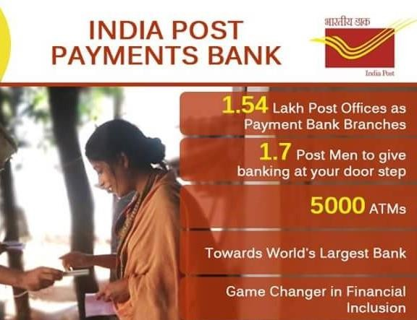
Current Operational Strength-

Indian Post Payment Bank Services

Account On Boarding

Merchant On Boarding

Third Party Services
Accounting Services

Other Account Related Services includes-
  - Updating PAN.
  - Beneficiary Management.
  - Account statement.
  - QR card.
  - Linking Adhaar Card.
  - Sharing complaints, etc.

Some Specific Attention to Rural Needs-

Indian Post Payment Bank has a specific orientation to rural sectors-
- Leveraging the trust which the India Post enjoys in the minds of the public.
- Minimizing and recovering NPAs.
- Helping to increase per capita income of rural people.
- Providing an effective financial service.
- Social Inclusion is another area, where IPPB is working rigorously.
- Rural MSME is getting leverage from Indian Post Payment Bank.
- IPPB has enabled Direct Benefit Transfer.

Low Digital Literacy RBI Mandates Service Charges

Some Operational Challenges

Stiff Competition Manpower Training

Useful Strategies to Overcome Challenges-
1) Collaborate with Department of Postal Services.
2) Mobilization of small savings,
3) Low-cost services to their customers.
4) Creating customer awareness for their financial products.
5) Medium for Direct Bank Transfer.
6) Engage in partnership with other Commercial Banks.
Conclusion-
Payment Banks have all the potentiality to provide most affordable banking services in our country.
Payment Bank is all set to transform the edifice of Postal Department in all aspects. A modernization of Post Offices is highly recommended to take the leverage of Post Payment Banks.

References-
1. Scher J Mark, 2001, "Postal Savings and the provision of Financial Services: Policy Issues and Asian Experiences in the use of the postal Infrastructure for Savings Mobilization", DESA Discussion Paper No 22, UN, 2001.
2. Rillo and Miyamoto, 2016, “Innovating Financial Inclusion: Postal Savings System Revisited”, ADBI Policy Brief No August 2016-3, ADBI, Japan.
3. Andorta and Manhas, (2017), "Emerging Role of Indian Post in Financial Inclusion and Socio-Economic Empowerment", Prestige International Journal of Management & ITSanchayan, Vol. 6(1), 2017, pp. 1-19
4. Das, S.K. (2011), “An Empirical Analysis on Preferred Investment Avenues among Rural and Semi-Urban Households”. Journal of Frontline Research in Arts and Science Vol. 01, pp. 26-36.
5. Chaubey, D.S. (2009), “Investment Pattern: A Psychographic Study of Investors of Garhwal Region of Uttarakhand”, RVIM Journal of Management Research, Rashtreeya Sikshana Samithi Trust, R.V. Institute of Management, Bangalore, Vol. 1, No. 1, Jan-June 2009, pp. 36.

