**Direct and indirect organogenesis in *Aerva lanata* (L.) Juss. Ex Schult**

Kandhan Varutharaju1, Chandrasekaran Thilip2, Abubakkar Aslam3,

Appakan Shajahan3*

1. Department of Botany & Biotechnology, Selvamm Arts and Science College (Autonomous), Namakkal-637 003, Tamilnadu, India.

2. Department of Botany, Government Arts and Science College, Vettukadu, Sendamangalam-637 404, Namakkal District, Tamilnadu, India.

3. Plant Molecular Biology Laboratory, Department of Botany, Jamal Mohamed College (Autonomous), Tiruchirappalli - 620 020, Tamil Nadu, India

*Corresponding author at: Plant Molecular Biology Laboratory, Department of Botany,

Jamal Mohamed College, Tiruchirappalli - 620 020, Tamil Nadu, India. Tel.: +91 9443874731.E-mail address: [shajahan.jmc@gmail.com](mailto:shajahan.jmc@gmail.com) (A. Shajahan).

Communication E-mail - k2varu@gmail.com

**Abstract**

An efficient protocol for direct and indirect organogenesis has been developed for the medicinal plant Aervalanata(L.). Direct regeneration was achieved from leaf and nodal segments of 20-day-old in vitro plantlets raised on Murashige and Skoog (MS) medium containing thiadiazuron (TDZ), 3% sucrose, and 0.8% agar. After 21 days of culture incubation, the maximum number of shoot organogenesis was obtained on medium containing 1.0mg L−1 TDZ. The shoots were able to produce in vitro flowers on medium containing TDZ in combination with 𝛼-naphthalene acetic acid (NAA). For indirect regeneration, the leaf explants showed better callus induction. Histological observation showed that the epidermal cells of the leaf explants exhibited continuous cell division, which led to the formation of numerous dome-shaped meristematic protrusions that subsequently developed into adventitious shoots. Upon transfer of shootlets to half-strength MS medium containing indole-3-butyric acid (IBA), around 86% of the regenerated shoots formed roots and plantlets. Rooted plants were hardened and successfully established in the soil. The regeneration protocol developed in this study provides an important method of micropropagation for this plant. Furthermore, this protocol may be used for large-scale production of its medicinally active compounds and genetic transformations for further improvement.

**Abbreviations**

MS Murashige and Skoog

TDZ Thidiazuron

BAP Benzylamino purine

NAA 𝛼-Naphthalene acetic acid

IBA Indole-3-butyric acid

IAA Indole-3-acetic acid.

2,4D 2, 4-Dichlorophenoxyacetic acid

BA Benzyladenine

KIN Kinetin

MS Murashige and Skoog

**1. Introduction**

Medicinal plants are natural resources yielding valuable herbal products that are often used in the treatment of various ailments [1]. Aervalanata(L.) a medicinal herb belonging to the family Amaranthaceae, is commonly called Polpala. It is endowed with various chemical compounds such as flavonoids, alkaloids, steroids, polysaccharides, tannins, phenolic compounds, and saponins [2, 3], which have contributed to its diverse uses in folklore medicine. Leaf extract of A. lanatais very effective in curing the urinary risk factors associated with calcium oxalate urolithiasis [4]. Urolithiasis, the formation of urinary stones, is one of the oldest known diseases. Archaeological findings give profound evidence that humans have suffered from kidney and bladder stones for centuries; even examinations of Egyptian mummies have revealed kidney and bladder stones. Now a days, various research is done on this plant, like the ex vitro rooting system [5], the antifungal efficacy of various plant parts [6], genetic fedility [7], the hairy root system [8], and the liquid culture system [9].

***1.1. Uses ofA. lanata***

The plant is reported for a number of pharmacological activities, namely, anthelminthic, demulcent, anti-inflammatory, diuretic, expectorant, hepatoprotective and nephroprotective, antidiabetic, antihyperglycemic, antimicrobial, cytotoxic, hypoglycemic, antihyperlipidemic, antiparasitic, and anthelminthic activities [10]. The bioactive compounds responsible for the above pharmacological activities are 𝛽-carboline, 𝛽-sitosterol, palmitic acid, alpha-amyrin, aervin, methyalervine, and anaervoside[11, 12].

***1.2. Propagation***

The requirement for this medicinal herb is currently met by the natural population. However, extensive utilization of this plant poses a potential threat to its existence [13]. Further, seed dormancy and seasonal availability prompted the evaluation of alternative approaches to generate the required propagation for in vitro studies, genetic transformation, and commercial production of A. lanata. In vitro regeneration provides an alternative means for large-scale multiplication. Plants have been successfully regenerated through micropropagation [14]. There are few reports on in vitro regeneration of A. lanata, which is also restricted to adventitious plantlet formation from shoot tips and nodal segments [13]. Direct shoot organogenesis from leaf segments represents a promising tool for mass propagation as well as genetic transformation. Therefore, in this study, an attempt has been made to develop an efficient direct and indirect regeneration system using leaf segments for A. lanata.(Fig.1).



**Fig.1: Graphical representation of *A. lanata.***

**2. Direct organogenesis**

***2.1. Establishment of aseptic mother plants***

Seeds of A. lanatawere collected from basins of the Cauvery River in January 2012, and the plants were raised in the medicinal plant garden of Jamal Mohamed College, Tiruchirappalli, India. Nodal segments from ex vitro mother plants were used as initial explants. They were washed in running tap water for 10 minutes, soaked in 5% (v/v) teepol for 2 minutes, surface sterilized with 0.2% mercuric chloride for 10 minutes, and rinsed three times with sterile distilled water. After that, they blotted using sterilized Whatman filter paper and allowed it to dry naturally. Then they were cut into small pieces of explants (0.5 cm in size) and inoculated on MS basal media supplemented with 1.0mg L−1 6-benzylaminopurine and 0.5mg L−1 NAA. The polarity of the shoots was maintained during inoculation.

***2.2. Culture condition***

The pH of the media was adjusted to 5.7 ± 0.1 before autoclaving at 121°C and 104 kPa for 15 min. All experiments were performed with semi-solid media gelled with 0.8% agar powder (Himedia, Mumbai, India). Cultures were maintained at 25 ± 2 °C, a 16-hour photoperiod under 40 molm−12 s−1 light intensity provided by white fluorescent tubes, and a relative humidity of 55–65%.

***2.3. Influence of TDZ***

The effect of TDZ, including concentration and duration of treatment, on shoot development was initially investigated. Leaf explants were cultured on MS basal medium alone or containing various concentrations of TDZ for the induction of shoot regeneration. Leaf explants cultured in all TDZ concentrations except those in basal medium enlarged considerably and turned green within 14 days of culture (Figs. 2A and B). All the explants in the basal medium turned brown and died within two weeks of culture. Sporadic shoot formation was observed when the basal medium was enriched with TDZ (Fig. 2C). After 28 days, more adventitious shoots were observed on leaf explants cultured on media containing 1.0 mg L−1 TDZ compared to the other TDZ concentrations, with an average of 23.6 ± 0.16 shoots per leaf explant and a frequency of shoot regeneration of 90%. Increasing the concentration of TDZ above 1.0 mg L−1 resulted in a marked reduction in shoot formation in leaf explants. In the present study, low concentrations (0.25–1.0mg L−1) of TDZ had a significant effect on the percentage of shoot bud regeneration from leaf segments, and higher concentrations exhibited an inhibitory effect (Table 1). Similar results were also reported in other plants, including Saussureainvolucrata[15] and Solanumaculeatissimum[16].

**Table 1: Effect of TDZ on shoot regeneration from leaf explants of*A. lanata.***

|  |  |  |
| --- | --- | --- |
| **TDZ (mg L−1)** | **Percentage of**  **responding explants (%)** | **Mean number of**  **shoot/explants**  **(mean ± SE)** |
| 0.0  0.25  0.5  1.0  1.5  2.0 | 0  50  70  90  60  40 | 0.0  8.7 ± 0.15  15.6 ± 0.16  23.6 ± 0.16  11.7 ± 0.15  6.7 ± 0.15 |

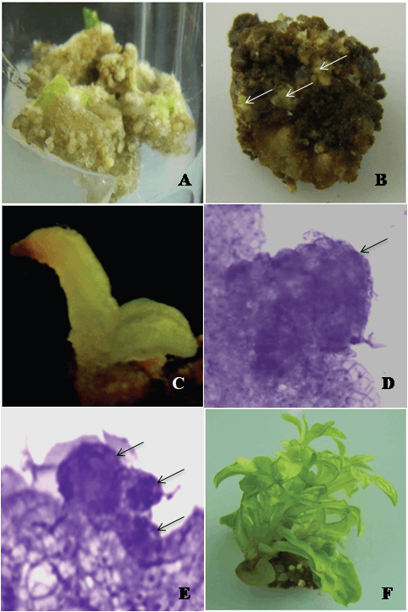

**Fig. 2:** **Direct organogenesis from leaf explants of A. lanata.(a)**and**(b)** Initiation of adventitious shoot buds (arrowhead) from leaf explants on MS medium containing 1.0mg L−1 TDZ. **(c)** Development of a shoot bud after 2 weeks of culture. **(d)**and**(e)** Leaf sections show a meristematic region (arrowhead). **(f)** Development of shoot buds after 3 weeks of culture.

***2.4. Influence on in vitro flowering***

TDZ has been demonstrated to be effective in inducing flowering in vitro for several plant species [17, 18]. An interesting feature found in the present study was that the treatment of leaf explants with TDZ in combination with NAA has a positive effect on flowering in vitro (Fig. 3A). Although 1.0mg L−1 TDZ with 0.5mg L−1 NAA achieved the highest ratio of flowering (data not shown) (Fig. 3B), it was not suited for multiple shoot formation. Meanwhile, TDZ alone or in combination with IAA failed to induce floral bud formation. In vitro flowering was also observed in Arachis hypogeal on MS medium containing cytokinins with NAA [19] and in Withaniasomniferaon MS medium containing cytokinins with IAA [20].

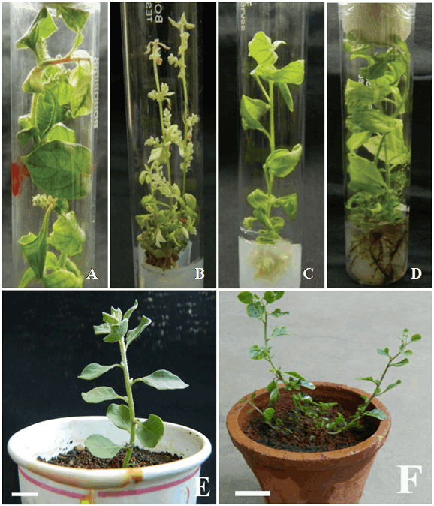

**Fig. 3: In vitro flowering and acclimatization of A. lanata. (a)**In vitro flowering on MS medium containing 1mg L−1 TDZ and 0.25mg L−1 NAA **(b)**In vitro flowering with inhibited shoot growth on MS medium containing 1mg L−1 TDZ and 5mg L−1 NAA **(c)** and **(d)**In vitro root induction in half-strength MS medium containing 1mg L−1 IBA **(e)** and **(f)** An acclimatized plant survived ex vitro.

***2.5. Rooting and establishment of plantlets***

For root development, 25mm regenerated shoots were excised and cultured on half-strength MS medium containing 0.5–2.0mg L−1 IBA for 7 days in plantlets in pots filled with soil, perlite, and vermiculate (1:1:1; v/v/v) mixture and acclimatized for 2 weeks under higher humidity before transferring to garden pots [21]. The success of micropropagation relies on the rooting percentage and survival of plantlets upon transfer to the field. Regenerated shoots larger than 25mm were selected and transferred to IBA media for rooting (Fig. 2C). The maximum frequency of rooting (86.6%) with the highest number of (11.7 ± 0.15) roots per shoot was obtained in IBA at 1mg L−1 after 28 days (Fig. 3D and 4). Shoots induced by TDZ and subsequently rooted in IBA have also been reported in Cyamopsistetragonoloba[22]. More than 200 plantlets with 4 to 5 fully expanded roots were successfully hardened off inside the growth chamber within a period of 4 weeks (Fig. 2E and F). Thereafter, these plantlets were transferred to soil and maintained in a shade house with a survival rate of 92.0%. Regenerated plants grew well and were phenotypically similar to the parental stock.

**Fig. 4:** Effect of IBA on *in vitro* rooting of *A. lanata* regenerated shoots after 28 days.

***2.6. Histological investigations***

The origin of the adventitious shoots was studied using histological analysis. Standard procedures were followed for histological studies [23]. The samples were fixed for 24 hours in FAA (70% ethanol, formalin, and acetic acid = 90:5:5; v/v/v), dehydrated in a graded ethanol series, and embedded in paraffin (58°C). Sections (~10 𝜇m thick) were stained with toluene blue O. The prepared slides were examined through a light microscope (Leica, Switzerland), and all images were photographed using a digital camera (Nikon, Japan). Histological analysis provided morphological details of the process of organogenesis from the leaf explants of A. lanata. One week after culture initiation, epidermal cells of the explants exhibited continuous cell division, leading to the formation of numerous dome-shaped meristematic protrusions with high cytoplasmic content and prominent nuclei (Fig. 2D and E). At later stages of development, adventitious shoot formation occurred, and shoots were formed directly from these meristematic protrusions. Similar findings have also been reported for Saintpauliaionantha[24], Chiritaspp. [25], and Titanotrichumoldhamii[26].

**3. Indirect organogenesis**

***3.1. Plant material and culture conditions***

Three-month-old nodal explants of field-grown A. lanatawere collected and surface sterilized by following the method of [27]. The nodal explants were inoculated onto MS [28] solid medium containing BA 1.5 mg/l and NAA 0.5 mg/l. The pH of the medium was adjusted to 5.7±0.1 using 1 N KOH/HCL prior to autoclaving at 1.05 kg cm-2 pressure at 121˚C for min. The cultures were maintained at 24±2˚C with 16-h light from cool white fluorescent lamps (57 mmol m-2 s-1 of photosynthetically active radiation).

***3.2. Induction of callus***

The effect of different concentrations and combinations of 2,4-D and NAA on callus induction from leaf and nodal explants of A. lanatais given in Table 2. The MS basal medium without growth regulators exhibited no callus formation. All the calli in the growth regulator supplement with media were observed to be initiated from the cutting edge of both leaf and nodal explants. The induced callus was fast-growing, yellow-green, and compact. Among the different concentrations of 2,4-D tested, the maximum callus induction response (67.0%) was on the medium containing 0.5 mg L-1 2,4-D. This response increased to 90.0% when 0.5 mg L-1 2,4-D was used in combination with 0.2 mg L-1 NAA (Fig. 5A and B). Compared, nodal explants formed calluses (78.7%) when cultured on MS basal medium supplemented with 0.5 mg L-1 2,4 D and 0.2 mg L-1  NAA. Whereas no callus formed in the presence of any concentrations of 2,4-D and 6-benzyladenine (BA) (data not shown). Comparatively, leaves responded better than nodal explants.

**Table 2: Effect of different concentrations and combinations of auxins on callus formation from leaf and nodal segments**

|  |  |  |  |  |  |
| --- | --- | --- | --- | --- | --- |
| **Plant growth regulators** | | **Leaf** | | **Node** | |
| **2,4-D** | **NAA** | **Callus induction frequency (%)** | **Nature of callus** | **Callus induction frequency (%)** | **Nature of callus** |
| 0.0  0.2  0.3  0.5  1.0  2.0  0.2  0.3  0.5  1.0  2.0 | 0.0  -  -  -  -  -  0.1  0.1  0.2  0.5  1.0 | 0.0  44.3h  49.9f  67.0b  63.6d  50.1f  52.3e  68.7b  90.0a  65.6c  48.4g | -  Yellowish green compact  White green compact  Yellowish green compact  Yellowish green compact  White green compact  Yellowish green compact  White green compact  Yellowish green compact  Yellowish green compact  White green compact | 0.0  39.6  46.8  59.0  54.1  40.2  42.1  55.3  78.7  63.6  52.4 | -  Brownish green compact  White green compact  Green compact  Brownish green compact  Brownish green compact  Brownish green compact  White green compact  Brownish green compact  Green compact  Brownish green compact |

***3.3. Germination of callus***

Subcultured callus demonstrated differential (regeneration) responses according to the concentrations and combinations of growth regulators in the culture medium. The medium containing 1.0 mg L-1 BA and 0.5 mg L-1 NAA was significantly different compared to other concentrations, as it induced the highest percentage (89.5%) of callus cultures to form multiple shoots developed and elongated, with the highest number of shoots per callus of 7.2 and the highest mean length of 3.8 cm recorded after 7 weeks of culture (Table 3; Fig. 5C and D). The combination of BA and NAA was generally more effective than KIN and NAA in inducing shoot formation from the leaf-derived callus. A few studies have shown that BA was more effective than KIN in enhancing shoot proliferation for several plant species, including Geoderumpurpureum[29], Curculigoorchioides[30], and Rubus[31].

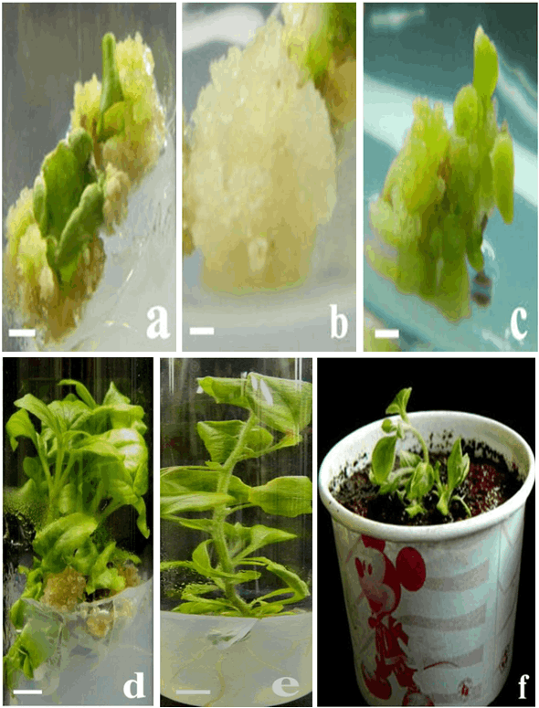

**Fig. 5: Callus induction and regeneration of plantlets from callus in A. lanata(a** and **b)** Induction of calli from leaf segments on MS medium supplemented with 0.5 mg L-1  2,4-D, and 0.2 mg L-1  NAA after 3 weeks of culture. **(c)** Initiation of multiple shoots from calli on MS medium supplemented with 1.0 mg L-1 BA in combination with 0.5mg L-1  NAA after 4 weeks of culture **(d)** Multiplication of shootlets on the same medium after 7 weeks of culture. **(e)** Rooting of the regenerated shoot with 1.0 mg L-1 IBA after 4 weeks of culture **(f)** An acclimatized plant survived in vitro.

**Table 3: Effect of different combinations and concentrations of cytokinins and auxin on shootregeneration of the leaf-derived callus culture**

|  |  |  |  |  |  |
| --- | --- | --- | --- | --- | --- |
| **Plant growth regulators (mg L-1)** | | | **Regeneration frequency (%)** | **Mean number of shoots per callus** | **Mean number shoot length (cm)** |
| **BA** | **KIN** | **NAA** |
| 0.0  0.2  0.5  1.0  2.0 | 0.2  0.5  1.0  2.0 | 0.0  0.1  0.2  0.5  1.0  0.1  0.2  0.5  1.0 | 0.0  54.8  67.2  89.5  76.3  52.4  59.7  67.3  47.2 | 0.0  3.2±0.1  5.6±0.3  7.2±0.2  4.0±0.2  2.1±0.3  2.8±0.4  3.0±0.1  2.2±0.5 | 0.0  2.1±0.3  2.6±0.1  3.8±0.2  2.6±0.4  1.8±0.4  2.3±0.5  2.7±0.1  1.0±0.3 |

***3.4. Hardening***

In vitro-derived shoots separated from multiple-shoot clusters started to root after 3 weeks of culture, and well-developed roots were recorded in 4-5 weeks on MS medium supplemented with 1.0 mg L-1 IBA (Table 4). The highest rooting response (88.5%) was achieved on the medium supplemented with 1.0 mg L-1 alone, with a mean number of 8.1 roots per shoot and a mean length of 4.4 cm (Fig. 5E). Stimulation of rooting by IBA in the present study agrees with similar findings in other medicinal plant species, including Limoniumwrightii[32], Nolinarecurvata[33], and Vignaunguiculata(34). The rooted plantlets were transferred into the soil mixture of perlite and vermiculate (1:1:1; v/v/v) without damaging their root systems and maintained in the shade house (Fig. 5F). Survival of 86.0% of plantlets was achieved during hardening for the first 4 weeks under 85.0% shading. The in vitro-derived plants were eventually transferred to their natural habitat. The regenerated plants did not show detectable variation in morphology and growth characteristics when compared with those of the mother plant.

**Table 4: Effect of different concentrations of IBA on root formation from regenerated shoots.**

|  |  |  |  |
| --- | --- | --- | --- |
| **IBA (mg L-1)** | **Response of roots**  **(%)** | **Mean number of**  **roots per shoot** | **Mean root**  **length (cm)** |
| 0.0  0.25  0.5  1.0  1.5  2.0 | 0.0  50.4  70.8  88.5  76.2  72.0 | 0.0  4.3±0.2  5.2±0.2  8.1±0.3  6.2±0.2  3.7±0.4 | 0.0  2.1±0.3  3.3±0.2  4.4±0.2  3.6±0.1  2.7±0.4 |

***3.5. Histological analysis***

Leaf explants were used for the initiation of the callus, and a histological study was carried out to confirm the origin of the shoot tip. In this case, it was observed that the undifferentiated mass of cells, called the primary callus, was derived from the parenchymatous cells of the explants. A detailed study showed that small groups of cells were surrounded by larger cells, and these two types of cells together gave rise to the shoot apical meristem. The meristematic division and the details are shown in Fig. 6A. The detailed histological analysis showed that the shoots regenerated from the leaf-derived callus of A. lanata have no organized cellular connection with the original explant tissue, indicating an adventitious shoot origin (Fig. 6B-D).

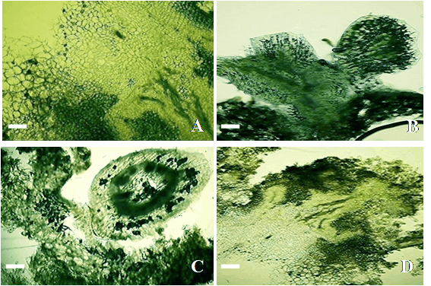

**Fig. 6: Histological analysis of indirect organogenesis (A)**Meristemoid development within the callus mass **(B)** Development of multiple shoot buds **(C** and **D)** Development of shoot buds with leaf primordia.

**4. Conclusion**

According to this study, TDZ is an efficient growth regulator for promoting shoot proliferation and adventitious shoot regeneration from leaf explants of A. lanata. However, along with NAA, it significantly influences in vitro flowering. Shoot proliferation rate was higher on MS medium containing 1.0 mg L−1 TDZ, and efficient rooting was observed on half-strength MS medium containing 1.0 mg L−1 IBA. This protocol is cost-effective and will help in the rapid multiplication, large-scale production, and conservation of A. lanata. This improved method for plant regeneration could be helpful for the study of phytomedicine production, somaclonal variation, and genetic transformation.

**References**

[1] Dulger B,Gonuz A. Antimicrobial activity of some Turkish medicinal plants. *Pakistan* Journal of Biological Science 2004; 7:1559–1562.

[2] Chandra S, SastryMS.Chemical constituents of *Aervalanata*. Fitoterapia 1990; 61(2):188.

[3] Zapesochnaya GG, Pervykh LN, Kurkin VA. A study of the herb *Aervalanata*. III. Alkaloids. Chemistry of Natural Compounds 1991; 27(3): 336–340.

[4] Surya MS, Ashiq M, Jayachandran K. *In vitro* production of vanillin from suspension culture of *Aervalanata*(L.) Juss. Ex Shultes. Indian Journal of Life Science 2012;2(1): 9–15.

[5] Shekhawat MS, Manokari M, Revathi J. In vitro propagation and ex vitro rooting of *Aervalanata* (L.) Juss. exSchult.: a rare medicinal plant. Indian Journal of Plant physiology 2017;22: 40-47.

[6] Vidhya R,Udayakumar R. Antifungal efficacy of leaf, flower and root of *Aervalanata* (L.) against selected fungal pathogens. Journal of Immunology Clinical Microbiology 2017; 2(1): 7-13.

[7] Sahu AR, Panigrahi J. Assessment of genetic fidelity of micro propagated plants of *Aervalanata* (L.) Juss. exSchult using DNA markers. Acta Scientific Agriculture 2018; 2(1): 121-125.

[8] Boobalan S, Kamalanathan D. Tailoring enhanced production of aervine in *Aervalanata* (L.) Juss. exSchult by *Agrobacterium rhizogenes*-mediated hairy root cultures. Industrial crops and products 2020;

[9] Varutharaju K, Thilip C, Raja P, Thiagu G, Aslam A, Shajahan A. An improved culture system for efficient shoot multiplication in *Aervalanata* (L.) Juss. exSchult. Plant tissue culture and biotechnology 2021; 31(1): 35-42.

[10] Yamunadevi M, Wesely EG, Johnson M. A Chromatographic study on the Glycosides of *Aervalanata*L. Chinese Journal of Natural Medicines 2011; 9(3): 210–214.

[11] Rajanna L,Nagaveni C, Ramakrishnan M. *In vitro* shoot multiplication of a seasonal and vulnerable medicinal plant- *Aervalanata*L. International Journal of Botany 2011; 7(3): 255–259.

[12] Rajesh R, Chitra K, Paarakh PM. *Aervalanata*(Linn.) Juss. exSchult.—an overview. Indian Journal of Natural Products and Resources 2011; 2(1): 5–9.

[13] Sahu AR, Rath SC, Panigrahi J. *In vitro* propagation of *Aervalanata*(L.) Juss. exSchult. through organogenesis. Indian Journal of Biotechnology 2013; 12: 260–264.

[14] Parveen S, Shahzad A, Anis M. Enhanced shoot organogenesis in *Cassia angustifolia*Vahl.—a difficult to root drought resistant medicinal shrub. *Journal* of Plant Biochemistry and Biotechnolgy 2012; 21(2); 213–219.

[15] Guo B, Amanda R, Stiles, Liu CZ. Thidiazuron enhances shoot organogenesis from leaf explants of *Saussurea involucrate* Kar. etKir. In Vitro Cellular and Developmental Biology 2012; 48(6): 609–612.

[16] Ghimire BK, Yu CY, Chung IM. Direct shoot organogenesis and assessment of genetic stability in regenerants of *Solanumaculeatissimum*Jacq. Plant Cell, Tissue and Organ Culture 2012; 8(3): 455–464.

[17] Gill R, Saxena PK. Somatic embryogenesis in *Nicotianatabacum*L.: induction by thidiazuron of direct embryo differentiation from cultured leaf discs. Plant Cell Reports 1993; 12(3): 154–159.

[18] Lin CS, Chang WC. Micropropagation of *Bambusaedulis*through nodal explants of field-grown culms and flowering of regenerated plantlets. Plant Cell Reports 1998; 17(8): 617–620.

[19] Lin CS, Lin CC, Chang WC. *In vitro* flowering of *Bambusaedulis*and subsequent plantlet survival. Plant Cell, Tissue and Organ Culture 2003; 72:71–78.

[20] Narasimhulu SB, Reddy GM. *In vitro* flowering and pod formation fromcotyledons of groundnut (*Arachishypogaea*L.). Theoretical and Applied Genetics 1984; 69(1): 87–91.

[21] SoundarRaju C, Kathiravan K, Aslam A, Shajahan A. An efficient regeneration system via somatic embryogenesis in mango ginger (*Curcuma amada*Roxb.). Plant Cell Tissue and Organ Culture 2013; 112: 387–393.

[22] Saritha KV, Naidu CV.*In vitro* flowering of *Withaniasomnifera*Dunal.—an important antitumor medicinal plant. Plant Science 2007; 172(4): 847–851.

[23] Nakano M, Nomizu T, Mizunashi K et al., Somaclonal variation in *Tricyrtishirta*plants regenerated from 1-year-old embryogenic callus cultures.ScientiaHorticulturae 2006; 110(4): 366–371.

[24] Ahmad N, Anis M. Rapid plant regeneration protocol for cluster bean (*Cyamopsistetragonoloba*L. Taub.). Journal of Horticultural Science and Biotechnology 2007; 82(4): 585–589.

[25] Ohki S. Scanning electron microscopy of shoot differentiation *in vitro* from leaf explants of the African violet. Plant Cell, Tissue and Organ Culture 1994; 36(2): 157–162.

[26] Nakano M, Takagi H, Sugawara S. et al., Adventitious shoot regeneration and micropropagation of *Chirita flavimaculata*WT. Wang, *C. eburnea*Hance, and *C. speciosa*Kurz. Propagation of Ornamental Plants 2009; 9(4): 216–222.

[27] Varutharaju K, SoundarRaju C, Thilip C, Aslam A, Shajahan A. High efficiency direct shoot organogenesis from leaf segments of *Aervalanata*(L.) Juss. Ex Schult by using thidiazuron. Scientific World Journal 2014; Article ID 652919: 6 pages.

[28] Murashige T, Skoog F, Skoog. A revised medium for rapid growth and bioassay with tobacco tissue cultures. Physiology of Plant 1962; 15: 473–497.

[29] Mohapatra A, Rout GR. *In vitro* micropropagation of *Geoderumpurpureum*R.Br. Indian Journal of Biotechnology 2005; 4: 568-570.

[30] Nagesh KS. High frequency multiple shoot induction of *Curculigoorchioides*Gaertn.: shoot tip V/S Rhizome disc. Taiwania 2008; 53(3): 242-247.

[31] Wu JH, Miller SA, Hall HK, Mooney PA. Factors affecting the efficiency of micropropagation from lateral buds and shoot tips of *Rubus*. Plant Cell Tissue Organ Culture 2009; 99: 17-25.

[32] Huang CL, Hsieh MT, Hsieh WC, Sagare AP, Tsay HS. *In vitro* propagation of *Limoniumwrightii*(HANCE) KTZE. (Plumbaginaceae), an ethnomedicinal plant, from shoot-tip, leaf and inflorescence node explants. In Vitro Cellular and Developmental Biology Plant 2000; 36: 220-224.

[33] Bettaieb T, Mhamdi M, Hajlaoui I. Micropropagation of NolinarecurvataHemsi.: b-Cyclodextrin effects on rooting. Scientia Horticulture 2008; 117: 366-368.

[34] Aasim M, Khawar KM, Ozcan S. *In vitro* micropropagation from plumular apices of Turkish cowpea (*Vignaunguiculata*L.) cultivar Akkiz. Scientia Horticulture 2009; 122: 468-471.