ARTIFICIAL INTELLIGENT EARLY DETECTION OF CARDIOVASCULAR DISEASE USING RICH INTERNET TECHNOLOGY APPLICATIONS

Paryati^{1*}
1*Informatics Engineering,Faculty of Industrial Technology, UPN"Veteran"Yogyakarta,Indonesia Street Babarsari No. 2 Tambakbayan Yogyakarta 55281
E-mail: yaya_upn_cute@yahoo.com, upnyaya@gmail.com

Abstract
A heart attack is the death of the heart muscle from the sudden obstruction of a coronary artery by a blood clot. Coronary arteries are blood vessels that supply the heart muscle with blood and oxygen. Blockage of the coronary arteries removes blood and oxygen from the heart muscle causing injury to the heart muscle. Injury to the heart muscle causes chest pain and pressure. If blood flow is not restored within 20 to 40 minutes, irreversible death of the heart muscle will begin to occur. The muscle continues to die six to eight hours at which time the heart attack is complete. The cause of a heart attack occurs due to a blockage of the coronary arteries after the rupture of an atherosclerotic plaque, which is a buildup of fatty acids and white blood cells in the walls of the coronary arteries that supply blood to the heart. The broken plaque creates blood clots. If the blood clot is large enough it can block the entire artery resulting in a heart attack. Most heart diseases are caused by high blood pressure which contributes to hardening of the arteries, high levels of bad cholesterol due to an uncontrolled diet with high levels of saturated fat and trans fat. It adds to the formation of atherosclerotic lesions and eventually arteries which can damage the lining of blood vessels and block the transport of oxygen and nutrients to the heart which can lead to the risk of heart attack. So the authors made a research application of interactive multimedia for heart disease with RIA technology. Software that supports the creation of this application is Adobe Flash CS3, Action script and Dreamweaver CS3. The system development methodology used is multimedia with the stages of concept, design, material collecting, assembly, testing. This application aims to be used as a medium of information and learning for people with heart disease and users about the definition of heart disease, its causes, various types of heart disease, symptoms, how to prevent and treat it.

Keywords : Artificial Intelligent, Rich Internet Application, Cardiovascular, Disease.

- INTRODUCTION.
A heart attack is the death of the heart muscle from the sudden obstruction of a coronary artery by a blood clot. Coronary arteries are blood vessels that supply the heart muscle with blood and oxygen. Blockage of the coronary arteries removes blood and oxygen from the heart muscle causing injury to the heart muscle. Injury to the heart muscle causes chest pain chest pressure. If blood flow is not restored within 20 to 40 minutes, irreversible death of the heart muscle will begin to occur. The muscle continues to die six to eight hours at a time when the heart attack is complete. The cause of a heart attack occurs due to a blockage of the coronary arteries after the rupture of an atherosclerotic plaque, which is a buildup of fatty acids and white blood cells in the walls of the coronary arteries that supply blood to the heart. The broken plaque creates blood clots. If the blood clot is large enough it can block the entire artery resulting in a heart attack. Most heart diseases are caused by high blood pressure which contributes to hardening of the arteries, high levels of bad cholesterol due to an uncontrolled diet with high levels of saturated fat and trans fat. It adds to the formation of atherosclerotic lesions and eventually arteries which can damage the lining of blood vessels and block the transport of oxygen and nutrients to the heart which can lead to the risk of heart attack. (Ikawati, 2011).
At this time there are many types of heart disease discoveries, so the authors conducted research on the application of heart disease with RIA technology. With advances in computer technology, it can help humans in various fields, one of which is interactive multimedia applications. Interactive multimedia is a computer program designed to model the ability to solve problems in more detail and interest. With the

development of interactive multimedia applications, heart disease applications can be made that can be used as a medium of information and knowledge for people with heart disease and the general public about heart disease, causes, types of heart disease, symptoms, prevention and treatment that can help heart disease patients. This system diagnoses the type of heart disease based on the symptoms experienced. Treatment is carried out based on the identification of the disease experienced by the patient which has been previously studied by experts, some are in the form of suggestions, suggestions, appeals.
The formulation of the problem is how to make an interactive multimedia application for heart disease with RIA technology that can help people with heart disease and for the general public.
The aim of this research is to make a learning application that can be used as a medium of information and knowledge for people with heart disease and the general public about the definition of heart disease, causes, types of heart disease, symptoms, ways of prevention and treatment that can help heart disease patients.
The system development methodology used in multimedia development includes the stages of concept, design, material collecting, assembly, testing (Suyanto, 2003). Making this system to the testing stage and the program was successfully executed according to its function.

LITERATUR REVIEW
The literature review that supports this research includes:
- Making Multimedia Applications to Help Learn Geometry. In this research the object is related to learning Geometry (Lisana, 2018).
- Kolb's Experiential Learning Model with Virtual Visualization to Improve Understanding of Concepts in Basic Electrical Physics Courses (Case Study: Informatics Engineering, University of Majalengka). In this research, the object is related to the learning of Basic Electrical Physics Course (Wahyuni, 2015).
The studies mentioned above are different from the research conducted by the author in making interactive multimedia applications for heart disease using Rich Internet Application (RIA) technology. But in general, there are many aspects obtained by previous researchers and can provide the information support needed in this study.

METODE
  - Concept
So far, information about heart disease is only obtained through books and the internet. People with heart disease have to be bothered by reading several books or looking for the information they need one by one by opening several web pages. Things like this often make people with heart disease feel bored quickly and become lazy to study and seek information about heart disease, its causes, types of heart disease, symptoms, prevention and ways of treatment.
This application is made by displaying various information about heart disease more practically because the information needed for heart disease is summarized in this application, both articles, pictures and videos, without having to search for information one by one on the internet. The display provided is more attractive and interactive so that users do not quickly feel bored in using and learning the information contained therein.
The concept of this application aims to assist heart disease patients in learning the definition of heart disease, causes, types of heart disease, symptoms, how to prevent and treat it more practical, interesting and interactive.

Design
Design (design) is a general description of the software system to be created. The purpose of the design is to provide a more general description to the user about the new application to be created, and to provide a complete design description as a guide for programmers in building the system. This design includes, navigation structure, flowchart view, and storyboard, collecting material.

Navigation Structure Design
The navigation structure used in making heart disease applications with RIA technology is a Hierarchical navigation structure, a navigation concept that begins with one node which is the main page and start page. The first page that will be encountered is the intro page, then it will enter the menu page. The menu has 5 submenus namely home, definition, causes, kinds, symptoms, prevention, treatment, exit. On the home page, it explains how the heart system works in humans. The Definition menu explains the meaning of heart disease. The Cause menu explains the causes of heart disease caused by age, heredity, smoking, diabetes, hypertension, obesity, lifestyle and emotions. On the menu, various types of heart disease consist of atherosclerosis, IMA, KKJ, GKJ, Ardiomyopathy, Arrimatia, PJR, Inflammation. The Symptoms menu consists of fatigue, chest pain, excessive sweating, headaches, nausea, body aches, irregular heartbeat,

shortness of breath, swelling when body fluids accumulate. The exit page contains a warning “yes” and “no” otherwise it will return to the menu page.

Figure 1. Structur Navigation

Design Flowchart View
Flowchart View is a diagram that provides an overview of the flow from one scene to another. In the flowchart view you can see the components contained in a scene along with the transition from scene to other scene, the relationship between one scene and another is expressed by a line following an arrow.

Storyboard Design
The storyboard design contains a visual description of the scene design, the audio used, the duration of each scene, and also information explaining the scene. The results of this storyboard will be used as a reference in making applications at the implementation stage.

Table Design
The following are database tables in designing RIA technology heart disease applications.

DISCUSSION AND IMPLEMENTATION
After the system has been analyzed and designed in detail, the next step is implementing the system. At this stage, the interface for cat and dog care applications with RIA (Rich Internet Application) technology using flash is displayed. It will also explain the hardware and software used in building a cat and dog care application with RIA (Rich Internet Application) technology along with pieces of ActionScript programs to link one file to another.

4,1 Devices Used
- The hardware specifications used to build this application are Processor Intel(R) Celeron(R) CPU N2840 @ 2.16GHz 2.16GHz, Memory 2.00 GB RAM, Hard drive 500 GB, Display 1366 x 768.
- The software used in building this application is as follows: Microsoft Windows 10 Home Single Language 64-bit Operating System, Programming Language: ActionScript 2.0, Graphic Processor: Adobe Flash CS 5 Professional.

Program Implementation
In this chapter we will discuss application programs, namely the appearance of the application, how the application works, so that it can produce the desired output and program modules for several processes that occur in the system. The application program is used as a means of connecting between the user and the computer, so that with the application program the user becomes easier. Here are some examples of the display of each scene in this application:

Display Menu Page
The menu page is the first scene that the user will encounter when entering this application. The following is a view of the page.
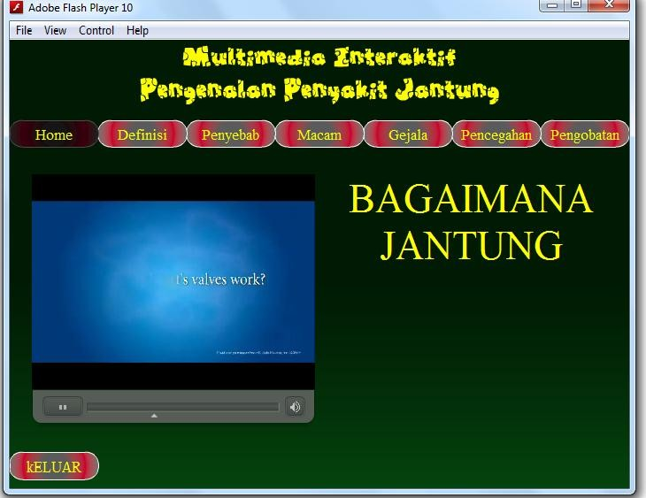
Figure 2. Display Menu Page.

Home Menu Page Display
The home menu page is the second scene that the user will encounter when entering this application. The following is a view of the page. This menu contains about how heart disease works.

Figure 3. Display Menu Home.

Definition Menu Page Display
The heart disease definition menu page is the third scene that the user will encounter when running this application. This scene contains various menus contained in the application. The following is a display of the menu page.
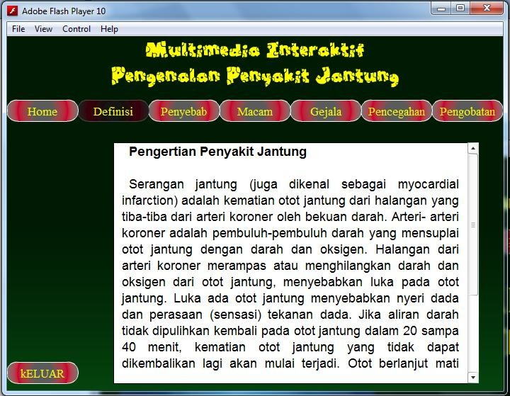
Figure 4. Display Menu Definition.

Display Menu Page Cause
The menu page that causes heart disease is the fourth scene that will be encountered by the user when running this application. This scene contains various menus contained in the application. The following is a display of the menu page.

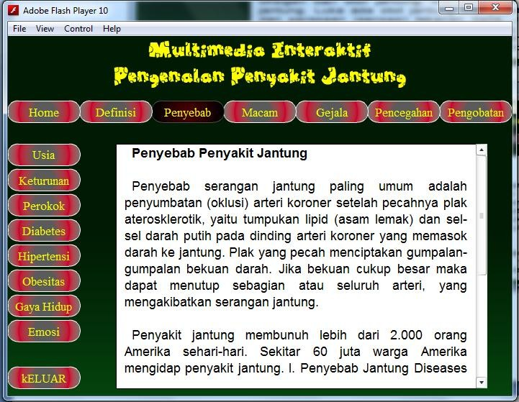

Figure 5. Display of the Cause Page.

Display Page Menu Sorts
The menu page for various heart diseases is the fifth scene that the user will encounter when running this application. This scene contains various menus contained in the application. The following is a display of the menu page.
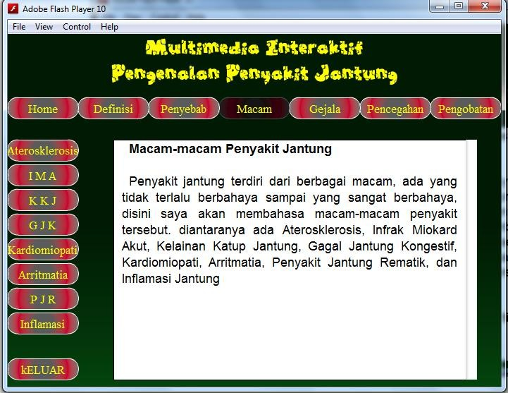

Figure 6. Display of Kinds of Cardiovascular Page.

Display of Symptom Menu Page
The symptom menu page is the sixth scene that the user will encounter when running this application. This scene contains various menus contained in the application. The following is a display of the menu page.
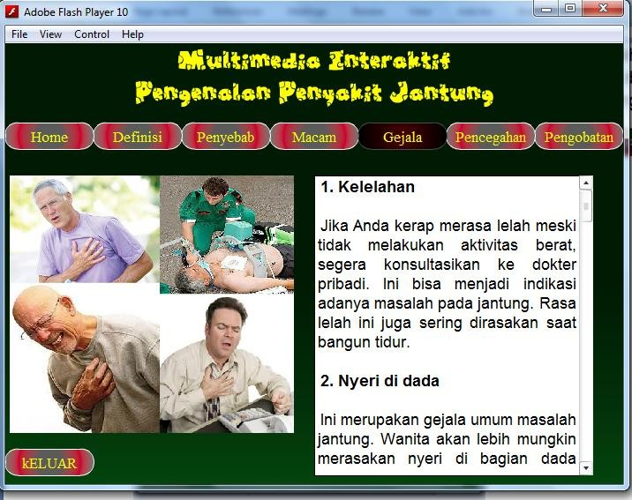

Figure 7. Display of Cardiovascular Symtom Page.

Prevention Menu Page Display
The heart disease prevention menu page is the seventh scene that the user will encounter when running this application. This scene contains various menus contained in the application. The following is a display of the menu page.
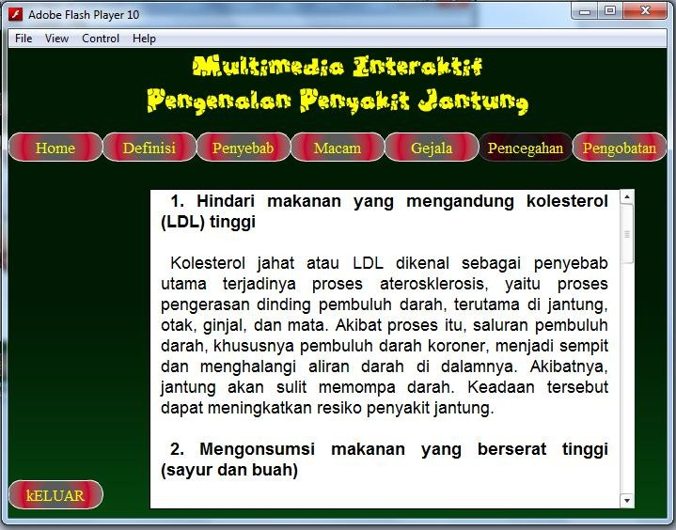
Figure 8. Display of Cardiovascular Prevention Page.

Display of Treatment Menu Page
The heart disease treatment menu page is the eighth scene that the user will encounter when running this application. This scene contains various menus contained in the application. The following is a display of the menu page.

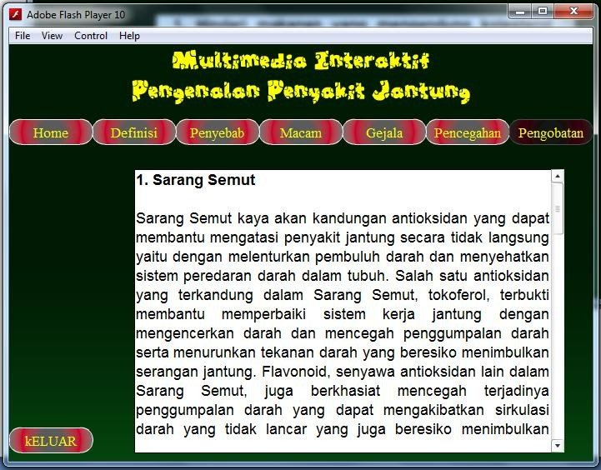

Figure 9. Display Page How to Treat Cardiovascular.

CONCLUSION.
Based on the results of this study, the following conclusions can be drawn:
a.Provide information to the user about the heart disease suffered, initial diagnosis based on the symptoms given.
- Help the user understand and obtain information about the types of heart disease.
- Assist users in identifying heart disease early, through processing symptom data, so that further treatment of the disease can be carried out quickly.
- Provide information to the user about how the treatment can be done and healing therapy.
- Data contained in the system can be updated or added as needed.

Bibliography
- Darma, Jarot, S, "Smart books master multimedia", PT. Transmedia, Jakarta, 2019.
- Hakim, Lukmanul, "Secret Core of PHP MySQLi Master (improved)", Yogyakarta: CV. Lokomedia, 2019.
- Ikawati, Z, "Pharmacotherapy of Heart Disease", Science Exchange, Yogyakarta, 2021.
- MADCOMS, "Advanced in 7 Days Adobe Flash CS6", Yogyakarta: Andi, 2023.
- Nugroho, B, 2014, Dynamic Web Programming Applications with PHP and MySQL, Gava Media, Yogyakarta.
- Sutopo, A.H, "Interactive Multimedia with Flash", Yogyakarta: Graha Ilmu, 2018.
- Suyanto, M, "Learning Interactive Multimedia", Andi Offset, Yogyakarta, 2018.
- Sutarman, "Building Web Applications with PHP and MySQL", Graha Science, Yogyakarta, 2018. Http://www.jantungkita.blogspot.com.
http://www.cfainc.org/

