Synthesis and Characterization of Tin Oxide (SnO) nanoparticles

Introduction:

Nanoparticles of metals and metal oxides are employed in a variety of applications, including catalysis, medicine, electronics, and others due to their unique chemical, thermal, optical, magnetic, and other characteristics compared to their bulk analogues. The use of supercritical fluids (SCF) has been proposed for a wide variety of synthesis processes, including the reverse micelle, fast expansion, and hydrothermal synthesis [1-3]. The hydrothermal procedure offers the most promising opportunities for the production of metal and metal oxide nanoparticles among these approaches [4-6]. SnO is a crucial semiconductor material due to its high electrical and thermal conductivity. SnO nanostructures have been shown to be an efficient photocatalyst, able to convert organic contaminants into less harmful small molecules. We provide herein a one-pot hydrothermal approach for the manufacture of SnO nanoparticles.
This chapter presents the synthesis of SnO nanoparticles. The synthesized SnO nanoparticles were characterized with X-ray Diffraction, TEM, SEM, FT-IR, EDAX and UV-Vis spectroscopy etc.

Synthesis of SnO Nanoparticles:
SnO nanoparticles were synthesized using a standard hydrothermal technique. The starting elements for the synthesis were SnCl₂.2H₂O and Dilute HCl. In a typical process, stock solutions of 0.1 M (2.3 g) SnCl₂.2H₂O are produced in 50 ml of 1.0 M HCl while stirring. Under constant stirring, an appropriate amount of urea was added to produce the stock solution of 250ml of SnCl₂ (0.1 M) to maintain a pH of 9 in the reactants.
The solution was placed in an autoclave lined with Teflon and heated to 150 degrees Celsius while under autogenous pressure for 1 hour. Finally, it was allowed to cool to room temperature on its own. The white solid product was rinsed with distilled water, filtered, and then dried in air at 60O C in an oven (figure 1) once the reaction was complete.
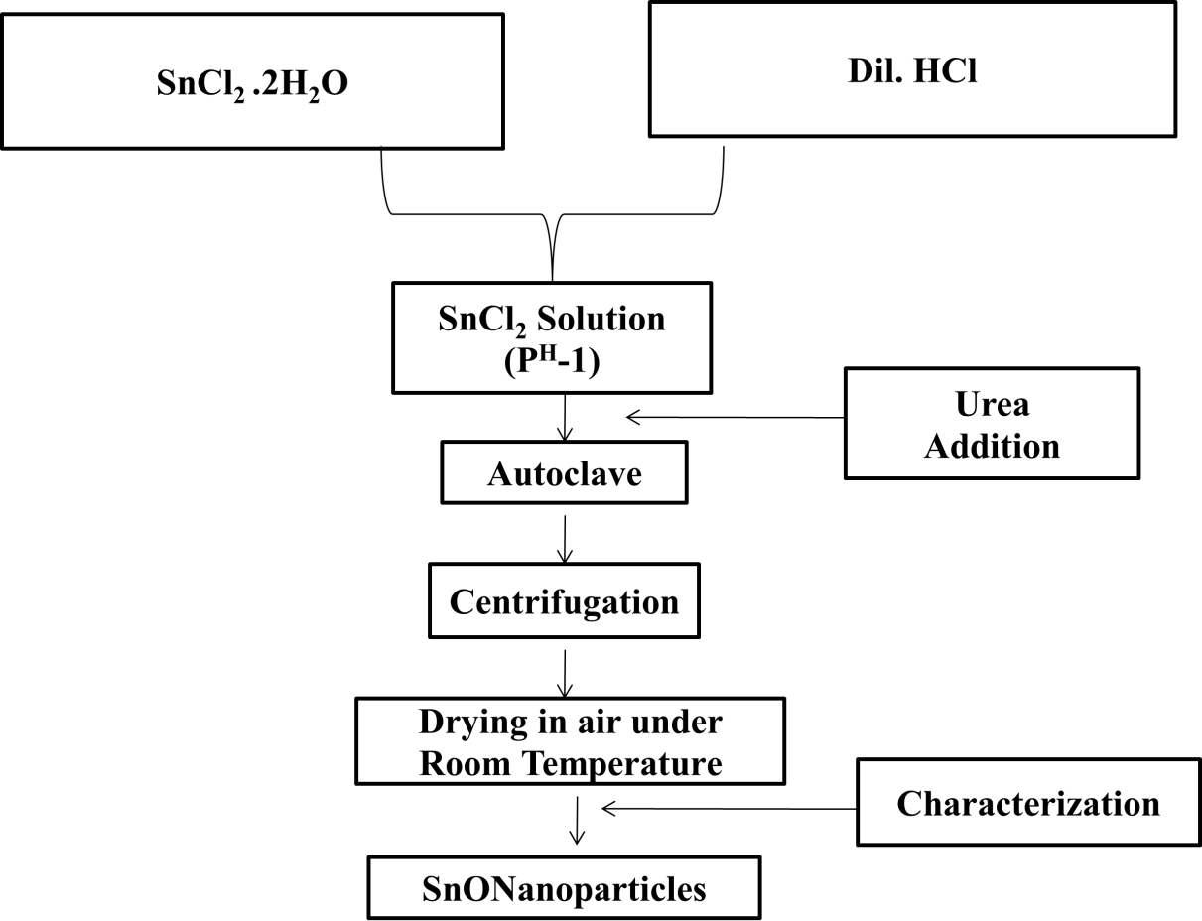

Figure 1: SnO Nanoparticles Synthesis Flowchart

Characterization of SnO nanoparticles
XRD of SnO nanoparticles
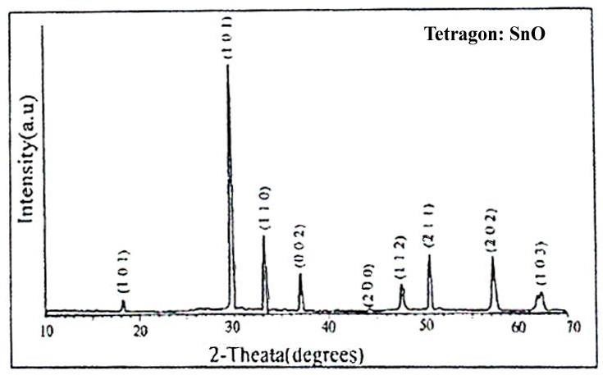
Figure 2: XRD pattern of SnO Nanoparticles

The recorded XRD pattern of SnO powder sample synthesized by hydrothermal technique is shown in figure 2. The calculated from the XRD data of SnO nano particles are found to be having diameter ~ 50 nm in size [7-8] with crystalline in nature. SnO nanoparticles formed in a polycrystalline phase, as seen by the XRD pattern, exhibiting a rutile structure with (0 0 1), (1 0 1), (1 1 0), (0 0 2), (2 0 0), (1 1 2), (2 1 1), (2 0 2) and (1 0 3) crystal planes at 18.2º, 29.8º, 33.2º, 37.1º, 44.3º, 47.8º, 50.7º, 57.3º, and 62.5º for SnO, and these values line up pretty well with the data from JCPDD No.36-1451.

TEM Micrograph of SnO Nanoparticles:

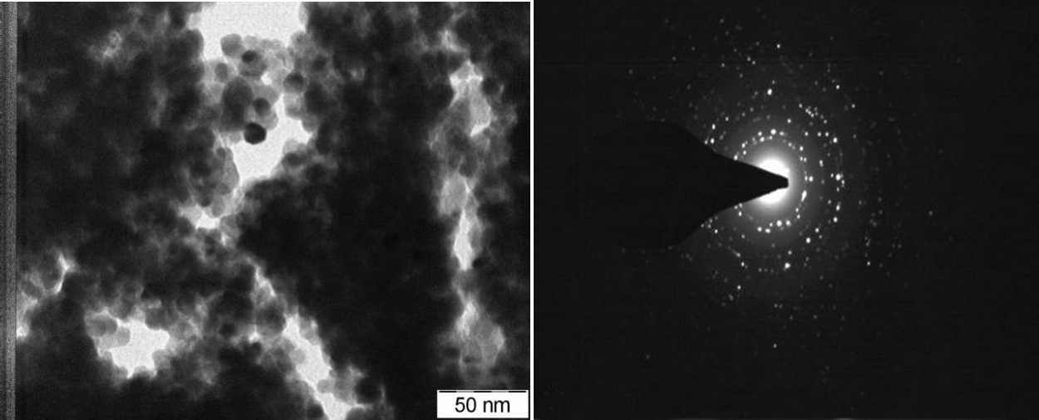

Figure 3: TEM of SnO nano partricles

Fig 3 represents the TEM image of SnO nanoparticles. SnO nanoparticles are easily discernible as tetragonal formations with a diameter of ̴50nm in TEM images, [7-10] which clearly indicates that the SnO nanoparticles are highly crystalline in nature.

SEM Micrograph of SnO Nanoparticles:

Figure 4 shows a scanning electron micrograph of SnO nanoparticles. Mesoporous particles with a molecular size of 50 nm are observed. Better clarity on the passivation of SnO nanoparticles' growing aspect can be seen in SEM micrographs at 1 nm. The formed shape of the composite was visible in the images, as were homogeneous particles with ̴100nm diameter. Furthermore, the closest look reveals that the particles synthesized using the hydrothermal process are mostly free of aggregation.
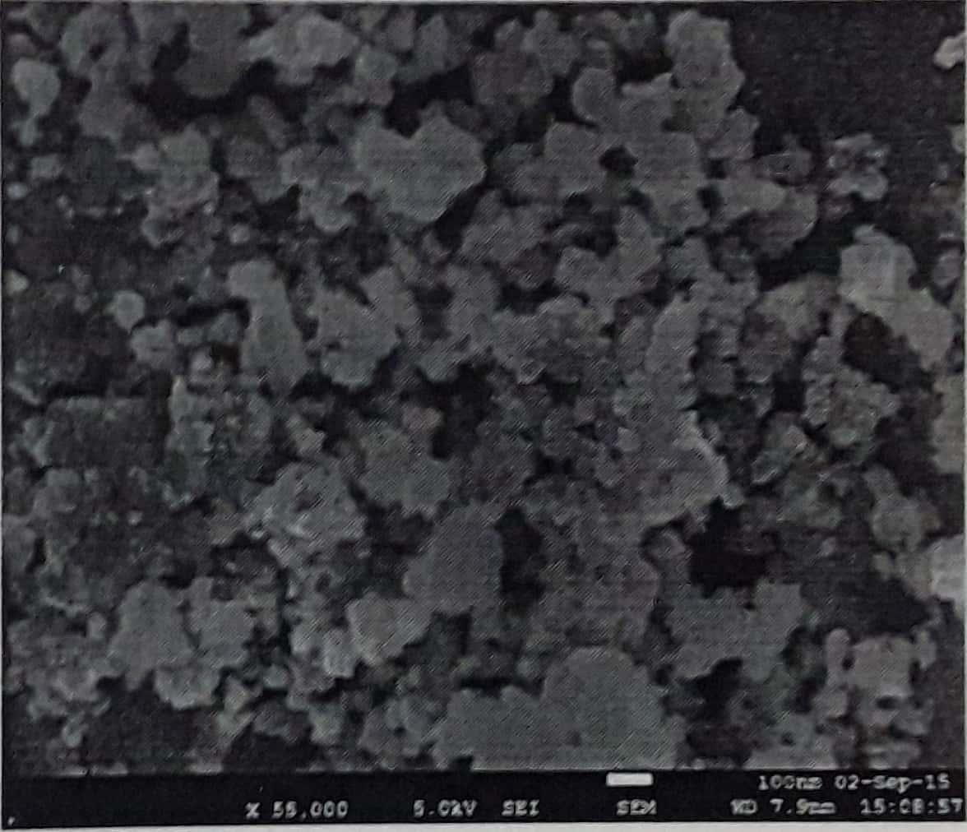

Figure 4: SEM image of SnO nanoparticles.

FT-IR Spectrum of SnO Nanopartilces:

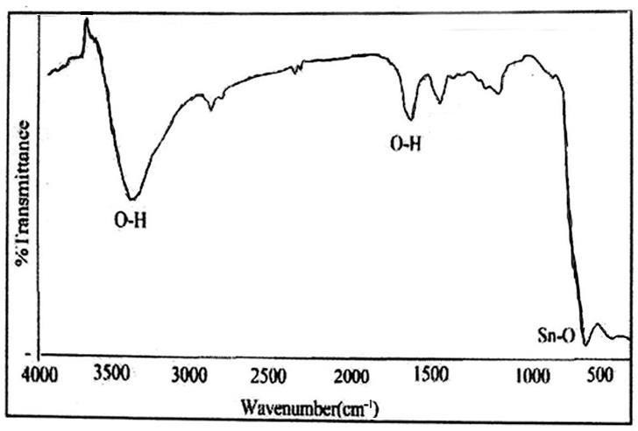
Figure 5: FTIR spectra of SnO nanoparticlas.

In the FT-IR spectrum of SnO nanoparticles, the O-H stretching vibration of surface hydroxyl collecting or adsorbed water is principally responsible for the solid vibrational peaks at 3456 cm⁻¹ and 1618 cm⁻¹. The peak was seen at 1409 cm⁻¹, which was assigned to N-O and may have resulted from the urea used in the experiment. A very strong Sn-O vibration may be seen at 515cm-1 in the low-wavenumber region, [7-8] which clear evidence of nanoparticle of SnO as shown in fig. 5.

EDAX of SnO Nanoparticles:

Table: 1 EDAX of SnO

Element | Weight % | Atomic %
O K | 31.29 | 45.29
Sn L | 68.71 | 54.71
Total | 100.00 | 100.00

Figure 7 EDAX graph of SnO nanoparticles and also obtained data from EDAX of SnO nanoparticles have shown in Table 1. EDAX examination carried out for SnO nanoparticles. The oxygen atomic weight percentage was determined to be 45.29%, while the tin atomic weight percentage was discovered to be 54.71% [8].

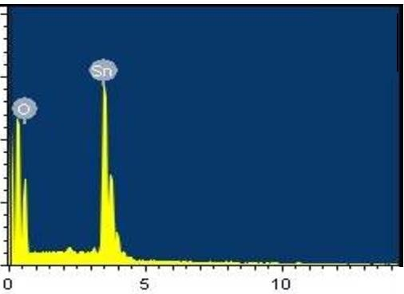
Figure 6: EDAX of SnO nanoparticles.

UV-visible spectroscopy:

The frequency at maximum absorbance was calculated. Using this method, we were able to calculate the band gap (in electron Volts) using given equation
𝐸 =
ℎ𝑐

𝜆

Where h is plank’s constant, E = 4.136 × 10−15 eV

The speed of light in vacuum, c = 3×108m/s
λ is wave1ength.

𝐸 =
4.136 × 10⁻¹⁵ × 3 × 10⁸
𝜆 =
1.241 × 10⁻⁶
𝜆 𝑒𝑉

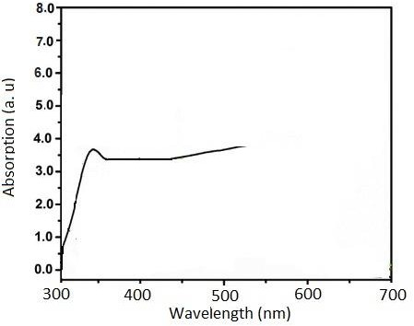

Figure 7: UV-visible spectroscopy of SnO nanoparticles.

Fig. 7 demonstrates the UV – Vis spectra of SnO nanoparticles. The absorbance spectrum was observed Energy band gap is 3.85 eV at 322 nm wavelength [11].

References:
[1]. Koster L. J. A., Mihailetchi V. D., Xie H. and Blom P. W. M., Appl Phys Lett, 2005, 87, 20.
[2]. Nikolay Radychev, Irina Lokteva, Florian Witt, Joanna Kolny- Olesiak, Holger Borchert, and Jürgen Parisi, J. Phys. Chem. C, 2011, 115(29), 14111.
[3]. V. Dyakonov, Thin Solid Films 451-52, 493-497(2004).
[4]. Jung, J. and Perrut, M. Journal of Supercritical Fluids, 2001,20, 179.
[5]. Zhang, Y. and Erkey, C. Journal of Supercritical Fluids, 2006, 38, 252.
[6]. Reverchon, E., Adami, R. and Caputo, G. Journal of Supercritical Fluids, 2006, 37, 298.
[7]. Tazikeh, S., Akbari, A., Talebi, A., & Talebi, E. (2014). Synthesis and characterization of tin oxide nanoparticles via the Co-precipitation method. Materials Science-Poland, 32(1),
98–101. doi:10.2478/s13536-013-0164-y.
[8]. Krishnakumar, T., Jayaprakash, R., Pinna, N., Phani, A. R., Passacantando, M., & Santucci, S. (2009). Structural, optical and electrical characterization of antimony-substituted tin oxide nanoparticles. Journal of Physics and Chemistry of Solids, 70(6), 993–999. doi:10.1016/j.jpcs.2009.05.013.
[9]. Xie Y, He Y, Irwin LP, Jin T, Shi X (2011) Antibacterial activity and mechanism of action of zinc oxide nanoparticles against Campylobacter jejuni. Appl Environ Microbiol 77:2325– 2331.
[10]. Akbar A, Anal AK (2014) Zinc oxide nanoparticles loaded active packaging, a challenge study against Salmonella typhimurium and Staphylococcus aureus in ready-to-eat poultry meat. Food Control 38:88–95.
[11]. Inbathamizh L, Mekalai Ponnu T, Jancy Mary E. Journal of Pharmacy Research, 2013, 6, 32.

