ENHANCED ADMISSION PREDICTION USING MACHINE LEARNING DURING COVID-19 PANDEMIC

¹R. Jayashree,
¹Assistant Professor, College of Science and Humanities, SRM Institute of Science and Technology, Kattankulathur, India

Abstract -The pandemic periods such as COVID-19 and other natural disasters significantly impact the education system. The number of school and college dropouts is increasing because of various reasons. The prevention of dropouts from educational institutions is significant in improving society. This paper analyzes the number of students discontinuing their studies at academic institutions yearly. Thus, the importance of preventing dropouts from the education system is emphasized in this study.

Keywords – Educational system, Pandemic situation, Classification, Predication.

Introduction

The COVID-19 pandemic is anticipated to have a huge influence on global education [2]. Throughout the world, student recruitment and retention are the foremost problem areas for universities and colleges. UNESCO released its figures on 23rd March 2020 stating that 1.3 billion students around the world are unable to attend schools or universities due to COVID-19 pandemic [2]. The report enumerated the long-term impact of the pandemic on the student’s productivity and learning throughout their life in the South Asian region [6]. Thus, not only admission practices and criteria, but the entire recruitment processes need a new method of outreach to handle the high risk of losing students. Recruiting and retaining high-quality teachers is essential for student learning.
Many education institutions need to manage a financial crisis since parents are unable to pay the fees on time [1]. As per “Centre for Monitoring Indian Economy”, in early April 2020, the unemployment shortage is between 8.4% and 23%. The unemployment rate is 30.9% in the urban location [7]. Admission deadline has been extended for more than 300 institutions to give students additional time to decide during this pandemic situation and many institutions waived entrance exam marks requirements for admission [4]. Despite all these adjustments, newcomer enrolment for the academic year 2020 is declined by 13% and according to the National Student Clearinghouse Research Centre, the overall enrolment dropped by 3.3% as a recent study. Of course, the percentage of enrolment declines vary by institution, on average, newcomer enrolment dropped by 18.9% in community colleges followed by 10.5% in public universities and colleges. International student freshman enrolment declined by 43% [4].

Review of Status of Research and Development
The corona virus pandemic has significantly affected the higher education institutions which is a perilous factor of India’s economic future [1]. Richa Choudhary [1] presented a study based on the forecasting model for admission from the student’s perception. The forecasting is carried out with the help of students’ previous performance and marks history. Cochran et al. [14] discussed barriers that stop students from joining the higher study. The GRE score in admission decision is viewed as a burdensome barrier on students’ side and also dependable with various admissions practices at many institutions [14]. Chari and Geoff [15] explained the importance of the admission criteria. The different departments or streams of an institution, like Computer Science, Biotechnology, Mathematics, Commerce, so on, receive different numbers of applications from students for admission. This number represents the weight-age of that department. Supervised or unsupervised learning techniques are used in the student dropout prediction model.
Students’ dropout problem must be seriously addressed and this is done through the application of Machine learning techniques which generates datasets with category information (academic performance, personal data or socio-economic) [5] under various platforms such as MOOC and LMS.
Several research works are conducted in various educational sectors by including the application of machine learning techniques [8–11]. Amal et al. [12] presented a model for predicting the probability of joining in a postgraduate course in the targeting universities that are appropriate for the given graduate student profile. Tampakas et al. [16] presented a graduation time prediction model based on students’ performance using a two-level algorithm for classification. The two major features of this algorithm are:
(1) Identify the students who are at high risk of dropping out (discontinue) of their studies with maximum accuracy.
(2) Classify the students based on their expected graduation time.

The studies paintings at the education sector with device gaining knowledge of strategies are largely categorised into the subsequent classes:

- Predicting what is the likelihood of a student getting admission to an institution of his/her preference.
- Predicting how probable an applicant gets admission based on the information provided in the application file [8].
- Predicting how many students discontinue their studies before graduation (dataset size 189) [9.16].
- Predicting what is student performance and progress (dataset size 288 and 2260) [10,13].
- Predicting whether a pupil will take up an admission or not.
- Prediction of students’ graduation time [16].

Importance of Admission Prediction in Education

The current economic recession will put a large number of teaching and non-teaching people jobs at risk. In [15] addressing the difference amongst faculty in their viewpoints on admissions practices within sectors is not possible even though the survey response rate was above 75%, since in most of the cases the responses represent an individual person from each institution. Dataset is not enough and the results are supported with statistical inference. If large data-sets are acquired, then the cost for further research must be developed [16]. Several researchers ignore the situation that estimation techniques and machine of measurement must be applicable to all tiers of educational administrators.

- RESULTS AND DISCUSSION

Lakkaraju et al. [3] suggested that the estimation methods should be designed to satisfy the wishes of educators instead of simplest targeted on generally used machine getting to know metrics. In addition, many literatures centered simplest on offering early prediction. aside from prediction, a greater dependable, robust and entire early-warning version is wanted with the functionality of figuring out college students vulnerable to dropout in future buddies. Need to extract records approximately key-factors affecting students’ overall performance from numerous sectors that are crucial to model a machine for ranking according to their chance of dropping and figuring out students at hazard even earlier than they drop[16].

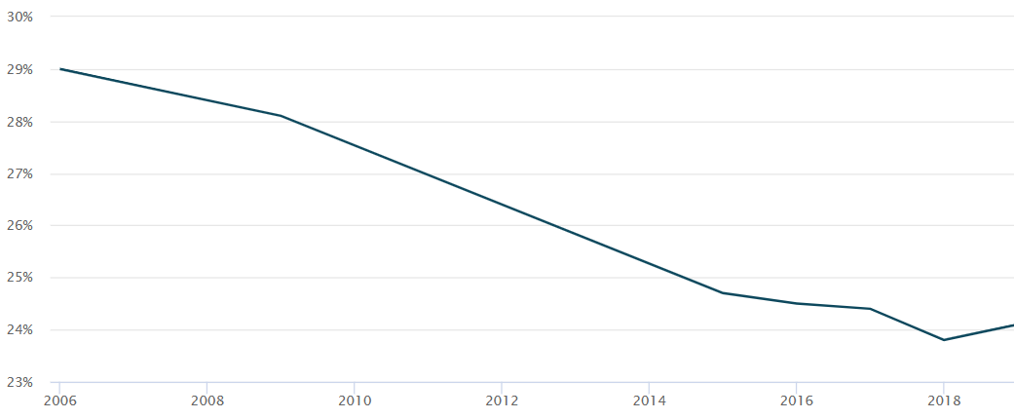
Fig.1. First-year college students drop out percentage at all institutions

Educational institutions are classified as,
- Public-institutions (PI)
- For-profit-institutions (FPI)
- Nonprofit-institutions (NPI)

In 4-year institutions, the percentage of first-time undergraduates retained for PI is 58.5% in the year 2020 which is 2.3% lesser than the previous year. In the case of FPI and NPI the student’s retained rates are 54.7% and 64.4% respectively. Therefore, the overall drop out percentage for full-time students in any 4-year institution is 40.8%

In 2-year institutions, the percentage of first-time undergraduates retained for PI is 60.5% in the year 2020 which is 2.3% lesser than the previous year. In the case of FPI and NPI the student’s retained rates are 67.4% and 68.1% respectively. Thus, the overall drop out percentage for full-time students in any 2-year institution is 34.67%

This is for full-time students, whereas for part-time students in all types of institutions, the drop-out percentages are,
PI – 58.3%
FPI- 55.6%
NPI – 57.1%
Here, drop-out list excludes the students
- who died or
- totally disabled or
- served in the armed forces and called to active duty or
- served with a foreign aid service of the federal government or
- served on official church missions

Fig.1 illustrates the First-year college students’ drop out percentage at all institutions.Comparingdrop outs of full-time students with part-time students shows that the drop outs rate of part-time students is 19.27% higher than part-time students.
From [17] first year college students who drop out of their study after their first year reveals that the drop out percentage is 31% in the year 2021. The study also states that school drop outs are greater than college drop out percentage as shown in Fig.2.

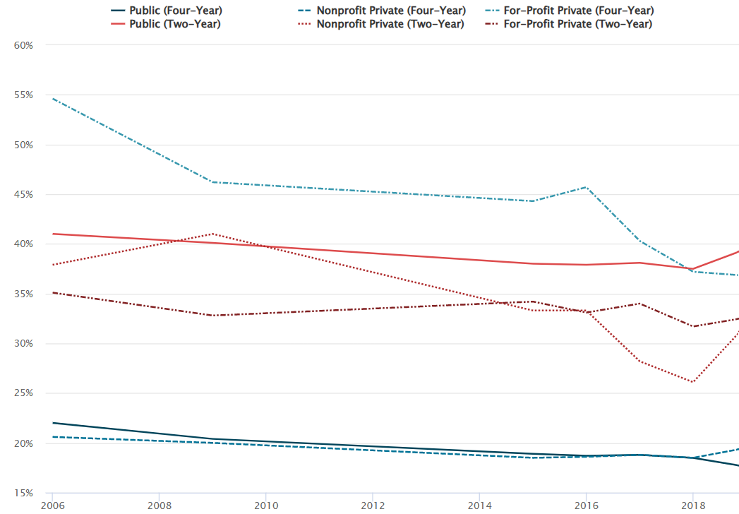
Fig.2. School students drop out percentage at all institutions

- CONCLUSION

As a conclusion, all the reviewed literatures focus on the admission process prediction from student’s point of view and also, they are not truly dependable taking into consideration of their accuracy and reliability. Thus, prediction on how many students are interested to joint in a respective academic institution by considering past data and ratio of student expectations and institution availabilities is the most required research field. Interested students’ data (overall score/rank) must meet with the target institution criteria.
In addition, the proposed project forecast the effects of unexpected events, like COVID-19 and significantly the size of dataset is huge than those used in the previous literature studies. A system using machine learning algorithms for forecasting student admission on an educational institution from that institution perspective assist the institution to identify the resource requirements and to take necessary steps accordingly. The employee of a respective institution also receives prior information about their upcoming days in that institution.

Undoubtedly, machine learning application still faces numerous challenges in education sectors which need to be addressed. Literature reviews shows the importance of considering student dropouts in an institution. Analysing the source institutions of the previously dropped out students’ detail measures the value of that institution apart from institutional ranking. Dropout rate is high for first one year after joining an institution [16]. Thus, monitoring students’ performance periodically for first one year is vital in the reduction of the dropouts.

REFERENCES

- www.ETGovernment.com. “COVID-19 Pandemic: Impact and Strategies for Education Sector in India - ET Government,” ETGovernment.com, government.economictimes.indiatimes.com/news/education/covid-19-pandemic-impact-and-strategies-for-education-sector-in-india/75173099.

- World Economic Forum, “COVID-19’s Staggering Impact on Global Education.” ,www.weforum.org/agenda/2020/03/infographic-covid19-coronavirus-impact-global-education-health-schools/.

- H. Lakkaraju, E. Aguiar, C. Shan, D. Miller, N. Bhanpuri, R. Ghani, and K.L. Addison, “A Machine Learning Framework to Identify Students at Risk of Adverse Academic Outcomes,” Proceedings of the 21th ACM SIGKDD International Conference on Knowledge Discovery and Data Mining,1909–1918, 2015. DOI: https://doi.org/10.1145/2783258.2788620.

- Smalley, Andrew. “Higher Education Responses to Coronavirus (COVID-19),” National Conference of State Legislatures, 27 July 2020, www.ncsl.org/research/education/higher-education-responses-to-coronavirus-covid-19.aspx.

- C. Lei and K.F. Li, “Academic Performance Predictors,” In: Proceedings – IEEE 29th International Conference on Advanced Information Networking and Applications Workshops, WAINA 2015. DOI: https://doi.org/10.1109/WAINA.2015.114

- B. Dhawan,“Coronavirus Impact on Education: Schools, Edtech Platforms Step up with Innovative Teaching Methods to Impart Knowledge,” The Financial Express, 14 Oct. 2020, www.financialexpress.com/education-2/coronavirus-impact-on-education-schools-edtech-platforms-step-up-with-innovative-teaching-methods-to-impart-knowledge/2105462/. Accessed 26 Dec. 2020.

- S.G.U.A. 23, “Impact of Coronavirus on Education in India,” Jagranjosh.com, 23 Apr. 2020, www.jagranjosh.com/general-knowledge/impact-of-coronavirus-on-education-in-india-1587642880-1.

- I.E. Livieris, T. Kotsilieris, V. Tampakas, and P. Pintelas, “Improving the evaluation process of students’ performance utilizing a decision support software,” Neural Comput. Appl. 2018, doi:10.1007/s00521-018-3756-y.

- E. Yukselturk, S. Ozekes, and Y.K. Türel, “Predicting Dropout Student: An Application of Data Mining Methods in an Online Education Program,” Eur. J. Open Distance E-Learn. 2014, 17, 118–133.

- V. Tampakas, I.E. Livieris, E. Pintelas, N. Karacapilidis, and P. Pintelas, “Prediction of students’ graduation time using a two-level classification algorithm,” In Proceedings of the 1st International Conference on Technology and Innovation in Learning, Teaching and Education (TECH-EDU 2018), Thessaloniki, Greece, 20–22 J, 2019.

- I.E. Livieris, K. Drakopoulou, T. Kotsilieris, V. Tampakas, and P. Pintelas, “DSS-PSP-a decision support software for evaluating students’ performance,” Eng. Appl. Neural Netw. (EANN) 2017, 744, 63–74.

- A. AlGhamdi, A. Barsheed, H. AlMshjary, and H. AlGhamdi, “A Machine Learning Approach for Graduate Admission Prediction,” Proceedings of the 2020 2nd International Conference on Image, Video and Signal Processing, 20 Mar. 2020, 10.1145/3388818.3393716. Accessed 26 Dec. 2020.

- K. Basu, T. Basu, R. Buckmire, and N. Lal, “Predictive Models of Student College Commitment Decisions Using Machine Learning,” Data 2019, 4, 65.

- G.L. Cochran, T. Hodapp, and E.E. Brown, “Identifying Barriers to Ethnic/Racial Minority Students’ Participation in Graduate Physics,” 2017 Physics Education Research Conference Proceedings, 3 Jan. 2018, 10.1119/perc.2017.pr.018.

- D. Chari and G. Potvin, “Understanding the Importance of Graduate Admissions Criteria According to Prospective Graduate Students.” Physical Review Physics Education Research, vol. 15, no. 2, 24 Sept. 2019, 10.1103/physrevphyseducres.15.023101.

- V. Tampakas, I.E. Livieris, E. Pintelas, N. Karacapilidis, and P. Pintelas, “Prediction of Students’ Graduation Time Using a Two-Level Classification Algorithm,” In: Tsitouridou M., A. Diniz J., Mikropoulos T. (eds) Technology and Innovation in Learning, Teaching and Education. TECH-EDU 2018. Communications in Computer and Information Science, vol 993. Springer, Cham. https://doi.org/10.1007/978-3-030-20954-4_42

- National Center for Education Statistics (NCES),“Retention of First-time Degree-seeking Undergraduates at Degree-granting Postsecondary Institutions, by Attendance Status, Level and Control of Institution, and Percentage of Applications,”Home Page, a Part of the U.S. Department of Education, 2021. https://nces.ed.gov/programs/digest/d21/tables/dt21_326.30.asp.

