Cryptocurrency Price Forecasting Using an Artificial Neural Network

¹ Tharmalingam Gunasekar,
Department of Mathematics,
Vel Tech Rangarajan Dr. Sagunthala R&D Institute of Science and Technology,
Chennai, Tamil Nadu, India.
tguna84@gmail.com.

³ M. L. Suresh,
Department of Mathematics,
Vel Tech Rangarajan Dr. Sagunthala R&D Institute of Science and Technology,
Chennai, Tamil Nadu, India.
mukunthusuresh@gmail.com.

⁵ Shyam Sundar Santra,
Department of Mathematics,
JIS College of Engineering, Kalyani,
West Bengal 741235, India.
shyam01.math@gmail.com.

² N. Dhatchinamoorthi,
Department of Mathematics,
Vel Tech Rangarajan Dr. Sagunthala R&D Institute of Science and Technology,
Chennai, Tamil Nadu, India.
vtp3487@veltec.edu.in.

⁴ Prabakaran Raghavendran,
Department of Mathematics,
Vel Tech Rangarajan Dr. Sagunthala R&D Institute of Science and Technology,
Chennai, Tamil Nadu, India. rockypraba55@gmail.com.

ABSTRACT
This investigation explores the dynamic realm of crypto currencies, driven by the growing demand for precise price predictions from investors, traders, and government authorities. Crypto currencies inherent volatility poses a formidable challenge for accurate forecasts due to the multitude of factors affecting their market values. In response, we introduce an innovative approach that harnesses artificial neural networks to predict crypto currency prices. The primary advantage of integrating artificial neural networks into the prediction process is their adaptability to capture the ever-changing and often unpredictable patterns that govern crypto currency markets. This approach involves optimizing lag and delay parameters, enabling artificial neural networks to effectively model the underlying drivers of these constantly shifting digital assets. To enhance forecast accuracy and timeliness, we explore various lag configurations over specific time intervals, culminating in results that highlight the model's efficacy. Our predictions undergo rigorous validation, with a particular focus on assessing the root mean square error as a key performance metric. Consistently, the results derived from our proposed artificial neural network model outperform traditional prediction methods, offering valuable insights to individuals, industries, and government entities navigating the multifaceted landscape of crypto currencies.

Keywords— Artificial Neural Network, crypto currency Price, Prediction Model, Optimal Lag

INTRODUCTION

In recent years, the cryptocurrency market has evolved into a dynamic and lucrative space, attracting investors, researchers, and enthusiasts alike. The volatility and complexity of this market necessitate robust forecasting methods to guide investment decisions. Artificial Neural Networks have emerged as a powerful tool for predicting cryptocurrency prices, leveraging their ability to discern intricate patterns within the data. This study delves into the application of artificial neural networks, drawing on a substantial body of research dedicated to financial forecasting.
The foundation of this investigation rests on a synthesis of diverse methodologies employed in the field. Kang et al. [1] have demonstrated the effectiveness of Convolutional Neural Networks (CNNs) and Stacked Gated Recurrent Unit (GRU) in predicting cryptocurrency prices. Their work showcases the potential of deep learning architectures in capturing intricate market dynamics. Additionally, Biswas et al. [2] have contributed significantly by exploring neural networks and deep learning techniques for cryptocurrency price prediction, providing valuable insights into the evolving landscape of financial forecasting methodologies.
The survey by Charandabi and Kamyar [3] offers an extensive overview of literature on predicting cryptocurrency price indices using Artificial Neural Networks. This comprehensive review underscores the prevalence and importance of artificial neural networks in this domain. Furthermore, Struga and Qirici [4] delve specifically into Bitcoin price prediction using neural networks, enriching the understanding of these models' applicability to specific cryptocurrencies.
Expanding upon these prior studies, this research broadens its focus to encompass the wider realm of time series prediction. In the study by Wang et al. [5], a novel approach is introduced that combines singular spectrum analysis with support vector machine regression to forecast failure time series. This integration adds an extra dimension to the methodologies being explored.
Furthermore, the pioneering research conducted by Kiran and Ravi [6] in software reliability prediction utilizing soft computing techniques, in conjunction with the influential publication by Haykin [7] on neural networks, lays the theoretical groundwork for the application of artificial neural network methodologies. Lakshmanan and Ramasamy [8] significantly contribute by implementing an artificial neural-network-based approach to model software reliability growth. This highlights the versatility of artificial neural networks across various domains.
In addition, Haykin's enduring contribution to the field of Neural Networks [9] provides a comprehensive reference for understanding the underlying principles and applications. Lastly, Dhiman and Kumar [10] put forth an innovative approach employing the Spotted Hyena Optimizer to address complex engineering problems. This highlights the dynamic and evolving landscape of optimization techniques.
This study aims to synthesize and extend the current body of knowledge on cryptocurrency prediction, leveraging the collective insights of these diverse methodologies. By harnessing the adaptability and learning capabilities of artificial neural networks, we endeavor to contribute to the ongoing discourse on effective forecasting strategies in this dynamic and evolving market.

METHODOLOGY FOR PROPOSED MODEL

Artificial neural networks, often referred to as connectionist systems, are computational systems that draw their theoretical inspiration from biological neural networks in the human body, though they are not exact duplicates. These artificial neural networks operate by learning from examples, eliminating the necessity for specific, rule-based programming [7]. The fundamental goal of a neural network is to generate an output pattern in response to an input pattern. Artificial neural networks are distinguished by their parallel and distributed architecture, which encompasses a significant number of units (neurons) and interactions [9].
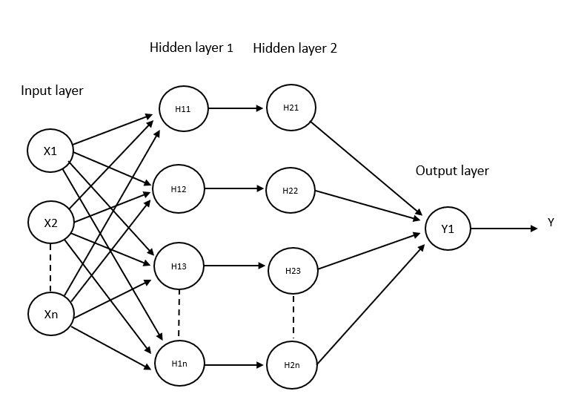
Fig. 1. Design of the Artificial Neural Network Structure

We utilize the back-propagation learning technique, which involves propagating the error signal in a reverse direction through the network. This entails refining and fine-tuning the weights of the network to enhance its efficiency [8]. This iterative method continues until the network is capable of producing the desired responses.

The steps involved in developing the artificial neural network model for our prediction are as follows:
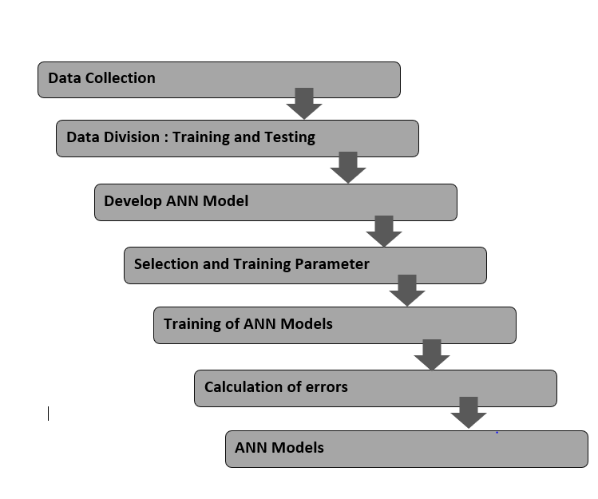
Fig. 2. Diagram of Model Development

In the proposed model, we focus on a single dependent variable, which is the closing price of crypto currency. As this variable constitutes a time series, we have adhered to a conventional time series forecasting model in carrying out our experiments, which has been outlined as follows [10]:
$K_{t}=h(x^{'})$
The set $\left\{x_{t-1},x_{t-2},…,x_{t-p}\right\}$ represents a series of delayed variables, illustrated in Figure 1 as the input parameters. The primary objective is to approximate the function [10]. This approximation is achieved through an iterative process that includes modifying the weights during the modeling process. The visual representation of the suggested model can be located in Figure 2.

To elucidate the construction of our proposed predictive model, we have divided the process into four distinct phases:

(a) Data Collection: We accumulated cryptocurrency price data from investing.com, covering a duration of 4 years and 10 months, amounting to roughly 2500 records. More precisely, we gathered information on the open, high, and low prices of the cryptocurrency.

(b) Data Normalization: Before initiating the training process, we performed data normalization. The closing price was scaled to fall within the range of $[0.01, 0.05]$ using the following equation:
$$A^{'}=\frac{l-Min}{Max-Min}\left(m-n\right)+n$$

In this context, $A$ stands for the normalized value, $l$ denotes the value undergoing normalization, $min$ signifies the minimum value within the series subject to normalization, $max$ represents the maximum value within the series being normalized, $n$ indicates the minimum value of the target range, and $m$ signifies the maximum value of the target range [10].

(c) Activation Function: The activation function, also referred to as the transfer function, establishes the connection between input nodes and output nodes within a neural network. In our case, we employed the sigmoid function, which is defined as:
$$h(x)=\frac{1}{1+e^{-x}}$$

(d) The training process of a neural network is a complex endeavor. It involves a sophisticated form of unconstrained nonlinear optimization, where the network's weights are continuously adjusted to minimize the mean squared error between the intended and observed output values across all input patterns. To achieve this, we utilized the Back-Propagation (BP) algorithm, which relies on the steepest descent gradient approach. This algorithm was employed to train the model and minimize errors. The error function, denoted as $E$, is defined as:
$$E=\frac{1}{2N}\sum_{l=1}^{n}{{(k_{l}-{k_{l}}^{d})}^{2}}$$
In this context, $k_{l}$ represents the network's output, while ${k_{l}}^{d}$ stands for the desired output for the $l^{th}$ input pattern. We utilize the steepest descent gradient methodology, and the partial derivatives are computed through the application of the chain rule. The revised guidelines for adjusting the weights and biases of this model are established using the subsequent equations:
$${w_{j}}^{new}={w_{j}}^{old}+ ∆w_{j}$$
$${g_{j}}^{new}={g_{j}}^{old}+ ∆g_{j}$$
Where $∆w_{j}=-ζ\frac{dE}{dw_{j}}$
$$=-ζ\frac{1}{n}\sum_{l=1}^{n}{(\left(k_{l}-{k_{l}}^{d}\right){ k}_{l}(}1-k_{l})\frac{y}{w_{j} x_{j}+g_{j}} x_{j})$$
$$∆b_{j}=-ζ\frac{dE}{db_{j}}$$
$$=-ζ\frac{1}{n}\sum_{l=1}^{n}{(\left(k_{l}-{k_{l}}^{d}\right){ k}_{l}(}1-k_{l})\frac{y}{w_{j} x_{j}+g_{j}} x_{j})$$
Here, $ζ$ serves as the learning parameter, controlling the convergence speed of the model.

RESULTS AND DISCUSSIONS

The proposed model's performance assessment focuses on predicting cryptocurrency prices, specifically the closing prices. The effectiveness of the proposed model is assessed using the Root Mean Square Error (RMSE) measure, defined in the subsequent manner:
$$RMSE=\sqrt{\frac{1}{n}{\left(k_{j}-\hat{k_{j}}\right)}^{2}}$$
In this equation, $k_{j}$ represents the actual (original) price, $\hat{k_{j}}$ denotes the predicted price, and $n$ is the total number of observations [10]. This evaluation method offers valuable insights into the model's predictive accuracy for cryptocurrency prices.

Table 1: The following presents RMSE values associated with various delay (lag) settings.

LAG | RMSE VALUE
2 | 11.39
3 | 10.62
4 | 8.51
5 | 9.75

The dataset has been partitioned into two sets, with 70% allocated for instructional training and 30% reserved for testing. The training set is utilized to ascertain the most effective lag value for our proposed model. Through a systematic adjustment of the lag value, we extract outcomes and pinpoint the lag value that results in the lowest RMSE values. Table 1 displays the RMSE values corresponding to lag values 2, 3, 4, and 5. Noteworthy is the observation that the RMSE reaches its nadir at a lag value of 4, which subsequently forms the foundation for our prediction.
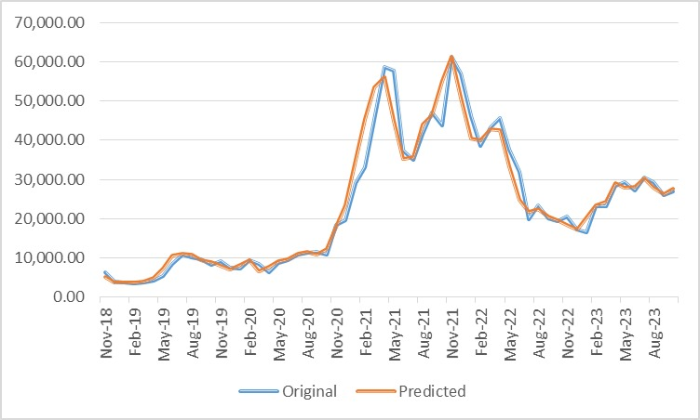
Fig. 3. Actual and Forecasted Closing Prices Over Time

CONCLUSION

This study has highlighted the efficacy of artificial neural network models for predicting crypto currency price trends, specifically in determining optimal lags. The artificial neural network model demonstrates strong performance in delivering accurate short-term forecasts, proving valuable for investors in their decision-making processes. It is crucial to acknowledge the inherent unpredictability of crypto currency markets, influenced by a multitude of both known and unknown factors. While the focus of this research has been on closing prices, it is evident that crypto currency values are sensitive to various elements, such as shifts in supply and demand, economic variables, and media-induced events. The adaptability of our approach to evolving price patterns is a notable strength. In further work, the incorporation of fundamental indicators and market trends into the model holds promise for enhancing its performance and applicability in the dynamic landscape of crypto currency markets.

REFERENCES

- Kang, C.Y., Lee, C.P., & Lim, K.M. (2022). Cryptocurrency Price Prediction with Convolutional Neural Network and Stacked Gated Recurrent Unit. Data, 7(11), 149.
- Biswas, S., Pawar, M., Badole, S., Galande, N., & Rathod, S. (2021, March). Cryptocurrency price prediction using neural networks and deep learning. In 2021 7th international conference on advanced computing and communication systems (ICACCS) (Vol. 1, pp. 408-413). IEEE.
- Charandabi, S.E., & Kamyar, K. (2021). Prediction of cryptocurrency price index using artificial neural networks: a survey of the literature. European Journal of Business and Management Research, 6(6), 17-20.
- Struga, K., & Qirici, O. (2018, November). Bitcoin Price Prediction with Neural Networks. In RTA-CSIT (pp. 41-49).
- Wang, X., Wu, J., Liu, C., Wang, S., & Niu, W. (2016). A hybrid model based on singular spectrum analysis and support vector machines regression for failure time series prediction. Quality and Reliability Engineering International, 32(8), 2717-2738.
- Kiran, N.R., & Ravi, V. (2008). Software reliability prediction by soft computing techniques. Journal of Systems and Software, 81(4), 576-583.
- Haykin, S. (2009). Neural networks and learning machines (3rd ed.). Pearson Education India.
- Lakshmanan, I., & Ramasamy, S. (2015). An artificial neural-network approach to software reliability growth modeling. Procedia Computer Science, 57, 695-702.
- Haykin, S. (1999). Neural Networks. Tom Robbins.
- Dhiman, G., & Kumar, V. (2019). Spotted hyena optimizer for solving complex and non-linear constrained engineering problems. In Harmony Search and Nature Inspired Optimization Algorithms: Theory and Applications, ICHSA 2018 (pp. 857-867). Springer Singapore.

