Digitalization as innovative development in Aquaculture and Fisheries as future importance
Durgesh Kumar Verma^{1*}, Monika², Satyaveer³, Ishwar Chandra,⁴ and Narendra Kumar Maurya³
¹ICAR-CIFRI, Regional Centre, Allahabad Uttar, Pradesh (211 002), India
²Sam Higginbottom University of Agriculture Technology and Sciences Prayagraj, Uttar Pradesh (211007), India
³College of Fisheries, Mangalore, Karnataka Veterinary, Animal and Fisheries Sciences, University, Bidar, Karnataka (575 002), India
⁴Faculty of Fisheries Science, Kerala University of Fisheries and Ocean Studies, Kochi, Kerala (682 506), India
Corresponding author Email- durgeshkumarverma4@gmail.com

ABSTRACT

Improving the livelihoods of fishermen, increasing industry sustainability, and economic growth are all possible outcomes of the digitalization of fisheries in India. Yet, it is crucial to ensure that all stakeholders, especially small-scale fishermen and fish farms, have access to and can afford these digital tools. By enhancing productivity, sustainability, and profitability while minimizing environmental effects, artificial intelligence has the potential to revolutionize fisheries and aquaculture. We may anticipate even more cutting-edge applications of artificial intelligence in the fisheries and aquaculture industries as these technologies develop and become more widely available. GIS and GPS have developed into helpful tools for fisheries management, helping to offer important information regarding fish populations, fishing activities, and oceanographic conditions. The creation of efficient management strategies, preservation of fish habitats, and upkeep of sustainable fishing methods all use this data.

Keywords: Digital technology, Artificial Intelligence, Fisheries and Aquaculture

INTRODUCTION

The aquaculture and fish industries have undergone a revolution thanks to digital technology, which has made it possible to monitor, manage, and optimize production with new technologies, proving new research and information to farmers. A combination of hardware and software tools, including sensors, drones, machine learning techniques, and data analytics platforms, are included in these technologies. Real-time good monitoring and management of the manufacture procedure are one of the most important advantages of digital technology in fisheries and aquaculture. The sensor which is found in drones can also be used to survey fish stocks, monitor the health of fish populations, control feeding, and measure water quality, oxygen levels, temperature and other environmental factors. As well, the invention of new aquaculture production techniques has been made possible by digital technology. Recirculating aquaculture systems (RAS), for instance, are land-based systems that use digital management systems to maintain the ideal water quality for fish growth. To analyze vast amounts of data gathered from sensors and other sources, data analytics platforms and machine learning algorithms can be employed. This can aid fish producers in increasing productivity, decreasing waste, and increasing profitability. Data analytics, for instance, can be used to forecast fish growth rates and determine the optimal time to harvest fish, increasing yields and revenues. IOT is used by around 50 billion electronic devices today, many of which are AI-powered. The goal of the computer science field of artificial intelligence (AI) is to develop intelligent machines that can emulate human cognitive abilities like perception, reasoning, learning, and problem-solving. AI has been employed more and more recently in a variety of industries, including aquaculture and fisheries, essential industries that support millions of people worldwide by giving them food, jobs, and financial advantages. These sectors do, however, confront a number of difficulties, including overfishing, environmental damage, disease outbreaks, and climate change. Several of these issues can be solved with AI, which will also increase fisheries and aquaculture productivity, sustainability and profitability.

DIGITALIZATION OF FISHERIES IN INDIA
The development of digital technology in India is going on very high, which is used in fisheries and aquaculture. The Indian government has launched a number of initiatives to encourage the use of digital technologies in fisheries and aquaculture. Encouraging sustainable fishing methods and increasing the livelihoods of fishermen, assists in enhancing the production, and efficiency of fisheries and aquaculture in India. There are also difficulties that need to be resolved, such as handling data privacy and security concerns and ensuring that the advantages of digitization are felt by all stakeholders, especially small-scale fishers and women industry. Tables no. 1, 2 and 3 show some examples of the digitalization of fisheries and aquaculture. One of the key initiatives is the e-PashuHaat portal, which was established by the Department of Animal Husbandry, Dairy and Fisheries (DAHDF) in collaboration with the National Dairy Development Board (NDDB). Another major initiative is the Matsya setu developed by NFDB, Fisheries Information System (FIS), which was started by the Government of India and many fisheries researchers, to provide information to fish farmers on different aspects of educational fish farming, such as the availability of allows fish farmers to communicate with one another and exchange knowledge and experiences. Fish landing also offers tools for fish farms to manage their inventory, obtain real-time price information, and keep track of sales. The government has also built fish seed banks and fish feed factories, which employ digital technology to increase production and distribution efficiency. Shri Parshottam Rupala to Launch the ‘Report Fish Disease’ App. Developed by ICAR - National Bureau of Fish Genetic Resources (ICAR-NBFGR) under National Surveillance Programme for Aquatic Animal Disease.

DIGITAL TECHNOLOGY IMPLEMENTATION IN THE FISHERIES AND AQUACULTURE
To boost fisheries industry productivity, long-term sustainability, Profitability, digital technology and computorial software and hardware are being used more and more frequently in areas like fish stock assessment, electronic monitoring (EM), precision fishing, supply chain management, GPS and GIS tracking, online marketplaces, aquaculture management, and artificial intelligence, which includes robotics, drone technology, remotely operated vehicles (ROVs), automated identification systems, etc., Table No. 1 shows that Some examples of digital technology.

Sr. No. | Digital Technology | Application
1. | Robotics | Address complicated tasks and laborious work, such as cleaning ponds and repairing damaged nets.
 |  | Monitoring behaviours, removing diseased fish, feeding.
 |  | Injecting vaccines.
 |  | Water inspections of nets, evaluating fish health and escapes.
2. | Drones | Monitor fish farms above and below water.
 |  | Check holes in damaged cages.
 |  | Data collection combining AI and cloud computing to improve aquaculture operations.
3. | Sensors/Remote  Sensing | Collecting water parameters in real-time.
 |  | Underwater sensors to monitor hunger levels of fish in ponds and cages.
 |  | Fish metabolism and heart rates.
 |  | Reduced wastage and improved feed rates.
4. | AI | Makes better and faster decisions.
 |  | less labor intensive.
 |  | Improved efficacy of feeders, water quality monitoring and control, harvesting and processing.
5. | Augmented Reality (AR) | Real-time simulation of environmental situations using digital interface (headsets).
 |  | Teaching, training and education.
 |  | Used for high-risk environments (remote) using human computer and multimedia platforms.
6. | 3D Printing | Printing hydroponic systems.
 |  | 3D verification devices.
 |  | 3D printed water sensors for monitoring water parameters.
 |  | Reduced equipment and production cost.
 |  | Connect big data across aquaculture industry.
 |  | Combined use of social media.
7. | Blockchain | Cybersecurity, safe data sharing.
 |  | Payment processing.
 |  | Industry protection.
 |  | Full traceability across value chain.
 |  | Reduce food wastage, improve food safety.
Source: Rowan, N.J., 2023
CYBERSECURITY INFORMATION TECHNOLOGY (IT) SECURITY
Protecting sensitive data and important systems against cyberattacks is known as cybersecurity or information technology (IT) security. Cybersecurity code function safeguards the gadgets (smartphones, laptops, and tables) and is how both individuals and organizations lower the chance of a cyberattack (Rowan, N.J., 2023).

CYBER-PHYSICAL SYSTEMS
Cyber-physical systems are those in which hardware and software are smoothly integrated to carry out predetermined functions.

APPLICATION OF GIS, GPS IN FISHERIES AND AQUACULTURE
A precise global radio navigation system, the Global Positioning System (GPS), is used today. A satellite-based navigation system called the Global Positioning System may pinpoint an object's precise position or placement on the surface of the earth. Aquatic research and limnology have included GPS and satellite remote sensing, which is gradually becoming recognized as a significant source for data collecting (Alum - Udensi, et. al., 2016). Global Positioning Systems (GPS) and Geospatial Information Systems (GIS) are crucial tools for managing, researching, and planning fisheries, including mapping fishing grounds, tracing fish movements, observing fishing activities, and conserving and protecting fish populations. Due to its ability to handle massive spatial datasets quickly and accurately, GIS has advantages over traditional methods (Isaak, D.J. and Hubert, W.A., 1997).

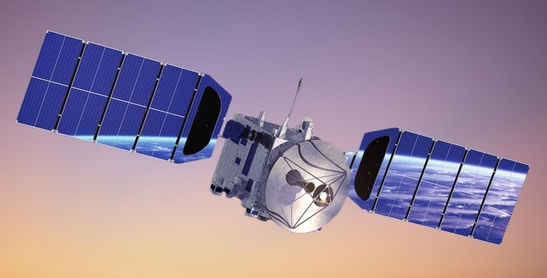

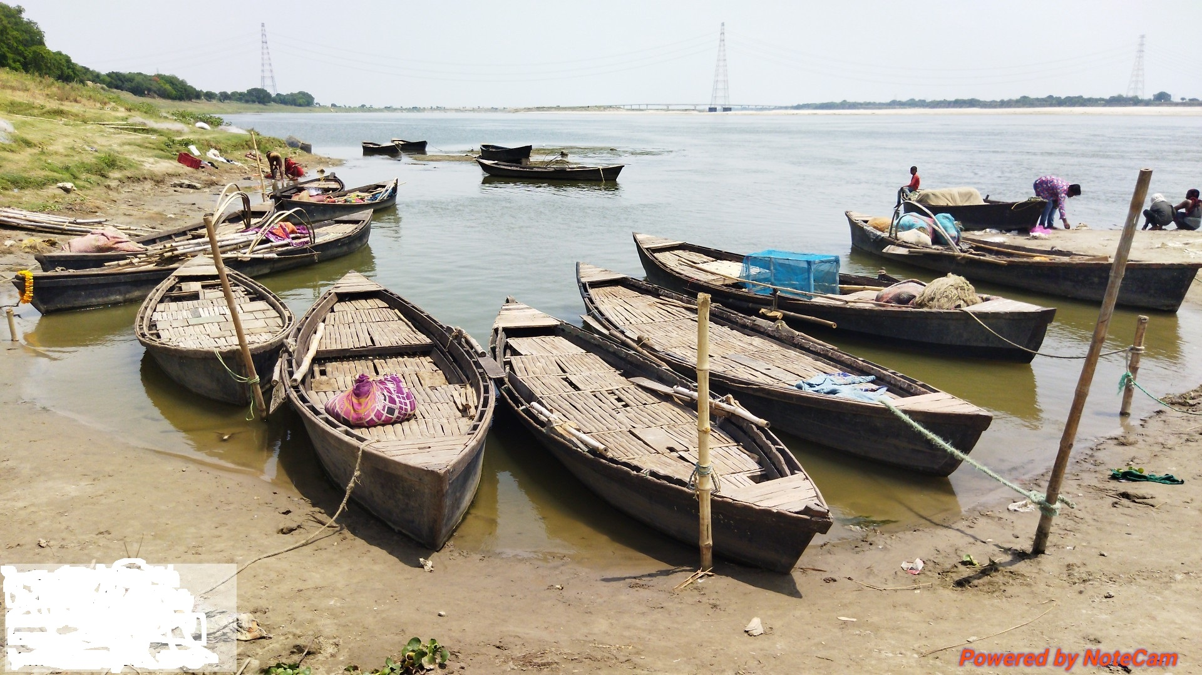
Fig. 1 GIS and GPS satellite

VIRTUAL REALITY
What we refer to as "Fish Tank Virtual Reality" is characterized by a stereo picture of a three-dimensional (or 3D) scene shown on a monitor employing a projection connected to the observer's head position (Ware, C. et. al., 1993). When a person uses specialized electronic devices, such as a helmet with a screen inside or gloves connected with sensors, they can interact with a computer-generated model of a 3D image or environment in a way that appears real or tactile.

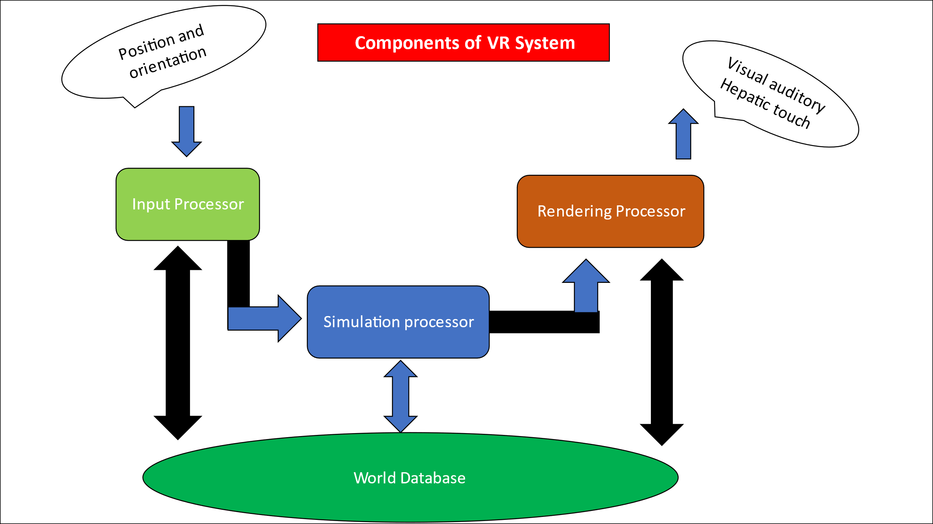
Fig. 2 Component of VR system

SMARTPHONE APPLICATIONS IN AQUACULTURE AND FISHING
In the area of fisheries and aquaculture, mobile applications can be quite beneficial. These are some examples of how mobile apps might be helpful such as monitoring weather, managing feed, tracking diseases, managing harvests, and monitoring water quality.

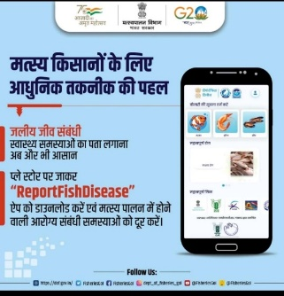 | 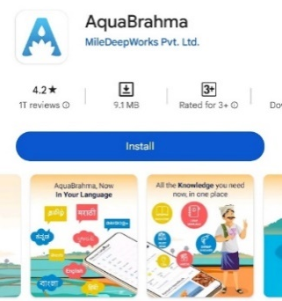
Fig. 3 Mobile Application use in aquaculture

QUALITY OF EXPERIENCE (QoE)
The Quality of Experience (QoE) is the level of enjoyment or irritation felt when using a product or service.

USE OF ARTIFICIAL INTELLIGENCE (AI) IN FISHERIES AND AQUACULTURE
Artificial intelligence (AI) has the potential to revolutionize the inland water fisheries sector in numerous ways. Use of Artificial intelligence (AI) in Fish Population Management, Fish stock assessment, Fishing gear optimization, Water quality management, Fish identification, Aquatic ecosystem monitoring, Fish detection and classification, Feed optimization, Disease detection and diagnosis, Aquatic weed detection and control, Intelligent solution for aquaculture and fisheries. We can anticipate seeing even more ground-breaking ideas emerge to assist these industries become more efficient and sustainable as technology develops (Jothiswaran, V., 2022). Some examples of AI Showing in table 2.

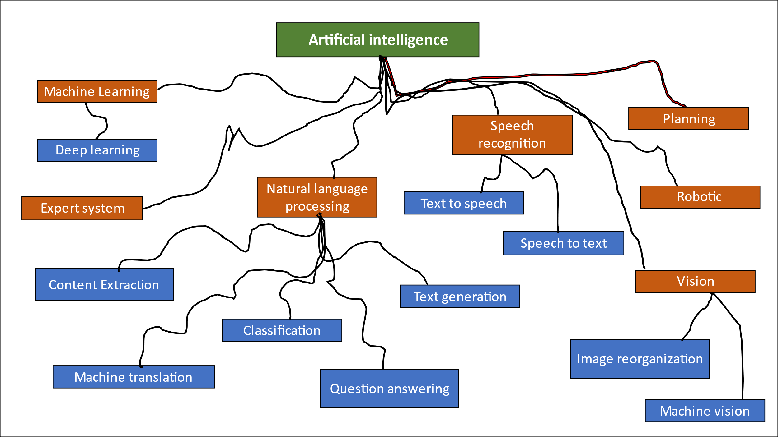Fig. 4 Application of Artificial Intelligence

Table 2: Examples of commercially available intelligent solutions for aquaculture and ﬁsh processing.
Sr. No. | Application | Developer/Products | Country | Weblink
1 | Monitoring and control of feeding rate | Observe Technologies | United Kingdom | https://observe.tech
 |  | eFishery- Feeder | Indonesia | https://eﬁshery.com
 |  | Umitron-CELL, FAI &EAGLE | Japan, Singapore | https://umitron.com
 |  | AQ1feedingsystems | Australia | http://www.aq1systems.com
 |  | Eruvaka-Pond Mother | India | https://eruvaka.com
2. | Monitoring and control of water quality | Real Tech-LiquidAi | Canada | https://realtechwater.com
 |  | Aqua Manager | Greece | https://www.aqua-manager.com/
 |  | Osmo Systems-Osmobot | USA | -
 |  | Siemens - SIMATIC S7–1500 and Totally Integrated Automation Portal | Germany | https://new.siemens.com
 |  | Smart Water Planet-Medusa and Cloud | Spain | https://smartwaterplanet.com
 |  | ShanghaiYuxi Automation Technology | China | http://www.yuxiel.com/
 |  | Eruvaka- Pond Guard | India | https://eruvaka.com
3. | Monitoring of ﬁsh biomass and growth rate (including counting and sorting) | XpertSea- Xpercount | Canada | https://www.xpertsea.com/
 |  | VAKI-Bioscanner, Smart Flow and Cloud | Iceland | https://vakiiceland.is
 |  | Innova Sea- Sea Station | USA | https://www.innovasea.com/
 |  | Aquabyte | Norway | https://www.aquabyte.ai/
 |  | Aqua Scan | Norway | https://www.aquascan.com/
 |  | SkalaMaskon-AGM ﬁsh egg sorter | Norway | www.skalamaskon.no
4. | Monitoring and forecasting disease outbreak | AquaCloud | Norway | https://aquacloud.ai
 |  | BioSort - iFarm | Norway | https://www.biosort.no/
 |  | IPI-IREF system | Singapore | https://www.ipi-singapore.org/
 |  | Aquaconnect-FarmMOJO | India | https://aquaconnect.blue
 |  | 4-Deep-Holographicmicroscopes | Canada | http://4-deep.com/
5. | Monitoring and forecasting disease outbreak | CageEye | Norway | https://www.cageeye.com/
 |  | View Point Behavior Technology | France | http://www.viewpoint.fr/
 |  | ZebraZoom | France | https://zebrazoom.org
 |  | idTracker | Spain | http://www.idtracker.es/
6. | Farm activity tracking and production planning | AKVA group-AKVA connect & Fishtalk | Norway | https://www.akvagroup.com/
 |  | Scale Aquaculture AS-Mercatus | Norway | https://scaleaq.com
 |  | Poseidon AI | Singapore | https://www.poseidon-ai.com/
 |  | Kamahu-SaaS solution | France | https://www.kamahu.com/
7. | Automation of ﬁsh processing systems | Marel - FleXicut, FleXisort and RoboBatcher | Iceland | https://marel.com
 |  | Skaginn3x | Iceland | https://www.skaginn3x.com
Source: Gladju, et. al., 2022.

BIG DATA
Big data is an ongoing growth in data and technologies that requires collection, storage, management, and analysis. Procedures and technologies that are complex and multifunctional. Volume (the number of data sets) and Velocity (the rate at which data is processed) Variety (data sources/types), and Reliability (analysed data quality) (Rowan, N.J., 2023).

APPLICATION OF DRONE TECHNOLOGY IN FISHERIES AND AQUACULTURE
Unmanned aerial vehicles/systems known as drones deliver near-real-time data on the people, processes, and landscapes they examine while using radio frequencies and pre-programmed GPS-guided flight scripts (Toonen, & Bush, 2020). Fisheries and aquaculture applications of drone technology include stock assessment, illegal fishing monitoring, search and rescue, fish population monitoring, environmental data collection, fish behavior monitoring, surveillance, mapping and surveying, and product delivery (Andronova et. al., 2019).
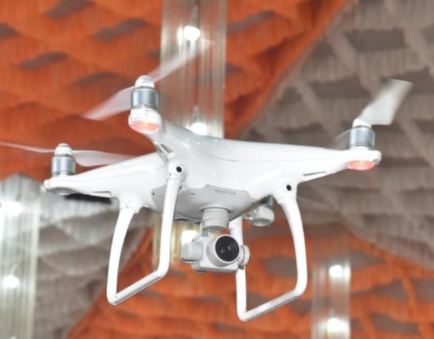
Fig. 5 Drone Carma

Blockchain
Blockchain is a decentralized, unchangeable database that makes it easier to track assets in a corporate network and record asset transitions using cryptographic techniques. Blockchain protocols collect, verify, and transmit transactions over the network of blockchains. The transactions are sequentially recorded by the blockchain technology. A value exchange or the activation of a smart contract could be included in a transaction (Zhang, Hanwen, and Fukun Gui. 2023).
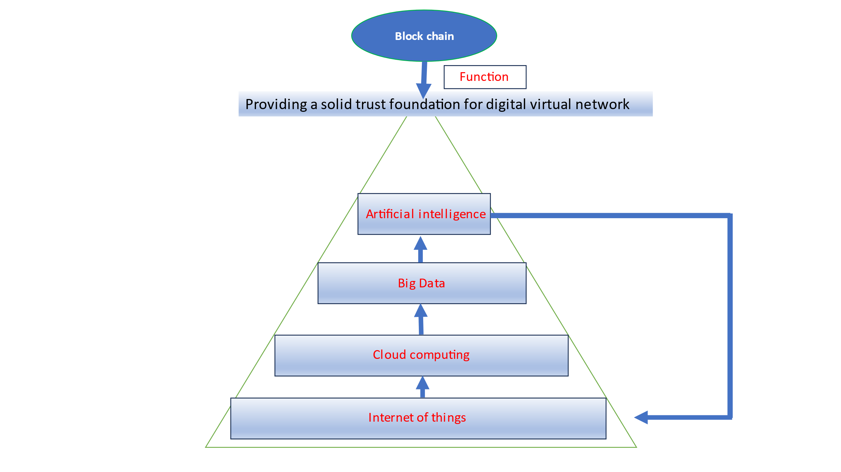 | 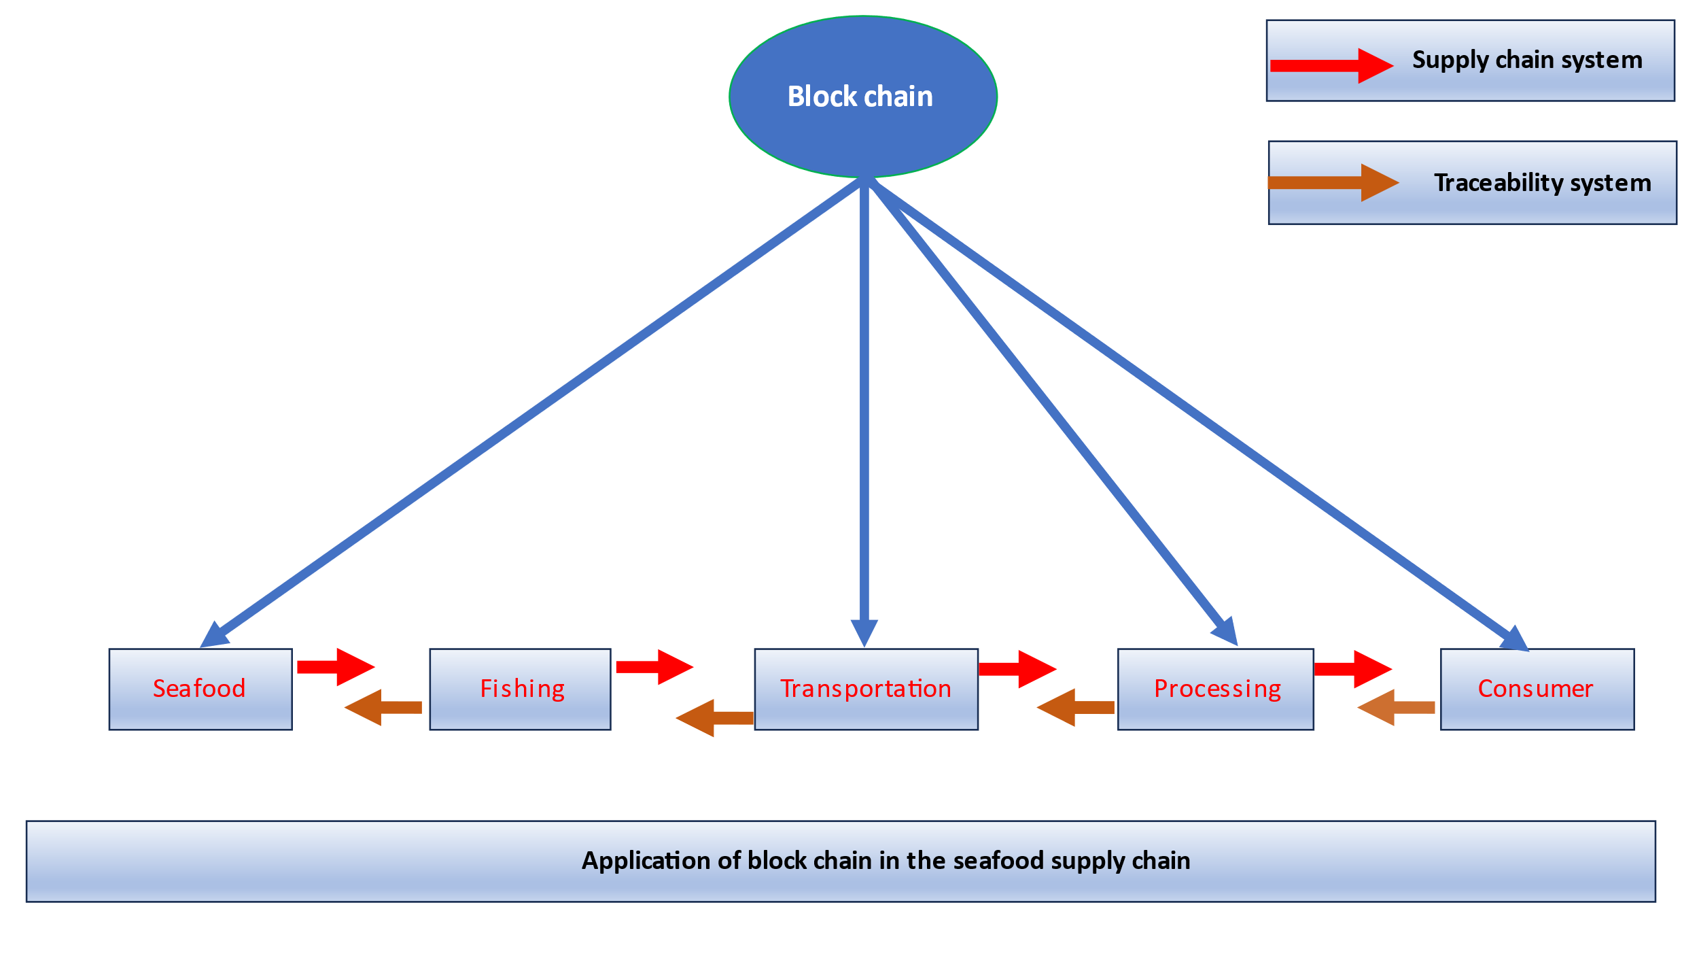
Fig. 6 Application of blockchain | Fig. 7 Application of blockchain in the seafood supply chain
Source: Zhang and Fukun 2023.
APPLICATION OF REMOTE SENSING IN FISHERIES
Remote sensing plays a crucial role in fisheries by providing valuable information about the ocean environment, fish stocks, and fishing activities. Remote sensing plays a significant role in fisheries by providing timely and spatially extensive data on oceanographic conditions, fish stocks, fishing activities, and habitat characteristics. These applications help in improving the efficiency, sustainability, Environmental indicators of fish distribution (Klemas V., 2013), fishing ground properties, measuring ocean temperature, measuring turbidity, oil pollution detection, Acoustic sensing of fish schools, and management of fisheries resources.

USE OF ROBOTIC TECHNOLOGY IN FISHERIES
Robotic technology has the potential to completely transform the aquaculture and fishing sectors, enhancing their productivity, sustainability, and profitability. Here are some examples of current robotic applications in fisheries and aquaculture, including automated fish feeders, fish processing and packaging, aquatic weed removal, environmental monitoring, autonomous underwater vehicles (AUVs), fish tracking and monitoring systems, fish transportation, and fish harvesting. Therefore, Robofish and other biomimetic robots are beneficial for studying how public receptiveness in guppies and possibly additional small fish species (Bierbach, D., et. al., 2018).

DIGITAL TWIN
Electronic and digital twin a virtual model created to faithfully represent a real object is called a digital twin. To track fish eating behaviour, illness, and growth, the system combines artificial intelligence (AI)-based Internet of Things (IoT) technology, cloud-based digital twins, machine learning, and computer vision capabilities (Lan H. et. al., 2003).

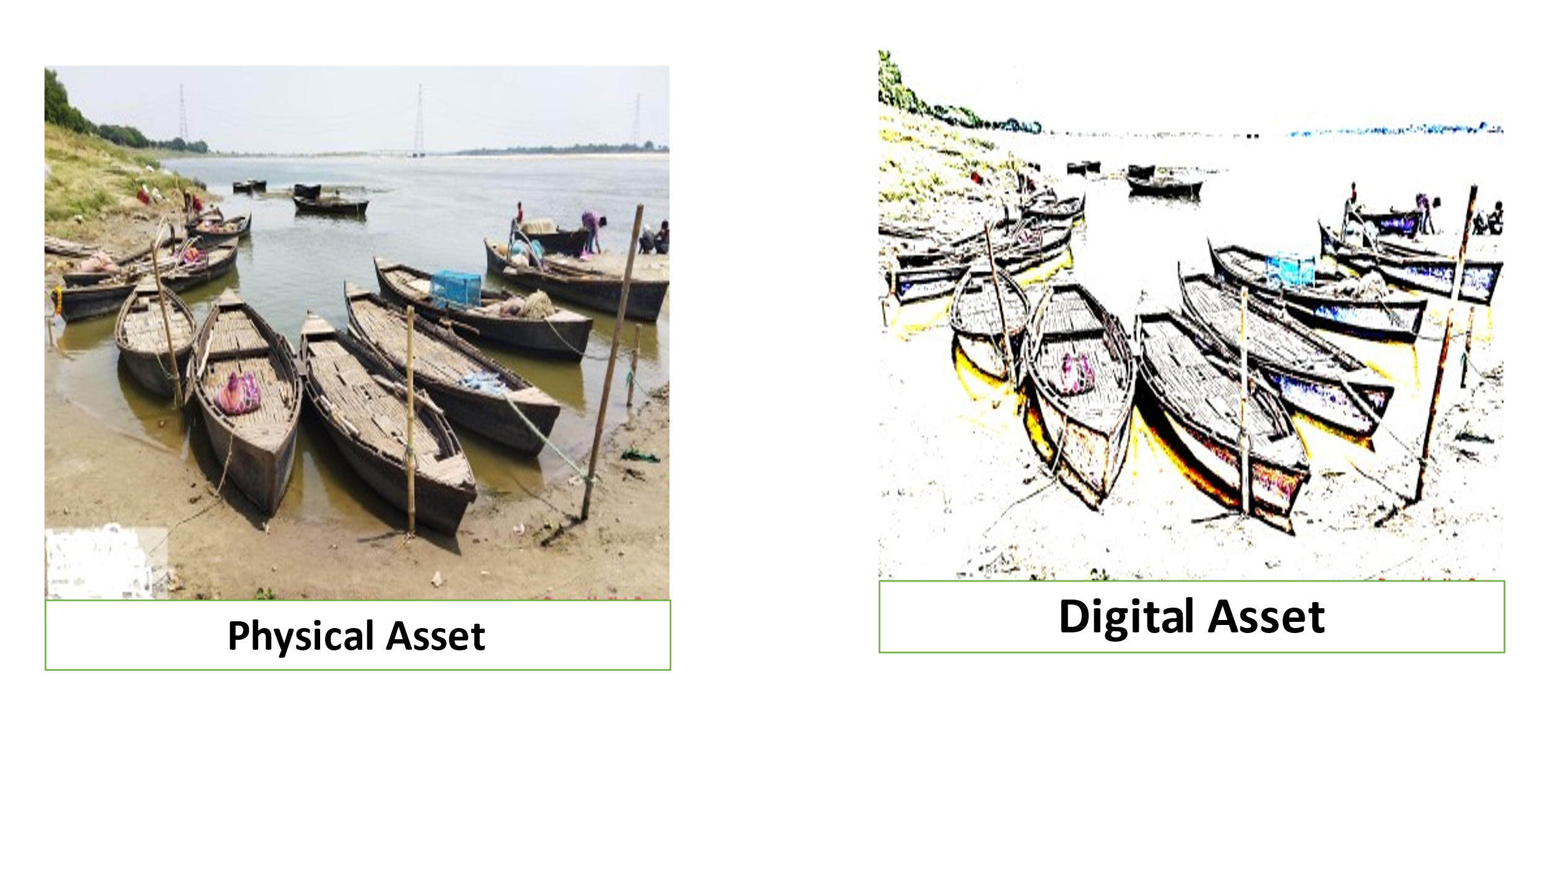
Fig. 8 Digital twine

Machine learning (ML)
Machine learning (ML), a subset of artificial intelligence, is the application and development of systems of computers that adapt and learn without following specific instructions by analysing data patterns and making conclusions from them applying algorithms and statistical models, by using sensors and machine learning, assess fish quality (Saeed, R. et. al., 2022).

USE REMOTELY OPERATED VEHICLES (ROVs) IN FISHERIES AND AQUACULTURE
Fish stock evaluation, habitat mapping, aquaculture operations and management, fish behavior studies, and underwater inspection are just a few of the uses for remotely operated vehicles (ROVs) in fisheries and aquaculture. The purpose of a ROV is to promote the safety of people working in underwater environments that are challenging to reach in order to collect samples for laboratory analysis or to take measurements using a probe. The characteristics that are evaluated include the water's pH, dissolved oxygen (DO), nitrates and dissolved ammonia (nitrate) (Rahim A., 2022).

CLOUD COMPUTING
Using software and tools that are based on a network of servers connected via the internet, including storage for data, servers, databases, and software, is known as cloud computing. Users can now rent resources for their computers on demand to access all data through the internet and store files and apps on virtualized servers. Using cloud computing, remotely monitor the water quality in the fish pond (Sivakumar, S. and Ramya, V., 2021).
EDGE CLOUD
A supplement to cloud computing, edge computing consists of storage and computation resources that are situated at the edge and connected via portable, application-aware networks that can sense and respond safely and instantly to changing needs.

INTERNET OF THINKS (IoT)
The "internet of things" is a system of connected, intelligent objects as well as services that can perceive or hear commands and respond by employing actuators. IoT enables sensor networks to connect remotely to, administer, and watch over systems and products. Fisheries Water Quality Monitoring System Using the Internet of Things (Ya’acob, N., et. al., 2021). Sensors have developed from simple sensing devices to more modern, adaptable, portable, Nano plasmonic, versatile, fatigue-resistant, outstanding performance effective sensors in high-volume applications like the Internet of Things and monitoring systems. and temperature-tolerant sensor devices. Monitoring fish quality is one of the very few industries where these high-grade innovative sensors are used (Saeed, R., et. al., 2022).
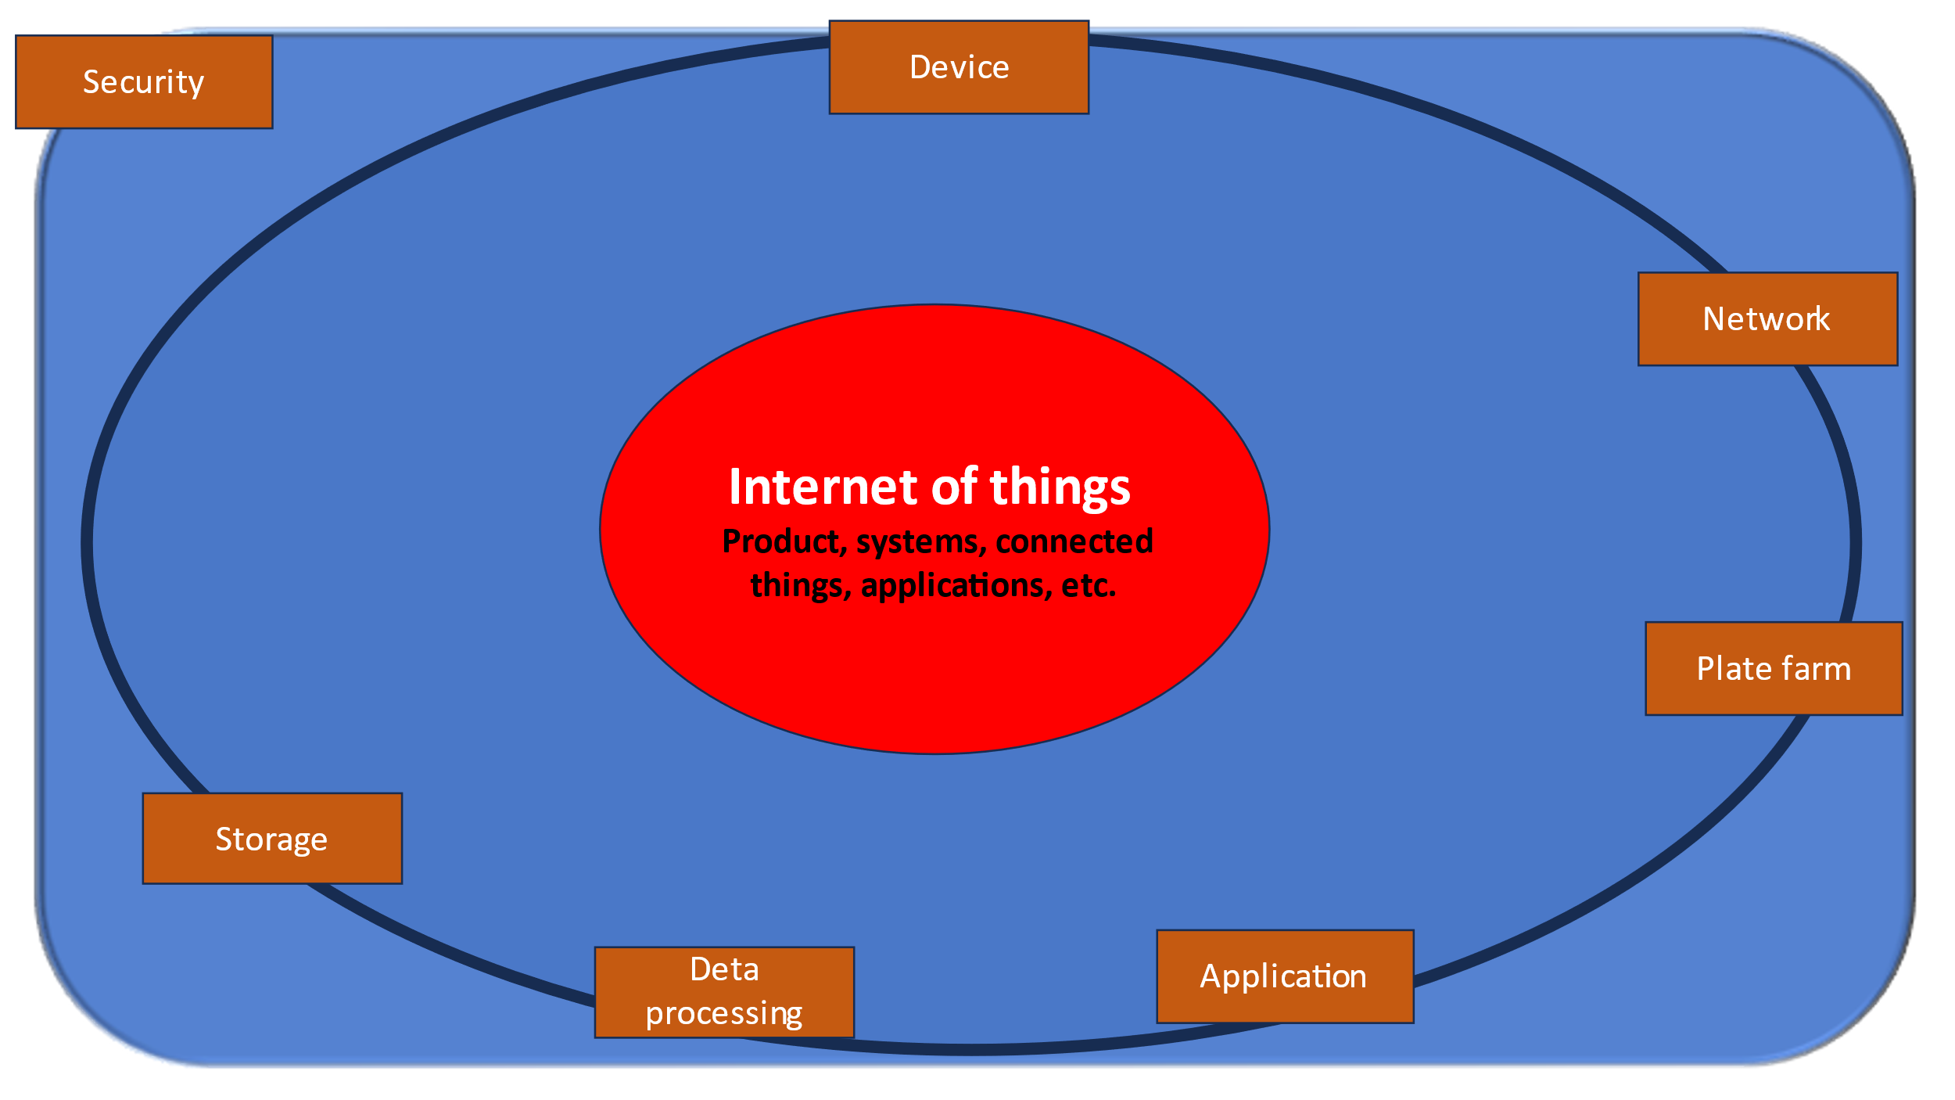
Fig. 9 Internet of thinks

USE OF COMPUTATIONAL (DATA MINING AND MACHINE LEARNING) METHODS IN FISHERIES AND AQUACULTURE
Techniques for data mining and machine learning can be used to improve productivity, control disease, and promote sustainability in fisheries and aquaculture operations. These methods can lessen the environmental effect of these activities while increasing their productivity and profitability. Some software name shown table 3.
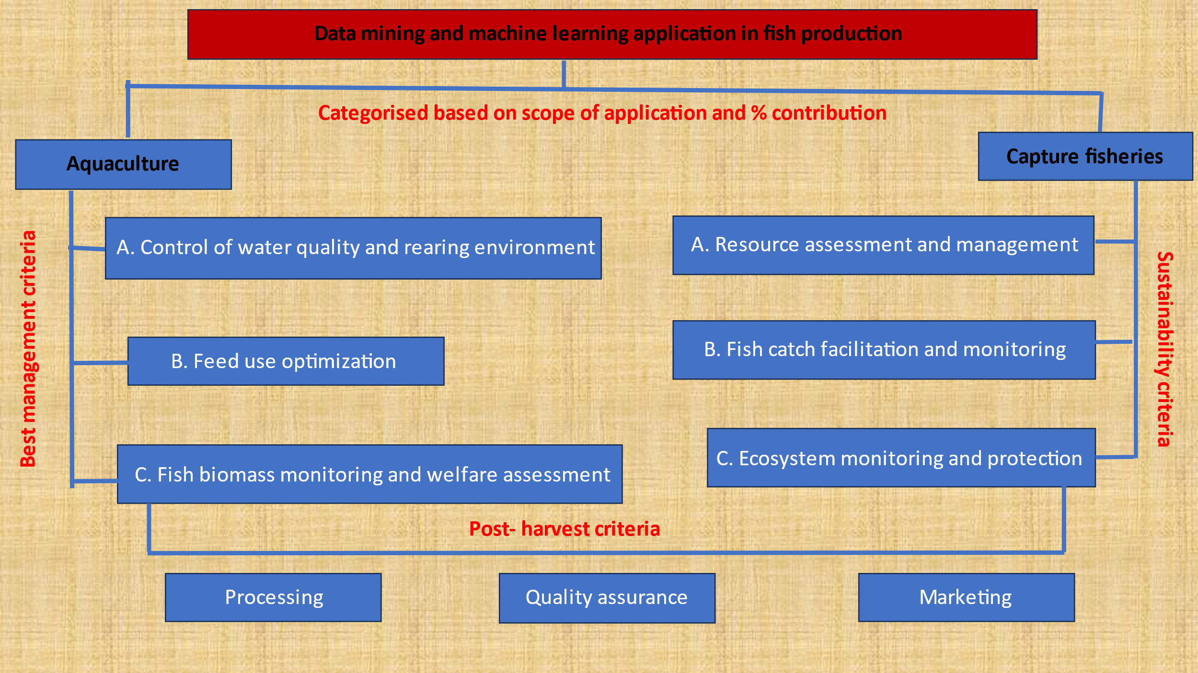
Fig. 10 Data mining and machine learning application in fish production
Source: Gladju, et. al.,2022.

Table 3: Different computational (data mining and machine learning) methods and their applications in aquaculture operations.

Computation method | Application | Domain
1. | Recirculating intensive aquaculture experts’ system (RIAX) | To increase the productivity of tilapia culture, feeding, temperature, water quality, flow, oxygen and water level must be monitored and controlled. | Farm management (RAS)
2. | Fuzzy logic-based expert system | Nitrate removal) rates and preventing the discharge of toxic byproducts in an automated denitrifying bioreactor in recirculating aquaculture systems. | Farm management (RAS)
3. | Fog computing for data acquisition and processing | Water quality and biomass management are monitored and controlled in real-time in recirculating aquaculture systems. | Farm management (RAS)
4. | Artiﬁcial neural networks | System for remote online water quality monitoring, forecasting, and management in intensive fish culture. | Farm management (RAS)
5. | Fuzzy logic controller | Using geothermal energy and a plate-type heat exchanger, the recirculating aquaculture system's water temperature is monitored and managed. | Farm management (RAS)
6. | Bond graph technique and air control algorithm | Using wave height and activity to automatically manage the submerging and surfacing of a submerged fish cage system. | Farm  management  (Cage system)
7. | Fog computing for data acquisition and processing | Detection and remote control of water flow and level in the grow bed of Aquaponics systems. | Farm management (Aquaponics)
8. | Kalman ﬁlter algorithm and optimization scheme | Based on water level sensing and prediction, fish farm water pumping is optimized and controlled for effective energy use. | Farm management
9. | Computational ﬂuid dynamics software ANSYSFLUENT and modiﬁed DO ecological model | To maintain sufficient oxygen levels in fish ponds and to increase energy savings, diffused aeration control system development and monitoring of dissolved oxygen profiles are necessary. | Farm management (Pond system)
10. | Microcomputer-processor and BASIC program | Automatic for the purpose of maintaining adequate oxygen levels in fish ponds and maximizing energy savings, diffused aeration control systems are being developed and dissolved oxygen profiles are being monitored. | Feed management
11. | Visual sign all processing system and support vector machine based classiﬁer | Monitoring fish feeding operations continuously and automatically in aquaculture tanks. | Feed management
12. | k-Nearest neighbor and principal component analysis | classification of fish behavior or condition for better feed usage using an automated feeder and image processing. | Feed management
13. | Adaptive neural-based fuzzy inference system | Using variations in water quality metrics to assess and make feeding decisions. | Feed management
14. | Spectral data processing and computing | Real-time bioreactor monitoring and control of the algal production system's efficiency in terms of nutrient delivery, biomass harvesting timing, light, and temperature. | Live feed production
15. | TDoA algorithm with acoustic telemetry and SLIM-LPWAN | Using telemetry data, real-time monitoring of fish behavior and decision-making in marine fish farms. | Fish behavior and welfare
16. | Adaptive neural-based fuzzy in refence system | fish behavior and decision-making in marine fish farms being tracked in real-time using telemetry data. | Fish behavior and welfare
17. | Kullback- Leibler divergence method | Using inter-individual time series data, we investigate the cause-and-effect dynamics of social learning and foraging behavior in fish. | Fish behavior and welfare
18. | AEFishBITtri-axial accelerometer and Cosinor analysis | For accurate phenotyping of farmed fish and the selection of more productive farmed fish, monitoring and connecting locomotor activity and respiratory frequency with body weight is necessary. | Fish behavior and welfare
19. | Multi-layer perceptron neural network and support vector machine models | Using visual machine technology, an intelligent system can distinguish between live and dead rainbow trout eggs. | Hatchery operation
20. | Support vector machine with radial based kernel | Using nutritional effects to categorize farmed rainbow trout non-intrusively. | Fish nutrition/product quality
Source: Gladju, et. al.,2022.

INFORMATION AND COMMUNICATION TECHNOLOGY (ICT)
The advantages of ICT for groups like farmers, rural communities, urban communities, students, teachers, and businessmen have been the subject of a plethora of prior studies, but there has been very little study and research on how ICT can help the aquaculture, fishing sector and fishermen develop (Omar, S., 2011). Includes the collection, retention, retrieval, processing, presentation, display, representation, management, organization, security, transfer, and exchange of information and data.
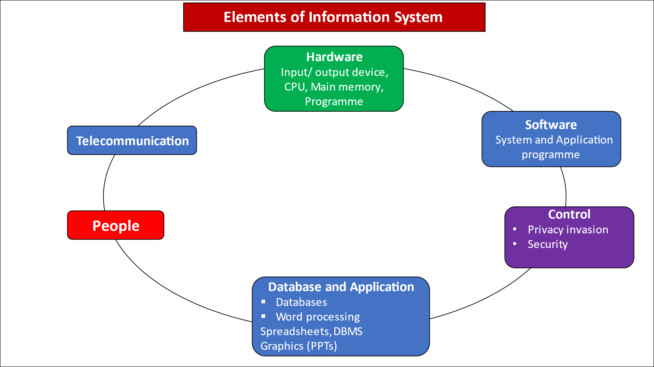
Fig. 11 Element of Information System
AUGMENTED REALITY
A computer-generated image is covered on an operator's revelation of the actual global using augmented reality technology, creating a composite view.

CONCLUSION
Fishing communities, customers, and the environment in India stand to gain significantly from the digitalization of the industry. But there is still a way to go, and more work needs to be done to guarantee that technology is used effectively and fairly to advance equitable and sustainable development. The efficiency and sustainability of fisheries and aquaculture could be increased with the help of artificial intelligence, ensuring a consistent supply of fish for food and other uses. Cobot, or collaborative robot, is a robot intended for direct human robot interaction with a shared space, or where humans and robots are in proximity.

REFERENCES
- Rahim, M. N. A., Hamid, D. T. A., Said, M. F. M., Jamaludin, M. N., & Rozalan, H. H. (2022). Design and development of remotely operated vehicle to assess the water quality in the aquaculture area. Asian People Journal (APJ), 5(2), 50-60. Available: https://doi.org/10.37231/apj.2022.5.2.409
- Toonen, H. M., & Bush, S. R. 2020. The digital frontiers of fisheries governance: fish attraction devices, dronesand satellites. Journal of environmental policy & planning, 22(1), 125-137. Available: https://doi.org/10.1080/1523908X.2018.1461084
- Alum-Udensi, O., Egesi, C. O., & Uka, A. 2016. Applications of GPS and GIS in Aquaculture and Fisheries. International Journal of Agriculture and Earth Science, 2(2), 2489-0081. Available: Applications of GPS.pdf (iiardjournals.org)
- Andronova, I.V., Belova, I.N. and Yakimovich, E.A., 2019, May. Digital technology in the fishing sector: international and Russian experience. In 1st International Scientific Conference" Modern Management Trends and the Digital Economy: from Regional Development to Global Economic Growth"(MTDE 2019) (pp. 277-280), Atlantis Press. Available: https://www.atlantis-press.com/article/125908833.pdf
- Gladju, J., Kamalam, B. S., & Kanagaraj, A. 2022. Applications of data mining and machine learning framework in aquaculture and fisheries: A review. Smart Agricultural Technology, 100061. Available: https://doi.org/10.1016/j.atech.2022.100061
- Rowan, N.J., 2023. The role of digital technologies in supporting and improving fishery and aquaculture across the supply chain–Quo Vadis? Aquaculture and Fisheries, 8(4), pp.365-374. Available: https://doi.org/10.1016/j.aaf.2022.06.003
- Zhang, Hanwen, and Fukun Gui. 2023. "The Application and Research of New Digital Technology in Marine Aquaculture." Journal of Marine Science and Engineering 11, no. 2 401. Available: https://doi.org/10.3390/jmse11020401
- Isaak, D.J. and Hubert, W.A., 1997. Integrating new technologies into fisheries science: the application of geographic information systems. Fisheries, 22(1), pp.6-10. Available: https://doi.org/10.1577/1548-8446(1997)022%3C0006:INTIFS%3E2.0.CO;2
- Omar, S.Z., Hassan, M.A., Shaffril, H.A.M., Bolong, J. and D’Silva, J.L., 2011. Information and communication technology for fisheries industry development in Malaysia. African Journal of Agricultural Research, 6(17), pp.4166-4176. Available: https://academicjournals.org/article/article1380811163_Omar%20et%20al.pdf
- Ya’acob, N., Dzulkefli, N.N.S.N., Yusof, A.L., Kassim, M., Naim, N.F. and Aris, S.S.M., 2021, August. Water Quality Monitoring System for Fisheries using Internet of Things (IoT). In IOP Conference Series: Materials Science and Engineering (Vol. 1176, No. 1, p. 012016). IOP Publishing. Available: DOI 10.1088/1757-899X/1176/1/012016
- Sivakumar, S. and Ramya, V., 2021, February. An intuitive remote monitoring framework for water quality in fish pond using cloud computing. In IOP Conference Series: Materials Science and Engineering (Vol. 1085, No. 1, p. 012037). IOP Publishing. Available: DOI 10.1088/1757-899X/1085/1/012037
- Saeed, R., Feng, H., Wang, X., Zhang, X. and Fu, Z., 2022. Fish quality evaluation by sensor and machine learning: A mechanistic review. Food Control, 137, p.108902. Available: https://doi.org/10.1016/j.foodcont.2022.108902
- Bierbach, D., Landgraf, T., Romanczuk, P., Lukas, J., Nguyen, H., Wolf, M. and Krause, J., 2018. Using a robotic fish to investigate individual differences in social responsiveness in the guppy. Royal Society open science, 5(8), p.181026. Available: https://doi.org/10.1098/rsos.181026
- Jothiswaran, V., Velumani, T. and Jayaraman, R., 2020. Application of artificial intelligence in fisheries and aquaculture. Biotica Research Today, 2(6), pp.499-502.
- Saeed, R., Feng, H., Wang, X., Zhang, X. and Fu, Z., 2022. Fish quality evaluation by sensor and machine learning: A mechanistic review. Food Control, 137, p.108902. Available: https://doi.org/10.1016/j.foodcont.2022.108902
- Lan, H.Y., Ubina, N.A., Cheng, S.C., Lin, S.S. and Huang, C.T., 2022. Digital Twin Architecture Evaluation for Intelligent Fish Farm Management Using Modified Analytic Hierarchy Process. Applied Sciences, 13(1), p.141. Available: https://doi.org/10.3390/app13010141
- Rahim, M.N.A., Hamid, D.T.A., Said, M.F.M., Jamaludin, M.N. and Rozalan, H.H., 2022. Design and development of remotely operated vehicle to assess the water quality in aquaculture area. Asian People Journal (APJ), 5(2), pp.50-60. Available: https://doi.org/10.37231/apj.2022.5.2.409
- Ware, C., Arthur, K. and Booth, K.S., 1993, May. Fish tank virtual reality. In Proceedings of the INTERACT'93 and CHI'93 conference on Human factors in computing systems (pp. 37-42).
- Ware, C., Arthur, K. and Booth, K.S., 1993, May. Fish tank virtual reality. In Proceedings of the INTERACT'93 and CHI'93 conference on Human factors in computing systems (pp. 37-42). Available: https://doi.org/10.1016/j.fishres.2012.02.027

