Agri-voltaic: A Sustainable Solution for Climate Smart Agriculture
Ramkishor Kurmi^{1*}, Manojit Chowdhury¹, Rohit Anand¹, Suyog Balasaheb Khose²
¹ICAR-Indian Agricultural Research Institute, New Delhi-110012, India
²Agricultural and food Engineering Department, Indian Institute of Technology Kharagpur, West Bengal-721302, India
Corresponding email: ramkishorkurmi5103@gmail.com

Abstract
Generation of renewable energy has currently gained more importance around the world than ever before. In India, Photovoltaic (PV) based electricity shares a major portion of total renewable energy generation. This technology harnesses the power of the sun to produce clean and renewable energy, offering a pathway towards a greener and more sustainable future. The potential of photovoltaic-based electricity generation lies in its versatility and accessibility. The installation of PV systems on open areas is the lowest cost option, are also installing on the agricultural land. This can result in a land-use conflict between energy and food production, and can be of major concern especially in regions with limited crop land area or having dense population. Since both food and energy are required for human population, the agri-voltaic (AV) systems can be seen as a way of combining PV and food production on the same land area at the same time. Since, different parameters such as shading effect of PV panels on microclimate and morphological characteristics of the plant, land equivalent ratio (LER) and levelized cost of electricity (LCOE) production are important for design of AV system. This chapter aims to give an insight about the design parameters and numerous benefits of AV system over tradition PV based electricity generation technique.
Keyword: Renewable energy, Agri-voltaic system, Alternate energy, Climate smart agriculture
- INTRODUCTION

Globally, the primary energy demand is increasing due to growing population and faster growth of world’s economy. It is expected to rise about 45 to 50% in the next 30 year from 572 Quadrillion British Thermal Units (Qbtu) in 2020-21 to 800 Qbtu in 2050-51 [1]. Currently, the non-renewable energy sources like coal, oil, natural gases and nuclear energy, contributing about 97% of the total primary energy demand of the world [2]. However, the availability of these non-renewable energy sources is limited and will last in the next 50-60 years [3]. Also, the burning of the non-renewable energy sources releases the large amount of greenhouse gases which adversely affect the environment. It is estimated that, about 74% of the global CO₂ emission came from the fossil fuels only [4].
As the global population continues to rise, the pressure to produce more food intensifies. However, this imperative coincides with the intensifying challenges of climate change, manifesting as extreme weather events, erratic rainfall, and rising temperatures. These factors disrupt traditional agricultural methods, threatening crop yields, water availability, and soil health. Consequently, the need to devise strategies that enhance productivity while minimizing environmental impact has become urgent [5].
People rely on various forms of energy, including human and animal labor, fossil fuels, and sustainable options like solar, wind, and tidal energy. The utilization of both fossil fuels and renewable energy sources enables nations to provide sustenance for a substantial population while also enhancing overall quality of life in diverse ways. These benefits encompass safeguarding against malnutrition and various illnesses [6]. However, the availability of non-renewable energy resources is constrained, and their depletion is imminent within the foreseeable future. Therefore, the researchers around the world looking toward the renewable energy sources to meet the future demand of energy. Solar energy is the best option among all the renewable energy sources because it provides clean energy and has ample potential to meet the future energy demand of the world.
At the heart of this challenge lies Agri-voltaics, an innovative concept that unites renewable energy and agriculture. Agri-voltaics capitalizes on the symbiosis between crop cultivation and solar energy generation, achieved by co-locating photovoltaic panels and agricultural activities on the same land. This synergy optimizes resource use, leveraging sunlight, land, and water to simultaneously produce clean energy and cultivate crops. The convergence of these two domains holds the potential to generate benefits that surpass their individual contributions.
This chapter embarks on a journey to explore Agri-voltaic as a solution that aligns agriculture with the imperatives of a changing climate. We delve into the foundational principles, benefits, design considerations, environmental impacts, economic viability, and policy support associated with Agri-voltaic systems. By examining these facets, we aim to unveil the role of Agri-voltaic in advancing both agricultural resilience and renewable energy adoption, paving the way for a more sustainable and interconnected future.
- SOLAR ENERGY POTENTIAL IN INDIA
India has a great potential for solar power and it is estimated so many times of the energy requirement which is about 5000 trillion kWh per year (Equivalent to 17060). The solar radiation incident over India is equal to 4–7 kWh per square meter per day [7], with an annual radiation ranging from 1200–2300 kWh per square meter. It has an average of 250–300 clear sunny days and 2300–3200 hours of sun shine per year [8]. The western part of India i.e., Gujrat and Rajasthan state, receive solar energy more than 6.5 kWh per sq. meter compared to other Indian states (Fig. 1). So, if only 1% of the incident solar energy extracted from solar radiation, it will easily meet the primary energy demand of 120 Qbtu of India in 2050 [9].
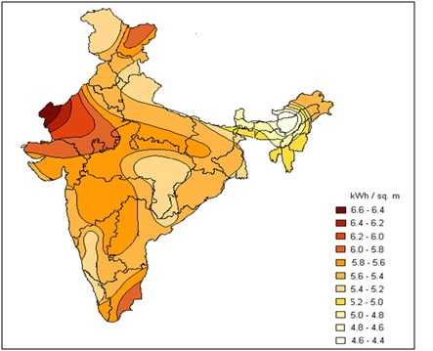
Fig. 1. Solar irradiance availability in India (Source: Garud and Purohit, 2009 [10])
There are many techniques of extracting energy from the solar radiation. The photovoltaic (PV) based electricity generation is most popular because of its techno economic feasibility and higher conversion efficiency which varies from 18-24% depending on the type of material used in the PV panel manufacturing.
- PHOTOVOLTAIC (PV) TECHNOLOGY
The PV cells consists of one or two layers of semiconducting material usually silicon. The photons emitted by the sun absorbed by the semiconducting material and creates the electric field electric field across the layer and cause the flow of current (Fig. 2).

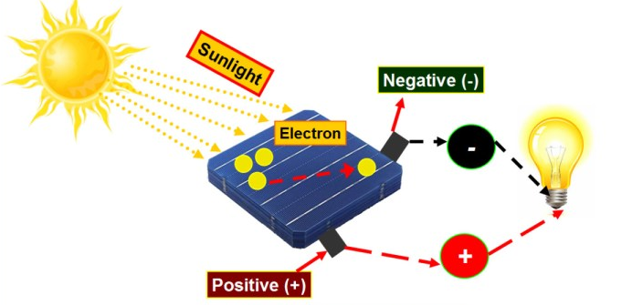
Fig. 2. Working of PV cell
One solar cell can produce only 0.7 watts of electricity when exposed to sunlight. Therefore, number of PV cells (varies from 32 to 144) arranged in the rows and columns to form the module and PV array also called PV panel.
- Methods of PV panel mounting
There are three common methods of PV panel mounting. These are as shown below (Fig. 3):
- Rooftop PV system: in this type of solar power system, the PV panel mounted on the rooftop surface of the residential buildings.
- Floating PV system: it is sometimes called floato-voltaic, is solar panels mounted on a structure that floats over the top surface of water bodies, typically a reservoir or a lake.
- Ground mounted PV system (PV-GM): this method of PV panel mounting is more common among all. The installation of photo-voltaic panels in open areas is the lowest cost option which results the PV system being establishing on agricultural land.

Fig. 3. Common methods of installation of PV panels
The major constrains of PV-GM is that, it covers about 4.5-5 acres area to produce 1 MW electricity [11]. The area underneath the panel cannot be used for the food production purpose. This can result in land use conflict between the energy and food production for ever growing population specially in the area having limited land or having dense population.
In view of this conflict, Agri-voltaic (AV) system can be of good option because it permitted the combined use of land for production of crop and electricity at the same time [12].
- AGRI-VOLTAIC (AV) TECHNOLOGY
The concept of agri-voltaics (AV) was initially proposed in the year 1982 by Goetzberger and Zastrow as a means of modifying solar power plants to enable additional crop production on the same area. In, this system, the PV panels mounted over the raised structure which covered only the one-third area of the total cropland by shading to maintain the microclimatic condition of the plant. Also, the structure raised about 3-4 m above the surface to provide enough ground clearance do that farm machineries can easily pass below the structure to perform mechanical operation in the cultivated area below the panels (Fig. 4). It took about three decades until this concept, referred to as agro-photovoltaic, agro PV, Agri-voltaic or solar sharing, was implemented in various projects and pilot plants worldwide.

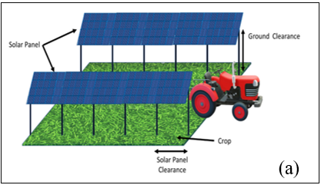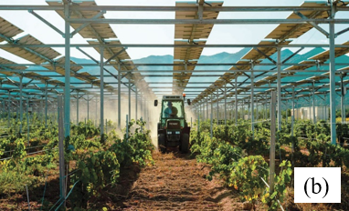
Fig. 4. Agri-voltaic (AV) system (Source: (a) Mahto et al., 2021 [13]; (b) David, 2022 [14])
The agri-voltaic (AV) system has some additional advantages. These are:
- Additional shading enhances the water use efficiency by reducing the concomitant water losses and protect the crop from heat stress during peak sunshine hours.
- It increases the land productivity by getting dual benefit from the same crop land.
- It provides opportunity to electrify the farm operations and adjacent rural area with solar power.
- It enhances the economic return of the farmers.
- Alternate option to replace use of fossil fuel from farm operations.
- Status of AV in India
There are 13 agri-voltaic pilot projects initiated in India in the last 6-7 years capacity ranging from 7 kW to 40 MW [15]. The location of these AV system is shown in Fig. 5.

Fig. 5. Map of agri-voltaic projects in India (Source: Mehta et al., 2021 [15])

Fig. 6. AV system of 105 kW capacity located at CAZARI (Source: Santra et al., 2018 [16])
The AV system of 105 kW capacity located in Central Arid Zone Research Institute (CAZRI) having the additional feature of water harvesting structure of 1 lakh liter capacity to collect the rainwater (Fig. 6). It was reported that, 37.5 mm irrigation can be applied with in one acre land with the collected water. Also, the AV system is able to produce 4 kW electric power per kW installed capacity per day. The selling of PV-generated electricity from around one-acre area would be about ₹7,60,000/- per year addition income apart from farming [16].
- Important parameters for design of AV system
There are some important parameters that need to consider in design of any AV system to assess its agronomic feasibility and performance under field condition. Among all, the effect of shading on the micro-climatic and morphological characteristics of the plant, land equivalent ratio (LER) and levelized cost of electricity (LCOE) production, are one of them. Microclimatic and morphological characteristic of the plant includes temperature of the leaf, photosynthetic photon flux density (PPFD), no. of leaves per plant, specific leaf area and biomass content. The LER and LCOE are the measure of techno-economic feasibility of AV system.
- Land Equivalent Ratio (LER): LER is used to assess the performance of the AV systems in terms of land surface requirements. It is computed by the following formula:
$LER=\frac{{(Fresh biomass)}_{AV}}{{(Fresh Biomass)}_{FS}}+\frac{{(Electricity Production )}_{AV}}{{(Electricity production)}_{FD}}$ (1)
Where, fun sun and full density condition was abbreviated as FS and FD respectively.
LER greater than 1 considered good for efficient AV system.
- Levelized cost of electricity (LCOE): The LCOE calculation method is used to calculate and compare the specific costs per unit of electricity produced. In practice, this method is the current cost comparison criterion of different electric power plant systems [17]. it can be calculated by:
$LOCE=\frac{I_{0} + \sum_{t=1}^{n}{A_{t}×{(1-i)}^{-t} -{ R}_{n}}}{\sum_{i=1}^{n}{M_{t,el}{ (1-i)}^{-t}}}$ (2)
Where:
I₀ = Capital cost
A_{t} = Operating cost
i = Interest rate
t = Time in year of electricity production
R_{n} = Residual value at the end of the useful life of AV system
$M_{t,el}$ = Electrical energy produced in a year
LER and LCOE are the two most important parameters that gives it overall performance in terms of land use efficiency and techno-economic feasibility of any AV system.
- Configurations of AV system
Reference [18] investigated the shading effect on microclimate and morphological characteristic of the plant and also calculated the LER for three different AV configurations. The configurations were Half Density (HF), control tracking (CT) regular solar tracking (ST) and Full Density (FS) AV system (Fig. 7). The HF and FD were stationary while the CT and regular ST system were dynamic AV system having different shading rate (Table 1).
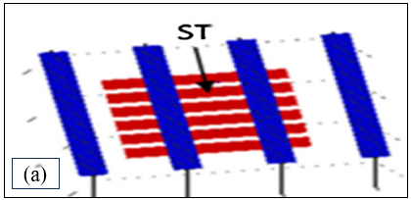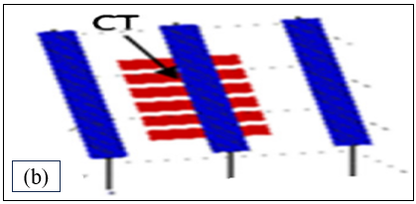
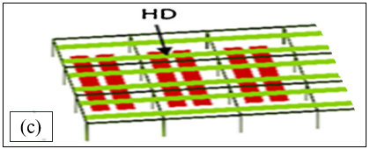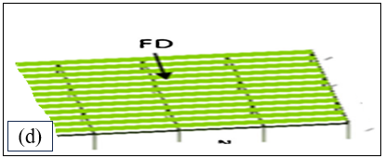
Fig. 7. Agri-voltaic configurations: (a) solar tracking (ST), (b) control tracking (CT), (c) Half density (HD), (d) full density (FD) (Source: Valle et al., 2017 [18])

Table 1. Specifications of the different agri-voltaic configurations (Source: Valle et al., 2017 [18] and Elamri et al., 2018 [19])
Particulars | ST | CT | HD | FD
Tilt angle of solar panels | Dynamic (+/-50°) | Dynamic (+/-50°) | Fixed (25°) | Fixed (25°)
Orientation of panel rows | North-South | North-South | East-West | East-West
Number of row | 4 | 3 | 6 | 12
Shading rate | 35% | 20% | 30% | 50%
The regular solar tracking system followed the sun movement from east to west to maximize the intercepted solar radiation while the purpose of control tracking was to achieved maximum shading to the crop during peak hours (11 AM to 3 PM) and minimize the shading during other day time.
The Madelona variety of lettuce crop was grown under ST, CT, HF and FS condition. FD and FS system was used as a reference to compare the mentioned parameters. The study was conducted in Lavalette near Montpellier, France (43°6N, 3°8E).
- Effect of PV panel shading on leaf temperature and photosynthetic photon flux density (PPFD)
The average temperature in cloudy and sunny day was 17.4°C and 18. 9 °C respectively under FS condition. The reduction in leaf temperature in all three AV (ST, CT and HD) system was negligible due to diffuse radiation during cloudy day. In sunny day, reduction in leaf temperature was more in HD and ST compared to CT condition due to panel shading. Since, Lettuce is usually cultivated under outdoor conditions with day and night-time temperatures of 15–22 °C and 3–12 °C, respectively [20]. Therefore, lettuce crop can be grown under all three AV system.
The PPFD is the amount of photosynthetically active photons (400-700nm) hitting a surface per unit area per unit time. It is responsible for photosynthesis process in the plant. The PPFD received by the plant was more in sunny day compared to cloudy day under FS condition. While the reduction in PPFD was higher in HD and ST compared to CT during sunny day.
- Effect of PV panel shading on number of leaves, and speciﬁc leaf area
The mean was calculated by collecting at least 30 plants per system for leaf number, and 27 plants per system for specific leaf area during both the season i.e., spring and summer. The significantly increased no. of leaves per plan was found in CT condition compared to ST and HD less shading. On the other hand, the specific leaf area was found higher in HD due to more shading which result thicker leaf compared to FS, ST and CT condition (Table 2).
Table 2. No. of leaves, and specific leaf area of lettuce plants grown in FS, HD, ST and CT condition (Source: Valle et al., 2017 [18])
Season | Light treatment | Number of leaves | Speciﬁc leaf area (cm²/g)
Spring | FS | 97.4 | 353
 | HD | 81.9 * | 449*
 | ST | 82.3* | 424*
 | CT | 89.9* | 369(ns)
Summer | FS | 111.9 | 430
 | HD | 84.5* | 627*
 | ST | 91.2* | 453*
 | CT | 99.8* | 442*
*Significant at 5% level; ns- non significant
F. Effect of PV panel shading yield or biomass content of the crop
The biomass data obtained at the 4 harvest dates (2 in spring and 2 in summer) for the cropping cycles of 2016 (Table 3). In spring, a significant decrease in biomass was observed between the agri-voltaic plots and the control plot (the average difference was -24%). In summer, differences also existed between the ST, CT and HD devices: the decrease was -16% for ST and CT against -31% for HD with respect to the fresh biomass harvested in the CP.
Table 3. Fresh biomass (FM) and fraction of marketable biomass (F_{ML}) at harvest dates, of lettuce plant grown under FS, HD, ST and CT plots in spring and summer season
 | Spring |  |  |  | Summer
 | FS | HD | ST | CT | FS | HD | ST | CT
Harvest 1
FM, g | 453.9 (a) | 329.3 (b) | 341.2 (b) | 334.8 (b) | 409.2 (a) | 284.0 (c) | 338.4 (b) | 308.8 (c)
4F_{ML} | 0.54 | 0.21 | 0.24 | 0.27 | 0.41 | 0.04 | 0.22 | 0.23
Harvest 2
FM, g | 636.3 (a) | 498.9 (b) | 493.0 (b) | 492 (b) | 574.4 (a) | 397.3 (c) | 492.7 (b) | 471.9 (b)
F_{ML} | 0.70 | 0.66 | 0.68 | 0.68 | 0.77 | 0.46 | 0.76 | 0.64
Letter a, b and c indicate significant difference at 5% level (Source: Elamri et al., 2018 [19])
Table 4. Shading effect on yield of different crops grown under FS and AV condition (Source: Zheng et al., 2021 [21])
Crop | Yield per hectare  in FS (kg/ha) | Yield per hectare  in AV (kg/ha)
Broccoli | 25530.00 | 23115.00
Shallot | 51225.60 | 50025.00
Garlic sprouts | 19209.60 | 18009.00
Garlic | 15640.50 | 15055.80
Rape | 2037.90 | 1818.15
Broad bean | 5706.90 | 5391.75
Jerusalem artichoke | 29411.25 | 36225.00
The reduction in biomass or yield of the crop under AV system are crop specific. Yield of most of the crops decreased under shading condition except Jerusalem artichoke which showed significantly increased yield by 23% (Table 4). It shows that the AV system has great advantages for the cultivation of shade-tolerant or shad loving crops.
- Electricity production under different AV condition
The maximum electricity production was achieved in FD condition during both spring and summer seasons. In comparison to the stationary HD system, ST increased total electricity production whatever the season spring and summer because PVPs mostly faced the sun throughout the day (Fig. 8)
Fig. 8. Total electricity production in whole cycle of lettuce growth over two seasons (spring and summer) in HD, ST, CT and FD condition (Source: Valle et al., 2017 [18])
- Land Equivalent Ration (LER)
The overall performance of the AV system was assessed on the basis of LER. The highest LER values were achieved with ST (1.5) in both spring and summer season, was mainly due to the highest values of electricity and maintained biomass production obtained with this system compared to HD and CT (Fig. 9). LER of 1.5 in ST means that separate crop and electricity productions might use 1.5 times more crop land area than combining both productions on the same land.
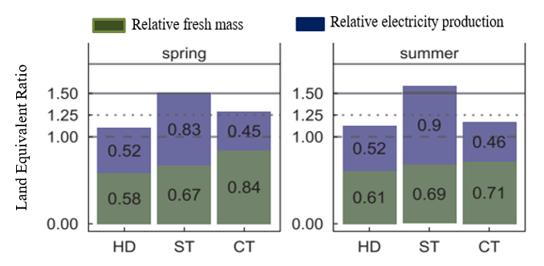
Fig. 9. LER for lettuce crop grown in spring and summer season under HD, ST, and CT condition (Source: Valle et al., 2017 [18])

- Levelized Cost of Electricity (LCOE)
In total, LOCE production for AV was 38% higher than that of Ground Mounted Photovoltaic (PV-GM) system. It was mainly due 63% higher capital cost in AV than PV-GM due to more expenditure in site preparation and mounting structures and hardware (Fig. 10)
Fig. 10. Comparison of the LCOE in Rupees per kWh of APV and PV GM split into capital and operating cost (Source: Schindele, et al., 2020 [22])
- CONCLUSION
The results obtained from the AV systems of having different shading rate pointed out that the shading effects of the PV panels is crop specific, require more study to implement it with other agricultural crops. LER exceeded 1 in all three cases (HD, ST and CT) indicating that, AV system is more advantages than production of electricity and crop separately. The regular solar tracking (ST) with higher electricity and maintained biomass production (LER 1.5) showing the best performances in terms of land use among other AV configurations (HD, FD and CT). The higher LCOE for AV compared to PV-GM was due to increased investment cost which can be minimized by getting dual profit from the same land.
References
- Samuel, R. (2019). Transient flow modelling of carbon dioxide (CO₂) injection into depleted gas fields. Thesis of Doctor of Philosophy. Department of Chemical Engineering University, London United Kingdom, 25-35.
- Fatima, N. (2019). Chemical transformation of oils derived from green and red algae to biodiesel and its related analogues. Thesis of Doctor of Philosophy. Department of chemistry, Federal Urdu University of Arts, Science and Technology, Pakistan. 18-27.
- Anonymous. (2019). When fossil fuels run out, what then. Available at https://mahb.stanford.edu/library item/fossil-fuels-run/ [Accessed on 13 June, 2023].
- Sims, R. E., Rogner, H. H. and Gregory. K. (2018). Carbon emission and mitigation cost comparisons between fossil fuel, nuclear and renewable energy resources for electricity generation. Energy Policy, 31(13):1315–1326.
- Singh, H. P., & Rao, N. K. (2023). Climate resilient and sustainable development of horticulture-Options and opportunities-A review. International Journal of Innovative Horticulture, 12(1), 1-14.
- Chowdhury, M., Lande, S. D., Khura, T. K., Parray, R. A., Upadhyay., P. K., and Kumar, P. (2023). Energetics and Cost Economics of Wheat–based Cropping System. Annals of Agricultural Research, 44(1): 37-45.
- MNRE. (2021). Solar energy: Overview. Available at https://mnre.gov.in/solar/current-status/ [Accessed on 15 June, 2023]
- Yadav, H. K., Kumar, V. and Yadav, V. (2015). Potential of solar energy in India: A review. International advanced research journal in science, engineering and technology, 2(1):63-66.
- EIA. (2019). Today in energy. Available at https://www.eia.gov/todayinenergy/detail.php?id=42295#:~:text=India's%20economic%20growth%20will%20continue,the%20world%20total%20to%2013%25. [Accessed on 14 June, 2023]
- Garud, S. and Purohit, I. (2009). Making solar thermal power generation in India a reality – overview of technologies, opportunities and challenges. The energy and resources institute, New Delhi, 1-12.
- Prabhu, V. S., Shraddha, S. and Mukhopadhyay, K. (2021). Life cycle assessment of solar photovoltaic in India: A circular economy approach. Springer, 2(1):507-534.
- Weselek, A., Ehmann, A., Zikeli, S., Lewandowski, I., Schindele, S. and Hogy, P. (2019). Agri-voltaic systems: applications, challenges, and opportunities. A review. Agronomy for Sustainable Development, 39(4):1-20
- Mahto, R., Sharma, D., John, R., Putcha, C. (2021). Agrivoltaics: A Climate-Smart Agriculture Approach for Indian Farmers. Land, 10; 2-28.
- David, R. R. (2022). Agrivoltaism: a win-win system?. Energy industry review. Available at https://energyindustryreview.com/analysis/agrivoltaism-a-win-win-system/ [Accessed on 15 June, 2023]
- Mehta, R. P., Pulipaka, S., Winter, T., Murali, P. and Vorast, M. (2021). Agri-voltaics in India: Overview of operational projects and relevant policies. National solar energy federation of India, 1-57
- Santra, P., Singh, R. K., Meena, H. M., Kumawat, R. N., Mishra, D., Jain, D. and Yadav, O. P. (2018). Agri-voltaic system: crop production and photovoltaic-based electricity generation from a single land unit. Indian Farming, 68(1):20–23.
- Bano, T. and Rao, K. V. S. (2016). Levelized electricity cost of five solar photovoltaic plants of different capacities. Procedia Technology, 24(1):505–512.
- Valle, B., Simonneau, T., Sourd, F., Pechier, P., Hamard, P., Frisson, T. and Christophe, A. (2017). Increasing the total productivity of a land by combining mobile photovoltaic panels and food crops. Applied Energy, 206 (1):1495–1507.
- Elamri, Y., Cheviron, B., Lopez, J. M., Dejean, C. and Belaud, G. (2018). Water budget and crop modelling for agri-voltaic systems: Application to irrigated lettuces. Agricultural Water Management, 208 (1), 440–453.
- Jeong, S. W., Kim, G. S., Lee, W. S., Kim, Y.H., Kang, N. J., Jin, J. S. and Shin, S. C. (2015). The effects of different night-time temperatures and cultivation durations on the polyphenolic contents of lettuce: Application of principal component analysis. Journal of Advanced Research, 6(3):493–499.
- Zheng, J., Meng, S., Zhang, X., Zhao, H., Ning, X. and Chen F. (2021). Increasing the comprehensive economic benefits of farmland with even-lighting agri-voltaic systems. PLoS ONE, 16(7):223-245.
- Schindele, S., Trommsdorff, M., Schlaak, A., Obergfell, T., Bopp, G., Reise, C. and Weber, E. (2020). Implementation of agri-voltaics: techno-economic analysis of the price-performance ratio and its policy implications. Applied Energy, 265(4):114-132.

