Performance Improvement of Household Refrigeration System by Using Various Nano Additives-A Review
ABSTRACT
Nano-based refrigerants, which are both energy efficient and ecologically beneficial, are currently being favored. The latest development, possibilities, in addition to research of nano-base refrigerant in refrigeration system is discussed in this study. It was discovered that different thermal properties of nano refrigerants have been observed to be favorable. Reduced power consumption, increased (COP), enhanced pressure fall characteristic of nano-oil, and increased conductivity of heat of mixture-refrigerant are just a few of the benefits. As a result of this debate, nanoparticles appear to be a strong contender for inclusion in a standard refrigeration system.
KEYWORDS
Heat transmission; pressure fall; refrigerant; nanoparticles; COP
INTRODUCTION
Refrigeration systems typically require a lot of energy. According to studies, the refrigeration systems in supermarkets might consume between 50 and 80 % of the total electricity utilized ^{[1].} As a result, experts have been looking for ways to improve refrigeration systems. Physical qualities of refrigerants such as gumminess, conductivity of heat, and relative density play a crucial role in elevated-recital energy rescue to the cooling section in refrigerate and cool operations like the single depicted shown in Figure 1. The creation of a more efficient thermal system has risen to the forefront in recent years, since the need for energy continues to rise as the world's population grows. The enhance in the signify hotness as a consequence of the release of dangerous compounds and orangery gas into the surroundings is also a source of worry. The majority of these emissions are caused by the depletion of fossil fuels and the usage of environmentally unfriendly refrigerants. Sustainability necessitates the development of ecologically friendly and more efficient energy-carrier refrigerants. Each nano-feedstock, on the other hand, has its own set of thermo-substantial property. Nanofluids, on the supplementary offer, have been used in a variety of fields and sectors, including medication delivery and medicine, nuclear energy, automotive, lubrication, microchannels, renewable energies, electronic cooling, methods of heating and cooling, and exchangers of heat [2–26]. The usage of refrigerant-base nanofluids is ahead traction, despite the fact that the disadvantages are still being studied.
The feedstock is being studied, as well as the loading of nanofluids into refrigeration systems, in order to achieve considerable beneficial effects. They want to make smaller and more economical refrigeration equipment by exhibiting several promising elements such as improved band steaming and convective warm transport coefficients [25]. We provide a brief overview of nano refrigerant uses in home and industrial refrigeration systems in this study. In addition, numerical analysis will be used to examine the effects of nanorefrigerants in a variety of thermal systems. We also present a review of key boundaries of nanoparticle for refrigeration system that must be considered for the period of different investigations, as well as potential outlook investigate areas and spaces that require greater consideration as of inquisitor in the current work.
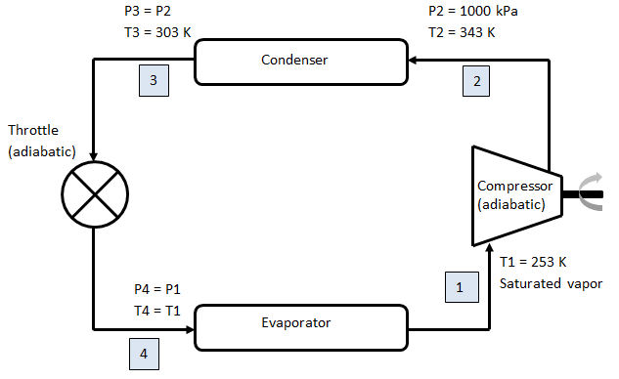
Fig. 1. VCR system
REFRIGERATION SYSTEMS WITH NANOREFRIGERANTS
Quick overview of the field of refrigeration systems used with nanofluids development.
This field of learn research space were studied to gain a sense of the effort that has been made in the region. The inquiry was carried out using the search term "Nanorefrigerant or Nanoparticle-base Refrigerant" and "Thermal presentation or high temperature transport presentation," and the following were discovered: (Figures from 2 to 7).
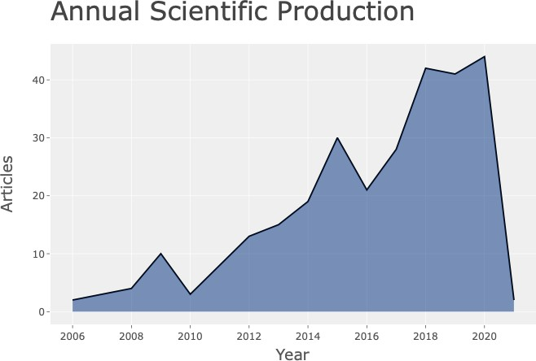
Fig. 2. A chart of yearly technical creation
Fig. 2 shows the consistent increase in publishing in the nanorefrigerant research domain from 2006 to 2020. This increase demonstrates that this field of study has enormous promise for improved refrigerants and refrigeration system.
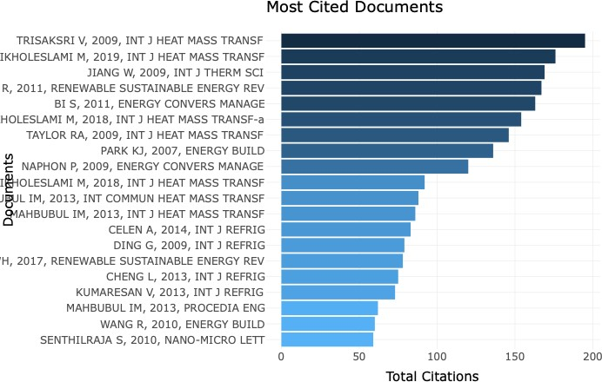
Fig. 3. A chart of Most cited research documents
The top referenced writers in nanorefrigeration are displayed in Figure 3. In descending order, the most referenced writers are Trisaksri, Ikholeslami, and Jiang, all of whom have studied significantly in this topic and delivered interesting results. Trisaksri and Wongwises, for example, conducted a thorough examination of these fluids. Similar work has been done in this area by others.
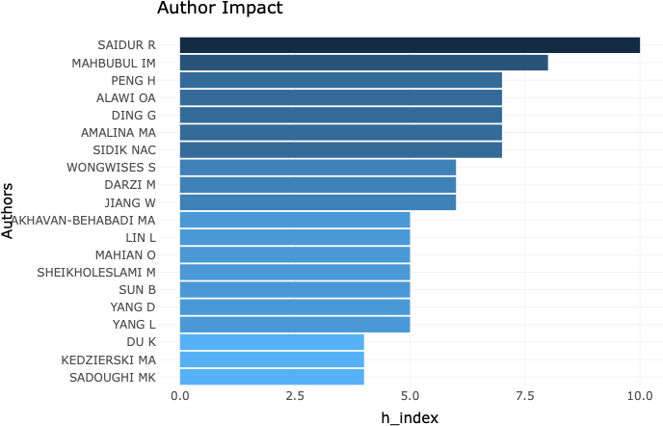
Fig. 4. A chart of Author’s h-index
Fig. 4 depicts a graph of h-index for author working in the nanorefrigeration field. We can observe that Saidur and Mahbubul are among the top performers in this category. They have an h-index of above 7.
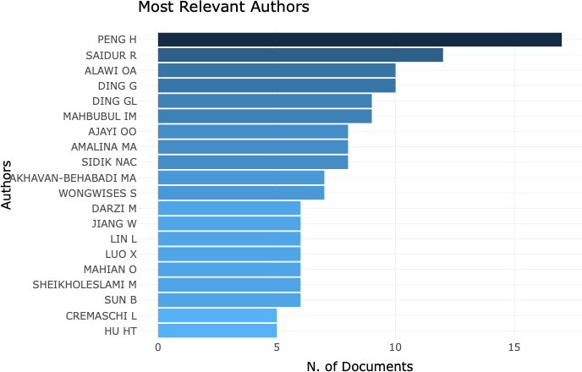
Fig. 5. A chart of Number of research documents by authors in this field

Peng and Saidur have the most papers in the field of nanorefrigerants, as shown in Figure 5. They each have a number of documents in excess of ten, indicating that they are actively working in this field.
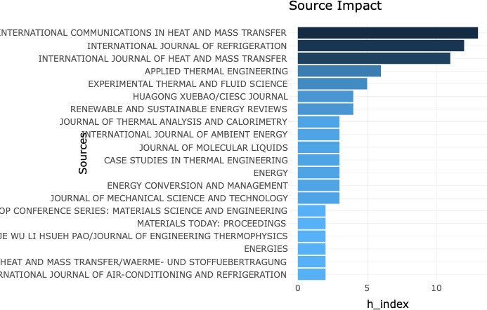
Fig. 6. A chart of the h- index of various journals

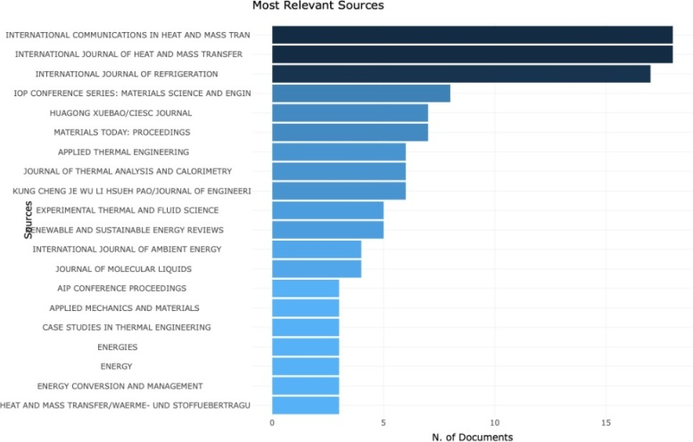
The h-index of worldwide relations in heat and mass transfer, international journal of refrigeration, and international journal on heat and mass transfer is more than 10, as seen in Figure 6. demonstrating that these journals have available significant papers in this field.

Figure 7 . A chart of various of documents published by various journals

Global relations in heat and mass transfer, International journal on heat and mass transfer, and International journal of refrigeration all include more than 15 papers, as shown in Figure 7. Demonstrating that these journals have published in various articles in this field.
Nanofluids increase the performance of refrigeration and air-conditioning systems.
This paper examines the impact of nanofluids on the performance of nanofluids in refrigeration and air-conditioning system. Nanofluid can play any of the following functions in improving the performance of refrigeration and air conditioning systems: (1,2) as lubricant-based nanofluids. (2) as refrigerant-based nanofluids and (2,3) as inferior fluid (coolant for heat elimination in refrigeration systems, and resulting refrigerant for the evaporator region) [27-35].
The thermophysical characteristics of nanorefrigerants, performance effectiveness of refrigerators and air conditioners were investigated by Mahbubul et al. [37]. Based on established correlations, a combination of Aluminum oxide (Al₂O₃) and R-134a containing 4.5% metallic oxide was employed as a nanorefrigerant in an even horizontal pipe at 283K to 308K temperature range. In terms of density (12%), viscosity (13.48%), and thermal conductivity, a nanorefrigerant blend of Al₂O₃ and R134a outperforms R134a when used alone (27.51 % ). R-134a, on the other hand, had a larger specific heat capacity than the nanofluid combination. In comparison to R-134a, the nanorefrigerant combination had a better COP in concentration (3.18%), specific heat capacity (2.43%), and Conductivity of Heat (14.2%). Application and preparation techniques for nano-refrigerants were discussed [38]. The nanofluid's stability potential was also investigated, and it was discovered to be influenced by the nanoparticle concentration in the refrigerant [39]. As a result, the nanoparticle concentration must be tuned to ensure long-term stability.
Several studies [40-43] have been conduct to determine the thermal characteristics of refrigerant-based nanofluids. The frictional pressure loss in a vapour compression refrigeration cycle was investigated using R600a and CuO [44]. The results revealed that adding nanoparticles to the refrigerant improved the frictional pressure decrease significantly. Transmission and convection be also observed to raise as a outcome of the CuO nanoparticles being added to the refrigerant. The refrigeration system was also charged with a mixture of R134a and CuO [42]. Their research revealed an increase in the COP and a decrease in power usage. The use of synthetic oil in the nano-mixture was also shown to increase the frictional qualities of the nano-mixture [42]. Different refrigerants were used to examine an aluminium oxide (Al₂O₃) based nanofluid [40,41]. The experimental experiments of demonstrated a capable enhancement in the heat transfer quality, through the vapour compression refrigerator consuming roughly 11.2% less power [40]. The hotness of the cooling section of the refrigerator dropped significantly around 6% - 10% when the baseline case-R134a was compared to the nanorefrigerant case (R134a + Al₂O₃) [41]. Similarly, in R134a [45], the heat transfer coefficient of nano refrigerant was investigated using Al₂O₃ nanoparticles. Their findings revealed that when particle concentration grew, the entire heat transmit coefficient, conductivity of heat, and specific heat lowered.
A group of researchers looked through the literature to see how nanofluids affect the energy effectiveness of system that utilise nanorefrigerants and nanolubricants [46]. They were discovered that using nanofluids in refrigeration systems improves the mechanical and thermodynamic features of the system. The use of zinc oxide(ZnO) nano lubricant (R152a) saved 19.1% of energy while posing no threat to the ozone layer, lowering the risk of global warming, and improving the efficiency of refrigeration systems. Using titanium oxide (TiO₂) nanoparticles charged into several common refrigerants, the cooling efficacy of refrigerants was investigated [47-49]. In a residential refrigerator, different concentration (gm./L) of TiO₂ in a 25g of refrigerant R600a were investigated [47]. The use of TiO₂ particles has been proven to boost cooling rates while drastically lowering energy usage. R-134a, on the other hand, was used in their experiment [49]. Their findings revealed that adding Titanium oxide nanoparticles to the refrigerant system enhanced the refrigerator's COP considerably [49]. When comparing pure R600a to R600a with TiO₂, a group of researchers determined that R600a with TiO₂ consumes around 11% less energy [48].
A group of researchers performed a algebraic analysis on a nanofluid made since mango bark [50]. The original idea was put to the test, and the results revealed a significant increase in Nusselt number of roughly 68 percent. The presentation of the condenser of the refrigerator's vapour compression was investigated using the mass flow rate and heat rejected [51]. When nanorefrigerant was used, their results showed an increase in mass flow rate and a decrease in heat redundant at the condenser part. Cupric Oxide (or) Copper (II) oxide as the nanoparticle and R600a as the base solution were used to study the pressure drop of nanorefrigerant [52]. Their research used a variety of nanoparticle mass fluxes, and the findings revealed a considerable pressure reduction owing to the refrigeration cycle's condensation flow pattern. To explore the energy characteristics of LPG refrigerant, researchers used various quantities of Al₂O₃ [53]. According to a group of researchers, a absorption of 0.6 gm/L yielded the best results, while a absorption of 0.3 gm/L outperformed other concentration in terms of COP [53]. On the other hand, at a absorption of 0.6 gm/L, the temperature of the ejection was lost. Available energy extent is taken into account in the investigation [54]. When compared to other nanomaterials, TiO2 and CuO nano-based refrigerants use the least amount of energy.
In the refrigerant R134a, two distinct nanorefrigerants (Aluminium Oxide-Ethylene glycol and Titanium Oxide-Ethylene glycol oils) are used as nano-based particles. With the application of Al2O3, the COP of the refrigeration system increased by around 11%, whereas TiO₂ delivers a noteworthy increase of about 20% of COP [55]. In a different study, Al₂O₃ was used with an R290/R600a refrigerant combination [56]. The blend concentration of all the fluids involved determines how much better the coefficient of performance improves. The optimum result is obtained when the R290/R600a ratio is 0.8:0.2 and Al₂O₃ nanoparticles are used [56]. By means of inclusion of nano-particles in the refrigerant mixture, COP rises while power consumption decreases.
Nano-oil in R600a refrigerant was investigated by means of a micro-fin pipe [57]. The loading parameters of the nano-oil, as well as the condensation pressures, were studied. The cooling cycle was likewise conducted in its purest form, with no additives. The results revealed that using isobutene (R600a) in the refrigerators exchanger of heat enhances heat transmission (condenser). The temperature transmission coefficient is raised to a substantial intensity of around 77%. According to one set of researchers, loading nanoparticles with low down vapour value appears to exist extremely efficient for elevated high temperature transmission [57]. The refrigerant R718 and other refrigerants were used to do computational and experimental assessments of nanoparticles [58]. When compared to when they didn't employ nano-particles, their thermal performance improved by 25%. However, the best results were obtained when Al₂O₃ was used in R134a, whereas the worst results were obtained when TiO₂ was used in R404a. CuO and R134a have also been used in computational investigations [59].
The introduction of Cu based nanoparticles boosts the heat transfer coefficient, according to the findings. For experimental assessment, the refrigerants R134a, R600a, and Polyalkylene Glycol oil were employed with Copper Oxide-based nanoparticles [60]. Their findings revealed that R134a has a lower COP than R600a due to R600a's lower energy consumption when compared to R134a. The Nusselt number was calculated using TiO₂ nanoparticles in R134a refrigerant [61]. During the testing, a variety of nanoparticle concentrations were utilised. Increases in heat flow, Reynolds number, and nanoparticle concentration were shown to enhance Nusselt numbers [61]. Copper, Copper Oxide, Aluminium, and Aluminium Oxide nanoparticles were investigated as a possible driving force for improving the refrigeration competence of R141b in soft and within uneven tubes, and the results showed that Cu-R141b nanofluid perform considerably improved when compare to new nanofluids, with ribbed tubes performing improved than soft tubes [62].
Table 1. A review of statistical studies on nanorefrigerants

Authors | Nanorefrigerants | particular/Two-Phase Modeling (Nanoparticles &  Refrigerants) | purpose
Alawi et al., 2015b | Alumina, ZnO, CuO,  SiO2 - R141b | a single-phase strategy | Annulus cylindrical pipe
Tashtoush et al., 2017 | Alumina, CuO - R123, R134a, R141b, R152a,  R22, R290, R600, R717 | a single-phase strategy | A refrigeration system with ejectors
Zohud et al., 2018 | Alumina, ZnO, CuO,  SiO2 - R1270 | a single-phase strategy | A homogeneous heat flux is applied to a circular tube.
Coumaressin and  Palaniradja, 2014a | CuO - R134a | a single-phase strategy | Household refrigerator
(Helvaci & Khan, 2017) | CuO, MgO, SiO2, Al2O3  - HFE 7000 | a single-phase strategy | Circular horizontal tube
(I. Mahbubul, Fadhilah,  Saidur, Leong, & Amalina, 2013) | Al2O3 - R134a | a single-phase strategy | Smooth horizontal tube
(S. Sanukrishna, Ajmal,  & Prakash, 2018) | TiO2 - R134a | Two-phase strategy | In a circular tube, the water is brought to a boil.
(Hernández et al., 2016) | Al2O3 - R133, R123,  R134a | Two-phase strategy | System of refrigeration
(Ajayi, Ibia, Ogbonnaya, Attabo, & Michael,  2017) | Cu, Al- R134a, R600a | Two-phase strategy | A vapour refrigeration system's capillary tube
(Rahman et al., 2019) | SWCNT - R407c | Single-phase strategy | System of air conditioning
(Dey & Mandal, 2021) | Al2O3 - R600a | Single-phase strategy | Evaporator with a shell and tube design
(Mohamadi et al., 2021) | Al2O3, SiO2- HFE7000 | Single-phase strategy | Circular tube that runs horizontally

A DISCUSSION OF NANO REFRIGERANT PROPERTIES

This section presents the review of the impacts of nanorefrigerant characteristics on refrigeration systems, as well as the implications of nanorefrigerant characteristics on refrigeration systems are being investigated. [63] conducted a thorough examination of the physical temperature parameters and performance aspects of a system of refrigeration employing nanofluids made of refrigerants. They proposed, among other things, that refrigerant thermal conductivities and nanoparticle thermal conductivities have a considerable influence in the distinctive behaviour of nanofluids, especially when they are utilised for heat transfer applications. The COP and the refrigeration system effectiveness are then determined by means of heat transfer. Thermal conductivities of typical refrigerants and nanoparticles are shown in Table 2. The qualities of the refrigerant are reported to enhance when nanoparticles are added. This improvement is dependent on the nanoparticle's concentration, size, and material qualities, conductivity of heat, specific mass and specific coductance are examples of these characteristics. The flow as well as heat transfer characteristics of an alumina/isobutane nanorefrigerant were investigated [64]. They looked at percentage by volume of 1 to 6% alumina particle at various temperature, as well as the mass flow through a smooth tube. They found that reducing the percentage by volume of nanoparticles reduces the conductivity of heat, fluidity, coefficient of convective heat transfer, and specific mass of the nanorefrigerant even as increasing at any temperature, the Nusselt number and specific heat for the nanorefrigerant (alumina/isobutane). However, when temperature increased, the Nusselt number, conductivity of heat, massic heat capacity, and coefficient of convective heat transfer all increased, whereas Specific mass and fluidity decreased.
Table 2. Conductivity of heat of various refrigerants and nano-materials.

Name of Refrigerant and Nano-material | Conductivity of heat  (W/m K)
Trichloromonofluoromethane[R11] | 0.101
Chlorodifluoromethane [R22] | 0.096
Tetrafluoroethane [R134a] | 0.083
Mixture of difluoromethane (CH₂F₂, called R-32) and pentafluoroethane (C₂HF₅, called R-125) [R410] | 0.014
Iso-Butane [R600a] | 0.106
Pentafluoroethane Trifluoroethane Tetrafluoroethane [R404a] | 0.015
Aluminium oxide [Al₂O₃] | 41
Cupric oxide or copper(II) Oxide [CuO] | 34
Titanium Oxide[TiO₂] | 4.7

Researchers often explore with attributes such as fluidity, hotness, quantity, volume of nano-particles, conductivities of heat, and specific mass. Hydrofluoroethers-7000, for example, are a new baseline generation refrigerant. Table 3 summarises the various refrigerant-based fluids that were investigated. The table summarises the performance of several combinations of nano particles within the base liquid. It will help to refrigerator designer understand the characteristics of different hybrid-refrigerants.

Table 3. Summary of Nano-based refrigerant research.

Refrigerant source based on nanofluids/nanofluids | Outcomes | Researchers
SiO₂ in HFE-7000 | 26% increase in the conductivity of heat  report at 0.03% by volume. | (Nawi, Rehim, Azmi, &  Razak, 2018)
TiO₂ in R600a  TiO₂ R600a/mineral oil | 9.5% less energy consumed employing 0.4 gm/L of TiO2-R600a. The use of TiO2 accelerated the freezing process.  The COP increased to 60.4%, which is a huge improvement. | (S. Bi et al., 2011)  (Jatinder et al., 2019)
Al₂O₃ in /Mineral oil Al₂O₃ in R141b  Al₂O₃ in R134a | A total of 19.91% of energy was saved. With heat flux of 152kWm⁻².  By 122% the heat transfer coefficient improves.  Thermal conductivity has increased by 31%.;  The density has increased by 12%.,  A 17 %increase in COP and a 15% rise in viscosity.  COP increased by 9 to 12 %. | (Padmanabhan& Palanisamy, 2012)  (I.M. Mahbubul, A. Saadah,  R. Saidur, M.A. Khairul, &  A. Kamyar, 2015)  (I.M. Mahbubul et al., 2015) (Singh & Lal, 2014)  (Kotu & Kumar, 2013)
Al₂O₃ in R113/CuO  R141b/CuO in R113 | The mass fraction, density, viscosity, and heat flux are all inversely proportional to the migration ratio, which is directly proportional to the refrigerant's liquid phase density.  The heat enhancement was observed to be around 33%. | (Hao Peng, Ding, & Hu, 2011b)  (H. Peng, Ding, & Hu, 2011c)
CuO in R134a | With a 21.4 % maximum frictional pressure drop throughout the system, a 28.6 % increase in heat transfer enhancement was found. | (Bartelt, Park, Liu,& Jacobi, 2008)
CuO in R134a | There was also an increase in heat transmission.. | (Henderson, Park, Liu, & Jacobi, 2010) (Abdel-Hadi  et al., 2011)
CuO in R134a | Better performance and heat transfer from the evaporator | (T. Coumaressin & K.  Palaniradja, 2014)
TiO₂ in R141b | Reduction in heat transfer | (V. Trisaksri & S.  Wongwises, 2009)
SiO₂ in R134a | A total of 162 % heat transmission was measured.  Heat transmission resulted in a decrease in particle concentration.. | (S. S. Sanukrishna, Shafi, Murukan, & Prakash, 2019)
ZnO in R134a | The thermal conductivity of cubic and spherical shapes improved by 42 % and 26 %, respectively.  The amount of energy utilized has decreased by 23%. | (Maheshwary,Handa, & Nemade, 2018)  (D. S. Kumar & Elansezhian, 2014)
TiO₂ in R123 | As the concentration of nanoparticles rises, the viscosity decreases.  Low concentration, on the other hand, was recommended for optimal performance. | (I. M. Mahbubul, Saidur, & Amalina, 2012)  (O. Alawi, Sidik, & Kherbeet, 2015)
TiO₂ in R134a | The COP increased by 19%, and around 17% less electricity is consumed. | (Subramani, Mohan, &  Prakash, 2013)
Ti in R11 | Efficiency increased significantly | (Naphon,Thongkum, &  Assadamongkol, 2009)
Al in R141b | The usage of nanoparticles resulted in an increase in heat transmission. | (B. Sun & Yang, 2013)
When the concentration of Al₂O₃ in the vapour compression refrigeration system is increased, the heat transfer coefficient improves, according to (Kanthimathi et al., 2017). (Table 4). The best nanomaterial to use is still a work in progress, since the best results are dependent on a variety of circumstances. As seen in Figures 2 and 3, the heat transmission and thermal conductivity rise significantly as the refrigerant concentration increases.

Table 4. Thermal conductivity and heat transfer coefficient of Al₂O₃ at different concentrations (Kanthimathi et al., 2017).

Concentration (%) | 0.04 | 0.2 | 1.2 | 3.1 | 4.0
Heat Transfer Coefficient  (Wm⁻²K⁻¹) | 436.3 | 554.6 | 2945.6 | 6784.6 | 10693.4
Thermal Conductivity (W/m K) | 0.0828 | 0.084 | 0.086 | 0.091 | 0.094

Tests [65] were carried out using the same geometry and input requirements for four different baseline refrigerants. In Table 5, the refrigeration coefficient of performance (COP) varies depending on the input parameter. Despite the fact that the choice of an environmentally friendly refrigerant has recently become the topic of research. Since greenhouse gas emissions have a negative influence on our biodiversity,, we cannot remain complacent with current refrigerants. R600a and R290 had the same percentage increase in COP at 6% volume fraction of Al₂O₃ (Table 5) four types of refrigerants, according to [65]. However, in terms of COP improvements, R134a and R404a lag behind the other refrigerants. A refrigeration system's performance coefficient is calculated using Equation 1.
COP = Heat Extracted/Work input | [1]

Table 5. COP characteristics for Al₂O₃ at a volume proportion of 6% [65].

Refrigerants | COP has improved. (%)
Tetrafluoroethane [R134a] | 19
Propane [R290] | 22
Pentafluoroethane Trifluoroethane Tetrafluoroethane [R404a] | 17
Iso-Butane [R600a] | 22

Table 6 lists the features of typical nano-based particles for simple comparison, reference, and selection. Here are the results of five main intrinsic features of nano-based particles. These characteristics are especially important in the heat transmission of the hybrid energy carrier. The combination of Tables 3 and 6 is required for in-depth examination when selecting nanoparticles for refrigeration systems. When comparing parameters like conductivity of heat based-nanoparticles in Table no.6 with the potential results in Table no. 3, inferences may be derived. As a result, these features [Table 6] Physical chemistry and heat transfer arguments for nanorefrigerants are crucial.
Table 6. Unique properties of some Nanoparticles
Particles made of nanomaterials | Properties
Silicon Oxide | Specific heat capacity – 749.9 Jkg⁻¹K⁻¹  Specific mass – 2.39 gcm⁻³  Conductivity of Heat – 1.36 Wm⁻¹K⁻¹  Molecular Weight. – 60.2 g mol⁻¹
Titanium Oxide | Specific heat capacity – 682.8 Jkg⁻¹K⁻¹  Specific mass – 4.24 gcm⁻³  Conductivity of Heat – 4.73 Wm⁻¹K⁻¹  Molecular Weight – 79.8 g mol⁻¹
Cupric Oxide | Specific heat capacity, - 880.2 Jkg⁻¹K⁻¹  Specific mass – 6.33 gcm⁻³  Conductivity of Heat – 32.8 Wm⁻¹K⁻¹  Molecular Weight – 79.55 g mol⁻¹
Aluminium Oxide | Specific heat capacity, - 525.3 Jkg⁻¹K⁻¹ Specific mass – 3.86 gcm⁻³  Conductivity of Heat – 36.21 Wm⁻¹K⁻¹  Molecular Weight – 101.99 g mol⁻¹
Zinc Oxide | Specific heat capacity - 523.38 Jkg⁻¹K⁻¹  Specific mass – 5.58 gcm⁻³  Conductivity of Heat – 23.51Wm⁻¹K⁻¹  Molecular Weight – 81.36 g mol⁻¹
Titanium | Specific heat capacity, - 520.91 Jkg⁻¹K⁻¹  Specific mass – 6.29 gcm⁻³  Conductivity of Heat – 16.96 Wm⁻¹K⁻¹  Molecular Weight – 79.61 g mol⁻¹
Aluminium | Specific heat capacity, - 921.3 Jkg⁻¹K⁻¹ ;  Specific mass – 2.68 gcm⁻³  Conductivity of Heat - 205.1 Wm⁻¹K⁻¹  Molecular Weight-26.97 g mol⁻¹

Boundaries of nanoparticles for refrigeration system

One of the challenges in producing nanoparticles for refrigerants is ensuring proper particle dispersion in the fluid to avoid rapid settling in the fluid medium (refrigerant). According to [66-68], this barrier has been mostly eliminated. Heat transfer efficiency improvement liquid, made of nanoparticles are critical for the effective release of work produced as demanded with numerous industry throughout the world. It is suggested that particle sizes of roughly 10nm and lower be used. Metallic fluids have a substantially greater thermal conductivity than normal fluids, according to research [65]. Clogging and abrasion are concerns with nanofluids that are dependent on nano–based particles in conventional fluids. Clogging and abrasions are likely to be less of an issue with nano-sized suspensions than with micro-sized suspensions [65]. The nano particle [65] is 10³ times the size of a micron-sized particle, increased area of the surface allows for a significant raise in conductivity of heat, decrease of corrosion, and fluid constancy. When nanoparticles are generated in pulverized structure, there is a clustering problem, which causes the particles to settle in the liquid. To avoid overheating of the nanoparticles, dispersion is normally done with the use of an intermittently regulated ultrasonicator in liquid. The use of a hydrocarbon-based nanorefrigerant also poses a danger of flammability. Several investigations [69-89] were conducted to assess its applicability and to lower the risk.
Proposed research directions
Based on a survey of articles in the open literature, the following investigation directions are suggested.
1. No investigate on the application of biobased nanorefrigerants has been published. The utilisation of biobased nanorefrigerants will be a fascinating research that will also benefit the environment.
2. The concentration of nanoparticles has been revealed to have a substantial influence on heat transmission and thermophysical properties of nano refrigerants. The optimal nano refrigerant ratio depending on particle size, concentration, temperature, and flow conditions will require further investigation.
3. There is a scarcity of research on numerical and analytical models for predicting physical attributes in the open literature. In this regard, future work is suggested.
4. While most numerical studies concentrated on utilising a single-phase technique to deal with nanorefrigerants, the two-phase mixture model will provide hurdles in future studies because to its great accuracy and high processing cost at the same time.
5. There are just a few researches on the usage of nanoparticles with natural refrigerants such hydrocarbons, NH₃, and CO₂ in the open literature. In terms of commercial and industrial applications, these investigations are required.
6. There have been no research on the influence of nanoparticles on new blend refrigerants like R1234yf.
7. Nano refrigerant flow through microchannels, twisted taped tubes, corrugated tubes, and other enhanced geometries is limited in research. Further study is needed to see how using nano refrigerants affect heat transfer coefficients and overall thermal performance of refrigerating systems.
CONCLUSIONS

This paper reviewed a number of studies on nano-based refrigerants, appraised the subject's innovative development and promise, and offered a few innovative prospect studies in the field. The major point of debate was that nanoparticles have a lot of potential if they're used in a standard system of refrigeration. Nanorefrigerant has been shown towards the improve refrigeration system concert and heat transmission. It was also observed that the refrigeration system's better performance is aided by its reduced cost, longer lifespan, and greater total rate of heat transfer. The specific conclusions are as follows::
• The use of nanoparticles in refrigerants has the potential to improve system efficiency.
• Adding nanoparticles to refrigerant enhances the refrigeration system's coefficient of heat transfer and conductivity of heat.
• The use of nanoparticles in refrigerants minimizes the amount of energy used.
• The use of nanorefrigerants increases the refrigeration system's overall thermal performance.
• There are no conflicting interests stated by the authors..
REFERENCES

- M.A. Abbas, Y.Q. Bai, M.M. Rashidi, & M.M. Bhatti, “Application of Drug Delivery in Magnetohydrodynamics Peristaltic Blood Flow of Nanofluid in a Non-Uniform Channel”, Journal of Mechanics in Medicine and Biology, Vol. 16, No. 04, 2016. doi:10.1142/s0219519416500524
- E.A.H. Abdel-Hadi, S.H. Taher, A.H.M. Torki, & S.S. Hamad, “Heat transfer analysis of vapor compression system using nano CuO-R134a”, Paper presented at the IPCSIT, Int. Conf. Adv. Mater Eng., 2011.
- D.S. Adelekana, O.S. Ohunakina, J. Gillb, O.E. Atibaa, I.P. Okokpujiea, & A.A. Atayero, “Performance of a Domestic Refrigerator infused with Safe Charge of R600a refrigerant and various concentrations of TiO2 nanolubricants”, Procedia Manufacturing, Vol. 35, Pp. 1158–1164, 2019. doi:10.1016/j.promfg.2019.06.071
- M.M. Ahmadpour, M.A. Akhavan-Behabadi, B. Sajadi, and A. Salehi-Kohestani, “Experimental Study of R600a/Oil/MWCNT Nano-refrigerant Condensing Flow Inside Micro-fin Tubes”, Heat and Mass Transfer,Vol. 56, Pp. 749–757, 2020. doi:10.1007/s00231-019-02739-2

- O.O. Ajayi, D.E. Ibia, M. Ogbonnaya, A. Attabo, & A. Michael, “CFD analysis of nanorefrigerant through adiabatic capillary tube of vapour compression refrigeration system”, Procedia manufacturing, Vol. 7, Pp. 688-695, 2017.
- O. Alawi, N. Sidik, & A. Kherbeet, “Measurements and correlations of frictional pressure drop of TiO2/R123 flow boiling inside a horizontal smooth tube”, International Communications in Heat and Mass Transfer, Vol. 61, Pp. 42-48, 2015.
- O.A. Alawi, & N.A.C. Sidik, “Influence of particle concentration and temperature on the thermophysical properties of CuO/R134a nanorefrigerant”, International Communications in Heat and Mass Transfer, Vol.58, Pp. 79-84, 2014.

- O.A. Alawi, N.A.C. Sidik, & R. Mamat, “Performance analysis of nanorefrigerants in heated and rotating concentric and eccentric annulus cylinders”, Jurnal Teknologi, Vol. 77, No. 8, 2015.
- M. Anish, G. Senthil Kumar, N. Beemkumar, B. Kanimozhi, & T. Arunkumar, “Performance study of a domestic refrigerator using CuO/AL2O3-R22 nanorefrigerant as a working fluid”, International Journal of Ambient Energy, Vol. 41, No. 2, Pp. 152-156, 2020.
- W. Azmi, M. Sharif, T. Yusof, R. Mamat, & A. Redhwan, “Potential of nanorefrigerant and nanolubricant on energy saving in refrigeration system–A review”, Renewable and Sustainable Energy Reviews, Vol. 69, Pp. 415-428, 2017.
- T. Babarinde, S. Akinlabi, & D. Madyira, “Enhancing the performance of vapour compression refrigeration system using nano refrigerants: a review”, Paper presented at the IOP Conference Series: Materials Science and Engineering, 2018.

- T. Babarinde, S. Akinlabi, & D. Madyira, “Experimental Study of Performance of R600a/CNT-Lubricant in Domestic Refrigerator System”, Trends in Mechanical and Biomedical Design, Pp. 741-751, 2021.
- S. Banooni, H. Zarea, & M. Molana, “Thermodynamic and Economic Optimization of Plate Fin Heat Exchangers Using the Bees Algorithm”, Heat Transfer-Asian Research, Vol. 43, No. 5, Pp. 427-446, 2014. doi:10.1002/htj.21087
- K. Bartelt, Y. Park, L. Liu, & A. Jacobi, “Flow boiling of R-134a/POE/CuO nanofluids in a horizontal tube”, Paper presented at the International Refrigeration and Air Conditioning Conference Purdue, 2008.
- S. Baskar, M. Chandrasekaran, T. Vinod Kumar, P. Vivek, & S. Ramasubramanian, “Experimental studies on flow and heat transfer characteristics of secondary refrigerant-based CNT nanofluids for cooling applications”, International Journal of Ambient Energy, Vol. 41, No. 3, Pp. 285-288, 2020.
- S.S. Bi, L. Shi, & L.I. Zhang, “Application of nanoparticles in domestic refrigerators”, Applied Thermal Engineering ,Vol.28, No.14,Pp.1834-1843,2008.
doi:https://doi.org/10.1016/j.applthermaleng.2007.11.018

- S. Bi, K. Guo, Z. Liu, & J. Wu, “Performance of a domestic refrigerator using TiO2-R600a nano-refrigerant as working fluid’, Energy Conversion and Management, Vol. 52, No. 1, Pp. 733-737, 2011.
- J. Buongiorno, L.W. Hu, G. Apostolakis, R. Hannink, T. Lucas, & A. Chupin, “A feasibility assessment of the use of nanofluids to enhance the in-vessel retention capability in light-water reactors”, Nuclear Engineering and Design, Vol. 239, No. 5, Pp. 941-948, 2009. doi:10.1016/j.nucengdes.2008.06.017
- J. Buongiorno, L.W. Hu, S.J. Kim, R. Hannick, B. Truong, & E. Forrest, “Nanofluids for enhanced economics and safety of nuclear reactors: An evaluation of the potential features, issues, and research gaps”, Nuclear Technology, Pp. 80-91, 2008.
- A.J. Chamkha, M. Molana, A. Rahnama, & F. Ghadami, “On the nanofluids applications in microchannels: A comprehensive review”, Powder Technology, Vol. 332, Pp.287-322,2018. doi:10.1016/j.powtec.2018.03.044

- J.M. Corberán, J. Segurado, D. Colbourne, & t.., J. G. “Review of standards for the use of hydrocarbon
refrigerants in A/C, heat and refrigeration equipment”, Int. J. Refrig, Vol. 31, Pp. 748–756, 2008.

- T. Coumaressin, & K. Palaniradja, “Performance Analysis of a Refrigeration System Using Nano Fluid”, International Journal of Advanced Mechanical Engineering, Vol. 4, No. 5, Pp. 521-532, 2014.
- D.S. Adelekana, O.S. Ohunakina, J. Gillb, O.E. Atibaa, I.P. Okokpujiea, & A.A. Atayeroa, “Performance of a Domestic Refrigerator infused with Safe Charge of R600a refrigerant and various concentrations of TiO2 nanolubricants”, Procedia Manufacturing, Vol. 35, Pp. 1158–1164, 2019.
- M. Darzi, M.K. Sadoughi, & M. Sheikholeslami, “Condensation of nano-refrigerant inside a horizontal tube”, Physica B: Condensed Matter, Vol. 537, Pp. 33–39, 2018. doi:10.1016/j.physb.2018.02.002
- P. Dey, & B.K. Mandal, “A numerical approach to estimate the thermophysical properties and convective heat transfer characteristics of Al2O3/R600a nanorefrigerant”, Paper presented at the AIP Conference Proceedings, 2020.
- P. Dey, & B.K. Mandal, “Performance enhancement of a shell-and-tube evaporator using Al2O3/R600a nanorefrigerant”, International Journal of Heat and Mass Transfer, Vol. 170, Pp. 121015, 2021.
- Y. Diao, C. Li, Y. Zhao, Y. Liu, & S. Wang, “Experimental investigation on the pool boiling characteristics and critical heat flux of Cu-R141b nanorefrigerant under atmospheric pressure”, International Journal of Heat and Mass Transfer, Vol. 89, Pp. 110-115, 2015.
- E. Ghasemi, S., Vatani, M., Hatami, M., & Ganji, D.D., “Analytical and numerical investigation of nanoparticle effect on peristaltic fluid flow in drug delivery systems”, Journal of Molecular Liquids, Vol. 215,Pp. 88-97, 2016. doi:10.1016/j.molliq.2015.12.001

- E.O.L. Ettefaghi, H. Ahmadi, A. Rashidi, A. Nouralishahi, & S.S. Mohtasebi, “Preparation and thermal properties of oil-based nanofluid from multi-walled carbon nanotubes and engine oil as nano-lubricant’, International Communications in Heat and Mass Transfer, Vol. 46, Pp. 142-147, 2013. doi:10.1016/j.icheatmasstransfer.2013.05.003
- R. Ghasemiasl, M.A. Taheri, M. Molana, & N. Raoufi, “Experimental investigation of thermal performance of the graphene oxide-coated plates”, Heat Transfer-Asian Research, Vol. 49, No. 1, Pp. 519-532, 2020. doi:10.1002/htj.21625
- B. Ghorbani, M. Akhavan-Behabadi, S. Ebrahimi, & K. Vijayaraghavan, “Experimental investigation of condensation heat transfer of R600a/POE/CuO nano-refrigerant in flattened tubes”, International Communications in Heat and Mass Transfer, Vol. 88, Pp. 236-244, 2017.
- A.J. Hamad, “Experimental investigation of vapor compression refrigeration system performance using Nano-refrigerant”, Wasit Journal of Engineering Sciences, Vol. 2, No. 2, Pp. 12-27, 2014.
- Q. He, S. Wang, M. Tong, & Y. Liu, “Experimental study on thermophysical properties of nanofluids as phase-change material (PCM) in low temperature cool storage”, Energy Conversion and Management, Vol. 64, Pp. 199-205, 2012.
- H. Helvaci, & Z.A. Khan, “Heat transfer and entropy generation analysis of HFE 7000 based nanorefrigerants”, International Journal of Heat and Mass Transfer, Vol. 104, Pp. 318-327, 2017.
- K. Henderson, Y.G. Park, L. Liu, & A.M. Jacobi, “Flow-boiling heat transfer of R-134a based nanofluids in
a horizontal tube”, Inernational Journal of heat and Mass Transfer, Vol. 53, No. 5, Pp. 944–951, 2010.

- D.C. Hernández, C. Nieto-Londoño, & Z. Zapata-Benabithe, “Analysis of working nanofluids for a refrigeration system’, Dyna, Vol. 83, No. 196, Pp. 176-183, 2016.
- T.G. Hovgaard, L.F. Larsen, M.J. Skovrup, & J.B. Jørgensen, “Power consumption in refrigeration systems-modeling for optimization”, Paper presented at the 2011 International Symposium on Advanced Control of Industrial Processes (ADCONIP), 2011.
- A. Ijam, & R. Saidur, “Nanofluid as a coolant for electronic devices (cooling of electronic devices)”,
Applied Thermal Engineering, 32, 76-82, 2012. doi:10.1016/j.applthermaleng.2011.08.032

- S. Izadi, T. Armaghani, R. Ghasemiasl, A.J. Chamkha, & M. Molana, “A comprehensive review on mixed convection of nanofluids in various shapes of enclosures”, Powder Technology, Vol. 343, Pp. 880-907, 2019. doi:10.1016/j.powtec.2018.11.006
- G. Jatinder, O.S. Ohunakin, D.S. Adelekan, O.E. Atiba, A.B.J. Daniel, Singh, & A.A. Atayero, “Performance of a domestic refrigerator using selected hydrocarbon working fluids and TiO2–Mo nanolubricant”, Applied Thermal Engineering, Vol. 160, Pp. 114004, 2019.
- W. Jiang, G. Ding, & H. Peng, “Measurement and model on thermal conductivities of carbon nanotube nanorefrigerants”, International Journal of Thermal Sciences, Vol. 48, No. 6, Pp. 1108-1115, 2009.
- C.S. Jwo, L.Y. Jeng, T.P. Teng, & H. Chang, “Effects of nanolubricant on performance of hydrocarbon refrigerant system”, Journal of Vacuum Science & Technology B: Microelectronics and Nanometer Structures Processing, Measurement, and Phenomena, Vol. 27, No. 3, Pp. 1473-1477, 2009.
- T. Kanthimathi, A. Teja, D.P. Saradhi, K.S.S.A. Reddy, & K.S. Kumar, “Enhancement of Heat Transfer Using Nano-Refrigerant”, International Journal of Pure and Applied Mathematics, Vol. 115, No. 7, Pp. 349-354, 2017.

- A. Kaood, & M.A. Hassan, “Thermo-hydraulic performance of nanofluids flow in various internally corrugated tubes”, Chemical Engineering and Processing-Process Intensification, Vol. 154, Pp. 108043, 2020.
- M.A. Kedzierski, M. Gong, & M.A. Kedzierski, “Effect of CuO nanolubricant on R134a pool boiling heat transfer with extensive measurement and analysis details: US Department of Commerce”, National Institute of Standards and Technology, 2007.
- E.E. Khalil, & A. Kaood, “Numerical Investigation of Thermal-Hydraulic Characteristics for Turbulent Nanofluid Flow in Various Conical Double Pipe Heat Exchangers”, Paper presented at the AIAA Scitech 2021 Forum, 2021.
- T.B. Kotu, & R.R. Kumar, “Comparison of heat transfer performance in domestic refrigerator using nanorefrigerant and double pipe heat exchanger”, Int. J. Mech. Indust. Eng., Vol. 3, No. 2, Pp. 67-73, 2013.
- B.P. Krishnan, K. Gokulnath, R.D. Vijayan, & A.R.G. Prabhu, “Performance Analysis of a Nano Refrigerant Mixture in a Domestic Refrigeration System”, Advanced in Natural and Applied Sciences, Vol. 11, No. 6, Pp. 508-516, 2017.
- B.P. Krishnan, R. Vijayan, K. Gokulnath, S. Vivek, & G. Sathyamoorthy, “Experimental Analysis of a
Vapour Compression Refrigeration System by Using Nano Refrigerant (R290/R600a/Al2O3)”, AIP Conference Proceedings, 050023, Pp. 1-12, 2019. doi:10.1063/1.5117995
- D.S. Kumar, & R. Elansezhian, “ZnO nanorefrigerant in R152a refrigeration system for energy conservation and green environment”, Front. Mech. Eng., Vol. 9, No. 1, Pp. 75-80, 2014.
- K.D. Kumar, & T. Ayyappa, “An Experimental Investigation on Application of Al2O3 Nanoparticles as Lubricant Additive in VCRS”, International Journal of Engineering Research and Application, Vol. 6, No. 10, Pp. 32-38, 2016.
- R.R. Kumar, K. Sridhar, & M.Narasimha, “Heat transfer enhancement in domestic refrigerator using R600a/mineral oil/nano-Al2O3 as working fluid”, International Journal of Computational Engineering Research, Vol. 03, No. 4, Pp. 42-50, 2013.
- S. Kumar, & A.C. Tiwari, “An Experimental Investigation of VCRS UsingR134a/R600a/PAG oil/ Nano-Cu as Working Fluid”, International Journal of Innovative Research and Technology, Vol. 6, No. 7, Pp. 116-120, 2019.
- V.S. Kumar, A. Baskaran, & K.M. Subaramanian, “A performance study of vapour compression refrigeration system using ZrO2 nano particle with R134a and R152a”, Int. J. Sci. Res. Publ., Vol. 6, Pp. 410-421, 2016.
- L. Kundan, & K. Singh, “Improved performance of a nanorefrigerant-based vapor compression refrigeration system: A new alternative”, Proceedings of the Institution of Mechanical Engineers, Part A: Journal of Power and Energy, Vol. 235, No. 1, Pp. 106-123, 2021.
- P.K. Kushwaha, P. Shrivastava, & A.K. Shrivastava, “Experimental Study of Nanorefrigerant (R134a+Al2O3) Based on Vapor Compression Refrigeration System”, Vol. 4, No. 3, Pp. 90-95, 2016.
- K. Lee, Y. Hwang, S. Cheong, L. Kwon, S. Kim, & J. Lee, “Performance evaluation of nano-lubricants of fullerene nanoparticles in refrigeration mineral oil”, Current Applied Physics, Vol. 9, No. 2, Pp. e128-e131, 2009.
- K.Y. Leong, R. Saidur, S.N. Kazi, & A.H. Mamun, “Performance investigation of an automotive car radiator operated with nanofluid-based coolants (nanofluid as a coolant in a radiator)”, Applied Thermal Engineering, Vol. 30, No. 17-18, Pp. 2685-2692, 2010. doi:10.1016/j.applthermaleng.2010.07.019
- J. Li, F. Meng, B. Yanga, & P. Xiao, “Research Progress of Nano-refrigerant and Its Application in Refrigeration”, 3rd International Conference on Architectural Engineering and New Materials, Vol. 978, Pp. 308-312, 2018.
- Z. Li, F.L. Renault, A.O.C. Gómez, M. Sarafraz, H. Khan, M.R. Safaei, & E.P. Bandarra Filho, “Nanofluids as secondary fluid in the refrigeration system: Experimental data, regression, ANFIS, and NN modeling”, International Journal of Heat and Mass Transfer, Vol. 144, Pp. 118635, 2019.
- D.W. Liu, & C.Y. Yang, “Effect of nano-particles on pool boiling heat transfer of refrigerant 141b”, Paper presented at the International Conference on Nanochannels, Microchannels, and Minichannels, 2007.
- I. Mahbubul, S. Fadhilah, R. Saidur, K. Leong, & M. Amalina, “Thermophysical properties and heat transfer performance of Al2O3/R-134a nanorefrigerants”, International Journal of Heat and Mass Transfer,Vol. 57, No. 1, Pp. 100-108, 2013.

- S. Sanukrishna, N. Ajmal, & M.J. Prakash, “Thermophysical and Heat transfer Characteristics of R134a-TiO2 Nanorefrigerant: A Numerical Investigation”, Paper presented at the Journal of Physics: Conference Series, 2018.
- S.S. Sanukrishna, M. Shafi, M. Murukan, & M.J. Prakash, “Effect of SiO2 nanoparticles on the heat transfer characteristics of refrigerant and tribological behaviour of lubricant”, Powder Technology, 2019.
- S.S. Sanukrishna, A.S. Vishnu, & M.J. Prakash, “Nanorefrigerants for energy efficient refrigeration systems”, Journal of Mechanical Science and Technology, Vol. 3, No. 8, Pp. 3993 – 4001, 2017. doi:10.1007/s12206-017-0746-4
- J. Sarkar, “Performance of nanofluid-cooled shell and tube gas cooler in transcritical CO2 refrigeration systems”, Applied Thermal Engineering, Vol. 31, No. 14-15, Pp. 2541-2548, 2011.
- F. Selimefendigil, & T. Bingölbalı, “Experimental Investigation of Nano Compressor Oil Effect on The Cooling Performance of a Vapor-Compression Refrigeration System’, Journal of Thermal Engineering, Vol. 5, No. 1, Pp. 100 – 104, 2019.
- M. Sharif, W. Azmi, A. Redhwan, R. Mamat, & T. Yusof, “Performance analysis of SiO2/PAG nanolubricant in automotive air conditioning system”, International Journal of Refrigeration, Vol. 75, Pp. 204-216, 2017.
- M. Sheikholeslami, M. Darzi, & Z. Li, “Experimental investigation for entropy generation and exergy loss of nano-refrigerant condensation process”, International Journal of Heat and Mass Transfer, Vol. 125, Pp. 1087-1095, 2018.
- M. Sheikholeslami, M. Darzi, & M. Sadoughi, “Heat transfer improvement and pressure drop during condensation of refrigerant-based nanofluid; an experimental procedure”, International Journal of Heat and Mass Transfer, Vol. 122, Pp. 643-650, 2018.
- M. Sheikholeslami, M. Darzi, & M.K. Sadoughi, “Heat transfer improvement and pressure drop during condensation of refrigerant-based nanofluid; an experimental procedure”, International Journal of Heat and Mass Transfer, Vol. 122, Pp. 643–650, 2018. doi:10.1016/j.ijheatmasstransfer.2018.02.015
- M. Sheikholeslami, B. Rezaeianjouybari, M. Darzi, A. Shafee, Z. Li, & T.K. Nguyen, “Application of nano-refrigerant for boiling heat transfer enhancement employing an experimental study’, International Journal of Heat and Mass Transfer, Vol. 141, Pp. 974-980, 2019.
- K. Singh, & K. Lal, “An investigation into the performance of a nanorefrigerant (R134a Al2O3) based refrigeration system”, Int. J. Res. Mech. Eng. Technol., Vol. 4, No. 2, Pp. 158-162, 2014.
- A.M. Soliman, S.H. Taher, A.K. Abdel-Rahman, & S. Ookawara, “Performance enhancement of vapor compression cycle using nano materials’, Paper presented at the 2015 International Conference on Renewable Energy Research and Applications (ICRERA), 2015.
- A. Sözen, E. Özbaş, T. Menlik, M.T. Çakır, M. Gürü, & K. Boran, “Improving the thermal performance of diffusion absorption refrigeration system with alumina nanofluids: An experimental study”, 1Q2QInternational Journal of Refrigeration, 44, 73-80, 2014.
- N. Subramani, A. Mohan, & M.J. Prakash, “Performance studies on a vapour compression refrigeration system using nano-lubricant,” Paper presented at the Proc. Int. Conf. Energy Environ. 2013.
- D. Sui, V.H. Langåker, & Z. Yu, “Investigation of Thermophysical Properties of Nanofluids for Application in Geothermal Energy”, Energy Procedia, Vol. 105, Pp. 5055-5060, 2017. doi:10.1016/j.egypro.2017.03.1021
- B. Sun, & D. Yang, “Experimental study on the heat transfer characteristics of nanorefrigerants innternal thread copper tube”, Inernational Journal of heat and Mass Transfer, Vol. 64, Pp. 559-566, 2013.
- B. Sun, & D. Yang, “Flow boiling heat transfer characteristics of nano-refrigerants in a horizontal tube’, International Journal of Refrigeration, Vol. 38, Pp. 206-214, 2014.
- M.M. Tafarroj, O. Mahian, A. Kasaeian, K. Sakamatapan, A.S. Dalkilic, & S. Wongwises, “Artificial neural network modeling of nanofluid flow in a microchannel heat sink using experimental data”, International Communications in Heat and Mass Transfer, Vol. 86, Pp. 25-31, 2017. doi:10.1016/j.icheatmasstransfer.2017.05.020
- B.M. Tashtoush, A.N. Moh'd A, & M.A. Khasawneh, “Investigation of the use of nano-refrigerants to enhance the performance of an ejector refrigeration system”, Applied energy, Vol. 206, Pp. 1446-1463, 2017.
- V. Trisaksri, & S. Wongwises, “Nucleate pool boiling heat transfer of TiO2–R141b nanofluids”, International Journal of Heat and Mass Transfer, Vol. 52, No. 5-6, Pp. 1582-1588, 2009.

- B. Vishnuprasad, B.J. Prakash, & V.V. Ramana, “Performance analysis of overall heat transfer coefficient using nano fluids on an automobile engine test rig”, International journal of Mechanical Engineering and robotics research ISSN, 2278-0149, 2013.
- X. Wang, Y. He, X. Liu, L. Shi, & J. Zhu, “Investigation of photothermal heating enabled by plasmonic nanofluids for direct solar steam generation’, Solar Energy, Vol. 157, Pp. 35-46, 2017. doi:10.1016/j.solener.2017.08.015
- D. Yang, B. Sun, H. Li, & X. Fan, “Experimental study on the heat transfer and flow characteristics of nanorefrigerants inside a corrugated tube”, International Journal of Refrigeration, Vol. 56, Pp. 213-223, 2015.
- D. Yang, B. Sun, H. Li, C. Zhang, & Y. Liu, “Comparative study on the heat transfer characteristics of nano-refrigerants inside a smooth tube and internal thread tube”, International Journal of Heat and Mass Transfer, Vol. 113, Pp. 538-543, 2017.
- A. Zaraki, M. Ghalambaz, A.J. Chamkha, M. Ghalambaz, & D. De Rossi, “Theoretical analysis of natural convection boundary layer heat and mass transfer of nanofluids: Effects of size, shape and type of nanoparticles, type of base fluid and working temperature”, Advanced Powder Technology, Vol. 26, No. 3,
Pp. 935-946, 2015. doi:10.1016/j.apt.2015.03.012

- S. Zhang, Z. Ge, H. Wang, & H. Wang, “Characteristics of flow boiling heat transfer and pressure drop of MWCNT–R123 nanorefrigerant: experimental investigations and correlations’, Nanoscale and Microscale Thermophysical Engineering, Vol. 20, No. 2, Pp. 97-120, 2016.
- M. Zohud, A. Ouadha, & R. Benzeguir, “Numerical study of the flow of R1270-based nanorefrigerants in a circular tube subject to uniform heat flux”, Micro & Nano Letters, Vol. 13, No. 12, Pp. 1693-1698, 2018.

