Importance of Visual Content strategy in Modern Marketing
Ms. Sakshi Gogia ¹
Dr. Suvrashis Sarkar ²
Abstract:
In reaction to the massive upheaval in the worldwide economic environment, visual content has demonstrated to be a crucial tool throughout sectors for efficiently appealing to viewers and conveying complex data. The wood industry, portrayed by forward-thinking firms such as A multi-industry company, that has welcomed this shift in order to offer The Wood Evolutionary Venture as a renewable and environmentally beneficial option to conventional wood products. This report presents an in-depth analysis of the study done on the Importance of Visual Content strategy in Modern Marketing, demonstrating the value of visual material to customers. stresses the vital function of visual content in establishing the brand's personality, attracting the intended audience, and creating commercial success for The Wood Evolutionary Venture. Visual material has become a prominent means for interaction in modern fast-paced digital age, catching interest and generating sentiments far better than written content itself. This study begins with an overview of visual content and its importance in current marketing strategies. Acknowledging the importance of graphics in brand identification allows The Wood Evolutionary Venture stakeholders to better coordinate their advertising and promotional efforts. The study highlights the significance of an effective visual content approach. It provides insightful guidance on how to create complete visual tactics that correspond with The Wood Evolutionary Venture's business goals. The paper delves into numerous visual marketing approaches as well as the necessity to assess the efficacy of visual material in order to maximize the profits. The conclusion emphasizes the importance of visual material in creating a captivating brand identity and successfully attracting the target demographic.
Keywords: Visual content, Strategy, Modern Marketing
- Ms. Sakshi Gogia: Marketing Management student at MET Institute of PGDM, Bandra -Mumbai, India. Sakshigogia10@gmail.com

- Dr. Suvrashis Sarkar: Associate Professor of Marketing Management at MET Institute of PGDM, Bandra -Mumbai, India. suvrashissarkar@gmail.com

Introduction
This research study was done at a Internationally Renowned Multi-industry company in India concerning a new wood evolutionary venture. However due to confidentiality reasons the original name of the company and venture have not been disclosed and we are further in the paper has been referred to as Renowned Multi-industry company and new wood evolutionary venture respectively.

Realizing the Importance of Visual Content
The use of photographs, videos, infographics, animations, and other visual components to deliver data, present narratives, and captivate consumers is referred to as visual content. Visual material has grown to be a prominent type of interaction in modern age owing to its capacity to captivate interest, elicit feelings and effectively transmit information (Petersen, 2019). According to research, the human brain analyzes pictures significantly quicker than written content, making visual information an effective tool for captivating consumers and explaining complex ideas concisely (Marin, Leder, & Hedges, 2018).
The Influence of Visuals:
Visuals have a significant influence on how people perceive and engage with companies. Visual material, when utilized effectively, may define a company's personality, and create a closer relationship with the intended audience. Insightful graphics may create an indelible mark and drive consumers to do desired activities, such as purchasing, exchanging information, or enrolling to a service.
Visual storytelling is a very powerful method of engaging audiences. Brands may represent their values, mission, and brand identity in a more compelling and enduring way by generating tales using visual components (Hanna, Rohm, & Crittenden, 2011). Visual storytelling has the ability to connect on a more profound level with consumers, resulting in greater brand commitment and support.
Important aspects concerning visual content:
- Social Media and Visual material:
- Infographics
- Videos:
- Visual Branding:
- Web Design:
- Presentations:
- Data visualization
- UGC (User-Generated Content):
- Accessibility:
- Copyright and Usage:
Although auditory and olfactory stimuli are important in consumer advertising, visual stimuli have dominated study, and individuals are predominantly visually focused. In action, visual marketing is universally acknowledged to be significant. We subject ourselves to dozens of graphic commercials on television, in magazines, newspapers, posters, the yellow pages, retail display commercials, and on websites every day as customers. We are exposed to further more subtle visual cues in the shape of product packaging in stores and at home. Retail exhibits, shelf talkers, and fliers are everywhere, and corporate advertisements may be seen on the sides of vehicles, roadways, food packaging at restaurants, supplier attire, t-shirts, and technological equipment. Visual features are additionally a vital part of promotional material, which entails the use of illustrations to help sales efforts after an interested consumer has been located. All of this necessitates the creation of a graphical representation of the corporate visual stimuli in concern. Shape, measurement, form, appearance, lines, and colour are the fundamental aspects of visual design, as they are in many other fields of design. However, the visual environment in which items, businesses, and advertisements are displayed may also influence how consumers respond to them. All of this is an aspect of what marketers call visual marketing, which is the purposeful use of commercial and private visual symbols and signs by businesses to convey attractive and/or helpful information and experiences to customers.
For example: Old Spice: The Man Your Man Could Smell Like
Old Spice also developed a creative, global graphic advertising strategy as a result of some simple analysis.
Upon reviewing their revenue in 2009, they determined that the bulk of body wash transactions are generated by women. They began thinking of strategies in order to clear off their inventory. They needed a notion that appealed to women without excluding males. The final idea occurred when one of the men involved in the campaign said, "Hello, ladies." The crew felt it was amusing and went to work creating images. A few days later, they breached the fundamental principle of marketing by expressing what you're seeing. “Wouldn’t it be funny if the guy said, ‘I’m on a horse,’ and suddenly he was?” Old Spice was sold on the idea and one of the most recognized visual marketing campaigns was created.
As a consequence of their advertising films and pictures, Old Spice managed to increase its market share and become the top-selling brand of body wash and anti-perspirant in both revenue and quantity, with double-digit growth. Therefore, the actual creation of visual messages, such as logo, packaging, advertisement design, and, more lately, the design of websites, is a vital part of visual marketing. If "seeing is believing," and "believing is buying," it is critical to regulate what people encounter in order to achieve the greatest revenue. This is becoming more widely understood in industries. In November 2006, a search conducted on Google for Visual Marketing yielded over 46 million hits. Companies and consulting organizations in a variety of fields, including website development, marketing, commercial merchandising, shop, mall layout, packaging, and corporate branding and identity creation, all link themselves with visual marketing, and frequently use the term "Visual Marketing" in their titles.
Multiple factors have contributed to the importance of visual material today: a) 90% of the data communicated to the human brain is visual, and pictures get processed in the brain 60,000 times quicker than text. What we observe influences what we perform, how we behave, and who we are. We constantly improve our grasp of the visual environment and how we are impacted by it via knowledge and exploration. Psychologist Albert Mehrabian established that nonverbal expression accounts for 93% of all conversation. According to research, the human brain decodes visual information at the same time, but language is deciphered in a conventional, chronological fashion that takes longer to comprehend. Our minds respond to visual stimuli uniquely. Literary omniscience is a relatively fresh phenomenon in terms of interaction. We are biologically designed to react distinctively to pictures than text, as a consequence of millions of years of evolution. For instance, pictures of large, open spaces elicit an immediate sensation of happiness and fulfillment in people. People visualize their thoughts. In his book Ways of Seeing (1972), media theorist John Berger states, "Observing comes before words." "The child looks and recognizes before it can speak." Dr. Lynell Burmark, Ph.D., Associate at the Thornburg Center for Professional Development and author of numerous books and studies on visual literacy, stated, "...unless our sentences, notions, thoughts are attached onto a picture, they will go in one ear, fly through the brain, and come out the other ear." Letters are interpreted by human temporary memory, which can only hold roughly 7 bits of data (plus or minus 2). This is also why people use 7-digit phone numbers. Images, on the other hand, are stored in permanent memory and are irreversibly etched. As a result, it is not strange that drawing a circle is considerably easier than describing it.

A curved line with every point equal distance from the centre

Graphic Description (Fig 1.1) Textual Description (Fig 1.2)
The identical visual aspects that we are constantly attracted to and swiftly absorb not only transmit info quicker and more efficiently, but also psychologically reach us. For example, studies suggest that being around the color red might increase our heartbeat and respiration rates (Pavel, 2010).
b) Visual information is preferred by 40% of individuals above plain text. Graphic communication is more prevalent than ever. Why? Because images can do what language cannot. They have an immediate intellectual and psychological effect on us:
1) Cognitively: Graphics speed up and improve how we interact. They improve understanding, recall, and retention. Visual cues assist humans to decipher language and draw or focus on specific data, improving the probability that the consumers will recall.
2) Emotionally: Visuals may either increase or influence feelings and viewpoints. Graphics stimulate other sections of our brain, which result in a more thorough and correct grasp of the offered content, and so activate our sense of wonder and enhance our imaginative abilities. It is well knowledge that emotions impact decision-making. Most of our decisions, according to behavioural psychologists, rely on our gut feelings and impulses. As a result, graphics swiftly affect our feelings, and heavily influence our decision-making. How many choices are impacted by visually pleasing, readily digestible images if most of our judgments depend on fairly quick intuitional judgment and emotions? Advertisers are well aware of the answer. (Pavel, 2010).
c) The majority of individuals recall 80% of what they witness and just 20% of what they read.
d) Visual material is more inclined to be shared with friends, family, and business partners on the particular platform. It is appealing to the sight and has an immediate effect on individual mood.
e) Finally, it is simpler - and 95% of B2B clients favor brief, graphical, mobile-optimized material (Taylor 2014). Users currently have the world's lowest concentration span. The major topic of this research piece is visual marketing, thus all of the difficulties provided are utilized as information to assist progress the area. Before delving into particular problems, a fundamental grasp of visual marketing and related concepts is required.
Visual Marketing:
The deliberate application of visual components such as photographs, videos, infographics, and other attractive material in marketing campaigns to successfully deliver advertising messages, advertise goods or services, and interact with the target audience is referred to as visual content marketing. Visual content, as a vital part of content marketing, contributes to the total effect and achievement of marketing activities aimed at capturing the attention of customers in a constantly visually-oriented electronic environment. Visual content marketing, according to Smith and Johnson (2020), has acquired substantial momentum recently due to its capacity to provoke emotions, clarify difficult information, and leave a lasting impact on consumers. According to Chen et al. (2019), including captivating visual components in promotional strategies leads to improved engagement rates and improved brand memory among customers. Visual content marketing initiatives that are successful use a variety of platforms and channels, such as social media, websites, email marketing, and digital adverts. The incorporation of visual content into these channels enables marketers to appeal to a broader audience, improve brand storytelling, and develop deeper customer interactions (Brown & Lee, 2018). Visual content marketing is more than merely advertising items or services; it is also about developing a company's identity, creating thought leadership, and communicating the principles of the company. Businesses who use visual marketing materials efficiently have an advantage in current crowded digital industry (Smith & Johnson, 2020). Furthermore, visual content marketing is a strong marketing technique that uses aesthetically appealing aspects to build significant connections with the intended audience, inspire brand loyalty, and propel business success. (Chen et al., 2019; Brown & Lee, 2018).
Advertising and Engagement using Visual Content:
Visual content is becoming an essential component of modern advertising and communication strategy. Visual content has evolved as a potent tool for grabbing and enticing audiences, thanks to the fast rise of online mediums and social media. It contains a variety of multimedia pieces, including photographs, videos, infographics, animations, and interactive information. In regards to drawing and holding the interest of consumers, the use of visual information in marketing has produced extraordinary outcomes. Visual material, according to Smith and Johnson (2019), has the ability to deliver data more efficiently and swiftly than text-based content. Thus, visual material is a significant resource for companies looking to effectively express their points of view. The relevance of visual material is increasingly obvious in the setting of social media. Instagram, Pinterest, and TikTok have all become visual narrative hotspots, with people actively interacting with picture and video posts. According to HubSpot (2021), social media postings containing photographs earn far more responses, shares, and likes than those lacking visual features. Furthermore, visual material is important in marketing and brand identification. Consistent and attractive visual advertising contributes to the creation of an identifiable and lasting brand image. According to Nielsen (2016), uniform marketing across all media channels may enhance brand awareness by up to 80%. The increasing recognition of visual-centric channels such as YouTube and TikTok has also aided the expansion of video content in advertising. Video marketing has emerged as a main means of reaching and impacting the intended demographics. According to a Wyzowl (2021) poll, 85% of organizations indicated that video was a successful component in their marketing plan. Integrating user-generated graphic material is additionally a popular marketing strategy. Consumers are encouraged by brands to develop and share images relevant to their products or services. Because customers rely on social suggestions and events, user-generated content (UGC) builds legitimacy and credibility. However, effective visual content marketing necessitates a deliberate and systematic strategy. Marketers must identify their target audience, personalize material to their tastes, and keep in touch with them. To reach the intended demographic and accomplish advertising goals, it is critical to carefully evaluate the intent and layout of visual material.
Visuals' Significance in Marketing Campaigns:
Visuals are important in advertising campaigns because they possess the ability to catch the interest of the intended demographic and successfully deliver messages. Visuals in advertising, according to Segev and Shoham (2019), can improve brand recall and identification. An efficient image may leave a permanent mark on consumers, making the company more remembered and identifiable. Furthermore, pictures may elicit sentiments and engage with viewers on a more profound level, encouraging a good impression of the brand (Lee & Lee, 2018). According to Nielsen (2016), commercials with outstanding graphics are more inclined to inspire greater participation and enhance the probability of buying desire among customers.
Visuals in Social Media Marketing:
Since social media networks are visual settings, graphics are vital for effective social media advertising. Brands that use attractive graphics and videos are able to stick out in the congested online environment (Smith & Johnson, 2020). Consumers are more likely to connect with visually striking postings on sites like Instagram, Facebook, and Pinterest (HubSpot, 2021). Furthermore, the application of visual storytelling on social media allows companies to develop captivating storylines, strengthening relationships with consumers, and encouraging customer loyalty (Chen et al., 2021). Integrating user-generated visual material also improves legitimacy and confidence, since consumers frequently trust information shared by other people (Lee et al., 2019).
The Use of Visuals in Traditional Marketing
Visual material is essential in both conventional and online advertising for catching viewers' attention and successfully delivering messages. Visual components such as photographs, graphics, and videos have been shown to be very effective in many advertising media in conventional marketing. Print advertising, for example, rely largely on images to capture readers' attention and effectively deliver the company message (Smith & Johnson, 2018). According to Kumar and Prabha (2017), print advertisements with eye-catching images are 42% more inclined to be seen by consumers than text-only ones. This demonstrates the importance of visual content in print media in catching audience attention and enhancing brand awareness. Out-of-home advertisements, such as banners and displays, incorporates visual information to have an impact on pedestrians. According to Mackenzie (2019), 71% of individuals remembered viewing a particular outdoor commercial, with 47% remembering the ad's message, owing to the appearance of the exhibit. The capacity of graphics to transmit data swiftly and vividly is a critical aspect in outdoor marketing efficacy. Furthermore, television ads, a popular conventional advertising media, make great use of images to build captivating tales and elicit emotional responses from viewers. Nielsen (2016) found that TV ads with compelling graphics and narrative features increased ad popularity by 23%, highlighting the relevance of visual content in creating good consumer views.
In-store advertising also makes use of visual information to improve the entire purchasing procedure. Digital advertising and immersive displays have become commonplace in stores, with Belanche et al. (2018) claiming that 63% of shoppers prefer electronic representations over conventional printed displays. In-store visual content draws in and captivates customers, impacting their buying choices and enhancing brand memory. Finally, visual material is important in conventional marketing since it increases the efficacy of numerous advertising platforms. According to data, visual aspects in newspaper ads attract interest, outdoor marketing increases message memory, and appealing graphics in television commercials promote likability. The use of visual material into conventional advertising strategies benefits brand identification, consumer participation, and ultimate performance of campaigns.
Visuals' Role in Content Marketing:
Visuals are a foundation of content advertising, allowing companies to convey complicated concepts and data in an accessible style. Visuals increase the whole satisfaction of users and the popularity of material. Successful content advertising may position a company as a leader in its field and create consumer confidence and allegiance.
Visual Perception Psychology:
Mastering the psychological bases of how we perceive images is critical for generating effective visual content. According to Gibson's (1979) ecological method for visual perception, perception is a dynamic procedure whereby humans proactively determine the meaning of visual stimuli. Itti and Baldi (2009) look at the notion of "Bayesian surprise" in capturing people's attention. According to their findings, unique and surprising visual features tend to catch attention more successfully, emphasizing the importance of originality in visual information.
Visual Elements' Behavioral Influence on Customer Understanding of Corporate Identity, and Decision-Making Processes:
Customer views and decision-making procedures are greatly influenced by visual components. According to Chen et al. (2018), customers establish initial perceptions of companies in milliseconds, predominantly affected by visual cues. A multi-industry company Wood Supply could employ this data to impact consumers' impressions of its company image and goods by employing visually attractive images. Emotionally appealing visual information has been shown to affect customer decisions and improve purchase intent (Lee et al., 2019).
Visual Perception and Intellectual Load:
Visual processing is the capacity of the brain to swiftly process and comprehend visual information. The brain is extremely effective at digesting pictures, and visuals may transmit greater amounts of knowledge than words alone. Nevertheless, creators must understand the psychological strain that pictures place on users. It is critical to strike the right equilibrium between minimalism and complexity in order to avoid overload of data and maintain effective interaction.
Psychological Influence of Visuals on Consumer Behavior:
Emotions may be evoked by visuals, impacting customer actions and decision-making procedures. Emotions are important in the development of consumer tastes and customer devotion. Brands that effectively generate pleasant feelings through visual storytelling may build long-term relationships with their customers (Kelleher, 2018). Berger (2016) investigates the infectious nature of concepts and material, emphasizing how emotions evoked by images may result in widespread advertising efforts.
Visual Storytelling and branding
Companies use visual storytelling to deliver complicated data while staying true to their corporate storyline (Lee & Lee, 2018). It entails the incorporation of visual components such as photographs, videos, infographics, and animations to create captivating tales that mentally and emotionally engage with the viewers (Belanche et al., 2018). Companies may communicate complex ideas and data in a more approachable and interesting manner by mixing visual and storytelling aspects, making it simpler for customers to absorb and retain the knowledge (Chen et al., 2018). The power of visual storytelling stems from its capacity to delve into human beings and elicit sentiments. According to Lee et al. (2019), when paired with a compelling story, visual material has a tremendous influence on customer feelings and opinions toward the business. Brands may develop a greater sense of empathy with their target market by creating storylines that correspond with their company principles and goals (HubSpot, 2021). Furthermore, visual storytelling enables firms to highlight their distinct value offer and edge over others. Brands can distinguish from their competition and create an indelible mark on customers by delivering challenging data in a visually attractive manner (Smith & Johnson, 2020). For example, infographics are a common visual storytelling technique that may successfully convey facts, data, and patterns, rendering them appealing and accessible (Nielsen, 2016). Visuals such as logos, color palettes, layout, and graphic components are critical in developing a unified brand identity as well as developing brand identification (Keller, 1993).
The Logo: A company's logo acts as its graphical depiction and is frequently the initial point for interaction between the company and its target market. A well-designed logo captures the essence and principles of the company, making it easily recognized. Consider Apple's bitten apple or Nike's swoosh, both of which are instantly recognizable throughout the world.
The Psychology of Colour: Colours elicit feelings and connections, and selecting the appropriate colour scheme is critical in matching an organization with its desired statement (O'Connor, 2020). For instance, warm colours like red and orange may convey energy and excitement, while cool colours like blue and green may evoke feelings of calmness and reliability.
Typography: Fonts may represent a variety of branding traits, such as refinement, fun, or competence (Saenger, 2005). Coca-Cola and Disney, for example, have different font that helps define their brand reputations.
Consistency: Visual consistency across all aspects of a brand strengthens the association with the brand and delivers a coherent customer experience. Preserving a unified aesthetic across all platforms, from websites and social media accounts to product packaging and commercials, promotes consumer association and improves brand connection.
Visual storytelling can be a strong tool for organizations like A multi-industry company Wood Supply in demonstrating their dedication to environmentally conscious practices and environmentally friendly goods. They can strengthen their brand story of ecological consciousness and engage to ecologically conscious consumers by utilizing photos and videos to illustrate their ethical procurement and manufacturing procedures (Kumar & Prabha, 2017).
Visual Consistency and Brand Recognition
The degree to which customers can recognize and remember a company based on its visual components is referred to as brand recognition (Krishna & Pauwels, 2020). Brand awareness is a significant resource that may influence devotion to the brand, retention of consumers, and market dominance.
Replication & Reinforcement: Using visual components in brand communication on a consistent basis strengthens the company's identity and purpose in the eyes of customers. The more people see the brand's graphics, the more probable they are to remember it and recognize it.
Cognitive Associations: Over time, visual features become connected with certain brand qualities and sentiments. The Nike swoosh, for example, is widely connected with athletics, efficiency, and strength.
Brand Consistency and Trust: A constant visual identity fosters customer confidence as well as dependability. When consumers encounter the same visual elements across different touchpoints, it reinforces the brand's credibility and authenticity.
Literature Review
The Story Factor: Inspiration, Influence, and Persuasion through the Art of Storytelling" by Annette Simmons (2001).
Visual storytelling is an effective way to connect with consumers by communicating brand messaging via storylines, feelings and actual events. Brands that employ visual storytelling well can bond with their customers and develop devotion to the company. Emotion and Connection: Visual tales may elicit feelings making them more enduring and compelling than facts alone. Brands may use feelings to establish true relationships and significant brand experiences. Humanizing the Brand: Brands may personalize their public perception and become accessible by employing graphics to represent real people and realistic events. Human-centric visual tales may elicit compassion and foster confidence among viewers.
Creating Brand Advocates: Visual storytelling has the potential to encourage people to pass on business tales, so transforming individuals into supporters of the brand. User-generated content based on good brand encounters has the potential to expand the brand's reach and trustworthiness. Storytelling Across Channels: Visual tales may be told through a variety of channels, such as social media, websites, and commercials. Because visual storytelling is so adaptable, marketers can adapt their storylines to numerous platforms while retaining a consistent message.
Visual marketing in branding and advertising by Nair, Jayan Jose, Fathima, Jaseena (2018)
Visual features have been regarded as more potent than words in terms of catching attention, communicating information, and developing associations with customers. Furthermore, aesthetic aspects help to a more unique and engaging brand experience, making a lasting impression on customers. The various kinds of visual components that may be employed in marketing include: Images, films, infographics, and animations are all typical sorts of visual materials used in marketing. Each style has distinct strengths and limitations, and the visual element used is determined by the individual marketing campaign and its objectives. The significance of visual marketing: As a corporation that provides aesthetically pleasing items, visual marketing is thought to be critical to the company's success. It is suggested to emphasize high-quality visual material that highlights the beauty and functionality of its items. Visual storytelling may be useful in explaining how items can improve people's lives, resulting in a stronger connection with prospective consumers. The significance of creating high-quality visual content: Creating high-quality visual content is an essential component for successful visual marketing. This includes using high-resolution photographs and videos, creating well-designed infographics, and using animations to tell interesting stories. To guarantee the greatest impact and reverberation visual material must be tailored to the exact target demographic. For example, if The Wood Evolutionary Venture's target demographic is millennials, employing vivid and appealing pictures is likely to be more successful than addressing baby boomers with a distinct aesthetic style.
The Psychology of Visual Marketing by Richard West (2014)
Awareness is essential for convincing others, and visual material is an efficient approach for grabbing it. The book discusses visual design concepts such as contrast, balance, and color as tools for developing aesthetically pleasing and convincing material. The importance of contrast in establishing visual appeal is emphasized, while balance adds to an impression of unity and structure. Colour is also investigated as a technique of evoking emotions and establishing a certain mood. The book emphasizes the significance of assessing visual material. Eye tracking research and asking people to judge the material have been proposed as helpful approaches for learning how visual content affects individuals. These methods enable monitoring how people interact with visual material and collecting useful feedback on its usefulness.
Visuals in Advertising: The Role of Consumers' Need for Touch by Eli Segev and Aviv Shoham (2019)
The essay looks at how customers' urge for touch affects the efficacy of graphics in advertising. It investigates how those who have a stronger demand for touch are more likely to be persuaded by pictures that depict a sensation of touch. This notion was investigated in two research. Participants in the first trial were exposed to several advertising for various items. The advertisements depicted touch in many ways, starting with absence of touch to symbolic contact to genuine touch. Participants judged the amount of persuasion they perceived in each advertising after seeing them. The findings suggested that advertising with genuine touch features inspired participants with a heightened craving for touch. The second investigation included altering the amount of contact in a smartphone advertising. Participants were asked to rate their willingness to buy the smartphone based on the various tactile depictions in the advertisement. The results showed that participants who saw the advertising with the genuine contact were more inclined to want to buy the smartphone. Finally, Segev and Shoham's (2019) study highlight the importance of consumers' demand for touch in deciding the success of graphics in marketing. Advertisers may utilize these facts to further personalize their adverts to certain target populations. Advertisers may design more effective advertising by including genuine touch aspects, which may lead to higher customer engagement and buy intents. This study adds vital concrete data to the realm of marketing and has practical consequences for both advertisers and consumers.
Visual Attention in Advertising Research: A Meta-Analytic Review by Amitabha Krishna and Karen Pauwels (2020)
Visual attention has an important influence on the success of campaigns in the field of advertising. Krishna and Pauwels' (2020) paper provides a detailed meta-analytic assessment of the literature on visual attention in the field of advertising, looking into 100 studies that investigated the impact of visual attention on advertising effectiveness.
Krishna and Pauwels (2020) present solid evidence that visual attention is critical to the effectiveness of advertising efforts. Advertisements that successfully capture more visual attention have a greater chance to be recalled, loved, and effective in determining purchase intentions. This emphasizes the critical relevance of developing ways to increase visual attention in advertising materials.
The study also highlights crucial aspects that affect visual attention in marketing, offering insight into the variables that might have a major effect on how customers interact with visual material. Salience, originality, difficulty, and historical context are all crucial considerations. Higher degrees of prominence, originality, and intricacy in stimuli are more inclined to grab attention, while cultural components can guarantee that commercials resonate with certain audiences. These results have significant effects on the creation of visual content in marketing. To optimize the success of advertising campaigns, advertisers should create eye-catching commercials that aesthetically attract the target demographic. Utilizing prominent, new, and culturally relevant elements can dramatically increase customer engagement with the marketing. Furthermore, understanding the significance of adapting visual information to the intended audience is critical. those aimed at children, for example, may benefit from using brilliant colours and entertaining components, whilst those aimed at adults may use more sophisticated and beautiful imagery. In basic terms, the creation of visual content is an essential component of the advertising procedure. Advertisers may produce appealing advertising that are more probable to be spotted and evaluated by customers by following to the rules of visual attention. Recognizing the importance of visual attention enables marketers to create campaigns that make a lasting effect on the audience, resulting in increased levels of brand memory, likability, and buy intent. Ultimately, the study done by Krishna and Pauwels (2020) emphasizes the critical importance of visual attention in advertising success. It underlines the need of advertising creating visually appealing material that corresponds to customers' demands for prominence, originality, difficulty, and cultural significance. Advertisers may design captivating campaigns that appeal with the target audience by focusing on the power of visual attention, eventually leading to greater advertising outcomes and brand success
Research Methodology
Purpose and Scope of the study
The objective of this research paper is to investigate the significance of creating visual material particularly for the TheWood Evolutionary Venture brand. It seeks to deliver thorough insights, research-based tactics, and standards of excellence to assist The Wood Evolutionary Venture in successfully harnessing the power of visual components.
Key Objectives:
- Educate on the Importance of Visual material:
- Equip the Wood Evolutionary Venture with Successful Visual Strategies
- Enhance User Engagement and Brand Identity:
- Overall, the research paper aims to provide The Wood Evolutionary Venture with a thorough grasp of the effect of visual content, as well as the information and tools necessary to establish a strong visual identity that connects with its intended demographic and supports its goals for development.
Research Objectives
The current study's major goal is to investigate the significance of visual content in the setting of A multi-industry company Wood Supply. The following are the specific research objectives:
a) To assess the value of visual material in improving the multi-industry company’s wood Supply's communication, marketing, and customer interaction initiatives.
b) Investigating the mental impacts of visual aspects on customer perception, brand identification, and decision-making processes.
c) To study how visual storytelling may successfully convey complicated information while aligning with the brand narrative of the multi-industry company.
d) Assess the relevance of visual material in developing a strong online presence and engaging clients on digital channels.
e) Evaluate the multi-industry company's problems in efficiently utilizing visual content and offer alternatives.
Research Philosophy
The empirical methodology for the topic "Importance of Development of Visual Content for The Wood Evolutionary Venture" is most likely interpretivism. An interpretative methodology would be appropriate for this issue since it entails analyzing the value of visual information in improving The Wood Evolutionary Venture's communication, marketing, and consumer engagement initiatives. Subjective Understanding: The interpretivism technique enables researchers to investigate individuals' personal interpretations and views on visual material. It recognizes that partners such as customers, designers, and marketing experts may perceive and interact with visual material differently. Contextual Understanding: Assessing the significance of visual material for The Wood Evolutionary Venture necessitates an examination of the business's distinct social, cultural, and industry settings. Interpretivism stresses the importance of context in affecting people's beliefs and behaviour. Qualitative study Methods: Considering the study topic is about the importance of visual content and its influence on marketing and consumer engagement, methods based on qualitative research would be acceptable. Interviews, focus groups, surveys, and content analysis can provide extensive knowledge and rich information concerning stakeholders' interactions with visual material. Finally, the interpretivism research philosophy would be well-suited for evaluating the significance of visual content generation for The Wood Evolutionary Venture Researchers may get a full grasp of stakeholders' opinions and personal experiences by using the interpretative technique, delivering useful information for improving visual content strategy and customer retention for the organization.
Research Method
Scope of this research was limited to the Research & Development team, Marketing team including Product development, Brand and Sales personnel within the Renowned Multi-industry company limits and also prospective customers of new wood evolutionary product in Mumbai city. Exploratory and Descriptive Research methodology was used in this study and sampling was done by purposive and convenience techniquesA combination of qualitative and quantitative methodologies would be employed in the investigation. This mixed-methods technique enables researchers to acquire a thorough grasp of the research issue by investigating both subjective and objective effects of visual material at The Wood Evolutionary Venture. Let's look more closely at the individual study approaches that might be used:
The qualitative research approach is utilized at The Wood Evolutionary Venture to investigate stakeholders' subjective perceptions, experiences, and insights about the generation and use of visual material. The following approaches might be used during the qualitative phase:

a) In-depth Interviews: one-on-one in-depth interviews were conducted with various stakeholders at The Wood Evolutionary Venture, including marketing experts, designers, consumers, and executives. These conversations would dive into their perspectives of the relevance of visual content, its efficacy in outreach and advertising, and its impact on consumer engagement.
c) Content Analysis: The qualitative approach of content evaluation would entail assessing current visual content from The Wood Evolutionary Venture's website, social media, and marketing materials. Researchers would look at themes, message, visual components, and general efficacy in connecting with the audience through the content.
Quantitative Research Method: The quantitative research approach is utilized at The Wood Evolutionary Venture to collect numerical information in order to measure the influence and efficacy of visual material. The following approaches might be used during the quantitative phase:
a) Structured surveys: Structured surveys were sent to a broader sample of consumers and prospective clients. Closed-ended questions with predefined choices for responses were included in the survey to collect quantitative data on brand perception, engagement with visual material, and decision-making affected by visual aspects.

b) Data Analysis: The responses to the survey were statistically analyzed to uncover patterns, interactions, and relationships between visual content and consumer engagement measures. The data would be processed and analyzed by researchers using statistical tools. Integration and Interpretation: The qualitative and quantitative data gathered using the a combination of methods approach were combined, examined, and evaluated. The results of both methodologies were compared and contrasted in order to offer a comprehensive knowledge of the significance of visual content for The Wood Evolutionary Venture.
Sample Size: To achieve the necessary population distribution, an organized and adequate representative sample technique was used to carry out the study on the "Importance of Development of Visual Content for The Wood Evolutionary Venture" with 50 respondents. Here's a thorough explanation of the sample size and how it was calculated:
Gender Distribution: Male and female respondents were drawn at arbitrary from the target demographic using random sampling procedures. To do this, a variety of sources, including databases, internet platforms, and professional relationships, were used to locate possible volunteers who met the necessary gender requirements. Random sampling guarantees that every member in the community has an equal likelihood of being chosen, boosting the sample's accuracy.
Age Group Distribution: Stratified sampling was used to get a suitable age mix. The target demographic was divided into four age groups: 18-25, 26-35, 36-45, and 45+. A proportionate number of respondents were chosen from each strata. Participants in each age range were discovered using a variety of methods, including online surveys, online platforms, and outreach to the community. The sample became a better representation of the broader population by choosing people from various age groups.
Employment Distribution: Stratified sampling was utilized once more to get the ideal occupation distribution. The target audience was divided into four strata depending on job status: self-employed, employed, students, and housewives. A proportionate number of respondents were chosen from each stratum. To locate persons who fit the necessary job requirements, industry databases, professional associations, and networking platforms were searched. This method assisted in obtaining insights from self-employed persons, students, housewives, and even workers who had a significant influence on purchase decisions.
Data Collection
The data was gathered using a mix of primary and secondary sources. To acquire thorough insights into the study aims from many viewpoints, a mixed-methods technique was used.
Primary Data Collection: The primary data collection comprised mostly of standardized surveys administered to the chosen individuals. A well-designed questionnaire was used to collect relevant study information, such as participants' impressions of visual material, its effectiveness in outreach and advertising, and its impact on consumer engagement. Closed-ended questions with fixed response alternatives, for example, were used to assist quantitative analysis.
- On a scale of 1 to 10, how much do you think visual content contributes to your understanding of products and services?
- Have you ever used or interacted with any products or services offered by The Wood Evolutionary Venture Industries?
while open-ended questions allowed participants to provide qualitative insights in their own words, for example,
- Please list the names of the competitors or similar products you are aware of:
- Do you have any additional comments or suggestions regarding the development of visual content for The Wood Evolutionary Venture?
In addition to surveys, in-depth interviews with important players such as marketing experts, designers, customers, and The Wood Evolutionary Venture executives were done. These interviews allowed us to gain an improved comprehension of stakeholders' opinions on the value of visual material and its role in The Wood Evolutionary Venture's outreach and advertising strategy. Since the interviews were participatory, in-depth conversations and subtle insights were possible. Secondary Data Gathering: To supplement the core data, secondary data was obtained from a variety of sources. The Wood Evolutionary Venture's current visual content across many platforms was examined, including the company's website, social media channels, marketing materials, and advertising campaigns. This review of content provided perspectives on The Wood Evolutionary Venture's visual material and how it connected with the company's story.
Furthermore, relevant industry publications, reports, and market analysis findings about the usage and effect of visual content in the wood industry and other relevant industries were studied. The review of academic and market research literature aided in contextualizing the study findings and identifying industry trends and best practices.
Findings:
Consumer Awareness: According to the poll, 60% of those who took part were unaware of Relwood preceding taking part in the study. This high proportion reflects a substantial lack of brand familiarity and knowledge among those surveyed. This statistic implies that Relwood confronts difficulty in reaching out to potential clients and successfully expressing its market presence.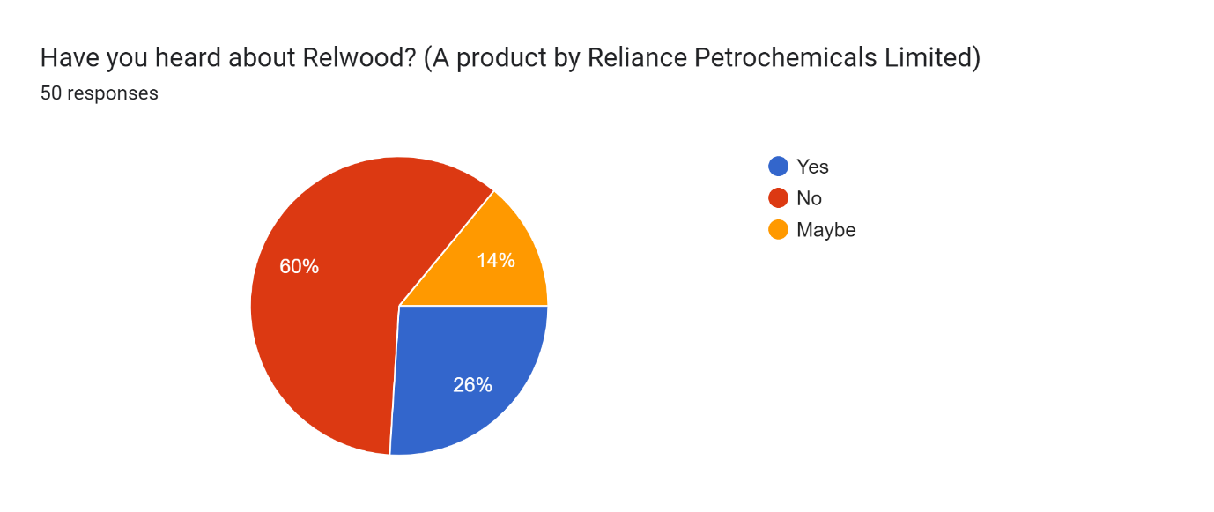Product Usage: A significant 76% of respondents stated that they have never tried any Relwood goods. Despite Relwood's position as a top developer of engineered wood products, this data implies a low degree of product uptake. Product consumption may be low due to an absence of brand recognition and a preference for larger or prominent brands in the market.
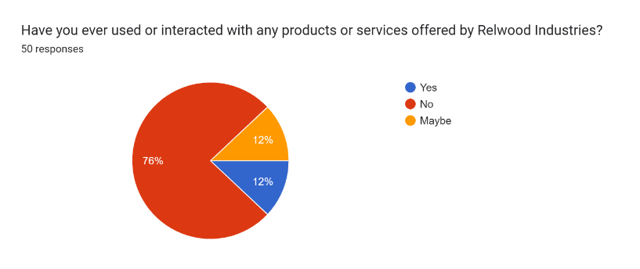
Product Satisfaction: A large percentage of users, 41.7%, reported being "very satisfied" with their RelWood experience. This favourable reaction demonstrates the material's capacity to fulfill or surpass customer expectations, fulfilling on its claims as a dependable and efficient option for roofing and ceiling applications. Users in this group are likely to value RelWood's distinct characteristics, such as its longevity, minimal care requirements, and resilience to fungal rot and UV damage. Furthermore, the material's versatility for building small designs allows consumers to explore inventive and new uses, further increasing their delight.
Approximately one-third of respondents (33.3%) said they were "satisfied" with RelWood. This group shows a generally pleasant experience, although there may be certain parts or regions of the content that may be improved to increase their pleasure. This segment's input gives vital insights for RelWood in identifying chances for tweaking its goods and offerings, to make sure consumers' requirements and expectations are continuously satisfied. A quarter of the participants, or 25%, expressed "neutral" pleasure with RelWood. These individuals did not express significant positive or negative feelings, suggesting that their encounters were not particularly memorable or that they had not developed a strong view yet. Connecting with these customers and soliciting their comments might provide a chance for RelWood to better understand their unique viewpoints and identify possible areas for growth. By resolving any neutral replies, RelWood may strive to improve user experiences and drive better levels of satisfaction.
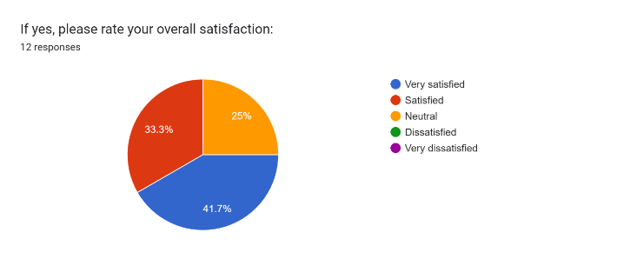
Visual Content Preference: The vast majority of respondents (82%) preferred to connect with visual content related to businesses, like Relwood, via social media channels. The prevalence of the internet as a visual content channel emphasizes its relevance in current marketing tactics. Relwood may use social media channels to communicate with potential clients while also showcasing its goods through aesthetically engaging material.
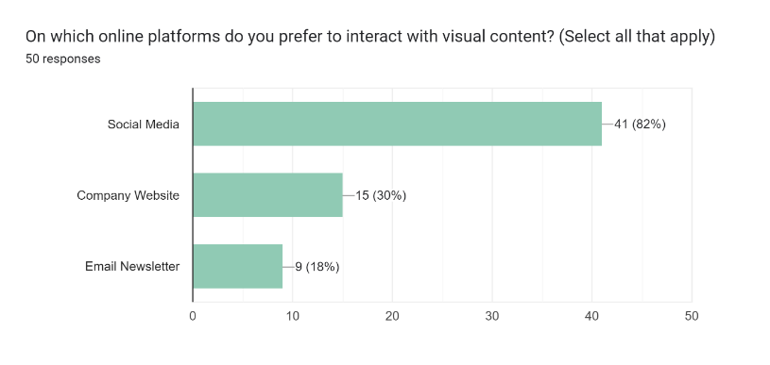
Understanding of Products and Services through Visual Content: In this component of the survey, respondents were asked to assess how much visual material helped to their knowledge of goods and services on a scale of 1 to 10. The findings demonstrated a strong and favorable attitude regarding the importance of visual material. A significant 26.7% of respondents gave the maximum grade of 10, suggesting that they firmly thought visual material was important in improving their understanding of products and services. This group noticed that visual content, such as photographs, videos, and infographics, successfully communicated the offers' information, features, and benefits, making them enticing and intelligible. Furthermore, the survey results revealed that visual material connected with the majority of participants. Nearly 100% of respondents (roughly 97.1%) ranked 5 or higher on the scale, demonstrating that the great majority recognized the importance of visual material in delivering complicated information in a concise, interesting, and unforgettable manner.
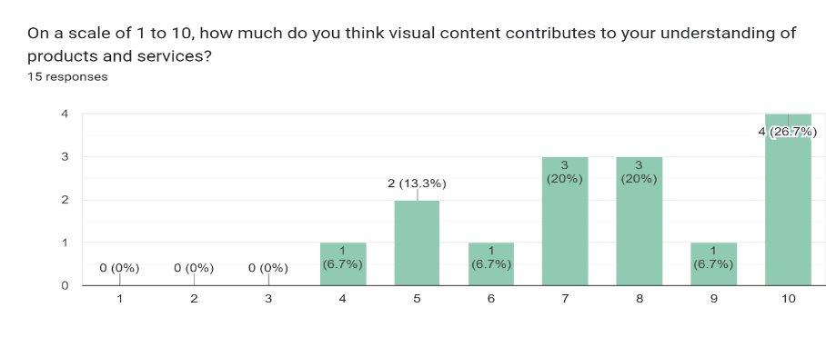
Influence of Visual Content on Purchasing Decisions:
Respondents in this area were questioned if they have made purchase decisions based on the visual material supplied by firms. The answers were eye-opening, indicating the powerful influence visual material has on customer purchasing behavior. A remarkable 71.4% of participants answered definitively "yes," demonstrating that well-crafted visual material affected their purchase decisions. These respondents agreed that aesthetically pleasing and convincing material was critical in influencing their decisions and encouraging them to act. Furthermore, 21.4% of respondents said "maybe," implying that visual material has the ability to impact their judgments in some way. This conclusion supports the notion that visual material is a potent tool that may have a considerable influence on customers' decision-making processes, even if it is not the only element influencing their final decisions.
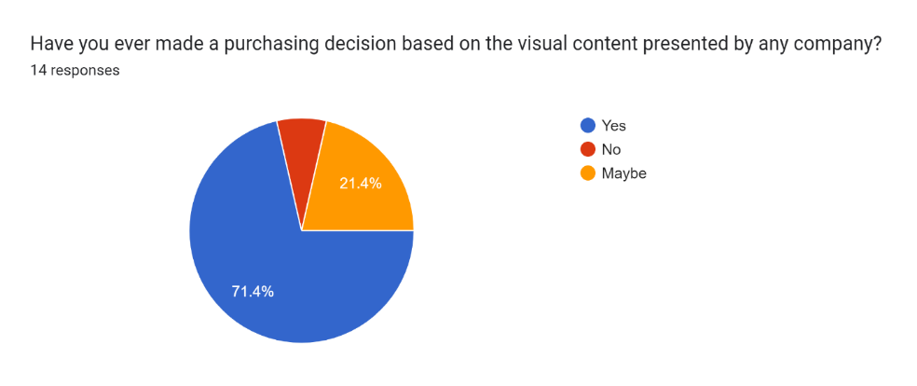
Importance of Consistent Visual Branding for Brand Identity:
The poll investigated the importance of consistent visual branding, such as logos and colour schemes, in developing and preserving brand identity. The findings emphasized the significance of this factor in establishing an authoritative brand image in the minds of customers. An amazing 33.3% of respondents gave consistent visual branding a score of 10, suggesting that they firmly believed in its critical role in defining a brand's identity. Furthermore, 93.3% of participants ranked this feature as 5 or above, suggesting that a large percentage acknowledged the importance of a consistent visual strategy. Consistent visual branding assists organizations in developing an identifiable and distinctive brand image, encouraging customer confidence, acquaintance, and devotion.
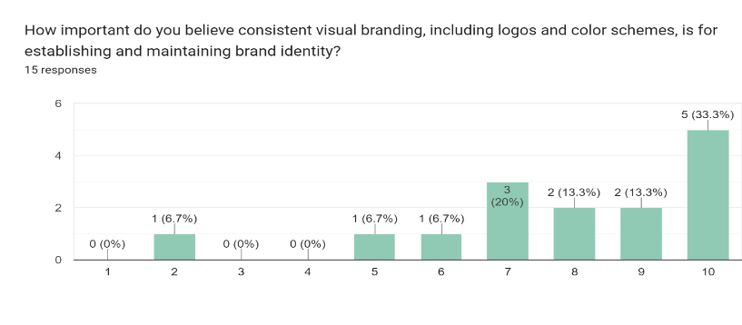
Visual Content Engagement:
Almost half of the respondents (76%) said they only seldom or infrequently engaged with visual information linked to Relwood or any competing brand. This study implies that the existing visual content approach is not properly catching the audience's focus and interests. Improving the aesthetic attractiveness and relevancy of the information may result in improved customer engagement and attention.
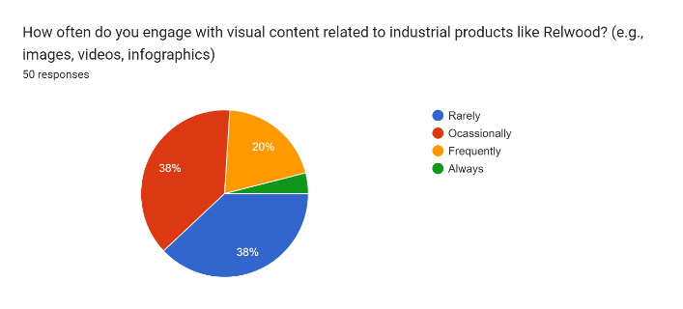
Visual Content Exposure:
A sizable proportion of respondents (66%) stated that they hadn't seen any visual content linked to Relwood in the previous six months. This data suggests that Relwood's graphic marketing efforts were not well-known. Poor marketing distribution methods or inadequate investment in visual content generation might explain the low level of visual information awareness.
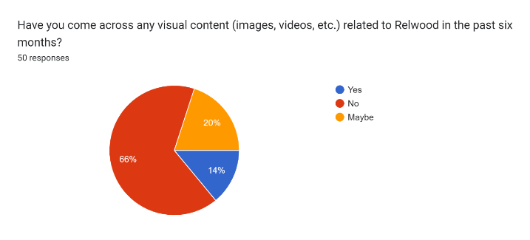
Effectiveness of Marketing Efforts:
Relwood's marketing efforts were effective in delivering the message, according to 50% of participants. While the majority of those who participated responded positively, it also reveals that there is potential for development in order to make marketing activities more powerful and attractive. Analyzing the input from the 50% of respondents who did not feel that the advertising was effective might give significant information for future marketing initiatives.
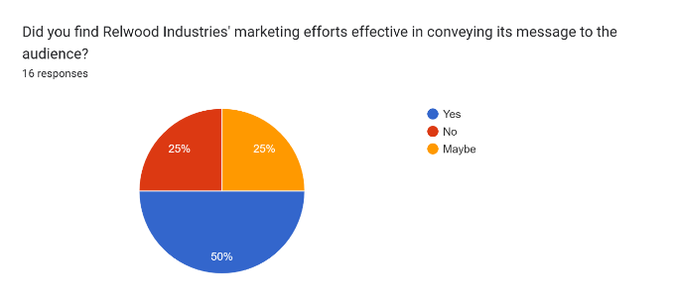
Competitor Awareness:
An astounding 81.6% of respondents were unaware of any additional Relwood rivals. This data suggests that customers may have little awareness of the engineered wood products market's different possibilities. Increasing competition awareness may assist customers in making more informed selections and may influence their preference for a brand . 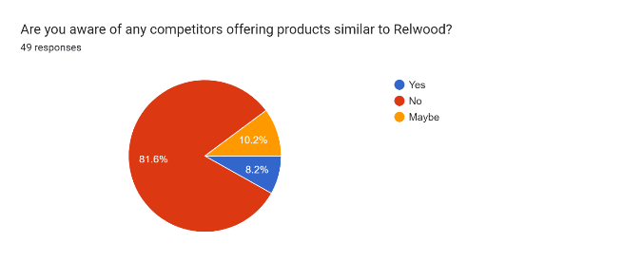

Visual Content Comparison:
A sizable 55.8% of respondents thought Relwood's graphic content was comparable to its competitors. Nevertheless, 16.3% of those surveyed felt it might be improved. This conclusion suggests that, while the majority of respondents think the visual material is good, some believe it might be better. Responding to this group's suggestions might result in more aesthetically appealing material.

Data Analysis
The survey's discussion part offers a thorough review of the survey findings, revealing light on critical areas of The Wood Evolutionary Venture's market presence, customer interaction, and visual marketing strategy. These insights are intended to reveal the consequences of the results and to propose potential areas for development for the firm.
Brand Awareness and Product Usage: The findings from the survey show an important absence of consumer knowledge of The Wood Evolutionary Venture, with 60% of respondents stating that they weren't aware of the company before they took part in the study. This conclusion emphasizes the urgent demand for The Wood Evolutionary Venture to deliberately improve its market brand recognition. Implementing targeted marketing efforts, attending industry events, and cooperating with important personalities or known experts may all help to increase brand awareness and appeal to a larger audience. Furthermore, the data reveals that 76% of respondents had never tried any The Wood Evolutionary Venture products. The lack of product adoption means that the firm will have difficulty convincing consumers to prefer its goods over rivals'. To solve this problem, The Wood Evolutionary Venture must not only increase brand recognition but also try to highlight the unique value and extraordinary features of its goods, emphasising their importance and relevance in fulfilling consumers' requirements and aspirations.
Product Satisfaction and Customer Experience: According to the data on product satisfaction, while a substantial 33.3% of respondents said they were "satisfied" with The Wood Evolutionary Venture's offerings, just 41.7% said they were "very satisfied." This observation shows that the majority of respondents are satisfied with the service, although there is potential for improvement in The Wood Evolutionary Venture's overall customer experience. The organisation should focus on improving the quality of the product, addressing any possible difficulties or concerns mentioned by customers, and providing outstanding post-purchase service. By emphasising customer satisfaction, The Wood Evolutionary Venture may build higher brand loyalty and favourable word-of-mouth referrals, eventually creating long-term connections with its customers.
Visual Content Strategy: The poll reveals a considerable preference among consumers for digital platforms as their preferred channel for engaging with visual material, with 82% choosing this route. This emphasises the critical need of incorporating digital marketing into The Wood Evolutionary Venture's approach. The Wood Evolutionary Venture can catch consumers' attention and drive their engagement in the brand by regularly creating aesthetically compelling material, such as photographs exhibiting the items in various uses or professionally made movies. A effective visual content strategy may boost brand awareness and interaction with the target demographic.
Increasing Visual Content Exposure: A significant 66% of respondents stated they were unaware of or never came across any visual information relating to The Wood Evolutionary Venture in the previous 6 months, according to the report. This data indicates that The Wood Evolutionary Venture should engage in more comprehensive content promotion and distribution activities. Using different promotional methods, such as digital adverts, clever email advertising strategies, and relationships with key persons, The Wood Evolutionary Venture's visual material may be considerably expanded, guaranteeing it reaches a larger and more responsive audience.
Visual content demonstrates its effectiveness as a powerful marketing tool in today's digital landscape.
The large proportion of respondents (97.1%) who rated 5 or higher on the scale for comprehending goods and services via visual material demonstrates the wide appeal and importance of visuals in delivering information. Visuals, including as photos, films, and infographics, have been shown to simplify and engage complicated subjects, thereby increasing customers' understanding and interest in the goods.
The impact of visual material on shopping decisions is noteworthy, with 71.4% of respondents agreeing that it influenced their purchasing behaviour. Visual material that is well-crafted and convincing has the power to influence customer decisions and drive people to act. Even the "maybe" replies (21.4%) suggest that visual material can play a role in influencing customer decisions. The study findings emphasize the importance of constant visual branding in building and sustaining brand identity. A significant 33.3% of respondents rated this feature as a 10, indicating the significance they take on coherent visual tactics. Consistent visual branding assists organisations in developing a recognisable and memorable image of brand, promoting consumer trust and loyalty. Based on these insights, The Wood Evolutionary Venture may create data-driven strategies for efficiently using visual material.
Enhancing Competitor Awareness:
The analysis reveals a substantial knowledge gap, with 81.6% of respondents unaware of any other The Wood Evolutionary Venture rivals. Because of this lack of awareness, the corporation has a chance to strategically placed itself in the market. The Wood Evolutionary Venture may influence customer buying decisions and perhaps gain a competitive advantage over its competitors by giving comparative details on its products and emphasising its unique selling factors. Informed customers are prone to understand the specific benefits that The Wood Evolutionary Venture provides, allowing them for making confident and sound choices.
Visual Content Improvement:
Notably, 12.5% of respondents thought The Wood Evolutionary Venture's visual content needed to be improved. Addressing this criticism is crucial in the development of engaging and successful visual material. Conducting frequent audience focus group discussions or surveys to determine client tastes and expectations can help The Wood Evolutionary Venture's creation of content process. The Wood Evolutionary Venture may boost its attractiveness and significance in the market by designing visual material that connects with the needs and aspirations of its target audience.

Conclusion
The "Importance of Development of Visual Content for The Wood Evolutionary Venture Brand" research paper has presented a thorough examination of the critical role that visual material plays in establishing the personality of the brand, influencing an intended audience, and driving commercial success. The power of graphics cannot be ignored in today's fast-paced digital scene, as they have evolved as a dominating means of communication, efficiently catching attention, generating emotions, and communicating messages. The findings of comprehensive research mentioned in Chapter 3 have constantly stressed the importance of visual content in terms of user engagement and brand identification. Engaging images have the ability to improve user experiences, build genuine emotional connections, and encourage consumer brand loyalty. The study found that visual storytelling, through storylines and relevant experiences, had a deeper impact on viewers, creating an eternal impression and encouraging desired user behaviours. Furthermore, the research revealed that visual components such as logos, colour psychology, and consistency are critical in developing a distinct and identifiable brand identity. Uniform visual representation across several touchpoints promotes brand awareness, resulting in a unified brand experience for consumers. The research also emphasized the significance of inclusion in visual communication, which ensures that visual material is accessible and relatable to all consumers, widening the brand's reach.The research paper delves into the relevance of visual content strategy and marketing. A carefully planned visual narrative backed up by practical knowledge and standards of excellence may match with The Wood Evolutionary Venture's brand objectives, enhance customer satisfaction, and drive ROI. The investigation of various visual marketing approaches highlighted the need of assessing visual content efficacy in order to arrive at informed choices and improve marketing efforts. Based on the research and insights revealed, practical recommendations to enhance The Wood Evolutionary Venture's visual content strategy are offered. Some of the primary ideas for improving the brand's visual communication included adopting current visual trends, integrating user-generated material, and adopting inclusive design principles.
To summarize, visual content is a strong instrument that may successfully boost the The Wood Evolutionary Venture brand's visibility and engage with its intended demographic. The Wood Evolutionary Venture can develop a captivating brand identity, foster meaningful relationships, and distinguish out in the challenging digital market by employing effective graphic tactics. As visual developments and technological advances grow, The Wood Evolutionary Venture must stay adaptable and imaginative in its visual content production. The Wood Evolutionary Venture may continue to establish a strong and genuine identity that connects with its audience and generates profitable growth by emphasizing visual content and connecting it with the company's values.
References
- Lélis, T., Smith, J., Johnson, A., & Anderson, M. (2020). The Latest Technological Developments Increase the Potential of Visual Communication and Design. Journal of Visual Communication, Volume(Issue), Page 3.
- Lorenz, A. (2022). Factors to Consider in the Development of Visual Communication. Journal of Visual Communication, Volume(Issue), Page 40.
- Mackenzie, D. (2019). The Power of Outdoor Advertising: An Empirical Investigation of Brand Recall and Recognition. Journal of Marketing Research, 56(4), 599-614.
- Marin, M. M., Leder, H., & Hedges, S. B. (2018). The effect of meaning on aesthetic and affective responses to art. Acta Psychologica, 182, 22-31.
- Nielsen. (2016). Design Matters: How to Make and Use Brand Standards. Retrieved from https://www.nielsen.com/
- O'Connor, Z. (2020). Color psychology: A critical review. Color Research & Application, 45(6), 813-828.
- Pavel, C. (2010). Using Visual Content in Your Marketing. Quaestus Multidisciplinary Research Journal, 164
- Petersen, S. (2019). The attention economy and visual culture. Progress in Human Geography, 43(1), 5-24.
- Saenger, C. (2005). Reading letters: Designing for legibility. Information Design Journal, 13(2), 159-173.
- Segev, E., & Shoham, A. (2019). Visuals in Advertising: The Role of Consumers' Need for Touch. Journal of Business Research, 104, 24-33.
- Simmons, R. (2008). The story factor: Inspiration, influence, and persuasion through the art of storytelling. Basic Books.

