“Online Gaming Management Platform”

Dr. Akhil Pandey¹, Dr. Vishal Shrivastava² , Er. Sangeeta Sharma³, Professor^{1,2}
Assistant Professor³, akhil@aryacollege.in¹, ³vishalshrivastava.cs@aryacollege.in^{2,},sangeetayuwansh1@gmail.com
Computer Science & Engineering Department ^{1,2,3},
Arya College of Engineering & I.T. Jaipur-302028, India

Abstract :
Online gaming management system in India is vast and growing rapidly, as the country has a large and growing population of gamers and a thriving gaming industry. But even though gamersandorganizersdonothaveasinglesolutiontobuildoutthetournamentalongwith the management.
This provides single stage gamers’ data, Brands can avail trust through the platform, Digital content broadcasting and posting platform engagement and less human resources are utilized.
To effectively plan, organize, and execute online gaming events that meet the needs and expectations of all organizers, gamers, and sponsors .While ensuring a positive return on investment and minimizing risk and

Challenges. Lack of online gaming management platform, Lack of exposure and event aggregation, Lack

of flexible data reporting system.
Keywords:
online gaming management system, growing population of gamers, tournament management ,single stage,engagement,plan,organize,execute,events,organizers,sponsors.

Introduction:
Online gaming has been a rapidly growing industry in India, with a large and growing population of gamers and a thriving gaming industry. However, despite this growth, gamers and organizers still face challenges in building and managing tournaments effectively.

One of the key challenges that gamers and organizers face is the lack of a single solution for tournament management. While there are various platforms and tools available for gaming, these are often limited in their capabilities and do not provide a comprehensive solution for managing tournaments. This can lead to difficulties in planning and executing gaming events, which can ultimately result in negative experiences for both gamers and sponsors.

To address these challenges, an online gaming management system can be used. This system provides a single stage for gamers' data, allowing for better organization and management of tournaments. Brands can also avail trust through the platform, providing a reliable and trusted source for gamers and sponsors alike. Additionally, the platform can serve as a digital content broadcasting and posting platform, providing better engagement and less human resources needed for event management.
The main purpose of an online gaming management system is to effectively plan, organize, and execute online gaming events that meet the needs and expectations of all organizers, gamers, and sponsors. The system does this by providing a comprehensive solution for managing tournaments, including tools for event planning, registration, tracking, and reporting. By doing so, the system ensures a positive return on investment and minimizes risk and challenges associated with event management.

The benefits of an online gaming system are that it provide a single platform for organize and supervision tournaments. This eliminates the need for multiple platforms and tools, reducing complexity and reformation the management process. The platform can also provide a range of features to support tournament management, including online registration and payment processing, bracket creation and management, and real-time scoring and updates.

Additionally, the platform can provide better engagement with gamers and sponsors, through features such as leader boards, live streaming, and social media integration. This plateform increases the visibility event and build a community of engaged gamers and sponsors. Furthermore, the platform can provide flexible data reporting, allowing organizers to analyze and optimize their events based on real-time data and insights.

Despite the benefits of an online gaming management system, main challenges is the lack of exposure and event aggregation. Many gamers and sponsors may not be aware of the events that are available, or may not have easy access to information about upcoming events. To address this challenge, organizers can use targeted marketing and social media to promote their events and reach a wider audience.

Another challenge is the lack of a flexible data reporting system. While an online gaming management system can provide a range of tools and features for managing tournaments, it is important to have a flexible data reporting system that allows organizers to analyze and optimize their events based on real-time data and insights. This can assembly round to classify areas for improvement and ensure that events are optimized for maximum engagement and impact.
Body:
The difficulty lies in creating a successful plan to organize, manage, and carryout online gaming events that satisfy the needs of all interested parties—organizers, participants, and sponsors. This entails making sure the result is satisfactory, increasing profits, and minimizing any potential hazards or roadblocks along the way. Although the online gaming sector has experienced recent significant growth ,there is still a sizable vacuum in the availabilityofanall-encompassingplatformforadministeringgamingevents.There is currently no centralized system that aid in organizing all the components required for event preparation and implementation. This might result in a lack of unity and misunderstandings amongst the various parties involved, leading to an in effective process that does not provide the expected outcomes. Additionally, because of the intense competition in the online gaming industry, events that receive little attention frequently go overlooked by the intended audience. This emphasizes the need of having a strong event aggregation system that can present all future events and give thorough information to the participants and sponsors. This can assist make the events more noticeable and significant and more appealing to the intended audience. An efficient data reporting system is crucial to evaluate the event's success and making wise decisions for subsequent events. It can be helpful to provide insightful information on the performance of the event and pinpoint areas for development with the aid of a customizable data reporting system that can be tailored to the demands of the event and the stakeholders involved. By doing this, the event planning process may be optimized andfuture outcomes canbe improved. In conclusion, a comprehensive platform that solves event management difficulties and offers a flexible, efficient, and effective solution for all stakeholders is required to plan and execute online gaming events efficiently.

Solution:

The Competitive Edge platform provides a solution to the difficulties involved in organizing and carrying out online gaming competitions. With the help of this platform, event planners will find it simpler to puttogethereffectiveeventsthatsatisfytherequirementsandexpectationsofallstakeholders.Theplatform's capacity to accept payments for organizers is one of its primary advantages. With the help ofthis function, event managers may more easily manage finances by handling payments swiftly andsecurelywithoutworryingaboutlaboriousfinancialprocedures.Thegamereports,whichareofferedina better style, are another important element. This makes it simpler for event planners and stakeholders to understand how the event performed and to decide how to optimize upcoming events. The platformoffersathoroughdatareportingsystemthatcanbetailoredtotheevent'srequirements,giving important sights into the event's success and potential development areas.
A centralized platform form an aging online gaming is also offered by the Competitive Edge platform. This makes it easier to bring together all the aspects required for event planning and execution, creating a more efficient process with better outcomes. The site also integrates with social media, which helps spread the word about the event.
The Competitive Edge platform's ability to automate the event planning and management process is one of its main advantages .Without the need for paper work and manual procedures,organizerscanconcentrateonmorecrucialactivitieslikemarketingtheevent,interactingwithparticipants,andmaking sure everyone has a good time. This makes it simpler to complete the process and lowers the possibility of mistakes, which makes it simpler for event planners to put together effective events. Last but no least,the Competitive Edge platform offers effective management ,enabling organizers to handle every facet of the event from a single platform. This speeds up and improves the efficiency of event planning and management by streamlining the procedure and reducing complexity. In summary ,the Competitive Edge platform is the answer to the problems encounter edin organizing and carrying out online gaming competitions. It offers event planners the tools and resources they need to put together successful events that satisfy the needs and expectations of all stakeholders thanks to its extensive features ,which include money processing ,data reporting , social media integration ,and effective administration.

Comparative Analysis with the Existing Solution:

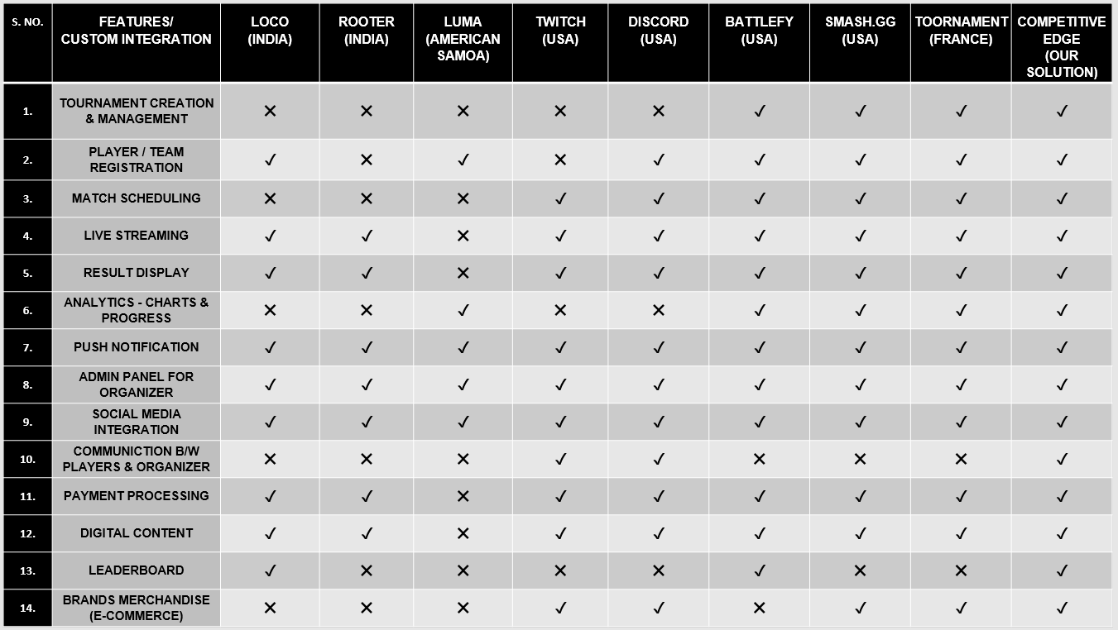

Conclusion:

In conclusion, an online gaming management system is an essential tool for effectively planning, organizing, and executing online gaming events in India. By providing a single solution for tournament management, the platform can streamline the event management process and provide better engagement with gamers and sponsors.

However, to maximize the benefits of the platform, it is important to address challenges such as lack of exposure and event aggregation, and lack of a flexible data reporting system. By doing so, organizers can ensure that their events are optimized for maximum engagement and impact, and deliver a positive return on investment for sponsors and gamers alike.

References:

- Gao, X., Qi, L., & Ji, X. (2019). An online game management platform based on blockchain and smart contract. Journal of Physics: Conference Series, 1172(1), 012046.

- Zhang, Y., Liu, J., & Chen, X. (2019). Design and implementation of an online gaming management platform. Journal of Physics: Conference Series, 1168(1), 012015.

- Xu, Y., Wu, X., Guo, S., & Shen, W. (2020). An online game management platform based on cloud computing and big data. Journal of Physics: Conference Series, 1665(1), 012010.

- Zhou, M., Cui, S., & Wang, F. (2018). Research on online

game management platform based on big data analysis. Journal of Physics: Conference Series, 1061(1), 012032.

- Chen, Z., Li, Y., & Li, Y. (2019). Design and implementation of an online game management platform based on microservices. Journal of Physics: Conference Series, 1365(1), 012018.

- Wang, S., Li, J., Li, X., & Li, Z. (2019). An online game management platform based on cloud computing and artificial intelligence. Journal of Physics: Conference Series, 1194(1), 012049.

- Li, Z., Liu, Y., & Zhang, Y. (2020). Design and implementation of an online game management platform based on Docker technology. Journal of Physics: Conference Series, 1631(1), 012024.

