IOT BASED STEERSMANSHIP SYSTEM FOR VISUALLY IMPAIRED HUMAN RACE

Tejeshwini C S
Information Science and Engineering
Vidya Vikas Institute of Engineering and Technology,
Mysore, India
thejanaveen.vviet@gmail.com
Priyanka D
Information Science and Engineering
Vidya Vikas Institute of Engineering and Technology,
Mysore, India
priyankapal.d@gmail.com

Dr. Archana B Indira
Computer Science and Engineering Computer Science and Engineering
Vidya Vikas Institute of Engineering and Technology, Proudadevaraya Institute of technology,
Mysore,Karnataka, India Vijaynagar,karnatakaIndia
archanashashikumar3612@gmail.com indira@pdit.ac.in

ABSTRACT
By using this smart cane, blind people can easily contact the physical environment, which is the vision of our steersman ship system. If we are attentive, we will quickly realize that they need help to walk. With the help of this intelligent blind cane, people can move around with confidence. Today, blind people use a standard blind cane to orient themselves while walking from one place to another. Although the standard cane is the most commonly used tool for visually impaired people today, it cannot help them identify risks at all levels of barriers. In this context, we propose a completely new intelligent method to assist blind or visually impaired people. The technology is used to give blind people the same mobility and confidence as sighted people. It also provides guidance and information to avoid obstacles such as people, water and sensor-based obstacles. The technology is linked to navigation from GPS navigation so that the location of the blind person's can be accurately determined.
Keywords— IoT, Navigation System, Visually Impaired, Sensors.

INTRODUCTION

.
our steersman ship system ,The ability to see is crucial to human existence, but some people have become immobilized by their blindness. In this essay, we propose a navigation method or tool that is useful for blind people. With the help of this blind stick, people can see obstacles in front of them and navigate both familiar and unfamiliar terrain. It uses IR sensors to detect obstacles, and the blind person is alerted to them by their phone vibrating or playing an audio message. The ability to move confidently, quickly, and safely in one's immediate environment is referred to as mobility and independence for visually impaired people, but it cannot be achieved without technology. One method ,we have introduced helps the blind person. With the help of GSM/GPS, the people using a telegram application in an android phone or computer worn by the blind person and the administrator to detect obstacles in front of them, it can protect the blind person. an administrator may watch from their home.

II.EASE OF USE

Using computer vision, it effectively detects various objects in the surrounding environment and appropriately alerts the user accordingly. This system can be a first step in enabling visually impaired human race to commute without using canes.

III.METHODOLOGY
- It serves as an example of the proposed paradigm in this situation. A microprocessor called Raspberry Pi is use to collect all the data.
- A buzzer alerts the user if there is an obstacle in front of the stick before the web camera starts recording video using Tensor Flow object detection. Finds the object and then uses the speaker to address it.
- The GPS module determines the user's location every 30 seconds.
-A fire sensor's job is tasked with locating nearby flames.- A water sensor is used to locate water nearby.
- A light sensor allows the user to determine whether it is day or night using a light sensor by listening to the speaker.

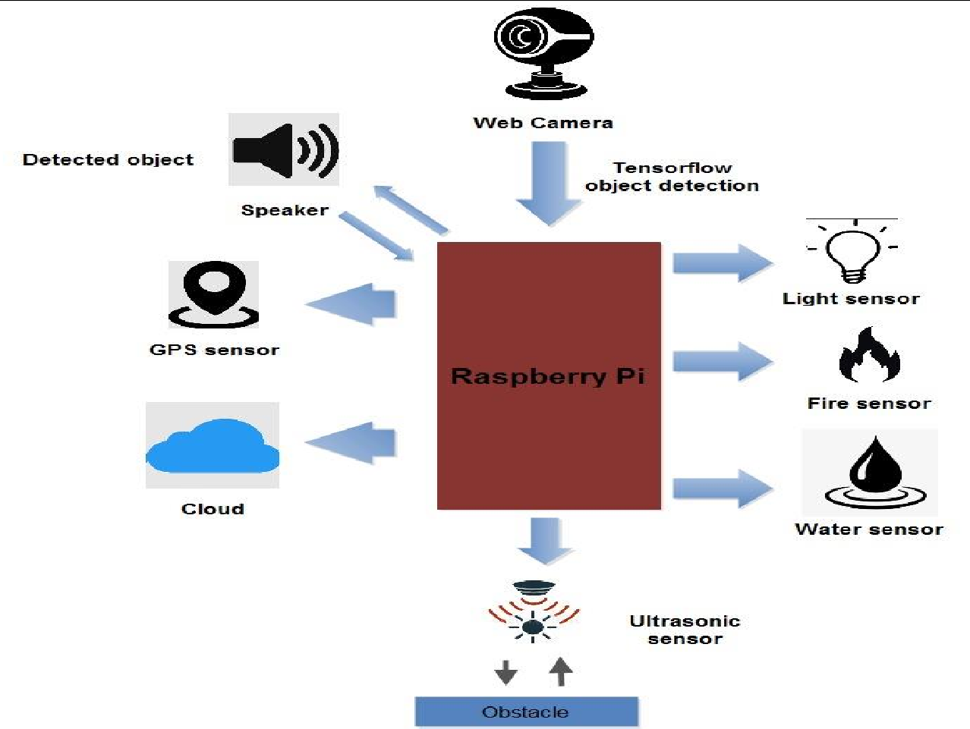

Fig: Architectural View of System

IV.MODELING AND ANALYSIS

- GPS: It is a global satellite navigation system that provides geolocation and timing information to a GPS receiver at any location on or near the earth where there is an unobstructed line of sight to four or more GPS satellites.
- Ultrasonic Sensors: ultrasonic/level sensors, as the name implies, use ultrasonic waves to measure distance. The sensor head emits an ultrasonic wave and picks up the wave that is reflected from the target. Ultrasonic and level sensors measure the distance of a target's distance by measuring the interval between transmission and reception.
- Buzzer: A buzzer or beeper is a mechanical, electromechanical, or piezoelectric sound signaling device (piezo for short). Buzzers and beepers are commonly used as alarm clocks, timers, train horns, and to confirm human input such as mouse clicks or keyboard input.
- Fire sensor: using various technologies, smoke detectors can detect tiny particles in the air to identify fires. Once they detect that these particles exceed a certain threshold, they trigger the alarm so that you and your family can escape.
- Water sensor: when installed in places where water should not be present, water sensors can also detect leaks. The sensor can send a notification to the homeowner via a smartphone app when Wi-Fi is enabled.
- Light Sensor: Light sensors pick up on the presence of light and convert that energy into an electrical signal. Radiant energy contained within the frequency spectrum from infrared to ultraviolet light frequency spectrum source can then be measured after conversion to electrical energy.
- Raspberry Pi: The Raspberry Pi is a small, inexpensive computer about the size of a credit card that connects to a computer monitor or TV and is operated with a standard keyboard and mouse. With the help of this powerful little device, people of all ages can learn about computer science and programming in languages like Scratch and Python.

Speaker: the Speaker acts as the representative, of the Chamber and delivers messages and speeches, e.g. to the Governor. He is also responsible for defending the privileges and rights of the House of Representatives and its members.
- Webcam: A webcam is a ubiquitous digital video device built into computers. Its primary purpose is to transmit images over the Internet. It is commonly used to capture images and for instant messaging applications.
- Tensor Flow Object Recognition: Tensor Flow object recognition is a computer vision method. As the name suggests, it helps identify, locate, and track an object in an image or video.

IV.RESULTS AND DISCUSSION
The development of an IoT-based steersman ship system for visually impaired human race is a promising technology application of technology that has the potential to improve the quality of life for many people with visual impairments. This system uses a combination of sensors, GPS technology, and machine learning algorithms to provide users with real-time information about their surroundings and navigate them to their desired destination.

V.CONCLUSION
The Blind Stick serves as a versatile interface for easy and convenient internal and external mobility for visually impaired people in the next phase of assistive apps. It's safe and affordable. This results in effective obstacle detection along the direction of the user. It provides low-cost, reliable, lightweight, low-power and efficient navigation with fast response times. Wireless connectivity between the components of the device will enhance the additional features of this instrument, increasing the range of ultrasonic sensors and incorporating technologies to measure the intensity of approaching obstacles approaching. With this approach, we particularly targeted visually impaired and blind people in all developing countries. A vibrator can also be attached for ease of use and flexibility. This incorporates a system to locate the person via the GPS and GSM systems in order to reach parents or caregivers in the field.

REFERENCES

- P. Chavan, K. Ambavade, S. Bajad, R. Chaudhari and R. Raut, "Smart Blind Stick," 2022 6th International Conference On Computing, Communication, Control And Automation (ICCUBEA, Pune, India, 2022, pp. 1-4
- C. Akbay, Ş. Kılıç, Ş. Kaya, H. Ünsal and E. H. Şen, "Smart Walking Stick Design For Blind People," 2022 Medical Technologies Congress (TIPTEKNO), Antalya, Turkey, 2022, pp. 1-4
- R. K. Kaushal, K. Tamilarasi, P. Babu, T. A. Mohanaprakash, S. E. Murthy and M. J. Kumar, "Smart Blind Stick for Visually Impaired People using IoT," 2022 International Conference on Automation,
Computing and Renewable Systems (ICACRS), Pudukkottai, India, 2022, pp. 296-300
- N. Loganathan, K. Lakshmi, N. Chandrasekaran, S. R. Cibisakaravarthi, R. H. Priyanga and K. H. Varthini, "Smart Stick for Blind People," 2020 6th International Conference on Advanced Computing and Communication Systems (ICACCS), Coimbatore, India, 2020, pp. 65-67
- N. Dey, A. Paul, P. Ghosh, C. Mukherjee, R. De and S. Dey, "Ultrasonic Sensor Based Smart Blind Stick," 2018 International Conference on Current Trends towards Converging Technologies (ICCTCT), Coimbatore, India, 2018, pp. 1-4.

