“Synthesis of silver nanoparticles from bacteria and fungi to check their efficiency against human pathogen”

Nirali Kathiriya¹, Dushyant Dudhagara² and Rasik Sojitra^{3*}
Department of Life Sciences, Bhakta Kavi Narsinh Mehta University, Junagadh, Gujarat, India^{1, 2, 3*}.
E-mail: nnirali996@gmail.com¹, dushyant.373@gmail.com², sojitrark13@gmail.com^{3*}

*Corresponding author: sojitrark13@gmail.com
Abstract
Currently, using microorganisms in order to develop reliable and ecofriendly methods for the synthesis of silver nanoparticles. In this study, we have investigated extracellular biosynthesis of silver nanoparticles using bacteria Bacillus subtilis and fungi Aspergillus niger. The formation of silver nanoparticles in the cell filtrates was confirmed by change in the color of cell filtrates, absorption peak at 420 nm for Bacillus subtilis and 430 nm for Aspergillus niger in UV-Vis spectra. The antibacterial efficacy of the produced nanoparticles was investigated against Staphylococcus aureus and Escherichia coli. The antifungal efficacy of the produced nanoparticles was investigated against Aspergillus niger. The biosynthesized AgNPs could be utilized as antimicrobial agents for effective disease management.
Key words: Bacillus subtilis, Aspergillus niger, silver nanoparticles, Green biosynthesis of silver nanoparticles, Antibacterial activity, Antifungal activity.

- Introduction
The old-style chemical nanotechnology is an interdisciplinary science of chemistry, biology, physics, engineering, and technology, performed at the nanoscale with dimension sizes from 1 nm to 100 nm, and has applications in various fields such as the food industry, innovative textiles, and agricultural production. It is also widely used in advanced medical technology. nanoparticles have unique properties that differ from bulk particles, and their properties change with decreasing dimensional size, resulting in a larger total area of ​​expansion (Ahmad A. et al., 2003). nanoparticles are at the forefront of the rapidly growing nanotechnology field. Synthesis of nanoparticles of specific composition and size is of great importance in scientific research. The properties of these particles in diverse applications such as catalysis, biochemical sensors, devices, stimulants, biopsies, tumor imaging, drug manufacturing and preparation methods, and pharmaceuticals are critically dependent on nanoparticle size and composition (Gahlawat et al., 2016). AgNPs are considered excellent antibacterial and anti-inflammatory agents and have been used to promote wound healing. manufacturing these particles expands the range of properties that can be achieved. nanoparticles are particle dispersions of solid particles ranging in size from 1 to 100 nm. nanoparticles have helped open new possibilities for designing new materials and characterizing their properties by tuning the size, shape, and distribution of molecules (El-Gamal et al., 2018). Pure nanoparticles are widely used for their unique properties and medical purposes, such as antibacterial, antifungal, anti-inflammatory and anticancer effects. The synthesized nanoparticles exhibit excellent antibacterial activity against gram-negative and Gram-positive pathogenic microorganisms. Silver nanoparticles have shown potential antimicrobial applications against multidrug-resistant bacteria (Kim et al., 2006). AgNPs are an attractive option because they are non-toxic to humans at low concentrations and also have broad-spectrum antimicrobial activity. the antibacterial activity of silver ions is well known, and the bactericidal activity of elemental silver in the form of NPs has been developed. The antibacterial activity of Ag NPs has been studied against yeast, Escherichia coli, Staphylococcus aureus, etc. (Fangfei et al., 2015). Silver nanoparticles have been shown to exert antiviral activity against HIV-1 at non-cytotoxic concentrations, but the mechanisms underlying their HIV-inhibitory activity have not been fully elucidated. These silver nanoparticles were studied using various in vitro assays to elucidate their antiviral mode of action against HIV-1 (Lara et al., 2010). Silver has long been used in various forms (metallic silver, silver nitrate, silver sulfadiazine) as an antiseptic to treat wounds, burns, and microbial infections. Silver has long been recognized as an antimicrobial agent against numerous pathogens and microorganisms commonly found in medical and industrial processes (Khan et al., 2018). Silver is a safe inorganic antibacterial agent that can kill approximately 650 pathogens (Jeong et al., 2005). It is highly toxic to bacteria such as E. coli and Staphylococcus aureus.
Methods to synthesize silver nanoparticles include the use of chemical solvents (Iravani S. et al., 2014). chemicals used in these methods are often toxic and reactive, pose risks to humans and the environment, and are too costly to use on a large scale. thus, there has been a need for an affordable, low-cost, reliable, non-toxic, and 'green' approach to synthesize stable metal nanoparticles of precise size and shape. two methods are used for the synthesis of silver nanoparticles, a 'bottom-up' method and a 'top-down' method. Bottom-up methods use materials and biological approaches to integrate nanoparticles by independently arranging atoms.
Two methods are used for the synthesis of silver nanoparticles:' bottom-up' and' top-down' methods. Bottom-up methods can integrate nanoparticles by independently assembling atoms to form new nuclei, which evolve into nanoscale particles, using materials and biological approaches. In top-down methods, nanoparticles are usually synthesized by evaporation and condensation, and bulk materials are reduced in size using various lithographic techniques. B. Grinding and milling. One of the main advantages of this method is the ability to synthesize large amounts of nanoparticles in a short time, but one of the main limitations of this method lies in this type of synthesis. The chemicals used are toxic and produce environmentally friendly by-products. Advances in green synthesis over chemical and physical methods are environmentally friendly, cost-effective, and readily transferable to large-scale synthesis of nanoparticles (Ahmed S et al., 2016). AgNPs are also known to have antibacterial activity against several viruses such as hepatitis B, respiratory syncytial virus, herpes simplex virus, and monkeypox virus. AgNPs and ions have been shown to have intrinsic cytotoxic activity (Sriram et al., 2012). physical methods used to manufacture nanoparticles include several methods such as milling and heat fusion. Physical synthesis of silver NPs has several drawbacks. it requires a lot of space, consumes an insignificant amount of energy in raising the ambient temperature around the source material, takes a very long time to reach thermal stability, and consumes several kilowatts or more of energy, requiring several minutes of preheating time to reach a stable working temperature (Jung JH et al., 2008). These all assemblies are very expensive. they provide concentrated mucus and require high energy costs (Mishra A et al., 2011). chemical methods include electrochemical synthesis, chemical reduction, and petrochemical reduction techniques (Gahlawat and Choudhury, 2019). sludge production with concentrated contaminants must still be disposed of. caustic dyes, coordinating dyes, docking dyes, strong and reactive dyes usually solidify, but the following flakes are larger in diameter and do not adhere well, leading to unremarkable results that are dangerous for everyone and the environment. these techniques are also cost-effective (Alsukaibi A.K. 2022). Some chemical synthesis techniques have short half-lives, typically 20 minutes. This point can be further reduced if dyes are available, but stability is affected by salt proximity, pH and temperature. several innovative techniques using biological reducing agents such as plant extracts, microorganisms, polysaccharides and fungi have been newly established to synthesize silver nanoparticles (Gayathiri E. et al., 2022). among them, bacterial-mediated biological techniques have been extensively studied due to their cheap and straightforward protocols. microorganisms containing a ‘silver resistance machinery' synthesize silver nanoparticles as a product of the detoxification pathway (Rezvani A et al., 2016). extracts and enzymes from microorganism’s act as both reducing and capping agents in biosynthesis. (Jain J et al., 2009) (Chugh D et al., 2011). microbial-mediated nanoparticle synthesis can result in intracellular or extracellular accumulation of reduced metals in elemental form (Ahmad et al., 2007).
Intracellular synthesis of nanoparticles requires additional steps such as sonication and reaction with appropriate detergents to release the synthesized nanoparticles (Kalimuthu et al., 2008). at the same time, extracellular biosynthesis is cheap and requires simple processing. This is advantageous for large-scale production of silver nanoparticles for exploring potential applications. This is because many studies have focused on extracellular synthesis of metal nanoparticles (Duran et al., 2005). in extracellular biosynthesis, microbial cells are separated from the growth medium and the cell-free supernatant is used for nanoparticle biosynthesis (Kowshik et al., 2002). extracellular biosynthesis offers an economical route to the purification process, but has limitations. extracellular biosynthesis does not allow complete control over the size distribution and shape of nanoparticles. extracellularly generated nanoparticles have a size distribution of 10 nm to 6 nm and different shapes. silver nanoparticles exhibit high antibacterial activity against many types of bacteria, including common microorganisms Staphylococcus aureus and Escherichia coli. according to the mechanisms described, silver nanoparticles interact with the bacterial outer membrane, halting respiration and other metabolic pathways, killing the bacteria. recent technological advances in chemically reducing silver compounds to nanoscale particles have made it possible to incorporate this valuable antimicrobial agent into a wide range of materials, including plastics, coatings and foams, and natural and man-made fibres. nano-sized silver already provides more permanent antimicrobial protection for the life of the product. recent research on inorganic non-materials with superior antibacterial properties has opened alternatives for the pharmaceutical and medical industries. silver is an ideal metal because it can be expected to effectively kill microorganisms. silver nanoparticles have recently been recognized as promising antibacterial agents, acting on a variety of targets both extracellularly and intracellularly. Silver nanoparticles showed very potent bactericidal effects against Gram-positive and Gram-negative bacteria, including multidrug-resistant strains, which has been fully demonstrated in several studies (Zeng et al., 2007). silver nanoparticles have attracted considerable attention among emerging nano products in nano pharmaceutical manufacturing due to their novel properties and clear curative potential in the treatment of many diseases, including retinal neovascularization (Kalishwaralal K et al., 2009). nanotechnology is an evolving technology that spans many fields such as chemistry, cosmetics and mechanical advancements, and has important applications, especially in the fields of electronics, magnetism, information storage and optoelectronics. (Murray et al., 2000), especially in the fields of pharmaceuticals and medical analysis, which also play an important role in environmental protection and energy conversion. various methods are available for the synthesis of silver nanoparticles. for example, silver particles are prepared by chemical, electrochemical, radiation, photochemical strategies, Langmuir-Blodgett methods and biological methods (Iravani et al., 2014).
Due to their ease of manipulation and manipulation of their genetic material, bacteria are potential candidates for the biological origin of nanoparticles (Faramarzi and Sadighi 2013). in addition, bacteria can survive all kinds of adverse conditions, such as hot or cold peaks, varying levels of alkalinity or acidity, and high salinity. at the same time, biologically formed nanoparticles have many applications, including catalysis of chemical reactions (Li et al., 2016), photoreceptors, and antibacterial agents (Ranjan and Jadeja 2017). in addition, it also has the ability to precipitate nanoparticles through metabolic activity. biological synthesis of nanoparticles by bacteria is believed to be facilitated by their ability to precipitate these molecules from cells, as these nanoparticles can be recovered by cell filtration, which is beneficial for intracellular synthesis. (Alsamhary et al., 2020). biosynthesis of nanoparticles can occur inside or outside the cell and is based on cellular metabolism within the organism. In some cases, nanoparticles can be produced by filtration of fungal cells, which is a suitable factor for biological synthesis of nanoparticles. Fungi also play a very important role in nanoparticle synthesis and have been used for the biosynthesis of silver nanoparticles due to their secretion of numerous proteins and their high NP productivity. The biosynthetic mechanism of the nanoparticles is expected to be the recovery of silver ions by fungal enzymes. Fungi secrete large amounts of enzymes and grow readily in any medium, making them ideal for the biosynthesis of silver nanoparticles (A. Ahmad et al., 2003). so far, many studies have been performed using different species of fungi for the biosynthesis of splitter nanoparticles, including: B. Aspergillus (K.C. Bhainsa and SF D'Souza, 2006). nitrogen is often considered the limiting factor for mushroom growth, as mushrooms require the most nitrogen of all minerals. unlike bacteria, fungi cannot fix atmospheric nitrogen, but happily utilize many other forms of nitrogen, such as amino acids, ammonium, and nitrates. Some fungi can convert nitrate to ammonium as the sole nitrogen source via the enzymes nitrate reductase and nitrite reductase (Zomorodian K et al., 2016). the exact reaction mechanism leading to the biosynthesis of splinter nanoparticles has not yet been elucidated. Previous studies have suggested that the reduced form of nicotinamide adenine dinucleotide (NADH) and NADH-dependent nitrate reductase likely play a role in the reduction of silver ions to metallic silver. In the present study, four Aspergillus species, including A. fumigatus were used to investigate the extracellular biosynthesis of debris nanoparticles. A clavatus, A. niger, A. flavus to investigate the possible role of nitrate reductase in the formation of ground nanoparticles, we analysed standard amounts and amounts of biosynthetic ground nanoparticles of the Aspergillus species studied their relationship with nitrate reductase activity. Bacillus subtilis, also known as haybacillus or grassbacillus, is a Gram-positive, catalase-positive bacterium commonly found in soil and the digestive tract of ruminants and humans. Bacillus subtilis, a member of the genus Bacillus, is rod-shaped and can produce robust protective endospores that allow it to withstand extreme environmental conditions. B. subtilis has historically been classified as an obligate aerobic type, but there is also evidence that it is a facultative anaerobic type. B. Bacillus subtilis is the best-studied Gram-positive bacterium and is considered a model organism for studying bacterial chromosome replication and cell differentiation. it is one of the bacterial champions in the production of secretory enzymes and is used on an industrial scale by nanotechnology companies and the synthesis of nanoparticles. The Bacillus cell wall is the outer structure of the cell that forms a second barrier between the bacteria and the environment while maintaining a triangular shape and resisting pressure caused by cell swelling. Aspergillus niger is an important fungus and one of the most common species in the genus Aspergillus. It causes a disease called "black mold" on certain fruits and vegetables such as grapes, apricots, onions and peanuts and can be a common food contamination. this fungus is ubiquitous in soil and is often reported indoors where its black colonies can be confused with colonies of Stachybotrys Aspergillus niger. it has been reported to produce a potent mycotoxin called ochratoxin. other sources disagree, claiming that the report is based on a misidentification of the fungal species.
Recent evidence suggests that some bona fide A. niger strains produce ochratoxin, so the fungus can be easily isolated from a variety of environmental sources and used in the laboratory for simple, nutritious applications such as PDA. It can also be grown on media with a low pH, making it very easy to maintain the fungus in the laboratory. fungi were chosen for the production of silver nanoparticles because their enzymatic secretory activity is easy to isolate and maintain. characterization studies of silver nanoparticles and nanoparticle-based devices are of interest for many industrial applications because of their unique and often advantageous properties. the high surface-to-volume ratio and size (quantum) effects of nanoparticles give rise to many size-dependent phenomena such as chemical, electronic, magnetic and mechanical properties. In this study, Bacillus strains were examined for the synthesis of silver nanoparticles. these different Bacillus species, only Bacillus subtilis shows a high potential for synthesizing silver nanoparticles. the main aim of this study was to develop a simple, inexpensive, biocompatible and environmentally friendly approach for the extracellular biological synthesis of silver nanoparticles using Bacillus subtilis. Analyses characterizing her AgNPs formed were performed using ultraviolet spectroscopy. these silver nanoparticles have also been tested for antibacterial activity against the pathogenic bacterium Staphylococcus aureus and antifungal activity against the fungus Aspergillus niger. The aim of this research work is to investigate the effect of time on the biosynthesis of silver nanoparticles. Aspergillus niger was studied for the synthesis of silver nanoparticles. the main aim of this study was to develop a simple, inexpensive, biocompatible and environmentally friendly approach for the extracellular biological synthesis of silver nanoparticles using Aspergillus niger, which was analysed using UV spectroscopy to characterize the formed AgNPs. These silver nanoparticles are also being studied to verify their antibacterial activity against the pathogenic bacterium Escherichia coli and their antifungal activity against the fungus Aspergillus niger.
- Materials and Method
2.1 Isolation of silver nanoparticles producing bacteria:
2.1.1 Collection of soil sample:
The soil samples collected from Narsinh Mehta garden, Junagadh, Gujarat, India. the soil samples up to a depth 10-15 cm were collected using sterile spatula and then packed in polythene bags.
2.1.2 Isolation of bacteria:
A quantity of 1.0 g of representative and homogenized soil was suspended in 9 ml sterile distilled water in a test tube dilution process was continued till 10⁻⁶ dilution. nutrient agar take place in autoclave. the medium was cooled and poured on to petri plates. aliquots were withdrawn and transferred to sterile selective media petri plates dilution of the samples add in nutrient agar plate and rotated in clockwise and anticlockwise directions for even spreading and allowed for solidification. the plates were inverted and incubated at room temperature 37˚C. when the bacterial colonies appeared on the plates, morphologically distinct bacterial colonies were picked up and maintained on nutrient agar slants.
2.1.3 Identification of bacterial isolates:
The morphological, physiological characterization of bacteria. cell morphology of the isolates was studied by simple staining method. the bacterial shape was observed under oil immersion objective. the gram’s reaction of the isolates was performed as per the common methods.
2.1.4. Purification of Bacillus subtilis:
Take a loop full Bacillus subtilis colony help of wire loop and striking on nutrient agar plate. this plate takes place in incubator for 37⁰ c for 24 hrs.
2.2 Production of biomass of bacterial isolates:
Purified bacterial isolates colonies were transferred into 200 ml sterilized nutrient broth containing flask and incubated on an orbital shaker at 37 °C and continuous agitation at 200 rpm for 24 hours. the microbial biomass was collected after 24 h of growing and centrifuged at 10,000 rpm for 10 minutes. the bacterial cells were separated by centrifugation. The cell free supernatant material was separated out and used for extracellular synthesis of nanoparticles.
2.3 Biogenic of silver nanoparticles from bacterial isolates:
Preparation of silver nanoparticles (Kalishwaralal et al., 2008) for the preparation of AgNPs, two solutions were prepared; the first one was: 100 ml of supernatant was mixed with one ml of silver nitrate solution (1 mM) and the second reaction mixture was prepared without AgNO3 that used as a control test. The designed solutions were incubated at 30 °C for 24 h. all solutions were preserved in dark to abolish any photochemical reversion during the experiment. then, the solutions turned from yellow into brown colure. the silver nanoparticles were purified by centrifugation at 10000 rpm for ten minutes, and collected for characterization.
2.4 Effect of time on silver nanoparticles biosynthesis:
To investigate the efficacy of time on the biosynthesis of silver nanoparticles, a fresh colony of the Bacillus subtilis produces for silver nanoparticles was selected. the culture tubes were incubated for 60 min then one ml of the growth was inoculated in new flasks containing 10ml LB broth incubated at 37 °C with continued shaking 150 rpm for 20 hrs. 1 ml of nanoparticle suspension was added to the experimental flask. The growth of the microbe was detected by determining the O.D. of culture at regular time interval (24 hrs.) by UV–Vis Spectroscope at 600 nm. an equal volume from each culture was outgoing and the optical density was calculated and draws the growth curves of microbial strains
  - isolation of silver nanoparticles producing fungi:
2.5.1 Collection of soil sample:
The soil samples collected from agriculture garden. The soil samples up to a depth 10-15 cm were collected using sterile spatula and then packed in polythene bags.
2.5.2 Isolation of fungi:
A quantity of 1.0 gm of representative and homogenized soil was suspended in 9 ml sterile distilled water in a test tube dilution process was continued till 10⁻⁶. potato dextrose agar media take place in autoclave. the medium was cooled and poured on to Petri plates. Aliquots was withdrawn and transferred to sterile selective media petri plates dilution of the samples add in potato dextrose agar plate and rotated in clockwise and anticlockwise directions for even spreading and allowed for solidification. the plates were inverted and incubated at room temperature 37˚C for 4 days. when the fungi appeared on the plates, morphologically distinct colonies were picked up and maintained on potato dextrose broth.
2.5.3 Identification of fungi:
Fungi were characterized by their morphology such as hyphae characteristics, presence or absence of spores, arrangement of conidia and reproductive structures by microscopic observation using lacto phenol Cotton Blue (LPCB) method.
2.5.4 Purification of Aspergillus niger:
A single spore was taken in an inoculation loop and streaked at potato dextrose agar plate and incubated for 4 days.
  - Production of biomass of fungi:
To prepare biomass, fungi were grown aerobically in liquid media containing (g/L) KH₂PO₄, 7.0; KH₂PO₄, 2.0; MgSO₄·7H2O, 0.1; (NH₄)₂SO₄, 1.0; yeast extract, 0.6; and glucose, 10.0. The flasks were inoculated and incubated on orbital shaker at 150 rpm at 25°C (Kamiar Zomorodian et al., 2016). The biomass was harvested after 72 hours of growth by filtering through a paper sieve, followed by substantial washing with distilled deionized water in order to remove any medium component from the biomass.
  - Biosynthesis of Silver Nanoparticles from fungi:
The biomass (25gm) wet weight was placed in individual flasks containing 100 ml water and incubated for 24 hrs. the biomass was filtered, and the cell filtrate was collected and used for biosynthesis of AgNPs. for biosynthesis of AgNPs, 50 ml of cell filtrate was mixed with 2 ml AgNO₃ solution (1mM) and reaction mixture without AgNO₃ was used as control. the prepared solutions were incubated at 28°C for 24 hrs. in abolish condition (Devi and Joshi, 2012). the color change from yellow to brown color indicates the production of silver nanoparticles in the sample. The silver nanoparticles were purified by centrifugation at 10000 rpm for ten minutes, and collected for characterization.
  - Characterization of silver nanoparticles:
The reduction of silver nitrate and formation of silver nanoparticles from microorganisms were characterized by visible color change and by UV-visible spectroscopy between 300 to 500 nm. the biosynthesized silver nanoparticles samples were periodically monitored for the bioreduction completion of Ag⁺ in aqueous solution as color change by visual inspection and subsequent scan in UV-visible spectra, the wavelength range between 420 to 440 nm were used for silver nanoparticles. (Kamiar Zomorodian et al., 2016).
  - Determination of antimicrobial activity of silver nanoparticles by well diffusion method:
The silver nanoparticles were centrifuged 10000 rpm and the silver dissolve the pellet in distilled water.
    - Antibacterial activity:
Preparation of Inoculum: The active young cultures for the study were prepared by sub-culturing a loopful of cells to the nutrient broth and incubated for 24 hours at 37˚C. agar well diffusion method: The Petri plates were prepared with 20 ml of Luria bertani agar media and the test cultures were swabbed on the surface of the solidified media and allowed to dry for 10 minutes and pour into agar and make a well. biosynthesized silver nanoparticles added in the well. silver nitrate was used as a control. the plates were incubated for 24 hrs. at 37˚C for bacterial growth. zones of inhibition were recorded in millimeters.
2.9.2 Antifungal activity:
Preparation of fungal Inoculum: The fungi cultures were grown on PDA plates at 37˚C, 4 days for fungi. spore suspensions were prepared in sterile distilled water.
Agar well diffusion method: The antifungal activity of the AgNPs was evaluated using the diffusion method. further Petri plates were prepared with 20 ml of potato dextrose agar media and the test cultures were swabbed on the surface of the solidified media and allowed to dry for 10 minutes and pour into agar and make a well. biosynthesized silver nanoparticles added in well then Silver nitrate was used as a control, after that Petri plate incubated at 37ºC for 48 hours. finally, the inhibition zones were measured.

- Result
Isolation of silver nanoparticles producing bacteria:
Soil samples taken Narsinh Mehta garden were used as source material for isolation studies. after the incubation period, about four morphologically dissimilar colonies were selected and subcultured in nutrient agar slants for further studies.
Identification of silver nanoparticles producing bacterial isolates:
The morphological, physiological characterization of bacteria by gram staining method. after use of gram staining method identification of Bacillus subtilis, Staphylococcus aureus and Escherichia coli.
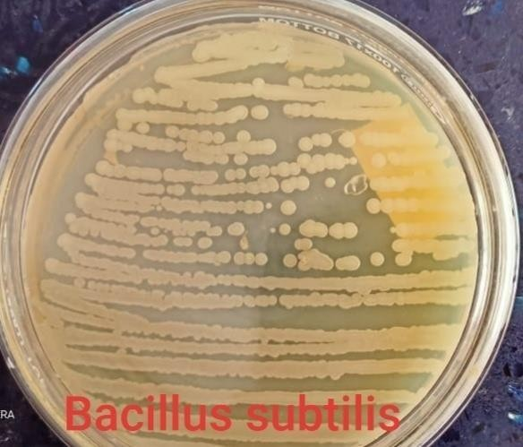
Figure-1 Bacillus subtilis pure culture on nutrient agar.
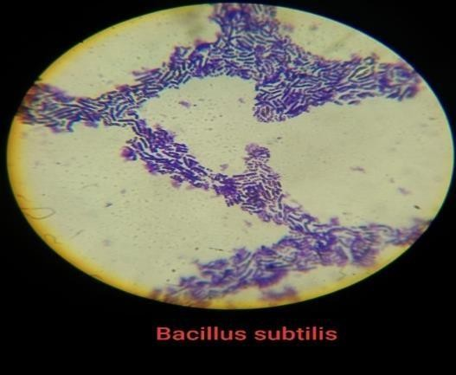
Colony characteristic (figure-1) of Bacillus subtilis on nutrient agar plate. they have irregular margin, 2-3mm size, dry and rough texture, flat elevation, white pigmentation and opaque opacity.
Figure-2 Bacillus subtilis microscopic view.
Colony characteristic of (figure-2) Bacillus subtilis in microscopic view performing gram stain. they have rod shaped, purple color and gram positive bacteria.
Identification of bacterial isolates:
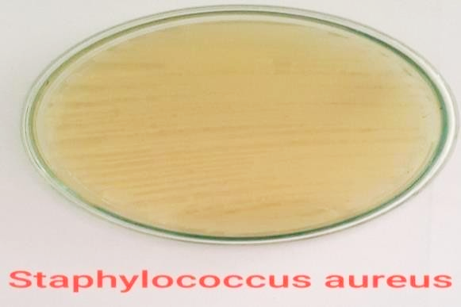
The morphological, physiological characterization of bacteria by gram staining method. after use of gram staining method identification of staphylococcus aureus and Escherichia coli.
Figure-3 Staphylococcus aureus pure culture on luria bertani agar.
Colony characteristic (figure-3) of Staphylococcus aureus on luria bertani agar medium. they have entire margin, convex elevation, 2-3mm size, smooth and shiny texture, flat elevation, yellow pigmentation and opaque opacity.
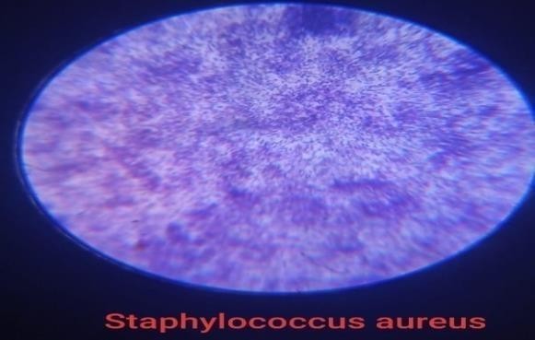
Figure-4 Staphylococcus aureus microscopic view.
Colony characteristic of (figure-4) Staphylococcus aureus in microscopic view performing gram stain. they have round shaped, purple color and gram positive bacteria.
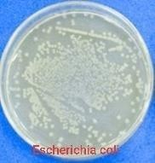
Figure-5 Escherichia coli on nutrient agar.
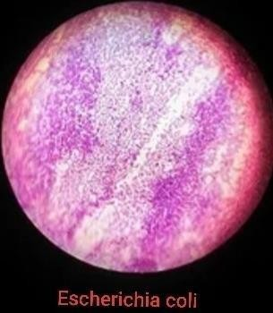
Colony characteristic (figure-5) of Escherichia coli on nutrient agar plate. they have entire margin, 1-2mm size, shiny texture, convex elevation, off-white pigmentation and opaque opacity.
Figure-6 Escherichia coli microscopic view.
Colony characteristic of (figure-6) Escherichia coli in microscopic view performing gram stain. they have rod shaped, pink color and gram negative bacteria.
Identification of silver nanoparticles producing fungal isolates:
Fungal isolates were identified up to morphological characteristics (spores, arrangement of conidia and reproductive structure) using lacto phenol cotton blue staining.

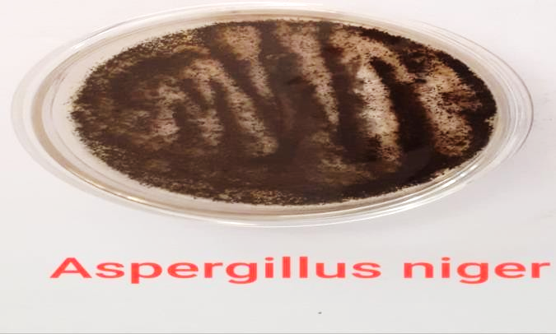
Figure-7 Aspergillus niger pure culture.
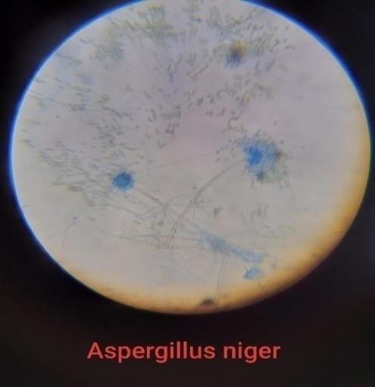
Colony characteristic of (figure-7) Aspergillus niger on potato dextrose agar plate. they have smooth structure, white surface color and reverse black color.
Figure-8 Aspergillus niger microscopic view.
Colony characteristic of (figure-8) Aspergillus niger in microscopic view performing of lacto phenol cotton blue staining. they have one celled conidia, branching septate hyphae, smooth cell walls and asexually reproductive structure.
Production of biomass from Bacteria:
After the agitation microbial biomass was collected around 24 hours after. so we observe from the (figure-9) clear biomass production and the (figure-10) cell free supernant.

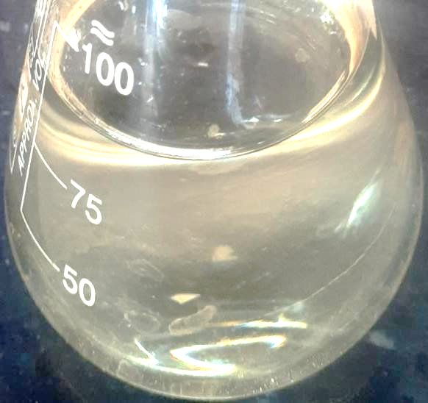
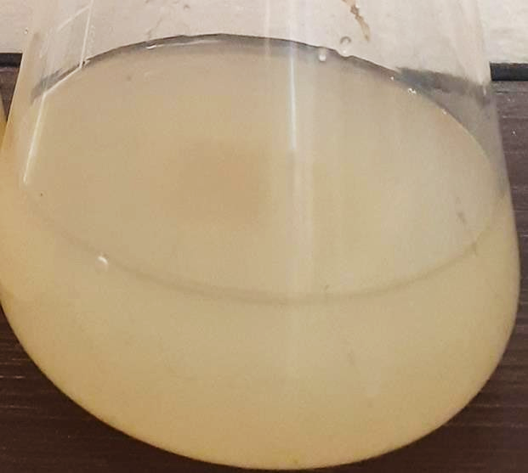

Figure-9 Biomass Production of B. subtilis. Figure-10 B. subtilis cell free supernant.
Biosynthesis of silver nanoparticles from Bacillus subtilis:
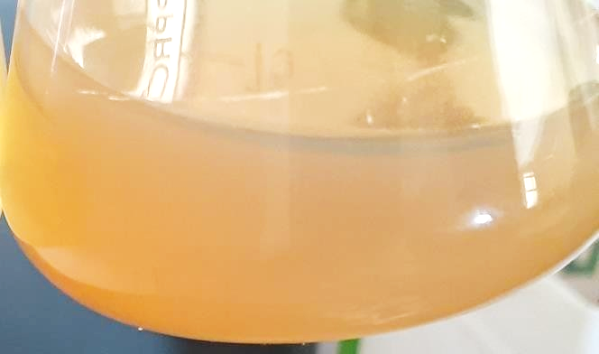
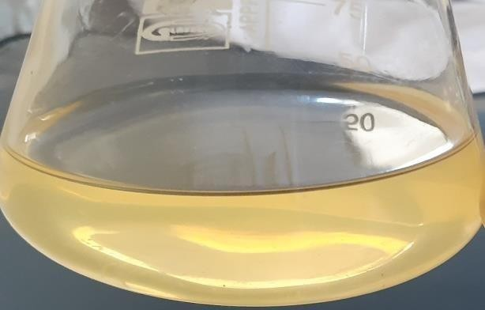

Figure-11 Control, without silver nitrate.

Figure-11 Control, without silver nitrate. Figure-12 silver nanoparticle suspension.
The biosynthesis of silver nanoparticles was initially confirmed through color change of the reaction mixture. the appearance of a pale yellow to (figure-12) brown color filtrate in the reaction vessels after incubation at room temperature confirms the formation of silver nanoparticles. in negative (figure-11) control (without silver nitrate), no color change was observed. in flask containing bacterial supernatant with silver nitrate solution color change from pale yellow to brown color was observed. The silver nanoparticles were concentrated and separated after centrifugation.

Effect of time on the biogenic silver nanoparticles:

Figure-13 Uv- visible spectrum of Effect of time on the biogenic silver nanoparticles.
As a (figure-13) function of time, the UV–Vis spectra absorbance at a concentration of 1 mM silver nitrate and cell free supernant indicates that the reaction was completed during of the incubation period. An increase in time does not affect the formation of silver nanoparticles.
Characterization of silver nanoparticles produces by Bacillus subtilis:
Figure-14 Uv- visible spectrum of synthesis for silver nanoparticles from Bacillus subtilis.
The primary characterization (figure-14) of silver nanoparticles was done with UV-Visible spectral analysis. this initial step to authenticate silver nanoparticles formation in aqueous solution is using UV- Visible spectroscopy. the absorbance pattern of the UV-Visible spectra in the range of 300-500 nm. A strong, broad peak observed at 420nm.
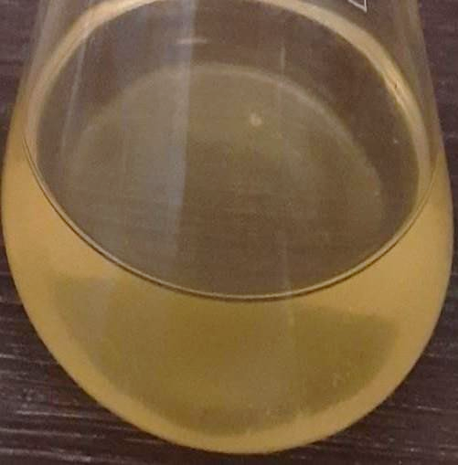
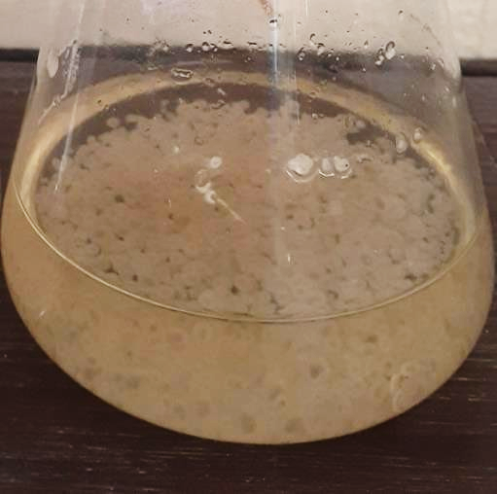
Production of biomass of fungi:

Figure-15 Mass production of A. niger. Figure-16 A. niger cell free supernant.
The biomass was harvested after 72 hours of growth by filtering through a paper sieve, followed by substantial washing with distilled water in order to remove any medium component from the biomass (figure-15). Fresh biomass was added to 200 ml of distilled water for 48 hours at 25°C in flask and agitated on orbital shaker at 150 rpm for 48 hours. After incubation, the cell filtrate was obtained by sieving the content through filter paper (figure-16).
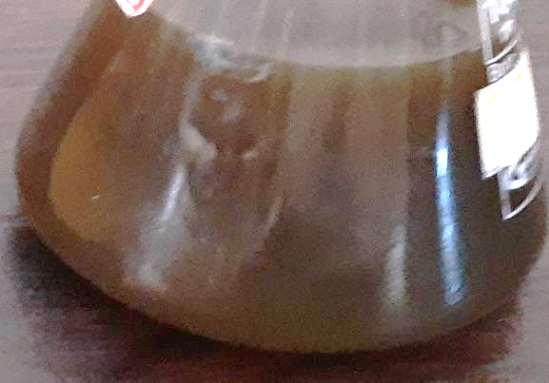
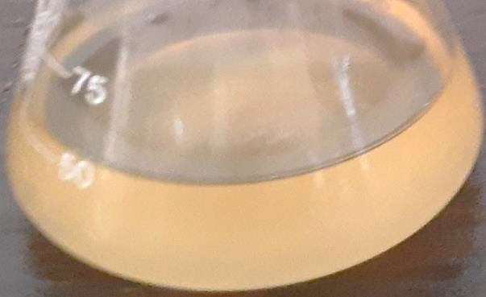
Biosynthesis of silver nanoparticles from Aspergillus Niger:

Figure-17 Control, without silver nitrate. Figure-18 Test, silver nanoparticle suspension

After incubation of the fungal cell filtrates with silver ions and maintenance in the dark, the cell filtrates showed a gradual change in color towards yellow to brown (figure-18). The color of the cell filtrates changed to intense brown after 48 h of incubation. This indicated the formation of sliver nanoparticles in the medium which was mainly. Controls (without silver ion, figure-17) exhibited no change in color of the cell filtrate in the same condition of incubation. The silver nanoparticles were concentrated and separated after centrifugation.
Characterization of silver nanoparticles produces by Aspergillus niger:

Figure-19 Uv- visible spectrum of synthesis of silver nanoparticles from Aspergillus niger.
The primary characterization of silver nanoparticles was done with Uv-Visible spectral analysis. This initial step to authenticate silver nanoparticles formation in aqueous solution is using Uv- Visible spectroscopy. the absorbance pattern of the Uv-Visible spectra in the range of 300-500 nm. a strong, broad peak observed at 430 nm (figure-19).

Antimicrobial activity of silver nanoparticles produces by Bacillus subtilis against staphylococcus aureus:
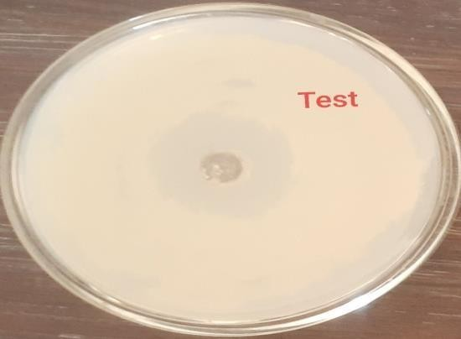
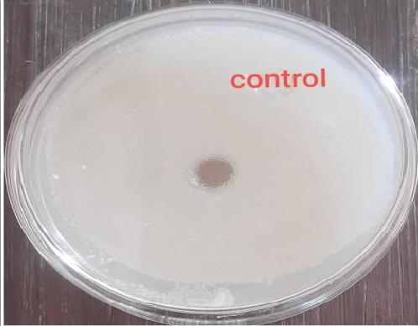

Figure-20 Control, silver nitrate. Figure-21 Test, silver nanoparticle.
After the incubated plate zone of inhibition (8mm) is observed against bacteria. Antibacterial activity of silver nanoparticles is gain best result against staphylococcus aureus. The diameters of clear area determined for staphylococcus aureus were 8 mm (figure-21). in control plate zone of inhibition is not observed (figure-20).
Antifungal activity of silver nanoparticles produces by Bacillus subtilis against Aspergillus niger:
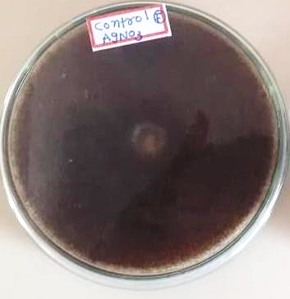
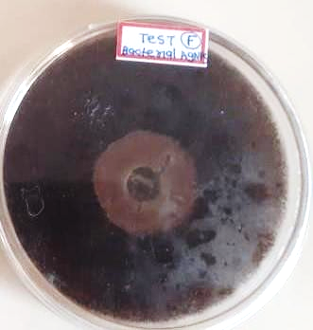

Figure-22 Control, silver nitrate Figure-23 Test, silver nanoparticles.
After the incubated plate zone of inhibition (10mm) is observed against fungi. antifungal activity of silver nanoparticles which produced by Bacillus subtilis is gain best result against Aspergillus niger. The diameters of clear area determined for Aspergillus niger were 11 mm (figure-23). in control plate zone of inhibition is not observed (figure-22).

Antimicrobial activity of silver nanoparticles produces by Aspergillus niger against Escherichia coli:
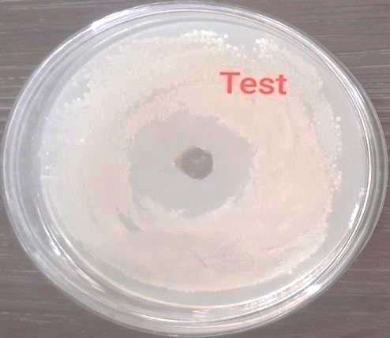
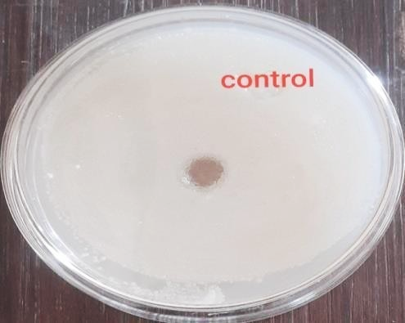
Figure-24 Control, silver nitrate. Figure-25 Test, silver nanoparticles.
After the incubated plate zone of inhibition (9.5mm) is observed against bacteria. antibacterial activity of silver nanoparticles produced by Aspergillus niger is gain best result against staphylococcus aureus. The diameters of clear area determined for Escherichia coli were 14 mm (figure-25). in control plate zone of inhibition is not observed (figure-24).
Antifungal activity of silver nanoparticles produces by Bacillus subtilis against Aspergillus niger:
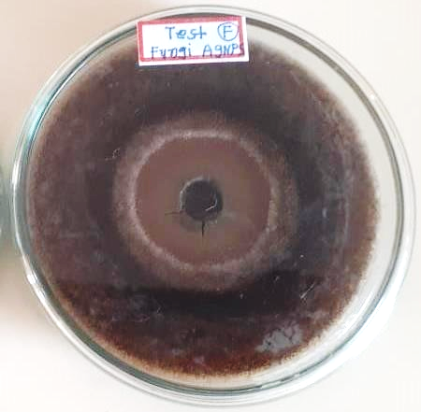
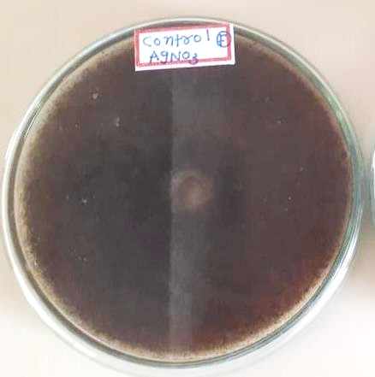

Figure-26 Control, silver nitrate. Figure-27 Test, silver nanoparticles.
After the incubated plate zone of inhibition (12mm) is observed against fungi. antifungal activity of silver nanoparticles against Aspergillus niger is better. The diameters of clear area determined for Aspergillus niger were 12 mm (figure-27). in control plate zone of inhibition is not observed (figure-26).

- Discussion
Silver nanoparticles are gaining popular nowadays because of their versatile applications in various fields of research. AgNPs are useful in treating various kinds of diseases in any forms. biosynthesis of silver nanoparticles using microbes is best alternative to accomplish the clean, economical and eco-friendly production among the microbes, prokaryotic bacteria have been most extensively used for the synthesis of nanoparticles, in the current study, soil microorganisms from Narsinh Mehta garden were screened for their ability to produce silver nanoparticles. The bacteria from this region are expected to have continuous interactions with metals, hence they could possess nanoparticle forming properties. Bacterial isolates obtained from soil samples were further screened for silver nanoparticles forming ability. The cell free supernatant of all the isolates were treated with 1mM AgNO₃ solution and observed for the color change from colorless to brown.
The change in color throughout the supernatant was occurred after 24 hour of incubation and the color was completed at 48h. in the current study, soil microorganisms from agriculture garden were screened for their ability to produce silver nanoparticles. The fungi from this region are expected to have continuous interactions with metals, hence they could possess nanoparticle forming properties. fungal isolates obtained from soil samples were further screened for silver nanoparticles forming ability. The cell free supernatant of all the isolates were treated with 1mM AgNO3 solution and observed for the color change from colorless to brown.
The production of silver nanoparticles by Bacillus subtilis characterization in Uv visible spectroscopy in a strong, broad peak observed at 420nm. It means production of silver nanoparticles capable Bacillus subtilis and gets best result. the production of silver nanoparticles by Aspergillus niger characterization in Uv visible spectroscopy in A strong, broad peak observed at 430nm. it means production of silver nanoparticles capable Aspergillus niger and gets best result. antibacterial activity of the biosynthesized silver nanoparticles against staphylococcus aureus and Escherichia coli produce the zone of inhibition. silver nanoparticles against staphylococcus aureus create zone of inhibition 8 mm and 9.5 mm respectively. it is good antibacterial activity of silver nanoparticles. antifungal activity of the biosynthesized silver nanoparticles against Aspergillus niger produce the zone of inhibition. diameter of zone against Aspergillus niger 10 mm and 12 mm.

- Conclusion
Soil samples used in the study were collected from Narsinh Mehta garden. the bacterial and fungal isolates obtained from agricultural garden soil samples were further subcultured on Nutrient agar and potato dextrose agar supplemented with 1mM concentration of sterilized AgNO3, to select silver nanoparticles producing isolates. the results indicated that among all the isolates Bacillus subtilis and Aspergillus niger showed the synthesis of AgNPs which was evidenced from the yellow color change to brown color. the UV-Vis spectral analysis showed an absorbance peak of Bacillus subtilis and Aspergillus niger at 420 nm and 430 nm.
Antibacterial activity of silver nanoparticles was performed by well diffusion method against staphylococcus aureus and Escherichia coli. antibacterial potential of AgNPs was assessed by measuring diameter of zone of inhibition against the pathogens. zone of inhibition against staphylococcus aureus 8 mm and Escherichia coli 9 mm. antifungal activity of silver nanoparticles was performed by well diffusion method against Aspergillus niger. the antifungal potential of AgNPs was assessed by measuring diameter of zone of inhibition against the pathogens. the zone of inhibition against Aspergillus niger is 10 mm and 12 mm.
this data suggests green and eco-friendly method to formation of silver bio-nanoparticles by Bacillus subtilis and Aspergillus niger. silver nanoparticles used as antimicrobial agent against pathogenic microorganism. silver nanoparticles also useful in the treatment of the many diseases. silver nanoparticles give best antimicrobial activity against fungi and bacteria. silver nanoparticles broadly used in medical field.

- References
- Ahmad, A., Mukherjee, P., Senapati, S., Mandal, D., Khan, M. I., Kumar, R., & Sastry, M. (2003). Extracellular biosynthesis of silver nanoparticles using the fungus Fusarium oxysporum. Colloids and surfaces B: Biointerfaces, 28(4), 313-318.
- Gahlawat, G., Shikha, S., Chaddha, B. S., Chaudhuri, S. R., Mayilraj, S., & Choudhury, A. R. (2016). Microbial glycolipoprotein-capped silver nanoparticles as emerging antibacterial agents against cholera. Microbial Cell Factories, 15, 1-14.
- El-Gamal, M. S., Salem, S. S., & Abdo, A. M. (2018). Biosynthesis, characterization, and antimicrobial activities of silver nanoparticles synthesized by endophytic Streptomyces sp. J. Biotechnol, 56, 69-85.
- Kim, J., Grate, J. W., & Wang, P. (2006). Nanostructures for enzyme stabilization. Chemical engineering science, 61(3), 1017-1026.
- Li, F., Collins, J. G., & Keene, F. R. (2015). Ruthenium complexes as antimicrobial agents. Chemical Society Reviews, 44(8), 2529-2542.
- Lara, H. H., Ayala-Núñez, N. V., Ixtepan Turrent, L. D. C., & Rodríguez Padilla, C. (2010). Bactericidal effect of silver nanoparticles against multidrug-resistant bacteria. World Journal of Microbiology and Biotechnology, 26, 615-621.
- Khan, A. U., Malik, N., Khan, M., Cho, M. H., & Khan, M. M. (2018). Fungi-assisted silver nanoparticle synthesis and their applications. Bioprocess and biosystems engineering, 41, 1-20.
- Jeong, S. H., Hwang, Y. H., & Yi, S. C. (2005). Antibacterial properties of padded PP/PE nonwovens incorporating nano-sized silver colloids. Journal of materials science, 40, 5413-5418.
- Iravani, S., Korbekandi, H., Mirmohammadi, S. V., & Zolfaghari, B. (2014). Synthesis of silver nanoparticles: chemical, physical and biological methods. Research in pharmaceutical sciences, 9(6), 385.
- Ahmed, S., & Ikram, S. (2016). Biosynthesis of gold nanoparticles: a green approach. Journal of Photochemistry and Photobiology B: Biology, 161, 141-153.
- Sriram, M. I., Kalishwaralal, K., & Gurunathan, S. (2012). Biosynthesis of silver and gold nanoparticles using Bacillus licheniformis. Nanoparticles in biology and medicine: methods and protocols, 33-43.
- Jung, W. K., Koo, H. C., Kim, K. W., Shin, S., Kim, S. H., & Park, Y. H. (2008). Antibacterial activity and mechanism of action of the silver ion in Staphylococcus aureus and Escherichia coli. Applied and environmental microbiology, 74(7), 2171-2178.
- Mishra, A., Tripathy, S. K., & Yun, S. I. (2011). Bio-synthesis of gold and silver nanoparticles from Candida guilliermondii and their antimicrobial effect against pathogenic bacteria. Journal of nanoscience and nanotechnology, 11(1), 243-248.
- Gahlawat, G., & Choudhury, A. R. (2019). A review on the biosynthesis of metal and metal salt nanoparticles by microbes. RSC advances, 9(23), 12944-12967.
- Alsukaibi, A. K. (2022). Various approaches for the detoxification of toxic dyes in wastewater. Processes, 10(10), 1968.
- Gayathiri, E., Prakash, P., Karmegam, N., Varjani, S., Awasthi, M. K., & Ravindran, B. (2022). Biosurfactants: potential and eco-friendly material for sustainable agriculture and environmental safety—a review. Agronomy, 12(3), 662.
- Rezvani Amin, Z., Khashyarmanesh, Z., & Fazly Bazzaz, B. S. (2016). Different behavior of Staphylococcus epidermidis in intracellular biosynthesis of silver and cadmium sulfide nanoparticles: more stability and lower toxicity of extracted nanoparticles. World Journal of Microbiology and Biotechnology, 32, 1-11.
- Chugh, D., Viswamalya, V. S., & Das, B. (2021). Green synthesis of silver nanoparticles with algae and the importance of capping agents in the process. Journal of Genetic Engineering and Biotechnology, 19(1), 1-21.
- Jain, J., Arora, S., Rajwade, J. M., Omray, P., Khandelwal, S., & Paknikar, K. M. (2009). Silver nanoparticles in therapeutics: development of an antimicrobial gel formulation for topical use. Molecular pharmaceutics, 6(5), 1388-1401.
- Shahverdi, A. R., Minaeian, S., Shahverdi, H. R., Jamalifar, H., & Nohi, A. A. (2007). Rapid synthesis of silver nanoparticles using culture supernatants of Enterobacteria: a novel biological approach. Process Biochemistry, 42(5), 919-923.
- Kalimuthu, K., Suresh Babu, R., Venkataraman, D., Bilal, M., Gurunathan, S. (2008). Biosynthesis ofsilver nanocrystals by Bacillus licheniformis. Colloids Surf B Biointerfaces volume 65, pages 150–153.
- Kalimuthu, K., Babu, R. S., Venkataraman, D., Bilal, M., & Gurunathan, S. (2008). Biosynthesis of silver nanocrystals by Bacillus licheniformis. Colloids and surfaces B: Biointerfaces, 65(1), 150-153.
- Duran, N., Priscyla, D., Marcato, P.D., Alves, O., De Souza, G., Esposito.E. (2005). Mechanistic aspects of biosynthesis of silver nanoparticles by several Fusarium oxysporum strains.J Nanobiotechnol. Volume 2005 issue 3, pages 1– 7.
- Kowshik, M., Ashtaputre, S., Kharrazi, S., Vogel, W., Urban, J., Kulkarni, S. K., & Paknikar, K. M. (2002). Extracellular synthesis of silver nanoparticles by a silver-tolerant yeast strain MKY3. Nanotechnology, 14(1), 95.
- Zeng, H., Zhao, C., Qiu, J., Yang, Y., & Chen, G. (2007). Preparation and optical properties of silver nanoparticles induced by a femtosecond laser irradiation. Journal of Crystal Growth, 300(2), 519-522.
- Kalishwaralal, K., Deepak, V., Ramkumarpandian, S., Nellaiah, H., & Sangiliyandi, G. (2008). Extracellular biosynthesis of silver nanoparticles by the culture supernatant of Bacillus licheniformis. Materials letters, 62(29), 4411-4413.
- Murray, C. B., Kagan, C. R., & Bawendi, M. G. (2000). Synthesis and characterization of monodisperse nanocrystals and close-packed nanocrystal assemblies. Annual review of materials science, 30(1), 545-610.
- Iravani, S., Korbekandi, H., Mirmohammadi, S. V., & Zolfaghari, B. (2014). Synthesis of silver nanoparticles: chemical, physical and biological methods. Research in pharmaceutical sciences, 9(6), 385.
- Faramarzi, M. A., & Sadighi, A. (2013). Insights into biogenic and chemical production of inorganic nanomaterials and nanostructures. Advances in Colloid and Interface Science, 189, 1-20.
- Li, J., Li, Q., Ma, X., Tian, B., Li, T., Yu, J., ... & Hua, Y. (2016). Biosynthesis of gold nanoparticles by the extreme bacterium Deinococcus radiodurans and an evaluation of their antibacterial properties. International journal of nanomedicine, 5931-5944.
- Ranjan, R., & Jadeja, V. (2017). Isolation, characterization and chromatography based purification of antibacterial compound isolated from rare endophytic actinomycetes Micrococcus yunnanensis. Journal of pharmaceutical analysis, 7(5), 343-347.
- Alsamhary, K. I. (2020). Eco-friendly synthesis of silver nanoparticles by Bacillus subtilis and their antibacterial activity. Saudi Journal of Biological Sciences, 27(8), 2185-219
- Ahmad, A., Mukherjee, P., Senapati, S., Mandal, D., Khan, M. I., Kumar, R., & Sastry, M. (2003). Extracellular biosynthesis of silver nanoparticles using the fungus Fusarium oxysporum. Colloids and surfaces B: Biointerfaces, 28(4), 313-318.
- Bhainsa, K. C., & D'souza, S. F. (2006). Extracellular biosynthesis of silver nanoparticles using the fungus Aspergillus fumigatus. Colloids and surfaces B: Biointerfaces, 47(2), 160-164.
- Zomorodian, K., Pourshahid, S., Sadatsharifi, A., Mehryar, P., Pakshir, K., Rahimi, M. J., & Arabi Monfared, A. (2016). Biosynthesis and characterization of silver nanoparticles by Aspergillus species. BioMed research international, 2016.
- Kalishwaralal, K., Deepak, V., Ramkumarpandian, S., Nellaiah, H., & Sangiliyandi, G. (2008). Extracellular biosynthesis of silver nanoparticles by the culture supernatant of Bacillus licheniformis. Materials letters, 62(29), 4411-4413.
- Zomorodian, K., Pourshahid, S., Sadatsharifi, A., Mehryar, P., Pakshir, K., Rahimi, M. J., & Arabi Monfared, A. (2016). Biosynthesis and characterization of silver nanoparticles by Aspergillus species. BioMed research international, 2016.

