Implementation ofLean Six Sigma in diagnostic Laboratories with quality standard ISO 15189

Rajal Dave, Sayali Dhumal
Department of Microbiology, Krsnaa Diagnostics Ltd., Pune, India
Phone no: +91 -8177820784

Ajay Kumar Prajapati
Department of Laboratory Medicine, Central Hospital, SWR, Hubli, Karnataka, India
Phone no: +91 -9739066434

Introduction
Advance diagnostics laboratories have almost replaced manual testing parameter into automated. With high burden of reducing cost with maintaining good quality and turnaround time, Many Clinical laboratories has adapted new approach and modify the procedural system. Laboratory Quality management system is one of the main regulatory systems of accreditation. The accreditation is providing by the government based on their scope of testing. There arerequirements of different actwhich need to be gathered. It is again based on the specialization of laboratory. i.e., ISO 15189 for diagnostics laboratory. Toacquire good quality reports, laboratory needs to emphasize on three important processesof diagnostic laboratory. These are pre-analytical, analytical and post analytical phases. However, the most common error is pre – analytical error.As per ISO 15189, the pre-analytical phase consists ofthe steps starts from the patients request form,patient preparation, collection & transportation of primary specimens to laboratory.
Laboratory Quality standard (ISO 15189)
ISO 15189 is an international standard used by diagnostics laboratories to build their quality management systems and to appraise their competence. Laboratory requires this standard document to propose and implementation of actions to focus risks and opportunities. When laboratory involved to addressing both opportunities and risks, it establishesto increase the validity of the quality management system, improvised results, and preventing adverse effects. This document will accelerate collaboration between clinical laboratories and other organization. It also aids in the commute of information and experience and in the cooperation between the standards and procedure. This document provides harmonization between standards and procedure.

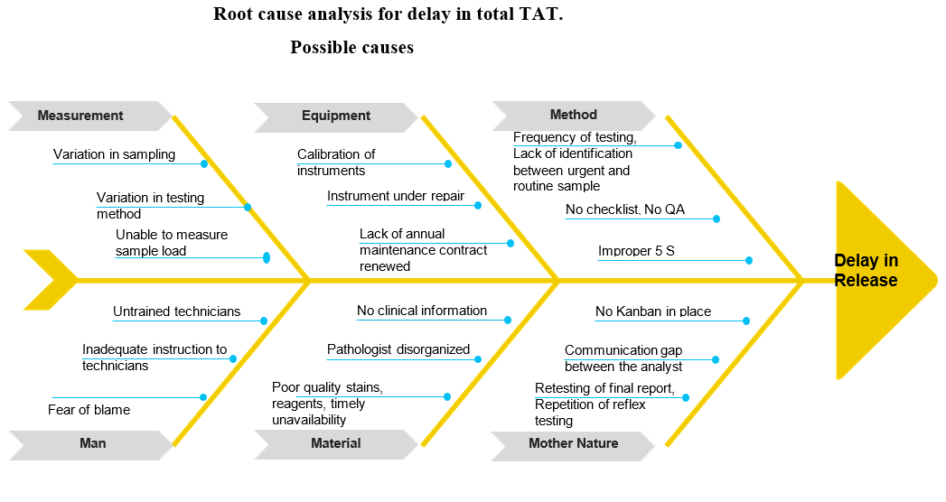
Figure – 1: Possible root cause for delay in repport release in clinical laboratory

Tools and Techniquesof Lean Six Sigma
The decision of Lean Six Sigma tools and techniques relay on the following:
- Service type/ processes
- Depend on used of approach (DMAIC / DMADV)
- Behaviour of Data (Quantitative/ Qualitative)
- Based on employee’s learning and competency level, which will help to understand and implementation.
Most widely used approach is DMAIC, which stands for Define, Measure, Analyse, and Improve& Control while DMADV means Define, Measure, Analyse, Design & Verify. Theimplementation ofDMAIC methodology when a process or results is in existence in an organisation but it not matching with consumer specification.
Based on Laboratory case, the below factors can take into consideration in selection and implementation of Six Sigma techniques.
- DMAIC Approach
- Behaviour of Data: qualitative and quantitative
- Education and competency level of employee
- Adaptability with the ISO 15189
Implementation of Lean Six sigma in diagnostics laboratories with ISO 15189 standard
To justify the motive of this chapter which mentioned objective – Implementation of Lean Six sigma in diagnostics laboratories with standard. Some important aspect needs to be aware of the below requirements:
A. ISO 15189 standard specific clause requirements for quality improvement & control of processes: The clauses:
1. The clauses 5.5 which is highlighting the Ensuring the validity of test results,
2. The clauses 4.9 which includes Complaints and
3. The clauses4.13 which includes non-conforming work.
All these clauses are like the quality control and improvement procedure. Also, these three clauses are very important and fundamental for accreditation of clinical laboratories.
B. One typical clause (4.15.2) says “Data from observation activities shouldanalyzed periodically, used as a control and to improve the laboratory's procedure. If the results of the data analysis from observed activities are found to be out of pre-defined factor, appropriate action shall be taken to avoid erroneous results from being reported.” This requirement allows the laboratories to implement the tools for quality improvement which needed for better performance achievement and this study proves worth.
C. Diagnostics laboratory process needs: Majority of thediagnostics laboratories carry out the procedure either by instrumental or through wet laboratory procedure and sometimes combination of both.
Lean Microbiology:
In today’s world of health care, the clinical laboratory is position of aggressively change of new disease, new technologies, new health care delivery techniques, a changing work area, economical pressure, and evolving reimbursement combine to challenge the; laboratory in ways that were unimaginable even decades ago. Lean management procedure within the clinical microbiology laboratory can help to focus these challenges both today and in future.
Examples of Lean initiatives:
Microbiology laboratory involves the integration of pre and post analytical processes through combination of multiple, modular systems to perform different tests which involvesmanual plating, incubation, analyzing and processing of specimens. Through minimal manual processing of specimen, standardization can be established to reduce the human error. Implementation of Lean techniques especially 5 S helps to enhance improve quality of microbiological workflow including enhanced microbial growth, better colony isolation, reduced need of bacterial subculture, and reduced time to result.
Process involved and improvements:
- Review of SOPS
- Staff education
- Streamlined culture reading with standardized follow-up protocol
- A pending of specimen’s process at end of second shift by assessment and plating for expansion to 16 hours’ operation. So, technologist significantly reduce the extend of the backlog without higher management authority intervention or the need of additional staffing. They were able to accomplish this by identify key barriers in specimen processing time and its peak hours for specimen receiving.
- To apply on First –in, first- out approach to specimen processing andassociated with other department to reduce batch sizes of samples through more frequent specimen pickups.
- Application of evidence-based decision making, which is core concept of Lean. When resources are limited, the natural tendency is to provide a simple fix to a problem.
- Standardization of work process by standard work document to visual aid and for analyzing and reporting of different specimen types.
- Physical redesigned of work benches including storage and clear labelling of all items. By standardizing each workstation, there was reduced room for error and reduce time for search of reagents and materials.
- Kanban used for inventory management of laboratory resources allowed for reduced need for extra storage space and waste due to unnecessary inventory by more usage pattern and ordering.
- Routine analysis over time allowed the department to adjust the timing of negative-preliminary results reporting to reduce the number of amended reports.
- Despite multiple use of PDCA cycle, all microbiological sample’s culture reports like pus, urine, blood, respiratory, fluids, no improvements were noted. So as a part of process of continuous improvement, all culture reports were started released in form of preliminary and final. This approach immediately shortens TATs (Turnaround time) of report.
- Most challenging part in microbiology lab. was staff motivation. That had been improved by conducting individual opportunity to demonstrate their organization skill.
Conclusion
This chapter is an endeavour to understand the key parameter of applicationof Lean Six sigma in the clinical laboratories. Implementation of Lean Six sigma in the Laboratory Qualitystandard (ISO 15189), the important results are,
- Identify and application ofproper Lean Six sigma tools and techniques like the clinical laboratory.
- Selection suitable DMAIC method.
- To understand the importance of Lean Six sigma in quality control management& improvement of the diagnostics laboratory.
- Develop framework of Lean Six sigma along with the method and tools & techniques which would be appropriate to the Laboratory standard (ISO 15189) collaboration.
So Lean practice within diagnostics laboratory & in Microbiology testing can help to attend many challenges for today and for future.

Reference
- Munro RA. Lean Six Sigma for the Healthcare Practice. ASQ Quality Press, 2009.
- George ML. Lean Six Sigma for Service. McGraw – Hill, New York, 2003.
- Duffy GL, Moran JW, Riley W. Quality Function Deployment and Lean-Six Sigma Applications in Public Health. ASQ Quality Press, ISBN 978-0-87389-787-7, 2010.
- Arthur J. Lean Six Sigma Demystified. McGraw Hill, 2007.
- Pries KH. Six Sigma for the New Millennium. A SSBB Guidebook, ASQ Quality Press, 2009.
- MacInnes RL. The Lean Enterprise, Memory Jogger for Service. GOLA/QPC, 2009.
- The Lean and Environmental Toolkit, www.epa.gov/lean.
- Shankar R. Process Improvement Using Six Sigma. A DMAIC Guide, ASQ Quality Press, 2009.
- Kubiak TM, Benbow DW. The Certified Six Sigma Black Belt, Handbook, Second Edition. ASQ Quality Press, 2009.
- Zarbo RJ. 2012. Creating and sustaining a Lean culture of continuous process improvement. Am. J. Clin. Pathol. 138:321–326. 10.1309/AJCP2QY1XGKTSNQF [PubMed] [CrossRef] [Google Scholar]
- Spear S, Bowen HK. 1999. Decoding the DNA of the Toyota Production System. Harvard Business Review, Boston, MA [Google Scholar]
- Liker JK, Franz JK. 2011. The Toyota way to continuous improvement: linking strategy and operational excellence to achieve superior performance. McGraw-Hill, New York, NY [Google Scholar]
- Deming WE. 2000. Out of the crisis. MIT Press, Cambridge, MA [Google Scholar]
- Zarbo R. 2010. Leaders wanted: a call to change the status quo in approaching health care quality, once again. Am. J. Clin. Pathol. 134:361–362.
- Zarbo RJ, D'Angelo R. 2006. Transforming to a quality culture. The Henry Ford production system. Am. J. Clin. Pathol. 126 (Suppl 1): S21–S29. 10.1309/KVT7NWVPJR73T4K6 [CrossRef] [Google Scholar]
- D'Angelo R, Zarbo RJ. 2007. The Henry Ford production system: measures of process defects and waste in surgical pathology as a basis for quality improvement initiatives. Am. J. Clin. Pathol. 128:423–429. 10.1309/X6N1Y3V2CB9HUL8G [PubMed] [CrossRef] [Google Scholar]
- Bonini P, Plebani M, Ceriotti F, Rubboli F. Errors in laboratory medicine. Clin Chem. 2002; 48:691–698. [PubMed] [Google Scholar]
- Plebani M. The detection and prevention of errors in laboratory medicine. Ann ClinBiochem. 2010; 47:101–110. doi: 10.1258/acb.2009.009222. [PubMed] [CrossRef] [Google Scholar]
- Barth JH. Clinical quality indicators in laboratory medicine. Ann CliBiochem. 2012; 49:9–16. doi: 10.1258/acb.2011.011126. [PubMed] [CrossRef] [Google Scholar]
- Giménez-Marín A, Rivas-Ruiz F, Mdel Pérez-Hidalgo M, Molina-Mendoza P. Pre-analytical errors management in the clinical laboratory: a five-year study. Biochem Med. 2014;24(2):248–257. doi: 10.11613/BM.2014.027. [PMC free article] [PubMed] [CrossRef] [Google Scholar]
- Plebani M. Appropriateness in programs for continuous quality improvement in clinical laboratories. ClinChimActa. 2003; 333:131–139. doi: 10.1016/S0009-8981(03)00177-3. [PubMed] [CrossRef] [Google Scholar]
- Hofgärtner WT, Tait JF. Frequency of problems during clinical molecular-genetic testing. Am J ClinPathol. 1999 Jul;112(1): 14–21.
- Plebani M, Sciacovelli L, Aita A. Quality Indicators for the Total Testing Process. Clin Lab Med. 2017 Mar;37(1):187–205.
- Bonini P, Plebani M, Ceriotti F, Rubboli F. Errors in Laboratory Medicine. Clin Chem. 2002;(5):8.
- Lippi G, Chance JJ, Church S, Dazzi P, Fontana R, Giavarina D, Grankvist K, Huisman W, Kouri T, Palicka V, Plebani M, Puro V, Salvagno GL, Sandberg S, Sikaris K, Watson I, Stankovic AK, Simundic AM. Preanalytical quality improvement: from dream to reality Clin. Chem Lab Med. 2011;49(7):1113–1126
- Institution BS. BS EN ISO 15189: 2012 medical laboratories. Place of publication not identified: Bsi Standards; 2012.
- Plebani M, Carraro P. Mistakes in a stat laboratory: types and frequency. Clin Chem. 1997;(8):4.
- Karcher DS, Lehman CM. Clinical Consequences of Specimen Rejection: A College of American Pathologists Q-Probes Analysis of 78 Clinical Laboratories. Arch Pathol Lab Med. 2014 Aug;138(8):1003–8.
- Process Sigma Calculator [Internet]. [cited 2018 Oct 5]. Available from: https://www.isixsigma.com/process-sigmacalculator/
- Six Sigma Calculators - Westgard [Internet]. [cited 2018 Oct 5]. Available from: https://www.westgard.com/six-sigmacalculators.htm
- Westgard S, Qc W. Benchmarking Quality, Optimizing QC. :15.
- BS EN 1SO 15189: 2012 – Medical laboratories – requirements for quality and competence (ISO 15189:2012)

