Sheep tail fat: A cure for multiple diseases

Tanjima Tarique Laskarª, Monica Arora^{b},
ªDepartment of Pharmaceutical Chemistry, Al-Ameen College of Pharmacy, Bengaluru, India
^{b}Department of Pharmaceutical Chemistry, Al-Ameen College of Pharmacy, Bengaluru, India

Email- tanjimatarique.12@gmail.com

INTRODUCTION

Since ancient times sheep or lamb fat of tail has been an indispensable component in the diets of people residing in various tropical regions of the earth due to the presence of important fatty acids. Asian peoples have been using lambs and sheep fat of tail for various medicinal purposes. The desert sheep survive mostly on natural herbs and that’s why it is a rich source of omega3-fatty acids from which an average of 600-700 therapeutic medicaments can be produced. The lucrative fatty acids the sheep or lamb possesses are amassed mainly in its tail region [1]. Fat-tailed sheep are hardy and adaptable and they are capable of enduring and withstanding the tough challenges of desert life. The fatty acids of tail constitute up to 15% of total carcass mass of the sheep and lambs. Several studies manifest that the edible fats of tail may serve as complementary dietary remedy for treatment of a wide range of ailments. Sheep fat of tail are also found to significantly prevent the activity of proinflammatory cytokines such as Interleukin 1β (IL-1β), Tumour necrosis factor alpha (TNF-α) and Cyclooxygenase-2 (COX-2) [2,3]. The fatty acids of tail are also reported to possess antioxidant activity and relieve joint pain and varicose veins. Use of sheep fat tail leads to normalization of hormonal levels and improves hormone synthesis thereby minimizing the risk of developing infertility and menopause in women. The fatty acid of tail slows down the process of aging of the body and the development of atherosclerosis, while improving the functioning of the heart as well as brain. The fatty acids of tail contain exactly those substances that are required for growth and development of foetus so scientists have established that it is imperative to consume the tail fats during pregnancy when the organs of the unborn baby are being laid [4,5]. It is beneficial to serve sheep tail fat to young children at the stage of their growth as it accelerates the mental development and academic performance of children. Men who eat tail fat will never suffer from impotence and infertility issues. It has protective action against alcohol intoxication so it can be served along with strong alcoholic drinks to minimize the risk of developing toxicities. This product can be consumed as food in winters because it provides energy needed for thermoregulation and heat production. The fatty acids are useful for smokers as well because it removes tar and other harmful substances from the lungs and works as a remedy for pneumonia as well. Doctors prescribe treatment with sheep tail fat for dystrophy and exhaustion. Fat tail fat is an irreplaceable product for various viral diseases. This product has a beneficial effect on the Gastrointestinal tract as a piece of fat protects the stomach from excess gastric juice, eliminates constipation, and normalizes the peristaltic movement of the intestinal walls and prevents the development of ulcers and gastritis [6]. Melted fat tail acts as a remedy for tumor of skin tissues including adipose tissue. The melted mass of fat is applied to the inflammation and rubbed for about 15-20 minutes which provides a beneficial impact on the inflammation and noticeable results can be obtained within a few weeks. Lamb fat is used as a medicine for cough and bronchitis for children and adults. One teaspoon of lamb fat along with a glass of boiled milk consumed on empty stomach improves the elimination of phlegm and toxins from body. Thus, the sheep tail fat may be considered as an advantageous source of medicament as it is an economical, affordable and easily accessible natural product [7,8].
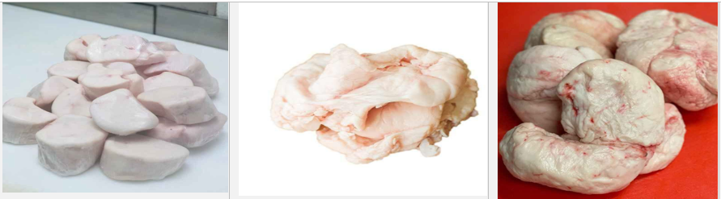
Figure 1: Fats of sheep extracted from the tail region
CHEMICAL COMPOSITION
Tail fat of sheep has a snow-white colour and when melted it becomes transparent in colour and does not freeze at normal room temperature. It is composed of proteins, fats (saturated & unsaturated), Vitamins (Vitamin B12, B1, B3, B2, B5, B6, K2, E, B9) and minerals (Zinc, Selenium, Phosphorus, Iron, Potassium, Copper, Magnesium, Sodium, Calcium & Manganese). The fat product contains fifteen fatty acids in measurable amounts such as oleic acid (39.6-53.5%), linoleic acid (2.1-3.7), linolenic acid (2.2-2.9%), margaric acid (0.9-2.3%), palmitic acid (18.2-23.6%, palmitoleic acid (1.4-3.6%), myristic acid (2.4-5.5%), myristoleic acid (0.3-2.1%), stearic acid (7.1-22.1%) pentadecanoic acid (0.6-1.0%), and arachidic acid (0.1-0.3%) [9,10].
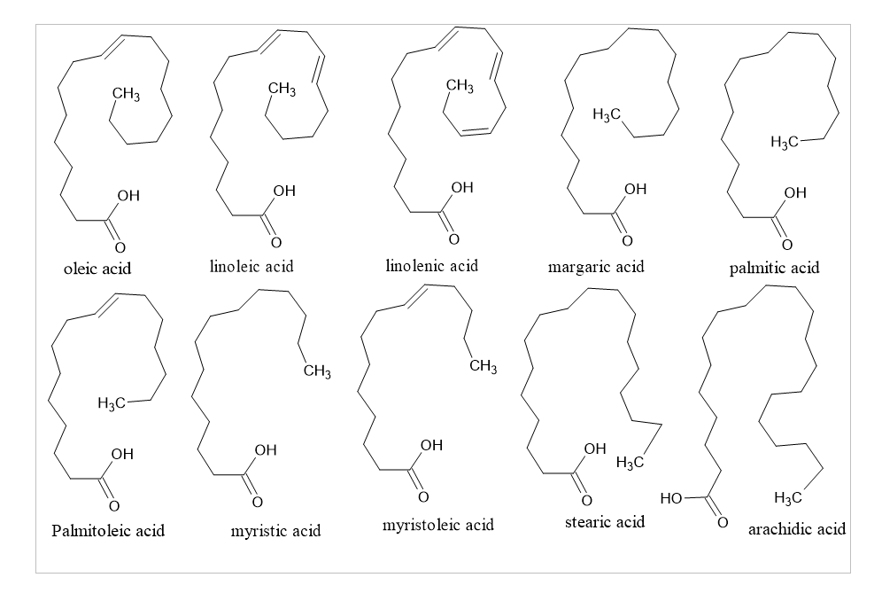 Figure 2: Structures of different types of fatty acids present in sheep tail
PHARMACOLOGICAL REVIEW

Sciatica
Sciatica is a condition characterized by considerable pain and disability in which the pains radiate towards the legs with or without associated neurological deficits. It is a condition where the pain radiates toward the sciatic nerve and moves from the hip regions to the leg and foot [11]. The more it persists, the more it radiates to the leg which causes weakness and numbness of the entire leg and foot. The symptom of sciatica includes a pain in lower back caused due to sciatic nerve which is accompanied by bladder and bowel incontinence. Sciatica has several causes among which the most common cause is due to hernia or fissure of disc that leads to scrunching of roots of sciatic nerve or it may develop due to infection of gram-negative rod-shaped enterobacteria which causes inflammation and pain of sciatic nerve. The pathophysiology behind sciatica is the presence of high levels of phospholipase A2 (PLA2) which is one of the main enzymes responsible for initiation of inflammatory process [12]. Phospholipase A2 acts on cellular membrane and releases Arachidonic acid which is a precursor of the proinflammatory mediators such as leukotriene and thromboxane. High levels of proinflammatory mediators or cytokines such as IL-1a, IL-1b, IL-6, IL-8, TNF-α, and prostaglandin E2 (PGE2) are responsible for triggering the pain of sciatic nerve [13]. The schematic diagram for pathophysiology of sciatica is given below:
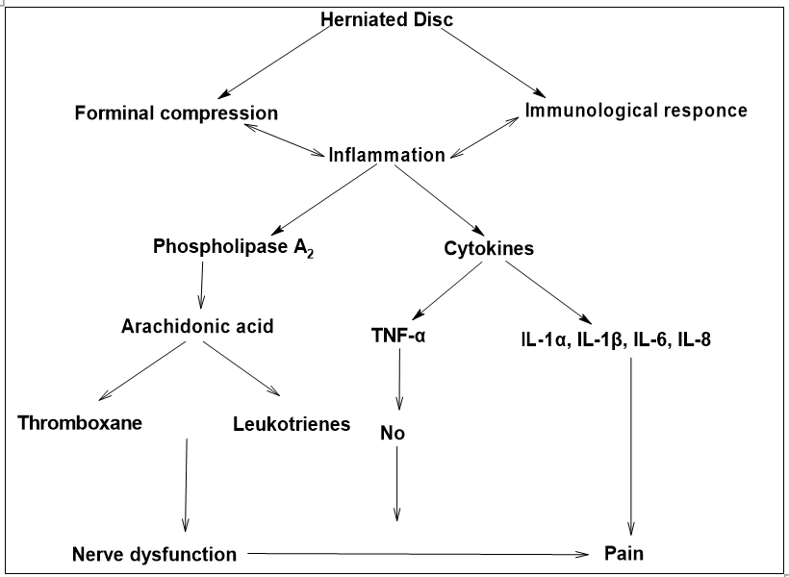
Figure 3: A flow diagram for the pathogenesis of Sciatica due to herniated disc
Increasing scientific evidence suggests that Omega-3 fatty acids group has predominant role in prevention and treatment of inflammation of the nerves caused due to herniated disk which is considered to be the major cause of Sciatica. The desert sheep is a rich source of omega-3 fats which are mainly stored in its tail. For using it as a medication for sciatica the fats of tail region should be melted at first so that the microorganisms if present are killed by the heat. The melted fat should be taken in three consecutive days on empty stomach so that no other lipids of the body can interfere in the absorption of lipids of the tail in the gastrointestinal tract [14]. The enzymes acting at the membrane of digestive tract converts the omega-3 fatty acids to type-3 prostaglandins which is responsible for reducing the inflammation and pain caused by Sciatica. Type-3 prostaglandins which are formed mainly from Alpha Linoleic Acid (ALA) are very beneficial for reducing the pains and inflammations caused due to sciatica [15,16].
Lung cancer
Lung cancer is a tragic and lethal disease prevailing worldwide and among which the most prevalent subtype is non-small-cell lung cancer (NSCLC). Patients with NSCLC have a poor survival rate due to acquired resistance to therapeutic medicaments. Several mechanisms are expected for furtherance of drug resistance so there is a crucial need of novel adjuvants to synergistically treat lung cancer [17,18]. Dietary fatty acids are considered as a beneficial adjuvant therapy for preventing the progression of cancerous disease. Increasing evidence suggests that saturated fatty acids such as heptadecanoic acid inhibits the proliferation of non-small-cell lung cancer (NSCLC). Sheep tails are rich sources of margaric acid which has the ability to inhibit cell proliferation by downregulating the Akt/S6K signalling pathway and supressing the expression of proliferative marker Ki-67. Therefore, three types of Sheep fatty acids namely Palmitic acid, Margaric acid and Stearic acid exerts a potent cytotoxic effect on NSCLC cells and among which the margaric acid is the most potent fatty acid for treatment of lung cancer [19].
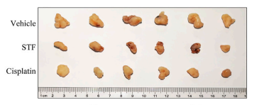
Figure 4: In-vivo Inhibition of NSCLC tumor growth in comparison vehicle and standard anticancer drug Cisplatin
Knee joint pain/Osteoarthritis
Osteoarthritis is caused mainly due to the progressive degeneration of cartilage tissue of knee joints. Proinflammatory cytokines including interleukin-1β (IL-1β) and tumour necrosis factor alpha (TNF-α) are reported for progression of oxidative stress in the cartilage tissue which is the main reason behind pathogenesis of osteoarthritis. These proinflammatory cytokines causes articular damage by increasing the synthesis of plasminogen and metalloproteinases and inhibits synthesis of type-2 collagen and chondrocyte replication in the matrix of knee joints. Medical treatment for this is limited due to the gastric, cardiovascular and other side effects and many patients reject the surgical treatment option [20]. Recent researches suggest that fatty acids present in sheep tail can be used for treatment of knee articular joint damages as it significantly inhibits the gene expressions of IL-1β, TNF-α and COX-2 in the knee cartilage tissue. Nevertheless, fatty acids present in the tail of sheep such as oleic, linoleic, palmitic, stearic and myristic acids have been reported to inhibit proinflammatory cytokines such and exhibit chondroprotective activity by improving the histopathological disturbances in the cartilage tissue of knee joints [21].
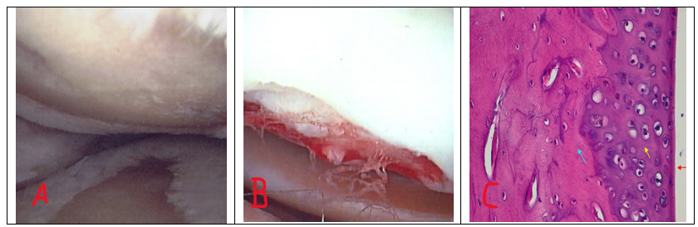
Figure 5: Comparison of healthy knee joint(A), Osteoarthritic joint (B) and Sheep tail fat treated cartilage tissue of damaged knee(C)
CONCLUSION
Despite having immense therapeutic potential, fats of sheep tail remained unnoticed and overlooked as a subject of research due to lack of productive performance. The fatty acids present in the tail region of sheep is distinctive, bio-active and contains unusual branched-chain fatty acids that are beneficial to human health and improves various health implications including sciatica. The nutritional value of fat tailed sheep is impressive as it contains a range of beneficial nutrients including healthy fatty acids, proteins, vitamins and minerals. Therefore, research on fatty acids of sheep tail should be upraised as it can be a better alternative in near future as a bioactive product in clinical practices because of its inexpensiveness and easy availability.
REFERENCE
[1] Mahachi LN, Rudman M, Arnaud E, Muchenje V, Hoffman LC. Application of fat-tailed sheep tail and backfat to develop novel warthog cabanossi with distinct sensory attributes. Foods. 2020 Dec 8;9(12):1822.
[2] Udo HM, Budisatria IG. Fat-tailed sheep in Indonesia; an essential resource for smallholders. Tropical animal health and production. 2011 Oct;43:1411-8.
[3] Zhang T, Gao H, Sahana G, Zan Y, Fan H, Liu J, Shi L, Wang H, Du L, Wang L, Zhao F. Genome‐wide association studies revealed candidate genes for tail fat deposition and body size in the Hulun Buir sheep. Journal of Animal Breeding and Genetics. 2019 Sep;136(5):362-70.
[4] Yousefi AR, Kohram H, Shahneh AZ, Nik-Khah A, Campbell AW. Comparison of the meat quality and fatty acid composition of traditional fat-tailed (Chall) and tailed (Zel) Iranian sheep breeds. Meat Science. 2012 Dec 1;92(4):417-22.
[5] Maleki E, Kafilzadeh F, Meng GY, Rajion MA, Ebrahimi M. The effect of breed on fatty acid composition of subcutaneous adipose tissues in fat-tailed sheep under identical feeding conditions. South African Journal of Animal Science. 2015;45(1):12-9.
[6] Khachadurian AK, Adrouni B, Yacoubian H. Metabolism of adipose tissue in the fat tail of the sheep in vivo. Journal of lipid research. 1966 May 1;7(3):427-36.
[7] Alipanah M, Kashan NE. Fatty acid composition of fat tail, visceral and meat fat of three Iranian sheep breeds. Journal of Food, Agriculture & Environment. 2011;9(2 part 1):416-8.
[8] Mehran M, Filsoof M. Fatty acid composition of sheep tail‐fats from five Iranian native breeds. Fette, Seifen, Anstrichmittel. 1976;78(5):187-9.
[7] Biswas P, Datta C, Rathi P, Bhattacharjee A. Fatty acids and their lipid mediators in the induction of cellular apoptosis in cancer cells. Prostaglandins & Other Lipid Mediators. 2022 Jun 1;160:106637.
[8] Kim HS, Mendiratta S, Kim J, Pecot CV, Larsen JE, Zubovych I, Seo BY, Kim J, Eskiocak B, Chung H, McMillan E. Systematic identification of molecular subtype-selective vulnerabilities in non-small-cell lung cancer. Cell. 2013 Oct 24;155(3):552-66.
[9]] Ünsal M, Yanlic KO. Fractionation and characterization of tail fats from Morkaraman lambs fed with diets containing Rosa canina L. seed at different levels. International Journal of Food Properties. 2005 May 1;8(2):301-12
[10] Cimen FK, Kockara N, Turkoglu M, Dundar C, Cetin N, Suleyman B, Coban A, Yarali O, Malkoc I, Suleyman H. Effect of sheep tail fat on the knee joint cartilage injury induced in rats with formalin. International Journal of Clinical and Experimental Medicine. 2017 Jan 1;10(5):7573-81.
[11] Savastano LE, Laurito SR, Fitt MR, Rasmussen JA, Polo VG, Patterson SI. Sciatic nerve injury: a simple and subtle model for investigating many aspects of nervous system damage and recovery. Journal of neuroscience methods. 2014 Apr 30;227:166-80.
[11] Moshref S, Jamal Y, Hummdi LA, Kaki AM, Al-Hibshi A. Intra-articular injection of autologous fat micro graft in sheep hind knee joints. Life Science Journal. 2013;10(4):2115-20.
[12] Savastano LE, Laurito SR, Fitt MR, Rasmussen JA, Polo VG, Patterson SI. Sciatic nerve injury: a simple and subtle model for investigating many aspects of nervous system damage and recovery. Journal of neuroscience methods. 2014 Apr 30;227:166-80.
[13] Unda SR, Villegas EA, Toledo ME, Asis Onell G, Laino CH. Beneficial effects of fish oil enriched in omega-3 fatty acids on the development and maintenance of neuropathic pain. Journal of Pharmacy and Pharmacology. 2020 Mar;72(3):437-47.
[14] Lockett MJ, Tomlinson DR. The effects of dietary treatment with essential fatty acids on sciatic nerve conduction and activity of the Na+/K+ pump in streptozotocin-diabetic rats. British journal of pharmacology. 1992 Feb;105(2):355.
[15] Pérez J, Ware MA, Chevalier S, Gougeon R, Shir Y. Dietary omega-3 fatty acids may be associated with increased neuropathic pain in nerve-injured rats. Anesthesia & Analgesia. 2005 Aug 1;101(2):444-8.
[16] Bourre JM, Youyou A, Durand G, Pascal G. Slow recovery of the fatty acid composition of sciatic nerve in rats fed a diet initially low in n− 3 fatty acids. Lipids. 1987 Jul;22(7):535-8.
[17] Wootton SK, Metzger MJ, Hudkins KL, Alpers CE, York D, DeMartini JC, Miller A. Lung cancer induced in mice by the envelope protein of jaagsiekte sheep retrovirus (JSRV) closely resembles lung cancer in sheep infected with JSRV. Retrovirology. 2006 Dec;3(1):1-5.
[18] Kim HS, Mendiratta S, Kim J, Pecot CV, Larsen JE, Zubovych I, Seo BY, Kim J, Eskiocak B, Chung H, McMillan E. Systematic identification of molecular subtype-selective vulnerabilities in non-small-cell lung cancer. Cell. 2013 Oct 24;155(3):552-66.
[19] Xu C, Zhang L, He H, Liu X, Pei X, Ma T, Ma B, Lin W, Zhang B. Sheep tail fat inhibits the proliferation of non-small-cell lung cancer cells in vitro and in vivo. Frontiers in Pharmacology. 2022 Aug 11;13:917513
[20] Ude CC, Ng MH, Chen CH, Htwe O, Amaramalar NS, Hassan S, Djordjevic I, Rani RA, Ahmad J, Yahya NM, Saim AB. Improved functional assessment of osteoarthritic knee joint after chondrogenically induced cell treatment. Osteoarthritis and cartilage. 2015 Aug 1;23(8):1294-306.
[21] Ude CC, Shamsul BS, Ng MH, Chen HC, Ohnmar H, Amaramalar SN, Rizal AR, Johan A, Norhamdan MY, Azizi M, Aminuddin BS. Long-term evaluation of osteoarthritis sheep knee, treated with TGF-β3 and BMP-6 induced multipotent stem cells. Experimental gerontology. 2018 Apr 1;104:43-51.

