UNFOLDING THE MOLECULAR RESOURCE ARSENAL: r-DNA TECHNOLOGY.

INTRODUCTION:

What is a recombinant DNA?
This is the technology where individual genes can be isolated and cloned by cleaving the DNA using restriction endonucleases into small fragments and then ligating the fragments to the replicating plasmid, only to guve forth a recombinant DNA.

The technology used to create recombinant DNA is known as genetic engineering or gene cloning. Genetic engineers use specialized techniques to isolate specific genes or DNA fragments of interest from one organism and then insert them into the DNA of another organism. This allows them to transfer desired traits, genes, or genetic information from one organism to another. Once inside the host cell, the recombinant DNA can be replicated and expressed, leading to the production of proteins encoded by the inserted genes (Birnboim and Doly 1979)

Historical Context:

The historical development of Recombinant DNA technology has revolutionized various fields, including biotechnology, medicine, agriculture, and basic scientific research. It allows scientists to produce valuable proteins, create genetically modified organisms (GMOs) with improved traits, study gene functions, and develop treatments for genetic disorders (Cohen 2013)

Recombinant DNA technology, with its roots dating back to the 1970s, has evolved through significant breakthroughs in molecular biology and genetics. The discovery of restriction enzymes and DNA ligase allowed the manipulation of DNA fragments and the creation of recombinant DNA molecules. The first successful combination of DNA from different sources marked a pivotal moment in the field. Gene cloning techniques and the development of PCR further accelerated progress. This technology has enabled the production of valuable proteins, gene therapy advancements, and genetic engineering in various industries. The completion of the Human Genome Project and the advent of genome editing tools like CRISPR-Cas9 have propelled recombinant DNA technology to new heights, fostering numerous applications in biotechnology, medicine, agriculture, and scientific research, aimed at enhancing human well-being and understanding the complexities of life.(Pingoud et al. 2014)

However, it is important to note that the creation and use of recombinant DNA are subject to ethical considerations and regulatory guidelines to ensure responsible and safe practices in biotechnology and genetic research.

Milestones in the Development of Recombinant DNA Technology

Recombinant DNA technology has undergone a series of transformative milestones that have revolutionized molecular biology and biotechnology. Beginning in the 1960s, the discovery of restriction enzymes, capable of cutting DNA at specific sites, paved the way for gene cloning. In 1972, the first recombinant DNA molecule was created, fusing DNA from different sources. This breakthrough opened up new possibilities for genetic engineering and biotechnology.

Throughout the 1970s and 1980s, gene cloning techniques rapidly advanced, enabling the isolation and insertion of specific genes into plasmids. The advent of PCR in 1983 further accelerated DNA amplification, making gene cloning and analysis more accessible and efficient. As the biotechnology industry flourished in the 1980s and 1990s, recombinant DNA technology played a crucial role in producing valuable proteins, such as insulin and human growth hormone, using genetically modified organisms (GMOs) (Stryjewska et al. 2013)

The completion of the Human Genome Project in 2003 was a groundbreaking achievement, providing a comprehensive map of the human genome and deepening our understanding of genetics and disease. The 2010s witnessed the emergence of genome editing technologies, most notably CRISPR-Cas9, which revolutionized gene editing by allowing precise and efficient modifications to DNA.

As research continues, advancements in synthetic biology have emerged, enabling the design and construction of artificial DNA sequences for the creation of novel organisms and metabolic pathways. Recombinant DNA technology continues to evolve and expand its applications, promising to transform various fields, including medicine, agriculture, environmental conservation, and beyond, shaping the future of biotechnology and genetic engineering (Redwan et al. 2008)

Fundamental Impact on Biotechnology and Society:

Recombinant DNA technology has profoundly impacted biotechnology and society in numerous ways. It has revolutionized medicine by enabling the production of therapeutic proteins, gene therapies, and personalized medicine, offering potential cures for genetic disorders and other diseases. Biopharmaceuticals, derived from this technology, have become more targeted and effective treatments for various illnesses. Moreover, genetically modified crops developed through recombinant DNA technology have increased agricultural productivity, improved resistance to pests and diseases, and enhanced nutritional content, addressing food security challenges and promoting sustainable agriculture.(Walsh 2002)

Beyond medical and agricultural applications, recombinant DNA technology has extended to environmental conservation efforts. It has allowed the development of microorganisms capable of biodegrading pollutants and cleaning up environmental contaminants, contributing to a greener and cleaner world. Additionally, the technology's impact on forensic science has been significant, with DNA fingerprinting and profiling techniques playing a crucial role in solving crimes and identifying individuals accurately.

However, the progress of recombinant DNA technology has raised important ethical and social implications. Genetic privacy, informed consent, and the potential for unintended consequences of genetic engineering remain subjects of ongoing debate. The complexity of intellectual property rights and patenting of genetically modified organisms and genes has also emerged as a challenge.

The growth of the biotechnology industry owes much to recombinant DNA technology, creating new avenues for research, development, and commercialization of biotechnological products and services. Nevertheless, the technology has also prompted diverse public opinions and attitudes, with some embracing its potential benefits and others expressing concerns about genetically modified organisms' impact on the environment and human health.

In conclusion, the impact of recombinant DNA technology is far-reaching, touching on biotechnology, medicine, agriculture, environmental conservation, and forensic science. It offers great promise for solving global challenges and improving human well-being. However, addressing ethical, legal, and social considerations is essential to ensure its responsible and beneficial application for society's overall welfare.

Tools of recombinant DNA technology:

Restriction Endonucleases:

In gene cloning, restriction enzymes, often referred to as "molecular scissors," play a vital role in the restriction digestion step. These enzymes can be broadly categorized into two classes based on their mechanisms of action: Exonucleases and Endonucleases. To facilitate the proper joining of the vector and the DNA fragment, both must be cut using the same type of restriction enzymes to generate compatible ends.

In the vector, the specific sites for these restriction enzymes are known as Multiple Cloning Sites (MCSs) or polylinkers. These sites serve as recognition sites or restriction sites where the molecular scissors make their cuts. The recognition sites can be composed of symmetrical inverted repeats, forming palindromic sequences, with lengths of 4, 5, 6, or 8 base pairs, as well as asymmetrical sequences. Based on the length of the recognition sites, endonucleases are referred to as four cutters, five cutters, six cutters, or eight cutters. In recombinant DNA technology, four cutters and six cutters are the most commonly used restriction enzymes.

The action of restriction enzymes can produce various types of ends, including sticky ends or staggered ends (5' protruding ends or 5' phosphate overhangs and 3' protruding ends or 3' hydroxyl overhangs), as well as blunt ends or flush ends. Sticky ends offer higher ligation efficiency compared to blunt-ended DNA molecules. To convert blunt-ended DNA into sticky-ended molecules, researchers use linkers and adapters. Adapters are short synthetic oligonucleotides with sticky ends, while linkers are blunt-ended synthetic oligonucleotides that contain restriction enzyme recognition sites to generate sticky ends.

Types of Restriction Endonucleases:

Restriction enzymes, also known as restriction endonucleases, display diversity in their characteristics, which can be categorized based on sequence specificity, cleavage position, composition of their subunits, and the requirements of their co-factors. Let's delve into these aspects:

1. Sequence Specificity: Restriction enzymes recognize specific DNA sequences known as recognition sites or restriction sites.

2. Cleavage Position: Restriction enzymes cleave DNA at specific positions within the recognition sites. Depending on their mode of action, some enzymes generate staggered ends with overhangs (sticky ends), while others create blunt ends with no overhangs.

3. Composition of Subunits: Restriction enzymes are typically composed of multiple subunits. The number and arrangement of subunits vary among different enzymes, impacting their overall structure and enzymatic activity.

4. Co-Factor Requirements: Some restriction enzymes require co-factors or specific conditions to function optimally.

5. Isoschizomers and Neoschizomers: Isoschizomers are different restriction enzymes that recognize the same DNA sequence and cleave at the same position. Neoschizomers, on the other hand, recognize the same DNA sequence but cleave at a different position.

Therefore the restriction enzymes are classified into four types:
- Type I restriction endonucleases
- Type II restriction endonucleases
- Type III restriction endonucleases
- Type IV restriction endonucleases

Type I restriction endonucleases:

Type I restriction endonucleases (REs) are a class of enzymes that recognize and cut DNA at specific sequences. They are found in bacteria and archaea, where they play a role in protecting the cell from foreign DNA, such as from viruses. This type of endonucleases recognize much longer sequences of DNA, typically 12 to 80 base pairs. Secondly, they cut the DNA at multiple sites within the recognition sequence. Most importantly they require ATP to be active.
Type I REs are not as commonly used in molecular biology as type II REs. However, they can be used to map the DNA of large genomes. They can also be used to study the structure and function of DNA.
Type II restriction endonucleases:
Type II restriction endonucleases (REs) are a class of enzymes that cleaves sites specifically. They are the most commonly used and most preferred endonucleases in molecular biology. Here are some of the features of type II restriction endonucleases:
They are found to recognize the short sequences of DNA, typically 4 to 8 base pairs. They cut the DNA within the recognition sequence, typically leaving a single-stranded overhang. They do not require ATP to be active like type one endonucleases. They have a wide range of applications, including gene cloning, DNA sequencing, gene editing, and genetic engineering.
Type III restriction endonucleases:
Type III are similar to type II as they are found to recognize short sequences of DNA. However, they differ in that they require a second protein to be active. This second protein is called a modification methylase. The modification methylase attaches methyl groups to the DNA at specific sites, activating the endonucleases to cleave. This type can then cut the DNA at these specific sites.
Though both type III and II are similar, type III is not most frequently used as type II. However, they have some specialized applications. For example, they can be used to study the structure and function of DNA. They can also be used to map the DNA of large genomes.
Here are some of the features of type III restriction endonucleases:
They recognize short sequences of DNA, typically 4 to 8 base pairs. They cut the DNA within the recognition sequence, typically leaving a blunt end. They require a modification methylase to be active. They are not as commonly used in molecular biology as type II REs. They have some specialized applications, such as studying the structure and function of DNA and mapping the DNA of large genomes.
Type IV restriction endonucleases:

Type IV REs are similar to type II REs in that they recognize short sequences of DNA. However, they differ in that they require ATP to be active. They have some specialized applications. Here are some of the features of type IV restriction endonucleases:
They recognize short sequences of DNA, typically 4 to 8 base pairs. They cut the DNA within the recognition sequence, typically leaving a blunt end. They require ATP to be active. They are not as commonly used in molecular biology as type II REs. They have some specialized applications, such as studying the structure and function of DNA and mapping the DNA of large genomes.
Type V restriction endonucleases:

Type V restriction endonucleases (REs) are a newly discovered class of enzymes that recognize and cut DNA at specific sequences. Type V REs are similar to type II REs in that they recognize short sequences of DNA. However, they differ as they do not require ATP to be active.
Type V REs are not as commonly used in molecular biology as type II REs. However, they have some potential applications. Here are some of the features of type V restriction endonucleases:
They recognize short sequences of DNA, typically 4 to 8 base pairs. They cut the DNA within the recognition sequence, typically leaving a blunt end. They do not require ATP to be active. They are not as commonly used in molecular biology as type II REs. They have some potential applications, such as studying the structure and function of DNA and developing new methods for gene editing.
Type V restriction endonucleases are a promising new tool that has the potential to be used in a variety of applications. However, more research is needed to fully understand their capabilities.
DNA ligase
This enzyme ligase is known for facilitating the joining of the strands of DNA by formulating phosphodiester bonds. This plays a vital role in repairing the breaks in the single stranded DNA using the complementary strand of double helix as the template. This is also involved in the replication of the DNA by joining the Okazaki Fragments, which are synthesized on the lagging strand of the DNA molecule.
Apart from this, these enzymes are known to maintain the integrity in the DNA. It is also involved in recombination, gene conversion etc. there are different types of ligases with its own specific function mentioned below:
- DNA Ligase I: The most versatile type of ligases and is found to be involved in replication, repair and recombination.
- DNA Ligase II: This type of ligase is specifically involved in replication, in joining Okazaki Fragments in the lagging strands.
- DNA Ligase III: this specifically involves the repair mechanism of the single stranded breaks. This is also found in the recombination of DNA.
- DNA Ligase IV: This type of ligase is involved in the repair of double stranded DNA but it mostly requires the help of other proteins for its function.
Mechanism:
The basic mechanism of a DNA ligase is found to be listed below:
- The enzyme is found to bind the site of damage or break.
- Further it uses the ATP to create a new phosphodiester bond between the 3’ hydroxyl group and the 5’ end of the phosphate group of other nucleotides.
- Ligases then release the DNA and move on the next break.
This enzyme is very efficient as it can join the strands quickly. This is also specific when it joins two complementary DNA. ligase being as necessary as it is, this is also very critical for the body as its absence will not be able to repair the damage, mutations and cancer.

Gene Cloning:

Gene cloning is a fundamental aspect of Recombinant DNA Technology, involving a series of experiments to assemble DNA fragments and create a recombinant DNA molecule. This technique revolves around joining DNA fragments from different sources and ligating them with a vector to generate the recombinant DNA molecule. Once formed, this recombinant DNA is introduced into a host cell for replication, resulting in the production of multiple identical copies of the molecule.

There are two main categories of methods for cloning a specific DNA segment into a vector: ligase dependent and ligase independent methods. Among these, ligase dependent methods, specifically cohesive end ligation and blunt end ligation, are commonly employed. Cohesive ended ligation involves using restriction enzymes to create cohesive or sticky ends, while blunt ended ligation requires multiple enzymatic modifications.

The development of Polymerase Chain Reaction (PCR) has significantly simplified and accelerated the cloning process. PCR amplified fragments can be cloned using various techniques, including engineering restriction enzyme sites at the 5' end of primers, ligase independent cloning, and TA cloning. Among these methods, TA cloning stands out as an efficient strategy. In TA cloning, the vector possesses a 3'-T overhang, and Taq polymerase can generate a complementary 3'-A overhang in the amplified PCR products by introducing a single 3'-A into them. This compatibility between the overhangs allows for direct cloning of the PCR product into the vector.

In summary, this chapter provides an overview of general cloning strategies, focusing on gene cloning's fundamental concepts and the advantages of TA cloning as a highly effective approach.

Features of Vectors:

The fundamental characteristics of cloning vectors are crucial for successful gene cloning experiments. These vectors must possess specific features to facilitate the cloning process effectively. Here are the key aspects of vectors used in cloning:

1. Circular DNA Molecule: Cloning vectors are typically circular DNA molecules rather than linear. This circular structure ensures stability during replication and enhances their ability to be propagated in host cells.
2. Origin of Replication (ori): A vital feature of cloning vectors is the presence of an origin of replication (ori) region. This ori site allows the vector to replicate independently within the host cell, enabling the production of multiple copies of the inserted DNA fragment.
3. Selectable Marker Genes: Cloning vectors must carry selectable marker gene sequences. These marker genes encode traits that distinguish transformed cells containing the vector from non-transformed cells. Common selectable markers include antibiotic resistance genes or genes conferring resistance to specific metabolic inhibitors.
4. Multiple Cloning Sites (MCSs) Region: The vector should have a region called the Multiple Cloning Site (MCS) or polylinker region. The MCS contains several unique restriction enzyme recognition sites in close proximity. These sites facilitate the insertion of foreign DNA fragments into the vector at specific locations, ensuring efficient cloning.
Cloning vectors possess essential characteristics, including circular structure, an origin of replication for autonomous replication, selectable marker genes, and a multiple cloning site (MCS) region for easy insertion of DNA fragments. These features collectively make cloning vectors powerful tools in gene cloning and recombinant DNA technology.

Vectors used for cloning:

S.No | Vectors | Insert Size
1. | Plasmid | ~ 10 Kb λ
2. | Phage | ~ 23 Kb
3. | Cosmid | ~ 45 Kb
4. | BAC | ~ 350 Kb
5. | YAC | ~ 1000 Kb

Cloning Steps:
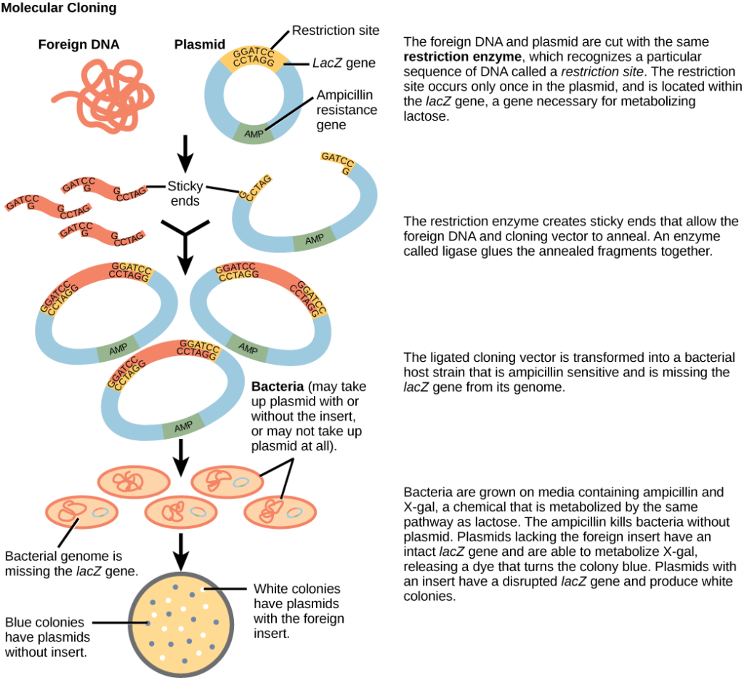
Gene Cloning:

During the initial stage of gene cloning, the target gene or DNA fragment intended for cloning is isolated using various methods. One commonly employed approach is the Polymerase Chain Reaction (PCR), which relies on sequence-specific primers to amplify the desired DNA fragments from sources such as extracted genomic DNA, RNA, organellar DNA, or gene libraries.

PCR is a powerful molecular biology technique that allows researchers to selectively amplify specific DNA sequences. The process involves the use of heat-stable DNA polymerases, such as Taq polymerase, to repeatedly copy and amplify the target DNA region. By employing sequence-specific primers that bind to the flanking regions of the target gene, PCR ensures the selective amplification of the desired DNA fragment.

The amplified DNA fragments produced by PCR serve as the starting material for the subsequent steps in the gene cloning process. This isolation and amplification of the target gene mediated by polymerases constitute a crucial initial step in gene cloning, enabling researchers to obtain a sufficient amount of the DNA fragment for further cloning procedures.

