**Optimization using RSM and partial purification of lipase from oil contaminated soil samples**

**Dr. P. Joyruth1 and Dr. Lali Growther2**

1. **Assistant Professor, Department of Microbiology, The American College, Madurai.**
2. **Professor and Head, PG and Research Department of Microbiology, Hindusthan College of Arts and Science, Coimbatore.**

**Abstract:**

Enzymes are protein with highly catalytic functions and produced by all living organisms. Commonly occurring natural enzymes are lipase, lactase, amylase and cellulase. Lipases catalyze the hydrolysis and acyl glycerol synthesis. Forty-eight strains were identified from oil contaminated soil samples. Out of forty – eight isolates fifteen organisms form clear halo zone around the colonies. Maximum activity of pH 8 was noted for *Acinetobacter indicus*. *Acinetobacter indicus* obtained maximum activity at 24hrs with 17.96U/ml. Glucose andpeptone confirmed the maximum activity of enzyme. CaCl2 obtained maximum activity of lipase for the isolates. DEAE Cellulose column chromatography produced the activity of 720U/g with purification fold of 7.81 and a yield of 20.5% for *Acintobacter indicus*. The molecular weight of lipase produced by *Acinetobacter indicus* was 60KDa.

**Keywords**: Enzyme, Lipase, Optimization, Chromatography, Molecular weight

1. **Introduction**

Enzymes are chemical catalysts and used for biotechnological applications. They are eco – friendly and gaining interest in industries in recent period. Based on report, market of enzyme revenue reach $ 20.31 billion by 2028 (https//www.grandview research.com/accessed on Nov 21, 2022). Enzymes are produced by fermentation of bio – based sources. Enzymes are applicable in various industries such as textiles, pharmaceutical, dairy, cosmetic, detergents and in synthesis of agro – chemical. Commonly occurring natural enzymes are lactase, amylase, cellulase and lipase. Microbial lipases are important because of their unique properties and produce bulk extracellular lipase. Example of bacteria that produce lipase includes *Bacillus, Serratia, Pseudomonas, Halomonas, Staphylococcus* etc., and fungi include *Rhizopus, Penicillium, Aspergillus* etc., Lipase (EC 3.1.1.3), catalyze the hydrolysis and acylglycerol synthesis. Availability of lipase are increased due to the achievement in cloning and expression of enzymes from microorganism and also having specific properties such as specificity, pH, temperature, stability. Organisms grown in tributyrin agar lacking Victoria Blue B produce clear zone around colonies that indicate production of lipase. In presence of Victoria blue B, lipolytic colonies produce dark zone against light blue background.

Lipases are produced by both solid state and sub merged fermentation. Submerged fermentation is favorable than solid state fermentation for enzyme production and microbial cells are distributed evenly throughout the medium in submerged fermentation. Growth of organism in nutrient enriched liquid medium is easy for sterilization. Production has been reported as batch, repeated-batch, fed batch and continuous fermentation. Media contain carbon, nitrogen, phosphorous sources and mineral salts are necessary for production of lipase. Optimization of fermentation medium and process is important to increase the profit.

RSM uses statistical experiment design such as Box – Behnken Design (BBD), Central Composite Design (CCD). Central composite design obtained by addition of points to estimate interaction effects and curvature. RSM can be combined with CCD, so designed the experiments by CCD and optimized by RSM. Activities of lipases were determined spectrometrically at 30 °C using p-nitrophenol palmitate as substrate. Lipase activities were performed by titrimetrically using olive oil hydrolysis. Several techniques are reported for purification of lipases such as hydrophobic interaction chromatography, precipitation, gel filtration, ion exchange chromatography and affinity chromatography. Purified Protein samples are important before determining protein properties and activities. These methods help to understand the functions of enzyme. In extracellular lipases, first step in purification is removal of cells by filtration or centrifugation. Cell lysis is needed additionally, if it is intracellular lipases. After precipitation ion exchange chromatography and gel filtration are preferred. For effective purification ion exchange chromatography or hydrophobic interaction chromatography are used. Extracellular lipases produced by *Rhizopus oryzae* are purified by ammonium sulfate precipitation, Sephadex G-75 gel filtration, sulfopropyl-sepharose chromatography and second sulfo-propyl-sepharose chromatography. Strategies of purification involve rapid, inexpensive, high yielding and amendable to large scale of operation.

1. **Materials and Methods**
   1. **Sample collection and molecular characterization**

Soil samples were aseptically collected from oil factories in Salem, Vellore, Peelamedu and Namakkal. The diluted samples were cultured on tributyrin agar plates by spread plate methods for isolation of bacteria after 24 hours of incubation. Clear zone forming colonies are lipase producers. Molecular characterization was determined by 16S rRNA gene sequencing, BLAST search analysis and construction of phylogentic tree was proceed by following standard methods. 16S r RNA sequencing was carried at MACROGEN, Korea. Similar sequences in BLAST program were retrieved and aligned with multiple alignment programs CLUSTAL W. The multiple alignment file was then used to create Boot – strapping tree using MEGA version 6 software.

* 1. **Identification of lipase gene from bacterial strains**

Genomic DNA from *Acinetobacter indicus* wasextractedand amplified the lipase gene by PCR.

* 1. **Production of enzyme under submerged fermentation (SMF)**

Among forty – eight isolates, sixteen positive bacterial strains were cultivated in production media for enzyme production. Media consists of 3% yeast extract, 3% Sucrose, 0. 1 g (g/l) CaSo4, 0. 5 g/l-KH2PO4, 0. 1g/l- MgSo4.7H2O, 1% olive oil and 100 ml of distilled water in 250ml conical flask. Inoculated flask was incubated at 37°C for 24-48 hours.

**Lipase assay**

Lipase activity was demonstrated spectrophotometrically at 30 °C by using p-nitrophenol palmitate (PNPP) as substrate. The absorbance was measured at 410 nm for first 2 minutes of reaction. One unit was defined as that amount of enzyme liberated 1µmol of PNP per minute.

**Effect of physico-chemical parameters**

The culture sample was optimized at different physico – chemical parameters such as temperature (20°C - 50°C), pH (4 -8), Incubation period (12 – 60hrs), Carbon sources (Glucose, sucrose, lactose, mannitol and maltose), Nitrogen sources (Casein, yeast extract, albumin, peptone and urea), metal ions (CaCl2, FeSO4, MgSO4, NaCl2 and ZnCl2), natural oils (Coconut oil, Castor oil, Groundnut oil and Neem oil), Surfactants (Tween 20, 40, 60, 80, 100, Triton X – 100 and SDS).

The lipase enzyme production was done by culturing the organisms in medium with optimized conditions. After culture, the supernatant was collected and tested the lipase activity to confirm the highest production of lipase.

* 1. **Statistical analysis of optimization factors**
     1. **Modeling by Response surface methodology (RSM)**

RSM is the statistical method for modeling the optimization to identify the interaction between one or more response parameters. RSM is use to study the combined effects of medium components and optimize the parameters in fermentation process.

**Selection of parameters for central composite design**

Using submerged fermentation, optimization of lipase depends on various factors such as temperature, pH, incubation time, moisture and chemical factors. The present study was based on central composite design (CCD) of response surface methodology (RSM), to perform response surface model.

**Statistical analysis**

The interaction terms on response and effect of parameters were studied by Analysis of Variance (ANOVA) and significance test to check the model adequacy. The analysis was made through surface plot using MINITAB 14 software.

**Enzyme purification**

Lipase enzyme was purified by different steps like ammonium sulfate precipitation, dialysis, and DEAE-Cellulose column chromatography. After each step, observed the lipase activity, protein estimation by Lowry’s method, specific activity and fold purification. The purification steps were carried out at 4°C

**Ammonium sulfate precipitation**

The crude enzyme was precipitated by ammonium sulfate at 30 - 70% saturation and then kept undisturbed for overnight at 4°C. The precipitate was collected by centrifugation at 15,000rpm for 15 minutes. The pellet obtained was dissolved in minimal volume of 10mM Tris HCL buffer at pH 7.5.

**Dialysis against buffer**

The pellet obtained after ammonium sulfate precipitation was dissolved in 10mM Tris HCl buffer at pH 7.5 and introduced into pre-treated dialysis bag and placed in 10mM Tris-HCl buffer and dialyzed overnight at 4°C. Then the lipase assay and estimation of protein by Lowry’s method were done to this sample.

* 1. **DEAE - Cellulose column chromatography**

Solution of dialysis contains both soluble and insoluble materials. This was centrifuged to remove insoluble material. The supernatant was applied to DEAE - Cellulose column (2.4x45 cm), equilibrated with 10 mM Tris HCl buffer, pH 7.5. Then it was eluted with 10mM Tris HCl buffer. The flow rate was adjusted to 0.5ml/min. About fifteen fractions were collected at a rate of 10ml/hr. The protein estimated by Lowry’s method and enzyme assay was performed to each fraction. The lipase which showed highest enzyme activity was pooled and stored at 4°C and used as the purified lipase.

**Estimation of protein**

Quantitative estimation of the protein content obtained after different steps were done by Lowry *et al.,* method.

* 1. **Determination of molecular weight by SDS-PAGE**

The molecular weight of the partially purified lipase from ammonium sulfate precipitation and dialysis was checked by SDS. **Result and discussion**

* 1. **Isolation of bacterial species from soil sample**

Totally 10 soil samples were collected from oil factory in Salem, Vellore, Peelamedu and Nammakal. Totally forty – eight bacterial species were isolated using nutrient agar and listed in table no.1.

**Table 1. Isolation of Bacterial species from oil factory**

|  |  |  |  |
| --- | --- | --- | --- |
| **Salem** | **Peelamedu** | **Vellore** | **Namakkal** |
| *Bacillus sp.,* | *Staphylococcus sp.,* | *Micrococcus sp.,* | *Staphylococcus sp.,* |
| *Pseudomonas sp.,* | *Pseudomonas sp.,* | *Staphylococcus sp.,* | *Bacillus sp.,* |
| *Staphylococcus sp.,* | *Klebsiella sp.,* | *Aeromonas sp.,* | *Klebsiella sp.,* |
| *Escherichia coli* | *Bacillus sp.,* | *Bacillus sp.,* | *Arthobacter sp.,* |
| *Proteus sp.,* | *Aeromonas sp.,* | *Escherichia coli* | *Pseudomonas sp.,* |
| *Klebsiella sp.,* | *Lactobacillus sp.,* | *Halomonas sp.,* | *Aeromonas sp.,* |
| *Micrococcus sp.,* | *Serratia sp.,* | *Pseudomonas sp.,* | *Pseudomonas sp.,* |
| *Streptococcus sp.,* | *Micrococcus sp.,* | *Streptococcus sp.,* | *Bacillus sp.,* |
| *Acinetobacter sp.,* | *Bacillus sp.,* | *Serratia sp.,* | *Lactobacillus sp.,* |
| *Staphylococcus sp.,* | Halomonas sp., | *Klebsiella sp.,* | *Serratia sp.,* |
| *Proteus sp.,* | *Enterobacter sp.,* | *Stenotrophomonas sp.,* | *Halomonas sp.,* |
| *Halomonas sp.,* | *Serratia sp.,* | *Enterobacter sp.,* | *Proteus sp.,* |

* 1. **Screening of microorganisms**

All the isolated microorganisms were screened for lipase production using tributyrin agar plates, only sixteen colonies showed clear zone around the colony and were selected for further studies. Clear zone producing strain was shown in figure 1.

**Figure 1. Plate showing clear zone around the colony**

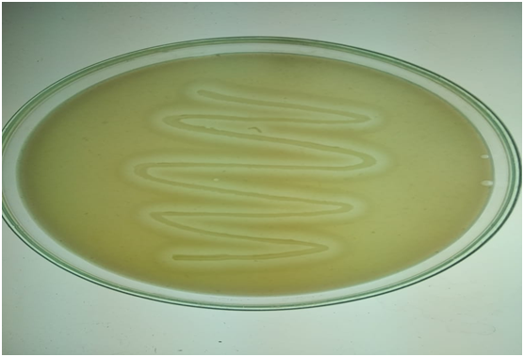

* 1. **Identification of bacterial strains**

Based on colony morphology, cell morphology and studied biochemical test, the isolates were identified (table:2).

**Table 2. Biochemical results for isolated organisms**

|  |  |  |  |  |  |  |  |  |  |  |  |  |  |  |
| --- | --- | --- | --- | --- | --- | --- | --- | --- | --- | --- | --- | --- | --- | --- |
| **S.No** | **Isolates** | **Gram staining** | **Motility test** | **Indole test** | **MR test** | **VP test** | **Citrate test** | **Catalase test** | **Oxidase test** | **Urease test** | **Carbohydrate Fermentation test** | | | |
|  | | | | | | | | | | | Sucrose | Maltose | Lactose | Fructose |
| 1 | *Bacillus sp.,* | + | + | _ | _ | + | + | + | _ | _ | + | + | - | + |
| 2 | *Pseudomonas sp.,* | - | + | - | _ | _ | + | + | + | _ | _ | _ | ­_ | _ |
| 3 | *Staphylococcus sp.,* | + | _ | _ | + | + | + | + | _ | + | + | + | + | + |
| 4 | *Klebsiella sp.,* | - | - | - | - | + | + | + | - | + | + | + | + | _ |
| 5 | *Proteus sp.,* | - | + | - | + | _ | + | + | - | + | _ | _ | _ | _ |
| 6 | *Serratia sp.,* | - | + | - | - | + | + | + | - | + | + | + | _ | + |
| 7 | *Lactobacillus sp.,* | + | - | - | + | - | - | - | + | - | + | + | + | + |
| 8 | *Streptococcus sp.,* | + | - | - | - | - | - | - | - | - | + | + | + | + |
| 9 | *Aeromonas sp.,* | - | + | + | - | + | + | + | + | - | + | + | _ | + |
| 10 | *Micrococcus sp.,* | + | - | - | - | - | - | + | + | + | _ | _ | _ | _ |
| 11 | *Arthrobacter sp.,* | + | - | - | - | - | - | + | - | -- | + | _ | + | _ |
| 12 | *Escherichia coli* | - | + | + | + | - | - | + | - | - | + | _ | + | _ |
| 13 | *Acinetobacter sp.,* | - | - | - | + | - | + | + | - | - |  |  | - |  |
| 14 | *Enterobacter sp.,* | - | + | - | - | + | + | + | - | - | + | + | _ | _ |
| 15 | *Stenotrophomonas sp.,* | - | + | - | - | - | + | + | - | - | _ | _ | + | + |

* 1. **Production of enzyme using submerged fermentation**

From forty- eight organisms, selected fifteen organisms were subjected for production of lipase by submerged fermentation and the activity of enzymes were shown in table 3. Out of fifteen strains, five isolates (*Bacillus sp., Acinetobacter sp., Serratia sp., Enterobacter sp., Stenotrophomonas* sp.,) were able to produce lipase above 11U/ml. *Acinetobacter* sp., were selected for further studies.

**Table 3. Lipase enzyme production in submerged fermentation of selected bacterial strains**

|  |  |  |
| --- | --- | --- |
| **S.No** | **Strains** | **Lipase Activity(U/ml)** |
| 1. | ***Bacillus sp.,*** | **12** |
| 2. | *Staphylococcus sp.,* | 09 |
| 3. | *Escherichia coli* | 05 |
| 4. | *Micrococcus sp.,* | 08 |
| 5. | *Klebsiella sp.,* | 04 |
| **6.** | ***Serratia sp.,*** | **13** |
| 7. | *Proteus sp.,* | 10 |
| 8. | *Pseudomonas sp.,* | 10 |
| **9.** | ***Enterobacter sp.,*** | **12** |
| 10. | *Aeromonas sp.,* | 07 |
| 11. | *Pseudomonas sp.,* | 11 |
| 12. | *Micrococcus sp.,* | 05 |
| **13.** | ***Acinetobacter sp.,*** | **15** |
| 14. | *Lactobacillus sp.,* | 09 |
| **15.** | ***Stenotrophomonas sp.,*** | **14** |

* 1. **Strain Identification with 16S r RNA**
     1. **Characteristics of lipase producing bacteria**

The enzyme assay revealed that among forty-eight isolates, five isolates (*Bacillus sp., Acinetobacter sp., Enterobacter sp., Serratia sp., Stenotrophomonas* sp.,) were found to be more potent for the production of lipase enzyme. The sequences were deposited in Genbank with accession number for Acinetobacter indicus was MW362187.

* + 1. **Phylogenetic analysis of the isolates**

The phylogenetic tree of isolates belonging to genera was constructed by Maximum Likelihood method. Scale bar of *Acinetobacter indicus* (0.0020 substitutions/site with identity 99%).

**Fig.No:2 - Phylogenetic Tree – *Acinetobacter Indicus***



* 1. **Effect of various physico – chemical parameters**

Maximum lipase activity was observed at 40°C by *Acinetobacter indicus.* Some microorganisms such as *Bacillus cereus* shows, 30°C as the optimum temperature for growth and production of lipase. Effect of temperature on lipase activity was optimized by incubated in different temperature (30°C - 45°C) and obtained 13.07U/g ds at 40°C in 48hrs.

Maximum activity of pH 8 was noted for *Acinetobacter indicus*. Bacteria prefer a pH around 7 for best growth and lipase production. Akila Rajan and Jayakumaran Nair, 2011, reported that maximum lipase enzyme activity was observed at pH 8.5, for both submerged and solid-state fermentation. The changes in pH of medium depend on products of metabolism, medium composition and end – product of their metabolism.

*Acinetobacter indicus* obtained maximum activity at 24hrs with 17.96U/ml. *Aspergillus costaricaensis* obtain maximum lipase activity at 48hrs of the incubation period. Activity of lipase decreases in longer incubation period due to accumulation of toxic end products, nutritional depletion and pH changes in medium. Production of enzyme begins from the second day of fermentation and maximum lipase activity was observed in log phase of growth.

**Table 4. Effect of incubation period on enzymatic activity**

|  |  |
| --- | --- |
| **Incubation periods** | ***Acinetobacter indicus***  **(U/ml)** |
| 12hrs | | 13.06±0.3 |
| 18hrs | | 14.93±0.7 |
| 24hrs | | 17.96±0.7 |
| 48hrs | | 14.86±0.8 |
| 60hrs | | 10.2±0.5 |

Glucose as sole carbon sources for *Acinetobacter indicus,* Glucose is beneficial carbon sources that enhance the maximum production of cold active lipase. Carbon sources provide maintenance of cellular functions and growth such as enzyme production. Carbon source from saccharides influenced the enzyme production.

Peptone confirmed the maximum activity of nitrogen sources. Peptone as nitrogen sources increased the production of lipases in *Pseudomonas* LSK25. CaCl2 obtained maximum activity of lipase for *Acinetobacter indicus* with 27U/ml, Metal ions form complexes ionized fatty acids and alter the solubility and behavior at oil – water interfaces, so inhibit enzyme activity. The addition of Ca2+ resulted in maximum production of lipase in 2%

**Table 5. Effect of metal ions on lipase activity**

|  |  |
| --- | --- |
| **Metal ions** | ***Acinetobacter indicus***  **(U/ml)** |
| **MgSo4** | | **24.9±0.36** |
| **CaCl2** | | **27±0.5** |
| **FeSo4** | | **17.96±0.35** |
| **NaCl2** | | **16.06±0.6** |
| **ZnCl2** | | **16±0.5** |

Maximum activity in presence of olive oil. Olive oil acts as an inducer for lipase production in *Bacillus mycoides* and *Bacillus coagulans*. The presence of olive oil with OD of 1.00 produce maximum lipase activity of 9.50 (U/ml)

Tween 80 showed increased activity of lipase in *Acinetobacter indicus* (30U/ml). The presence of surfactants in medium enhances the secretion of protein, by altering the permeability of cell membranes. The presence of Tween 80 in the medium was obtained best inducer for production of lipase in *Candida rugosa*.

**Table 6. Effect of surfactants on lipase activity**

|  |  |
| --- | --- |
| **Surfactants** | ***Acinetobacter indicus***  **(U/ml)** |
| Tween 20 | | 14.03±0.45 |
| Tween 40 | | 10.2±0.52 |
| Tween 60 | | 19.16±0.56 |
| Tween 80 | | 30±0.2 |
| Tween 100 | | 21.13±0.3 |
| Triton X-100 | | 16±0.5 |
| SDS | | 12.06±0.3 |

* 1. **Optimization of medium for lipase production by the statistical approach**

Optimum concentration of individual factors was obtained by subjecting the significant factors to central composite design (CCD). Using RSM the final medium optimization and interaction among the significant factors were studied. Similar report studied by Kiran *et al.,* 2010. *Pseudomonas aeruginosa* AT10 produce rhamnolipids, by optimizing the culture media using RSM.

**Table 7 ANOVA for response surface model of *Acinetobacter indicus***

|  |  |
| --- | --- |
| **Term** | **Lipase activity** |
| *F* value | 33.32 |
| Prob> F | <0.0001 |
| Std.Dev. | 1.22 |
| Mean | 19.35 |
| R2 | 0.9898 |
| Adj.R2 | 0.9601 |
| Ade. precision | 18.1589 |

**Fig. No:3 Response surface graph – *Acinetobacter indicus***

**Interaction effect of Interaction effect of pH Interaction effect of Interaction effect of pH**

**pH and Temperature and Incubation period pH and Glucose ( *P – 0.0359*) and Peptone**

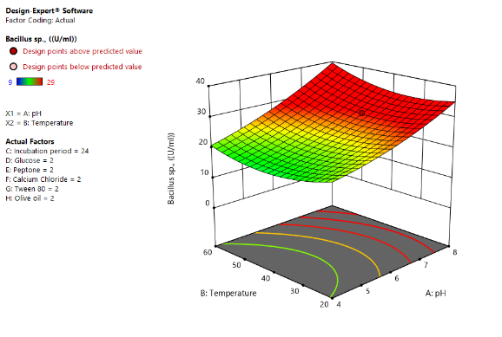 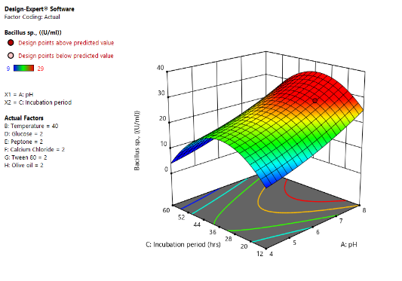 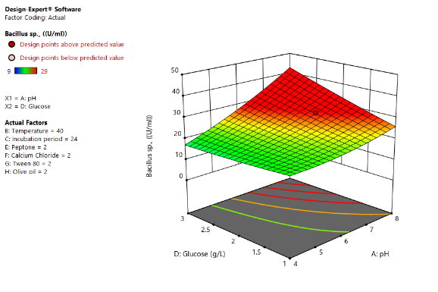 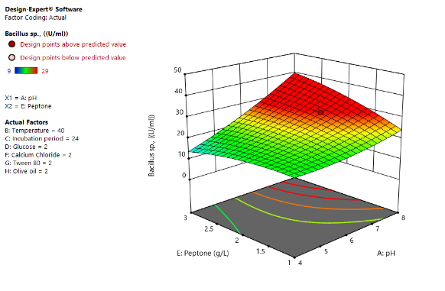

**Interaction effect of pH Interaction effect of pH Interaction effect of Interaction effect of Temperature**

**and Calcium chloride and Tween 80 Olive oil and pH and Incubation period**

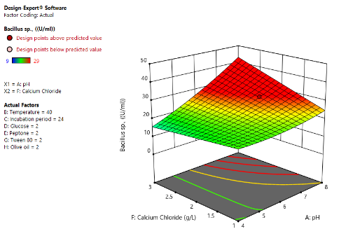 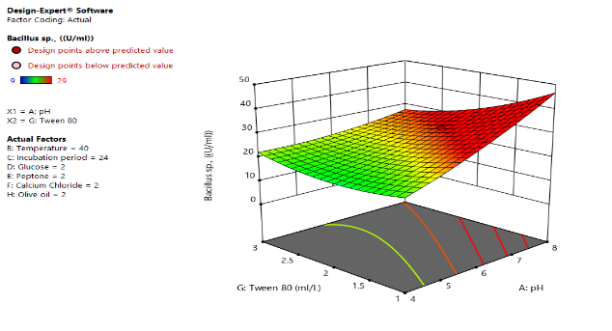 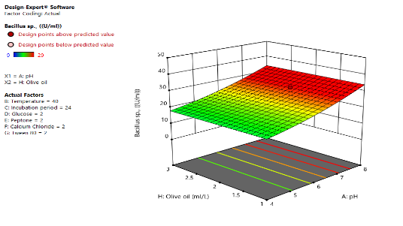 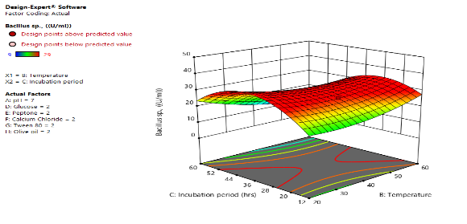

**Interaction effect of Interaction effect of Peptone Interaction effect of Cacl2 Interaction effect of**

**Temperature and Glucose and Temperature and Temperature Tween 80 and Temperature**

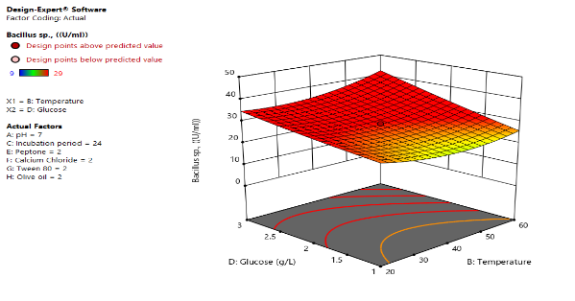 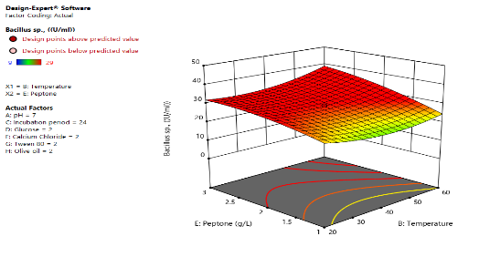 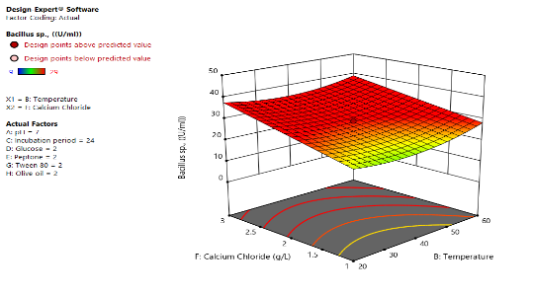 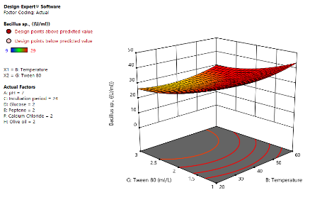

**Interaction effect of Olive Interaction effect of Glucose Interaction effect of Peptone Interaction effect of Cacl2**

**oil and Temperature and Incubation period and Incubation period and Incubation period**

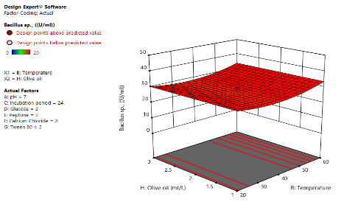 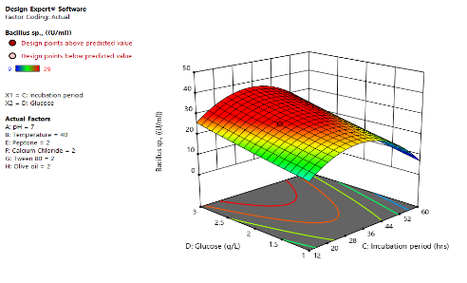 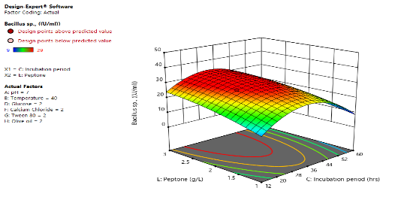 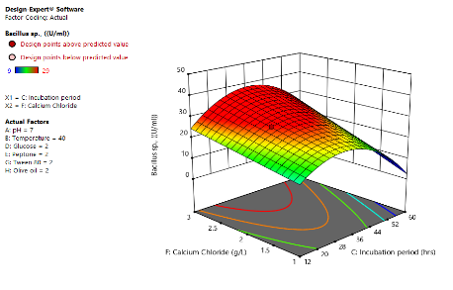

**Interaction effect of Tween 80 Interaction effect of Olive oil Interaction effect of Interaction effect of**

**and Incubation period and Incubation period Peptone and Glucose Glucose and Cacl2**

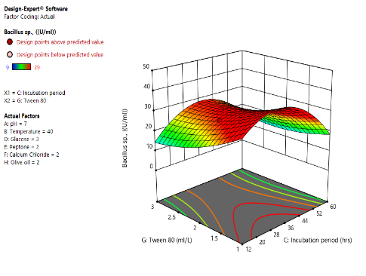 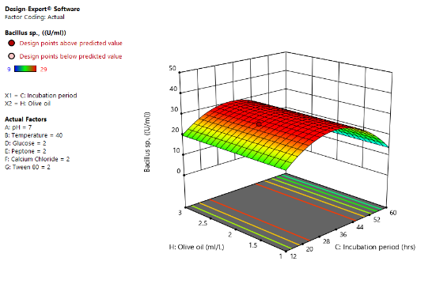 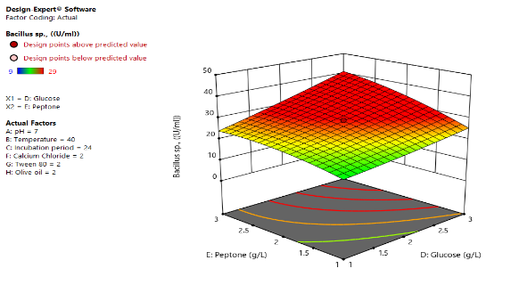 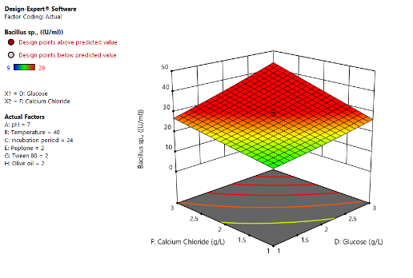

**Interaction effect of Interaction effect of Interaction effect of Interaction effect of**

**Tween 80 and Glucose Olive oil and Glucose Cacl2 and Peptone Tween 80 and Peptone**

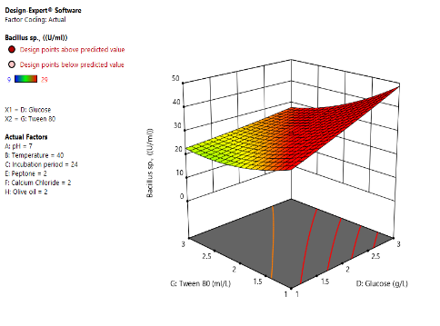 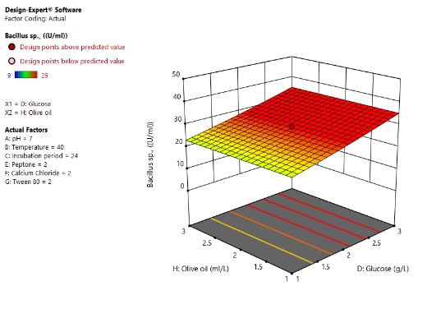 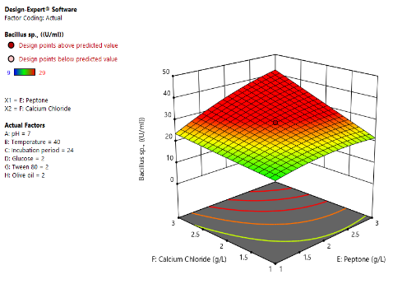 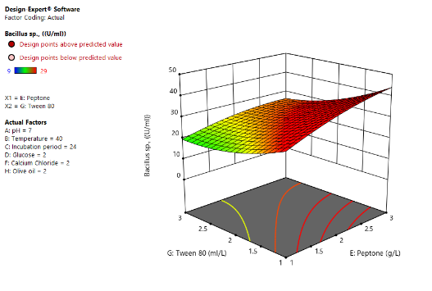

**Interaction effect of Interaction effect of Interaction effect of Interaction effect of**

**Olive oil and Peptone Tween 80 and Cacl2 Cacl2 and Olive oil Olive oil and Tween 80**

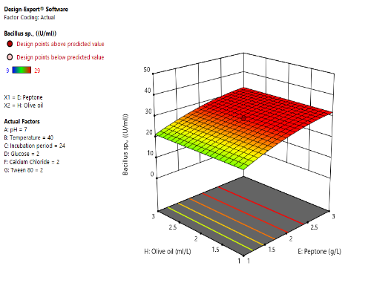 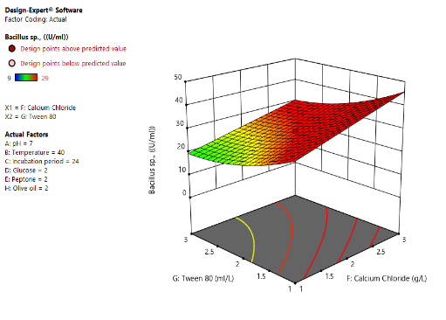 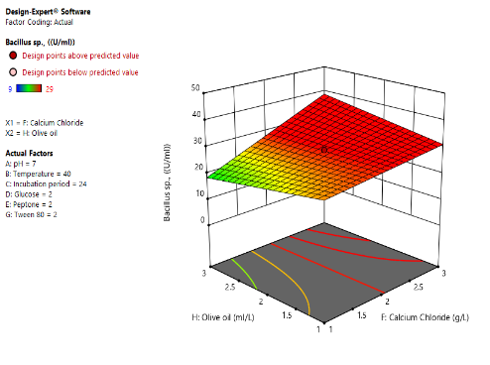 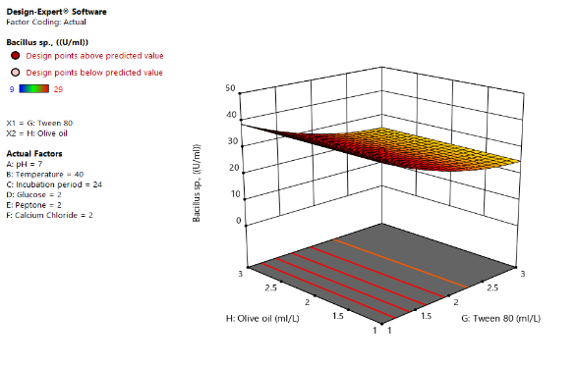

* 1. **Purification of lipase**

The enzyme was purified by Ammonium sulphate precipitation, dialysis, DEAE – cellulose column chromatography and SDS – PAGE.

* + 1. **Ammonium sulfate precipitation**

Maximum production of lipase was 47U/ml obtained by *Acinetobacter indicus* with 40% concentration of Ammonium sulfate precipitation. *Bacillus* *stearothermophilus* shows 40% of Ammonium sulfate precipitation produce high amount of activity, with 1.03 purification fold.

**Table 8. Lipase activity in Ammonium Sulfate precipitation**

|  |  |  |
| --- | --- | --- |
| **Concentration of Ammonium sulfate** | ***Acinetobacter indicus*** | |
| **Lipase Activity (U/ml)** | **Protein (mg/ml)** |
| 30% | 45 | 0.21 |
| **40%** | **47.58** | **0.40** |
| 50% | 41 | 0.30 |
| 60% | 40.5 | 0.24 |
| 70% | 39 | 0.22 |

* + 1. **Dialysis**

Dialysis has increased the activity to 47.58U/ml in *Acinetobacter indicus*

* + 1. **DEAE – Cellulose column chromatography**

DEAE – Cellulose column chromatography has increased the activity to 55U/ml for *Acinetobacter indicus*.

In *Acinetobacter indicus,* the crude enzyme showed the specific activity of 72.31U/ml, Ammonium sulphate precipitation has increased the activity to 75.80U/ml with purification fold of 1.048 and yield of 67.14. Dialysis has increased the activity to 92.18U/ml with a purification fold of 1.21 and yield of 42.14%. DEAE – Cellulose column chromatography has increased the activity to 720U/ml with purification fold of 7.81 and yield of 20.5%. The result was tabulated in table no 9. Joseph *et al.,* 2011, reported that DEAE – Cellulose column chromatography obtained 35.64-fold purification with specific activity of 93.38U/mg.

**Table 9. Purification of lipase enzyme from *Acinetobacter indicus***

|  |  |  |  |  |  |  |  |  |
| --- | --- | --- | --- | --- | --- | --- | --- | --- |
| **Fractions** | **Total volume (ml)** | **Activity (U/ml)** | **Protein (mg/ml)** | **Total protein (mg)** | **Total activity (U)** | **Specific Activity (U/ml)** | **Purification (Fold)** | **Recovery (%)** |
| Culture filtrate | 100 | 35 | 0.484 | 48.4 | 3500 | 72.31 | 1 | 100 |
| Ammonium sulphate | 50 | 47 | 0.310 | 31.0 | 2350 | 75.80 | 1.048 | 67.14 |
| Dialysis | 25 | 59 | 0.200 | 20.0 | 1475 | 92.18 | 1.21 | 42.14 |
| DEAE cellulose chromatography | 10 | 72 | 0.100 | 1.0 | 720 | 720 | 7.81 | 20.5 |

* 1. **SDS – PAGE**

The molecular weight of lipase produced by *Acinetobacter indicus* was 60 KDa. Lipase isolated mostly from *Aspergillus* sp., have molecular weight of 25 to 70KDa reported by Contesini *et al.,* 2010. Due to glycosylation of purified protein separated by SDS – PAGE. Lipase from *E. nidulans* NFCCI3643 have a molecular weight around 54KDa. Hu *et al.*, 2018 observed the molecular weight of protein in SDS – PAGE was 51KDa.

**Figure 4. Determination of molecular weight (SDS-PAGE)**

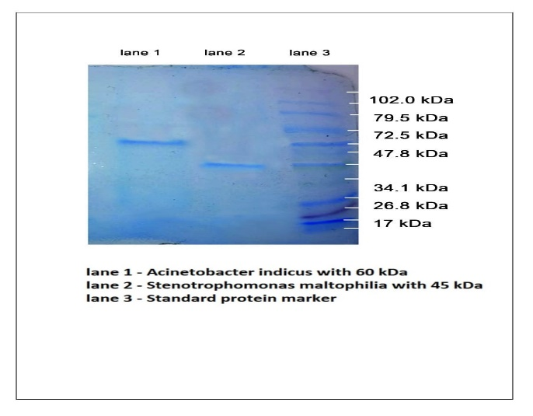

1. **Conclusion**

Oil contaminated soil has a potential application in detergent industries. The enzyme was optimized by various physical parameters. Maximum lipase activity was observed at 40°C at pH 8. Glucose and peptone as sole sources for maximum production of lipase. CaCl2 and Tween 80 showed increased activity of lipase in *Acinetobacter indicus* (30U/ml),Partial purification ofenzyme with ammonium sulfate precipitation, dialysis and DEAE Cellulose column chromatography produced the activity of 720U/g with purification fold of 7.81 and a yield of 20.5%.