3D BIOPRINTING- TRENDS IN FUTURE PHARMACY

Dr Sneha thakur ¹, Dr Kalepu Swathi², Dr Mitta Chaitanya ³,Dr Koduru Swathi⁴,Rushitha Gollapalli⁵

1, - Associate Professor, HOD, Department of Pharmacognosy, St. Pauls college of Pharmacy, Turkayamjal, R.R Dist, Hyderabad-501510, Telangana

2,3,4- Associate Professor, Bojjam Narasimhulu Pharmacy College for Women, Saidabad, Hyderabad-500059

5-Student, Bojjam Narasimhulu Pharmacy College for Women, Saidabad, Hyderabad-500059

Introduction
In order to create complex living tissues and organs with the desired 3D cellular architecture and functions, 3D bioprinting is a computer-aided technology that involves the rapid printing of bio functional materials[1] and their supporting components in a layer-by-layer manner on a substrate or a tissue culture dish. Humans have long aspired to the in vitro biomanufacturing of tissues and organs for two reasons: organ transplantation and precise tissue models. First off, there[2] is a severe lack of organs available for transplant. In 2016, there were only 16000 people donated organs in USA compared to 160,000 organ transplant recipients. It is now far too hopeful to use 3D bioprinting to alleviate the shortage of organ transplants because human organs are so complicated, as demonstrated by the production of duplicates of delicate structures[3] and the biologically mysterious process of organ growth. Second, traditional approaches used for drug monitoring and medical mechanism analysis, such as two-dimensional (2D) cell culture or animal experiments, have many drawbacks. The micro environment [4] Compared to 2D cell culture, where 2D models are used, in vivo is significantly more complex which may produce the [5] opposite outcomes. Furthermore, the interior environments of animals and humans are very [6] different from one another. These elements increase the urgency of the need for more precise[7] in vitro models, which 3D bioprinting is good at. The most ideal method for creating live[8], Now known as 3D bioprinting, which permits spatio-temporal[9] directed manipulation of a range of cells, 3D cell-laden structures in vitro. In a predictable amount of time, 3D bioprinting[10] will undoubtedly play a bigger and bigger part when making organ models in vitro.

3D bioprinting: its history, methodology, and classification
The ability to 3D bioprint (Figure 1) fully functional organs[11] for transplant is currently not very plausible. The fact that bioprinting methods have considerably advanced[12] cannot be disputed, though. Several pioneers, including Thomas Boland, Gabor Forgacs, and Vladimir Mironov, saw the natural fusion of technologies, including cell patterning, with others, such as commercial inkjet printing, decades ago in order to construct living structures that might one day be used in human organ transplantation. The image below shows a chronology of the development of bioprinting technology up to the present.
Extrusion 3Dprinting technology, also known as fused filament fabrication (FFF), is a popular additive manufacturing process that involves the placement of melted thermoplastic materials are arranged in layers. This technology has gained significant attention due to its ability to fabricate complex geometries, high accuracy, and relatively low cost compared to other 3D printing techniques. Firstly, the fundamental principles of extrusion 3D printing, including the types[14] of thermoplastic materials used, extrusion process, and nozzle geometry, will be discussed, Secondly, the different parameters that affect the quality of printed objects such as layer height, printing speed, and nozzle temperature will be explained. Finally, the applications of extrusion 3D printing technology will be highlighted. This includes its use in prototyping, production of low volume parts, and even in medical applications such as the fabrication of prosthetic and implants. In conclusion extrusion 3D printing technology isa promising technology that has the potential to revolutionize many industries and has already made[15] significant contributions to the field of additiv4 manufacturing.
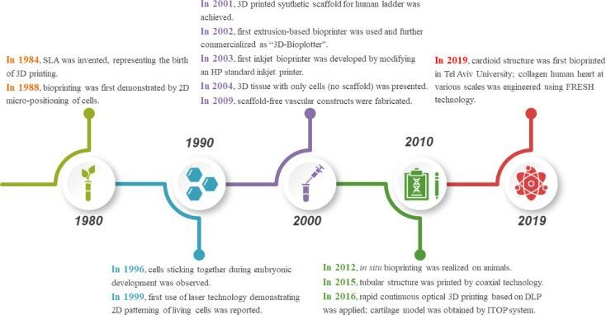
Figure 1: Development of 3D Printing technique[2]
Stereolithography (SLA)[16], which Charles Hull created in 1984 to print 3D objects from digital data, is regarded as the invention that gave rise to 3D printing. In 1988, Klebe used cytoscribing technology to deposit[17] cells on a surface using a conventional Hewlett-Packard (HP) inkjet printer. In order to assess tissue cohesion, Forgacs and colleagues discovered in 1996 that apparent tissue[18] surface tension constituted the macroscopic expression of cellular molecular adhesion. Odde and Renn used laser assisted bioprinting for the first time in 1999 to deposit living cells[19] for creating analogues with intricate anatomical structures. Direct printing of a bladder-shaped scaffold and the seeding of human cells both happened in 2001. Landers et al. described the first extrusion-based bioprinting method in 2002; it was later marketed as "3D-Bioplotter." By adapting[20] an HP ordinary inkjet printer, Boland and Wilson created the inkjet bioprinter introduced in 2003. A year later, their team used a commercial SLA printer to achieve cell-loaded bioprinting[21]. The same year, 3D tissue made entirely of cells— without a scaffold—was created. In order to deposit living cells, electrohydrodynamic jetting was used in 2006. Norotte et al. created[22] scaffold-free vascular tissue in 2009 via bioprinting. Skardal et al. attempted in situ bioprinting[23] in 2012 using mice models. Many other bioprinting items were introduced in the years that followed[24], including artificial livers and articular cartilage in 2012, tissue integration with the circulatory system in 2014, and more. Gao et al. used coaxial technology to create a tubular framework in 2015. Rapid continuous optical 3D printing based on DLP was used by Pyo et al. in 2016[25]. The same year, Anthony Atala's research team used an integrated tissue-organ printer to create a cartilage model (ITOP). Noor and colleagues created a perfusable scale-down heart in 2019[26]. A few months later, Lee et al. used the freeform reversible embedding of suspended hydrogels (FRESH) technique to successfully bioprint collagen human hearts at different scales[27].
There are four steps that make up the 3D bioprinting process:
  - Data acquisition: 3D models can be created directly using computer-aided design (CAD) software or indirectly by scanning and reconstructing objects employing techniques like X-rays, computed tomography (CT), magnetic resonance imaging (MRI), etc. Then, with the aid of specialised software, 2D horizontal slices of the 3D models with customizable size and orientation would be created. The various bioprinting techniques would further transform these data into particles or filaments[28].
  - Material selection: Depending on the needs of printed structures and methodologies, cells, growth agents, hydrogels, and other materials should be carefully chosen. Technically speaking, the concoction of these biomaterials is known as Bioinks.[29], though these are typically just thought of as cell-filled hydrogels. To ensure biocompatibility, printability, and mechanical property, the choice of bioinks is essential as shown in Figure 2
  - Bioprinting: The proper configuration of printing parameters must be checked prior to bioprinting. Additionally, keeping an eye on the printing process is essential for making adjustments when issues arise.[30].
  - Operationalize: Following printing, the goal is to physically and chemically stimulate dispersed cells to link and produce some functions of real tissue or organ.
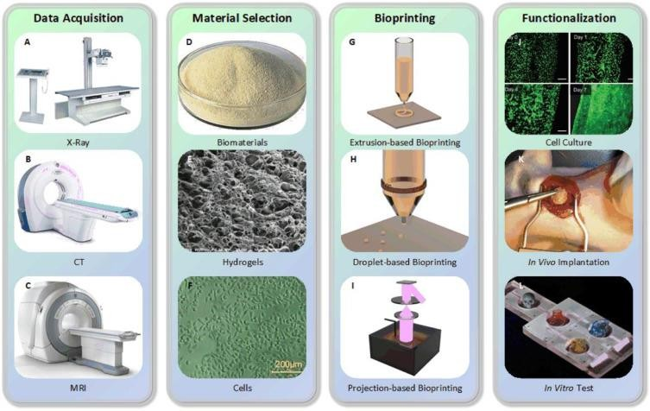
Figure 2: Process of 3D printing
The bioprinting technique (X-ray (A), CT (B), and MRI(C) machines, respectively) Alginate is (D). Image of GelMA captured with a scanning electron microscope (E) (used with permission from WILEYVCH Weinheim-based Verlag GmbH & Co. KGaA Copyright 2018), Human umbilical vein endothelial cells are seen in (F) (HUVECs) (copyrighted 2018 WILEYVCH Weinheim-based Verlag GmbH & Co. KGaA)[31]; (G) The principle of extrusion-based bioprinting, (H) The fundamentals of piezoelectric inkjet bioprinting, (I) Theory of digital light processing (DLP), (J) Blood vessel cultured with endothelial progenitor[32] cells (copied with permission from Gao et al., Copyright 2017), (K) Rats were used for the cardiac patch implantation in-vivo,made using forward transfer mediated by laser (LIFT)[33] ((Reproduced with permission of Elsevier, Copyright 2011), Biochip for in vitro examinations, modified from our unpublished research (L)[34].
Extrusion-based, droplet-based, and photocuring-based bioprinting are the three primary methodologies used in 3D bioprinting[35], which are based on various prototype principles and printing materials. Extrusion-based bioprinting uses continuous filaments made of bioinks to make structures; droplet-based bioprinting[35] creates discrete droplets to stack into structures; and photocuring-based bioprinting uses photocuring materials to solidify and build 3D models layer by layer[36].

Extrusion-based bioprinting:
Because of its adaptability and accessibility, extrusion-based bioprinting, also known as direct ink writing and derived from inkjet printing, is the most popular method of 3D bioprinting[37]. Extrusion-based bioprinting creates ongoing filaments with continuous extrusion force rather than a single droplet. This method can be used to print biomaterials with a wide variety of viscosities and varied cell densities. Extrusion-based bioprinting is preferred by researchers to create tissue architectures with adequate mechanical properties. For a variety of applications, Extrusion-based bioprinting may also be perfectly compatible with coaxial and multi-material printing.

Principles:
Theoretically, extrusion-based bioprinting uses mechanical or pneumatic drive to extrude bioink (often from a syringe) via a nozzle to create continuous micro filaments that are then deposited on a receptive substrate and finally stacked into the required structures. The substrate might be either solid (like a culture dish), liquid (like a growth media), or something made of gel. After configuration[38], software often generates the nozzle's path based on digital models. The final bioprinted structures would be influenced by factors like temperature, nozzle diameter, extrusion pressure, movement speed, extrusion speed, route interval, etc as shown in Figure 3,4
The three major classifications are pneumatic, piston, and screw-driven of popular extrusion-based bioprinting, respectively, based on the various actuating ways of liquid dispensing systems[23].
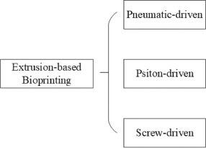
Figure 3: Types of extrusion Printers

Classification of extrusion-based bioprinting:
Pneumatic-driven extrusion:
Compressed air is used by a pneumatically[24] driven extrusion device to achieve liquid dispensing. Typically, It consists of a syringe loaded with bioink and a pipe and adapter connection to an air pump. Because they maintain their filament condition after extrusion, hydrogels with shear-thinning properties function well with pneumatically powered systems. Air from the air pump must be sterilised for pneumatic systems. Therefore, the best strategy to reduce contamination of the bioprinted constructions is to use a filter on the airway.
Additionally, smooth extrusion must be ensured as much as possible, which necessitates the addition of additional liquid or gel-based medium whenever semi-solid or solid state bioink is encountered in order to maximise its viscosity.
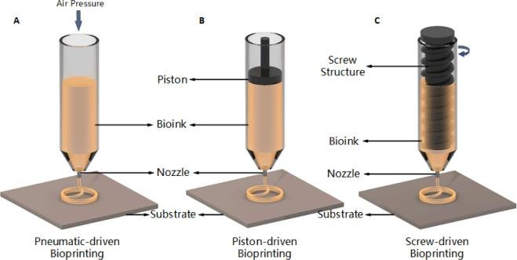

Figure 4: Types of Extrusion Based Printers[6]

Piston-driven extrusion:
Using mechanically driven liquid dispensing devices, biomaterials with a high viscosity, such as man-made or naturally occurring high-molecular polymers, can be extruded more successfully. Piston-driven extrusion is one of them, and the market is flooded with related goods like micro-infusion pumps. The piston and motor are connected in this configuration by a guiding screw. When the motor turns on, the piston[26] converts the spinning motion of the guiding screw into linear motion, which pushes the bioink out of the nozzle to produce filaments.

Screw-driven extrusion:
Screw-driven devices, a different kind of mechanically[25] driven liquid dispensing system, offer more volumetric control and aid in the extrusion of biomaterials with higher viscosities. The operation of a screw-driven system is similar to that of a piston-driven system, with the exception that a screw attached to the motor is used directly for extrusion rather than a piston. Screw-driven devices, however, may inadvertently harm the cell loaded with bioink while also providing increased pressure. Consequently, it is vital to design the screw pieces cautiously. There have also been studies that combine screw- and piston-driven systems. Polycaprolactone (PCL) was originally[21] printed by Visser et al. using a screw-driven method, and later hydrogel was printed on PCL using a piston-driven method. In summary, piston and screw-driven systems offer greater printability and higher resolution with semi-solid- or solid-state biomaterials than pneumatic-driven methods do (For instance, cell aggregates). Contrarily, gadgets using these two techniques have restricted volume, are more difficult to clean and disinfect (especially for screw-driven devices) and cost more.
Using extrusion to create bioprints dependable method for creating biomaterials when the right bioinks are used, notably for the production of hydrogels[18] that are capable of shear-thinning and rapid crosslinking. The final bioprinted formation will be influenced by the extrusion pressure, substrate surface properties, nozzle diameter, bioink viscosity, nozzle movement speed, bioink extrusion speed, and other variables.
Extrusion-based bioprinting is popular among academics worldwide because of its versatility, affordability, and ability to print porous materials.

TRIALS:
The first lab-grown bladder was successfully transplanted into dogs. In the lab, bladder cells were seeded into a mould fashioned like a bladder, where they multiplied and eventually formed an organ. Synthetic bladders typically don't work since they aren't compatible with bodily tissue. Utilizing the urothelial cells that line the inside of the bladder as well as the smooth muscle cells that line the bladder's exterior, bladder[19] was grown in lab. A synthetic human bladder was developed as the first human organ in 1999. Cells from seven spina bifida patients were taken from Wake Forest University School of Medicine in Winston-Salem, North Carolina, and used to generate slender sacs of tissue. An artificial scaffold of a human bladder was created by scientists using building blocks, and it was then covered in human bladder cells, which multiplied to construct a new bladder. They used the patient's cells in order to prevent rejection by the body. The bladder is the only organ(Figure 5) that has been 3D printed[17] and successfully transplanted into a human so far. Luke Massella received it in 2004 to replace his damaged bladder, and since then, there have been no issues related to the transplant. Luke Massella's bladder's cells and tiny scraps were removed by surgeon Anthony Atala at the Boston Children's Hospital to start the process. Atala was able to build a new bladder in a lab using these samples. Later, a 14- hour medical procedure was performed on Atala to implant the artificial bladder.

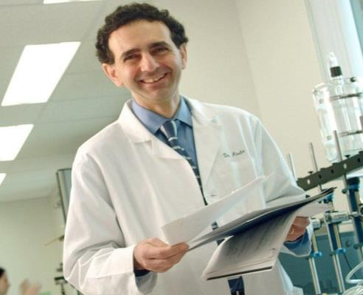
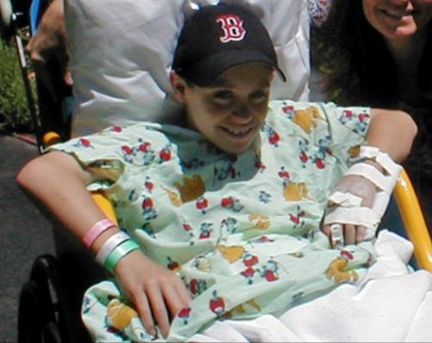

Figure 5: Trials and applications of 3D printing[7]

Applications
The four types of bioprinting applications include cytobiology, drug discovery, tumour models, and regenerative medicine. Cytobiology includes research on fundamental questions regarding cell proliferation, intercellular relationships, and transgenosis. It also encompasses the creation of single cells or multicellular combinations. Pharmacokinetics, drug screening, and auxiliary drug development are all components of drug research. The major goals of a tumour model are the construction of various tumour pathology models, the study of carcinogenesis mechanisms, targeted therapy, and other related activities. Regenerative medicine, which is more closely related to bioprinting[38], entails the production of artificial tissues and organs, including the fabrication of neuronal, cardioid, liver, and other organ tissues, as well as scaled-up tissue vascularization and cell therapy. As we previously indicated, these use cases cover 3D bioprinting broadly as well as in depth.
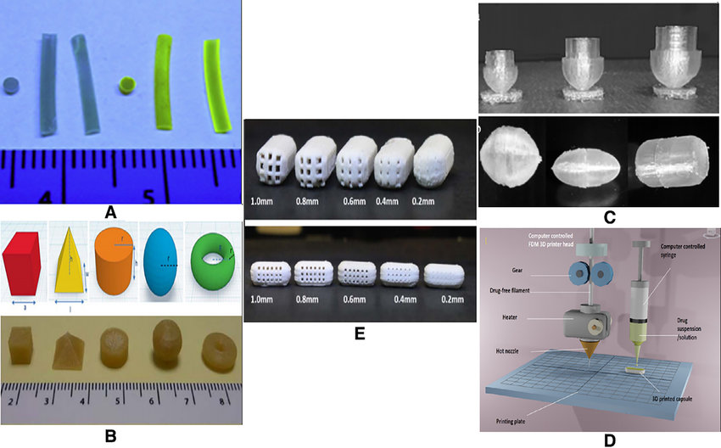

Figure 6: applications of 3D printing in pharmaceutical sector[10]

References

- Wang J, Goyanes A, Gaisford S, Basit AW. Stereolithographic (SLA) 3D printing of oral modified-release dosage forms. Int J Pharm. 2016;503(1–2):207–212. doi: 10.1016/j.ijpharm.2016.03.016. [PubMed] [CrossRef] [Google Scholar]
- 9. Pere CPP, Economidou SN, Lall G, Ziraud C, Boateng JS, Alexander BD, et al. 3D printed microneedles for insulin skin delivery. Int J Pharm. 2018;544:425–32. [PubMed]
- 10. Clark EA, Alexander MR, Irvine DJ, Roberts CJ, Wallace MJ, Sharpe S, Yoo J, Haguea RJM, Tucka CJ, Wildman RD. 3D printing of tablets using inkjet with UV photoinitiation. Int J Pharm. 2017;529(1–2):523–530. doi: 10.1016/j.ijpharm.2017.06.085. [PubMed] [CrossRef] [Google Scholar]
- 11. Kyobula M, Adedeji A, Alexander MR, Saleh E, Wildman R, Ashcroft I, Gellerte PR, Roberts CJ. 3D inkjet printing of tablets exploiting bespoke complex geometries for controlled and tuneable drug release. J Control Release. 2017;261(March):207–215. doi: 10.1016/j.jconrel.2017.06.025. [PubMed] [CrossRef] [Google Scholar]
- 12. Jamróz W, Kurek M, Łyszczarz E, Szafraniec J, Knapik-Kowalczuk J, Syrek K, Paluch M, Jachowicz R. 3D printed orodispersible films with aripiprazole. Int J Pharm. 2017;533(2):413–420. doi: 10.1016/j.ijpharm.2017.05.052. [PubMed] [CrossRef] [Google Scholar]
- 13. Arafat B, Wojsz M, Isreb A, Forbes RT, Isreb M, Ahmed W, Arafat T, Alhnan MA. Tablet fragmentation without a disintegrant: a novel design approach for accelerating disintegration and drug release from 3D printed cellulosic tablets. Eur J Pharm Sci. 10.1016/j.ejps.2018.03.019. [PubMed]
- 14. Li Q, Guan X, Cui M, Zhu Z, Chen K, Wen H, Jia D, Hou J, Xu W, Yang X, Pan W. Preparation and investigation of novel gastro-floating tablets with 3D extrusion-based printing. Int J Pharm. 2018;535(1–2):325–332. doi: 10.1016/j.ijpharm.2017.10.037. [PubMed] [CrossRef] [Google Scholar]
- 15. Khaled SA, Burley JC, Alexander MR, Yang J, Roberts CJ. 3D printing of tablets containing multiple drugs with defined release profiles. Int J Pharm. 2015;494:643–50. [PubMed]
- 16. Huang W, Zheng Q, Sun W, Xu H, Yang X. Levofloxacin implants with predefined microstructure fabricated by three-dimensional printing technique. Int J Pharm. 2007;339(1–2):33–38. doi: 10.1016/j.ijpharm.2007.02.021. [PubMed] [CrossRef] [Google Scholar]
- Lamichhane, S., Bashyal, S., Keum, T., Noh, G., Seo, J. E., Bastola, R., … Lee, S. (2019). Complex formulations, simple techniques: Can 3D printing technology be the Midas touch in pharmaceutical industry? Asian Journal of Pharmaceutical Sciences. doi:10.1016/j.ajps.2018.11.008
- Gioumouxouzis CI, Tzimtzimis E, Katsamenis OL, et al. Fabrication of an osmotic 3D printed solid dosage form for controlled release of active pharmaceutical ingredients. European Journal of Pharmaceutical Sciences. 2020;143:105176. doi:10.1016/j.ejps.2019.105176
- Reddy Dumpa N, Bandari S, A. Repka M. Novel Gastroretentive Floating Pulsatile Drug Delivery System Produced via Hot-Melt Extrusion and Fused Deposition Modeling 3D Printing. Pharmaceutics. 2020;12:52. doi:10.3390/pharmaceutics12010052
- Chatzitaki A-T, Tsongas K, Tzimtzimis EK, et al. 3D printing of patient-tailored SNEDDS-based suppositories of lidocaine. Journal of Drug Delivery Science and Technology. 2021;61:102292. doi:10.1016/j.jddst.2020.102292
- Krause J, Müller L, Sarwinska D, et al. 3D Printing of Mini Tablets for Pediatric Use. Pharmaceuticals. 2021;14:143. doi:10.3390/ph14020143
- Wang J, Zhang Y, Aghda NH, et al. Emerging 3D printing technologies for drug delivery devices: Current status and future perspective. Advanced Drug Delivery Reviews. 2021;174:294–316. doi:10.1016/j.addr.2021.04.019
- Khaled SA, Burley JC, Alexander MR, et al. 3D printing of five-in-one dose combination polypill with defined immediate and sustained release profiles. Journal of Controlled Release. 2015;217:308–14. doi:10.1016/j.jconrel.2015.09.028
- Khaled SA, Burley JC, Alexander MR, et al. 3D printing of tablets containing multiple drugs with defined release profiles. International Journal of Pharmaceutics. 2015;494:643–50. doi:10.1016/j.ijpharm.2015.07.067
- Sadia M, Isreb A, Abbadi I, et al. From ‘fixed dose combinations’ to ‘a dynamic dose combiner’: 3D printed bi-layer antihypertensive tablets. European Journal of Pharmaceutical Sciences. 2018;123:484–94. doi:10.1016/j.ejps.2018.07.045
- Genina N, Boetker JP, Colombo S, et al. Anti-tuberculosis drug combination for controlled oral delivery using 3D printed compartmental dosage forms: From drug product design to in vivo testing. Journal of Controlled Release. 2017;268:40–8. doi:10.1016/j.jconrel.2017.10.003
- Robles-Martinez P, Xu X, Trenfield SJ, et al. 3D Printing of a Multi-Layered Polypill Containing Six Drugs Using a Novel Stereolithographic Method. Pharmaceutics. 2019;11:274. doi:10.3390/pharmaceutics11060274
- Gioumouxouzis CI, Baklavaridis A, Katsamenis OL, et al. A 3D printed bilayer oral solid dosage form combining metformin for prolonged and glimepiride for immediate drug delivery. European Journal of Pharmaceutical Sciences. 2018;120:40–52. doi:10.1016/j.ejps.2018.04.020
- Seoane-Viaño I, Ong JJ, Luzardo-Álvarez A, et al. 3D printed tacrolimus suppositories for the treatment of ulcerative colitis. Asian Journal of Pharmaceutical Sciences. 2021;16:110–9. doi:10.1016/j.ajps.2020.06.003
- Yang Y, Xu Y, Wei S, et al. Oral preparations with tunable dissolution behavior based on selective laser sintering technique. International Journal of Pharmaceutics. 2021;593:120127. doi:10.1016/j.ijpharm.2020.120127
- Lin X, Fu H, Hou Z, et al. Three-dimensional printing of gastro-floating tablets using polyethylene glycol diacrylate-based photocurable printing material. International Journal of Pharmaceutics. 2021;603:120674. doi:10.1016/j.ijpharm.2021.120674
- Li Q, Guan X, Cui M, et al. Preparation and investigation of novel gastro-floating tablets with 3D extrusion-based printing. International Journal of Pharmaceutics. 2018;535:325–32. doi:10.1016/j.ijpharm.2017.10.037
- Xu X, Goyanes A, Trenfield SJ, et al. Stereolithography (SLA) 3D printing of a bladder device for intravesical drug delivery. Materials Science and Engineering: C. 2021;120:111773. doi:10.1016/j.msec.2020.111773
- Liang K, Carmone S, Brambilla D, et al. 3D printing of a wearable personalized oral delivery device: A first-in-human study. Sci. Adv. 2018;4. doi:10.1126/sciadv.aat2544
- Alhnan MA, Okwuosa TC, Sadia M, et al. Emergence of 3D Printed Dosage Forms: Opportunities and Challenges. Pharm Res. 2016;33:1817–32. doi:10.1007/s11095-016-1933-1
- Awad A, Trenfield SJ, Pollard TD, et al. Connected healthcare: Improving patient care using digital health technologies. Advanced Drug Delivery Reviews. 2021;178:113958. doi:10.1016/j.addr.2021.113958
- Norman J, Madurawe RD, Moore CMV, et al. A new chapter in pharmaceutical manufacturing: 3D-printed drug products. Advanced Drug Delivery Reviews. 2017;108:39–50. doi:10.1016/j.addr.2016.03.001
- Trenfield SJ, Awad A, McCoubrey LE, et al. Advancing pharmacy and healthcare with virtual digital technologies. Advanced Drug Delivery Reviews. 2022;182:114098. doi:10.1016/j.addr.2021.114098
- Spritam (levetiracetam); full prescribing information. Spritam. 2015.https://spritam.com/#/hcp/zipdose-technology/manufactured-using-3d-printing. (accessed Mar 2022).
- TRIASTEK RECEIVES FDA IND CLEARANCE FOR 3D PRINTED DRUG TO TREAT RHEUMATOID ARTHRITIS. 3D Printing Industry. 2021.https://3dprintingindustry.com/news/triastek-receives-fda-ind-clearance-for-3d-printed-drug-to-treat-rheumatoid-arthritis-184159/ (accessed Mar 2022).
- Zheng Y, Deng F, Wang B, et al. Melt extrusion deposition (MEDTM) 3D printing technology – A paradigm shift in design and development of modified release drug products. International Journal of Pharmaceutics. 2021;602:120639. doi:10.1016/j.ijpharm.2021.120639
- Consultation on Point of Care manufacturing. Gov.uk. 2021.https://www.gov.uk/government/consultations/point-of-care-consultation/consultation-on-point-of-care-manufacturing (accessed Mar 2022).
- Elbadawi M, Gustaffson T, Gaisford S, et al. 3D printing tablets: Predicting printability and drug dissolution from rheological data. International Journal of Pharmaceutics. 2020;590:119868. doi:10.1016/j.ijpharm.2020.119868
- Elbadawi M, McCoubrey LE, Gavins FKH, et al. Harnessing artificial intelligence for the next generation of 3D printed medicines. Advanced Drug Delivery Reviews. 2021;175:113805. doi:10.1016/j.addr.2021.05.015
- Elbadawi M, Muñiz Castro B, Gavins FKH, et al. M3DISEEN: A novel machine learning approach for predicting the 3D printability of medicines. International Journal of Pharmaceutics. 2020;590:119837. doi:10.1016/j.ijpharm.2020.119837

