WATER FOOTPRINT: MAKING THE INVISIBLE VISIBLE
Afreen Fatima*, Apoorva Singh Parihar, Sadanand Yadav, Deepa Srivastava
Department of Chemistry, C.M.P Degree College, University of Allahabad
211002, U.P, India
E-mail-afreenfatimaau06@gmail.com

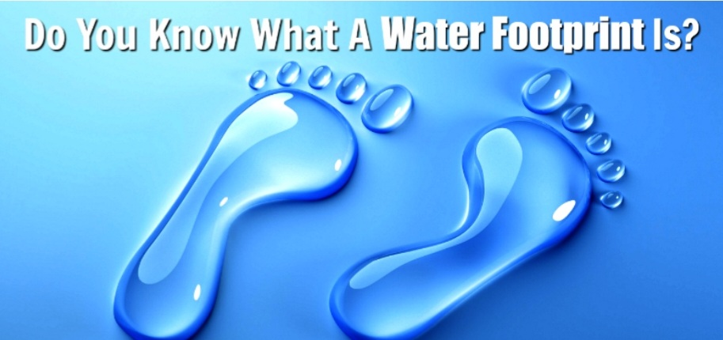
Source: TinkerPrograms.com

INTRODUCTION
The water footprint is a measure of the total volume of freshwater that is used to produce the goods and services consumed by individuals, communities, or nations. It encompasses not only the water consumed directly, such as drinking water or irrigation water, but also the water embedded in the production and supply chains of goods and services. By quantifying the water footprint, we gain insights into the hidden water consumption associated with our daily lives and the products we use.
The concept of water footprint was first introduced in 2002 by Arjen Hoekstra, a professor at the University of Twente in the Netherlands. It provides a comprehensive approach to evaluate the water use associated with different human activities, including agriculture, industry, and domestic consumption. This holistic perspective is essential for understanding the true extent of our water consumption and its potential impacts on water availability and quality.

Founder of Water Footprint Concept: Professor Arjen Hoekstra

One of the key advantages of the water footprint concept is its ability to highlight the virtual water trade between regions. Virtual water refers to the water "embedded" in products that are traded across borders. For example, when a country imports water-intensive goods, it effectively imports the water used in their production. This allows water-scarce regions to alleviate their water stress by importing water-intensive products, but it also creates dependencies and can exacerbate water scarcity in exporting regions.
Moreover, the water footprint concept goes beyond mere water consumption and considers the environmental and social implications of water use. It enables the assessment of water pollution, habitat degradation, and the displacement of local communities due to water-intensive activities. By examining the water footprint of specific sectors or products, policymakers, businesses, and individuals can identify opportunities for water conservation, pollution prevention, and sustainable water management.
In recent years, the water footprint concept has gained traction as a valuable sustainability indicator and has been applied in various contexts, including corporate water management, national water policies, and international agreements. It helps stakeholders understand the interdependencies between water resources, food production, energy generation, and economic development, fostering more informed decision-making and promoting water stewardship.
In this discussion, we will delve deeper into the concept of water footprint, exploring its methodology, applications, and implications. By understanding and addressing our water footprint, we can work towards ensuring a more sustainable and equitable use of this vital resource for the benefit of present and future generations.

Understanding Water Footprint:
The water footprint represents the total volume of freshwater used directly and indirectly by an individual, community, or organization throughout the production and consumption processes of goods and services. It is a comprehensive measure that encompasses three main components:
1. Blue Water Footprint: The term "blue water footprint" describes how much surface and groundwater is used in the process of producing goods and services. It comprises water drawn from lakes, rivers, and aquifers that is evaporated, used in products, or consumed in such a way that it cannot be used again.
2. Green Water Footprint: This component represents the amount of rainfall that is stored in the soil and later evaporated or transpired by plants during the production of agricultural commodities. It accounts for the water consumed by crops and vegetation and plays a vital role in food production.
3. Grey Water Footprint: The grey water footprint measures the volume of freshwater required to dilute and assimilate pollutants generated through human activities. It represents the amount of water needed to maintain water quality standards and reflects the potential environmental impact associated with various processes.
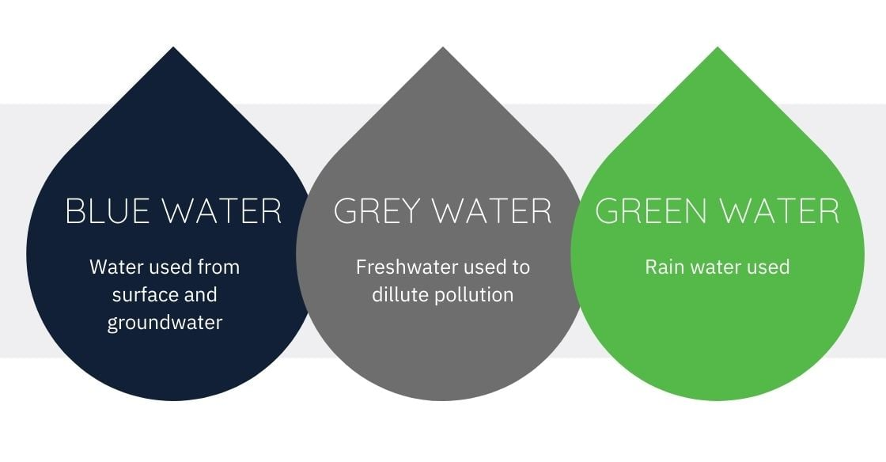
Source: SOURCE INTELLIGENCE

Calculation Procedure
To calculate water footprint accurately, a life cycle approach is adopted, taking into account all stages of the supply chain. This involves assessing water usage from raw material extraction and processing to manufacturing, distribution, use, and disposal or recycling. Various methodologies, such as the Water Footprint Network's standard, are available to estimate water footprints at different scales, from individual products to entire nations. The water footprint is a measure of the total volume of freshwater used directly and indirectly in the production of goods and services by an individual, organization, or community. It takes into account both the water consumed (withdrawn and not returned to its source) and the water polluted during the production process.

- To calculate the water footprint, follow these general steps:
1. Define the scope: Determine the system boundaries and what is included in the water footprint assessment. For example, you can assess the water footprint of a specific product, a company, or an individual's activities.
2. Identify water use categories: Categorize the water use into green, blue, and grey water. Green water refers to rainfall, blue water represents surface and groundwater sources, and grey water is associated with pollution.
3. Collect data: Gather information on water consumption from various sources, such as direct measurements, utility bills, or published data. You may need to consider water used within your organization, water used by suppliers, or water used throughout the supply chain.
4. Calculate the water footprint components:
• Green Water Footprint
• Blue Water Footprint
• Grey Water Footprint
5. Sum up the components: Add the green, blue, and grey water footprints together to obtain the total water footprint.
6. Interpret the results: Analyze and interpret the water footprint data. You can compare it to benchmarks or use it for making decisions on water management and efficiency improvements.
It's worth noting that the calculation methods and specific factors used can vary depending on the context and the purpose of the assessment. There are also specialized tools and software available to assist in calculating water footprints, such as the Water Footprint Network's Water Stat or the Global Water Footprint Standard.
Keep in mind that the calculation of a comprehensive water footprint can be complex, especially for large-scale assessments. Consulting experts or specialized resources may be beneficial in ensuring accuracy and reliability in the calculations.

- The water footprint of some selected food products from crop and animal origin.

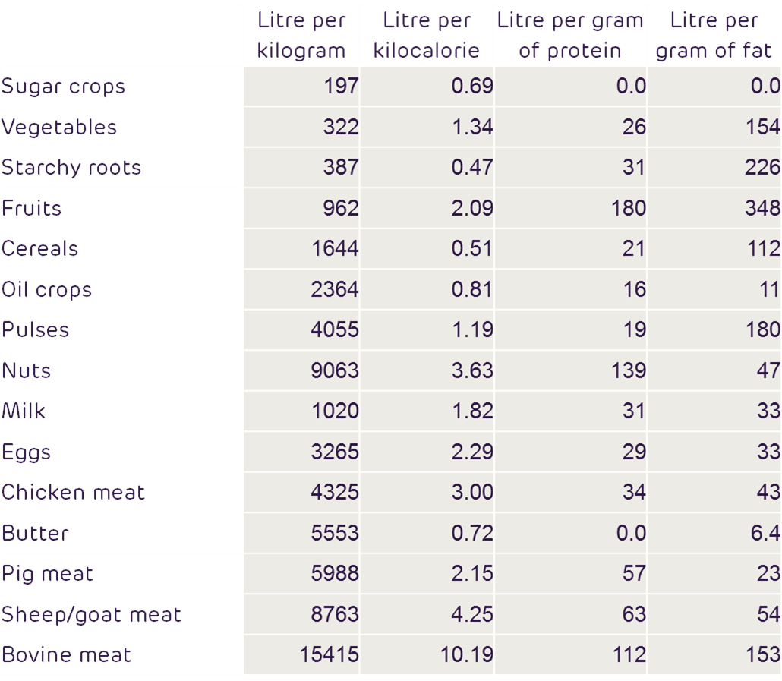
Source: Mekonnen and Hoekstra (2010)

Application of Water Footprint
- Water Management: Water footprint analysis can assist in the management of water resources at various scales, from individual households to industrial sectors and even entire countries. By quantifying the water use associated with different activities, decision-makers can develop strategies to optimize water consumption and minimize environmental impacts.

- Sustainable Agriculture: Agriculture is one of the largest water-consuming sectors globally. Water footprint assessment can help farmers and agricultural industries understand the water requirements of various crops and farming practices. It enables the identification of water-efficient techniques, crop choices, and irrigation methods, promoting more sustainable agricultural practices.

- Industry and Manufacturing: Water is a vital resource in industrial processes, manufacturing, and energy production. Assessing the water footprint of industrial activities can lead to the implementation of water-saving measures, recycling and reusing strategies, and the development of more sustainable production methods. It helps industries identify potential hotspots where water conservation efforts can be focused.

- Product Labeling and Certification: Water footprint information can be used for product labeling and certification schemes, similar to carbon footprint labels. This allows consumers to make informed choices by considering the water impact of different products. Labels and certifications can encourage companies to reduce their water footprints by improving production processes and using water resources more efficiently.

- Supply Chain Management: Understanding the water footprint of a product or service involves considering the water used throughout its entire supply chain. This knowledge can help companies identify water-intensive processes or regions within their supply chains and work towards water-efficient alternatives. It enables companies to assess and manage water risks associated with their supply chains, ensuring sustainable and responsible sourcing practices.

- Policy Development: Water footprint assessments provide policymakers with valuable information for formulating water management policies and regulations. Governments can use this data to develop water allocation plans, set water use efficiency targets, and implement measures to promote sustainable water use across sectors. Water footprint analysis can contribute to integrated water resource management and sustainable development planning.

Overall, the application of water footprint analysis helps raise awareness about water consumption and promotes the adoption of more sustainable practices in various sectors, leading to improved water management and conservation.
Challenges
- Data availability and reliability It might be difficult to gather precise and thorough statistics on water use across the supply chain. It calls for thorough data on water usage during several industrial phases, such as raw material extraction, manufacturing procedures, and transportation. This information might not always be accessible or trustworthy, especially for businesses operating in various areas or nations with various degrees of data collecting and reporting standards.
- Variability of water resources: The quantity and quality of water can change greatly between different geographical areas and seasons. When calculating the water footprint, it is important to take into account the unique characteristics of the local water resources, such as rainfall patterns, the availability of surface water, and groundwater reserves. Calculations incorporating such fluctuation can be difficult, especially when working with worldwide supply chains or products that depend on various water sources.

- Complex supply chains: Numerous items have intricate supply chains with numerous suppliers and middlemen. It can be difficult to monitor water use along these supply chains, particularly when working with globalised sectors where goods may be produced in one nation, put together in another, and sent all over the world. These complex networks need to be transparent and accountable, which calls for collaboration and data sharing across various stakeholders.

- Indirect water use: Indirect water use, which is distinct from direct water consumption and refers to the water needed to create inputs used in the production process, is another form of water usage. This includes water used to cultivate crops, create animal feed, or manufacture energy. Understanding a product's whole life cycle, including its raw materials, intermediate components, and final disposal, which can be complicated and resource-intensive, is necessary to account for indirect water consumption.

- Contextual factors: The availability, quality, and competing water uses in the local area should be taken into consideration while evaluating water footprints. Depending on these elements, the effect of water use on ecosystems and communities may differ. It is crucial to take into account the social and environmental effects of water consumption in a given setting, as well as the vulnerability and resilience of the local water resources.

- Behavioral change and stakeholder engagement:. In addition to technical solutions, changing behaviour and involving stakeholders are also necessary to comprehend and address water footprints. Governments, corporations, communities, and individuals must frequently work together to promote sustainable water management and encourage water-efficient practices. Significant problems might arise when attempting to develop collaboration among multiple stakeholders and overcome resistance to change.
Addressing these challenges requires improved data collection and reporting systems, enhanced collaboration among stakeholders, and the development of standardized methodologies for assessing and comparing water footprints. Efforts to raise awareness, promote water efficiency, and implement sustainable water management practices are crucial in mitigating the water-related challenges faced by societies and ecosystems.

Conclusion:
The idea of a water footprint offers useful information about how much freshwater is consumed during the manufacturing process. Assessment and addressing water footprints, however, create considerable difficulties. Data accessibility, resource fluctuation, intricate supply chains, accounting for indirect water consumption, contextual considerations, the need for behavioural change, and stakeholder engagement are some of these problems. Collaboration, enhanced data collecting, standardized procedures, and awareness-raising initiatives are needed to overcome these obstacles. We can cut water use, work towards sustainable water management, and protect this precious resource for present-day populations as well as the health of the planet by managing water footprints properly.

References:
1. Hoekstra, A.Y., & Chapagain, A.K. (2008). Globalization of water: Sharing the planet's freshwater resources. Oxford University Press.
2. Chapagain, A.K., & Orr, S. (2009). An improved water footprint methodology linking global consumption to local water resources: A case study of Spanish tomatoes. Journal of Environmental Management, 90(2), 121-131.
3. Mekonnen, M.M., & Hoekstra, A.Y. (2010). The green, blue and grey water footprint of crops and derived crop products. Hydrology and Earth System Sciences, 14(9), 1847-1860.
4. Mekonnen, M.M., & Hoekstra, A.Y. (2011). The green, blue and grey water footprint of farm animals and animal products. Value of Water Research Report Series No. 48, UNESCO-IHE, Delft, the Netherlands.
5. UNESCO (United Nations Educational, Scientific and Cultural Organization). (2012). Water footprint assessment manual: Setting the global standard. Paris, France.
6. Mekonnen, M.M., & Hoekstra, A.Y. (2016). Four billion people facing severe water scarcity. Science Advances, 2(2), e1500323.
7. Pfister, S., Koehler, A., Hellweg, S., & Koehler, S. (2009). Assessing the environmental impacts of freshwater consumption in LCA. Environmental Science & Technology, 43(11), 4098-4104.
8. Ridoutt, B.G., Pfister, S., Manzardo, A., Bare, J., Boulay, A.M., Cherubini, F., & Verones, F. (2019). Water footprinting standards and methodologies for assessing water use at the product and company level: A critical review. Science of the Total Environment, 670, 758-772
9. FAO. 1984. Crop water requirements. By: J. Doorenbos and W.O. Pruitt. FAO Irrigation and Drainage Paper 24. Rome, Italy.
10. FAO. 1985. Water quality for agriculture. By: R.S. Ayers and D.W. Westcot. FAO Irrigation and Drainage Paper 29 Rev. 1. Rome, Italy
11. Kaur, J., Gill, K. K., Kaur, S. & Aggarwal, R.  Estimation of crop coefficient for rice and wheat crops at Ludhiana Estimation of crop coefficient for rice and wheat crops at Ludhiana. J. Agrometeorology 19 (2), 170–171
12. Lu, Y., Zhang, X., Chen, S., Shao, L. & Sun, H.  Changes in water use efficiency and water footprint in grain production over the past 35 years: a case study in the North China Plain. J. Clean. Prod. 116, 71–79.

