Bioprinting: Advancements, Applications and Challenges in Regenerative Medicine

1.1 Introduction to Bioprinting

Bioprinting is an advanced technology to create three-dimensional (3D) tissue-like structures mimicking the characteristics of natural tissues. It is a rapidly evolving technology showing the potential to revolutionize the field of regenerative and personalized medicine by addressing the issue of shortage of tissues and organs which is currently one of the most critical challenges in healthcare affecting millions of patients all around the world. It uses a digital file as a blueprint according to which 3D tissues (or organs) constructs are fabricated by layering or depositing bioinks which are formulated by the biomaterials and living cells. Bioprinting has the potential of offering innovative solutions for tissue repair and regeneration, thus providing hope for patients with organ failure or tissue damage.

Bioprinting first came into picture in 1988, when Robert J. Klebe used an inkjet printer for printing cells and when Thomas Boland invented cell-embedded bioprinting in 2003, the technology got accelerated. It is a subset of tissue engineering with a more specific and advanced approach to tissue fabrication. Tissue engineering is an umbrella term used for a multidisciplinary field that includes various techniques for tissue repair and regeneration. It involves the design and development of biological mimics to repair, replace, or regenerate damaged or diseased tissues. On the other hand, bioprinting is a state-of-the-art technology, specifically designed for the precise fabrication of 3D structures using living cells, biomaterials, and bioactive molecules. It utilizes a layer-by-layer approach to create complex tissue-like structures similar to conventional 3D printing, however instead of using materials such as polymers, plastics, ceramics, metals, and composites which are commonly used in conventional 3D printing, bioprinting incorporate living cells usually mixed in with a biomaterial (such as polymer). The basic purpose of bioprinting is to recreate complex tissues and organs with a high level of spatial accuracy, cell viability, and functionality.

1.2 Potential Applications of Bioprinting

1.2.1. Organ Shortages: As mentioned before the shortage of donor organs for transplantation is one of the most critical challenges in healthcare. There are several factors which lead to this shortage of organs such as lack of enthusiasm among the public towards organ donation, complications in legal work associated with organ donation, lack of facilities of organ storage, difficulties in obtaining consent etc. Sometimes, patients with end-stage organ failure placed on the transplant waiting lists wait for several years to find a compatible donor. Some even lost their lives even before they could find the one. This has been the situation for years in healthcare systems around the world. Bioprinting has the potential to address this shortage by creating patient-specific artificial organs which are miniature 3D organ models that mimic the structure and function of real organs. This can significantly increase the availability of organs for transplantation, and hence saving countless precious lives.

1.2.2. Personalization and Customization : The traditional organ transplantation often involves the risk of organ rejection by the patient’s body due to incompatibility to the offered organ. Bioprinting allows the design and development of organs and tissues as per the need and anatomy of each individual patient, thereby reducing the risk of organ rejection as well as post-surgical complications associated with organ rejection. Bioprinting personalized the treatment process by making the use of autologous material i.e. patient's own cells to create tissues or organs which improves the integration and functionality of the implanted tissue or organ. This patient-specific personalized and customized approach increases a higher chance of successful engraftment and long-term survival, ultimately improving patient outcomes.

1.2.3. Reduced Waiting Times : During the process of the traditional organ transplantation, the issue of high demand and low availability of the organ is significant. Bioprinting can deal with this problem, by providing a rapid solution to the problem of long period waiting experienced by the patients in need of organs. However, since in bioprinting the artificial organs are created in the laboratory, the need to wait reduces significantly and timely treatment is provided to the patients.

1.2.4. Elimination of Immunological Barriers: In the traditional organ transplantation process, the immune system of the recipient may recognize the new organ as ‘foreign’ and trigger transplant rejection. To prevent this, a type of drugs called immunosuppressive drugs are given to the transplant recipient to prevent organ rejection. Bioprinting can reduce the possibility of side effects and risks of infections often arise in the traditional organ transplantation process due to the use of these immunosuppressive drugs . Bioprinting can create organs from the patient's own cells, reducing the likelihood of immunological rejection and the need for long-term immunosuppression.

1.2.5. Precision Medicine: The personalized approach specific to the individual patients adopted by bioprinting align with the principles of precision medicine. In bioprinting a patient’s unique needs and characteristics are taken into consideration by designing the treatment on the basis of their personal details such as their genetic makeup, lifestyle, and environmental factors.

1.2.6. Regenerative Therapies: The potential of bioprinting is not just limited to organ transplantation, but it can also be applied to regenerative therapies for the treatment of damaged or diseased tissues. Bioprinting can help in promoting tissue repair and regeneration and hence can provide hope and relief to the patients suffering from tissue injuries, chronic wound , cardiovascular diseases, neurological disorders, bone injuries and other such conditions.

1.2.7. Drug Screening, Testing and Disease Modeling:

Bioprinted tissues and organs can be utilized for drug screening, testing and disease modeling, for better and safer development of drugs. The 3D bioprinted models can provide a more accurate representation of human physiology by better mimicking the cell-cell interaction, diffusion kinetics and other features than traditional 2D cell cultures (Mazzocchi et al. 2019). It can also be an effective alternative for animal models which often raise ethical concerns over animal rights. Determination of a drug candidate’s efficacy can be a lot faster when using a bioprinted tissue as an in vitro model. Thus, bioprinting can contribute to providing a faster, more ethical and cost-effective route for drug development.

2. Processes and Key Components of Bioprinting

2.1 Bioprinting Process
In bioprinting, a specialized bioprinter is used to deposit bioinks, which are cell-laden biomaterials, in a controlled and precise manner. Bioinks can contain a variety of cell types, biomaterials, and bioactive molecules, depending on the tissue being printed. The bioprinted constructs are designed to mimic the microarchitecture and cellular composition of original tissues, making them more functional and relevant to the desired application.

There are several steps involved in the process of bioprinting from designing, imaging, selecting suitable materials, preparation of bioinks, printing final analysis of the printed construct. All of these steps are categorized into three main categories : pre-bioprinting, bioprinting and post-bioprinting. Figure 1 gives an overview of all these steps.

2.1.1 Pre-bioprinting
This involves designing and imaging of the digital model that will later be printed and the selection of the suitable materials that will be used for printing. Images are usually created with computerized tomography or magnetic resonance imaging. This step also includes formulation of bioink. Once the desired image is finalized, certain cells are isolated, multiplied and combined with the selected bio-ink.
2.1.2 Bioprinting
This is the main step of the overall bioprinting process where the cell-laded bio-ink is placed into a cartridge and the necessary printheads for creating the target structure are selected. Several techniques are used for this process however the most commonly used bioprinting techniques are inkjet-based, extrusion-based, and laser-based bioprinting (Li et al. 2016).
a. Inkjet-based Bioprinting: This is a non-contact printing process that uses thermal or piezoelectric actuators to deposit droplets of bioink onto a substrate to build the 3D structure. Inkjet-based bioprinters operate in a similar manner as the conventional inkjet printers. The main advantages of this technique are its high speed and ability to print volumes of bioink, making it suitable for printing cells in a gentle manner.

b. Extrusion-based Bioprinting: Extrusion-based bioprinting involves forcing the bioink through a nozzle or syringe to deposit it layer-by-layer, building the 3D structure. In this technique, instead of droplets, a continuous stream of bioinks containing hydrogel precursors and living cells is dispensed.

c. Laser-based Bioprinting : This technique uses a laser as the energy source to deposit biomaterials onto a substrate. The laser-based bioprinter usually consists of three parts: a pulsed laser source, a ribbon coated with liquid biological materials and a receiving substrate. The laser source is used to irradiate the ribbon so that the liquid biological materials coated on the ribbon get evaporated and reach the substrate in droplet form.

2.1.3 Post-bioprinting
This stage is necessary to ensure the stability of the printed structure and involves providing it with mechanical and chemical stimulation to control cell growth.

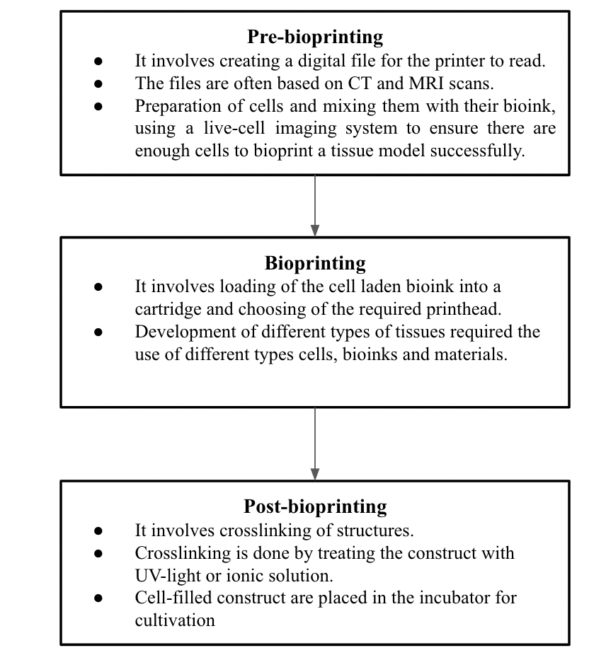
Figure 1: Basic steps of bioprinting

2.2. Key Components of a Bioprinting System

A bioprinting system is a complex technology that requires several key components for an effective deposition of living cells and biomaterials in a layer-by-layer manner to create 3D tissue-like structures having structure similar to the original tissue. The key components of a bioprinting system include bioinks, bioprinters and cell sources which are shown in figure 2 with their function and types.

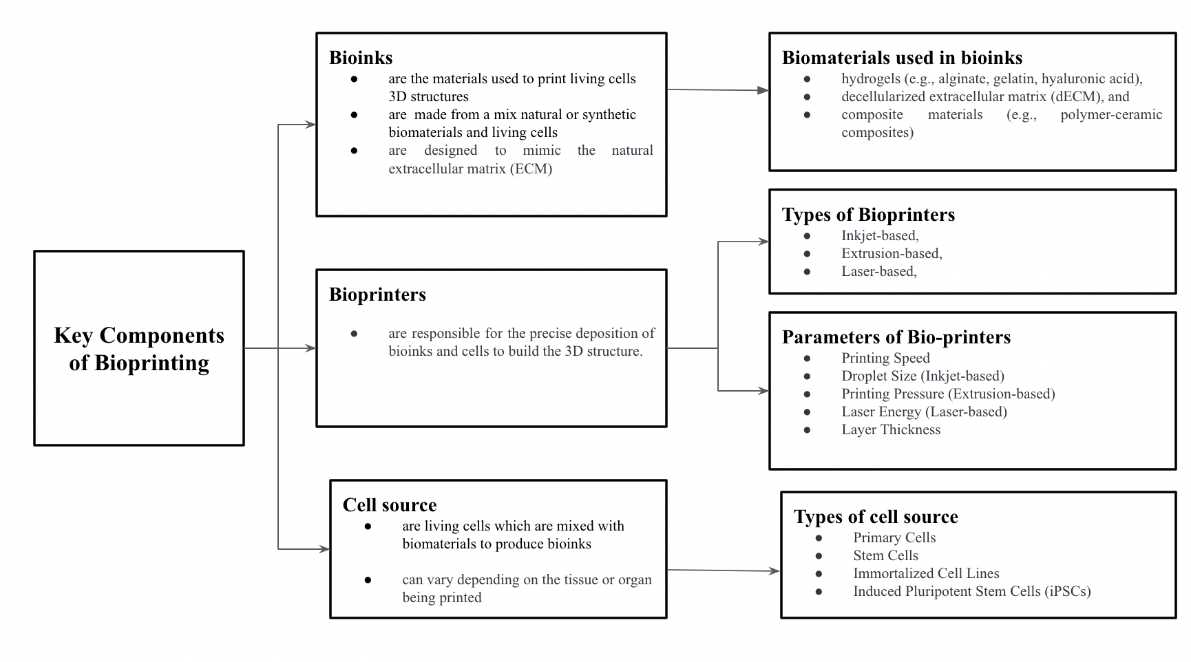

Figure 2: Key components of bioprinting

For the accurate formation of 3D-bioprinted construct, it is important for all the key components of a bioprinting system to work together in a coordinated manner. Each bioprinting technique has its own benefits and limitations and the selection of the particular bioprinting technique is dependent on the specific application. Later, according to that specific application other components and parameters are selected. The future success and advancement in the field of personalized and patient-specific therapies rely on the advancement, optimization and refinement of the bioprinting techniques.

3. Case Studies and Clinical Applications

Bioprinting has shown immense potential in several regenerative medicine areas, revolutionizing the field by offering innovative solutions for tissue repair and regeneration. Here are some applications of bioprinting in different regenerative medicine areas:

3.1. Wound Healing:

Bioprinting has shown promising results in improving wound healing by creating bioprinted skin constructs consisting of the patient's own cells and suitable biomaterials (Skardal et al. 2012). These created 3D skin constructs mimic the native skin's structure and function and can help in promoting the acceleration of closure of chronic wounds. Typically the bio-ink for skin regeneration contains donor keratinocytes (the primary type of cell found in the outermost layer of skin), fibroblasts (cells that provide the structural framework for tissue), collagen and stem cell with scaffolding biomaterials (Lee et al. 2009; Lee et al. 2014). More recently, 3D-bioprinted pigmented skin constructs have also been fabricated in which the printing materials contain an addition of melanin-producing cells i.e. melanocytes along with other traditional materials (Min et al. 2018; Ng et al. 2018). Bioprinting techniques are still facing many limitations for replicating the exact anatomy of human skin such as not being able to regenerate hair follicles or sweat glands. They cannot be vascularized or stimulate regeneration of nerves, hair follicles and sweat glands. However, even with current advancements skin bioprinting technology has brought a new hope for patients dealing with chronic wounds, burns, skin diseases.
3.2. Cardiac tissue
Cardiovascular disease (CVD) is a major cause of morbidity and mortality worldwide, and still remains one of the biggest challenges for medical researchers. Due to the limited regenerative capacity, an adult's cardiovascular tissue is unable to repair itself or self-renew after injury. In the advanced stages of most CVD, heart transplantation or replacement is usually the only therapeutic option which is restricted by the shortage of donor hearts.
Advancements in bioprinting have facilitated in implementing new therapeutic treatments for CVD. Bioprinting has shown the immense potential to create cardiac tissue constructs that closely resemble native heart tissue. Though the technology is still in its infancy stage especially quite far from realizing its ultimate goal of recreating a complete human heart with all the functions of a natural organ, many studies have demonstrated the successful bioprinting of cardiovascular constructs (i.e., vasculature constructs, myocardium, and heart valve conduits). These constructs have been implanted onto the hearts of patients with myocardial infarction (heart attack) for improving cardiac function and repair damaged heart tissue.

3.3. Urological tissue repair

The urinary or renal system comprising the kidneys, ureters, bladder, and urethra. Its role is not limited to only removal of waste from the body; it plays a vital role in maintaining our overall health by regulating blood volume and pressure, managing the levels of electrolytes, and keeping our blood pH in check. Due to lifestyle disorders and other factors urological disorders and diseases are on the rise worldwide. They give rise to significant healthcare expenses affecting the quality of life, and even shortening the survival times of affected patients. Most common and serious urological disorders and diseases include dysfunction and/or cancer of kidney, bladder, urethra and prostate. Tissue or organ transplant is usually the only option of medicinal treatment for the patients of end-stage urological diseases. However, due to the limited global availability of matching donor organs, this type of treatment is limited to a very small percentage of total patients. In several clinical trials, researchers have successfully managed to create and implant bioprinted bladders for patients with bladder defects or dysfunctional bladders seeded with the patients’ own cells promoting the bladder regeneration and function.

It's essential to note that while these studies show promising results, the field of bioprinting is still relatively new, and more research is needed to further validate the safety and efficacy of bioprinted constructs in regenerative medicine. Nonetheless, these preclinical and clinical studies demonstrate the potential of bioprinting to revolutionize regenerative therapies and provide personalized treatments for patients with various medical conditions.

4. Challenges in Bioprinting:

4.1. Finding suitable printing materials

The biggest challenge which restricts the successful implementation of bioprinting is the very limited availability of the suitable printable and biocompatible materials which are essential for the formulation of bio-inks. Bio-inks must have specific physicochemical properties to ensure that the resultant tissue-constructs are biocompatible with the original tissues and able to be produced at scale. Finding biomaterials that closely mimic the properties and behavior of human tissues without causing any adverse effect to the patient is an ongoing challenge.

4.2. Scaling up Bioprinting Technology for Industrial Production

One of the primary challenges in bioprinting is scaling up the technology to produce tissues and organs on an industrial level. Bioprinting larger and more complex structures requires precise control over multiple printing parameters while maintaining cell viability and structural integrity.

4.3. Replicating complex structures and functions

Accurate replication of the human tissues and organs is one of the biggest challenges in bioprinting. The natural human tissues and organs are complex architectures consisting of several intricate structures which are difficult to reproduce in a laboratory due to complicated interplay of many cells. Furthermore, the currently used bioprinters have limited printing size which makes bioprinting of smaller structures more feasible as compared to the larger organs due to the complexity in the structure of larger organs.

4.4. Vascularization in Bioprinted Constructs

Vascularization, which is the process of growing a network of blood vessels within tissues, is still a significant challenge in bioprinting. The blood vessels are essential for long-term functionality of bioprinted tissues as they perform functions such as supplying sufficient oxygen and nutrients to cells and waste removal. Without vascularization, the bioprinted organ would be unable to perform these necessary functions leading to cell death, tissue failure or organ malfunction.

There are several reasons behind experiencing the difficulties in bioprinting the vascular networks. Difficulty in replicating the intricate structures of blood vessels precisely is one of the main reasons. Other than this, bioprinting the vascular networks with proper sizing and scaling of blood vessels is another huge technical challenge since the blood vessels come in varying sizes of large arteries and veins to minute capillaries. Ensuring sufficient perfusion, meaning the allowance of blood to flow through the bioprinted blood vessels and seamless integration of the bioprinted blood vessels with the surrounding tissue without causing any inflammation are other significant challenges that need to be addressed for proper vascularization in bioprinted constructs.

4.5. Ethical and Regulatory Considerations

Bioprinting is a new and evolving technology hence there is still no universal regulatory body or standards for establishing guidelines for bioprinting. Moreover, the dynamics and complexities involved in the technology make it harder to fit in the current regulations and policies on the use of substances of human origin, such as human tissues and cells, blood and organs. However, since bioprinting technology is rapidly advancing from preclinical to clinical era, there are several key aspects that need to be carefully addressed to ensure safety and efficacy.

- Ethical Issues: Informed consent, privacy of the data of the concerned patient, and responsible use of bioprinted products are some of the major ethical issues which are of concern for the policy and decision makers. The manufacturers of the bioprinted products must ensure that individuals denoting the cells and tissues should be fully aware and properly understand the purpose and risks involved with the process. The manufacturers should also discourage any practice involving the data leak or misuse of the fabricated products.

- Proper classification of bioprinted products: Classifying the novel bioprinted tissues and organs into a correct category is crucial since there are different standards and regulations for different categories. The bioprinted products can fall into the category of medical devices which are essentially the non-biological products, biological products, or combination products, depending on their intended use. However , since different sets of rules are applied to non-biological and biological products, ethical and legal complexities can arise for the combination products.

In conclusion, while bioprinting is a relatively new technology, its potential applications are revolutionary. It is an area of research that is continually evolving and holds tremendous promise for improving healthcare and revolutionizing the field of regenerative medicine.As the field advances it promises to play a transformative role in shaping the future of medicine and regenerative therapies and more specific regulations are expected to be established to ensure the safety, efficacy, and ethical use of bioprinting technologies and products. The challenges and potential future developments highlight the ongoing advancements and possibilities in the field of bioprinting. Ongoing research seeks to optimize and refine the bioprinting techniques to achieve more sophisticated and clinically relevant tissue constructs, ultimately offering the potential for personalized and patient-specific therapies.

References:

- Bioethical and Legal Issues in 3D Bioprinting - PMC. https://www.ncbi.nlm.nih.gov/pmc/articles/PMC7557521/
- Bioprinting: Ethical and societal implications - ASCB | ASCB. https://www.ascb.org/science-news/bioprinting-ethical-and-societal-implications/
- Bioprinting, explained simply https://www.cellink.com/blog/bioprinting-explained-simply/#:~:text=Bioprinting%20explained%20(simply!),that%20let%20living%20cells%20multiply.

- Cui, H., Miao, S., Esworthy, T., Zhou, X., Lee, S. J., Liu, C., ... & Zhang, L. G. (2018). 3D bioprinting for cardiovascular regeneration and pharmacology. Advanced drug delivery reviews, 132, 252-269.

- Datta, P., Barui, A., Wu, Y., Ozbolat, V., Moncal, K. K., & Ozbolat, I. T. (2018). Essential steps in bioprinting: From pre- to post-bioprinting. Biotechnology advances, 36(5), 1481–1504. https://doi.org/10.1016/j.biotechadv.2018.06.003
- Ethics and Policy for Bioprinting - PubMed. Available at: https://pubmed.ncbi.nlm.nih.gov/32207105/

- Ferrari, A., Baumann, M., Coenen, C., Frank, D., Hennen, L., Moniz, A., ... & Nielsen, R. Ø. (2018). Additive Bio-Manufacturing: 3D Printing for Medical Recovery and Human Enhancement: Study. European Parliament.

- Gungor-Ozkerim, P. S., , Inci, I., , Zhang, Y. S., , Khademhosseini, A., , & Dokmeci, M. R., (2018). Bioinks for 3D bioprinting: an overview. Biomaterials science, 6(5), 915–946. https://doi.org/10.1039/c7bm00765e

- Lee, V., Singh, G., Trasatti, J. P., Bjornsson, C., Xu, X., Tran, T. N., ... & Karande, P. (2014). Design and fabrication of human skin by three-dimensional bioprinting. Tissue Engineering Part C: Methods, 20(6), 473-484.

- Lee, W., Debasitis, J. C., Lee, V. K., Lee, J. H., Fischer, K., Edminster, K., ... & Yoo, S. S. (2009). Multi-layered culture of human skin fibroblasts and keratinocytes through three-dimensional freeform fabrication. Biomaterials, 30(8), 1587-1595.

- Lewis, A., Koukoura, A., Tsianos, G. I., Gargavanis, A. A., Nielsen, A. A., & Vassiliadis, E. (2021). Organ donation in the US and Europe: The supply vs demand imbalance. Transplantation Reviews, 35(2), 100585.

- Li, J., Chen, M., Fan, X., & Zhou, H. (2016). Recent advances in bioprinting techniques: approaches, applications and future prospects. Journal of translational medicine, 14(1), 1-15.

- Mazzocchi, A., Soker, S., & Skardal, A. (2019). 3D bioprinting for high-throughput screening: Drug screening, disease modeling, and precision medicine applications. Applied Physics Reviews, 6(1).

- Min, D., Lee, W., Bae, I. H., Lee, T. R., Croce, P., & Yoo, S. S. (2018). Bioprinting of biomimetic skin containing melanocytes. Experimental dermatology, 27(5), 453-459.
- Ng, W. L., Qi, J. T. Z., Yeong, W. Y., & Naing, M. W. (2018). Proof-of-concept: 3D bioprinting of pigmented human skin constructs. Biofabrication, 10(2), 025005.
- Ngo, T. D., Kashani, A., Imbalzano, G., Nguyen, K. T., & Hui, D. (2018). Additive manufacturing (3D printing): A review of materials, methods, applications and challenges. Composites Part B: Engineering, 143, 172-196.

- Murphy, S. V., & Atala, A. (2014). 3D bioprinting of tissues and organs. Nature biotechnology, 32(8), 773-785.

- Patentability, Global Development and Ethical Considerations of Bioprinting. https://gfljd.worldbank.org/sites/default/files/documents/resources/patent-bioprininting.pdf

- Skardal, A., Mack, D., Kapetanovic, E., Atala, A., Jackson, J. D., Yoo, J., & Soker, S. (2012). Bioprinted amniotic fluid-derived stem cells accelerate healing of large skin wounds. Stem cells translational medicine, 1(11), 792-802.

- Varkey, M., Visscher, D. O., van Zuijlen, P., Atala, A., & Yoo, J. J. (2019). Skin bioprinting: the future of burn wound reconstruction?. Burns & trauma, 7, 4. https://doi.org/10.1186/s41038-019-0142-7
- Wang X. (2019). Advanced Polymers for Three-Dimensional (3D) Organ Bioprinting. Micromachines, 10(12), 814. https://doi.org/10.3390/mi10120814
- What is Bioprinting? https://www.news-medical.net/health/What-is-Bioprinting.aspx

- You, F., Eames, B. F., & Chen, X. (2017). Application of extrusion-based hydrogel bioprinting for cartilage tissue engineering. International journal of molecular sciences, 18(7), 1597.

