Liquid Crystal Nano-particle composites -Display applications
Mukesh Mishra
ShriRamswaroop Memorial University, Lucknow- Deva Road, Uttar Pradesh, India-225003

Abstract:Many studies have been conducted in the past to improve the characteristics of LCs using methods other than chemical synthesis. A method to accomplish this goal is by dispersing NPs in liquid crystal materials. One of the key techniques to improve the qualities of LCs is doping, which is the mixing of extremely minute amounts of an additive into an LC. Because they may be utilized to efficiently enhance the characteristics of liquid crystals, liquid crystal–nanoparticle composites (LC-NPs) have developed as a multidisciplinary topic of research and are attracting tremendous attention from scientists in the soft matter research community. Different kinds of nanomaterials are employed to tailor the liquid crystal to specific applications. This chapter's content focuses on how adding nanoparticles to nematic liquid crystals (NLCs) might improve their electrical and electro-optical characteristics. These composites of LC-NPs are very significant for applications involving displays.
Key Words: Liquid crystals, Nanoparticles, Liquid crystal naocomposites

Introduction:
An electronic visual display, video display, or flat-panel display that makes advantage of liquid crystals' ability to modulate light is called an LCD. LCDs are useful for displaying fixed pictures that may be concealed or exhibited, such preset text, numbers, and 7-segment displays used in digital clocks, or random graphics like those seen in general-purpose computer displays. LCDs are utilized in a wide variety of devices, such as signs, TVs, instrument panels, computer monitors, and cockpit displays in airplanes. They have mostly supplanted cathode ray tube (CRT) displays in consumer electronics, including video players, gaming consoles, clocks, watches, calculators, and phones. Using nematic materials rather than conventional liquid crystalline materials, a small team of researchers created a unique LCD display. The characteristics of LCs may be interestingly and practically manipulated by NPs, and this will probably be crucial for LC-based electronics and display applications. This chapter describes the production of nanocomposites using 4-pentyl-4'-cyanobipheny (5CB) nematic liquid crystalline material and barium titanate nanoparticles (BTNPs). Ferroelectric nanoparticles (BTNPs) with a persistent dipole moment enable adjacent LC molecules to realign, which enhances the electro-optical characteristics of LCs through a parallel correlation between NPs and LCs.I've distributed BTNPs throughout 5CB in order to examine the different display settings in just N phase. A number of researchers have previously reported on the thermodynamic [1–5], dielectric [6–20], and electro-optical [21–30] characteristics of 5CB, a fundamental display material. Between 17 and 34.5ºC, 5CB exclusively contains the nematic (N) phase [31–33]. In Figure 5.1, the molecular structure of 5CB is shown. 100 nm-diameter BTNPs have been obtained from Sigma-Aldrich. The process of creating nanocomposites involves dispersing BTNPs in 5CB. This chapter disperses different doses of 0.05, 0.5, and 5.0 weight percent BTNPs and examines a number of physical characteristics. In this chapter Graph 1, 2, 3 and 4 are for pure 5CB, 5CB + 0.05 wt % BTNPs, 5CB + 0.5 wt % BTNPs and 5CB + 5.0 wt % BTNPs, shown respectively.

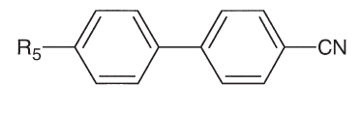
Figure 1.1. Pure 5CB [7].

1.2 Results and Discussion
1.2.1 Thermodynamic Study
Under PLM, the amalgamation of BTNPs in NLC was examined. If a certain nanomaterial exhibits aggregate-forming behavior, this approach explains the initial outcome [34]. No evidence of NP aggregation was seen when the nanocomposites were analyzed in the N phase using PLM. The influence of BTNPs on the isotopic-nematic transition temperature (TIN) or nematic-isotropic transition temperature (TNI) throughout the heating and cooling phases was determined using DSC. Ensure the LCD applications, accurate studies of the phase transition temperatures are mandatory [35]. To maintain the system, nanocomposite materials were subjected to five heat cycles prior to writing the original data. Host and its various NPs concentrations DSC thermogramsis displayed in Figure 1.2a & b during Calefaction and chilling cycles. Host and its various NPs concentrations has been carried out, both in heating and chilling cycles. Data was recorded at varying scanning speeds ranging from 2.5 °C min-1 to 15 °C min-1. In case of heating, transition temperatures move towards a lower temperature as the scan rate drops, while in chilling, they shift toward a higher temperature [36].

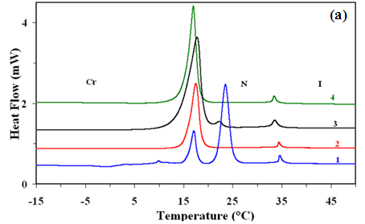
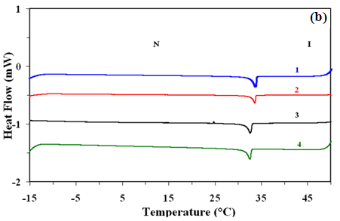
Figure 1.2: DSC plots for the (a) calefaction and (b) chilling cycles.
.

Using a least squares fit, the transition temperatures at a scan rate of 0 °C min-1 have been extrapolated [37], providing the various temperatures for the calefaction and chilling cycles as follows: Calefaction cycles:
5CB: Cr-(18.0 ^{º}C±0.5ºC)-N-(34.7ºC±0.5ºC)-I
5CB + 0.05 wt% BT NPs: Cr-(17.5ºC±0.5ºC)-N-(33.9ºC±0.5ºC)-I
5CB + 0.5 wt% BT NPs: Cr-(17.3ºC±0.5ºC)-N-(33.5ºC±0.5ºC)-I
5CB + 5.0 wt% BT NPs: Cr-(17.1ºC±0.5ºC)-N-(33.3ºC±0.5ºC)-I
Chilling cycles:
5CB: I-(33.5ºC±0.5ºC)-N
5CB + 0.05 wt% BT NPs: I-(33.6ºC±0.5ºC)-N
5CB + 0.5 wt% BT NPs: I-(33.0ºC±0.5ºC)-N
5CB + 5.0 wt% BT NPs: I-(32.7ºC±0.5ºC)-N
Various studies have examined pure 5CB [1–5]. It is observed from the experimental data that the nanocomposite's transition temperatures, or TNI (or TIN), are sifted downward to pure 5 CB. Not a single sample of host sample or various mixed samples crystallizes at the minimum temperature of -15 °C. Based on the DSC data described above, we may deduce that enhance the concentration of BTNPs reduces transition nematic to isotropic, a finding that is further supported by PLM. The majority of significant investigations demonstrated that combining ferroelectric NPs (BTNPs and Sn2P2S6) increases the TNI of the nanocomposites [38–41], while a small number of tests also shown a TNI reduction [42–45]. The TNI in this experiment significantly decreases when the BTNP concentration in 5CB rises. TNI drops by approximately 0.5 °C in the scenario of 0.05 wt% BTNPs, 1.5 °C in 0.5 wt% BTNPs, and 1.4 °C in 5CB + 5.0 wt% BTNPs. Gorkunov and Osipov [46] claim that the average distance between the mesogenic molecules in the liquid crystal (LC) matrix is increased and subsequently diluted as a result of the spherical NPs. As a result, the transition temperature into the N phase drops, the strength of intermolecular contacts also reduces, and the Nematic ordering also falls.According to Lopatina et al. [47], there may be a significant drop in TIN as a result of the dipolar induction interaction between ferroelectric NPs and the surrounding nematic liquid crystal medium. Another reason for a reduction in transition temperature of isotropic to nematic, according to Gupta et al. [48], is that BTNPs make the system more disordered and cause themesophase to become unstable. The DSC analysis indicates that TIN quickly decreases with increasing concentration at low concentrations (<1wt%). However, TIN declines more slowly at greater concentrations (>1wt%) than it does at lower values. Gorkunovet al. [49] likewise report the same results. Phase separation may occur at higher concentrations within a range of NPs concentrations, however at smaller doping there is little potential of phase separation and the TIN drop is caused by the dilution effect. According to Vardanyan et al., only a portion of nanoparticles are homogeneously mixed in the mesophase, although NP aggregation is seen at greater concentrations [50]. The results of these investigations also indicate that TIN declines quickly at low concentrations because of its high miscibility, whereas TIN lowers more slowly at high concentrations. The latter appears as a result of phase separation developing.
1.2.2 UV-Vis Study
Figure 1.3 displays the spectra for 5CB, BTNPs, and its nono scattered sample. The 5CB plot displays the longest wavelength (λ_{max}) absorbance at 302 nm, whereas the BTNPs display λ_{max} at 285 nm (refer to the inset of Figure 1.3). These results are consistent with the corresponding λ_{max} published in the literature [51, 52]. Relation has been used to find the optical band gap of host and its nano mix samples [53, 54].
$αhν={B(hν-E_{g})}^{m}$(1.1) The various terminology and methods of determine the band gap with this equation is also discussed earlier in details [53-57]
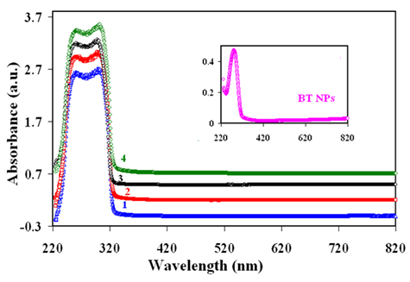
Figure 1.3:Absorption spectra for the host and its nano mix samples.

$Band gap$curves for BTNPs is given in Figure1.4. The measured $bandgap$ of BTNPs from the intercept of the straight line at $α$ = 0 has been found to be 4.03 eV. According to Wempleet al. [58] particles larger than 15 nm,${ E}_{g}$ is aboutequivalent to that of barium titanate in bulk. ${ E}_{g}$Plots for pure 5 CB, and its nanocomposites are shown in Figure 1.5. The$band gap$ of host 5CB has been calculated to be to be 3.82 eV (seeFigure1.5a). $E_{g}$for5CB + 0.05 wt% BTNPs (Figure 1.5 b), 5CB + 0.5 wt% BT NPs (Figure 1.5 c) and 5CB +5.0 wt% BTNPs (Figure 1.5 d) have been determined to be 3.80 eV, 3.82 eV and 3.81 eV respectively. Diminution in $E_{g}$ for 0.05 wt% BTNPs is accountable for the boost in the conductivity.
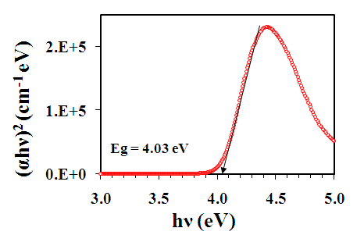
Figure 1.4.Band gap (E_{g}) of pure BTNPs.

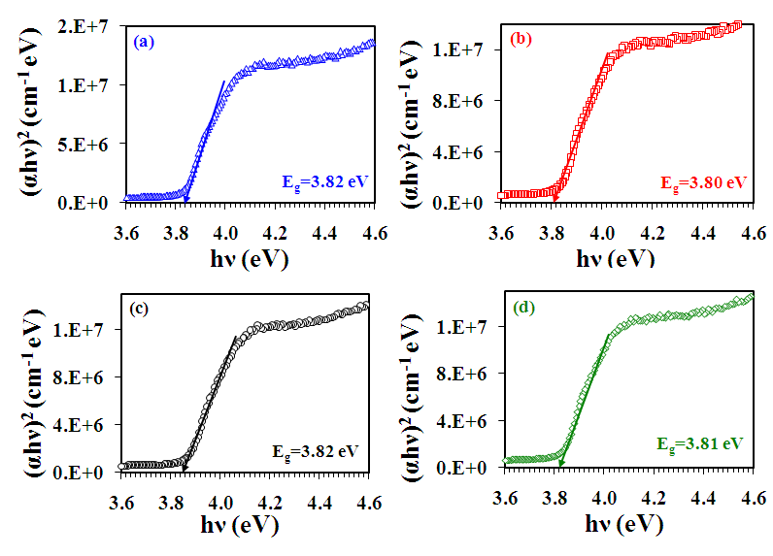Figure 1.5.Calculation of optical band gap of host and its nano mix samples. Figure a, b, c and d are for pure 5 CB, 5CB + 0.05 wt % BTNPs, 5CB + 0.5 wt % BTNPs and 5CB + 5.0 wt % BT NPs, respectively.

1.2.3 Electro-Optical Study
Host sample and its nano mix samplesin nematic phase at 23 °C, transmission intensity with voltage is presented in Figure 1.6. This information provides information on threshold (V_{th}), switching voltage (∆V), and the steepness (slope) of the transmission voltage curve (TVC). Nematic molecules reorient in the direction of the external applied voltage, resulting in maximum intensity and minimum intensity states beneath the polarizing light microscope various voltages, respectively. Freedericksz transition is another name for the reorientation of nematic directors caused by an electric field from a brilliant state (Figure 1.6 Inset a) to a minimum intensity condition (Figure 1.6 Inset b) [59, 60]. Threshold voltage (V_{th}) is the voltage required to achieve transition. A brilliant state is seen at low voltages where the molecule lies in the planar alignment less than V_{th}. A dark state is seen when the molecules gradually transition to the homeotropic orientation when the applied voltage is raised above V_{th}.
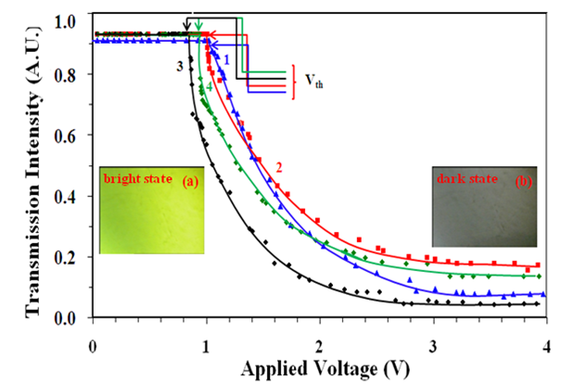
Figure 1.6: Transmission voltage (T-V) curves for host and its nano mix samples at frequency 1 kHz..

The $∆V$ is taken as$V_{90}-V_{10}$, where $V_{90}$and $V_{10}$are the voltages resultant to the transmission intensity of 90% and 10% of the maximum value. The lower value of $∆V$ (~0.5-1.0) is helpful for the applications. High steepness of the slope (($I_{90}-I_{10}$)/$V_{90}-V_{10}$)) of the TVC is also useful. I haveillustrated the character of dielectric anisotropy$(∆ε^{'})$, to discuss the parameters, where${ ∆ε^{'}=ε_{‖}^{'}-ε}_{⊥}^{'},{ ε}_{‖}^{'}$ and $ε_{⊥}^{'}$ are the longitudinal and transverse components of relative permittivity respectively. $ε_{‖}^{'}$ and $ε_{⊥}^{'}$ components of relative permittivity of the host and its nano mix samples on temperature scale are shown in Figure 1.7. [61].
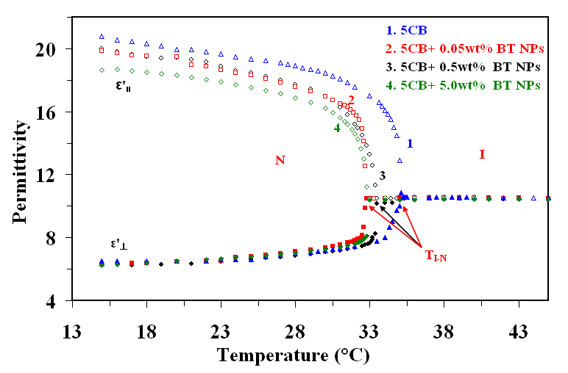Figure 1.7: Plot of the longitudinal ($ε_{‖}^{'}$) and transverse $(ε_{⊥}^{'})$ components of the relative permittivity for the host and its nano mix samples.

Figure1.7 Illustrate the $ε_{⊥ }^{'}$is approximately unaffected after escalating the amount of BTNPs, while the $ε_{‖}^{'}$component significantly decreases in dissimilarity to the outcomepublishedpreviously [40, 61]. So$∆ε^{'}$decreases with enhancing the amount of BTNPs.The $V_{th}$is given by [60, 62-64]
$${ V}_{th}=π{\left(\frac{K_{11}}{ε_{0}∆ε^{'}}\right)}^{1/2}(5.2)$$
$ε_{‖}^{'}$,$ε_{┴}^{'}$and average ($ε^{'}$= ($ε_{‖}^{'}$+ 2 $ε_{┴}^{'})$/3)components of the permittivity, $∆ε^{'},$ ratio of the${ ∆ε^{'}}/{ε_{⊥}^{'}}$,${ V}_{th}$,$∆V$, slope of the TVC ($=\left({∆I}/∆V\right)=({I_{90}-I_{10}}/{(V_{90}-V_{10}}$)), and $k_{11}$ are given in Table 1.1 for the Nematic phase at 23.0 °C. ${ V}_{th}$decrease as the order parameter reduces (i.e. ∆$ε^{'}$) because the existence of suitableNPs. It should be noted that although an increase in ∆$ε^{'}$ was seen experimentally, the drop in $V_{th}$ reported in earlier research [61] was explained by assuming that $k_{11}$ remained unchanged with the accumulation of NPs. But according to my current research, introducing NPs causes a drop in $k_{11}$ and ∆$ε^{'}$ . Previous reports [66] have also mentioned this decrease in the Freedericksz$V_{th}$and of the S caused by inorganic magnesium oxide (MgO) NPs in the N phase. In this investigation, specifically for the 0.05 weight percent BTNPs mixed sample, the ∆$ε^{'}$decreases by 5%, and the ultimate K₁₁ value is 32% (refer to Table 1.1). Ultimately, this results in a ~2% drop in $V_{th}$by when compared to the pure sample.
Nevertheless, with 0.5 weight percent of BTNPs composites, there is a 7% drop in ∆E and a 52% change in K₁₁ value, which results in a 17% decrease in V_{th} relative to the pure sample. Conversely, V_{th} is less distorted than expected for larger concentrations (>1 weight percent). At the same time as V_{th} for 5.0 wt% of BTNPs has lowered by 8%, K₁₁ and ∆^' have decreased by 46% and 14%, respectively. Higher concentrations (>2–3% weight percent) of submicron particles produce a nearly stiff liquid crystal suspension, according to Reznikov et al. [61]. For 5.0 wt% of BTNPs scattered systems, V_{th} does not alter considerably as a result.
Table 1.1 indicates that while the steepness of the T-V curve grows, ∆V reduces as the concentration of BTNPs increases, or up to 0.5 weight percent. The increase in the T-V curve's steepness is mostly caused by a decrease in ∆V. ∆V and steepness are unchanged at 0.5 weight percent BTNPs relative to the pure sample.
Table 1.1: Various parameters in the Nematic (at 23.0 °C) phases.
concentration ε'║ε'⊥ ε'= (ε'║ + 2 ε'⊥)/3 ∆ ε' ∆ ε'/ ε'⊥V_{th}∆V∆I/∆VK₁₁
5 CB 19.66.5 10.8 13.1 2.0 1.02 1.25 0.64 16.50
0.05wt% BT NPs18.9 6.5 10.6 12.4 1.9 1.00 1.06 0.75 11.13
0.5wt% BT NPs18.7 6.5 10.5 12.2 1.9 0.85 0.99 0.80 7.91
5.0wt% BT NPs17.9 6.7 10.4 11.2 1.7 0.94 1.20 0.66 8.88

1.2.4 Dielectric Study
From Maier and Meier theory [67]
$$∆ε^{'}=\frac{NHF}{ε_{O}}\left[∆α-\frac{F}{2kT}P^{2}\left(1-3\cos^{2}β\right)\right]S (1.3)$$
Equation (1.3) indicates that $∆ε^{'}$ is significantly dependent on both N and S. It is expected that N will decrease as doping of BTNPs increases, as $∆ε^{'}$will also decrease as BTNP concentration increases. According to Kirkwood et al. [68], this translates to a lower value of $ε_{‖}^{'}$and consequently$∆ε^{'}$'. Vardanyan et al. [69] state that NPs raise the proportion of 5CB dimmers, which lowers the system's $∆ε^{'}$. The frequency dependence of $ε_{┴}^{'}$ for host and its nano mix samples indicates that up to 10MHz, results are roughly invariant. This suggests that within the frequency frame of our findings, there is no relaxation mechanism for the planar orientation of molecules. As so, I was unable to determine the relaxation frequency that corresponded to the rotation of the molecule along the long axis. However, because of the rotation of the molecules along their short axes [70–72].Figure 1.8 displays the frequency fluctuations in the experimental data of $ε_{‖}^{'}$ and $ε_{‖}^{''}$for both host and its nano mix samples in the Nematic phase. As seen in Figure 1.9, the permittivity ( $ε_{‖}^{'}$) and loss $( ε_{‖}^{''} )$values for host and its nano mix samplesfall on the Cole-Cole semi circles.It is clear that the observed relaxations are a typical Debye process [76, 77] from the value of the distribution parameter derived from the fitting of the experimental data as well as from the Cole-Cole [73-75] plots displayed in Figure 1.9 (plots are entire semi circles).

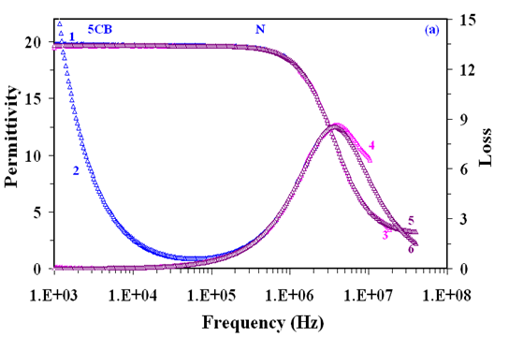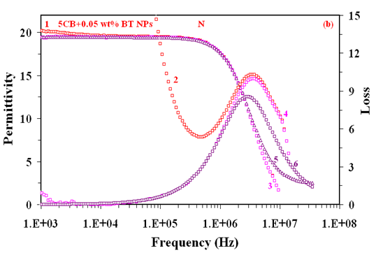
Figure1.8 is continued on next page also…..

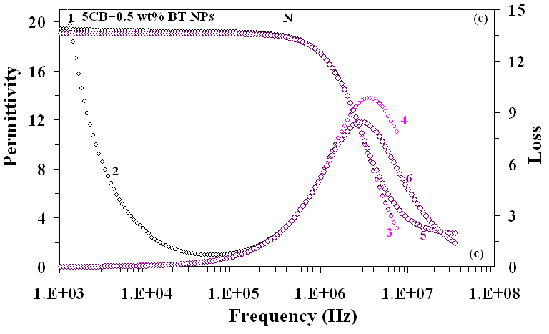
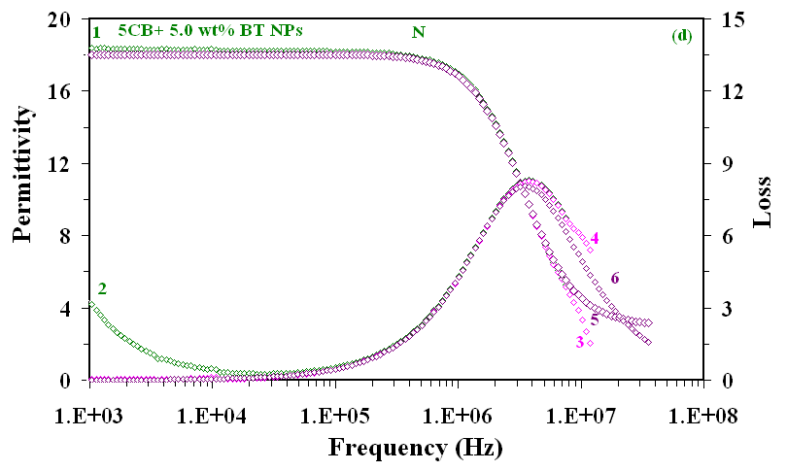
Figure 1.8: longitudinal component of the relative permittivity ($ε_{‖}^{'}$) and the loss ($ε_{‖}^{''}$)in the Nematic phase (23.0 °C). Curves1 and 2 show the measured value of$ε_{‖}^{'}$and${ ε}_{‖}^{''}$.Curves 3 and 4 represents the corrected data for$ε_{‖}^{'}$and$ε_{‖}^{''}$ obtained by subtracting the high and low frequency corrections from the measured data. Curves 5 and 6 are the generated data of $ε_{‖}^{'}$and$ε_{‖}^{''}$after low and high frequency corrections.Figure (a) Host, (b) 5CB + 0.05 wt % BTNPs, (c) 5CB + 0.5 wt % BTNPs and (d) 5CB + 5.0 wt % BTNPs dispersed samples.

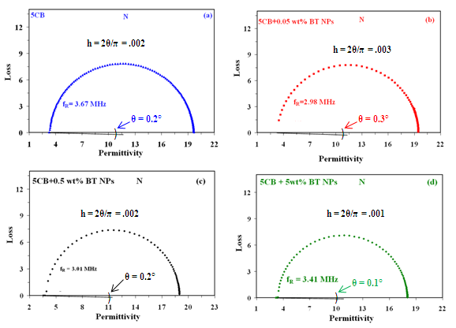
Figure 1.9: Cole-Cole plots showing the variation of loss ($ε_{‖}^{''}$) with permittivity ($ε_{‖}^{'}$).

Fig. 1.10 shows the variation of relaxation frequency with the temperature. For host (a), relaxation frequency is same as earliest published data [78]. The measured data of $f_{R}$ at 24 °C for barium titanate nanoparticles distributed in host at 0.05 wt%, 0.5 wt%, and 5.0 wt% are 2.85 ±0.5ºC MHz, 3.5 ±0.5ºC MHz, and 3.40 ±0.5ºC MHz, respectively.
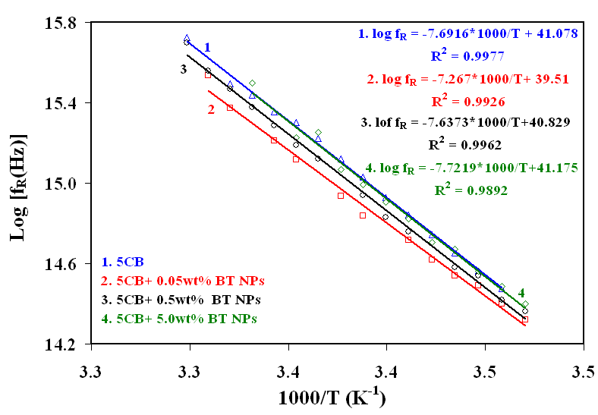
Figure 1.10: Deviation of relaxation frequency with temperatue (K⁻¹) showing Arrhenius behaviour of the observed relaxation mode.

Activation energy$(W_{A})$for the observed relaxation process was calculated by the Arrhenius equation [79, 80]
$logf_{R}= logf_{0}-\frac{W_{A}}{}N_{A} kT$(1.4)
From Figure 1.10, plots of log $f_{R}$vs reciproal of absolute temperature have been obtained by the method of least square fit. With slopes of the straight lines, $W_{A}$ have been measured for host and its nanomix samples. I have determined$W_{A}$of 63.9 kJ mol⁻¹ for the pure 5 CB sample in the N phase, same as [78] measured earlier. The observed $W_{A}$are 59.9 ±0.5ºC mol⁻¹, 60.4 ±0.5ºC kJ mol⁻¹, 63.32 ±0.5ºC kJ mol⁻¹ for 0.05 wt% BTNPs, 0.5 wt% BTNPs and 5.0 wt% BTNPs dispersed host respectively. From experimental data , it is concluded that${ W}_{A}$has decreased for 0.05 wt% BTNPs. However, for other concentrations, ${ W}_{A}$ increases.In N phase at 23.0 °C, Figure 1.11(a) shows the frequency versus conductivity parallel ($σ_{‖}$) to the direction of host and its nanomix samples. Figure shows that conductivity is frequency dependent at higher frequencies, whereas it is constant at lower frequencies [81, 82]. Figure 1.11 (b) displays the temperature dependency of longitudinal ionic conductivity $\left(logσ_{i‖}\right). σ_{i‖}$ grows by two orders of magnitude for the 0.05 weight percent BTNPs composite system, and for the 0.5 weight percent BTNPs composites, $σ_{i‖}$ is about comparable to that of pure 5CB. According to Singh et al., conductivity anisotropy rises in NLC as a result of BTNP dispersion [39].
But for 5.0 wt% BTNPs composite,$σ_{i‖}$ smaller values as compared to host. At 23.0 °C, the $σ_{i‖}$ are 8.40 × 10⁻⁷ ±0.5ºC S m⁻¹ for host and that of composites are 5.57 × 10⁻⁵ ±0.5ºC S m⁻¹ (0.05 wt %), 8.82 × 10⁻⁷ ±0.5ºC S m⁻¹ (0.5 wt %) and 2.21 × 10⁻⁷ ±0.5ºC S m⁻¹for 5.0 wt%. The solid lines in Figure 1.11 (a)showArrhenius behaviour of the conductivity.The availability of more space allows ions to move more easily within the samples, which is the cause of conductivity enrichment [31].One significant finding is that when the doping concentration increases, $σ_{i‖}$ falls because larger concentrations result in the formation of nanoscale ferroelectric NPs aggregates [83–86]. Higher concentrations (4.5 weight percent) of montmorillonite (MMT) nanoplatelets in 5CB have a considerable propensity to aggregate, according to Shaydyuket al [87]. As a result, $σ_{i‖}$ declines in our instance as well at greater concentrations (5.0 wt% BTNs).Because BTNPs move easily in the parallel to the nematic director, I have been able to induce enhancement in the single longitudinal component of the $σ_{i‖}$. There is no discernible movement of BTNPs along the transverse direction of the nematic director, as shown by the unchanging value of the$σ_{i⊥}$.

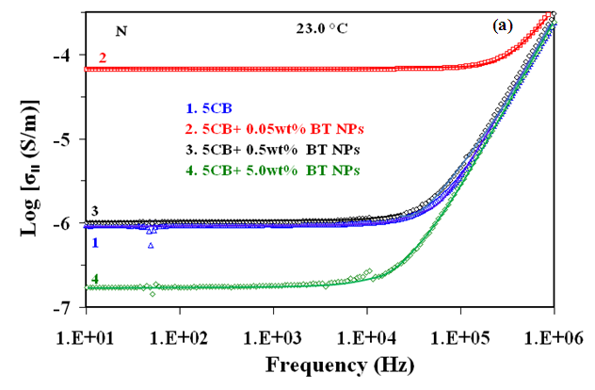
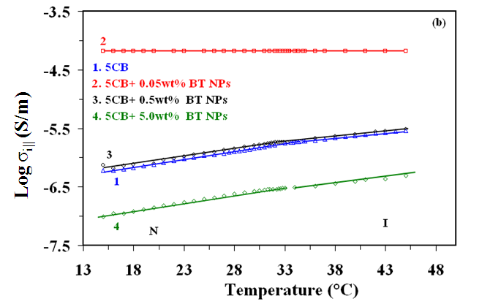
Figure 1.11: (a) Deviation of conductivity along to the director (σ‖) with frequency and (b) variation of the logarthim of ionic conductivity along to the director (σ_{i‖}) with temperature for host and its nanomix samples.

1.3 Conclusion:
The conclusions that may be drawn from the experimental findings and discussion are as follows:
- It has been discovered that the nematic-isotropic transition temperature falls by 0.1 ±0.5ºC °C for 0.05 wt%, 1.5 ±0.5ºC °C for 0.5 wt%, and 1.6 ±0.5ºC °C for 5.0 wt% of BTNPs as the concentration of BTNPs in 5 CB increases.
- As the concentration of BTNPs rises, the dielectric permittivity's longitudinal component significantly drops while its transverse component stays unchanged.As a result, dielectric anisotropy also drops by around 5% at 0.05 weight percent, 7% at 0.5 weight percent, and 14% at 5.0 weight percent of BTNPs.
- Above 0.05 weight percent, the relaxation frequencies of an observed relaxation mode corresponding to the molecules' flip-flop rotation around their short axis fall initially, but they increase as the concentration increases in host.
- Above 0.05 weight percent, the activation energies of an observed relaxation mode that corresponds to the molecules' flip-flop rotation along their short axis diminish, but they then increase when the concentration of BTNPs in 5CB increases.
- For 0.05 weight percent BTNPs nanocomposites, the longitudinal component of conductivity has increased by roughly two orders of magnitude, but it declines with increasing concentration.
- The 5CB optical band gap (3.82 eV) is now 3.80 eV for 0.05 weight percent, 3.81 eV for 0.5 weight percent, and 3.81 eV for 5.0 weight percent of BTNPs.
- The mixing of BTNPs in host causes the threshold voltage to drop by 2% ± 1% for 0.05 wt%, 16% ± 1% for 0.5 wt%, and 9% ± 1% for 5.0 wt%. While the steepness of the TVC curve has increased, switching voltage and splay elastic unvarying have reduced.
References:
- P. P. Karat, N. V. Madhusudana. Mol. Cryst. Liq. Cryst. 36, 51, 1976.
- D. Porter, J. R. Savage, I. Cohen. Phys. Rev. E. 85, 041701, 2012.
- N. I. Lebovka , L. N. Lisetski , M. I. Nesterenko , V. D. Panikarskaya , N. A. Kasian , S. S. Minenko& M. S. Soskin. Liq. Cryst. 40, 968, 2013.
- M. Kuzma, M. M. Labes. Mol. Cryst. Liq. Cryst. 100, 103, 1983.
- U. Shivakumar, J. Mirzaei, X. Feng, A. Sharma, P. Moreira, T. Hegmann. Liq. Cryst. 38, 1495, 2011.
- R. Verma, R. Dhar, R. Dabrowski, M. Tykarska, V. K. Wadhawan, M. C. Rath, S. K. Sarkar. J. Phys. D: Appl. Phys. 42, 085503, 2009.
- R. Basu, G. S. Iannacchione. Appl. Phys. Lett. 93, 183105, 2008.
- A. Schonhals, H. L. Zubora, R. S. Fricke, L. Frunza, R. Moldovan. Cryst. Res. Technol. 34, 1309, 1999.
- S. Urban, B. Gestblom, R. Dabrowski. Phys. Chem. Chem. Phys. 1, 4843, 1999.
- M. Kole, T. K. Dey. J. Appl. Phys. 113, 084307, 2013.
- G. P. Sinha, F. M. Aliev. Phys. Rev. E. 58, 1998, 2001.
- R. Basu, G. S. Iannacchione. J. Appl. Phys. 106, 124312, 2009.
- J. Jadzyn, P. Kedziora. Mol. Cryst. Liq. Cryst. 145, 17, 1987.
- P. G. Cummins, D. A. Dunmur, D. A. Laidler. Mol. Cryst. Liq. Cryst. 30, 109, 1975.
- C. Dascalu, A.L. Alexe-Ionescu, G. Barbero. J. Electroanal. Chem. 767, 63, 2016.
- F. Al-Hazmi, A. A. Al-Ghamdi, N. Al-Senany, F. Alnowaiser, F. Yakuphanoglu. J. Mol. Liq. 190, 169, 2014.
- A. Bogi. S. Faetti. Liq. Cryst. 28, 729, 2001.
- A.V. Zakharova, A. Maliniak. Eur. Phys. J. E. 4, 435, 2001.
- S. Urban , H. G. Kreul, A. Wurflinger. Liq. Cryst. 12, 921, 1992.
- A. Dawid, W. Gwizdala. Rev. Adv. Mater. Sci. 23, 37, 2010.
- B. J. Frisken, P. P. Muhoray. Phy. Rev. A. 39, 1513, 1989.
- J. F. Blach, S. Saitzek, C. Legrand, L. Dupont, J. F. Henninot, M. Warenghem. J Appl. Phys. 107, 074102, 2010.
- S. P. Yadav, K. K. Pandey, A. K. Mishra, R. Manohar. Acta. Phys. Pol. A. 119, 824, 2011.
- S. Oka, M. Kimura, T. Akahane. Appl. Phys. Lett. 80, 1847, 2002.
- G. B. Hadjichristov, Y. G. Marinov, A. G. Petrov, L. Marino, N. Scaramuzz. J. Phys.: Conf. Ser. 682, 012015, 2016.
- G. B. Hadjichristov, Y. G. Marinov, A. G. Petrov, E. Bruno, L. Marino, N. Scaramuzza. Mol. Cryst. Liq. Cryst. 610, 135, 2015.
- D. Rajh, S. SHelestick, A. Mertelj, P. Umek, S. Irusta, A. Zak, I. Dolenik. Phys. Status. Solidi A. 210, 2328, 2013.
- F. Z. Elouali, D. A. Tabet, U. Maschke. Mol. Cryst. Liq. Cryst. 502, 77, 2009.
- I. Chashechnikova, L. Dolgov, T. Gavrilko, G. Puchkovska, Ye. Shaydyuk, N. Lebovka, V. Moraru, J. Baran, H. Ratajczak. J. Mol. Struct. 563, 744, 2005.
- J. Baran, L. Dolgov, T. Gavrilko, L. Osinkina, G. Puchkovska, H. Ratajczak, Y. Shaydyuk, A. Hauser. Phils. Mag. 87, 4273, 2007.
- A. S. Pandey, R. Dhar, S. Kumar, R. Dabrowski. Liq. Cryst. 38, 115, 2011.
- T. Bezrodna, I. Chashechnikova, T. Gavrilko, G. Puchkovska, Y. Shaydyuk, A. Tolochko, J. Baran, M. Drozd. Liq. Cryst. 35, 265, 2008.
- P. P. Korneychuk, O. G. Tereshchenko, Y. A. Reznikov, V. Yu. Reshetnyak, K. D. Singer. J. Opt. Soc. Am. B. 23, 1007, 2006.
- M. V. Rasna, L. Cmok, D. R. Evans, A. Mwrtelj, S. Dhara. Liq. Cryst. 42, 1059, 2015.
- V. G. Chigrinov. Liquid Crystal Devices: Physics and Applications. Bostan, MA: Artech House, 1999.
- R. Dhar. Liquid Crystals: Electrical, Optical and Thermodynamical Properties. D. Phil. Thesis submitted to the University of Allahabad, Allahabad, India, 1996.
- R. Dhar, R. S. Pandey, V. K. Agrawal. Indian. J. Pure Appl. Phys. 40, 901, 2002.
- M. Kaczmarek, O. Buchnev, I. Nandhkumar. Appl. Phys. Lett. 92, 103307, 2008.
- U. B. Singh, R. Dhar, R. Dabrowski, M. B. Pandey. Liq. Cryst. 41, 953, 2014.
- F. Li, O. Buchnev, C. Cheon, A. Gluushchenko, V. Resshetnyak, Y. Reznikov, T. J. Sluckin, J. L. West. Phys. Rev. Lett. 97, 147801, 2006.
- F. Li, J. West, A. Glushchenko, C. Cheon, Y. Reznikov. J. SID. 14, 523, 2006.
- Y. Lin, R. Douali, F. Dubois, A. Segovia-Mera, A. Daoudi.Eur. Phys. J. E. 38, 103, 2015.
- O. Kurochkin, H. Atkuri, O. Buchnev, A. Glushchenko, O. Grabar, R. Karapinar, V. Reshetnyak, J. West, Y. Reznikov. Condens. Matter. Phys. 13, 33701, 2010.
- O. Kurochkin, O. Buchnev, A. Iijin, S. K. Park, S. B. Kown, O. Grabar, Y. Reznikov, A colloid of ferroelectric nanoparticles in a cholestric liquid crystal, J. Opt. A: Pure Appl. Opt. 11, 024003, 2009.
- A. Lorenz, N. Zimmermann, S. Kumar, D. R. Evans, G. Cook, M. F. Martinez, H. S. Kitzerow. J. Phys. Chem. B. 117, 937, 2013.
- M. V. Gorkunov, M. A. Osipov. Soft matter. 7, 4348, 2011.
- L. M. Lopatina, J. V. Selinger. Phys. Rev. Lett. 102, 197802, 2009.
- M. Gupta, I. Satpathy, A. Roy. R. Pratibha. J. Colloid. Interface. Sci. 352, 292, 2010.
- M. V. Gorkunov, G. A. Shandryuk, A. M. Shatalova, I. Y. Kutergina, A. S. Merekalov, Y. Kudryavtsev, R. V. Talroze, M. A. Osipov. Soft Matter. 9, 3578, 2013.
- K. K. Vardanyan, R. D. Walton, D. M. Bubb. Liq. Cryst. 38, 1279, 2011.
- S. T. Wu. J. Appl. Phys. 69, 2080, 1991.
- M. R. A. Bhuiyan, M. M. Alam, M. A. Momin, M. J. Uddin, M. Islam. Int. J. Matter. Mech. Engg. 1, 21, 2012.
- J. Tauc. Amorphous and liquid semiconductor. Plenum. New York, 1974.
- J. Tauc. A. Menth. Non. Cryst. Solids. 8, 569, 1972.
- O. Harizanov, A. Harizanova, T. Ivanova. Mater. Sci. Eng. B. 106, 191, 2004.
- R. Ashiri, A. Nemati, M. S. Ghamsari, H. Aadelkhani. J. Non. Cryst. Solids. 355, 2480, 2009.
- H. X. Zhang, C. H. Kam, Y. Zhou, X. Q. Han, Y. L. Lam, Y. C. Chan, K. Pita. Mater. Chem. Phys. 63, 174, 2000.
- S. H. Wemple. Phys. Rev. B. 2, 2679, 1970.
- T. D. Ibragimov, A.R. Imamaliyev, G.M. Bayramov. Optik. 127, 2278, 2016.
- C. Cirtoaje, E. Petrescu, V. Stoian. Physica E. 67, 23, 2015.
- Y. Reznikov, O. Buchnev, O. Tereshchenkov, V. Reshetnyak, A. Glushchenko, J. West. Appl. Phys. Lett. 82, 1917, 2003.
- U. B. Singh, M. B. Pandey, R. Dhar, R. Verma, S. Kumar. Liq. Cryst. 2016 http://dx.doi.org/10.1080/02678292.2016.1159344
- R. Dhar, A. S. Pandey, M. B. Pandey, S. Kumar, R. Dabrowski. Appl. Phys. Express. 1, 12501, 2008.
- K. K. Vardanyan, D. M. Sita, R. D. Walton, W. M. Saideld, K. M. Jones. RSC Adv. 3, 259, 2013.
- P. G. de Gennes, J. Prost. The Physics of Liquid Crystals. 2nd ed., Clarendon Press, Oxford, 1993.
- F. Haraguchi, K. I. Inoue, N. Toshima, S. Kobayashi, K. Takatoh. Jpn. J. Appl. Phys. 46, L796, 2007.
- W. Maier, G. Meier. Z. Naturforsch. 16, 262, 1961.
- J. G. Kirkwood. J. Chem. Phys. 7, 911, 1939.
- K. K. Vardanyan, E. D. Palaazzo, R. D. Walton. Liq. Cryst. 38, 709, 2011.
- R. Nozaki, T. K. Bose, S. Yagihara, Phys. Rev. A. 46, 7733, 1992.
- H. Kresse, H. Stettin, F. Gouda, G. Anderson. Phys. Status Solidi A. 111, K265, 1989.
- S. Mohyeddine, M. B. Pandey, D. Revannasiddaiah. Phase Transitions. 82, 11, 2009.
- K. S. Cole, R. H. Cole, R. H. J. Chem. Phys. 9, 341, 1941.
- M. B. Pandey, R. Dhar, V. K. Agrawal, R. Dabrowski. Mol. Cryst. Liq. Cryst. 414, 63, 2004.
- M. B. Pandey, R. Dabrowski, R. Dhar. Ferroelectrics. 395, 99, 2010.
- O. Koysal, M. Okutan, M. Durmus¸ F. Yakuphanoglu, S.E. San, V. Ahse. Synt. Met.156, 58, 2006.
- C. J. F. Bottcher, P. Bordewijk. Theory of Electric Polarization, Vol II. Elsevier, Amsterdam, 1978.
- N. Yadav, R. Dabrowski, R. Dhar. Liq. Cryst. 41, 1803, 2014.
- N. E. Hill, W. E. Hill, A. H. Price, M. Davis. Dielectric properties and molecular behaviour. London: Van Nostrand Reinhold, 1991.
- M. B. Pandey, R. Dhar, V. K. Agrawal, R. P. Khare, R. Dabrowski. Phase Transitions. 76, 945, 2003.
- B. Kamaliya, M. V. Kumar, C. V. Yelamaggad, S. K. Prasad. Appl. Phys. Lett. 106, 083110, 2015.
- S. L. Srivastava, R. Dhar. Radiat. Phys. Chem. 47, 287, 1996.
- R. Basu, A. Garvey. Appl. Phys. Lett. 105, 151905, 2014.
- S. P. Meeker, M. C. K. Poon, J. Crain, E. M. Terentjev. Phys. Rev. E. 61, 6083, 2000.
- V. J. Anderson, E. M. Terentjev, S. P. Meeker, J. Crain, W. C. K. Poon, Eur. Phys. J. E. 4, 11, 2001.
- S. P. Yadav, R. Manohar, S. Singh. Liq. Cryst. 42, 1095, 2015.
- Y. Shaydyuk, G. Puchkovska, A. Goncharuk, N. Lebovka. Liq. Cryst. 38, 155, 2011.
- M. R. Herrington, O. Buchnev, M. Kaczmarek, I. Nandhkumar. Mol. Cryst. Liq. Cryst. 527, 72, 2010.
- A. Glushchenko, C. Cheon, J. West, F. Li, E. Buyuktanir, Y. Reznikov, A. Buchnev. Mol. Cryst. Liq. Cryst. 453, 227, 2006.
- S. N. Paul, R. Dhar, R. Verma, S. Sharma, R. Dabrowski. Mol. Cryst. Liq. Cryst. 545, 105, 2011.

