A critical review on the role of hydrogen as a clean fuel source
Dr. Shobhana Ramteke^{1*} and Dr. Bharat Lal Sahu^{2*}
¹School of Studies in Environmental Science, Pt. Ravishankar Shukla University, Raipur-492010, CG, India
²Assistant Professor, Department of Chemistry, Guru Ghasidas Vishwavidyalaya, Bilaspur-495009, CG, India.
*Corresponding author: shubrmtk21@gmail.com; bharatred007@gmail.com
ABSTRACT
Due to population growth and increased human activity, the world's energy requirements have significantly increased. In the modern world, fossil fuels play a significant role in providing energy, but they also contaminate the environment by releasing greenhouse gases into the atmosphere. Hydrogen is a well-known efficient energy carrier and is found in both renewable and non-renewable sources. This review article gives a general overview of the biomass (biological and thermochemical) and water splitting (photolysis, thermolysis, and electrolysis) processes that are used to create hydrogen from renewable sources. Discussions about these methods' shortcomings are present. The study also looks at a number of important obstacles to the global development of the hydrogen economy. The paper concludes with some recommendations for further research for scientists to aid in improving the efficacy of specific production construction mechanisms and policy direction to lessen investment risks in the sector to scale up the hydrogen economy.
Keywords: Biomass, Hydrogen production, Dark fermentation, Hydrogen Power system Renewable energy
INTRODUCTION
Despite the fact that fossil fuels today satisfy a large fraction of global energy demand, the negative impacts of fossil fuel combustion are unavoidable such as greenhouse gases, acid rain, and other environmental and human health implications. To that aim, global energy transformation is gaining traction, which is aided by the fast growth in the field of renewable energy. To boost this momentum and reduce pollutants, hydrogen has been investigated as an alternative energy carrier, while producing power from hydrogen by using a fuel cell which produces no local pollution because the sole waste is clean water [1]. Furthermore, hydrogen may be generated locally, reducing a country's reliance on external energy supplies [2]. The availability of water on Earth, in particular, ensures that hydrogen may be produced in a somewhat sustainable manner. Water splitting using electrolysis presents intriguing prospects for synergy with renewable energy. Because of the intermittent nature of some renewable energy supplies, hydrogen may be created before it is required, making it appropriate for distributed and centralised production that is directly connected to remote renewable resources. An electrolyzer's hydrogen is ideal for use with fuel cells. Presently, energy executives consider hydrogen to be the least impactful and least definite issue confronting the global energy system. Hydrogen products are now utilised in the various industrial sector as raw materials. However, if we realise its full potential as a complete energy carrier, it has the potential to play a significant role in many more sectors. The majority of the estimated 50 million metric tonnes generated annually on a worldwide scale is used as a feedstock for ammonia synthesis, with oil refining accounting for 35% [2-3]. When it realises its role as a flexible energy carrier, as shown in Figure 1. Hydrogen integration has progressed steadily in recent years, from production and storage through re-electrification and safety concerns. Extensive descriptions of current development may be found elsewhere, and a number of research are attempting to characterize current progress in hydrogen system integration using unique methodologies [3]. There is broad agreement that creating hydrogen from renewable energy sources (solar, wind, etc.) has significant potential for global sustainability [4]. A review of clean hydrogen generating technologies is offered in this review article. This is not the first time the various hydrogen production methods have been explored, since there have been some studies, covered in earlier sections, and some of them [5-6] have evaluated one or more kinds of the processes connected with hydrogen synthesis. Aside from the emphasis on clean technologies in this study, it also goes beyond a review of the technologies and exposes the constraints connected with them. There are additional challenges in the industry that are impeding the worldwide advancement of the hydrogen economy. 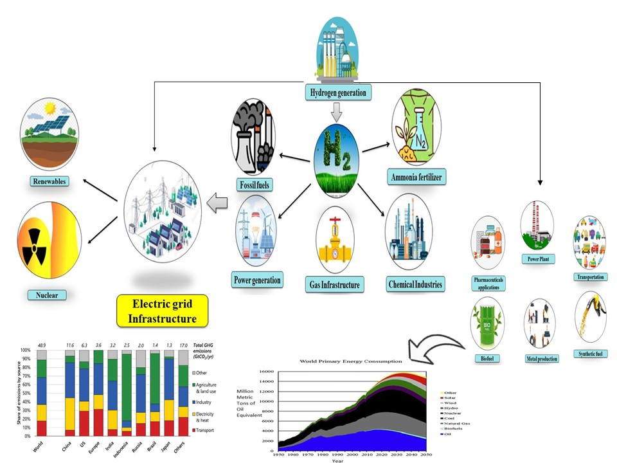
Figure 1. Representation of the various Hydrogen production routes.
Status of the Global Hydrogen Production
According to the International Energy Agency (IEA) technologies for producing hydrogen were especially resilient during the pandemic, and their momentum is expected to continue in 2020. According to the IEA study, 2020 was a record year for policy action and low-carbon output, with 10 countries worldwide adopting hydrogen policies. Figure 2 depicts the growth in demand for H₂ over time; it can be observed that the generated hydrogen is largely utilised in the manufacturing of 51% of NH₃, while remaining roughly 31% is used in oil refining, rest 10% is used in the production of methanol CH₃OH, and the last remaining 8% has various applications [8]. Hydrocarbon steam reforming is now the most widely used method for producing hydrogen on a global scale, accounting for more than 90% of industrial hydrogen production plants. The Badische Anilin-und-Soda-Fabrik (BASF) created it in 1926 [7-8]. According to the same research, 75 nations throughout the world have implemented net-zero carbon aspirations, accounting for more than half of global GDP, and over 30 have hydrogen-focused programmes.
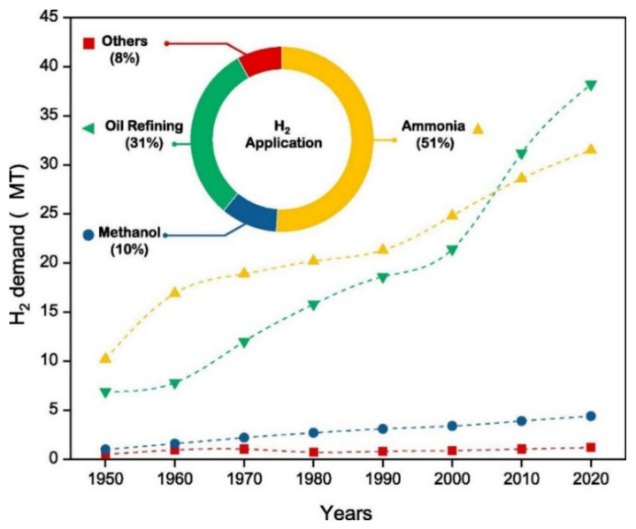
Figure 2. Hydrogen demand worldwide and its share on various uses https://www.ncbi.nlm.nih.gov/pmc/articles/PMC8880752/figure/membranes-12-00173-f002/
Hydrogen technologies
This section introduces some hydrogen technologies often utilized in hydrogen power plants. They include electrolytic hydrogen generation, hydrogen re-electrification via fuel cells, hydrogen storage, and converter technologies. The properties of these technologies are given and proved by certain experimental findings.
Electrolytic hydrogen production
Water electrolysis, coal gasification and Steam reforming etc are the most common industrial generation technologies of hydrogen today. Other hydrogen generation technologies, for example reforming C₂H₆O ethanol and C₁₂H₂₂O₁₁ sugars, [9-10]. Decreasing amount of renewable power, there is an increasing interest in water electrolytic hydrogen production, which uses electricity to extract hydrogen from water while emitting no carbon byproducts such as Carbon dioxide CO₂.
Water electrolysis principle
Cathode and Anode two electrodes are placed in the electrolyte solution which is linked to the power source which helps to conduct current in the water electrolysis cell, as illustrated in Figure 3. Degraded water helps to create hydrogen H₂ on the cathode which has negative charge and oxygen on the anode which has positive charge with a sufficiently enough voltage is been placed between the two electrodes [11]. The inclusion of an electrolyte increases the conductivity of the water, allowing it to conduct electricity continuously. In the process of water electrolysis, solid polymer electrolytes and acids are often utilised, and ions diverse are considered as charge carriers: OH, H⁺, O₂, etc. Water electrolysis reactions at various charge carriers' electrodes may change, Meanwhile, the overall reaction is considered to be always the same
2H₂O + Electricity + Heat → 2H₂ + O₂

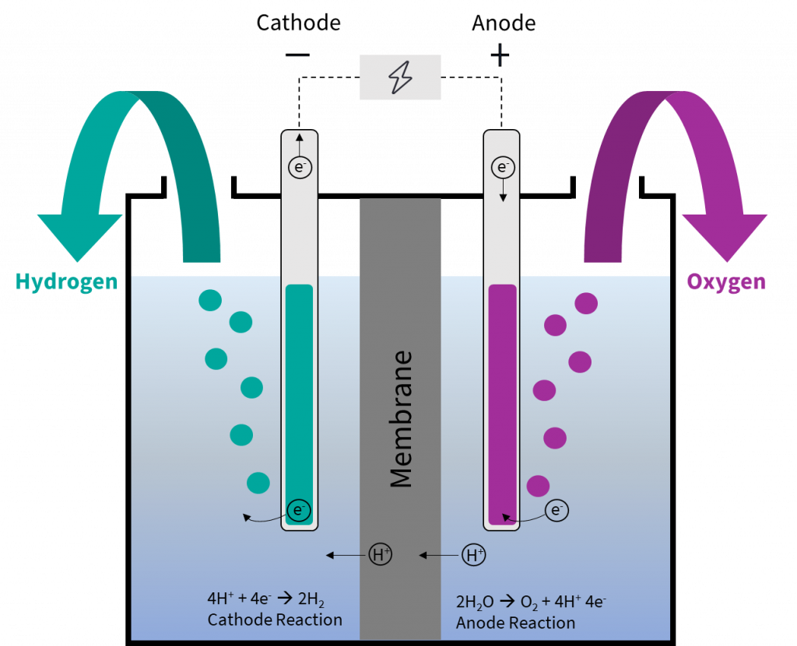
Figure 3. Representation of the Water electrolysis principle.

Hydrogen production paths
Hydrogen production is mostly done by using either fossil fuels or through RS, which is presented in Figure 4. The most common method is known as "steam reforming." Because of its high hydrogen-to-carbon ratio within the hydrocarbons group, methane is the most commonly employed fuel in this process; hence, the created byproducts are minimized [12]. Table 1. The reformation process begins with the mixing of methane CH₄ with steam, which is then forwarded over a catalyst bed at a high pressure of approximately 1.5-3 MPa and a temperature which is ranged from 600-800 °C to form a mixture of carbon monoxide (CO) and hydrogen H₂, as shown in below Equation [1]. The second phase comprises with the shift reaction, which involves the interaction of extra steam with the CO from the previous phase to create additional hydrogen H₂ and CO₂, as shown in below Equation [2]
CH₄+H₂O→CO+3H₂ (1)

CO+H₂O→CO₂+H₂ (2)

The further method for producing hydrogen which involves fossil fuels is coal gasification. In this technique, coal is partially oxidized at high pressure, roughly 4 MPa, and T°C with the help of oxygen and steam to produce CO, methane, CO₂, and other chemicals [13]. At temperatures above 1000 °C and pressures above 1 bar, hydrogen and CO are usually stable [Table 3]. The procedure is depicted in Equations (3) and (4) [13-16].

$C+\frac{1}{2}$O₂$→CO$ (3)

C+H₂O→CO+H₂ (4)

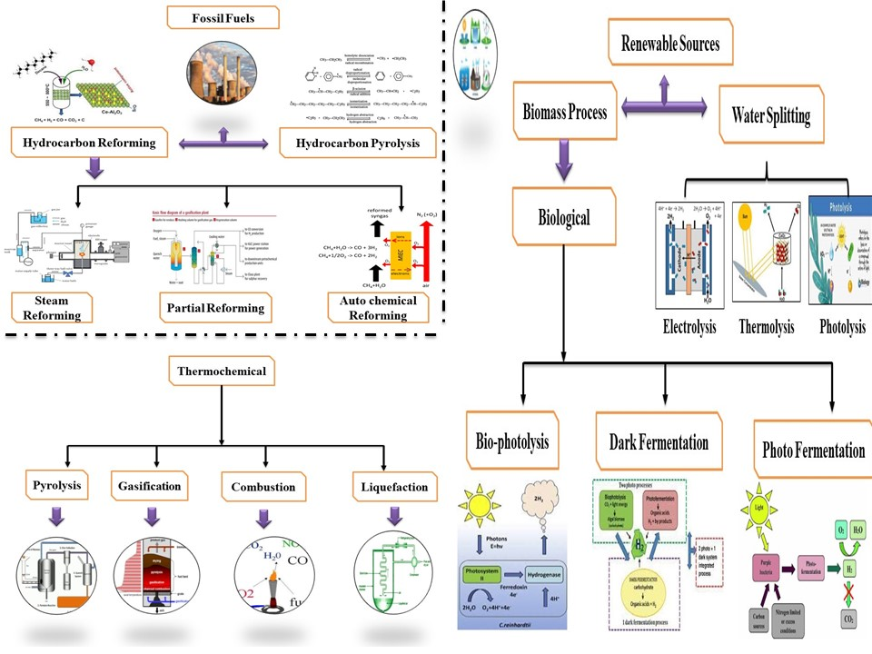
Figure 4. Representation of various Routes to hydrogen production.

Table 1: Representation of the hydrogen production technologies involves from biomass
Technology | Principle | Source as a energy | Operating Condition
Dark fermentative | Biological | Carbohydrate-rich substrates | Anoxic conditions
Photo fermentative | Biological | Small organic molecules | Anaerobic Conditions
Pyrolysis | Thermochemical | biomass dried | 300-1000°C in the absence of oxygen
Gasification | Thermochemical | biomass dried | 800-900°C
Hydrothermal Liquefaction | Thermochemical | biomass wet | 250-370°C and 4-22 MPa
Steam reforming | Thermochemical | Biomass-derived liquids | 800-1000°C

Hydrogen Production
Despite the hydrogen generation potential of the various biomass technologies outlined in the preceding section, the various processes have significant constraints that may prevent them from being used for hydrogen production. Table 4 provides an overview of current research approaches.
Biological process
Photo-fermentation: Photo-fermentation method has a modest yield in comparison to H₂ generation; it is also essential for bacterial control. Furthermore, it necessitates a large surface area and has a significant energy need. H₂ output is expected to be between 10 and 49 grammes per kilo gramme of feedstock [17-19]. The chemical reaction for the production of hydrogen by using photo fermentative mechanism with combination of acetate is conferred in Equation (5).
2CH₃COOH + 2H₂O → 4H₂ + 2CO₂, ∆Go = +104 kJ (5)
Dark fermentation: Dark fermentation procedure necessitates pre-treatment and has a significant number of by-products, as well as a poor rate of generation and yield of H₂. The H₂ output is expected between 4-43 g/kg feedstock [19] Figure 5.
- Pyruvate: formate lyase:
Pyruvate + CoA → acetyl − CoA + formate
- Pyruvate: ferredoxin oxido reductase:
Pyruvate + CoA + 2Fd(ox) → acetyl − CoA + CO₂ + 2Fd (red)
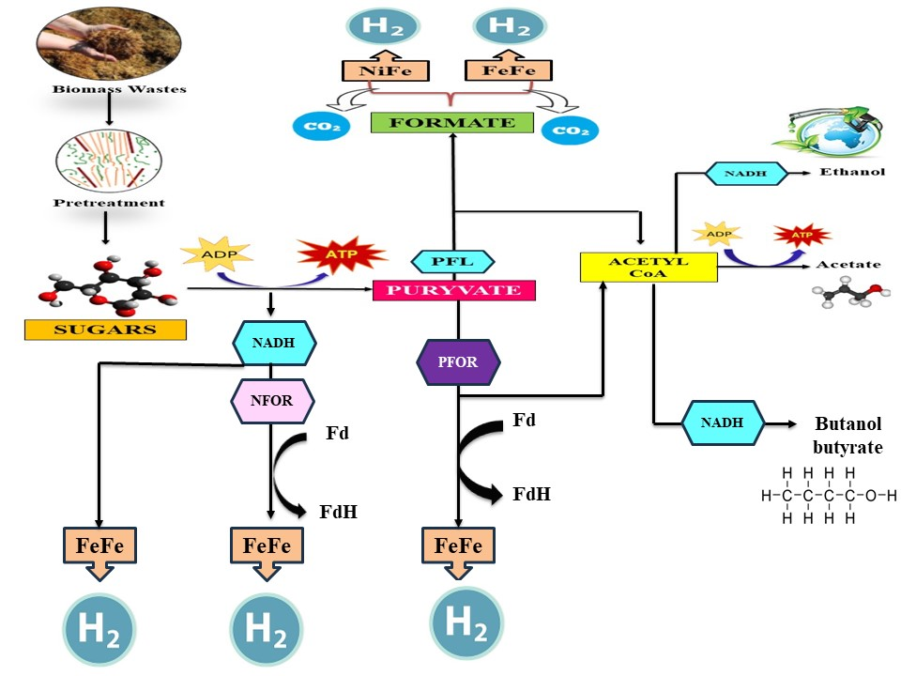
Figure 5. Dark Fermentation process Metabolic ways for converting substrate to hydrogen.
Thermochemical process:
Biomass pyrolysis: Biomass pyrolysis method necessitates catalyst regeneration, CO₂ emissions, the creation of production of char and tar, and variation in H₂ as a repercussion of biomass complexity and composition fluctuation. The H₂ feedstock production is expected to be between 26 and 65 g/kg [19].
Steam reforming: Steam reforming demanded catalyst renewal, runs at high temperatures, and generates CO₂. The H₂ output is expected to be between 40 and 130 g/kg feedstock [20].
C₆H₁₀O₅ + H₂O → 6CO + 6H₂
C₆H₁₀O₅ + 3H₂O → 4CO + 2CO₂ + 8H₂

C₆H₁₀O₅ + 7H₂O → 6CO₂ + 12H₂
Partial oxidation: Partial oxidation: This process operates at high temperatures, emits CO₂, is only suited for a few molecules, and requires a substantial amount of oxygen. H₂ yields have been reported to range between 17 and 150 grammes per kilogramme of starting material [20-21].
C₆H₁₀O₅ + 12O₂ → 6CO + 5H₂
C₆H₁₀O₅ + O₂ → 5CO + 5H₂ + CO₂
C₆H₁₀O₅ + 2O₂ → 3CO + 5H₂ + 3CO₂

Biomass gasification

One of the most feasible, sustainable, and possibly carbon-neutral hydrogen generation processes is biomass gasification. Biomass is a renewable resource that absorbs CO₂ from the atmosphere as it grows, resulting in a far lower net carbon footprint than fossil fuels. However, the viability of hydrogen generation from biomass must be directly tied to the region's raw material availability and cost. The physicochemical qualities, distribution, and hydrogen concentration of the starting material are the most important aspects. The structural composition and morphology of biomass feedstocks vary widely, and all of these features must be addressed when mixing feedstocks with suitable conversion methods [22]. Moisture, energy, and ash are thus the most significant characteristics to consider when evaluating biomass utilisation using this technique. Techno-economic research accompanied by competent life cycle evaluations are so critical in this area. Because of the low density of biomass, the transportation and storage expenses of biomass feedstock or generated hydrogen must be effectively justified in terms of economies of scale. The technique will be tough to compete with. Similar to coal, the most viable approach for biomass feedstock is gasification. It produces the most at high temperatures (usually 500-1300 °C), as demonstrated in the equation below. Surprisingly, combining biomass gasification with carbon capture and storage can produce negative carbon emissions (Figure 6).
Biomass+H₂O↔CO+CO₂+CH₄+H₂+char+tar
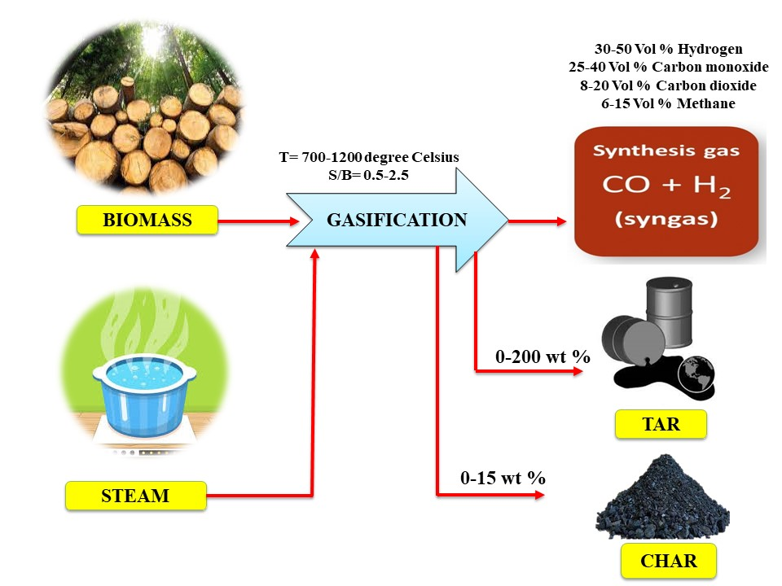
Figure 6. Representation of the procedure for biomass steam gasification.
Hydrogen Utilization
Fuel and Power Systems
Domestic and industrial heat comprise 33 and 50% of global carbon dioxide emissions and universal energy consumption rate, respectively. The bulk gases generated by the typical burning method of natural gas which are implicated in several environmental pollution concerns (i.e. greenhouse gaseous emissions). The principal source of carbon dioxide emissions was energy consumption, with a global emissions rate of 33.1 gigatonnes in 2018, primarily due to the combustion of fossil fuels. In contrast, using H₂ gas as an alternative fuel to natural gas has proven to be an effective strategy to minimize greenhouse gas emissions. Because of its reactive nature, it may immediately contribute in the decarbonization process in the energy sector after it is created from renewable energy sources, as illustrated in Figure 7. The hydrogen is currently generated by conventional i.e. non-renewable sources at a rate of 19%, 31%, and 49% from coal, heavy oil/naphtha, and natural gas, respectively, resulting in the release of about million 560 tonnes of CO₂ each year [23]. Furthermore, excess electricity generated by power plants may be turned into hydrogen, which can be either directly consumed or chemically processed into chemicals utilised in other industrial aspects [23]. Furthermore, hydrogen is employed as a single propellant in the aerospace sector or in conjunction with oxygen. The indicated liquid mixture (oxygen and liquid) creates a high quantity of energy, making it more appropriate for space applications. Because of the release of water during hydrogen combustion, as well as its high effectiveness relative to petrol, these characteristics qualify it for usage as an automobile fuel [24-25].
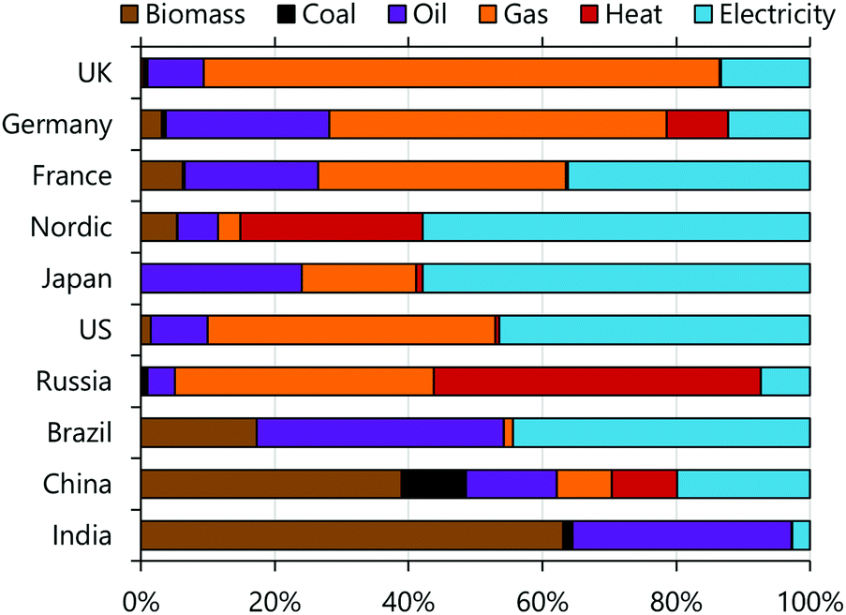

Figure 7. Representation of fuels used for domestic heating in ten countries, estimated using the DESSTINEE model with data from the IEA. Biomass includes both traditional (wood, dung) and modern (wood and miscanthus products); heat is generated off-site and sold to users; electricity includes both traditional (resistance and night-storage heaters) and modern (heat pumps).

Power-to-gas
Power-to-gas is a technique that uses electrical energy to produce a flammable gas. Power-to-hydrogen methods are becoming increasingly popular due to the assumption that hydrogen is a combustible gas with a high-power density [23]. According to the literature, multiple pilot projects have begun globally, with Europe having the greatest establishment rate of 85%, followed by the United States and Japan [24]. Germany, among other European nations, built a power-to-gas plant with a maximum output capacity of (40-100 megawatts) for industrial applications, and it will pump into the natural gas grid operating system beginning in 2022 [25].

Fuel cells

Fuel cells have recently attracted international interest for their efficiency and environmental friendliness as energy producers. In practice, they are integrated electrochemical devices that are commonly utilized to transform given chemical energy into electrical energy via redox processes [25]. In terms of energy generating efficiency, they can act as energy carriers. Fuel cells are made up of two electrodes (anode and cathode) separated by electrolytes that allow ions to migrate between them [24-25].

Process of Biomass in Hydrogen Production
Biomass is viewed as more promising than fossil fuels in terms of hydrogen generation due to its enormous reserves and supply, ease of oxidation, and high yearly output. As seen in Figure 8, hydrogen may be created in a variety of ways in connection to biomass. This comprises thermochemical conversion of wood waste, photocatalysis (PC) of municipal solid waste, lignin, sawdust, forest residues, agricultural waste, cellulose, polyols, fermentation of microalgae and cassava, biomethane (biogas), steam reforming of gasified biomass tar, and so on [24]. Despite the fact that CO₂ is released during the creation of hydrogen from biomass, the number of gaseous emissions is equivalent to the amount absorbed by organisms during their lifetime. [14]. The two ways that may be employed to manufacture hydrogen from biomass are biological and thermochemical processes. These will be covered in following sections. In comparison to coal & biomass has a relatively high hydrogen-to-carbon ratio. C₆H₁₀O₅ (pure cellulose) is thought to have a hydrogen-to-carbon of about 1.7, compared to 0.7 for typical bituminous coal [14]. Biomass using help to reduce reliance on hydrocarbons. Through a technique known as photosynthesis, biomass may restore CO₂ equilibrium in the atmosphere [24].
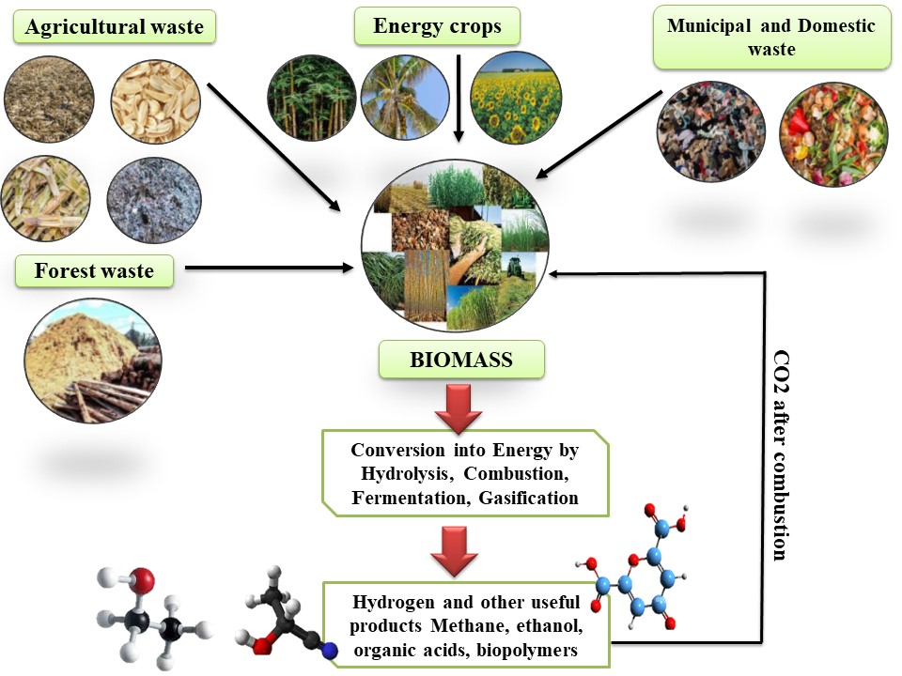
Figure 8. Representation of the various Biomass sources which are conversion into hydrogen and other beneficial products.

Transportation sector
Cars based on hydrogen fuel provide a possible alternative to outperform traditional battery-powered powertrains. Globally, hydrogen-fueled vehicle sales are expected to be 3% in 2030 and 36% in 2050. Different kinds of hydrogen (liquid and compressed) is used to power hydrogen-powered vehicles. The (high pressured) compressed H₂ is the most suited form in the Clarity and Nexo vehicle storage systems; hydrogen-based fuel cell cars developed by Honda and Hyundai, respectively. At the same time, liquid hydrogen powers the BMW Hydrogen 7 car [22]. The aviation industry is recognised as the quickest transportation option, with yearly growth in air traffic expected. Kerosene is the most popular aeroplane fuel. Various aviation fuels frequently exhibit a requirement, i.e., resistance to corrosion and extreme temperature fluctuations [22]. It's worth remembering that petroleum accounts for the vast bulk of aviation fuel. Alternative, less hazardous fuels such as liquid hydrogen (H_{2(l)}) are being created and are expected to be eco-friendly in order to increase energy preservation and lessen the negative environmental consequences of fossil fuels. Table 2 shows how the physicochemical parameters of hydrogen and kerosene fuels differ. As an aviation fuel, chilled hydrogen fuel has the potential to outperform kerosene. It generates less greenhouse gases emissions and is easily manufactured from a range of sources. Aside from that, running hydrogen-powered aircraft is distinguished by low maintenance costs, long-life engines, high energy content, and improved combustion.
Table 2: Representation of the physico-chemical properties [25]
S.No | Physicochemical properties | Kerosene | Hydrogen
1 | Chemical formula | C₁₂H₂₆C₁₅H₃₂ | H₂
2 | Density | 0.8 | 0.071
3 | Boiling point | 167-266 | -252.7
4 | Melting point | -50 | -259.2
5 | Vol% for combustion limit | 1.1-3.3 | 13-65
6 | Combustion heat | 42.7 | 121
7 | Flame temperature | 2125.9 | 2025.9
8 | Heat Vaporization | 360 | 440
9 | Standard heat of formation | -208.4 | 0
10 | Minimum ignition energy | 0.25 | 0.02
11 | Thermal efficiency | 42.9 | 120.0

Ammonia (NH₃) Production
Ammonia (NH₃) is regarded as one of the most important compounds, with massive global production rates. Brightling (2018) projects that the largest ammonia manufacturing facility will have a daily capacity rate of 3200 metric tonnes. Ammonia which is used as a fertilizer in agriculture. It is also used in polymer manufacturing, explosives, refrigerants, medicines, gas sensors, and fuel cells. The catalytic interaction between N₂ and H₂ elements via the Haber process promotes the ammonia synthesis process [25]. It is carried out in the as-designed reactor at pressure and temperature operating parameters of 20-30 Mpa and 300-500 °C, respectively, using potassium carbonate KOH-promoted finely split iron catalysts and the needed energy of 2.4 EJ. [25]. Furthermore, the H₂ used in the synthesis of ammonia process is generally generated from steam gas reforming, which is not considered ecologically favorable. As a result, there is growing interest in alternative green and sustainable ammonia synthesis processes, such as electrochemical hydrogen manufacture approaches and photocatalytic nitrogen fixation (artificial photocatalysis). Figure 9 The energy sources used determine the distinctness of the electrochemical ammonia production processes. Hydrogen may be created from water using an electrolysis technique that uses sustainable green energy sources and so reduces harmful greenhouse gases emissions [25].
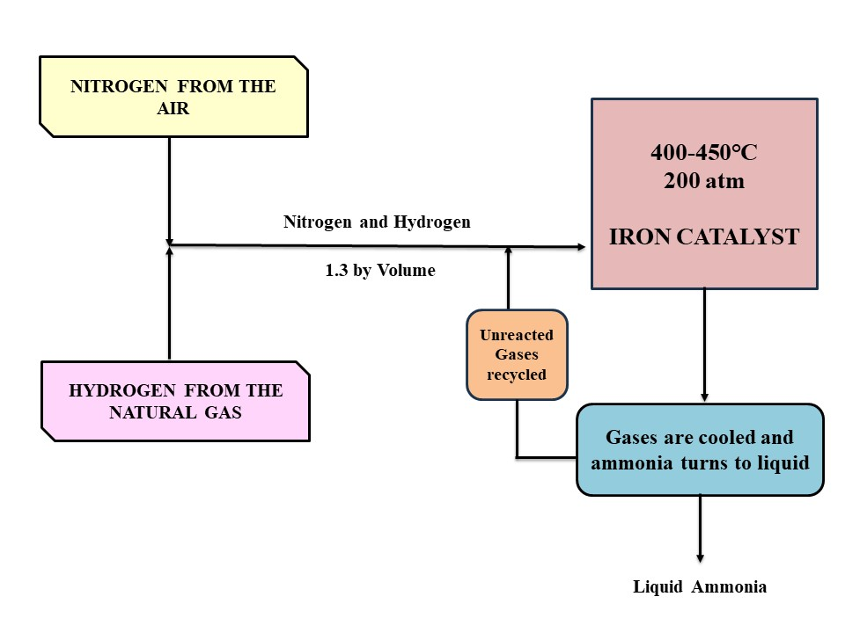
Figure 9. Flow chart scheme for the process of production of ammonia.

Metallurgical industries
In general, hydrogen may form oxy-hydrogen flames & function as a reducing agent in industrial metallurgical processes to extract metals from their ores. During the process of oxy-hydrogen flames synthesis which is known as exothermic reaction, hydrogen is permit to combine with oxygen at very high temperatures approximate 3000 °C to form oxy-hydrogen flames, which are then utilised for various welding & cutting on different non-ferrous metals. The metals can be pulverised and used in metallurgical applications later on, or they can be included into a composite material.
Hydrogen role in the World’s Energy Generation in Future
As previously said, hydrogen energy has the ability to act as an carrier to energy, and this has become critical in terms of sustainable growth in global, both in developing and developed nations [12-25]. According to research, the globe will require 500 to 1000 EJ of primary energy by 2050 [13]. Energy consumption is predicted to rise considerably higher in emerging nations, reduction [22-25]. Hydrogen and Fuel cells are widely regarded as critical future energy-supply technologies. It is predicted that RS shares of 35% and 70% by 2050 on total energy consumption might 10% and 33% by 2050 [25]. Hydrogen which can be transported and stored, and converted into electrical energy which is used as a fuel cells. H₂ is environmentally beneficial, depending on the energy source used to produce it. There are several theories why H₂ is an excellent and reasonable choice as a chemical fuel for the replacement of fossil fuels. The fundamental reason is that it is a supplementary energy carrier to electricity [15-20]. H₂ is viewed as a possible energy source creation which might help reduce CO₂ emissions. Figure 10 depicts a comparison between hydrogen technology and fossil fuel. It is projected that using hydrogen produced through traditional methods can reduce carbon emissions by roughly 20% when utilised in fuel cells. As a result, carbon emissions may be greatly decreased by employing RS to produce hydrogen [24-25]. According to the Hydrogen Council's research, H₂ demand and supply might reach 10 EJ per year by the end of 2050, with an additional 5-10% rise every year after that. As a result, H₂ can be considered a possible powerful rival in the world's energy system in the future [18].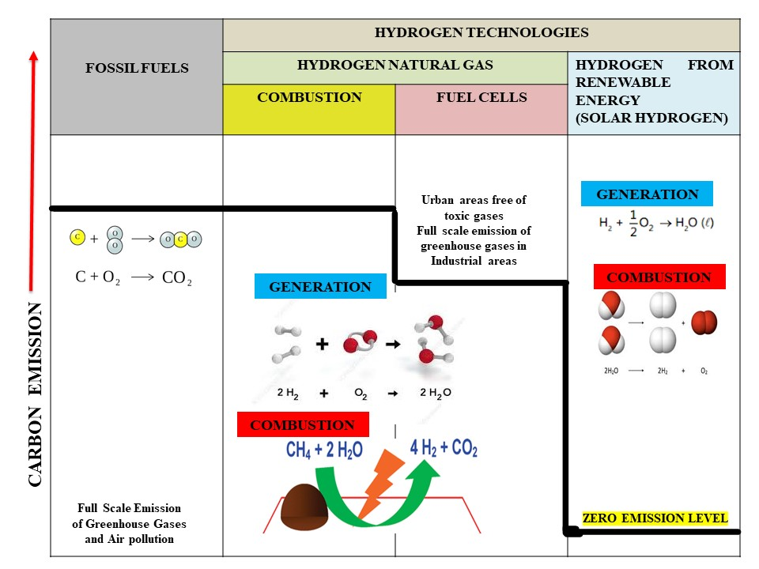
Figure 10. Impact of hydrogen production and combustion on emission of carbon
CONCLUSION
To ensure long-term production of clean and green hydrogen, it is necessary to perform a comprehensive review of potential production methods and their environmental consequences, as well as seasonal storage and utilization choices. Hydrogen may be produced using either fossil-based or renewable feedstocks; however, each process has advantages and disadvantages. The existing hydrogen colour coding is inaccurate, presuming that green hydrogen always has fewer carbon emissions than blue or grey hydrogen, which is not necessarily true. Water electrolysis is gaining traction; nonetheless, fulfilling 24% of energy demand with hydrogen under a 1.5-degree scenario of climate change mitigation will entail vast quantities of extra renewable electricity generation. In this scenario, essentially 31,320 terawatt-hours of electricity would be required to power electrolysers, which is more than is presently generated globally from all sources combined. The cost and accessibility of freshwater is one side of the coin, and the closeness of these two suppliers, namely renewable energy and freshwater, is the other. Water electrolysis research goals include decreasing the capital cost of electrolysis technology, discovering water supplies, finding utilization pathways for the generated oxygen, and boosting process efficiency. The economic viability of manufacturing hydrogen from biomass must be strongly tied to the availability and affordability of raw materials in the surrounding region when it comes to biomass gasification. The biomass physicochemical characteristics, dispersion, and hydrogen rate are the most important features of the supply materials. Because biomass feedstocks vary so significantly in structural composition and form, all of these aspects must be taken into account when combining the feedstock with the proper conversion method. In conclusion, the most prevalent hydrogen generating routes, such as steam methane reforming, water electrolysis, coal or biomass gasification, and methane pyrolysis with or without carbon capture and storage technologies, are fraught with difficulties.
AUTHORS CONTRIBUTION
All the review, interpretation, and conclusion were discussed and planned by both the authors. The first author (Dr. Shobhana Ramteke) wrote the first draft of the review article manuscript and critically re-viewed the whole review article manuscript for further valuable intellectual content. The second author (Dr. Bharat Lal Sahu) collected all the information, wrote and edited the whole review article manuscript and meanwhile both the authors have read and agreed to the published version of the review article.
REFERENCES
- Abe J.O.; Popoola A.P.I.; Ajenifuja E.; Popoola O.M.; Hydrogen energy, economy and storage: review and recommendation. Int J Hydrog Energy. 2019, 44:15072–15086. https://doi.org/10.1016/j.ijhydene.2019.04.068

- Abou Rjeily M.; Gennequin C.; Pron H.; Abi-Aad E.; & Randrianalisoa J.H.; Pyrolysis-catalytic upgrading of bio-oil and pyrolysis-catalytic steam reforming of biogas: a review. Environ Chem Lett 2021, 19:2825–2872. https://doi.org/10.1007/s10311-021-01190-2

- Agyekum, E.B.; Energy Poverty in Energy Rich Ghana: A SWOT Analytical Approach for the Development of Ghana’s Renewable Energy. Sustain. Energy Technol. Assess. 2020, 40, 100760

- Gyamfi, B.A.; Adebayo, T.S.; Bekun, F.V.; Agyekum, E.B.; Kumar, N.M.; Alhelou, H.H.; Al-Hinai, A. Beyond Environmental Kuznets Curve and Policy Implications to Promote Sustainable Development in Mediterranean. Energy Rep. 2021, 7, 6119–6129.

- Oh, S.; Nam, W.; Joo, H.; Sarp, S.; Cho, J.; Lee, C.-H.; Yoon, J. Photoelectrochemical Hydrogen Production with Concentrated Natural Seawater Produced by Membrane Process. Sol. Energy 2011, 85, 2256–2263

- Oliveira, A.M.; Beswick, R.R.; Yan, Y. A Green Hydrogen Economy for a Renewable Energy Society. Curr. Opin. Chem. Eng. 2021, 33, 100701

- Malerød-Fjeld, H.; Clark, D.; Yuste-Tirados, I.; Zanón, R.; Catalán-Martinez, D.; Beeaff, D.; Morejudo, S.H.; Vestre, P.K.; Norby, T.; Haugsrud, R.; et al. Thermo-Electrochemical Production of Compressed Hydrogen from Methane with Near-Zero Energy Loss. Nat. Energy 2017, 2, 923–931.

- Ishaq, H.; Dincer, I. Multi-Objective Optimization and Analysis of a Solar Energy Driven Steam and Autothermal Combined Reforming System with Natural Gas. J. Nat. Gas Sci. Eng. 2019, 69, 102927.

- Kamaroddin, M.F.A.; Sabli, N.; Nia, P.M.; Abdullah, T.A.T.; Abdullah, L.C.; Izhar, S.; Ripin, A.; Ahmad, A. Phosphoric Acid Doped Composite Proton Exchange Membrane for Hydrogen Production in Medium-Temperature Copper Chloride Electrolysis. Int. J. Hydrogen Energy 2020, 45, 22209–22222.
- Okonkwo, P.C.; Bhowmik, H.; Mansir, I.B.; Al, M.A.A.A.S.; Al Sfarini, N.F.A. Effect of Electrode Spacing on Hydrogen Production Using a Home-Made Alkaline Electrolyzer. Mater. Lett. 2022, 306, 130841
- Salari, A.; Hakkaki-Fard, A.; Jalalidil, A. Hydrogen Production Performance of a Photovoltaic Thermal System Coupled with a Proton Exchange Membrane Electrolysis Cell. Int. J. Hydrogen Energy 2021, 47, 4472–4488.
- Lu, C.; Li, W.; Zhang, Q.; Liu, L.; Zhang, N.; Qu, B.; Yang, X.; Xu, R.; Chen, J.; Sun, Y. Enhancing Photo-Fermentation Biohydrogen Production by Strengthening the Beneficial Metabolic Products with Catalysts. J. Clean. Prod. 2021, 317, 128437.
- Ratnakar, R.R.; Gupta, N.; Zhang, K.; van Doorne, C.; Fesmire, J.; Dindoruk, B.; Balakotaiah, V. Hydrogen Supply Chain and Challenges in Large-Scale LH2 Storage and Transportation. Int. J. Hydrogen Energy 2021, 46, 24149–24168.
- Abdalla, A.M.; Hossain, S.; Nisfindy, O.B.; Azad, A.T.; Dawood, M.; Azad, A.K. Hydrogen Production, Storage, Transportation and Key Challenges with Applications: A Review. Energy Convers. Manag. 2018, 165, 602–627.
- Turn, S.; Kinoshita, C.; Zhang, Z.; Ishimura, D.; Zhou, J. An Experimental Investigation of Hydrogen Production from Biomass Gasification. Int. J. Hydrogen Energy 1998, 23, 641–648.
- Aydin, M.I.; Karaca, A.E.; Qureshy, A.M.M.I.; Dincer, I. A Comparative Review on Clean Hydrogen Production from Wastewaters. J. Environ. Manag. 2021, 279, 111793.
- Zhao, B.; Zhang, X.; Sun, L.; Meng, G.; Chen, L.; Xiaolu, Y. Hydrogen Production from Biomass Combining Pyrolysis and the Secondary Decomposition. Int. J. Hydrogen Energy 2010, 35, 2606–2611.
- Wang, Y.; Jing, Y.; Lu, C.; Kongjan, P.; Wang, J.; Awasthi, M.K.; Tahir, N.; Zhang, Q. A Syntrophic Co-Fermentation Model for Bio-Hydrogen Production. J. Clean. Prod. 2021, 317, 128288
- Qiu, Z.; Martín-Yerga, D.; Lindén, P.A.; Henriksson, G.; Cornell, A. Green Hydrogen Production via Electrochemical Conversion of Components from Alkaline Carbohydrate Degradation. Int. J. Hydrogen Energy 2021, 47, 3644–3654.
- Nikolaidis, P.; Poullikkas, A. A Comparative Overview of Hydrogen Production Processes. Renewable Sustainable Energy Rev. 2017, 67, 597−611.
- Dincer, I.; Acar, C. Review and Evaluation of Hydrogen Production Methods for Better Sustainability. Int. J. Hydrogen Energy 2015, 40 (34), 11094−11111.
- Shiva Kumar, S.; Himabindu, V. Hydrogen Production by PEM Water Electrolysis. A Review. Mater. Sci. Energy Technol. 2019, 2 (3), 442−454.
- Lepage, T.; Kammoun, M.; Schmetz, Q.; Richel, A. Biomassto-Hydrogen: A Review of Main Routes Production, Processes Evaluation and Techno-Economical Assessment. Biomass Bioenergy 2021, 144, 105920.
- Gollakota, A. R. K.; Kishore, N.; Gu, S. A Review on Hydrothermal Liquefaction of Biomass. Renewable Sustainable Energy Rev. 2018, 81, 1378−1392.
- Agyekum, E.B.; Nutakor, C.; Agwa, A.M.; Kamel, S. A Critical Review of Renewable Hydrogen Production Methods: Factors Affecting Their Scale-Up and Its Role in Future Energy Generation. Membranes 2022, 12, 173.,https://doi.org/10.3390/membranes12020173

Table 3. Recent studies different findings on the production of hydrogen
S.No | Year | Mechanism | Results (hydrogen Production) | Reference
1 | 2011 | Photo electrochemical | 270 mol/cm² h. | Oh, S.; et al., 2011
2 | 2017 | Thermo electrochemical | 87% was obtained for the modeled hydrogen plant | Malerød-Fjeld, H.; et al., 2017
3 | 2019 | Evaluation of solar driven natural gas reforming system | The exergy efficiency is 31.1%, while the energy efficiency is 59.1%. | Ishaq, H.; Dincer, I. 2019
4 | 2019 | Proton exchange membrane | 91–97% | Kamaroddin, M.F.A.; et al., 2020
5 | 2021 | Alkaline water electrolysis | It was identified that smaller spacing distances for electrodes increases the interaction between the immersed electrode and the ionic electrolyte, which increases the rate of the electrochemical reaction, efficiency, and production of hydrogen. | Okonkwo, P.C.; et al., 2022
6 | 2021 | Proton exchange membrane electrolysis cell (PEMEC) | The PVT/PEMEC/PCM system recorded negligible effect. | Salari, A.; et al., 2021
7 | 2021 | Photo fermentation | 15.93% | Lu, C.; et al., 2021
8 | 2021 | Bio-hydrogen production based on lignocellulosic biomass | Hydrogen Production is 165 mL/g with a mean Hydrogen concentration of 52.3%. | Wang, Y.; et al., 2021
9 | 2021 | Water electrolysis, electrochemical conversion | The results indicate that there exists the potential to use industrial waste streams for sustainable hydrogen production. | Qiu, Z.; et al., 2021

Table 4: Representation of Diﬀerent Hydrogen Production Technologies
WATER
S.No | Technology | Advantages | Drawback | Energy efficiency (%) | H₂ yield | Cost | Reference
1 | Electrolysis | Simplicity, low temp, zero carbon emissions, O₂ as a byproducts | Required High pressure, problem in energy storage, low system efficiencies | 55 ̶ 50% | 111ª | 4.15-10.30 | Nikolaidis, P. et al., 2017
2 | Thermolysis | Clean and sustainable, zero carbon emissions, O₂ as a byproducts | Separation step is required to avoid the recombination,  High capital cost | 2-50 | 111ª | 7.98-8.40 | Dincer, I.; Acar, C. 2015
3 | Photoelectrolysis | Contributes to the sustainability of the energy supply photonic and electrical energies can be converted to chemical energy | Low efficiency requires a significant surface | 0.06 ̶ 14 | 111ª | 4.98-10.36 | Nikolaidis, P. et al., 2017
4 | Biophotolysis | Low operating temperature and pressure can be produce hydrogen at ambient conditions | Photocatalytic material is required a significant surface area to collect enough sunlight | 10-15 | 111ª | 1.42-2.13 | Shiva Kumar, S.; Himabindu, V. 2019
BIOMASS
5 | Dark fermentation | Can produce hydrogen at any time because light is not required | Hydrogen yield is metabolically restricted, high byproduct generation, low efficiency | 60-80 | 4-44 | 1.68-2.57 | Shiva Kumar, S.; Himabindu, V. 2019
6 | Photo fermentation | Allows for hydrogen production from a wide range of substrate, including waste streams | Strict control of environmental conditions is required | 0.1-12 | 9-49 | 2.57-2.83 | Shiva Kumar, S.; Himabindu, V. 2019
7 | pyrolysis | Developed technology, abundant and cheap feedstock. Solid, liquid and ga product streams, carbon neutral emission | Hydrogen yield depends upon the feedstock tar formation | 35-50 | 25-65 | 1.59-2.20 | Lepage, T. et al., 2021
8 | Gasification | Abundant and cheap feedstocks, carbon-neutral emission | Requires oxidation agents, hydrogen yields upon the feedstock tar formation | 30-60 | 40-190 | 1.77-2.05 | Dincer, I.; Acar, C. 2015
9 | Hypothermal liquification | Abundant and cheap feedstocks, drying step is not required, high energy efficiency, solid, liquid and gas product strams | Hydrogen yield depends upon the feedstock presence of nitrogenated compounds | 85-90 | 0.3-2 | 0.54-1.26 | Gollakota, A. R. K. et al., 2018
10 | Steam reforming | Developed technology, avoid the costly upgrading of the bio-oil | Produce carbon co-products | 74-85 | 40-130 | 1.83-2.35 | Shiva Kumar, S.; Himabindu, V. 2019

