ODONTOGENIC KERATOCYST-A TYPE OF BENIGN CYSTIC NEOPLASM/AGGRESSIVE CYST
Nishtha . U. More¹
morenishtha03@gmail.com
+91 8237928894
Yogita Dental College and Hospital,
Narangi river side, Dapoli road,
Khed - 415709.
ABSTRACT

Odontogenic Keratocyst (OKC) is a type of odontogenic cyst (OC). It can be described as a developmental Odontogenic cyst of distinctive form. Its specific histopathological features and clinical behavior of aggressive type make it considerably special. FNAC is most useful in oral cancer detection of squamous cell carcinoma. Odontogenic Keratocyst, was first identified and described in 1876. From 1971 till date, 39 cases of Odontogenic Keratocyst have been reported making it a rare case.

Keywords - Odontogenic Keratocyst (OKC), Odontogenic cyst (OC), Conebeam CTScan (CBCT), Fine needle aspiration cytology (FNAC), Dental lamina, resorption of bone, bone aggressive behavior, periapical cyst, and dentigerous cyst.

- INTRODUCTION

Odontogenic keratocysts can be described as pathologic cavities with epithelial lining encircled with fibrous tissue arising from odontogenic tissues usually occurring in tooth-binding regions of the jaw (maxilla and mandible). The resorption and displacement of adjacent teeth are caused by to destruction of the bony jaw because of cystic condition. The main pediatric population is involved. In general practice, periapical cysts are common. Usually, diagnosis is done by Fine needle aspiration biopsy (FNAC) /Fine needle aspiration cytology (FNAC). FNAC is most useful in oral cancer and, detection of squamous cell carcinoma. Previously, staying in touch with an Oral surgeon can reduce the extension of bone destruction and can be treated by enucleation. From 1971 to date, only 39 cases of Odontogenic Keratocyst have been found. The overall pathology service received has a major part of biopsies related to Odontogenic cysts. As the lining epithelium generates so much keratin that nearly fills the cyst lumen, it is called a 'Keratocyst'. There is a rise in osmotic pressure within the lumen of the cyst, so the cyst enlarges. The reason for the increase in the size of the two cysts is a rise in osmotic pressure in the lumen of the cyst. A similar mechanism is not seen to hold for Odontogenic Keratocyst as the cause may be unknown due to sudden changes in genetic material. In recent years, the term Cystic neoplasm (now known as KOCT) is given for this lesion. It shows a rapid mitotic rate and is associated with genetic and chromosomal abnormalities. Odontogenic keratocysts are seen more in pediatric patients. There is slight male predilection. The posterior body and ascending ramus part of the mandible considerably have a high tendency to show involvement in OKC.

Usually, asymptomatic conditions of small Odontogenic keratocysts and some extremely large cysts are associated with pain, swelling, or drainage. The lumen of the cyst consists of clear liquid similar to the serum transudate or is filled with cheesy material - keratinaceous debris. Infiltration of inflammation is absent in this thin fibrous wall and consists of a uniform layer of stratified squamous epithelium. The epithelium and rete ridge formation are not usually seen.

- CASE REPORT

A 31-year-old male reported to the clinic with a history of epigastric pain, stromal discomfort, burning, nausea, and vomiting. Treatment was done by diet counseling and antacid/acid-blocking mediators. It was thought that it was a case of Gastritis but later when the patient revisited complaining of pain and pus discharge in the lower left back region of the jaw; after diagnosis, it was recognized as a case of OKC. Investigations showed CBCT of the lower jaw (fig.2) and multiloculated scalloped radiolucent panoramic body and ramus region of the left mandible. The patient was advised for FNAC treatment by surgical intervention under GA. After some years, the patient again reported with growth of lesions over time. OKC recurrence rate is 2.5% to 62%(14). So it can be considered rare. Intervention - According to treatment protocol; treatment proceeds 1st with marsupialization. After marsupialization, reduced expression of ki-67 and B-cell lymphoma-2(bcl-2) markers were revealed after 1st histochemical analysis. An aggressive approach was taken regarding the lower left posterior region as it showed incomplete resolution so needed to be excised. Later more recurrence has been seen. The diagnosis concluded that OKC originated from Odontogenic epithelium i.e. dental lamina in the alveolus left from tooth development stages. Mainly thought to arise from the rest of Serres. The pathogenic mechanism of OKC was explained by Regzi and more. Mechanism favoring growth and expansion of Odontogenic Keratocyst are of high proliferation rate and shows over-expression of antiapoptotic proteins (bcl-2) and expression of matrix metalloproteinase (MMPs2 and9). Pathogenesis of this cyst is due to a mutation seen in PTCH1(patched) gene.

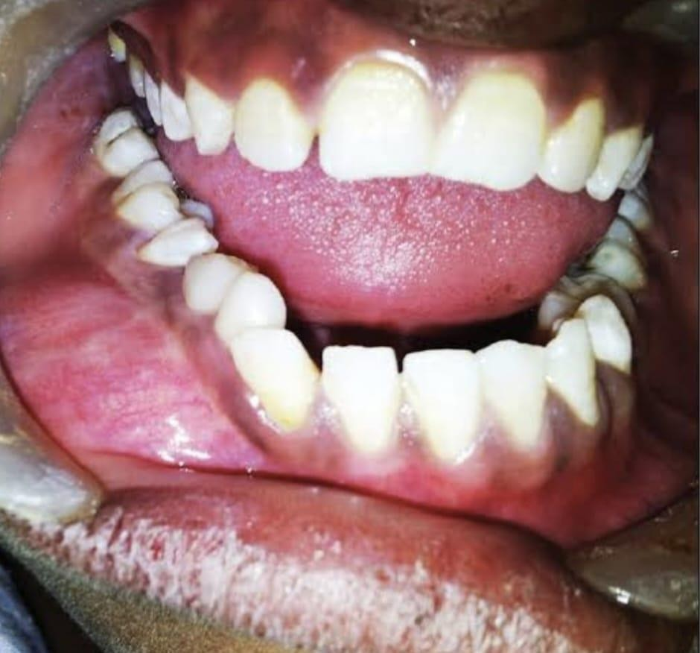

Figure 1: Odontogenic Keratocyst (OKC) noted in the basal epithelial layer

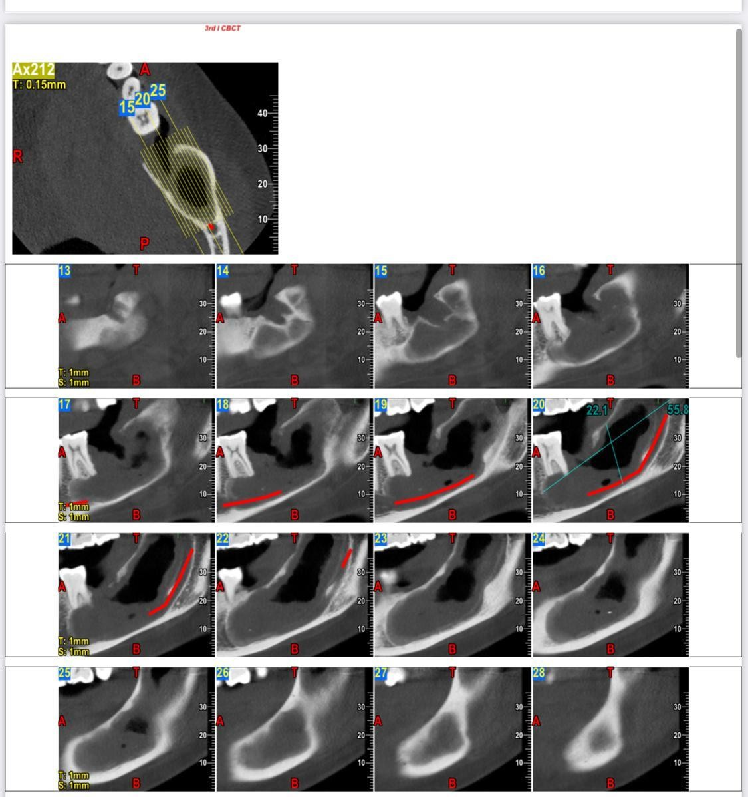
Figure 2: shows the Conebeam CT Scan (CBCT) of the lower jaw and multiloculated scalloped radiolucent panoramic body and rahmus region of the left mandible.

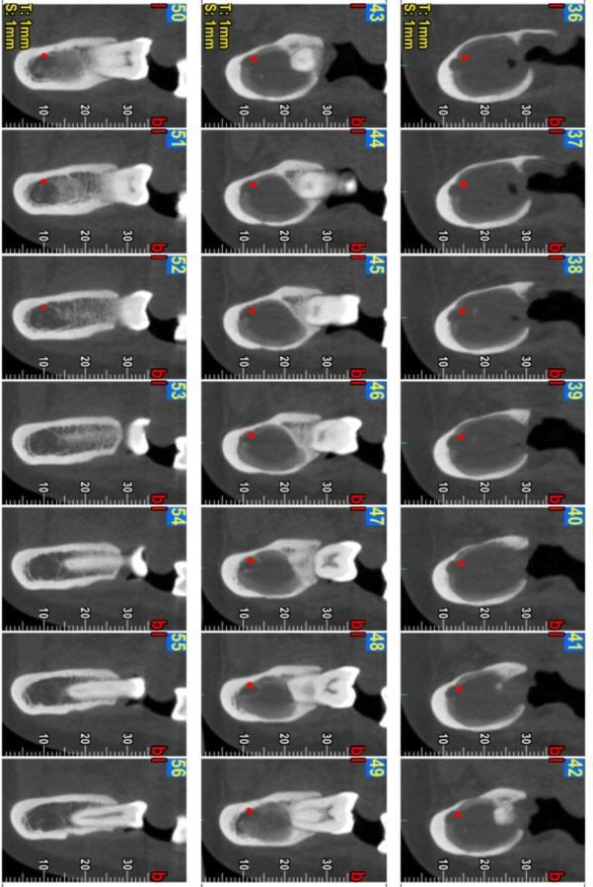

Figure 3: This Image shows (Black region) that the cyst has caused resorption of bone with the pus formation(white part 50 -54).

III.GENETICS

The gene map to chromosome 9q22.3-q31 is the PCTH gene. It is said that it has a tumor-suppressing function. The Hedgehog signaling pathway has an important molecule called Protein Patched Homolog-1(PCTH1). For the SHH ("sonic hedgehog") ligand, the PCTH is straight away formed with the so-called oncogene SMO (smoothened). The molecular evidence of two hit mechanisms in pathogenesis shows loss of alleles for more than two loci of 9q22(9.20) causing over-expression of bcl-1 and TP53 as seen in the Nevoid Basal cell carcinoma syndrome(NBCCS). Thus, it states that the neoplasm is represented by KCOT. In the progression of the development of sporadic KCOT, it is said the PCTH gene is the significant factor. The genes located in the 12q(21) show over-expression and amplification. This could also be due to the loss of LTAS2 and FHIT genes.
All this research has explained the aggressive nature of Odontogenic Keratocyst.

IV.TREATMENT

The best debate is considered in the ongoing topic of whether to recognize odontogenic keratocyst as a benign neoplasm or a cyst. Usually 1st priority is given to surgically excised cyst. The wall of the cyst is very thin, and weak and may easily be broken into pieces that might be the reason for incomplete eradication of OKC. On the other hand, a different method is also used to remove the lesion involving the ramus. A syndrome associated with Odontogenic Keratocyst is NBCCS which generally results in its recurrence. The most used treatment is enucleation. Usually, the left behind part is the epithelial rest of the cyst wall because of limited surgical access to the posterior part of the mandible, therefore the lesion frequently appears in the molar region of the mandible. The size of the lesion is not to be considered during its prognosis after the surgery. Usually, the treatments used are- Marsupialisation which is one of the advanced techniques to treat keratocyst followed by primary closure with enucleation, packing open with enucleation, and chemical/ fixation with cryosurgery, or resection. Cyst-oriented treatment is a kind of conservative type.
The lesion itself is responsible for its recurrence. Usually, remnants of dental lamina lead to its recurrence.
A syndrome associated with Odontogenic Keratocyst is Jaw cyst Badal cell neves bifid rib syndrome.

V. CONCLUSION

Odontogenic Keratocyst is not taken into consideration as an important or international topic. Many times, ' the cyst' origin stays untreated due to the negligence of the doctor, so the way to handle the cyst should be changed and a newer perspective should be added to the treatment of odontogenic keratocyst.
As we discussed, the recurrence lies in the remnants of dental lamina so, the aim should be professionally to excise the cyst completely. The clinical practitioner should focus on removing the cause rather than merely treating the cyst.
In this modern world, communication is a tool, if cysts like OKC are neglected in respective to histological and genetic studies, it may result in malocclusion and resorption of mandibular bone while compromising our ability to communicate.
As the case of Odontogenic Keratocyst lies in genetic mutation, the treatment would be easy if it is considered a hot topic for the Human genome project.

VI. REFERENCES

- Philipsen HP, Reichart PA. Classification of odontogenic tumors. A historical review. J Oral Patho Med.2006;35:525-9.
- Hauer A. Ein Cholesteatom I'm linken Unterkiefer unter eninem retinierten Weisheitszahn. Zeitsschrift fir Stomatologie. 1926;24:40-59.
- Barnes L, Eveson JW, Reichart P, Sidranksy D, editors. Lyon:IARC Press;2005. Pathology and genetics of head and neck tumors.
- Toller P. Origin and growth of cysts of the jaws. Ann R Coll Surg Engl. 1967;40:306-36.
- Robinson HB. Primordial cysts versus keratocysts. Oral Surg Oral Path Oral Med.1975;40:326- 4.
- Pogrel MA, Schmidt BL. The odontogenic keratocyst. Oral Maxillofac Surf Clin North Am.2003;15:321-6
- Soskolne WA, Shear M. Observations on the pathogenesis of primordial cysts. Br Dent J. 1967;123:321–6.
- Forssell K, Sainio P. Clinicopathological study of keratinized cysts of the jaws. Proc Fin Dent Soc. 1979;75:36–45.
- Philipsen HP. Om keratocyster (kolesteatom) i kaeberne. Tandlaege bladet. 1956;60:963–81.
- Pindborg JJ, Hansen J. Studies on odontogenic cyst epithelium. 2. Clinical and roentgenologic aspects of odontogenic keratocysts. Acta Pathol Microbiol Scand. 1963;58:283–94.
- Ahlfors E, Larsson A, Sjögren S. The odontogenic keratocyst: A benign cystic tumor? J Oral Maxillofac Surg. 1984;42:10–9.
- Shear M. The aggressive nature of the odontogenic keratocyst: Is it benign cystic neoplasm? Part 1 Oral Oncol. 2002;38:219–26.
- Regezi, Sciubba, Jordan . 4th ed. St. Louis, Missouri: Saunders Company; 2003. Oral Pathology Clinicopathological correlations; pp. 250–2.
- TJ. The odontogenic keratocyst: A cyst, or a cystic neoplasm? J Dent Res. 2011;90:133–42.
- Brannon RB. The odontogenic keratocyst A clinicopathologic study of 312 cases. Part I. Clinical features. Oral Surg Oral Med Oral Pathol. 1976;42:54–72.
- Reichart PA, Philipsen HP. London: Quintessence Publishing; 2004. Odontogenic tumors and allied lesions.
- Neville BW. Update on Current Trends in Oral and Maxillofacial Pathology. Head Neck Pathol. 2007;1:7580.
- Madras J, Lapointe H. Keratocystic odontogenic tumor: Reclassification of the odontogenic keratocyst from cyst to the tumor. J Can Dent Assoc. 2008;74:165–65h.
- Levanat S, Gorlin RJ, Fallet S, Johnson DR, Fantasia JE, Bale AE. A two-hit model for developmental defects in Gorlin syndrome. Nat Genet. 1996;12:85–7.
- Lo Muzio L, Staibano S, Pannone G, Bucci P, Nocini PF, Bucci E, et al. Expression of cell cycle and apoptosis-related proteins in sporadic odontogenic keratocysts and odontogenic keratocysts associated with the nevoid basal cell carcinoma syndrome. J Dent Res. 1999;78:1345–53.
- Heikinheimo K, Jee KJ, Morgan PR, Nagy B, Happonen RP, Knuutila S, et al. Gene expression profiling of odontogenic keratocyst. J Oral Pathol Med. 2004;33:462.
- Eyre J, Zakrezewska JM. The conservative management of large odontogenic keratocysts. Br J Oral Maxillofac Surg. 1985;23:195–203.
- Morgan TA, Burton CC, Qian F. A retrospective review of the treatment of odontogenic keratocyst. J Oral Maxillofac Surg. 2005;63:635–9.
- Dammer R, Niederdellmann H, Dammer P, Nuebler-Moritz M. Conservative or radical treatment of keratocysts: A retrospective review. Br J Oral Maxillofac Surg. 1997;35:46–8.
- Forssell K, Forssell H, Kahnberg KE. Recurrence of keratocysts. A long-term follow-up study. Int J Oral Maxillofac Surg. 1988;17:25–8.
- di Magliano Pasca M, Hebrok M. Hedgehog signaling in cancer formation and maintenance. Nat Rev Cancer. 2003;3:903–11.
- Taipale J, Chen JK, Cooper MK, Wang B, Mann RK, Milenkovic L, et al. Effects of oncogenic mutation in Smoothened and Patched can be reversed by cyclopamine. Nature. 2000;406:1005–9.
Zhang L, Sun ZJ, Zhao YF, Bian Z, Fan MW, Chen Z. Inhibition of SHH signaling pathway: Molecular treatment strategy of odontogenic keratocyst. Med Hypotheses. 2006;67:1242–4.

