Nanorobotics: A novel approach in the Drug Delivery System of Cancer Chemotherapy and it’s application.
Mr Kashyap Saurabh R., Miss. Panchwagh Mayuri P.
Department of pharmacy practice, ASPM’S K.T Patil College of Pharmacy, Osmanabad, Maharashtra 413 501.
*Corresponding author’s E-mail: Kashyapsaurabh241@gmail.com
Abstract:
One of the most awaited developments in the field of health care is the development of nanorobotics, which consists of complex submicron devices made of nanocomponents. It has a promising future in the field of medicine administration for cancer, the leading cause of death in people under the age of 85 years. Nanorobots could deliver and disperse massive amounts of anticancer drugs to kill cells without harming healthy cells, reducing the side effects of current therapies like chemotherapy damage. The final version of this invention will have a substantial impact on disease detection, therapy, and prophylaxis thanks to a tight collaboration between experts in robotics, medicine, and nanotechnology. Due to modern scientific capabilities, it has become possible to attempt the creation of nano-robotic devices and interface them with the macro world for control. Countless such machines exist in nature and there is an opportunity to build more of them by mimicking nature. Nowadays these nanorobots play a vital role in the field of BioMedicine. Especially in the treatment of cancer, Cerebral Aneurysm, kidney stones removal, also to remove the defective part in our DNA structure and some other treatments that have the greatest aid to save human lives. This paper includes a study on several ways to cancer therapy utilizing nanorobots. Furthermore, it offers insight into the future breadth of this area of research.
Keyword:
Nanotechnology, nanorobots, cancer, treatment, nanomedicine, drug delivery system, chemotherapy
Introduction:
Cancer is the uncontrolled growth of abnormal cells in the human body. Cancer is characterised by unchecked cell proliferation that defies the regular cycle of cell division. These cells are referred to as cancer cells. Signal transduction is used to directly monitor the growth, proliferation, and cell division of normal cells. Cancer cells, however, create independent growth and proliferative mechanisms. Malignant is a disease that causes carcinogenesis, a process that transforms healthy cells into malignant cells. Although there are many different varieties of cancer clinically, the biological cause of cancer, which results from a problem with gene expression, is the same. Various factors cause normal cells to turn into cancer cells. These elements or substances are referred to as carcinogenic.^{1,2}
The best way to define nanotechnology is as a description of atomic and molecular-level activities that have practical uses. One billionth of a metre, or around 1/80,000 of the diameter of a human hair, or 10 times the diameter of a hydrogen atom, is referred to as a nanometer. The capacity to measure, manipulate, and construct matter with features on the scale of 1-100 nm is a size-related issue.⁴ Automating molecular production will be crucial for nanotechnology to become cost-effective. The engineering of molecular goods requires the use of nanorobots, which are miniature robotic machines.
Researchers have recently drawn attention to the astonishing technical trend known as nanotechnology, which is characterised by the explosive development of electronics for use in communication, health care (known as nanomedicine), and environmental monitoring. The scientific bottlenecks that affect the longevity of living things, particularly humans, are the subject of a lot of contemporary research. The majority of these bottlenecks are caused by diseases with few or no other options for healing and therapy.^{1,4}
Nanorobots are similar in size to biological organelles and cells. Imagine artificial cells (nanorobots) patrolling the circulatory system, spotting minute amounts of infections, and eliminating them. This opens up a vast array of potential uses in environmental monitoring for microorganisms and in health care, for instance. This could amount to a programmable system and have significant medical ramifications, leading to a paradigm change from treatment to bar. If nanorobots were small enough to enter the cells, alternative uses like cell healing may be possible.⁶ Additionally, tiny sensors and actuators are necessary if the idea of a physically connected elevated information infrastructure is to become a reality.
According to the Quintiles IMS Institute's Global Oncology Trend Report, the cost of cancer drugs was $100 billion worldwide in 2014. The development of nanorobotics was most likely driven by the treatment of cancer. Chemotherapeutic agents used to treat cancer are dispersed non-specifically throughout the body where they affect both cancerous and healthy cells, limiting the dose that can be given to the tumor and also resulting in subpar treatment due to high toxicity.^{8,11} To combat the lack of specificity in traditional cancer therapy agents, molecularly focused medical care has arisen.
By exclusively targeting the neoplastic-specific cells and tissues and protecting the surrounding healthy cells from the toxicity of the chemotherapy medications being employed, a nanorobot can assist with smart chemotherapy for medication administration and give an effective early dissolution of cancer. Chemotherapy and radiation therapy are frequently used to treat cancer.^{6,14} They frequently work well in eliminating cancer cells. They have long-term effects and seriously harm healthy tissue. Nanoparticles will increase the intracellular concentration of medicine in cancer cells while reducing toxicity in normal cells by utilising both passive and active targeting mechanisms. As a result, this paper concentrates on new technological developments in nanorobotics harvesting primarily for the utilisation of drug delivery systems for the treatment of cancer.¹
Pathophysiology of cancer:
The formation of malignant tumors or cancer in the body follows a common pathophysiological process, regardless of the histological and physiological differences between different forms of cancer.
Damage to the genetic machinery of cells (such as mutation, abnormalities in gene expression, activation of tumor promoter genes, inactivation of tumor suppressor genes, etc.) is generally acknowledged as the aetiology of cancer.⁵
Malignant tumor formation is thought to be largely dependent on damage to the cell's genetic machinery and the silencing of anti-tumor genes. However, it should be remembered that the inactivation of tumor suppressor genes is one of the body's normal physiological reactions, and when this reaction develops into a pathophysiological situation, it causes the development of cancer.^{7,9}

Normal cell
Expression of altered gene product and loss of regulatory gene product
DNA damage
Malignant neoplasm
Mutations in the genome of somatic cells
Activation of growth promoting oncogenes
Alteration of genes that regulate apoptosis
Inactivation of cancer suppressor genes

Inherited mutation in:
Genes affecting DNA repair.
Genes affecting cell apoptosis.

Fig. No.1 Pathophysiology of cancer.
First step: mutation and tumor initiation.
- A single cell that has undergone genetic modification will mutate, which will cause it to proliferate abnormally and become a tumor cell.
Second step: cell proliferation and tumor progression.
- Additional mutations continue to develop inside the tumor population's cells as the tumor progresses.
- The rapid growth and proliferation of mutant cells give them a selective advantage over normal cells. As a result, the progeny of a cell with this extra mutation will predominate within the tumor population.
Third step: clonal selection and malignancy.
- Tumor cell division then produces new tumor cell clones with faster growth rates or other traits (such as survival, invasion, or metastasis) that provide them with a selective advantage. It is known as clonal selection.
- Throughout a tumor's development, clonal selection occurs, causing tumors to grow more quickly and turn more aggressive.

Fourth step: Metastasis
- Cancer cells can spread to other parts of the body through a complicated process called metastasis, in which they separate from the primary tumor and move through the circulation or lymphatic system.
- The cells continue to divide at the new places, where they eventually produce more tumors made up of cells that resemble the original tissue.
- The propensity of tumors to metastasis plays a significant role in the lethality of diseases like pancreatic cancer and uveal (iris, ciliary body, or choroid of the eye) cancers.
- There are still a lot of fundamental questions regarding the clonal structures of metastatic tumors, phylogenetic relationships between metastases, the scope of ongoing parallel evolution in primary and metastatic sites, how the tumor spreads, and the part the tumor micro-environment plays in determining the metastatic site.
Nanorobots and their types:
Nanorobots are miniature machines that can perform tasks on par with those currently performed by larger machines. They have applications in industry, medicine, and other fields, such as the development of nanomotors used for energy conservation. Nanorobots have also demonstrated their utility in reducing infertility issues by acting as an engine and enhancing sperm motility when attached to them. The two types of nanorobots that are explored the most are organic and inorganic.^{5,8} By fusing DNA cells from bacteria and viruses, organic nanorobots—also referred to as bio-nanorobots—are produced. This particular kind of nanorobot poses less risk to the organism. Inorganic nanobots are more dangerous than biological nanobots since they are made from materials like synthetic proteins, diamond structures, and other things. Researchers have developed a method of encapsulating the robot to get around this toxicity obstacle, reducing the likelihood that it would be destroyed by the body's self-defence mechanism.⁹
Understanding the biological motors of live cells will enable scientists to comprehend how to energise micro and nano-sized devices employing reactive mechanisms. A nano valve was developed by the Chemistry Institute of the Federal Fluminense University. It consists of a tank with a shutter covering it, where dye molecules are kept and can depart when the lid is opened uniformly. This device is constructed of beta-cyclodextrins, organometallic compounds, and silica (SiO2) and will be employed for therapeutic purposes.^{11,9} Proteins are used in some experiments to fuel nanomotors that can move enormous objects, as well as the construction of nanorobots using DNA hybridization and antibody proteins.
How Nanorobot kills Tumor cell:
Engineers at the University of California San Diego have developed tiny ultrasound powdered robots that can swim through blood, removing harmful bacteria along with the toxin they produce.These proof of concept nanorobots could one day after a sale an efficient way to detoxify and decontaminate biological fluids. These nanorobots are specially designed for the cancer cell treatment and its target is found in the cancer cell with the help of blood clotting protein leading to death of the tumor.
Each nanorobot is made from a flat rectangular DNA origami sheet , 90 nanometers by 60 nanometers in size. A key blood clotting enzyme , called thrombin ,is attached to the surface.
Thrombin can block tumor blood flow by clotting the blood within the vessel that feeds tumor growth , causing a sort of tumor mini heart attack and leading to tumor tissue death.
Steps in killing of cancer cells: ^{1,3,4}
Step -1:
First, an average of four thrombin molecules was attached to a flat DNA scaffold. Next , the flat sheet was folded in on itself like a sheet of paper into a circle to make a hollow tube. They were injected with an IV into a mouse , then traveled through the bloodstream , homing I on the tumor.
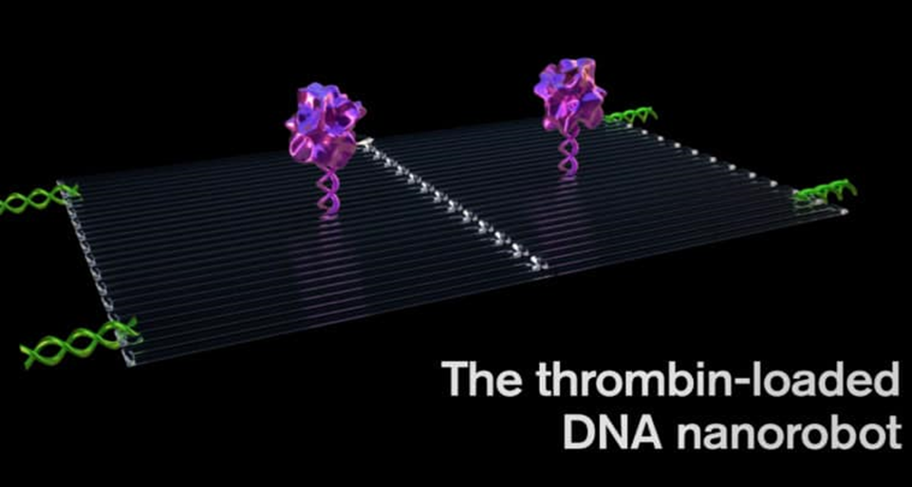
Fig. No.2 Thrombin loaded DNA nanorobot
Step -2:
They key to programming a nanorobot that attacks only a cancer cell was to include a special payload on its surface called a DNA aptamer , The DNA aptamer could specifically target a protein called nucleolin, that is made in high amounts only on the surface of tumor endothelial cells and not found on the surface of healthy cells.
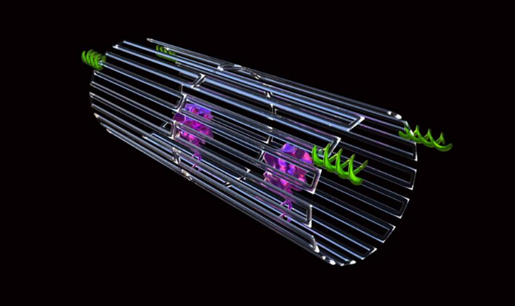
Fig. No.3 Nanorobot enclosed in DNA sheath with tumor targeting DNA
Step -3 :
Once bound to the tumor blood vessels surface , the nanorobot was programmed like the notorious Trojan horse, to deliver its unsuspecting drug cargo into the very heart of the tumor, exposing the thrombin.
Fig. No.4 Illustrates Nanorobots killing the tumor cell .
Chemotherapy drug delivery using nanorobots in cancer treatment:
More effective targeted drug administration has been made possible by recent developments in medication delivery, which use nanosensors to identify specific cells and smart medications to control discharges.¹ Since rapidly replicating cells are a key characteristic of malignant cells, traditional chemotherapeutic medicines work by destroying them. The majority of anticancer drugs have a narrow therapeutic window and frequently cause cytotoxicity to healthy stem cells that divide quickly, including those in the bone marrow, macrophages, gastrointestinal tract (GIT), and hair follicles. This results in side effects like myelosuppression (lower production of WBCs, which produces immunosuppression), mucositis (inflammation of the GUT lining), alopecia (hair loss), organ dysfunction, thrombocytopenia/anaemia, and haematological side effects, among other things.^{9,10}
When doxorubicin is combined with other antineoplastic medications to reduce its toxicity, it is used to treat a variety of cancers, including Hodgkin's disease. Breast cancer is treated with the intravenous injection of the medication paclitaxel. Bone marrow suppression and increasing neurotoxicity are two serious adverse effects. The intra-DNA binding filament is produced by the alkylating medication cisplatin.^{4,14,12} It can be nephrotoxic and has side effects including euphoria and violent vomiting. By blocking type 1 topoisomerases, an enzyme necessary for cellular duplication of genetic material, camptothecin is used to treat neoplasia.
Numerous projects have been started to use nanotechnology to create DDS that can lessen the side effects of conventional therapy. Doxorubicin was coated on the surface of single-walled carbon nanotubes (SWNTs). Metastatic cancer cells were treated with doxorubicin using a polymer prodrug/collagen hybrid. An innovative development in the field is the use of polymeric pro-drug nanotechnology in the treatment of aberrant cells that divide quickly.⁵
By exclusively targeting the neoplastic-specific cells and tissues and protecting the surrounding healthy cells from the toxicity of the chemotherapy medications being employed, a nanorobot can assist with smart chemotherapy for medication administration and give an effective early dissolution of cancer.^{12,13} Chemical molecules can be retained in the bloodstream for as long as necessary thanks to nanorobots acting as drug transporters, providing chemotherapy with the appropriate pharmacokinetic characteristics.
By injecting nanobots intravenously, it is possible to use them in clinical settings for diagnosis, treatment, and surgery. The recipient's body may be infused with the nanorobots intravenously. The pharmacokinetics of chemotherapy includes uptake, metabolism, and excretion as well as a rest interval to give the body a chance to heal before the next chemotherapy session. Patients are frequently treated in two-week cycles for small tumors.^{1,12} Using proteomic-based sensors, nanorobots can quickly examine and diagnose cancer as a primary time threshold for medicinal applications. The transport of protein medications to solid tumors can be predicted using the kinetics of the ingestion of a very small molecular weight magnetic resonance contrast agent. The study of nanorobotics must include testing and diagnosis.
After nanorobots pass cellular membranes for targeted administration, the medication's effectiveness will depend on how long it remains in the tumor. Medication transport channels from plasma to tissue have an impact on chemotherapy to achieve more effective tumor chemotherapy depending on its shape. According to the most recent research, site-specific functionalization, DNA creation of molecular-scale devices with improved shape control, and nanotechnology ensure fascinating benefits in the development of nanomedicine.^{6,8} In vivo, deployment is still hampered by biological milieu unpredictability and innate immune activation, though. Therefore, the main advantage of using nanobots to administer cancer medications is that they lessen the adverse impacts of chemotherapy.
The most effective way for the nanorobot design incorporates carbon nanotubes and DNA, which are currently candidates for the newest sorts of nanoelectronics. A complementary metal oxide semiconductor (CMOS) is utilised to create circuits with typical sizes in the tens of nanometers for compound biosensors with sole-chain antigen-binding proteins. This method uses stimulation induced by proteomics and bioelectronics signals for medication release. As a result, anytime the nanorobot detects preset variations in protein gradients, nano actuators are activated to adjust drug delivery. Relevant variables directly linked to major medical target identification include thermal and chemical signal alterations. B cell lymphoma-2 (Bcl-2) and E-cadherin are a few examples of variable protein aggregation within the body close to a therapeutic target under pathological circumstances.⁵⁻⁷ Furthermore, tissues with inflammation frequently experience temperature variations. The most crucial clinical and therapeutic suggestions for nanorobot template examination are integrated into the framework as chemical and thermal properties. Additionally, it incorporates chemical and thermal properties as the fundamental diagnostic and therapeutic guidelines for evaluating nanorobot frameworks.⁸
Limitation of nanorobotics used in cancer therapy:
Nanorobots do, however, have several drawbacks, such as high design and development costs, high complexity, and interface issues. The drug-carrying nanorobots can hardly get through blood capillaries because of how thick blood is at the nanoscale. Due to molecular collisions brought on by Brownian motion in the molecules, the behaviour of the nanorobot becomes unpredictable and uncontrollable. One significant obstacle and significant issue that academics are working to overcome is this instability. The development of appropriate feedback sensors to enable autonomous control at a larger scale represents the other major problem.
Nanorobots must be fully operational with minimal supervision, highly efficient, controlled, and inexpensive in large manufacturing. They must, however, be large enough to handle both endogenous and external information from various sensory systems and small enough to enter the body without physically degrading live tissues. Due to a lack of efficient procedures in the realm of nanotechnology, the nanoscale structures needed for various applications have not been produced from a design perspective. Physicists embrace the bottom-up manufacturing method—the notion of developing gadgets atom by atom—but chemists do not favour it because of the high reactivity of the majority of atomic species.
Other difficulties for researchers include creating nanorobots with sizes below the nanometer range, as well as controlling huge groups of nanorobots (called swarms). Additionally, there are many unique design challenges in the realm of nanorobotics, including sensing, navigation, power communication, locomotion, and component manipulation. The ability to manipulate matter at the molecular level to change the behaviour (dynamics and characteristics) of nanorobots is another challenge related to their structural design. In general, the automation, power, and production of nanorobots is a difficult and extremely unique subject.
Future of nanotechnology in the area of medicine:
Numerous traditional scientific disciplines, including medicine, chemistry, physics, materials science, and biology, have come together to establish the developing field of nanotechnology to combine the necessary cooperative skills to produce these novel technologies. There is a wide range of potential uses for nanotechnology, from enhancing current procedures to developing whole new tools and abilities. The last few years have seen an exponential rise in interest in nanotechnology research, which has uncovered new uses for the technology in medicine and given rise to a cutting-edge subfield termed nanomedicine. It covers the art and science of identifying, treating, and preventing disease, traumatic injury, and pain relief; preserving and improving human health using nanoscale architectured materials, biotechnology, and genetic engineering; and eventually, complex machine systems and nanorobots, known as "nanomedicine."
Nanomedicine may develop technology for in vivo diagnostics that can function inside the human body to diagnose illnesses earlier and discover and monitor hazardous substances and cancer cells. A surgical nanorobot controlled or directed by a human surgeon may function as a semi-autonomous on-site surgeon when introduced into the body via the intravenous route or cavities. While retaining connection with the supervising surgeon via coded ultrasonic signals, an internal computer may control the device's activities, including scanning for disease and diagnosing and treating harm using nano manipulation. Scientists were able to create a new generation of self-sustaining implanted medical devices, sensors, and portable gadgets by converting mechanical energy from human movement, muscle stretching, or water flow into electricity.
By bending and then releasing piezoelectric and semiconducting zinc oxide nanowires, nanogenerators produce electricity. The production of nanowires on polymer-based films and the use of flexible polymer substrates may one day enable portable devices to be powered by the motion of their users. Among the applications are fluorescent biological labelling, drug and gene delivery, pathogen detection, protein sensing, DNA structure probing, tissue engineering, tumor identification, separation and purification of biological molecules and cells, MRI contrast enhancement, and phago kinetic research.

Application of nanorobots in medicine:
Nanorobots are anticipated to make it possible for people suffering from various ailments to receive new treatments, which will signal a significant advancement in medical history. Recent advancements in the field of biomolecular computing are a promising first step towards enabling more complicated nanoprocessors in the future. Studies aimed at developing the biosensors and nano-kinetic tools needed to enable the operation and movement of medical nano-robotics have also advanced.³
The use of nanorobots may advance biomedical intervention through minimally invasive operations, assist patients who require ongoing bodily function monitoring, or even increase treatment efficacy through the early detection of potentially fatal diseases.⁸
For example, the nanorobots may be used to attach to moving immune cells or white blood cells, enabling them to reach injured regions more quickly and aid in their recovery. Nanorobots will be used in chemotherapy to treat cancer by administering exact chemical dosages, and a similar strategy might be used to make nanorobots capable of delivering anti-HIV medications.^{10,11} Nanorobots could be utilised as auxiliary equipment for damaged organs to process certain chemical reactions in the human body. Nanorobots may be used for monitoring diabetes and regulating glucose levels for patients.³
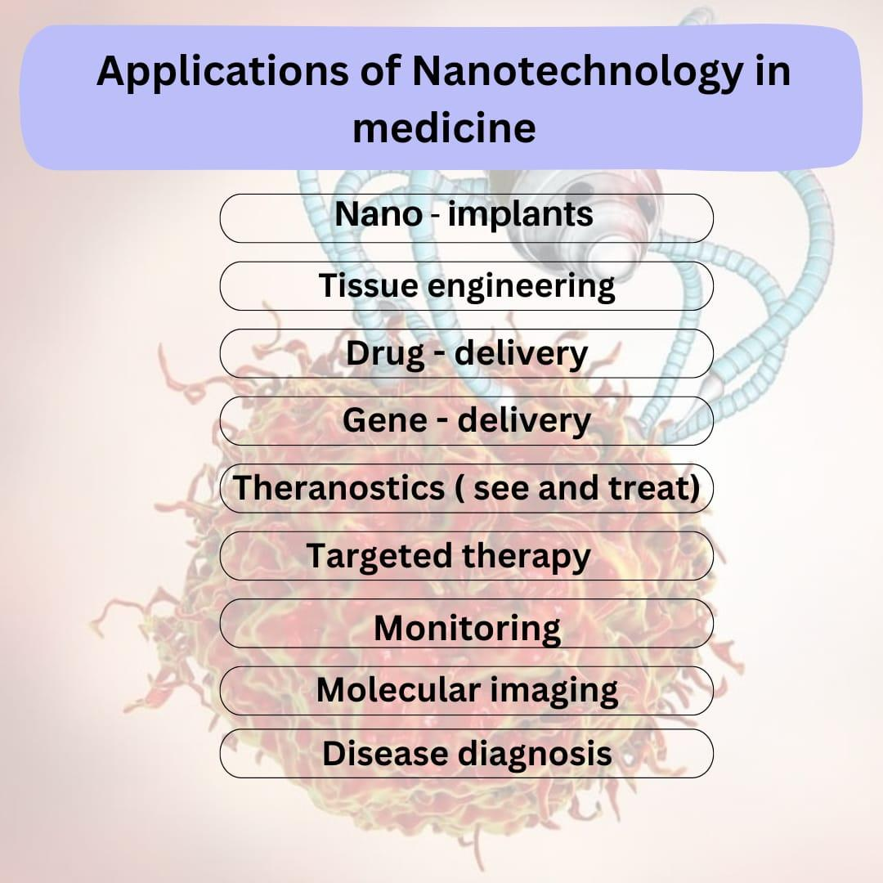
Fig. Illustrates applications of Nanotechnology in medicine
- Nanorobot used in gene therapy:
By comparing the molecular structures of the DNA and proteins found in the cell to desired or known reference structures, medical nanorobots can quickly correct hereditary disorders. Any deviations can then corrections may be made, or desired changes may be added. Chromosome replacement therapy may occasionally be more effective than CY to repair a damaged chromosome. A human cell's nucleus is home to an assembler-built repair vessel that carries out certain genetic upkeep. The nanomachine gently pulls an unwound strand of DNA through an aperture in its prow for analysis after stretching a super coil of DNA between its lower set of robot arms. While this is happening, the upper arms pull regulatory proteins away from the chain and deposit them in an intake port. The information in the database of a larger nano computer located outside the nucleus and linked to the cell-repair ship by a communications link is compared to the molecular structures of both DNA and proteins.⁶ The repair vessel would be smaller than the majority of bacteria and viruses, yet capable of therapies and cures far beyond the reach of modern doctors. If irregularities found in either structure are corrected and the proteins are reattached to the DNA chain,^{7,8} which re-coils into its original form with a diameter of only 50 nanometers, the repair vessel would be smaller than most bacteria and viruses. Internal medicine would gain new significance when a patient's blood contained trillions of these devices.¹⁴ The molecular level of disease would be tackled, including viral infections, cancer, and arteriosclerosis might be eradicated.
- Nanorobot used for brain aneurysm:
A medical gadget prototyped using computational nanotechnology is the nanorobot for brain aneurysm prognosis. Prototyping of equipment, manufacturing methods, and inside-body transduction are the three key components of this. To produce nanorobots quickly and effectively, equipment prototyping is a critical component of computational nanotechnology. It aids in the exploration of essential issues related to medical instruments and device prototypes. The construction of race cars, aircraft, submarines, ICs, and medical equipment all used a similar strategy in the past. The same can now be applied to advance the study and development of medical nanorobots.^{2,3} The manufacturing technology used to create the nanorobot should be incorporated into the biochip. As a result, a description of the architecture of the nanorobot is offered together with new materials, photonics, and nanobioelectronics. Additionally, the parameters for the inside-body interactions and nanorobot morphology are based on cell morphology, microbiology, and proteomics. Medical prognosis is based on changes in chemical gradients and telemetric instruments, with the nanorobots activated depending on proteome overexpression.¹² These three ideas make up the essential components needed to enhance the creation and application of medical nanorobots, as they are described in the study. Nanorobots must monitor vessel endothelial damage before a subarachnoid haemorrhage happens to determine the prognosis of brain aneurysms.¹⁴
The early stages of a brain aneurysm are detected by nanorobots using these variations in chemical concentration. The robot uses chemical nano biosensor contact to detect the bio-molecules because they are too small to be detected accurately. The primary morphologic characteristics of brain aneurysms are used as models for the investigation of nanorobot interaction and sensing within the distorted blood artery. Intracranial NOS concentrations are low, and pNOS's positive interactions with N-oxide can even lead to occasional false positives.⁹
Along with the fluid flow, cells and nanorobots are constantly entering one end of the workstation. The setup for sensing and control activation can be changed for different values, such as modifying the detection thresholds, for the nanorobots to detect protein over-expression. Any nanorobots that are silent while inside the workplace are treated as though they have not detected any signals, and as the fluid departs the workspace, they are lowered with it. The electrochemical sensor on the nanorobot produces a feeble signal of less than 50 nA when it detects NOS in small quantities or within a typical gradient [23–25]. In this situation, the nanorobot disregards the NOS concentration because it is within the normal range of intracranial NOS. Each time the cell phone has received at least a total of 100 nanorobots higher proteomic signal transduction as a practical threshold for medical diagnosis, to prevent noise distortions and produce a higher resolution, the model deems this to be a strong indication of an intracranial aneurysm. When the nano robots' sensors are engaged, they also provide their positions at the precise moment that they identified a high NOS protein concentration, giving important details on the location and size of the vessel bulb.^{8,10}
- Nanorobots used in dentistry:
The development of a brand-new field called Nano dentistry is being fueled by the increased interest in the potential dental uses of nanotechnology. Nanorobots use oral analgesia, tooth desensitisation, and tissue manipulation to realign and straighten an uneven set of teeth as well as to increase the durability of teeth. It is further detailed how preventive, restorative, and curative procedures are carried out by nanorobots.⁹ For extensive tooth repair, nano dental techniques use a variety of tissue engineering approaches. To replace the entire dentition, a biologically autologous full replacement tooth that has both mineral and cellular components is made and installed primarily using nanorobotics.^{13,14,10}
Sapphire, a substance created by nanotechnology in dentistry, improves the durability and aesthetics of teeth. Upper enamel layers are replaced with artificial material that has been covalently linked, such as sapphire. This substance is 100 to 200 times harder and more resilient to failure than ceramic.^{8,9} Sapphire is somewhat vulnerable to acid corrosion, much like enamel. Sapphire offers the greatest conventional whitening sealant and cosmetic substitute. Nanocomposites are a new type of restorative material that improves tooth durability. Nanocomposites are created by nano-agglomerating discrete nanoparticles and evenly dispersing them in resins or coatings. The nanofiller contains an alumina silicate powder with a 1:4 ratio of alumina to silica and a mean particle size of about 80 nm. The nanofiller has great hardness, elasticity modulus, translucency, aesthetic appeal, excellent colour density, high gloss, and a 50% reduction in filling. It also has a refractive index of 1.503. They mix with a tooth's natural structure much better and are preferable to traditional composites.¹²
Conclusion:
The primary goal of producing this paper is to give an overview of the technological advancement of nanotechnology in medicine by creating a nanorobot and using it as a novel method of drug delivery in the treatment of cancer. A growing number of people are diagnosed with cancer each year, which is a group of diseases typified by the body's malignant cells developing and spreading out of control. Cancer treatment is most likely what inspired the development of nanorobotics; it can be successfully treated with current medical technology and therapeutic tools, with nanorobotics playing a vital role. The following considerations should be taken into account when determining a cancer patient's prognosis and chances of survival: If the progression of the disease is time-dependent and a prompt diagnosis is established, a better prognosis can be obtained. Another crucial element is developing effective targeted drug delivery methods to lessen the adverse effects of chemotherapy on patients.
Nanotechnology when used as a diagnostic and therapeutic tool for cancer and diabetic patients, nanotechnology demonstrated how actual advancements in new manufacturing technologies are permitting creative works that may aid in creating and using nanorobots most effectively for biomedical issues. The effectiveness, comfort, and speed of future medical treatments will once more increase significantly with the development of molecular nanotechnology, while also significantly lowering their risk, expense, and invasiveness. Nanorobotics has the potential to revolutionise healthcare and the way diseases are treated in the future, even though his science currently sounds like science fiction. It creates new opportunities for extensive, prodigious research. Nanotechnology will affect health care and human existence more fundamentally than other developments.
Acknowledgement:
The authors are thankful to the Principal, ASPM’s K. T. Patil College of Pharmacy for providing necessary facilities for study.
Reference:
- da Silva Luz GV, Barros KV, de Araújo FV, da Silva GB, da Silva PA, Condori RC, Mattos L. Nanorobotics in drug delivery systems for treatment of cancer: a review. J Mat Sci Eng A. 2016;6:167-80.
- Jaffray DA, editor. World congress on medical physics and biomedical engineering, june 7-12, 2015, Toronto, Canada. Springer; 2015 Jul 13.
- Ross JS, Schenkein DP, Pietrusko R, Rolfe M, Linette GP, Stec J, Stagliano NE, Ginsburg GS, Symmans WF, Pusztai L, Hortobagyi GN. Targeted therapies for cancer 2004. American journal of clinical pathology. 2004 Oct 1;122(4):598-609.
- Maeda H. The enhanced permeability and retention (EPR) effect in tumor vasculature: the key role of tumor-selective macromolecular drug targeting. Advances in enzyme regulation. 2001 May 1;41(1):189-207.
- Bhat AS. Nanobots: the future of medicine. International Journal of Management and Engineering Sciences. 2014;5(1):44-9.
- Sharma NN, Mittal RK. Nanorobot movement: Challenges and biologically inspired solutions. International journal on smart sensing and intelligent systems. 2008 Mar 1;1(1):87-109.
- Artemov D, Solaiyappan M, Bhujwalla ZM. Magnetic resonance pharmacoangiography to detect and predict chemotherapy delivery to solid tumors. Cancer research. 2001 Apr 1;61(7):3039-44.
- Sivasankar M, Durairaj R. Brief review on nano robots in bio medical applications. Adv Robot Autom. 2012 Feb 27;1(101):2.
- Frcitas RA. Exploratory design in medical nanotechnology: a mechanical artificial red cell. Artificial Cells, Blood Substitutes, and Biotechnology. 1998 Jan 1;26(4):411-30.
- Patil M, Mehta DS, Guvva S. Future impact of nanotechnology on medicine and dentistry. Journal of Indian society of periodontology. 2008 May;12(2):34.
- Acebes-Fernández V, Landeira-Viñuela A, Juanes-Velasco P, Hernández AP, Otazo-Perez A, Manzano-Román R, Gongora R, Fuentes M. Nanomedicine and onco-immunotherapy: from the bench to bedside to biomarkers. Nanomaterials. 2020 Jun 29;10(7):1274.
- Moghimi SM, Hunter AC, Murray JC. Nanomedicine: current status and future prospects. The FASEB journal. 2005 Mar;19(3):311-30.
- Soto F, Wang J, Ahmed R, Demirci U. Medical Robotics: Medical Micro/Nanorobots in Precision Medicine (Adv. Sci. 21/2020). Advanced Science. 2020 Nov;7(21):2070117.
- Salata OV. Applications of nanoparticles in biology and medicine. Journal of nanobiotechnology. 2004 Dec;2(1):1-6.

