NEW INTEGRATIVE APPROACHES OF RHEUMATOID ARTHRITIS
Puja Kumari*, Ankit Rai, Alok Soni, Raghvendra Dubey, Nirmal Dongre, Shashi Alok
The term "arthritis" is associated from the Greek words arthron, which means "joint," and -itis, which means "inflammation." It due to redness, heat, swelling, and soreness. So, disciplinary arthritis defines a red, hot, swollen, and sore joint. Arthritis is a precondition characterized by painful and inflexible joints. If the joints are red, hot, and swollen.
1.1 Types of arthritis
(Warhadpande, 2019)
- Rheumatoid arthritis
- Osteoarthritis
- Juvenile arthritis
- Psoriasis arthritis
A. Rheumatoid arthritis
Rheumatoid arthritis is a chronic inflammatory illness that mostly affects the joints but can also affect the blood vessels, skin, lungs, and heart. Several pieces of evidence point to the disease's autoimmune nature. Because the disease's primary manifestations.
The typical immune system has the ability to distinguish'self' from 'non-self' or foreign tissues; when challenged with a foreign invading agent, the host ordinarily responds with an inflammatory response without inflicting harm to self-tissues¹.
Autoimmune diseases, on the other hand, are primarily caused by a failure to distinguish between'self' and 'nonself.' Instead, the body reacts by immunologic means, such as the presence of auto antibodies or t cells pre activity against own tissues, both of which may or may not cause tissue damage and thus are not always pathogenic.
In other words, autoimmunity is the opposite of tolerance. RA frequently progresses to destruction of the articular and alkylosis of the joints. Extraarticular lesions may involve skin heart blood vessel and lungs, and thus the clinical manifestation can reassemble other systemic autoimmune disorders such as systemic lupus erythromatosis scleroderma².
B. Osteoarthritis
Osteoarthritis is defined as the continuing degradation of joint articular cartilages. As a result, the extracellular matrix and articular cartilage cells are the principal targets of osteoarthritis therapy.
C. Juvenile arthritis
The most frequent type of arthritis in children and adolescents is juvenile idiopathic arthritis (JIA), also known as juvenile rheumatoid arthritis (JRA). (In this context, juvenile refers to start before the age of 14-16, a condition to refer by idiopathic with no known origin, and arthritis refers to inflammation³.
D. Infectious arthritis (Septic arthritis)
Its is caused by a bacterium infecting one or more joints. The joint is normally lubricated with a tiny amount of fluid known as synovial fluid or joint fluid.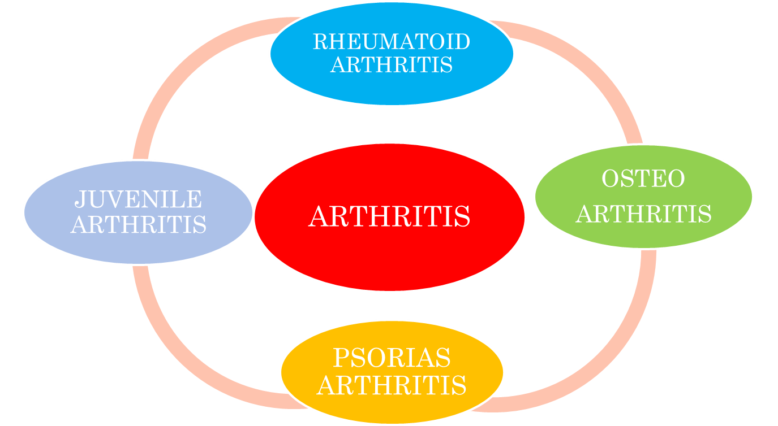

1.2 Prevalence /Population
According to statistics, RA and associated musculoskeletal illnesses afflict more than 0.5-1% of the global population, and it is expected that one in every five Americans will suffer from one of these ailments by 2020. Female’s area affected by RA three times more often than males, and the disease can start at any age, with a peak incidence at 50–60 years of age. The pre valence in the second to fourth decades and is the three times more common in women than men⁴.
1.3 Pathophysiology of Rheumatoid arthritis
The synovitis, swelling and joint damage that characterize active RA are the end results of complex autoimmune and inflammatory processes that involve components of both the innate and adaptive immune systems.
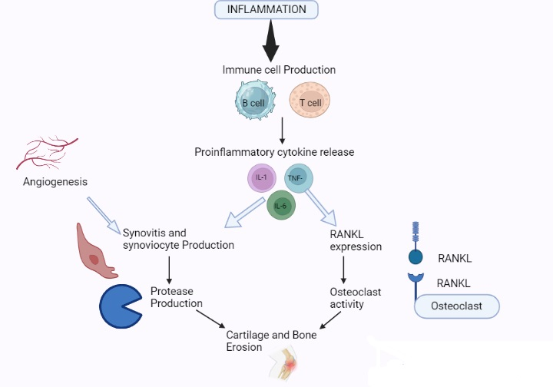
TNF-interleukin 1 (IL-1) and interleukin 6 (IL-6) have been identified as important mediators in the autoimmune illness rheumatoid arthritis (RA). Interleukin 1 is involved in bone resorption and cartilage breakdown, however it may not be as important in joint swelling and inflammation. Pathogenesis, as in other autoimmune diseases, involves genetic predisposition and environmental factors that contribute to illness onset, progression, and chronicity. It is produced by a complex interplay between genes and environment, which results in a symmetric breakdown of immune tolerance and synovial inflammation. Pathophysiology is the study of aberrations in normal mechanical, physical, and metabolic function induced by a disease, aberrant condition, or state that qualifies to be designated as a disease. This includes the illness's genesis, progression, and chronicity. It is caused by a complicated interplay between genes and environment, which leads to a breakdown of immunological tolerance and synovial inflammation in a symmetric pattern. Pathophysiology is the study of abnormality of normal mechanical physical and biochemical function either caused by resulting from a disease abnormal syndrome or condition that may know qualified to be called a disease⁵.
Several stages of rheumatoid arthritis are recognized as synovitis pannus fibrous and ankyloses and bony and alkylosis in rheumatoid arthritis pathogenesis.
Stage (i) Synovities during stage one including joint pain and stiffness.
Stage(ii) Pannus formation
Stage (iii) Fibrous alkyosis
Syage (iv) Bonny alkyosis
Causative factor and risk factor-Most types of arthritis are caused by many factors acting together.
Genetic make-up had the possibility likely to develop a certain disorder.
- Obesity
- Female gender
- secondary arthritis
- Greater bone density
- Joint laxity
- Repetitive joint overuse
- Joint injury
- Posttraumatic joint in congruity
- Instability or malalignment
- Joint dysplasia
- Repetitive, excessive joint torsion
- Crystal deposition
- Neuromuscular dysfunction
- Articular cartilage abnormalities may lead to joint degeneration by putting stress on the articular surface and joint instability.
- Penetration of sub-chondral bone
- Joint abrasion
Symptoms and signs
There are different varieties of arthritis, but the common symptoms for all conditions include varying levels of pain, swelling, joint stiffness, and occasionally a persistent ache surrounding joints. Tenderness and swelling in several joints, weight loss, fever, fatigue and sleepiness, and weakness are all symptoms. Lupus and rheumatoid arthritis, for example, can cause a range of symptoms in different organs⁶.
1.4 Biomarker of RA:-
Biological markers, also known as biomarkers, are biologic traits that can be objectively tested and serve as indicators of normal or pathologic processes as well as measurements of response to therapy.
- Anti-cyclic citrullinated peptides antibody, antibodies and assay.
- Positive anti CCP in other disease.
- Anti nuclear anti body test
- Anti CCP band RA prognosis
- Anti MCV Antibody
- Other Anti-cyclic citrullinated peptides antibody.
1. Disease acting and prognosis
Erythrocytic seddmentation value
2. Activity and prognosis
C –reactive protein
Multiple protein biomarkers algorithms
3. Investigation and other biomarkers
Immune abnormalities and auto antibodies.
4. Genetic factors
Other acute phase markers
Tissue specific marker
Rheumatoid arthritis susceptibility genes in RA
The association of particular human leukocytes antigen HLA alleles with RA This particular senotype represented a set of alleles at the HLA DRB genes locus
Non coding RNA (NCRNA) molecules are composed of long non coding RNA’S small nucleolar RNA’s microRNA and circular RNA’S which play an essential role in disease meet and progression and can be used in the early diagnosis and prognostic approaches to RA diease and the current knowledge on the subject focusing on recent advances in RNA MCRNA and as diagnpstric and prognostic biomarkers from the bio fliud to the tissue level .
With all the test and biomarkers high specificity presence eearly in the disease process and ability to identify patient who are likely to have severe disease and irreversible damage. RA with an emphasis and diagnostic performance prognostic capability and relevance to pathogens and new treatment para diagnose in RA⁷.
1.5 Future Prospectus of Rheumatoid Arthritis-
Despite all improvement in Rheumatoid Arthritis. We are still not able to present or, cure the disease. Thus RA is still the reason for disability and reduced quality of life for many patients.
Rheumatoid Arthritis recent research updates it is heterogeneous disease that based on data combining genetic risk factors and auto antibodies, can be classified into anti- citrullinated protein antibodies (ACPAs)- positive and negative RA.
Best phenomena for RA treatment prevent –to- target may become a new treatment approach by combining genetic and epigastric data for personalized treatment.
As genetic and cell based therapies are evolving the cure of RA .Researchers continue to learn each everything about the various form everything about the various form of arthritis and complexity of the many ways they can develop. Eventually, cure for specific types of the disease may be found and find to better treatments and clinical trials are key to finding safe and effective treatments.In current research on RA points to bacterial strain in the gut as a disease trigger. The strin discovered in the lining of the intestine may proud the body to attack healthy tissue in the joints⁸.
Disease modifying Anti-rheumatoid drugs and new treatments for RA latest FDA approach Biological.
S.N. | DRUGS NAME | DRUG CLASS
1. | Golimumab  Certolizumab | Tnf – α factor blockers
2. | Tofacitinib | Janus Kinase inhibitors
3. | Toclizumab | Interleukin-6 (IL-6) receptor antagonist

1.6 References
- Ahuja, S.C. Ahuja, S. Ahuja, U. Nirgundi (Vitex negundo) – Nature’s Gift to Mankind. Asian Agri-History,2015;19(1);5-32.
- Danielle, E. S. Sara, W. Meghan, B. Association of Body Mass Index with Physical Function and health related quality of life in adults with Arthritis. Arthritis.2013;60; 1-10.doi: 10.1155/2013/190868
- Dawei, W. Yuping, L. Wei, L. Huwei, L. Separation methods for antibacterial and antirheumatism agents in plant medicines. J Chromatogr B Analyt Technol Biomed Life Sci, 2004;812(1-2); 101-117.doi: 10.1016/j.jchromb.2004.06.049.
- Derek G.WallerBSc (HONS), D. M. Rheumatoid arthritis, other inflammatory arthritides and osteoarthritis. , 2018;373-383.
- Dharmendra, K. Rajesh, K. Kumari, S. Medicinal property of Nirgundi. Journal of Pharmacognosy and Phytochemistry, 2018;7(1);2147-2151.doi: 2278-4136
- Harith J. M. Nurzalina Abdul K. K. Mohd, Z. B. A. Roziahanim, M. Vikneswaran, A. L. M. In vivo anti-arthritic and anti-nociceptive effects of ethanol extract of Moringa oleifera leaves on complete Freund's adjuvant (CFA)-induced arthritis in rats. Integrative Medicine Research, Integr Med Res, 2018;7(1):85-94.doi: 10.1016/j.imr.2017.11.002
- James, R. O. D. Robert, L. Claire, H. et al., Treatment of Rheumatoid Arthritis with Methotrexate Alone, Sulfasalazine and Hydroxychloroquine, or a Combination of All Three Medications.Arthritis Rheum,1996;46(5):1164-1170.doi:10.1002/art.10228
- James, W. D. Mini, Y. Sunmin, P. Efficacy of turmeric extracts and curcumin for alleviating the symptoms of joint arthritis: A systematic review and meta-analysis of randomized clinical trials. Journal of Medicinal Food, 201619(8);717-719. doi: 10.1089/jmf.2016.3705.

