Desert Aquaculture
^{1*}Dr. M. K Yadav, ²Dr. R.S Chauhan, ³Dr. M.L Ojha and⁴, Mr. N.K Yadav, Dr. Naresh Raj Keer
¹Assistant Professor, Department of Aquaculture, Sage University Bhopal, M.P, India
²Former Dean, Department of Aquaculture, COF, GBPUAT Pantnagar, U.K, India
³Associate Professor Department of Aquaculture, MPUAT Rajasthan, India
⁴P.hD Research Scholar, Department of Aquaculture, CAU, Tripura,India
⁵Assistant Professor & Head, College of Fisheries, kishanganj, Bihar, India
*Email- mahendra@gmail.com
Abstract
The practices of aquaculture in semi-arid areas had a significant social and economic impact by provided that a means of food production, contributing to the livelihoods of individuals, and generating income.“The primary goal of aquacultureisachievementof productivity and particularly batter utilization of water resources for integrated aquaculture and animal husbandry. The integrated aquaculture systems in arid and Sami-arid regions to produce quality food thought year for peoples. These types of activity(in Arid and Sami-arid) are basically involved in the desert aquaculture; it iscoveredapplication of salt affected soil or area. Desert aquaculture technologies is used to enhancing the fish production as well as treat the salt affected soil through the saline aquaculture. The creation of helophytes via saline water is furthermostappropriatemethod of transforming desert ecosystem and food production for inhabits living in coastal regions.
Keywords - Global Hunger Index, NGOs, COVID-19 Pandemic, and Climate change

Introduction
The current population of India is 1,415,125,754 as Feb. 5, 2023, assembled on Worldometer elaboration of the latest United Nations data. After a decade of steady decline in hunger, global hunger is on the rise, affecting almost 10 percent of people worldwide. The number was starved people increased by 150 million between 2019 and 2022, in a crisis largely caused by conflict, climate change and the COVID-19 pandemic (WHO 2022 and FAO 2022). India has the highest number of undernourished people in the world (Worldometer) with an estimated 194.4 million people (14.37% of its population) undernourished (WEF 2021). India has one of the highest child malnutrition rates in the world, with a third of malnourished children in the world being Indian.This is very serious problem to India. Hungry problem can be controlled via desert aquaculture technology because India hasvast arid and semi-arid area. India has two semi-arid climatic zones, one in the north bordering the thar, desert, extending into the states of Rajasthan, Punjab and northern Gujarat, and the other in parts of the states of Deccan and Madras to the south.
The term ‘desert aquaculture’ denotes to culture production of fish, shellfish and aquatic plants in arid areas, semi-arid and areas somewhere water supply is limited. The concept of desert aquaculture was first start in southern Israel in 1979 with the finding of locally available geothermal water near a village in the Arava Valley.It hums paradoxical, assumed the evident lack of appropriate surface waters for such a resolution in these areas. However, during the past four decades, the commercial ‘desert aquaculture’ area has been successful in some countries around the world, utilizing several sources of aquatic including fresh and brackish groundwater resources.Formerlypleasingamethod to desert aquaculture, first we should recognizelocationswhere aquaculture cum agriculture can be combined. We also estimatenative environmental circumstances including soil and water quality, topography, and climate. An arid area, fisheries activateswill requirementreforms to become a likely production system permitting to each environmental condition. Aquaculture activities would be founded on a composed ecosystem management method, the basic principle is to integrate the biological and environmental occupations of a diverse group of organisms into a unified system. Noble management is regularlymeasured to be the same as practical practice in the presentation of aquaculture technologies. Satisfactory and appropriateconservation of farms and apparatus, successful broodstock management (SBM), Breeding, seed production, Pond management like, stocking, feeding, and water quality maintenance, disease control doneby biosecurity measures, harvesting, processing and marketing are the keyfundamentals of this managingtheory.
Why aqua farming in the desert areas
Many countries are facing the challenges of population growth and the problem of food shortages. Fish is also gaining popularity due to rich sources of different types of nutrients like protein, vitamins and fatty acids.Climate variation and overfishing activities of the adjoiningoceansmark the enlargement of fishing.
Desert zones (arid and semi-arid) providehugeareas establish aquaculture activities, and resources can be recycled to irrigate and top-dress surrounding land for more traditional agriculture, rising dates, olives, and many additional crops.Desert aquacultures are also beneficial because they're not connected to the main water supply, so the problems of disease control and contamination are reduced. Aquaculture in deserts and arid regions has grown steadily over the last decade, thanks to modern technology and alternative energy sources. Allowing water to be used more effectively and efficiently in these extreme locations, allowing it to be used both for irrigating and watering plants, production of fish used.
Concept and origin of desert aquaculture
Southern Israel's desert aquaculture industry began in 1979 with the discovery of geothermal water near an Arava Valley village. The development of aquaculture in desert and arid regions over the past decades in seven countries and regions such as Australia, Egypt, Israel, Mexico,South Africa, United States of America and Central Asia. Desert aquaculture conditions are considered by high day temperatures, cold winter nights, high solar radiation, occasional rainfall and very low relative humidity. Aquaculture activities experienced in desert and arid lands described by low precipitation (<250 mm/year), high solar radiation, high rate of evaporation, using subsurface and surface water.Allan, Banens and Fielder(2001) suggested that pond farming may be the most economically viable production system for inland aquaculture. Ponds are generally considered to be the lowest investment system with the lowest maintenance costs. Apart from biomass limitations, potential areas for pond farming (e.g. salt tolerant areas, SIS drainage areas) are located in inland areas where large water surface temperatures such as ponds vary (Allan et al., 2009; Hutchinson and Flowers, 2008).
A schematic model of the Integrated Coastal Desert Aquaculture approach for sustainable production is shown in Figure 1.
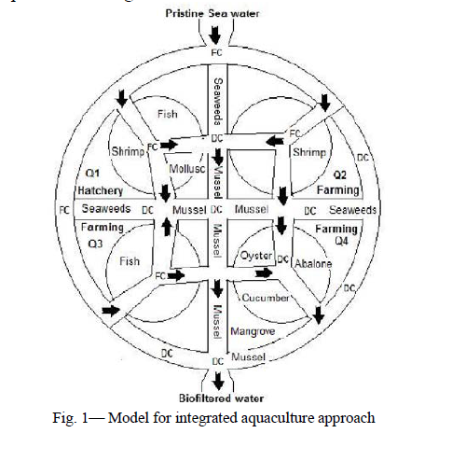

Fig. 1 Partridge, Lymbery and George, 2008
This model shows the uniform growth of everyone in a sustainable way. The system consists of four blocks (Q1, Q2, Q3 and Q4) with hatchery in (Q1), shrimp (Q2), fish (Q3) and shellfish and sea cucumber (Q4). It's possible, required juvenile fish, shrimp, shellfish, and sea cucumbers may be farmed in hatcheries, and fish and shrimp may be farmed in each farm. The fourth quarter is used to grow oysters, mussels, sea cucumbers and mangroves. Biological filtration of drainage water can be performed by algae and mussels in drainage channels (DC).
For system operation, clean seawater is brought in through the supply channel (PC) and 3/4 drainage is sent to 4/4 to completely settle the organic load and nutrients. The system discharges biologically filtered seawater, minimizing pressure on coastal ecosystems. According to Sanger and Siddiq (1992) shrimp farming requires mangrove areas ranging from 35 to 190 times the pond surface area. It will serve as a breeding ground and fish farm for local fish and shrimp species. Aquaculture systems using mangroves, oysters and seaweed as biofilters have proven effective in reducing environmental pressures. Algae grow rapidly in shallow water by absorbing nutrients directly from the surrounding seawater. Sea cucumbers digest sessile diatoms, organic debris and decaying algae and are potential candidates for cultivation in aquaculture wastewater treatment ponds. Using brackish water to produce salt plants is the most sustainable way to preserve desert ecosystems and produce food for people living in coastal areas. The biological filtrate leaving the proposed system can be useful for irrigation of coastal halophytes.
RAS Technology in desert aquaculture
Farming technologies have been proven to produce fresh, tasty and healthy fish, including salmon, grouper, sea bream and more, from farm to local market, while consistently respecting production goals. The roots of aquama technology are an area characterized by a desert climate with high temperatures and little rainfall. By conducting research on different species and shrimp at the company's research and development center in the Negev desert, enables producers to achieve profitable production in any environment and climate. By taking advantage of the natural desert environment, the system provides efficient temperature control, which enables low-cost production.RAS systems are very environmentally friendly in terms of energy and water, with several patents for water treatment and filtration technologies that significantly reduce water consumption and guarantee a discharge minimal liquid throughout the production process.
RAS flexibility of thought and design is key to the success of its technology, ensuring that its systems adapt to different needs. When planning an installation, intelligent selection and assignment of system components results in a robust installation that is easy to use and requires minimal maintenance. Additionally, optimized power patterns and advanced power management systems reduce feed conversion ratio (FCR) and operating costs.
Stable, economical and powerful RAS
RAS ability to establish stable and profitable aquaculture and production in any environment and climate is especially important today. The recent border closure due to the corona pandemic has affected the import and transportation of supplies, making local production very expensive. With RAS technology, onshore facilities can continue to meet market demand under all circumstances, even when borders are closed.
Suitable finfish and shellfish species for desert aquaculture
Important fish species for desert aquaculture are such as Sea bass, common carp, mullet, striped bass, tilapia and ornamental fish, crustacean species like Redclaw, crayfish, shrimp, e.g. L.vannamei, F. indicus and P.monodon.
Microalgae example Dunaliellasalina.
Different methodologies have been well-known to operatevarious water sources in analogous arid zones:
Usage of groundwater
Rainwater basinsoperative as irrigation reservoirs and ‘mega’ fishponds
Super intensive RAS
Broadagri-aqua water usage
Significant land-based pond systems
Use of groundwater
The quality of groundwater is not always suitable for human consumption, as it can become mineralized and contain sodium chloride, which is beneficial for tilapia culture. Such water is too saline for agriculture, with the maximum recommended salt content for irrigation usually 2ppt to 3ppt so saline water or salt affected lands are used in aquaculture for better utilization of this water.
Rainwater reservoirs functioning as irrigation reservoirs and ‘mega’ fishponds
Rain-fed ponds are supplied from rainfall and surface runoff. No water is supplied during the dry season. These ponds are often small depressions in impermeable soil, with a dike built at the lower side to retain more water. Ponds can be fed from a water body such as a stream, a lake, a reservoir or an irrigation canal. These may be fed directly (e.g. barrage ponds), by water running straight out from the water body to the ponds, or indirectly (e.g. diversion ponds), by water entering a channel from which controlled amounts can be fed to the ponds.
Intensive recirculating systems
In intensive recirculating system water from outdoor fish ponds, raceways and tanks is passed into sediment ponds for removal of solids. Highly-intensive systems may support up to 50 kg of fish/m3 of water. Culture is intensive, as the stock is entirely dependent on a comprehensive artificial diet and there is acute management of water parameters.
Large-scale agri-aqua water usage
By implementing agri-aqua-animal husbandry, one location can help to reduce conflicts between farming and aquaculture in coastal regions. By recycling nutrients properly, producing agricultural goods more efficiently, and diversifying into other crops, this system fosters sustainability while reducing the potential for conflict.
Large-scale land-based pond systems
The most common production system is extensive pond culture, where fish feed on endogenous food produced by the aquatic ecosystem. These usually involve simple techniques based largely on skill and domesticated species like carp, exotic carp and cat fishes and have been developed empirically through trial and error by generations of fish farmers. Pioneering technologies rely more on knowledge generated by extensive research efforts carried out in developed countries. In the North, technology imports have led to composite and successful intensification of production systems and commodity chains; attempts to transfer to developing countries have often failed. Technologies must be adapted to the local socio-economic context, to the capacity of social agents to deal with it, to the availability of local expertise and to the degree of domestication of cultivated species.

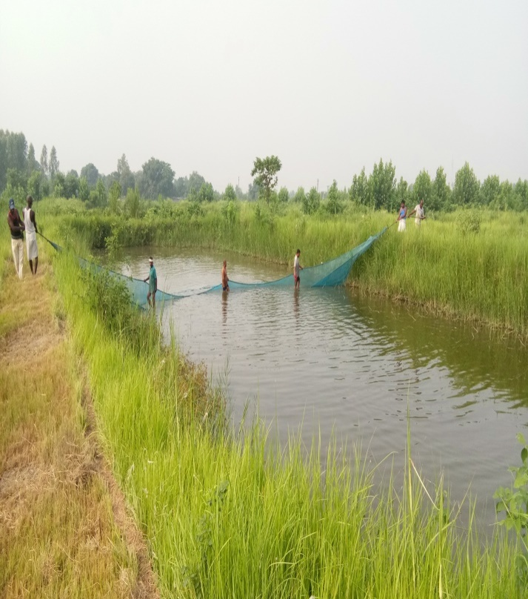
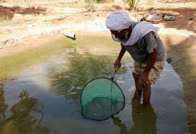
Fig. 2 Fish seed Collection for stocking

Advantage and Disadvantages of Desert Aquaculture
Huge amounts of brackish water that can merely partly recycled for agriculture remainaccessible; there is hygienic and uncontaminated water (seawater or from other sources) outstanding to few or no survivingtrades; there is a warm ambient climate; geothermal bores can maintain high temperatures in the winter through greenhouse use; the dry climate allows water cooling in summer; there is inexpensive land; geographic isolation provides a naturalquarantine; there are minimal ecological risks; year-round production can be achieved.Generally speaking, the development of aquaculture in desert areas is more difficult. Indeed, the livestock industry in desert areas has drawbacks, but that does not mean that there are no advantages. Since the desert mainly uses groundwater, the water quality is better than inland areas, so if you choose aquaculture species suitable for brackish water environment, the yield will be guaranteed to a certain measure. In fact, some countries, including Egypt and Israel, have practiced aquaculture in desert areas and are doing well. The development of aquaculture in the desert has been favored by the high yield and the diversity of cultivated species. It is not easy to clearly define the main advantages and disadvantages of aquaculture in desert and arid regions. It is clear that aquaculture can be practiced more easily in areas where water is abundant and easily accessible, but the presence of groundwater presents a real opportunity for dry areas that might otherwise remain low yielding. The success of fish farming in these arid regions will ultimately depend on the prices these fish can fetch in the market, either locally or for export. Therefore, the total cost of production, including the cost of transporting agricultural inputs to the farm itself and transporting fish to the receiving market, will play an important role in determining the commercial viability of a farm.
Conclusion
Over the past few years, arid conditions in Israel, Australia and other agricultural countries have further imposed restrictions on water use for agriculture and aquaculture. This has drawn attention to the development of smart agriculture and aquaculture systems. Therefore, more productive use of saline groundwater in desert regions is becoming increasingly important. Ultra-high-density, high-capacity systems that can make the most of water are being developed. Various integrated aquaculture systems are also being tested. Therefore, different types of salt-tolerant fish species that being used in aquaculture. Aquaculture systems different types of fish species are tested in arid and semi-arid regions to fulfill the requirement of fish consumption and nutrias diet of human. In arid and semi-arid regions, fisheries activities will requirementalterations to develop anauspicious production system conferring to every environmental condition. Aquaculture performswould be built on a composed ecosystem management method, the rudimentaryprinciple is to combine the biological and environmental utilities of a diverse group of organisms into a combined system.
Acknowledgement
The authors gratefully acknowledge to University. Thanks to my guide to writing this wonderful book chapter.
Reference
Appelbaum, S (2011) Aquaculture experiences in the Negev Desert in Israel. Aquaculture in Desert and Arid Lands: DevelOpmental Constraints and Opportunities, pp.113-118.https://d1wqtxts1xzle7.cloudfront.net/31569880/aquaculture
Arlosoroff, S (2007) Wastewater management, treatment, and reuse in Israel. In M.K. Zaidi, ed. Wastewater reuse–risk assessment, decision-making and environmental security, pp. 55–64.NATO Security through Science Series. Netherlands, Springer.https://link.springer.com/chapter/10.1007/978-1-4020-6027-4_6
Avnimelech, Y, Mokady, S & Schroeder, G. L (1989) Circulated ponds as efficient bioreactors for single-cell protein production. Israeli Journal of Aquaculture – Bamidgeh, 41, 58–66.https://www.cabdirect.org/cabdirect/abstract/19901423437?gitCommit=4.13.20-5-ga6ad01a
Chithambaran, S (2016) Desert aquaculture & environmental sustainability.Pp21-45.https://nopr.niscpr.res.in/handle/123456789/40539
Crespi, V, and Lovatelli, A (2011) Global desert aquaculture at a glance.Aquaculture in desert and arid lands, p.25.https://d1wqtxts1xzle7.cloudfront.net/31569880/aquaculture-libre.
Crespi, V. and Lovatelli, A (2011) Aquaculture in desert and arid lands: development constraints and opportunities.FAO.https://agris.fao.org/agris-search/search.do?recordID=XF2017001161
FAO (2022) Food Security and Nutrition in the World 2022 report, issued on July 6 by U.N.https://www.thehindu.com/news/international/number-of-undernourished-people-in-india-declines-to-2243-million-obesity-among-adults-on-the-rise-un-report/article65611180.ece
GHI (2022) Global hunger index The Indian express 17 February 2023. . https://indianexpress.com/article/india/global-hunger-index-india-2022-8209687/
Hepher, B&Pruginin, Y (1981) Commercial fish farming.New York, USA, Wiley- Interscience, John Wiley and Sons.261 pp.
https://www.taylorfrancis.com/chapters/edit/10.1201/9780203759028-8/attributes-tropical-pond-cultured-fish-david-teichert-coddington-thomas-popma-leonard-lovshin
Hulata, G and Simon, Y (2010) An overview on desert aquaculture in Israel. In Aquaculture in desert and arid lands: development constraints and opportunities. FAO Technical Workshop (Vol. 6, No. 9).https://www.fao.org/3/ba0114e/ba0114e05.pdf
Issar, A.S (1994) Fossil water under the deserts of the Middle East: a safeguard against strife. Stud. Environ. Sci., 58: 351–361.https://gus.com/article/10.1007/BF00117878
Kolkovski, S (2010) An overview on desert aquaculture in Australia. In Aquaculture in desert and arid lands: development constraints and opportunities. FAO Technical Workshop (pp. 6-9).https://www.fao.org/3/ba0114e/ba0114e03.pdf
Kolkovski, S, Simon, Y, Hulata, G &Ayaril, N (2013) Desert aquaculture. Aquaculture: Farming aquatic animals and plants, (Ed. 2), pp.107-125.https://link.springer.com/article/10.1007/BF00117878
Leghorn, L., & Parker, K. (2022). Woman's worth: Sexual economics and the world of women. Taylor & Francis. https://books.google.co.in/books?hl
Lucas, J.S, Southgate, PC& Tucker, C, S (2019) Aquaculture: Farming aquatic animals and plants. John Wiley & Sons.https://books.google.co.in/books.
Milstein, A, Zoran, M. &Krambeck, H.-J (1995) Seasonal stratification in fish culture and irrigation reservoirs: potential dangers for fish culture.Aquacult.Internat., 3: 1–7.https://link.springer.com/article/10.1007/BF00117878
Milstein, A, Zoran, M. &Krambeck, H.-J (2001) Destratification as a tool for fish culture improvement in deep water reservoirs.Aquacult.Internat., 9: 3–15.https://link.springer.com/article/10.1023/A:1012538711129
Mires, D (2000) Development of inland aquaculture in arid climates: water utilization strategies applied in Israel. Fisheries Management and Ecology, 7, 189–195.https://onlinelibrary.wiley.com/doi/abs/10.1046/j.1365-2400.2000.00186.x
Nativ, R, Bachmat, Y &IssarA S (1987) Potential use of the deep aquifers in the Negev desert, Israel: a conceptual model. J. Hydrol., 94: 237–265.https://www.sciencedirect.com/science/article/abs/pii/0022169487900552
Sadek, S (2011) An overview on desert aquaculture in Egypt. In Aquaculture in Desert and Arid Lands: Developmental Constraints and Opportunities. FAO technical workshop. Rome, Italy: FAO (pp. 6-8).https://www.fao.org/3/ba0114e/ba0114e08.pdf
Shaalan, M, El-Mahdy, M, Saleh, M, and El-Matbouli, M (2018) Aquaculture in Egypt: insights on the current trends and future perspectives for sustainable development. Reviews in Fisheries Science & Aquaculture, 26(1), pp.99-110.https://www.tandfonline.com/doi/abs/10.1080/23308249.2017.1358696
Suloma, A& Ogata, H.Y (2006) Future of rice-fish culture, desert aquaculture and feed development in Africa: the case of Egypt as the leading country in Africa. Japan Agricultural Research Quarterly: JARQ, 40(4), pp.351-360.https://www.jstage.jst.go.jp/article/jarq/40/4/40_351/_article/-char/ja/
Vo, T.T.E, Je, S.M, Jung, S.H, Choi, J, Huh, J.H. &Ko, H.J, (2022) Review of Photovoltaic Power and Aquaculture in Desert. Energies, 15(9), p.3288.https://scholar.google.com/scholar?hl=en&as_
WHO (2022) World health organization UN report 6 July 2022.https://www.who.int/news/item/06-07-2022-un-report--global-hunger-numbers-rose-to-as-many-as-828-million-in-2021
WPM (2023) world population meter, Indian population.https://www.worldometers.info/world-population/india-population/

