5-(4-fluorophenyl)-2-hydroxypyridine: An outstanding transition metal ions fluorosensor
Anuva Samanta*
Department of Chemistry, Victoria Institution (College)
78-B, A. P. C. Road, Kolkata 700009, India

Corresponding Authors: anuva.samanta25@gmail.com

ABSTRACT
The photophysical responses of 5-(4-fluorophenyl)-2-hydroxypyridine (FP2HP) towards various transition metal salts have been examined using steady state absorption and fluorescence techniques. This molecule shows keto-enol tautomerisation in the excited state. But it fluoresces very weakly as it possesses electron deficient fluorine atom and electron rich nitrogen atom. This may direct the molecule to undergo electron transfer process by light induced. In the existence of the d-block metal ions, like Hg²⁺, Zn²⁺, Fe²⁺, Cd²⁺, Cu²⁺ etc., the target molecule exhibits noteworthy deviations in its absorption and fluorescence properties. All the experimental phenomenon leads to the assumption that this structurally simplest molecule (FP2HP) can be excellently exploited as a chemosensor for transition metal ions based on chelation enhanced fluorescence (CHEF) mechanism.

Keywords: Transition metal, electron transfer, 5-(4-fluorophenyl)-2-hydroxypyridine, chelation enhanced fluorescence

I. INTRODUCTION
Transition metal ion sensing refers to the detection and measurement of transition metal ions in various environments, such as biological systems, environmental samples, and industrial processes [1-3]. Detecting and monitoring these metal ions is essential for understanding their roles in different systems and for addressing potential environmental and health concerns. Transition metal ion sensing has broad applications, including environmental monitoring, medical diagnostics, and research in fields such as biochemistry and materials science. The choice of sensing method depends on factors such as sensitivity, selectivity, and the specific requirements of the application [1-6]. In recent years, study in this area is focused to monitor the polluting species such as As³⁺, Cd²⁺, Pb²⁺, CO due to ever-increasing air and water pollution [7-8]. Chelation-enhanced fluorescence is a technique used in fluorescence spectroscopy to amplify the fluorescence signal of a fluorophore when it forms a stable complex (chelate) with a metal ion. The interaction between the metal ion and the fluorophore alters the photophysical properties of the fluorophore, resulting in increased fluorescence intensity. This approach is particularly useful for the selective detection of metal ions in biological, environmental, and analytical chemistry applications. Photoinduced electron transfer (PET) can lead to the quenching of fluorescence. When a fluorophore acts as the donor, the transfer of an electron to an acceptor, results in a non-radiative decay process, reducing the fluorescence intensity. This phenomenon is very common in the fluorophores containing nitrogen functional group [9-10]. The d-block elements are excellent quenchers and this metal induced quenching phenomenon is mainly redox in nature [11-12]. Intrinsic quenching properties [13] will be minimized if metal-receptor interaction is greater than the metal-fluorophore interaction. The photophysics of 5-(4-fluorophenyl)-2-hydroxypyridine (FP2HP) by spectroscopic measurement concluded lactim-lactam tautomerization in excited state [14]. This molecule, 5-(4-fluorophenyl)-2-hydroxypyridine (FP2HP), structurally is quite interesting for PET process as it comprises an electron donating nitrogen center and electron withdrawing fluorine atom. Here the use of FP2HP as a novel fluorosensor for transition metal element has been discussed.

II. MATERIALS AND METHODS
A. Materials. The synthesis of FP2HP has been elaborately reported before [14]. The aqueous solution of FP2HP are prepared using triple distilled water. Organic solvents used in this study are spectroscopic grade. The metal salts such as Hg(H₂O)₆(ClO₄)₂, Zn(H₂O)₆(ClO₄)₂, Fe(H₂O)₆(ClO₄)₂, Cu(H₂O)₆(ClO₄)₂, Co(H₂O)₆(ClO₄)₂, Cd(ClO₄)₂.H₂O were locally obtained and were used after purification.

B. Absorption and emission. Hitachi UV-Vis (Model U-3501) spectrophotometer and Perkin Elmer (Model LS-55) fluorimeter are used respectively for the measurement of absorption and florescence spectra. Fluorescence quantum yield of the entitled molecule in different environments were determined using β-napthol (Φ_{f}=0.23 in MCH) as a reference molecule [14].

III. RESULT AND DISCUSSIONS
A. Spectral behavior in solvents
As portrayed in Fig. 1a, FP2HP exhibits two absorption band at ~260nm and ~310nm in solvents of varying polarity. As hydrogen binding interaction is possible in this N-containing molecule, both the absorption bands are slightly shifted to lower wavelength in protic solvents. These bands are allotted to be originated from ππ* type of transitions as its molar extinction coefficient (ε) value is quite high. From the reported literature survey of the parent compound 2-hydroxy-pyridine [15-16], the lower wavelength and the higher wavelength absorption band are recognized to be the lactim and lactam form of FP2HP, respectively [14].
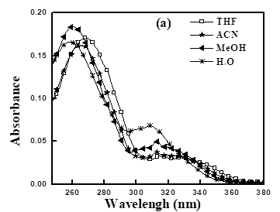
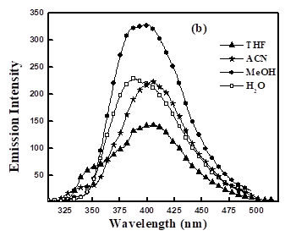
The excited state performance of FP2HP in different solvents is rather complex, as shown in Fig. 1b. On excitation at 260nm, it exhibits dual fluorescence band at ~340nm and ~410nm, in ACN, THF and DMSO etc. Since the formation of hydrogen bonding is not possible in such polar aprotic solvents, we can conclude that these two bands are originated from the enol form and the keto form of FP2HP. In case of polar protic solvents, transition of the enol form to its tautomeric keto form is barrierless, so single emission spectra of the keto form originate at ~395nm. All the steady state spectral data of the title compound have been reported in Table 1. On excitation, the studied molecule exhibits proton transfer reaction (ESIPT), i.e. the lactim-lactam tautomarization reaction. Interestingly, as shown in Table 1, the quantum yield (Φ_{f}) for the lactam form is high than that of the lactim form. The moderately low fluorescence quantum yields of FP2HP may be explained on the basis of photoinduced electron transfer (PET) process. Comparing with the previously reported molecular system qualified for PET process [17-18], it can be assumed that electron transfer occurs from the nitrogen atom with lone pair to fluorine atom having electron deficiency.

Fig.1 (a) Steady state absorption and (b) fluorescence spectra of FP2HP in various solvents at room temperature.

Table 1: Ground state absorption (λa) and excited state fluorescence (λ_{f}) maxima and quantum yields (Φ_{f}) of FP2HP at 298K.
Solvents | λ_{a}  (nm) | λ_{f}  (nm) | Φ_{f} (E-form) (x10²) | Φ_{f} (K-form) (x10²)
THF | 269, 325 | 352, 403 | 0.05 | 2.22
CAN | 266, 325 | 338, 407 | 0.24 | 2.47
MeOH | 260, 318 | 396 | - | 4.44
H₂O | 259, 310 | 392 | - | 9.25

B. Spectral features of FP2HP towards metal ion sensitivity
The spectral behaviors of FP2HP are quite fascinating with the addition of metal ions. This feature directs the molecule to be considered as fluorosensor for different metal ions. Complexation with 3d block metal ions such as Cu(II), Zn(II), Fe(II), or Hg(II) guide to a change both in the absorption and fluorescence spectra of FP2HP, but no such characteristic outcome was noticed for alkali metal ions like Na(I), K(I), Ca(II) etc. Fig. 2 displays the absorption spectra of FP2HP resulting from the consequences with the addition of the transition metal salts to its acetonitrile solution. Spectroscopic titrimetric analysis of FP2HP with increasing concentration of metal ions (Cu²⁺, Fe²⁺, Hg²⁺, Zn²⁺) results to reduction of the optical density of higher energy band with a hypsochromic shift of the higher wavelength band. No such distinguishable changes are noticed with the addition of other metal ions like Mn²⁺, Ni²⁺, Co²⁺, Cd²⁺. The blue shifting of the lower frequency band can be clarified as follows. The loan pair of nitrogen is participated in the ππ* transition hindering the nπ* transition thereby increasing the energy gap between S₀ and S₁ state of the molecule. From Fig 1a, it is obvious that the absorption spectra of enol are solvent independent while keto form has solvent dependent spectral properties. In ACN, FP2HP has absorption maximum at ~325nm while it is ~15nm blue shifted in water. Since the inorganic salts used in the sensing properties contain water of crystallization, the environment around the fluorosensor may behave quite similar to aqueous medium and thereby also presenting the blue shift.
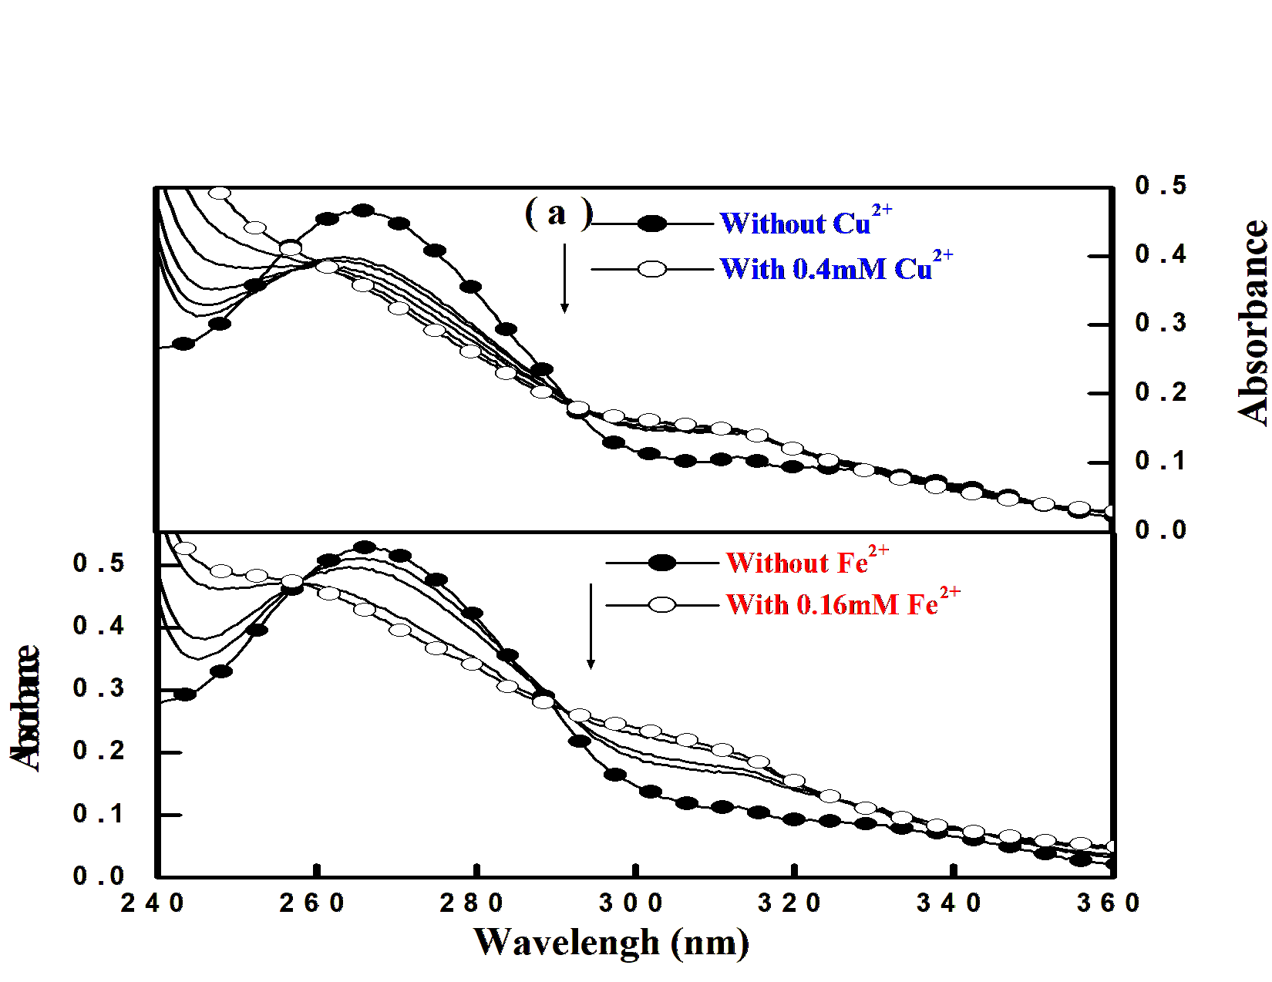
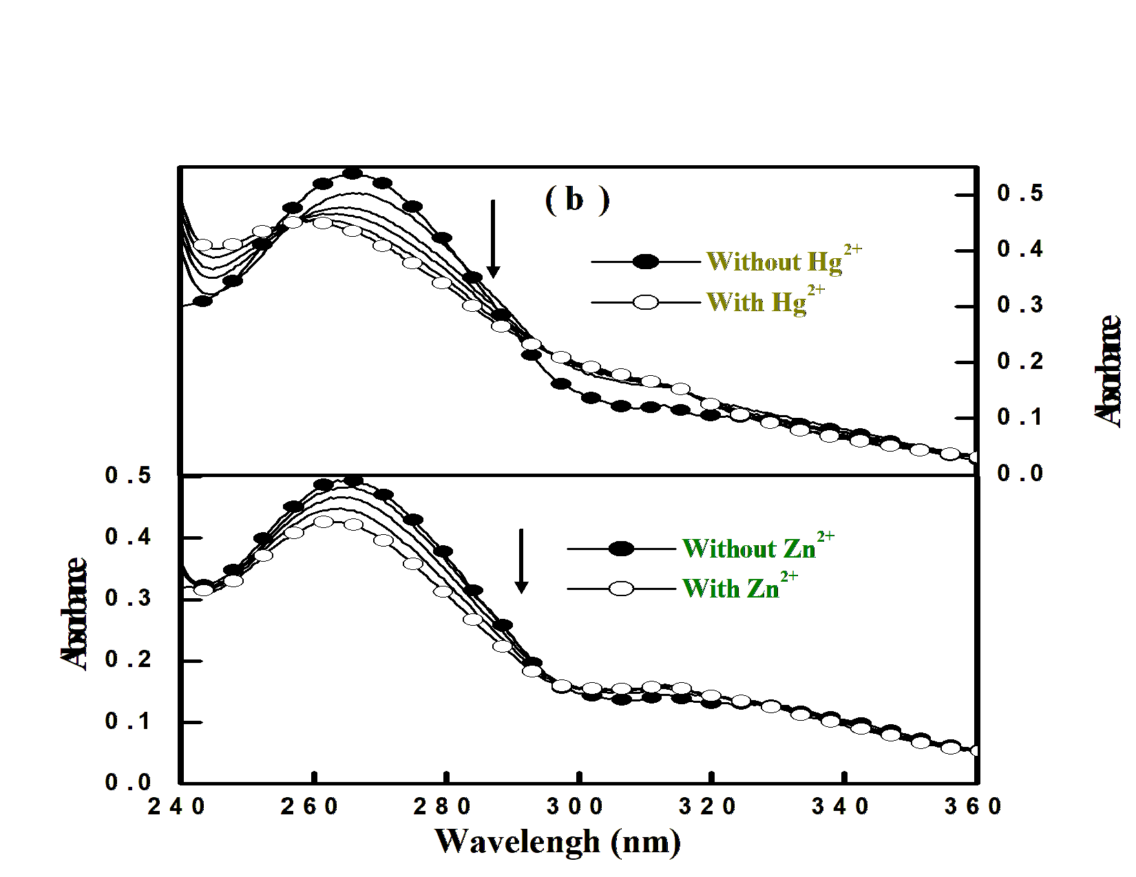

Fig. 2: Absorption spectra of FP2HP as a function of (a) Cu(II) and Fe(II) in ACN. (b) Hg(II) and Zn(II) in ACN.

As illustrated in the steady state UV-Visible spectral studies, the same identical condition is used in case of fluorimetric titrations of FP2HP with the addition different d block metal element in acetronitrile solution. With the incremental addition of metal ions, the target molecule displays excellent fluorescence enhancement as portrayed in Fig. 3. This can be explained on the basis of inhibition of renowned PET process. As the lone pair on nitrogen center is being engaged to the added metal ions the PET process is arrested. The usual excited state PT reaction is also blocked due to this type of metal-probe complex formation. The spectral details of the receptor FP2HP in the presence of different metal ions are listed in Table 2. With the incremental addition of metal ion, emission intensity of the system leads to an enhancement with minor red shifting and with the accumulation of the metal solution up to a certain concentration, it reaches to maximum fluorescence intensity and beyond this concentration fluorescence quenching could be observed. It is noticeable that the spectral shift is found to be less remarkable in case of fluorescence (~8nm) than that was detected for its ground state behavior (absorption) in presence of any metal ion. A small bathochromic shift (~6-8nm) on the emission maxima of FP2HP on addition of various metal ions is observed. This may be clarified on the basis of weakening of the bond strength of metal ions with fluorophore as the charge density is decreased over nitrogen atom on electronic excitation.
It is quite obvious from Table 2 and Fig. 4 that the noticeable chelation enhanced fluorescence enhancement (CHEF) occurs only for some specific metal ions like Cu²⁺, Fe²⁺, Hg²⁺, Zn^{2+,} though in case of other metal ions like Mn²⁺, Cd²⁺ etc., fluorescence intensities increase insignificantly. It is worth noting that Fe²⁺, notorious for its quenching efficiency, exhibits excellent fluorescence enhancement with its interaction with the fluorophore. So, it can be easily assigned that in presence of transition metal ions, the fluorescence enhancement because of metal ion binding is greater than the quenching-based reduction in the emission intensity. Similarly, other quenching metals Cu²⁺, Hg²⁺ also exhibit the identical results as was detected in case of Fe²⁺ ion. Overall fluorescence enrichment of FP2HP with the addition of d block metal ions directs that this molecule undergoing ESIPT can be also used as metal sensor.

Fig. 3: Steady state emission spectra of FP2HP in acetonitrile solution with increasing concentration of (a) Cu(II) ([Cu²⁺]=0 to 150μM) and Fe(II) ([Fe²⁺]=0 to 460μM) (b) Hg(II) ([Hg²⁺]=0 to 260μM) and Zn(II) ([Zn²⁺]=0 to 280μM)

Fig. 4: Metal enhanced fluorescence diagram of FP2HP in presence of d block metal ions.

Table 2: Fluorescence parameters of FP2HP in the presence of different metal ion input
Ionic Input | Fluorescence Enhancement (FE) | Φ_{f} (x10²)
Nil | 1.0 | 2.47
Cr²⁺ | 10.3 | 3.37
Mn²⁺ | 6.7 | 6.20
Fe²⁺ | 25.3 | 18.57
Co²⁺ | 11.9 | 4.42
Ni²⁺ | 1.5 | 1.07
Cu²⁺ | 25.4 | 54.77
Zn²⁺ | 17.8 | 13.60
Cd²⁺ | 8.8 | 6.46
Hg²⁺ | 27.7 | 17.17

CONCLUSIONS
In this present report, it has been shown that the title molecule 5-(4-fluorophenyl)-2-hydroxypyridine (FP2HP) can be used as a fluorosensor for several transition metal ions like Hg²⁺, Fe²⁺, Cu²⁺ etc. The title molecule exhibits fluorescence signature on proton transfer reaction in the S₁ state as it undergoes keto-enol tautomerism. But the quantum yield in fluorescence is quite low due to the presence of possible light induced electron transfer reaction. The transition metal induced enhancement of fluorescence intensity suppresses both proton transfer (PT) and electron transfer (ET) reaction in the excited state. Thus, the authorized molecule can be excellently employed as a novel sensitive CHEF based sensor in fluorescence for different d block metal elements.

REFERENCES
[1] A. P. deSilva, H. Q. N. Gunaratne, T. Gunnlaugsson, A. J. M. Huxley, C. P. McCoy, J. T. Rademacher and T. E. Rice (1997) Signaling recognition events with fluorescent sensors and switches. Chem. Rev. 97, 1515-1566.
[2] A. P. deSilva and P. Tecilla (2005) Special issue on fluorescent sensors. J. Mater. Chem. 15, 2617-2976.
[3] K. Rurack (2001) Flipping the light switch ‘ON’ – the design of sensor molecules that show cation-induced fluorescence enhancement with heavy and transition metal ions. Spectrochim. Acta. Part A. 57, 2161.
[4] A. W. Czarnik (1992) Fluorescent Chemosensors for Ion and Molecule Recognition, ACS, Washington.
[5] B. Valeur and I. Leray (2000) Design principles of fluorescent molecular sensors for cation recognition. Coord. Chem. Rev. 205, 3-40.
[6] E. Kimura and T. Koike (1998) Recent development of zinc-fluorophores. Chem. Soc. Rev. 27, 179-184.
[7] D. J. Anderson, B. G. Yan Xu, L. M. Ng, L. Z. Kricka, K. J. Skogerboe, D. A. Hage, L. Schoeff, J. Wang, L. J. Sokol, D. W. Chan, K. M. Ward and K. A. Davis (1997) Clinical chemistry. Anal. Chem. 69, 165R-229R.
[8] C. A. Burtis and E. R. Ashwood (1999) Tietz Textbook of Clinical Chemistry. W. B. Saunders, Philadelphia.
[9] A. J. Bryan, P. deSilva, S. A. deSilva, R. A. D. D. Rupasinghe and K. R. A. S. Sandanayake (1989) Photo-induced electron transfer as a general design logic for fluorescent molecular sensors for cations. Biosensors. 4, 169-179.
[10] A. P. deSilva, H. Q. N. Gunaratne, J-L Habib-Jiwan, C. P. McCoy, T. E. Rice and J-P Soumillion (1995) New fluorescent model compounds for the study of photoinduced electron transfer: The influence of a molecular electric field in the excited state. Angew. Chem. Int. Ed. Engl. 34, 1728-1731.
[11] A. W. Varnes, R. B. Dodson and E. L. Wehry (1972) Interactions of transition-metal ions with photoexcited states of flavines. Fluorescence quenching studies. J. Am. Chem. Soc. 94, 946-950.
[12] J. A. Kemlo and T. M. Shepherd (1977) Quenching of excited singlet states by metal ions. Chem. Phys. Lett. 47, 158-162.
[13] R. A. Bissel, A. P. deSilva, H. Q. N. Gunaratne, P. L. M. Lynch, G. E. M. Maguire, C. P. McCoy and K. R. A. S. Sandanayake (1993) Fluorescent PET (photoinduced electron transfer) sensors. Top. Curr. Chem. 168, 223-264.
[14] A. Samanta, B. K. Paul, S. Kar and N. Guchhait (2010) Excited state keto-enol tautomerization reaction in 5-(4-fluorophenyl)-2-hydroxypyridine: Spectroscopic study and quantum chemical calculation (rev. submitted J. Fluores.).
[15] A. Held and D. W. Pratt (1993) Ammonia as a hydrogen bond donor and acceptor in the gas phase. Structures of 2-pyridone-NH3 and 2-pyridone-(NH3)2 in their S₀ and S₁ electronic states. J. Am. Chem. Soc. 115, 9718-9723.
[16] Y. Matsuda, T. Ebata and N. Mikami (1999) Vibrational spectroscopy of 2-pyridone and its clusters in supersonic jets: Structures of the clusters as revealed by characteristic shifts of the NH and CO bands. J. Chem. Phys. 110, 8397-8407.
[17] A. Tamayo, C. Lodeiro, L. Escriche, J. Casabo, B. Covelo and P. Gonza´lez (2005) New fluorescence PET systems based on N₂S₂ pyridine-anthracene-containing macrocyclic ligands. Spectrophotometric, spectrofluorimetric, and metal ion binding studies. Inorg. Chem. 44, 8105-8115.
[18] T. Asami, M. Baba and S. Yoshida (1993) Inhibition of photosynthetic electron transport (PET) by halogenated 4-hydroxy-pyridine derivatives. Biosci. Biotech. Biochem. 57, 350-351.

