Application of 3D Printing in Food Processing Industry
1. P Babu  Subject Matter Specialist(Agril Engg)  Krishi Vigyan Kendra Kondempudi,Anakapalli  ANGRAU, Lam Guntur,India.  babucae002@gmail.com | 2. E Mounika  Ph. D Scholar  Department of Processing and Food Engg  CIAE, Bhopal, M.P.  mounikareddy26516@gmail.com
3. Jinukala Srinivas  Assistant Professor  Department of Agril. Engg  CUTM, Paralakhemundi, Odisha.  jsrinivas.527@gmail.com | 4. G Vani  Ph. D Scholar  Department of Processing and Food Engg  CIAE,Bhopal,M.P.  vani14027@gmail.com
5. S Sai Mohan  Ph. D Scholar  Department of Agril. Engg  Dr. NTR CAE Bapatla, ANGRAU, A.P.  samalasaimohan@gmail.com. | 6. B.O. Madhu  Ph. D Scholar  Department of Processing and Food Engg  NIFTEM-Thanjavur  osbmsai@gmail.com.

ABSTRACT
Digital fabrication technology—also known as 3D printing or additive manufacturing—creates tangible items from a geometric representation by adding the material one another one. An emerging technology is 3D printing which is extensively utilized around the globe. Layer by layer, material may be deposited to create an item using 3D printing technology and a computer-aided design (CAD) model. 3D food printing blends 3DP and digital gastronomy technology to make food items with customisation in form, color, flavor, texture, and even nutrition. This is in contrast to robotics-based food manufacturing technologies developed to automate manual operations for mass production. Review criteria for the chosen prototypes include fabrication platforms and printing mediums. For both single- and multi-material applications, an elaborate justification of the various 3DP technologies and the dispensing/printing process that goes along with them is included. The effects of food printing on customized nutrition, on-demand food production, food processing technology, and process design are eventually documented. An overview of the various 3D printing methods, applications of the technology, and materials utilized in the manufacturing business are all covered in this book chapter.
Keywords:, 3D food printing, Customized food fabrication, Extrusion based,Platform design, multi-material.
I. INTRODUCTION
Customized food products are in greater demand on the market, and the majority of these products are now created and manufactured by artists with specialized training. For such a little quantity, the price is rather exorbitant. One possible solution to close this gap is three-dimensional (3D) food printing, also known as Food Layered Manufacture (Sun et al., 2015). Without the need of molds, tools, or human labor, it intends to layer-by-layer build 3D custom-designed food products. Therefore, this technology can boost production effectiveness and cut manufacturing costs for the creation of customized food items.
Layer-by-layer deposition is a process used in three-dimensional (3D) printing, commonly referred to as additive manufacturing, to produce computer-aided designed items on a platform. An actual, three-dimensional item may be created using the 3D printing method from a computer model. The model is built as STL (stereolithography) files in the graphic engineering (CAD) tool. Rapid prototyping was the original purpose of 3D printing, but as technology has advanced, it is now also employed for producing finished goods. The layer must be strong enough throughout the printing process for it to support both its own weight and that of an adjacent layer without suffering from severe deformation or shape change. Food which is pure, semi-liquid, or powdered can be transformed into conventional food form through 3D printing. After the printing process, some of the food has to go through additional processing, such cooking, baking, or frying.
Numerous research was investigated the flexibility of formulation for 3D food printing. When evaluating geometrical precision and object size, Wang et al.'s (2018) investigation into printing fish surimi gel found that surimi gels prepared with a 1.5g NaCl/100g surimi combination are the most suitable. Yang et al. (2018) 3D printed lemon juice gels with potato starch added and found that 15g/100g lemon juice gel was best for printing cylinders and other predefined shapes. The relationship between formulations' rheological qualities, such as viscosity, and printing behavior is only briefly discussed in a few publications. Doughs containing prebiotics were successfully 3D printed by Zhang et al. (2018).
A. HISTORY OF 3D FOOD PRINTING
In the 1980s, plastic & photopolymer were utilized to create the first functional 3D printer. Food printing was not intended for the first generation of 3D food printers, which the would be printed like metal, ceramic, and polymers. 10 Years long back, the first 3D food printer was created, depositing food pastes onto a platform using a syringe-based extruder. syringe-based extrusion printers were used for High viscosity food pastes . There are several types of 3D food printers that have been invented recently, according to Fuh et al. (2015):
- Fab@Home Paste extrusion by fex. Chocolate, Nutella, (Cornell Univ.) (2006)
- Sugar printing, CandyFab (EvilMad Scientist Lab) (2006–2009)
- Senior food printing from pastes that performs well in FP7 from 2012 to 2015 (Biozoon).
- In 2013, 3D Systems introduced the printing of complex forms using sugar sculptures.
- 2013, bioprinter-produced in vitro meat (Modern Meadow)
- Chocolate printing in 2014 (Hershey's & 3D Systems)
- Pasta with printing from 2015 (Barilla & TNO)

II. MANUFACTURING TYPES IN 3D PRINTING
1. Additive manufacturing
2. Subtractive manufacturing
- Food may be printed using additive manufacturing (AM), sometimes named as solid freeform fabrication (SFF) or 3D printing, along with other three-dimensional things. In AM (Marga et al., 2012), items are made by layering materials on top of one another. Downtime, capacity utilisation, and total operating expenses are all decreased. This manufacturing approach often works well with materials like plastic that have a low melting point. There is no material waste throughout these operations. Using additive manufacturing technology, complex forms may be produced with ease.
- Subtractive manufacturing (SM) is the process of fabricating 3D products by gradually removing material from solid blocks layer by layer. irrespective of whatever their point of melting, all solid materials may be manufactured using this method. The material wasted during these processes takes the form of chips, scraps, dissolved ions, vapours, etc. The capacity of SM techniques to fabricate complicated forms is restricted.
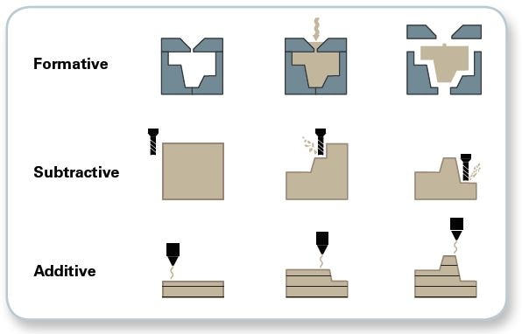
Plate 1 :Main Difference between the subtractive manufacturing
and additive manufacturing
III. EXTRUSION BASED 3D FOOD PRINTING
Extrusion is a robotic creating technique that is digitally controlled and utilized in 3D food printing to increase complicated food items layer by layer. It begins with material loading, moves the material stream along a predetermined path after being pushed out of the nozzle tip in a regulated way, and eventually bonds the embeeded layer to create an integrated completed solid structure.
The one or more extrusion units and multi-axis stage make up the extrusion-based food printer. It is criticized because of its few material options and lengthy construction process while having a small size and cheap maintenance costs (Sun et al., 2015). Such printers can alter food creation in real time with the help of computer control.
A clear consecutive procedure may be used to create foods in a 3D printer (Plate 2). The first step is to create a 3D CAD model with the required geometry. To learn as much as possible about a geometry's surface properties, either a model is produced or it is scanned. The right slicing application is then used to separate it into many layers. During this process, machine codes are generated for each sliced layer. The produced G-codes and M-codes are then sent to the printer to print the required recipe (Plate 2.1). The numerical control language that CAD software uses to tell motors where to print, how quickly to print, and which axis to print on is known as G-codes. M-codes are additional instructions that support the machine's operation.
Because these programs require a lot of storage and are challenging to use owing to the complexity of processing huge quantities of data (STL files), this is tied to issues with developing G-codes. The time and quality requirements for the made food are impacted by this. The user's skill level and the functionality required determine the best software to use for model development, scanning, and printing applications.
An example of a typical 3D printer is shown in Plate 3 (Peng 2015), which includes the following components: (1) a control circuit for integrating the computer and the printer; (2) a motor, filament, and drive system for directing the motors; (3) a mixing chamber to store and mix the material supply; (4) feed rollers; (5) flow sensors; (6) pressure regulators; (7) nozzles; and (8) a printing platform over which the food is printed. The printing platform is made up of a dispensing/sintering unit, a user interface, and a three-axis stage (Cartesian coordinate). To customize the manufacturing process to customers' needs, one can use digital control over the material supply system. Foods may be printed using platforms that have been created by oneself or on commercial platforms. Foods cannot be printed in three dimensions using regular printers, but they may be modified to fit specialized printing requirements. A modified version of an existing platform (which is freely accessible as open source) is a commercial platform. This involves modifying the print head to one that can regulate flow rates or one that can employ a food-grade substance as a process binder. Examples include printing edible 3D items made of cheese and chocolate as well as 3D sugar sculptures utilizing computer-controlled laser equipment. Because self-developed platforms can accommodate a broad range of fluctuations in the material supply, fabrication is flexible.
Plate 2: Process flow chart for a typical extrusion based food 3D printing

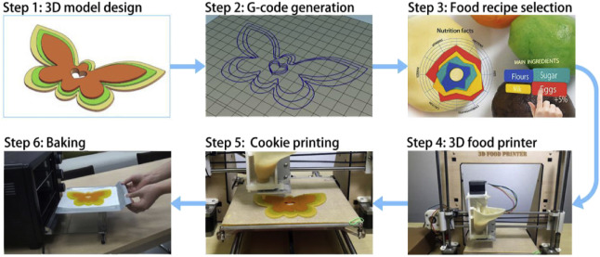
Plate 2.1 : Pictorial representation of Extrusion-based 3D Food Printing

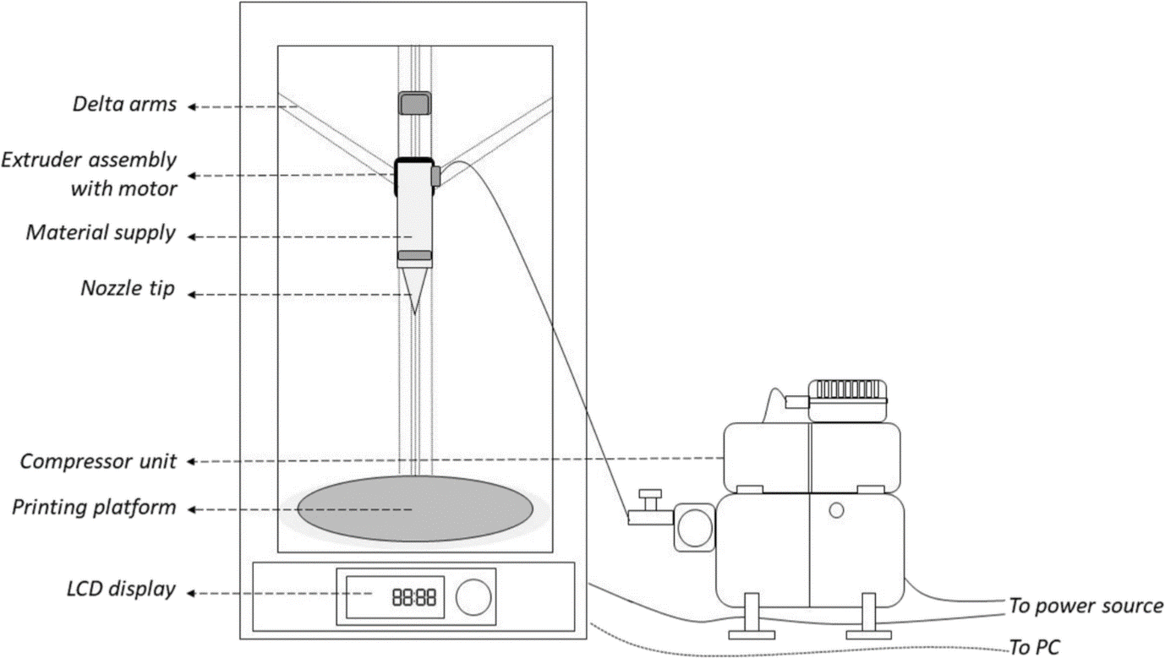

Plate 3 : Typical extrusion based type 3D food printer
IV. FOOD PRINTER CONFIGURATION (Dalbhagat et al., 2019)
The Cartesian, Delta, Polar, and Scara configurations are the multi-axis stages used in food printing..
A. Cartesian conﬁguration
The Cartesian arrangement, as seen in plate 4(a), contains X, Y, and Z axes for left-to-right, front-to-back, up-and-down motion, respectively. It includes with a printer moving along X-Z axis and a square stage positioned on Y-axis, or vice versa, with a printhead moving along Z-axis and a square stage positioned on X-Y axis. Pizza printers made by BeeHex Robot, Foodini, and Choc Creator are a few examples of Cartesian configuration. This configuration makes it difficult to use as a consumer end device since it needs a lot of space to operate as a printer. The moving printhead is also quite heavy when filled with food, which slows down printing and causes a jerking action every time the printing direction changes. Large-height 3D-printed food portions could collapse as a result of it. Last but not least, the Cartesian configuration's comparatively sluggish printing speed is a bottleneck that prevents it from being used in commercial machine designs.
B. Delta conﬁguration
A triangle print head is carried above a fixed circular print stage by three arms in a delta arrangement, as seen in plate 4(b). This configuration has fewer parts, which lowers machine and maintenance costs. Delta-configured machines, including the Pinya3 printer is now being developed for the market. This printers are less expensive, quicker, and can produce higher volume food pieces in less time than the Cartesian configuration. However, when the print head is moving at a quicker rate and is filled with liquid produce (such as melted chocolate), the quick acceleration and deceleration may result in liquid vibration during the printing process. As a result, the extrusion procedure could become unstable. For applications comprising the extrusion of liquid materials, a modified Delta configuration—a fixed print head with a moving print stage—is recommended.
C. Polar conﬁguration
Polar configuration, as compared to Cartesian configuration, employs polar coordinates to describe points on a circular grid as opposed to a square. This printer typically features a rotating stage as well as a print head that can move up and down to cover the Z axis and left and right to cover the tangential axes of X and Y, as illustrated in plate 4(c). With just slight mechanical imperfections and minimal calibration, this configuration can provide a perfect circle and equal performance for all direction movements. Examples include the TNO food printer and the XOCO 3D printer, both of which have a rotating build plate and a single pillar.
D. SCARA conﬁguration
Since the FDA Food Safety Modernization Act (FSMA) took action in 2011, Selective Compliant Assembly Robot Arm (SCARA) has seen a significant increase in attention from the food production industries. This set up is simple to construct and was modified for 3D printing. It comprises of an X-Y-moving robot arm and an extra actuator for Z-moving motion. This configuration has been used in the conceptual design "Sanna: the food printer of 2020" from Columbia University to transform unprocessed raw, frozen food purees into delectable, cooked, and texturized plates.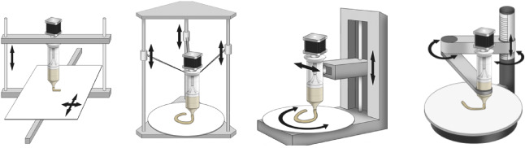
Plate 4 : Food printer conﬁguration: A. Cartesian, B. Delta, C. Polar D. Scara
V. EXTRUSION MECHANISM IN FOOD PRINTING
Sun et al. (2018) employed three extrusion methods to extrude liquid and semisolid materials. namely: syringe-based extrusion, screw-based extrusion and air pressure driven extrusion.
A. Syringe-based extrusion
The syringe-based extrusion unit, as displayed in Plate 5(a), consists of a syringe to hold food ingredients and a step motor to power the extrusion procedure. The step motor is designed to produce lining motion, regulate the syringe plunger's position, and force the food substance out of the nozzle. Commercial machine designs like the CocoJet 3D Printer and Choc Creator have used it. The extrusion rate, or how rapidly the material can be pushed out of the printer, may be quickly and easily altered by altering the motor speed. To force high viscosity materials through the extruder, more force is required. This approach dramatically increases the printing payload for a variety of materials. Food ingredients that are semi-solid or solid can be printed using this kind of extrusion equipment. The syringe unit should be carefully chosen; otherwise, overloading might result in increased power requirements owing to increased friction force.
B. Air pressure driven extrusion
A pneumatic pump and an enclosed food cartridge are part of the air pressure driven extrusion unit used to create the pasta-making 3D printer from Barilla and the BeeHex 3D printer. The material in the encapsulated food cartridge is forced out of the nozzle by the pneumatic pump's generated air pressure, as seen in plate 5(b). Through regulating valves, the pump may simultaneously drive many extrusion heads with different extrusion speeds. When the extrusion rate is changed, the reaction time is quite slow.
The likelihood of food contamination is lower in the aforementioned two extrusion techniques since mechanical parts do not come into direct touch with the food ingredients. While, if scaled up for industrial production, additional devices may be required to fill/refill extremely viscosity fluid into the syringe cartridge without air bubbles.
While liquid materials print best when utilizing the air pressure driven extrusion, solid and semi-solid materials may stick to the interior wall of the food cartridge rather easily. A filtering device must be attached to the airway to sterilize the air coming from the pneumatic pump in order to prevent contamination of the printing medium.
C. Screw-based extrusion
Food-related ingredients were loaded into the cartridge and moved to the nozzle with the help of auger screw for continu0ous printing, depicted in plate 5(c). The food cartridge in this screw-based extrusion is made with a large top hole for material loading, followed by a narrower tube construction and the extrusion nozzle. The materials are continually brought lower during the printing process by a motor-driven screw, passing through the extrusion nozzle with little interference from air bubbles. The screw and cartridge for an autoclave should be made of food-grade stainless steel due to the direct interaction with food products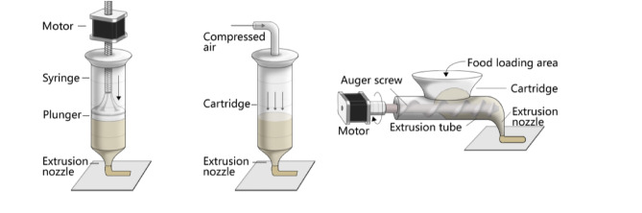
Plate 5 : Various types of Extrusion mechanism, A. Syringe Based. B. Air Pressure Driven C. Screw Based
VI. PRINTING VARIABLES AND PROCESS PARAMETERS
Nozzle tip diameter, deposition rate, nozzle depth height, suck back and push back times, hot air temperature, and air gap between layers are important design and process characteristics in 3D printing.
- Researchers have developed nozzle tips with a reduced diameter that produce smooth, fine-resolution food prints. Larger tip sizes and faster printing rates both diminish the printer's accuracy and resolution.
- Lower nozzle heights lead to insufficient printing accuracy and weak mechanical properties in chocolate products, whereas excessively high nozzle heights make it challenging for the material supply to reach the printing platform.
- The importance of nozzle height as a printing parameter was validated by investigations using lemon juice (as a gel). They also created a function that connects the extrusion rate, movement speed, and nozzle diameter. Lower speeds can produce continuous filaments; too high speeds (over 35 mm/s) cause the filaments to drag.
- The stage speed, extrusion rate, and nozzle diameter all influence layer thickness. Better food surface and thinner layer thickness may result from smaller nozzles, and vice versa.
- For the same extrusion rate, a higher stage moving speed might break the deposited stream or result in deformation, while a slower stage moving speed could cause the extruded stream to accumulate, resulting in an increase in layer thickness and a reduction in surface quality..
- While printing food, the extrusion rate shouldn't be constant or only proportionate to the immediate stage movement speed, but should be almost adjusted to account for the stage speed variation. A low extrusion rate is advised, for instance, if the stage movement speed is almost zero and the printing path is changing direction. The printed food portions may expand in some places and become hollow in others while the extrusion rate is constant. The extrusion rate throughout the printing route should be adjusted using an intelligent control technique.
VII. AVAILABLE PRINTING MATERIAL AND RECIPES
A. Classification of Printing Material (Martina et al., 2018)
Material supplies can be categorized as natively printable materials, non-printable materials, and alternative ingredients.
B. Non-Natively printable materials
Non-printable traditional food materials like rice, meat, fruit and vegetables, largely consumed by people every day, are not printable by nature. It has been allowed and used in several culinary sectors to add hydrocolloids to these solid materials to enable their ability to be extruded. Lipton et al. (2010) modified conventional food recipes using straightforward ingredients to produce intricate geometries and unique formulas. With the use of two hydrocolloid systems, Cohen et al. (2009) studied the structural requirements for post-processing materials including protein pastes and cake batters.
C. Natively printable materials
Smooth extrusion from a syringe is possible with natively printed materials such hydrogel, cake icing, cheese, hummus, and chocolate (Cohen et al., 2009). The most successful substance, as determined by viscosity, consistency, and solidifying qualities, was pasta dough, which was evaluated for printability research utilizing Fabaroni machine. The flavor, nutritional content, and texture of food products manufactured using natively printed materials may all be completely regulated. Some materials that are natively printed are stable enough to maintain their shape after deposition, don't need any post processing, and can be saved for use in space and medicine.
VIII. RATIONAL CHOICE OF 3D PRINTING TECHNIQUE BASED ON MATERIALS PROPERTIES
Aligning food-grade materials with printing procedures has been one of the major difficulties in 3D food printing. Here, three crucial elements linked to food material properties are proposed for the logical design of three-dimensional food structures:
- Printability: This feature depends upon the material's ability to be handled and deposited by a 3D printer and to maintain its structure after deposition. The viscosity or rheological characteristics of the material have an impact on the printability of liquid-based AM technologies, such as drop-on-demand approaches. In addition to rheological characteristics, certain gelation processes (crosslinking) and thermal characteristics (melting point and glass transition temperature) might have an impact on 3D printing methods based on extrusion. Particle size distribution, bulk density, wettability, and flowability are other factors that can affect powder-based 3D printing.
- Applicability: The ability of AM technologies to create intricate patterns and structures may seem attractive. Additionally, AM is made more fascinating by adding nutritious content to the specially created structures. The qualities of the materials also determine the usability of AM technology.
- Post-processing: The 3D design of food should ideally be resistant to post-processing techniques including oven baking, immersion in boiling water, and deep frying. A precise choice of materials with the necessary physical-chemical, rheological, and mechanical qualities is crucial in the quest of structures that can withstand cooking.
IX. IMPACTS FROM 3D FOOD PRINTING (Nachal et al., 2019)
Food printers extend mass-customization capabilities into the commercial culinary sector and provide aesthetic skills to delicious dining. This facilitates the production of customized foods with high value and low volume, which is now not achievable. Additionally, it offers research instruments for controlling the structure-development of solid food products at various scales. Because this technology is still in the early stages of development, it's critical to comprehend what it stands for and how it may be used in the marketplace. In order to determine how this new technology will satisfy consumers' wants and maybe alter peoples' lifestyles, it is also important to monitor technological advancements and pertinent applications.
X. ADVANTAGES OF 3D FOOD PRINTING
The advantages of 3D food printing, as follows:
1. Food personalisation 2. Dietary adaptation of meal composition 3.Use of novel ingredients that are not yet utilized or are not well-liked by consumers 4.Meal preparation is simple and straightforward, and simultaneous aesthetic and practical modification is possible, 5. New food textures, a longer shelf life 6. ease of transport to even the most distant places on earth or into space (NASA), and longer shelf life, 7. New chances to design dishes in an aesthetic manner and produce culinary masterpieces, 8.Being a food designer gives you the power to create your own meals, and mass personalization is an effective and affordable method of doing so.
XI. DISADVANTAGES
- Limitations of size: At present, 3D printing technology is constrained by size restrictions. The use of 3D printers to create really huge items is currently not practical.
- Limitations of raw material: Currently, 3D printers can use around 100 different types of raw materials. Considering the vast variety of raw materials used in conventional production, this is negligible. To develop strategies that will allow 3D printed objects to be more strong and lasting, further study is needed.
- Cost of printers: The price of a 3D printer still prevents the typical homeowner from purchasing one. Additionally, multiple 3D printers are needed in order to produce various item kinds. Additionally, printing in color requires more expensive printers than printing in monochrome.
- Fewer Manufacturing Jobs: This is valid for all new technologies. The economy of developing nations, notably China, which rely heavily on low-skill occupations, may be significantly impacted by this disadvantage.
XII. CHALLENGES IN 3D PRINTING OF FOOD
Ingredient mix rheology, structural accuracy and shape stability, compatibility with conventional food processing methods (such baking and drying), and printing speed are the biggest challenges in 3D food printing. For instance, it has been demonstrated that conventional cookie recipes are suitable with 3D printing, but owing to the large quantity of lipids present, they lose their form and structure during post-processing (such as baking) (Lipton et al., 2010). Therefore, the components and their quantities must be changed in order to make cookie recipes suitable for 3D printing. For instance, increasing the butter content in the butter-egg yolk-sugar combination lowered the form stability after printing, whereas increasing the egg yolk concentration boosted width/length stability but decreased height stability.
A. Material science : a. Form stability 2. Control of the ingredient and recipe (need for thickeners, enzymes, and crosslinking agents with shape memory) 3. Make traditional dishes. 4. Printing supplies that work well with conventional cooking methods like frying and baking. 5. Food ingredients' rheology varies throughout time 6. Reliable printed materials
B. Production technology 1. Security 2. Cartridges with easily-cleaned surfaces 3.Throughput 4.Large reservoir or high throughput required for extensive printing 5. Speed 6. Can run thousands of units either quickly or affordably (especially true for the food business).
XIII. THE FUTURE OF 3D PRINTING IN FOOD INDUSTRY
With the ability to close the gap between small and large-scale enterprises and provide customers a great deal of control over the food they eat, 3D food printing is set to have a significant influence on the global economy. Among the ways that 3D printing will impact the food sector in the future are:
- As a result of being able to produce food based on demand, food producers will be able to manage their inventories more easily and affordably.
- For a food business, a significant portion of expenses will be for raw ingredients. They will be able to reduce expenses by using 3D printing to produce food that is more affordable and sustainable.
- The production of food might be radically altered by 3D printing, which would enhance resource management and reduce food waste.Additionally, 3D food printing offers FMCG food producers the chance to create better, healthier food. PepsiCo, for example, has declared that they are considering using 3D printing to create healthier potato chips.
- Using 3D printing to make attractive looking food in a range of forms and colors, chefs and cooks all around the world are demonstrating how it can improve food innovation and culinary creativity.
XIV. REFERENCES
[1] Dalbhagat, C.G., Mahato, D.K., Mishra, H.N., 2019. Effect of extrusion processing on physicochemical, functional and nutritional characteristics of rice and rice-based products: A review. Trends of Food Science and Technology,85(1),pp.226–240.
[2] Fuh, J.Y.H., Hong, G.S., Zhou, W., Huang, D., Sun, J., 2015. An overview of 3D printing technologies for food fabrication. Food Bioprocess Technology, 8 (8),pp.1605–1615
[3] Nachal, N., Moses A., J., Karthik, K., Anandharamakrishnan, C., 2019. Applications of 3D printing in food industry: A review. Food Engineering Rev.
[4] Lipton, J., Arnold, D., Nigl, F., Lopez, N., Cohen, D.L., Nore´n, N., Lipson, H., 2010. Multi-material food printing with complex internal structure suitable for conventional post processing. Solid Free Fabrication symposium.809-815
[5] Martina, L., Nurmela, A., Nordlund, E., Kortelainen, Nesli Sozer. 2018. Applicability of protein and ﬁber-rich food materials in extrusion-based 3D printing. Journal of Food Engineering. 20-27.
[6] Peng, Z., 2015. 3D Food Printer: Development of Desk-top 3D Printing System for Food Processing (Master Thesis). National University of Singapore, Mechanic Engineering, Singapore.
[7] Sun J, Zhou, W., Yan L, Huang, D., Lin, L. 2018. Extrusion-based food printing for digitalized food design and nutrition control. Journal of Food Engineering..1-11
[8] Sun, J., Zhou, W., Huang, D., Fuh, J.Y., Hong, G.S., 2015. An overview of 3D printing technologies for food fabrication. Food Bioprocess Technol. 8(8), pp.1605-1615.
[9] Wang, Lin, Zhang, M., Bhandari, B., Yang, C., 2018. Investigation on fish surimi gel as promising food material for 3D printing. Journal of Food Enginering. pp.101–108.
[10] Yang, F., Zhang, M., Bhandari, B., Liu, Y., 2018. Investigation on lemon juice gel as food material for 3D printing and optimization of printing parameters. Food Sci. Technol.87, 67–76
[11] Zhang, Yimin Lou, Maarten A.I. Schutyser.,2018. 3D printing of cereal-based food structures containing probiotics. Food Structure. 14-22.

