Aromatherapy

Jasmeen Syan
Assistant Professor
College of Pharmacy, Shivalik Campus
Dehradun, Uttarakhand
Email- jasmeen.syan@copdoon.org
Mobile No.- 6395577900

Abstract: In complementary and alternative medicine, aromatherapy is frequently used to treat medical issues. In this sort of treatment, essential oils are frequently used since they contain unpleasant components. One of the most rapidly expanding alternative medical practices is aromatherapy, which merges massage with counselling and pleasant aromas while using essential oils and aromatic chemical compounds from plants. Scientific research demonstrates that aromatherapy, which involves breathing in or absorbing fragrant plant extracts, may also help calm your body and reduce discomfort. Studies have shown that essential oils can alter behavior and alter brainwaves. Aromatherapy, when practiced safely and effectively, has a lot to offer as a complement to traditional medicine or as an alternative therapy. Aromatherapy examines various forms of practices for the discipline as well as the problems with quality and safety that come up when applying essential oils in healthcare.
Key Words: Essential oil, Therapy, Distillation, Aroma, Medicines, Traditional
Introduction
The words aroma, which means fragrance or smell, and therapy, which means treatment, are the roots of the phrase aromatherapy. This treatment is an organic technique to restore one's body, mind, and spirit. [1]. Aromatherapy in the treatment of a wide range of problems and illnesses has grown increasingly popular. A review of the literature shows that this therapy acquired a lot of interest in the 20th and 21st centuries as well, and as a result of its value, appeal, and widespread application, it has become recognized as aroma medical therapy [2].
Alternative complementary medicine known as aromatherapy uses essential oils to balance and enhance our emotional and physical wellbeing. Aromatherapy and essential oils' aromatic sensations have an enormous effect on the mind and body. The regulated utilisation of essential oils to support and maintain an individual's physical, psychological, and spiritual wellness is known as aromatherapy. The science and art of using organically sourced fragrance essences from plants to balance, harmonise, and advance the health of body, mind, and spirit is known as aromatherapy, also known as essential oil therapy. It aims to integrate psychological, spiritual, and physiological processes to strengthen a person's intrinsic healing process [3,4,5]. The use of essential oils for medicinal, cosmetic, aromatic, fragrant, and spiritual purposes has grown in importance [6,7]. The main therapeutic components of aromatherapy are essential oils, which are thought to be highly concentrated compounds extracted from flowers, leaves, stalks, fruits, and roots as well as resins [8]. Saturated and unsaturated hydrocarbons, alcohol, aldehydes, esters, ketones, oxides, phenols, and terpenes are all components of essential oils, which can result in peculiar aromas [9].
Within a brief period of time, the application of aromatherapy in holistic health has advanced significantly [10]. Many studies have been conducted to look at how this therapy impacts the human brain and its emotions, according to a review of the literature on it. Recent scientific debate has focused heavily on its function in mood, attentiveness, and mental stress in healthy persons. Through the use of electroencephalogram patterns and functional imaging investigations, several researchers attempted to look into the impacts on work ability, response speed, and certain spontaneous behaviours on the brain [11]. When compared to artificial odours, this treatment was shown to be better. In general, synthetic perfumes contain irritants such propellants and solvents that might irritate individuals [12,13]. Although the study and application of essential oils in herbal medicine is not, aromatherapy is a distinct science and practice. Scientists often work with entire plants compared to plant constituents like essential oils. A conventional or clinical herbalist, however, might create or employ a medicinal-grade essential oil in the context of their work. The scientists uses essential oils refers to themselves as herbalists rather than aromatherapists. In their practices, aroma therapists and mind-body practitioners commonly work together to create therapeutic spaces that show how plants may improve their customers' emotions [14].
Classification of Aromatherapy
- Cosmetic aromatherapy: Many types of essential oils are used in this therapy to make cosmetic items for the skin, body, face, and hair. These essential oils are used for their varying cleaning, moisturising and toning actions. Essential oils can be used in face products to promote healthy skin. On a personal level, using foot or full-body aromatherapy during a bath will be a quick and efficient approach to enjoy an experience. A few drops of the appropriate oil have a similar revitalizing and renewing effect [15].
- Massage aromatherapy: It has been demonstrated to produce excellent outcomes to add pure vegetable oil as well as grape seed, almond, or jojoba oils. This is frequently described as massage therapy that uses a therapeutic touch. [16].
- Medical aromatherapy: In order to massage patients during surgery, Rene-Maurice Gattefosse, the founder of modern aromatherapy, has used the medical understanding of the effects of essential oils on promoting and curing clinically established medical conditions [17].
- Olfactory aromatherapy: Humans have been found to benefit from olfactory aromatherapy, which is accomplished by the inhalation of essential oils, in terms of their mental health, tranquillity, relaxation, or bodily restoration. Stress-relieving scents that bring back pleasant memories of smells are combined with this technique. [18].
- Psycho-aromatherapy: In psycho-aromatherapy, aromatic oils can be used to evoke a certain mood or emotional state while also providing the pleasures of relaxation, energization, or a good recollection. In this form of therapy, the patient inhales the oils as they are being infused. Both aromacology and psycho-aromatherapy concentrate on the study of aroma and its effects, whether they are artificial or natural [19].
Plants used in Aromatherapy
1. Jasmine
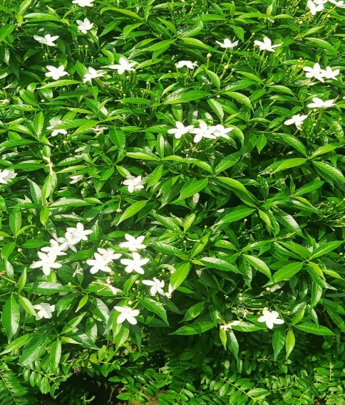
Figure 1: Jasmine Plant Species
Biological source: It consist of fresh flowers of Jasminum officinale, belonging to family Oleaceae.
Commonly known as Jasminum sambac, Mogra, Chameli
Description: Jasmine features long, climbing stems and tiny, white blossoms, though some varieties can grow vivid yellow flowers. Each flower typically has four to nine petals, two locules, one to four ovules, two stamens, and filaments that are extremely short.
Cultivation: Jasmines are grown all over India, although only in Coimbatore, Madurai, and Dindigul (Tamil Nadu); Bangalore; and Maharashtra are they grown commercially.
Chemical Constituent: It contain volatile oil, benzyl acetate, linalool, Ethereal extract from the leaves yield an alkaloid and jasminaldehyde, ricinoleic acid, linalyl acetate, jasmone.
Uses: Skin Diseases, Gout, Wound Healing, Rheumatoid Arthritis [20].
2. Lemon
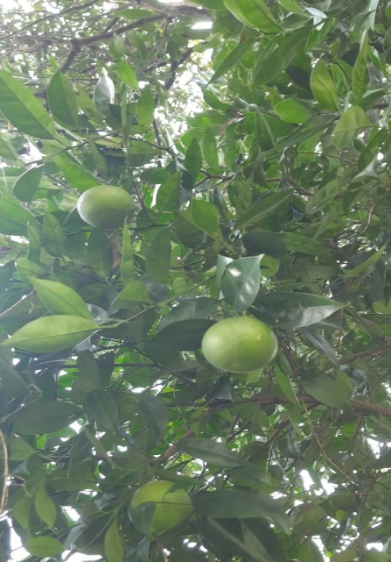
Figure 2: Lemon Plant Species
Biological Source: Lemon peel is the outer part of pericarp of the ripe fruit or nearly ripe of Citrus limonis belonging to the family Rutaceae.
Common names: Lemon, Nimbu.
Description: The genuine lemon tree grows to a height of 10 to 20 feet (3-6 meters) and typically has thorny branches. The alternating leaves, which are initially reddish, turn dark green above and light green below. The sparsely perfumed flowers can grow singly or in groups of two or more in the axils of the leaves. The opened blooms have 4 or 5 petals that are 3/4 in (2 cm) long, white on the top (inside), and purplish on the bottom (outside), as well as 20–40 more or less joined stamens with yellow anthers. The buds are reddish. The fruit is round and has a protuberance that resembles a nipple at the top.
Cultivation: In India Andhra Pradesh, Maharashtra, Tamil Nadu, Gujrat, Rajasthan, and Bihar are among the states where lemons are grown.
Chemical constituent: It contains Limonene, linalool, caryophyllene, myrcene, sabinene, terpitene, ascaridole, torreyol, tetra decanoic acid, linalyl acetate, borneol, alpha thujene.
Uses: Carminative, stimulant, Flavouring agent, perfumes, skin disease [21].
3. Mentha
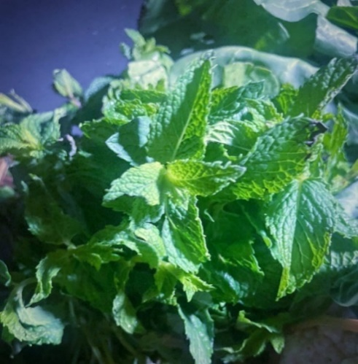
Figure 3: Mentha Plant Species
Biological Source: It is the oil obtained by the distillation of Mentha piperita, belonging to family Lamiaceae.
Common names: Pudina, Corn Mint
Description: The optimal conditions for peppermint growth are a somewhat warm, preferably humid climate, with well-drained, deep soils rich in humus. If peppermint is planted, nurtured, and allowed to grow, it will flourish. Digging runners and laying them in shallow trenches three feet apart on well-prepared soil is the standard way of cultivation.
Cultivation: In India, Japan, Thailand, Korea, and Taiwan, it is commonly available. The northern Indian states of Jammu & Kashmir, Punjab, and Haryana are where it is primarily cultivated.
Chemical Constituents: It contains menthol, menthone, eucalyptol, limonene, elemene, carvone, pulegone, menthofuran, linalool, alpha- pinene, carveol, terpineol, ocimene, piperitone, eugenol.
Uses: Helps in digestion, rich in nutrients, decreases breastfeeding pain, improves cold symptoms, improves irritable bowel syndrome, boosts immune system, manages stress, promotes restful sleep, rich in antioxidants, anti-microbial for infections [22].
Pharmacological actions
1. Heart Rate: In Yale University research (1988) the sedative effects of scents were measured using changes in blood pressure and heart rate. The scent of spiced apples has strong vasodepressant and stress-relieving properties. Yamaguchi (1990) also measured the impact of lemon and rose smells using variations in heart rate. When compared to rose scent, lemon aroma increased heart rate while rose aroma decreased it. This research suggests that although rose scent has a calming impact (a drop-in heart rate), lemon aroma has a stimulating effect [23].
2. Blood Pressure: Blood pressure is one of the physiological factors that is most frequently observed. The use of an essential oil-based scent to lower stress in people as determined by the drop in blood pressure and self-ratings was patented by Warren et al. in 1987. According to this study, essential oil lowers systolic blood pressure by 9 mmHg. Additionally, individuals report feeling happier and more at peace with themselves, as well as less anxious, angry, and embarrassed. Two components of nutmeg oil, myristicin and elemicin, might be responsible for these effects [24].
3. Anti-Tumour Activity: Human melanoma adriamicin-resistant cells were able to grow more slowly when treated with tea tree oil respectively. In melanoma cells, a caspase-dependent pathway connected this activity to apoptosis. If geraniol, a component of plant essential oils, sensitises human colon cancer cells, 5-fluorouracil therapy is increased. The relationship between essential oils and their anti-tumor action is now being investigated [25,26].
4. Anti-oxidant Activity: Essential oil is a potent antioxidant with strong antibacterial and antioxidant properties in vitro. It also has a significant hydroxyl radical scavenging effect. The antioxidant capacity of the essential oils is strong; they change the superoxide dismutase parameters and increase vitamin E and vitamin C concentrations [27].
5. Anti-Inflammatory Activity: Tea tree oil reduced the histamine reactivity of flare and weal in people. 100% tea tree oil applied topically after 10 minutes can decrease the irritation caused by histamine diphosphate [28].

Conclusion:
Based on the aforementioned data and research, we can say with confidence that aromatherapy is a risk-free, all-natural gift from nature to mankind. Every organ benefits from the application of scent, which also helps to get rid of disease symptoms. Aromatherapy controls the physiological, spiritual, and psychological upliftment for the next phase of life. Essential oils can be a helpful supplement to cancer treatment, assisting in the management of side effects like nausea and insomnia. In addition to being preventative, this medication can be used in both the acute and chronic phases of sickness. The pharmaceutical business is working to create alternative, all-natural, and environmentally friendly medications for illnesses connected to infections and metabolism. The bioavailability and reaction time of drugs may be improved by utilizing these essential oils. Research and development in this field are expected to continue, and they are dedicated to determining how aromas affect people's emotions. Advanced research into the endocrine, immunological, and pharmacological effects of aromas has already begun, and it is anticipated that it will soon yield important findings.
Bibliography
- Worwood VA. Aromatherapy for the Healthy Child: More Than 300 Natural, Nontoxic, and Fragrant Essential Oil Blends. New World Library; 2000.
- Esposito ER, Bystrek MV, Klein JS. An elective course in aromatherapy science. American Journal of Pharmaceutical Education. 2014 May 15;78(4).
- Hedaoo SA, Chandurkar PA. A review on aromatherapy. World Journal of Pharmaceutical Research. 2019 Mar 28;8(7):635-51.
- Gabriel Mojay. What is Aromatherapy? National Association for Holistic Aromatherapy. https://naha.org/explore-aromatherapy/about-aromatherapy/what-is-aromatherapy/.
- Querequincia JM, Faller EM. A Review on the different studies on aromatherapy conducted in the Philippines. GSC Biological and Pharmaceutical Sciences. 2021 Aug 30;16(2):028-31.
- Evans WC. Trease and Evans' pharmacognosy. Elsevier Health Sciences; 2009 May 27.
- Svoboda KP, Deans SG. Biological activities of essential oils from selected aromatic plants. InInternat. Symposium on Medicinal and Aromatic Plants 390 1994 Aug 21 (pp. 203-209).
- Dunning T. Aromatherapy: overview, safety and quality issues. OA Altern Med. 2013;1(1):6.
- Schiller C, Schiller D. 500 formulas for aromatherapy: mixing essential oils for every use. Sterling Publishing Company, Inc.; 1994.
- Buchbauer G, Jirovetz L, Jager W, Plank C, Dietrich H. Fragrance compounds and essential oils with sedative effects upon inhalation. Journal of pharmaceutical sciences. 1993 Jun;82(6):660-4.
- Vethanayagam D, Vliagoftis H, Mah D, Beach J, Smith L, Moqbel R. Fragrance materials in asthma: a pilot study using a surrogate aerosol product. Journal of Asthma. 2013 Nov 1;50(9):975-82.
- Silva-Néto RP, Peres MF, Valença MM. Odorant substances that trigger headaches in migraine patients. Cephalalgia. 2014 Jan;34(1):14-21.
- Cooke B, Ernst E. Aromatherapy: a systematic review. British journal of general practice. 2000; 50(455):493-6.
- Buckle J. Aromatherapy. Nursing Times. 1993; 89(20):32-5.
- ZIOSI P, Manfredini S, Vertuani S, Ruscetta V, Radice M, Sacchetti G. Evaluating essential oils in cosmetics: antioxidant capacity and functionality. Cosmetics and toiletries. 2010;125(6).
- Chang SY. Effects of aroma hand massage on pain, state anxiety and depression in hospice patients with terminal cancer. Journal of Korean Academy of Nursing. 2008 Aug 1;38(4):493-502.
- Maeda K, Ito T, Shioda S. Medical aromatherapy practice in Japan. Essence. 2012;10(4):14-6.
- Price S. Aromatherapy for Common Ailments: How to use essential oils--such as Rosemary, Chamomile, and Lavender--to prevent and treat more than 40 common ailments. Simon and Schuster; 2003 Dec 23.
- Perry N, Perry E. Aromatherapy in the management of psychiatric disorders: clinical and neuropharmacological perspectives. CNS drugs. 2006 Apr;20:257-80.
- Dr. Josh Axe. Jasmine Oil- Mood Booster and Stress Buster. Dr. Axe Food is Medicine; July 23, 2018. https://draxe.com.
- . Cathy Wong. Lemon Essential Oil Benefits and Uses; March 31, 2019. https://www.verywellhealth.com.
- Alankar S (2009) A review on peppermint oil. Asian J Pharm Clin Res 2: 27-33.
- Schwartz et al., 1988. Psychology, 15: 281; cited according reference of Manley, C. H. 1993. Psychological effect of odor. Crit. Rev. Food Sci. Nutr., 33(1): 57-62.
- Warren, C.B., Munteanu, M.A., Schwartz, G.E., Benaim, C., Walter, H.G., Leight, R.S., Withycombe, D.A., Mookerjee, B.D., and Trenkle, R.W. 1987. Method of causing the reduction of physiological and/or subjective reactivity to stress in humans being subjected to stress conditions.
- Carnesecchi S, Langley K, Exinger F, Gosse F, Raul F. Geraniol, a component of plant essential oils, sensitizes human colonic cancer cells to 5-fluorouracil treatment. Journal of Pharmacology and Experimental Therapeutics. 2002 May 1;301(2):625-30.
- Carnesecchi S, Langley K, Exinger F, Gosse F, Raul F. Geraniol, a component of plant essential oils, sensitizes human colonic cancer cells to 5-fluorouracil treatment. Journal of Pharmacology and Experimental Therapeutics. 2002 May 1;301(2):625-30.
- Baratta MT, Dorman HD, Deans SG, Biondi DM, Ruberto G. Chemical composition, antimicrobial and antioxidative activity of laurel, sage, rosemary, oregano and coriander essential oils. Journal of Essential Oil Research. 1998 Nov 1;10(6):618-27.
- Koh KJ, Pearce AL, Marshman G, Finlay‐Jones JJ, Hart PH. Tea tree oil reduces histamine‐induced skin inflammation. British Journal of Dermatology. 2002 Dec 1;147(6):1212-7.

