Futuristic Trends in Renewable & Sustainable Energy
Biomass as Source of Energy for Sustainable Development
Dr. Monika Panchani ¹Associate Professor, Department of Zoology, Dr. Sanjay Narang, ²Associate Professor, Department of Zoology, Dr. Radhika Jamwal ³Assistant Professor, Department of Zoology, Dr. Manoj Thakur ⁴Assistant Professor, Department of Environment Science

INTRODUCTION
Sustainable development is a concept that aims to meet the needs of the present generation without compromising the ability of future generations to meet their own needs. It involves finding a balance between economic growth, social progress, and environmental protection. Sustainable development recognizes that economic, social, and environmental issues are interconnected and must be addressed together. Sustainable Development Goals (SDGs) are a set of 17 global goals established by the United Nations (UN) in 2015. Sustainable Development Goal 7 (SDG 7) is one of the 17 global goals established by the United Nations in 2015 as part of the 2030 Agenda for Sustainable Development. SDG 7 aims to ensure access to affordable, reliable, sustainable, and modern energy for all. It recognizes that access to clean and reliable energy is crucial for eradicating poverty, improving health and education, combating climate change, and promoting economic growth. Biomass energy can fulfill the SDG7 goal to some extent as it is generated by converting organic materials into usable forms of energy, including heat, electricity, and biofuels. Biomass energy is derived from organic materials such as plants, crop residues, wood, and agricultural waste. These resources can be replenished over time through sustainable practices such as reforestation, crop rotation, and responsible waste management. The sustainability of biomass as an energy source depends on responsible sourcing, efficient conversion technologies, and proper management of environmental and social impacts. Biomass is renewable energy source and used in conjunction with energy efficiency measures to ensure a sustainable and low-carbon future.
The sustainability of biomass as an energy source depends on several factors. Here are some key points to consider:
- Renewable Nature: Biomass is considered a renewable energy source because it comes from living or recently living organisms.
- Carbon Neutrality: Biomass is often considered carbon-neutral because the carbon dioxide (CO2) released when it is burned is roughly equivalent to the amount of CO2 absorbed by the plants during their growth.
- Resource Management: Sustainable biomass production requires responsible resource management practices. This involves ensuring that biomass is obtained from well-managed forests or dedicated energy crops that are grown on available agricultural land without causing deforestation or encroachment into natural habitats.
- Energy Efficiency: Biomass energy systems should be designed and operated efficiently to maximize the energy output while minimizing waste and emissions. Modern technologies, such as biomass gasification and anaerobic digestion, can increase energy conversion efficiency and reduce environmental impacts.
- Environmental Impacts: Although biomass can be a renewable energy source, certain biomass feedstocks or production methods may have negative environmental impacts. For example, using certain agricultural residues as biomass feedstock might affect soil quality or disrupt nutrient cycles. It is important to assess the environmental implications on a case-by-case basis and implement sustainable practices.
- Local Considerations: Biomass energy can have positive socioeconomic impacts at the local level. It can create jobs in rural areas, stimulate local economies, and provide an alternative to fossil fuels. However, it is crucial to involve local communities in decision-making processes and ensure that their needs, concerns, and rights are respected.
BIOMASS & BIOMASS ENERGY:
Biomass refers to any organic material derived from plants, animals, or microorganisms that can be used as a renewable source of energy or for the production of various products. It is a form of stored solar energy that can be utilized through different conversion processes. Biomass can be obtained from various sources, including agricultural residues, forestry residues, energy crops, food waste, and even dedicated biomass plantations. Biomass energy refers to energy derived from organic matter, such as plants, agricultural residues, wood, and animal waste (Fig:1). It is considered a renewable energy source because the organic materials used in biomass energy can be replenished through natural processes. On Earth approximately 545.8 gigatons of biomass are present, of which Plants account for 82.4 %, Animals about 0.47 % while bacteria make up 12.8 % biomass. Humans account for 0.01 % of the total biomass on Earth. Biomass is obtained from the carbonaceous waste left over from numerous human and natural processes as sustainable energy source.
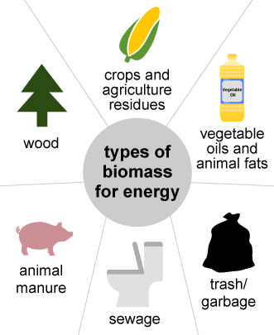
Fig:1: Types of biomass ( Source: U.S. Energy Information Adminstration , public domain)
There are several methods used to harness biomass energy, each with its own advantages and applications. Incineration,combustion, pyrolysis, Gasification, Anaerobic Digestion and Cogeneration etc.
Here are some of the common types of biomass energy methods
1. Combustion: Biomass can be burned directly to produce heat or electricity. In this method, organic materials are combusted in a controlled manner, releasing heat energy. The heat can be used to generate steam, which then drives a turbine to produce electricity. Combustion is the most common method of utilizing biomass energy and is often used in industrial settings and biomass power plants.
2. Gasification: Gasification involves the conversion of biomass into a gas known as syngas (synthesis gas). The process occurs at high temperatures in the presence of limited oxygen or air. The resulting syngas can be burned for heat or used to generate electricity. Gasification has the advantage of producing a clean-burning fuel that can be used in various applications, including combined heat and power systems and gas turbines.
3. Anaerobic Digestion: Anaerobic digestion is a biological process that breaks down organic materials in the absence of oxygen. Microorganisms decompose biomass, such as agricultural waste, food waste, and animal manure, to produce biogas, which consists primarily of methane and carbon dioxide. Biogas can be used as a renewable fuel for heating, electricity generation, or as a vehicle fuel. Additionally, the byproduct of anaerobic digestion, called digestate, can be used as a nutrient-rich fertilizer.
4. Pyrolysis: Pyrolysis involves the thermal decomposition of biomass in the absence of oxygen or with limited oxygen. The process produces three main products: biochar, bio-oil, and syngas. Biochar is a solid charcoal-like substance that can be used as a soil amendment, while bio-oil is a liquid that can be further processed and used as a fuel or chemical feedstock. Syngas can be burned to generate heat or used for electricity production.
5. Cogeneration: Cogeneration, also known as combined heat and power (CHP), is a method that simultaneously produces both heat and electricity from biomass energy sources. The heat generated during electricity production is captured and used for space heating, water heating, or industrial processes, maximizing the overall energy efficiency of the system. Cogeneration systems are widely used in industries, district heating systems, and large-scale facilities.
Examples of different sources of biomass energy: Biomass can be wood, sawdust, straw, seed waste, manure, paper waste, household waste, wastewater, etc. Here are some very common examples.
PLANTS AS A SOURCE OF BIOMASS ENERGY:

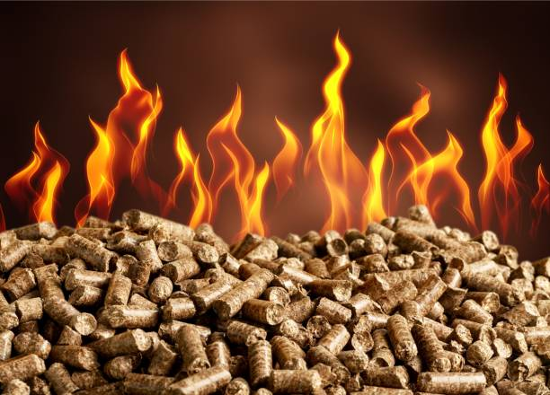
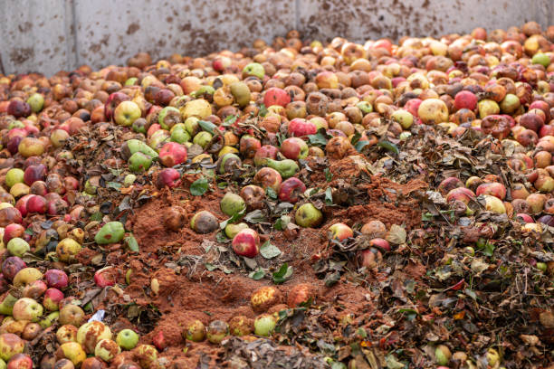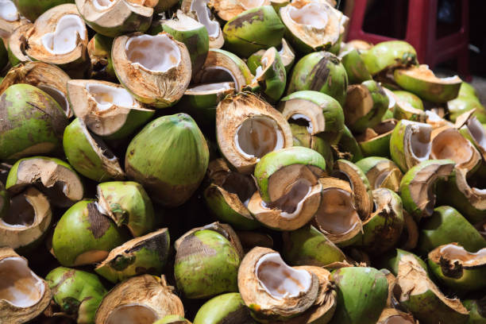
Fig:2 :Plant biomass
Plants can play a significant role in the production of biomass energy, providing a renewable and environmentally friendly alternative to fossil fuel. Here are some key points about using plants as a source of biomass energy (Fig:2):
- Feedstock: Plants are used as feedstock for biomass energy production. Various types of plants can be utilized, including agricultural crops like corn, sugarcane, switchgrass, and miscanthus, as well as forest residues and organic waste materials.
- Conversion Processes: Biomass energy can be obtained through different conversion processes. The most common methods include combustion, fermentation, anaerobic digestion, and pyrolysis. Each process has its own advantages and is suitable for different types of feedstock.
- Solid Biomass: Plants can be converted into solid biomass, such as wood chips or pellets, which can be used directly for heating and electricity generation in biomass power plants or residential settings. This method is widely used and established.
- Biofuels: Plants can also be processed to produce liquid biofuels, such as ethanol and biodiesel. Ethanol is primarily produced from crops like corn and sugarcane, while biodiesel is typically derived from oil crops like soybeans and palm.
- Environmental Benefits: Biomass energy from plants is considered a renewable energy source because plants can be grown and harvested repeatedly. It can help reduce greenhouse gas emissions and dependence on fossil fuels.
- Challenges: While biomass energy has its advantages, there are also challenges to consider. Competition with food production, land use conflicts, and potential environmental impacts from intensive cultivation are some concerns associated with large-scale biomass production. It is important to implement sustainable practices and ensure proper resource management.
- Research and Development: Ongoing research is focused on improving biomass conversion technologies, increasing energy efficiency, and exploring advanced feedstocks that minimize environmental impact and maximize energy yields.
ANIMALS AS A SOURCE OF BIOMASS ENERGY:
Animals can be utilized as a source of biomass energy through various methods. Here are a few examples:
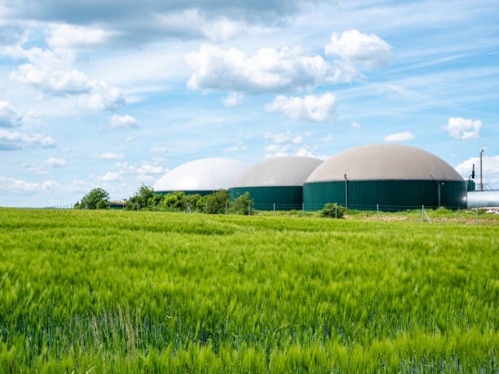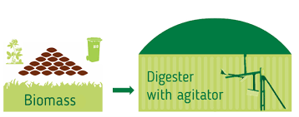
Fig:3: Biogas plant
- Biogas production: Animal waste, such as manure, can be used to produce biogas through a process called anaerobic digestion. Whole crops such as maize, millet, white sweet clover, and many others can be made into silage and then converted into biogas. In this process, microorganisms break down the organic matter in the waste, releasing methane gas, which can be captured and used as a renewable energy source. Biogas can be used for heating, electricity generation, or as a fuel for vehicles.
- Animal byproducts: Certain animal byproducts, such as fats and oils, can be converted into biodiesel. Rendering facilities collect and process these byproducts, extracting the fats and oils, which are then converted into biodiesel through a chemical reaction called transesterification. Biodiesel can be used as a substitute for diesel fuel in transportation or as a heating fuel.
- Biomass combustion: Animal biomass, such as animal residues or dedicated energy crops, can be burned to produce heat or electricity. The biomass is typically dried and then burned in a controlled manner, releasing energy in the form of heat. This heat can be used directly for heating purposes or converted into electricity through steam turbines.
It's worth noting that the use of animals for biomass energy production must be done in an ethical and sustainable manner, ensuring proper waste management, animal welfare, and environmental considerations.
KITCHEN WASTE/FOOD WASTE AS A BIOMASS RESOURCE:
Kitchen waste, also known as food waste, can indeed be utilized as a biomass resource. When properly managed, kitchen waste can be processed and converted into biomass energy through various methods. Here are a few ways kitchen waste can be utilized as biomass:
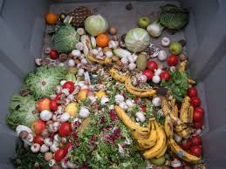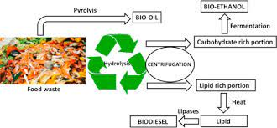
Fig:4: Food waste as energy source

- Anaerobic digestion: Anaerobic digestion is a biological process that breaks down organic materials in the absence of oxygen. Kitchen waste can be collected and placed in an anaerobic digester, where it undergoes decomposition by microorganisms, producing biogas (mainly methane) as a byproduct. Biogas can be used as a fuel for cooking, heating, or electricity generation.
- Composting: Composting is a natural decomposition process that converts organic waste into nutrient-rich compost. Kitchen waste, such as fruit and vegetable scraps, coffee grounds, and eggshells, can be composted along with yard waste to create a nutrient-dense soil amendment. The resulting compost can be used in gardening, agriculture, or landscaping.
- Biomass pellet production: Kitchen waste can be processed into biomass pellets, which are dense, cylindrical fuel sources. The waste is typically dried, ground, and compressed into pellet form. Biomass pellets can be burned in specialized stoves or boilers to produce heat or converted into electricity in biomass power plants.
- Animal feed: Certain types of kitchen waste, such as leftovers or vegetable trimmings, can be repurposed as animal feed. Before feeding kitchen waste to animals, it's important to ensure it is safe and free from harmful substances. Some food waste may require processing or treatment to remove potential contaminants.
- Waste-to-energy facilities: In some areas, waste-to-energy facilities exist where kitchen waste, along with other types of municipal solid waste, is incinerated to produce heat and electricity. These facilities employ advanced technologies to minimize environmental impacts and maximize energy recovery from waste.
It's important to note that while kitchen waste can be a valuable biomass resource, prevention and reduction of food waste should be prioritized. Minimizing food waste through proper meal planning, storage, and mindful consumption is crucial for both environmental and social reasons.
MUNICIPAL WASTE AS A BIOMASS ENERGY SOURCE:
Municipal waste, also known as solid waste or trash, can be utilized as a biomass energy source through a process called waste-to-energy (WtE). WtE facilities convert municipal solid waste into renewable energy, reducing the volume of waste while simultaneously generating electricity or heat. Here are some key points about municipal waste as a biomass energy source. Municipal waste is a diverse mixture of materials, including organic waste (food scraps, yard waste), paper, plastics, metals, and other non-recyclable materials. The organic fraction of municipal waste is particularly valuable as a biomass energy source. The most common methods include incineration, gasification, and anaerobic digestion. Each process has its own advantages and considerations.
a. Incineration: This process involves burning waste at high temperatures, typically in the presence of oxygen. Heat generated from the incineration process can be used to produce steam, which drives a turbine to generate electricity.
b. Gasification: Gasification converts waste into a synthetic gas (syngas) by subjecting it to high temperatures in a low-oxygen or oxygen-starved environment. The syngas can be used directly in a gas engine to generate electricity or further refined into other fuels.
c. Anaerobic Digestion: This process decomposes organic waste in the absence of oxygen, producing biogas (methane and carbon dioxide) as a byproduct. The biogas can be used for electricity generation or as a renewable natural gas (RNG) fuel for transportation.
- Environmental advantages : Using municipal waste as a biomass energy source offers several environmental advantages. It reduces the volume of waste going to landfills, mitigating methane emissions and minimizing the need for new landfill sites. Additionally, it provides a renewable energy alternative to fossil fuels, contributing to greenhouse gas reduction and resource conservation.Waste-to-energy facilities can serve as an integral part of an integrated waste management system. By combining recycling, composting, and waste-to-energy processes, communities can maximize the diversion of waste from landfills and reduce environmental impacts.
- Challenges and Considerations: Implementing waste-to-energy technologies requires careful consideration of factors such as emissions control, ash management, and public acceptance. Emissions control technologies, like scrubbers and filters, are employed to minimize air pollutants. Proper management of ash residues, which can contain heavy metals and other contaminants, is crucial. Public awareness, education, and stakeholder engagement are essential for successful implementation.

ADVANTAGES OF BIOMASS AS ENERGY SOURCE
- Carbon neutrality: Biomass energy is considered carbon-neutral because the carbon dioxide (CO2) emitted during combustion is approximately equal to the CO2 absorbed by plants during photosynthesis. This makes it an attractive alternative to fossil fuels, which release carbon that has been sequestered for millions of years.
- Diverse feedstock: Biomass energy can be derived from a wide range of sources, including wood pellets, crop residues, dedicated energy crops (such as switchgrass) agricultural waste, and even organic waste from industries and municipalities. This diversity of feedstock allows for flexibility and reduces dependency on any single source.
- Energy generation: Biomass energy can be used in various ways. Biomass power plants generate electricity by burning biomass to produce steam, which drives turbines connected to generators. Combined heat and power (CHP) systems use the heat produced during biomass combustion for district heating or industrial processes, making them more efficient than separate heat and power generation.
- Biofuels: Biomass can also be converted into liquid biofuels, such as ethanol and biodiesel, which can be used in transportation. Advanced biofuels, including cellulosic ethanol, can be produced from non-edible plant materials, further expanding the potential feedstock and reducing competition with food crops.
- Technological advancements: Ongoing research and development are focused on improving biomass conversion technologies, increasing efficiency, and reducing costs. Innovations include gasification, pyrolysis, and anaerobic digestion, which offer different pathways for converting biomass into useful energy products.
- Waste management and circular economy: Biomass energy plays a crucial role in waste management by converting organic waste into energy, reducing landfill waste, and mitigating greenhouse gas emissions from decomposition. It aligns with the principles of the circular economy by utilizing waste as a resource and minimizing environmental impacts.
- Regional benefits: Biomass energy production can have positive socio-economic impacts on rural areas by creating jobs in farming, forestry, and manufacturing. It can also enhance energy independence and reduce reliance on imported fossil fuels, contributing to energy security.
FUTURE PROSPECTIVE OF BIOMASS ENERGY:
The future of biomass energy looks promising as a renewable and sustainable energy source. The biomass energy sector has witnessed significant advancements and new avenues in recent years. Here are some notable developments and new avenues in the biomass energy sector:
- Advanced Biomass Conversion Technologies: Technological innovations have led to the development of advanced biomass conversion technologies, such as biomass gasification, pyrolysis, and torrefaction. These processes convert biomass into syngas, bio-oil, or solid biofuel, which can be used for various energy applications.
- Bioenergy with Carbon Capture and Storage (BECCS): BECCS involves capturing carbon dioxide (CO2) emissions from biomass power plants or biofuel production facilities and storing it underground. This approach helps in reducing greenhouse gas emissions and can contribute to achieving climate change mitigation goals.
- Waste-to-Energy: Biomass resources derived from organic waste, such as food waste, agricultural residues, and sewage sludge, can be converted into biogas through anaerobic digestion. Biogas can then be used for electricity generation or as a substitute for natural gas.
- Microbial Fuel Cells: Microbial fuel cells (MFCs) are devices that convert organic matter, such as wastewater or agricultural waste, into electricity using bacteria. MFCs offer potential applications in small-scale decentralized systems, particularly in rural areas or remote locations.
- Algae Biofuel: Algae-based biofuels have gained attention as a sustainable alternative to traditional transportation fuels. Algae can be cultivated in ponds or bioreactors, and their oils can be extracted and processed into biodiesel or other biofuels. Algae cultivation also offers the benefit of CO2 capture and potential wastewater treatment.
- Combined Heat and Power (CHP) Systems: Biomass CHP systems generate both heat and electricity from biomass feedstocks. These systems are highly efficient, utilizing the waste heat produced during electricity generation for heating or industrial processes, making them an attractive option for district heating and industrial applications.
- Biochar Production: Biochar is a carbon-rich solid material produced through the process of pyrolysis or gasification of biomass. It can be used as a soil amendment to enhance soil fertility and sequester carbon, thereby contributing to climate change mitigation and sustainable agriculture.
- Integrated Biorefineries: Integrated biorefineries aim to maximize the value derived from biomass by producing multiple products such as biofuels, biochemicals, and bioplastics. These facilities integrate various conversion processes to utilize different components of biomass, minimizing waste and maximizing resource efficiency.
- International Cooperation and Policy Support: Many countries and international organizations are increasingly recognizing the importance of biomass energy in their energy transition strategies. This has resulted in policy support, research collaborations, and investments in the biomass energy sector.

CHALLENGES:
Some of these challenges include:
- Feedstock Availability: Biomass energy relies on a consistent and abundant supply of biomass feedstock. Ensuring an adequate and sustainable supply of biomass can be challenging, especially on a large scale. It requires careful management of biomass resources and efficient collection and transportation systems.
- Resource Competition: Biomass feedstock can be used for various purposes, including food production, animal feed and industrial applications. There can be competition for biomass resources between different sectors, which may pose challenges in balancing the demand for biomass energy with other essential needs.
- Storage and Handling: Biomass materials often have high moisture content and can be bulky, which makes storage and handling complex. Proper storage and handling techniques are required to prevent degradation, microbial growth, and energy losses. Additionally, biomass energy systems need effective methods for collecting, preprocessing, and transporting feedstock.
- Conversion Efficiency: Biomass energy conversion processes, such as combustion, gasification, and fermentation, are not always highly efficient. The energy content of biomass can be lower compared to fossil fuels, and the conversion technologies may have limitations in achieving optimal energy conversion rates. Improving conversion efficiency is crucial to maximize the energy output and make biomass energy economically viable.
- Environmental Impact: While biomass energy is considered renewable, the environmental impact of its production and utilization must be carefully managed. Unsustainable harvesting of biomass resources can lead to deforestation and habitat loss. Additionally, the combustion of biomass can release air pollutants and greenhouse gases if not properly controlled. Ensuring sustainable practices and implementing emissions control technologies are essential to mitigate environmental concerns.
- Technological Advancements: The development and deployment of advanced biomass energy technologies require significant research and development efforts. Innovations are needed to improve the efficiency, cost-effectiveness, and environmental performance of biomass energy systems. Advancements in areas such as biomass preprocessing, conversion technologies, and waste management can help overcome existing challenges.
- Policy and Financial Support: Biomass energy development often requires supportive policies and financial incentives to encourage investment and market growth. Governments need to provide a stable regulatory framework, incentivize biomass energy production, and support research and development initiatives. Access to adequate funding and subsidies can also facilitate the deployment of biomass energy projects.
USE OF BIOMASS IN INDIA CURRENT SCENARIO
Renewable energy sources represent 22% of total energy supply (8.8 EJ), with 88% of it being bioenergy. Biomass is a significant source of energy in India, particularly in rural areas where access to traditional forms of energy is limited. India has been actively pursuing biomass energy projects as part of its renewable energy portfolio. Here are a few notable examples of biomass energy and projects in India:
- Cooking Fuel: Biomass, primarily in the form of firewood, agricultural residues, and animal dung, is widely used as a cooking fuel in rural households. It is estimated that around 70% of rural households in India rely on biomass for cooking.
- Electricity Generation: Biomass is also utilized for electricity generation in India. Biomass power plants, known as biomass gasifiers, are set up in various regions to convert biomass into electricity. These power plants use agricultural residues, forest waste, and dedicated energy crops as feedstock.
- Biofuel Production: India has been promoting the production and use of biofuels to reduce dependence on fossil fuels and lower greenhouse gas emissions. Biomass feedstocks such as sugarcane, jatropha, and oilseeds are used for the production of biofuels like ethanol and biodiesel.
- Government Initiatives: The Government of India has implemented several initiatives to promote the use of biomass. One such initiative is the National Biomass Cookstoves Initiative, which aims to provide cleaner and more efficient cooking stoves to rural households. Additionally, the Ministry of New and Renewable Energy (MNRE) provides financial incentives and subsidies for biomass-based power generation projects.
- Indian Institute of Science (IISc) Biomass Gasification Project: The Indian Institute of Science in Bangalore has been involved in research and development of biomass gasification technology. They have implemented several pilot projects to test the viability of converting agricultural residues into producer gas, which can be used for cooking, heating, or electricity generation.
- Punjab Biomass Power Ltd: Located in the state of Punjab, this project is one of the largest biomass power plants in India. It has a capacity of 150 MW and utilizes agricultural residues like paddy straw, wheat straw, and sugarcane trash to generate electricity.
- Maharashtra State Power Generation Company (MAHAGENCO): MAHAGENCO has set up multiple biomass power plants in Maharashtra. For instance, the Khaperkheda Thermal Power Station in Nagpur has a dedicated biomass power plant with a capacity of 10 MW.
- Tamil Nadu Biomass Power Projects: Tamil Nadu has been a frontrunner in biomass power generation. The state has numerous biomass power projects, such as the MW-scale projects by projects by companies like Muthukur Renewable Energy Limited, Sree Amman Biofuels, and OPG Power Generation.
- Andhra Pradesh Biomass Power Projects: Andhra Pradesh has also embraced biomass energy. Projects like the Sri Rayalaseema Green Energy and Sri Vijaya Visakha Biomass Power Plants have contributed to the state's renewable energy capacity.
- Co-firing in Thermal Power Plants: Several thermal power plants across India have adopted co-firing technology, where biomass is mixed with coal during combustion to reduce greenhouse gas emissions. For example, the NTPC Dadri Thermal Power Plant in Uttar Pradesh has successfully implemented co-firing of biomass pellets.
- The Government of India has set target of achieving 20% blending of ethanol in petrol by 5 years to 2025-26.
- Use of maize and surplus rice for ethanol production in collaboration with Food Corporation of India (FCI)
- Importance to technologies for bio-based renewable fuels, chemicals, and materials to replace the petrochemical products contributing to greenhouse gases emissions reductions.
- Under Mission Innovation 2.0, India and the US are co-leading the Mission Innovation Collaborative platform initiative on “Innovation for Sustainable Aviation Fuel” (ISAF).
- Galvanizing Organic Bio-Agro Resources (GOBAR)-DHAN, announced on February 1, 2018 for the improvement in sanitation in Indian villages by processing livestock manure and solid agricultural waste to produce biogas.
- To promote Hydrogen as a clean fuel for the mobility sector.
- Bio manures produced as Fermented Organic Manure and Fermented Liquid Organic Manure under Fertilizer category for retail sale in the country. (Source: IEA Bioenergy Report,2021)

SUMMARY:
Biomass energy derived from organic matter, such as plants, agricultural crops, forest residues, and organic waste is considered a renewable energy source.The organic materials used for biomass energy can be replenished through natural processes. Biomass can be converted into various forms of energy, including heat, electricity, and biofuels.Biomass energy has several advantages. First, it is a carbon-neutral energy source. When biomass is burned or converted into biofuels, it releases carbon dioxide (CO2) into the atmosphere. However, the CO2 emitted during combustion is roughly equal to the CO2 absorbed by the plants during their growth, creating a closed carbon cycle. This makes biomass energy a viable option for reducing greenhouse gas emissions and mitigating climate change.Another benefit of biomass energy is its potential to promote sustainable development. By utilizing locally available organic materials, biomass energy can enhance energy security and reduce dependence on fossil fuels. It can also create new job opportunities in the biomass supply chain, including biomass cultivation, harvesting, transportation, and conversion.Moreover, biomass energy can contribute to waste management and environmental sustainability. Organic waste, such as agricultural residues and food waste, can be utilized as biomass feedstock, reducing the amount of waste sent to landfills and minimizing methane emissions. Additionally, by utilizing biomass resources sustainably, we can help preserve biodiversity and ecosystems by avoiding excessive exploitation of natural resources.However, the sustainability of biomass energy depends on several factors. The sourcing and management of biomass feedstock must be done in an environmentally responsible manner. It is crucial to ensure that biomass is harvested and cultivated in a sustainable way, without causing deforestation, land degradation, or other negative environmental impacts. Additionally, the efficient conversion of biomass into energy is essential to maximize energy output and minimize emissions.To achieve sustainable development with biomass energy, it is crucial to implement comprehensive policies and regulations. These should encourage sustainable biomass production, promote research and development for efficient conversion technologies, and ensure the protection of ecosystems and biodiversity. It is also important to consider the social and economic aspects of biomass energy, including equitable distribution of benefits, local community involvement, and the overall impact on rural development.

REFERENCES:
      - Ara Kirakosyan; Peter B. Kaufman (15 August 2009). Recent Advances in Plant Biotechnology. p. 169. ISBN 9781441901934. Retrieved 14 February 2013.
      - Contescu, C.I.; Adhikari, S.P.; Gallego, N.C.; Evans, N.D.; Biss, B.E. Activated Carbons Derived from High-Temperature Pyrolysis of Lignocellulosic Biomass. C J. Carbon Res. 2018, 4, 51.
      - International Journal of Food Microbiology. Volume 365, 16 March 2022, 109538
      - Kılkı¸s, ¸S.; Krajaˇci´c, G.; Dui´c, N.; Rosen, M.A.; Al-Nimr, M.A. Advancements in sustainable development of energy, water and environment systems. Energy Convers. Manag. 2018, 176, 164–183.
      - Mehedintu, A.; Sterpu, M.; Soava, G. Estimation and forecasts for the share of renewable energy consumption in final energy consumption by 2020 in the european union. Sustainability 2018, 10, 1515.
      - Muresan, A.A.; Attia, S. Energy efficiency in the romanian residential building stock: A literature review. Renew. Sustain. Energy Rev. 2017, 74, 349–363.
      - Science direct
      - The 17 Goals. Sustainable Development Goals. UN. Retrieved 10 August 2022.
      - United Nations (2015) Resolution adopted by the General Assembly on 25 September 2015, Transforming our world: the 2030 Agenda for Sustainable Development (A/RES/70/1 Archived 28 November 2020 at the Wayback Machine)
      - United Nations (2017) Resolution adopted by the General Assembly on 6 July 2017, Work of the Statistical Commission pertaining to the 2030 Agenda for Sustainable Development .

AUTHORS CREDENTIALS:
Lead and Corresponding Author:
1.Dr. Monika Panchani ,Associate Professor , Department of Zoology, Vallabh Degree College (VGC), Mandi, Himachal Pradesh, India-175001
Email: monaharipanchani@gmail.com
Mobile: 9418263032

Co-authors:

2. Dr. Sanjay Narang, Associate Professor (Zoology), Vallabh Degree College (VGC), Mandi, Himachal Pradesh, India-175001
Email: sanjaynarang2020@gmail.com Mobile: 9418480595
3.Dr. Radhika Jamwal, Assistant Professor (Zoology), Vallabh Degree College (VGC), Mandi, Himachal Pradesh, India-175001
Email : radhika_mnd@yahoo.co.in Mobile: 9418080991
4. Dr. Manoj Thakur, Assistant Professor (Environment Science), Vallabh Degree College (VGC), Mandi, Himachal Pradesh, India-175001
Email: manojthakur0083@gmail.com
Mobile: 9418421270

