The Role of Natural Products in Dental Hygiene
Sushant, Kiran Yadav, Ram Kumar*
Assistant Professor, Faculty of Pharmaceutical Sciences, The ICFAI University, Himachal Pradesh.
Associate Professor, Faculty of Pharmaceutical Sciences, The ICFAI University, Himachal Pradesh.
*Assistant Professor, Department of Pharmaceutical Science and Technology, Maharaja Ranjit Singh Punjab Technical University, Bathinda.

Corresponding Author: ramkumar17040@gmail.com

Abstract:
Natural products are compounds produced from natural sources such as plants, minerals, or animals that are used to enhance oral hygiene and avoid oral health disorders. These items are frequently lightly processed, allowing them to keep their natural qualities without the addition of synthetic additives. Natural medicines have been employed by numerous civilizations throughout history to preserve dental health. For example, ancient civilizations such as the Egyptians and Greeks used herbs, bark, and minerals to clean their teeth and gums. Plants such as neem and clove have long been used in Ayurvedic practices in India for their possible dental benefits. Natural components are also used in traditional Chinese medicine to maintain dental health.
Keywords: Dental health, natural products, plant extracts.
Importance of Natural Products in Modern Dental Hygiene:
Several factors contribute to the present trend towards natural oral hygiene products:
- Holistic Approach: People are increasingly seeking holistic approaches to healthcare that take into account the body's total well-being. Natural goods are consistent with this attitude since they provide potential advantages without the use of harsh chemicals.
- Environmental Issues: The environmental effect of synthetic chemicals contained in many traditional dental products is becoming more well acknowledged. Natural items frequently have a minimized ecological impact.
- Reduction of Harmful Effects:Some traditional dental products contain substances that might produce adverse effects or allergic responses. Natural products are thought to be compassionate alternatives.

- Antibiotic Resistance: Antibiotic resistance has been exacerbated by the misuse of antibiotics in dental treatment. Natural items with antibacterial qualities may be able to assist alleviate this problem.
- Demand from Consumers: The natural oral care industry is expanding due to rising customer demand for eco-friendly and organic goods.
- Validation of Ancient Wisdom: Many traditional applications of natural items in dental care are being verified by current investigations as scientific study advances.
Overall, the study of natural products in oral health provides a synthesis of old wisdom and current scientific knowledge.
Natural goods that can be used in dental hygiene include essential oils (e.g., tea tree oil, clove oil), plant extracts (e.g., neem, aloe vera), and bee-derived compounds (e.g., propolis). These products may provide antibacterial, anti-inflammatory, and antioxidant actions, which are important for preserving oral health. Dental practitioners and the general public may make educated judgements about their oral care routines by knowing the historical backdrop, current interest, and advantages of natural products.
Using natural products in dental care products has gained popularity due to several reasons:
- Safety: Natural ingredients often have a lower likelihood of causing adverse reactions or allergies compared to synthetic chemicals. People are becoming more conscious about the potential risks associated with certain synthetic ingredients used in dental products.
- Minimal Chemical Exposure: Some individuals are concerned about exposure to potentially harmful synthetic chemicals found in traditional dental products. Natural ingredients are seen as a way to reduce the overall chemical load on the body.
- Environmental Impact: Many natural dental care products are formulated with biodegradable and eco-friendly ingredients, reducing the environmental impact of oral hygiene routines. This appeals to consumers who prioritize sustainability.
- Holistic Approach: Natural dental products often align with holistic health practices that focus on overall well-being. People who follow holistic lifestyles may prefer products that align with their values.
- Gentler Formulations: Natural ingredients are often perceived as gentler on sensitive oral tissues. They might be less abrasive or harsh compared to some synthetic ingredients found in traditional dental care products.
- Herbal and Ayurvedic Traditions: In some cultures, traditional herbal and Ayurvedic practices have emphasized natural ingredients for oral health. This has influenced the use of natural ingredients in dental care products.
- Preference for Familiar Ingredients: Consumers may prefer ingredients they recognize and understand. Natural dental products often use ingredients that are commonly found in nature and are easily recognizable.
- Fluoride Concerns: Some individuals are concerned about the potential negative effects of fluoride, which is a common ingredient in toothpaste. Natural dental products often provide fluoride-free alternatives for those who prefer to avoid it.
- Natural Flavor and Aroma: Natural dental products can offer appealing flavors and aromas derived from essential oils and natural extracts, enhancing the overall sensory experience of oral care.
It's important to note that the term "natural" can be vague and not always synonymous with safety or effectiveness. Not all natural ingredients are suitable for dental products, and not all synthetic ingredients are harmful. Additionally, the efficacy of natural dental products can vary, so it's essential to choose products that are supported by scientific evidence and have been approved by dental professionals or regulatory bodies.
SOME COMMONLY USED NATURAL PRODUCTS FOR THE DENTAL HEALTH:
- Tea Tree Oil:
The main tea tree oil constituents are as follows in Figure 1, Figure 2 and Figure 3.
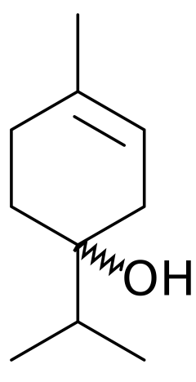
FIGURE 1- Terpinen-4-ol
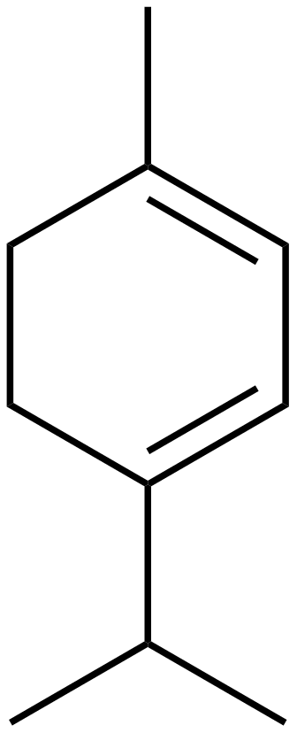
FIGURE 2- TERPINENE
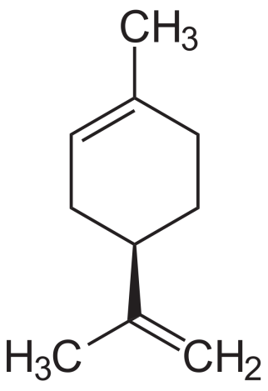
FIGURE 3- LIMONENE
Uses:
Tea tree oil, obtained from the leaves of the Melaleuca alternifolia plant, has powerful antibacterial effects. It has historically been used to treat a variety of infections.
Advantages:
- Antimicrobial Action: Tea tree oil's main active compound, terpinen-4-ol, has been shown to have strong antimicrobial effects against bacteria, viruses, and fungi.
- Gum Health: It can help reduce gum inflammation and combat bacterial growth associated with gum disease.
- Bad Breath: Tea tree oil's antibacterial properties can help fight bacteria responsible for bad breath.
Disadvantages:
- Potential Irritation: Undiluted tea tree oil can be irritating to the skin and mucous membranes. Dilution is essential before use.
- Allergic Reactions: Some individuals may be sensitive or allergic to tea tree oil, resulting in skin reactions or other adverse effects.

- Neem:
The main neem oil constituents are as follows in Figure 3, Figure 4 and Figure 5.

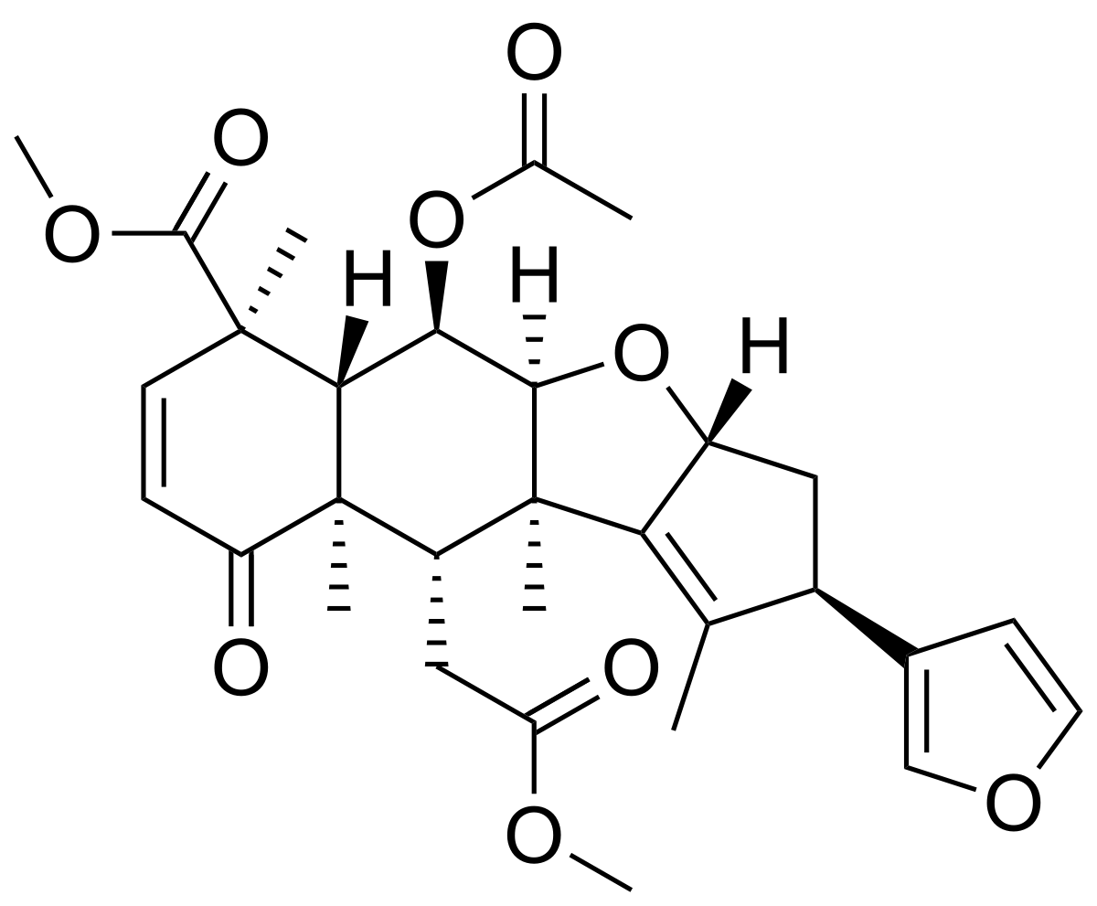
FIGURE 4- NIMBIN
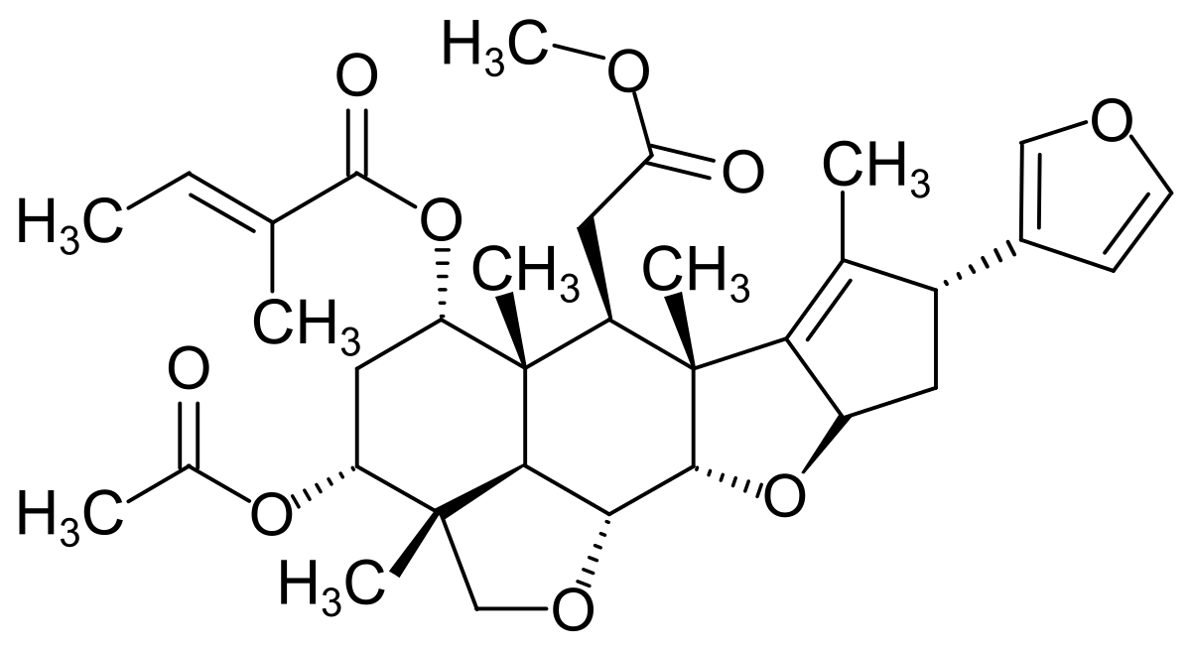
FIGURE 5- SALANNIN
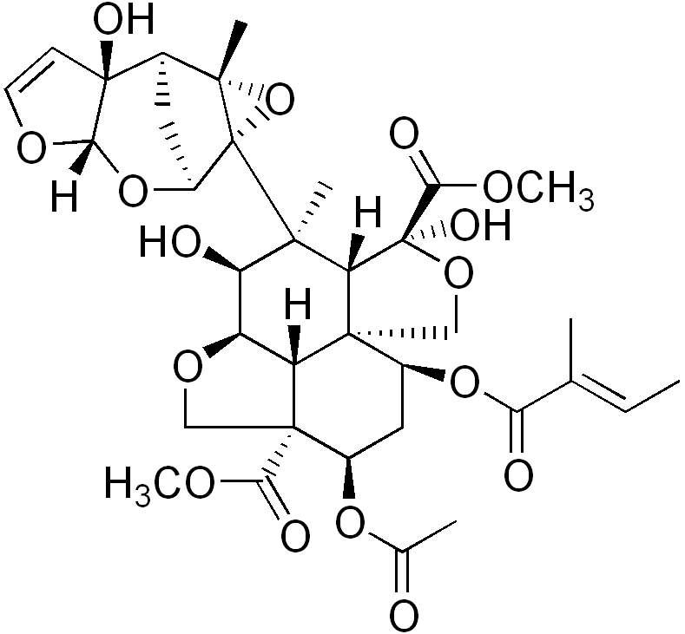
FIGURE 6- AZADIRACHTIN
Uses:
Neem, derived from the neem tree (Azadirachta indica), has been used for centuries in Ayurvedic medicine for its potential health benefits, including dental care.
Advantages:
- Antibacterial Properties: Neem contains compounds that exhibit antibacterial effects, making it effective against oral bacteria.
- Gum Health: Neem's anti-inflammatory properties can help improve gum health and alleviate gingivitis symptoms.
- Plaque Control: Neem's ability to inhibit bacterial growth can aid in reducing plaque buildup.
Disadvantages:
- Bitter Taste: Neem has a strong bitter taste that some individuals may find unpleasant.
- Limited Research: While traditional use is well-established, more clinical research is needed to validate its specific dental benefits.

- Aloe Vera:
The main aloe vera constituents are as follows in Figure 7 and Figure 8.

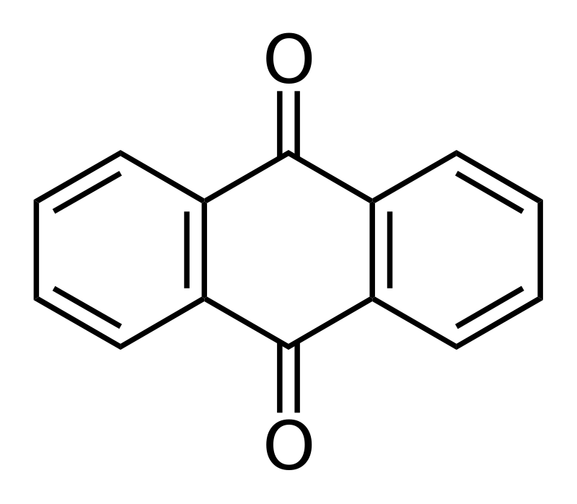
FIGURE 7- ANTHRAQUINONE
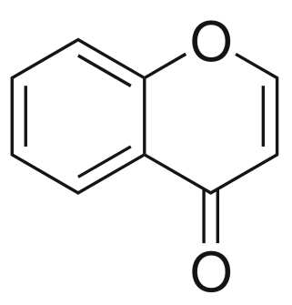
FIGURE 8- CHROMONE
Uses:
Aloe vera, extracted from the leaves of the aloe plant, is known for its soothing and healing properties and has been used in various skincare and health products.
Advantages:
- Soothing Effect: Aloe vera can provide relief from oral discomfort, including minor burns, irritation, and inflammation.
- Wound Healing: It has potential wound-healing properties that can aid in the recovery of oral tissues.
- Antioxidant Content: Aloe vera contains antioxidants that may contribute to oral health.
Disadvantages:
- Texture and Taste: Aloe vera gel may have a slimy texture and a slightly bitter taste, which some people might find off-putting.
- Digestive Effects: If ingested in large quantities, aloe vera gel can have laxative effects. Proper use and moderation are important.

It's important to remember that everyone's reaction to natural goods is different. Some people may be allergic or sensitive to these natural elements. Moderation, correct usage, and consultation with a dental expert are recommended, as with any oral care product. When evaluating natural goods, it's critical to understand their possible advantages and drawbacks, and to make educated judgements based on personal tastes and needs.

5. Clinical Applications of Dental Products:
- Prevention of Gum Disease and Cavities:
- Natural items with antibacterial and anti-inflammatory characteristics, such as tea tree oil, neem, and propolis, can help prevent gum disease (gingivitis and periodontitis) and cavities.
- These products can help reduce the growth of dangerous bacteria in the mouth, lowering the risk of plaque formation and swelling of the gums and decay.

- Relief from Oral Discomfort and Irritation:
- Aloe vera and chamomile are natural ingredients with soothing attributes. These treatments can be used to relieve oral pain caused by conditions such as mouth ulcers, gum inflammation, and post-dental surgery irritation.

- Support for Fresh Breath:
- Many natural items, such as tea tree oil, cinnamon, and peppermint, have natural aromatic ingredients that can aid in the treatment of bad breath.
- These items can help to eliminate odor-causing germs in the mouth while also providing a pleasant experience.
- Adjunctive Therapy to Conventional Treatments:
- Natural products can be used in addition to traditional dental care as complimentary therapies. Using mouthwashes containing tea tree oil or propolis, for example, in addition to regular brushing and flossing, can improve oral hygiene habits and contribute to better overall oral health.

Advantages of Clinical Applications:
- Holistic Approach: Natural products provide a holistic approach to oral health, considering both prevention and treatment.
- Reduced Chemical Exposure: Many conventional dental products contain synthetic chemicals. Natural products offer an alternative for those who prefer minimal chemical exposure.
- Antibiotic Alternatives: Because of the growth in antibiotic resistance, researchers are looking for alternative antimicrobial agents, making natural compounds with antibacterial capabilities very useful.
- Gentle yet Effective: Natural solutions can frequently deliver good outcomes without the harshness that conventional ones can.

Disadvantages and Considerations:
- Limited Scientific Evidence:While many natural items appear to have potential, scientific research on their efficacy and safety in dental applications is still in its early stages.
- Individual Sensitivities:Natural products, like any other chemical, might cause allergies or sensitivities in certain people.
- Consistency of Effects:Natural products may not give immediate or consistent effects for all consumers, and individual reactions may differ.
- Regulation and Quality Control:Natural oral care products may have varying quality and efficacy due to a lack of standardised rules.

Natural product clinical uses in dental hygiene provide a wide variety of advantages, from prevention to symptom alleviation. While the benefits are obvious, it is critical that people exercise caution, contact dental specialists, and make educated decisions when introducing natural products into their oral care regimens. The ability of these items to supplement traditional dental treatments highlights their importance in holistic oral health methods.

6. Safety and Considerations:
1. Potential Allergies and Sensitivities:
- Individual Variability:People's sensitivities to natural components might vary, just like any other product. Some people may develop allergies or sensitivities to certain natural product components.
- Patch Testing:Before utilising a new natural product, execute a patch test on a tiny portion of epidermis to check for any adverse effects.
2. Interaction with Conventional Dental Products:
- Compatibility:Compatibility should be examined when mixing natural products with conventional dental products such as toothpaste or mouthwash. Some interactions may have an impact on the efficacy of either product.
- Professional Advice: Before combining various products, consult a dental expert to ensure that they are used safely together.
3. Regulation and Quality Control:
- Lack of Standardization:The natural products production may lack established rules, resulting in varied product both in terms of effectiveness and quality.
- Certifications:Look for commodities that have been certified by acknowledged agencies to ensure their genuineness and quality.
4. Dilution and Dosage:
- Dilution for Concentrated Products: Some natural items, such as essential oils, must be carefully diluted before usage so as to prevent irritation or adverse reactions.
- Dosage Consideration: Excessive usage of a natural product may not result in improved benefits and could trigger agony.
5. Ingestion Risk:
- Oral Ingestion:Some natural products, such as oil pulling using coconut oil, are meant for oral usage. While intake in high doses is normally safe, it might induce gastrointestinal distress.
6. Professional Advice:
- Consultation with Dental Professionals: Consult your dentist or dental hygienist before making substantial changes to your oral care routine. They may provide you advice based on your specific oral health needs.
Advantages of Safety Considerations:
- Avoiding Adverse Reactions: Prioritising safety procedures minimises the likelihood of unwanted reactions or allergies while utilising natural goods.
- Effective and Comfortable Use: If the natural dental products are used properly they are very much effective nad comfortable for the user.
Disadvantages and Challenges:
- Lack of Standardization: The absence of standardised norms might create uncertainty regarding product quality and safety.
- Individual Compliance:Some people may not follow accurate dilution or usage rules, which might lead to challenges as well.
- Balancing Act:Finding the perfect balance between natural products and conventional dental care necessitates intelligent decision-making.
The importance of safety concerns in maximising the advantages of natural goods while minimising possible dangers cannot be overstated. Individuals may comfortably include natural products into their oral care routines by being mindful of allergies, interactions, correct usage, and contacting dental specialists. The importance of safety guarantees that the potential benefits of utilising natural products for dental hygiene are realised without jeopardising oral health or general well-being.
7. Future Directions and Challenges:
1. Further Research and Clinical Trials:
- Scientific Validation:To confirm the efficacy, safety, and long-term benefits of natural products in oral hygiene, more rigorous scientific research and well-designed clinical studies are required.
- Specific Mechanisms:Understanding the specific mechanisms by which herbal remedies work is able to guide the development of customised oral care solutions.
2. Integration of Natural Products in Professional Dental Practice:
- Educational Initiatives:Dental practitioners should be educated on the possible advantages and limits of natural products so that they may give their patients with informed advice.
- Treatment Protocols:In order to ensure consistent and successful use, natural products must be included into established treatment regimens.
3. Public Awareness and Education:
- Evidence-Based Information:Educating the public on the evidence-based advantages of natural goods can help to debunk myths and encourage informed decision-making.
- Safe Usage:Users can minimize bad responses by providing information about optimal dilution, usage, and potential interactions.
4. Sustainable Sourcing and Ethical Practices:
- Environmental Impact:As the demand for natural goods develops, it is critical to ensure sustainable sourcing practices to avoid overexploitation of natural resources.
- Ethical Considerations:It is critical for ethical sourcing to ensure fair labour practises and to help local communities in the manufacturing of natural goods.
5. Regulatory Framework:
- Standardization: Standardized rules for natural oral care products can help to assure consistency in quality and safety.
- Labeling Transparency:Labelling that is clear and accurate can assist customers in making sound choices and avoiding possible allergies.

Challenges:
- Lack of Regulation:In the natural goods sector, the lack of standardised rules can lead to variable product quality and deception.
- Misinformation:Misleading marketing promises can lead to customer misunderstanding and unreasonable expectations.
- Consumer Compliance:It might be difficult to ensure that users follow correct dilution, usage, and guidelines.
- Research Gap:Natural product incorporation into standard dental care is hampered by a lack of rigorous research and clinical studies.
Future Perspectives:
The future of natural products in dental hygiene is exciting, but it also presents issues that must be addressed. The function of natural products in dental care can progress positively by encouraging additional research, improving professional education, and expanding public awareness. Researchers, dental professionals, producers, and regulatory organizations must work together to guarantee that natural products are successfully and safely integrated into dental hygiene practices.
Conclusion:
In conclusion, natural dental products have a significant benefit over their synthetic equivalents. They use natural components that are frequently free of harsh chemicals to promote dental health while minimising environmental effect. Choosing such items is consistent with a holistic approach to well-being, which benefits both personal health and the environment.

