Artificial Intelligence and its Influence on Consumer Behaviour in the Indian Banking System
Dr. Kishore Kunal*, Dr. Ramprakash K.R**, Dr. C. Joe Arun***
*Dr. Kishore Kunal – Associate Professor, Loyola Institute of Business Administration (LIBA).
** Dr. Ramprakash K.R – Teaching Faculty, Loyola Institute of Business Administration (LIBA.
*** Dr. C. Joe Arun – Director, Loyola Institute of Business Administration (LIBA).
Abstract
The rapid advancement and adoption of artificial intelligence (AI) in the banking sector have led to a paradigm shift in customer service, personalization, and overall banking experience. However, the impact of AI-enabled services on customer behaviour, satisfaction, and loyalty remains an area of interest and warrants further investigation. This study aims to understand the perception of customers towards AI-enabled banking services, identify the level of customer satisfaction with these services, and analyze the impact of AI-driven banking solutions on customer satisfaction, which in turn influences customer loyalty. The findings of this study provide valuable insights for banks and other financial institutions, helping them to better understand the customer perspective on AI-enabled services.
Keywords: Artificial Intelligence, AI Adoption, Trust in AI.
- Introduction
Artificial Intelligence (AI) has permeated every aspect of human life and is playing an increasingly significant role in the transformation of numerous industries, including the banking sector [1]. Over the last decade, AI has reshaped banking operations, services, and strategies, prompting researchers and industry experts to examine its profound influence on the sector [2]. This chapter delves into the dynamics of AI integration in banking, illustrating how financial institutions are harnessing the power of advanced technologies to streamline operations, enhance customer experiences, and drive profitability.
The advent of AI in banking has ushered in a new era marked by heightened efficiency and increased customization. Complex tasks are now automated, reducing error margins, and the vast amounts of data that banks deal with are more efficiently processed and analyzed through AI technologies [3]. The role of AI extends beyond operational efficiency, serving as a tool to better understand customers, predict behaviors, and deliver personalized services [4].
The banking sector has been at the forefront of using contemporary technologies to reimagine and provide clients with more complex and high-quality services. It is no exception when it comes to AI also. Banks have already begun using artificial intelligence, and the majority of them have seen improvements in customer engagement, competitiveness, accelerated innovation, higher margins, and business intelligence, among other things.
While the integration of Artificial Intelligence (AI) in the banking industry worldwide has been accelerating, the impact of this technological transformation on consumer behaviour, especially within the Indian banking system, remains under-studied. As consumer behaviour plays a pivotal role in the successful adoption and utilisation of AI technologies, a lack of understanding of this area could hinder the optimisation of AI applications in the banking industry. Despite the significant investment in AI by Indian banks, there is a paucity of research examining how these AI innovations influence consumer perceptions, attitudes, and behaviours. Therefore, the problem this research seeks to address is the gap in existing literature regarding how AI influences consumer behaviour within the Indian banking industry. This research will also seek to understand the specific factors that drive or inhibit consumers' adoption and usage of AI-enabled services within this industry.
- Literature Review
Artificial Intelligence (AI) has been progressively pervading various sectors, with banking being a key industry undergoing rapid transformation due to AI applications [5]. The potential benefits of AI in banking encompass several aspects including customer service, risk management, fraud detection, credit scoring, and personalized banking. It is forecasted that AI could save the banking industry more than $1 trillion by 2030 [6].
AI in banking is primarily implemented for efficiency, accuracy, and cost-effectiveness. Technological advancements have provided banks with tools to reconfigure their service delivery mechanisms, create more personalized offerings, and increase operational efficiency [5]. Despite the numerous advantages of AI adoption in banking, concerns persist regarding data privacy, transparency, and ethical considerations, thereby necessitating a balance between AI use and the potential risks it brings [7]. Moreover, the "black box" problem, wherein the decision-making process of AI systems is not entirely understood or transparent, remains a challenge [8].
Customer service has always been a cornerstone of banking operations, and AI is transforming how this service is delivered, fostering significant efficiencies and enhancing customer experiences [9]. One of the key areas in which AI has been instrumental is the advent and advancement of chatbots and virtual assistants. As described by, chatbots such as Bank of America’s Erica and HSBC’s Amy are capable of handling a broad array of customer queries, enabling round-the-clock customer service. Further, studies on FinTech [10] indicates that these AI systems not only help in delivering prompt responses to customer queries but also facilitate the freeing up of human resources for more complex tasks that require human intervention.
The ability to accurately assess and manage risk is crucial in banking, with far-reaching implications for the financial health of institutions and their customers. AI has shown considerable promise in enhancing risk management strategies [11]. AI models have proven to be more efficient and accurate in predicting potential risks compared to traditional methods. These models consider a broad range of variables and their complex interrelations, enabling a more comprehensive risk assessment [12]. In addition, AI is increasingly used in portfolio management to predict market trends and mitigate investment risk. [13] present an AI model that uses real-time data and machine learning algorithms to forecast market trends and suggest investment strategies. The study demonstrates that this model can increase returns while effectively managing risk. AI has also found application in operational risk management. Banking operations can be subjected to various forms of risk, including transaction errors, system failures, and process inefficiencies. AI can identify these potential risk points by analyzing patterns in historical data and predicting future occurrences [14]. AI has shown potential for managing liquidity risk as well. As demonstrated by [15], machine learning algorithms can predict future cash flows and assess liquidity risk more accurately, which is vital for bank stability and regulatory compliance. Despite these advances, challenges remain in the application of AI in risk management. The "black box" nature of many AI algorithms may hinder their transparency, leading to concerns about accountability and ethical use [8]. Furthermore, ensuring data privacy while implementing AI models is another critical concern [7]
While AI's influence on consumer behavior has been extensively studied, less research has been conducted on its direct impact on customer loyalty, especially in the context of the Indian banking sector. Customer loyalty, marked by repeated patronage and deep-seated commitment to a specific bank, is crucial in a competitive market environment [10]. The existing literature has predominantly focused on personalization, customer engagement, and satisfaction [16], but has not explicitly linked these factors to customer loyalty. This leaves a gap in our understanding of how AI can be leveraged to enhance loyalty among bank customers.
India's banking sector has been witnessing rapid digitization, with AI increasingly integrated into various aspects of banking operations. With the growing number of tech-savvy customers in India, AI-powered services like chatbots for customer service, AI-driven credit assessments, fraud detection, and personalized financial advice have become increasingly prevalent [12]. However, how these AI-powered interactions influence customer loyalty in the Indian banking context remains largely unexplored. Customer loyalty is driven by factors such as trust, satisfaction, perceived value, and customer relationship management [17]. AI, with its potential to enhance customer service, personalization, and the overall customer experience, can significantly influence these factors. However, the relationships between these factors and how they translate into customer loyalty in the context of AI applications in Indian banking require empirical investigation. Moreover, considering the cultural, economic, and digital diversity in India, the expectations and perceptions of AI services can vary significantly among customers [14]. Hence, understanding how these diverse customer segments perceive and interact with AI, and how that influences their loyalty towards their bank, is a research question of considerable relevance. Lastly, as the banking sector worldwide and specifically in India becomes more competitive with the entry of FinTech and digital-only banks, traditional banks need to find ways to enhance customer loyalty [15]. Understanding how AI can be leveraged to achieve this can provide valuable insights for both bank management and policymakers.
In conclusion, there is a clear and significant need to study the impact of AI on customer loyalty in the Indian banking sector. Addressing this research gap can provide valuable insights for the banking sector and contribute to the academic discourse on the influence of AI on consumer behavior.
- Methodology
  - Theoretical Framework
The theoretical framework for this study is grounded in several theories related to customer satisfaction, loyalty, technology adoption, and AI usage in the service sector. These theories are the Technology Acceptance Model [18], the Expectation Confirmation Theory [19], and the Service Quality Model (SERVQUAL) [20]. These theories will guide the development of hypotheses and the understanding of the relationship between the study variables.
Technology Acceptance Model (TAM)
The TAM posits that perceived usefulness and perceived ease of use are significant determinants of technology adoption and use. This study will extend the TAM by integrating the perceived threat of using AI-enabled banking services into the model. Here, the perceived threat is hypothesized to influence the adoption and use of AI-enabled banking services, which in turn can impact customer satisfaction with these services.
Expectation Confirmation Theory (ECT)
The ECT is widely used in investigating customer satisfaction. According to this theory, customer satisfaction is determined by the gap between customer expectations and the perceived performance of the product or service. If the perceived performance meets or exceeds expectations, the customer will be satisfied. In the context of this study, the perceived performance corresponds to the AI-enabled banking service components such as responsiveness, reliability, empathy, assurance, convenience, and personalization. The greater these components align with customer expectations, the higher the customer satisfaction.
Service Quality Model (SERVQUAL)
The SERVQUAL model, which highlights the gap between customer expectations and perceptions of service quality, is also applicable in this context. The five dimensions of service quality in SERVQUAL – reliability, assurance, tangibles, empathy, and responsiveness – can be extended to the AI-enabled banking service components. Customers' perceptions of these components would determine their overall perception of service quality, which in turn would affect their satisfaction level.
Integration of Theories
These theories collectively provide a comprehensive theoretical framework to understand how AI in banking affects customer loyalty. Customer satisfaction with AI-enabled banking services (as predicted by the extended TAM and ECT) and the perceived quality of AI-enabled banking services (as predicted by SERVQUAL) will impact customer loyalty towards the bank. On the other hand, the perceived threat in using AI-enabled banking services may negatively affect customer satisfaction, thereby potentially decreasing customer loyalty.
The integration of these theories in this study's framework provides a comprehensive understanding of the interactions between the variables. This integration can provide valuable insights into the impact of AI on customer loyalty in the Indian banking sector and how this impact can be enhanced or mitigated.
Figure 1: Theoretical Model - Impact of AI on Consumer Behaviour
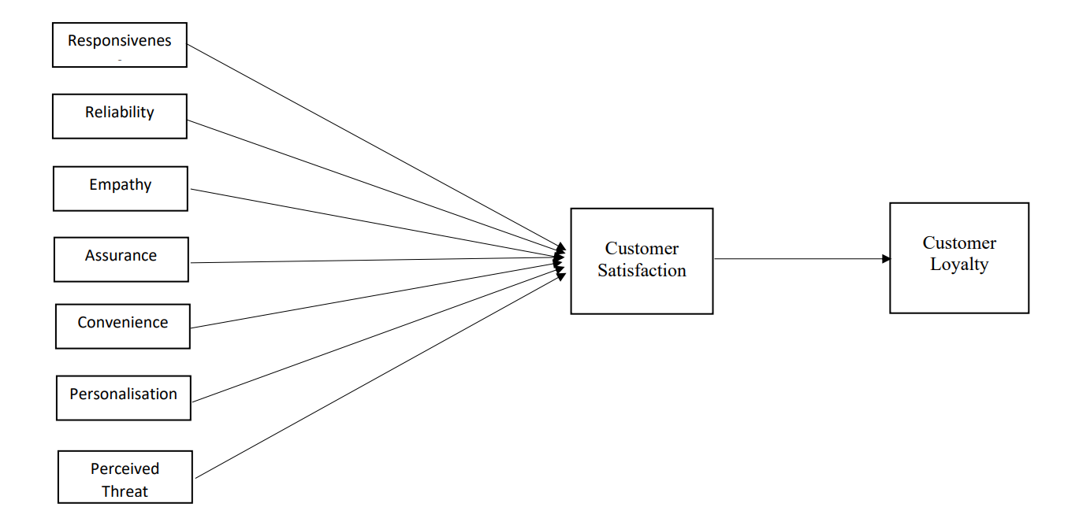
  - Hypotheses of the Study
H1 – Responsiveness of AI-enabled banking services has a significant impact on customer satisfaction
H2 – Reliability of AI-enabled banking services has a significant impact on customer satisfaction
H3 – Empathy of AI-enabled banking services has a significant impact on customer satisfaction
H4 – Assurance of AI-enabled banking services has a significant impact on customer satisfaction
H5 – Convenience of AI-enabled banking services has a significant impact on customer satisfaction
H6 – Personalization of AI-enabled banking services has a significant impact on customer satisfaction
H7 – Perceived Threat of AI-enabled banking services has a significant impact on customer satisfaction
H8 – Customer satisfaction towards AI-enable telecom services has a significant impact on customer loyalty towards the bank
  - Sampling and Data Collection
Our research involved a total sample size of 600 participants. This figure was intentionally selected to exceed the required 485 participants as computed by the G* Power software, thereby ensuring the robustness of the results and reducing Type I and II errors. The primary data for the study was collected via an online survey, utilizing a well-structured and pre-tested questionnaire. Participants were selected using a random sampling approach, which aimed to secure a representative subset of the overall population. The online nature of the survey facilitated a widespread reach, and allowed for quick and efficient data collection. The response rate, while not explicitly measured, is satisfactory due to the attainment of our desired sample size. In the sections that follow, we will present the analysis of this data in order to answer the research questions and to further explore the influence of AI on consumer behaviour in the Indian banking sector.
- Results and Analysis
In this section, we delve into the results and analysis of our research, which was aimed at understanding the impact of Artificial Intelligence (AI) on consumer behaviour within the Indian banking industry. This section highlights the outcomes derived from the data collected and examined through the Partial Least Squares Structural Equation Modelling (PLS-SEM) approach, utilizing the SMART PLS software. It elucidates the relationship between various constructs of our theoretical framework, as revealed by the empirical study.
. In terms of demographic distribution (Table 1), the sample consisted of 68% males (410 individuals) and 32% females (190 individuals). As for age distribution, 61% of the participants were less than 40 years old, while 39% were above 40. Concerning the period of use, 74% of participants had been using the service for less than five years, while 26% had been using it for more than five years.
Table 1: Demographics
Gender |  | Age |  | Period of Use
Male | 410  (68) | Less than 40 | 364  (61) | Less than 5 years | 446  (74)
Female | 190  (32) | More than 40 | 236  (39) | More than 5 Years | 154  (26)
Total | 600 | Total | 600 | Total | 600
Source: Primary Data
Note: Figures in parentheses represents percentage to the total.
  - Assessment of the Measurement Model
This research adheres to the guidelines proposed by [21] for reporting PLS-SEM outcomes, especially concerning the evaluation of the measurement model. The study uses individual indicators that are reflective. [21] suggest that the evaluation of reflective measurement models should include measures of internal reliability, consistency, convergent validity, and discriminant validity. The assessment of internal reliability involves the examination of indicator loadings, as depicted in Table 2. According to [22], indicator loadings articulate the degree of shared variance between individual variables and their corresponding constructs. They ensure the indicator's reliability in reflective measurement models. As per Table 4.1, it's evident that all indicator loadings exceed the advised benchmark of 0.708 [21], suggesting that the corresponding construct reliably accounts for over 50% of the variance of the associated indicator. Therefore, the model's indicator reliability is satisfactory.
Table 2: Indicator Loadings
Construct | Item | Loadings
Responsiveness | RES01 | 0.889
 | RES02 | 0.902
 | RES03 | 0.866
Reliability | REL01 | 0.824
 | REL02 | 0.849
 | REL03 | 0.846
Empathy | EMP01 | 0.939
 | EMP02 | 0.925
 | EMP03 | 0.889
Assurance | ASS01 | 0.892
 | ASS02 | 0.917
 | ASS03 | 0.931
Convenience | CON01 | 0.899
 | CON02 | 0.934
 | CON03 | 0.929
Personalisation | PER01 | 0.905
 | PER02 | 0.905
Perceived Threat | PT01 | 0.804
 | PT02 | 0.77
 | PT03 | 0.832
Customer Satisfaction | CS01 | 0.901
 | CS02 | 0.887
 | CS03 | 0.898
Customer Loyalty | CC01 | 0.86
 | CC02 | 0.923
 | CC03 | 0.921
Source: Primary Data
Following the indicator reliability, the next step is to evaluate internal consistency and convergent validity. The evaluation of internal consistency involves composite reliability and ρA, whereas convergent validity requires an examination of the Average Variance Extracted (AVE). Table 3 provides the composite reliability, ρA, and AVE for our model. Based on Table 3, both composite reliability and ρA fall within the suggested ranges of 0.70 to 0.95, and all AVE values exceed the recommended benchmark of 0.5. This suggests that the model has an adequate level of internal consistency and convergent validity.
Table 3: Reliability and Validity
Constructs | ρA | Composite Reliability | Average Variance Extracted
Assurance | 0.911 | 0.938 | 0.834
Convenience | 0.918 | 0.943 | 0.847
Customer Loyalty | 0.886 | 0.929 | 0.813
Customer Satisfaction | 0.879 | 0.924 | 0.801
Empathy | 0.912 | 0.941 | 0.842
Perceived Threat | 0.724 | 0.844 | 0.644
Personalization | 0.779 | 0.901 | 0.819
Reliability | 0.793 | 0.878 | 0.705
Responsiveness | 0.902 | 0.916 | 0.784
Source: Primary Data
The last step in evaluating a reflective measurement model involves the establishment of discriminant validity, which is the measure of the distinctness of each construct from others. [22] suggest that the Heterotrait-monotrait (HTMT) ratio is a suitable measure for discriminant validity. The HTMT values are presented in Table 4.3. A high HTMT value indicates a low discriminant validity. Table 4 shows that all HTMT values are significantly below the conservative cut-off of 0.85, suggesting that the model has a good level of discriminant validity.
Table 4: HTMT Ratio of Correlations
 | Assurance | Convenience | Customer Loyalty | Customer Satisfaction | Empathy | Perceived Threat | Personalization | Reliability
Convenience | 0.562
Customer Loyalty | 0.444 | 0.458
Customer Satisfaction | 0.309 | 0.280 | 0.343
Empathy | 0.456 | 0.682 | 0.393 | 0.310
Perceived Threat | 0.206 | 0.247 | 0.772 | 0.185 | 0.228
Personalization | 0.342 | 0.452 | 0.390 | 0.392 | 0.447 | 0.225
Reliability | 0.431 | 0.534 | 0.310 | 0.300 | 0.524 | 0.139 | 0.581
Responsiveness | 0.543 | 0.521 | 0.466 | 0.389 | 0.394 | 0.360 | 0.329 | 0.316
Source: Primary Data
  - Assessment of the Structural Model
The study conforms to the guidelines put forth by [21] for evaluating the structural model. [21] suggest that the evaluation process should encompass three crucial aspects, including the examination of collinearity, the validation of the importance and significance of path coefficients, and the assessment of the model's explanatory and predictive power. Table 5 illustrates the outcomes of our structural model, while Figure 2 provides a visual representation of the significance of path coefficients corresponding to each hypothesis.
In our model, potential collinearity issues were examined using the Variance Inflation Factor (VIF). As Table 4.4 indicates, all VIF values are less than 3, with the highest inner VIF value for our model construct being 2.08 [21]. This suggests that collinearity within the inner model is not a significant concern and should not impact the regression results.
The next step involves the assessment of the size and significance of the path coefficients. For instance, age significantly influences six predictors and the endogenous construct, customer loyalty; similarly, gender significantly influences six predictors but not the endogenous construct. The period of use has a notable impact on five predictors and one endogenous construct, customer commitment, but not on the other endogenous construct.
Figure 2 elucidates the significance and magnitude of path coefficients between endogenous and exogenous constructs. As per Figure 2, only responsiveness and personalisation significantly and positively affect customer satisfaction. Constructs such as customer satisfaction, responsiveness, personalisation, assurance, and convenience positively impact customer loyalty, the study's endogenous construct. However, perceived threat exerts a significant negative influence on customer loyalty.
With respect to control variables, age has significant impact on six predictors, namely reliability (β = -0.412), empathy (β = -0.429), assurance (β = -0.274), personalisation (β = -0.436), convenience (β = -0.45), and customer satisfaction (β = -0.552), and also on the endogenous construct – customer loyalty (β = -0.158); gender also has a significant impact on six predictors, namely reliability (β = 0.589), empathy (β = 0.548), assurance (β = 0.262), convenience (β = 0.489), personalisation (β = 0.701), and customer satisfaction (β = 0.435); and period of use has significant impact on five predictors namely reliability (β = 0.419), empathy (β = 0.399), convenience (β = 0.436), personalisation (β = 0.257), and perceived threat (β = -0.356), and also on the endogenous construct, customer commitment (β = 0.117). Control variables such as gender and period of use doesn’t have any significant impact on the endogenous construct of the model.
Examining the R² values in Table 5, we find that responsiveness and personalisation are key predictors in determining customer satisfaction (R² = 0.254). Moreover, constructs like perceived threat, assurance, convenience, personalisation, responsiveness, and customer satisfaction significantly contribute to explaining customer loyalty (R² = 0.541), the study's primary endogenous construct. Among all predictor constructs, perceived threat has the highest f² effect size (f² = 0.515), followed by personalisation (f² = 0.015) and convenience (f² = 0.012).
- Discussion and Conclusion
The results of the study lend significant insights into the role of various factors of AI-enabled banking services in shaping customer satisfaction and loyalty.
Firstly, the hypotheses H1 and H6, which proposed that the responsiveness and personalization of AI-enabled banking services have a significant impact on customer satisfaction, have been supported by the findings. This conclusion is evidenced by the R2 value of 0.254, indicating that a considerable portion of the variation in customer satisfaction can be attributed to these two factors.
The study, however, does not provide sufficient evidence to confirm or reject the hypotheses H2, H3, H4, H5, and H7, which pertained to the influence of the reliability, empathy, assurance, convenience, and perceived threat of AI-enabled banking services on customer satisfaction, respectively. Further research might be required to investigate these relationships more exhaustively.
Lastly, the hypothesis H8, which proposed that customer satisfaction towards AI-enabled banking services significantly impacts customer loyalty towards the bank, has been strongly supported by the data. As indicated by the R2 value of 0.541, customer satisfaction along with the aforementioned constructs - perceived threat, assurance, convenience, personalization, and responsiveness - significantly contribute to explaining customer loyalty, the primary endogenous construct of the study.
In conclusion, the study provides compelling evidence supporting the significant role of responsiveness, personalization, and overall customer satisfaction in driving customer loyalty in the context of AI-enabled banking services.
Figure 2: Structural Model Results
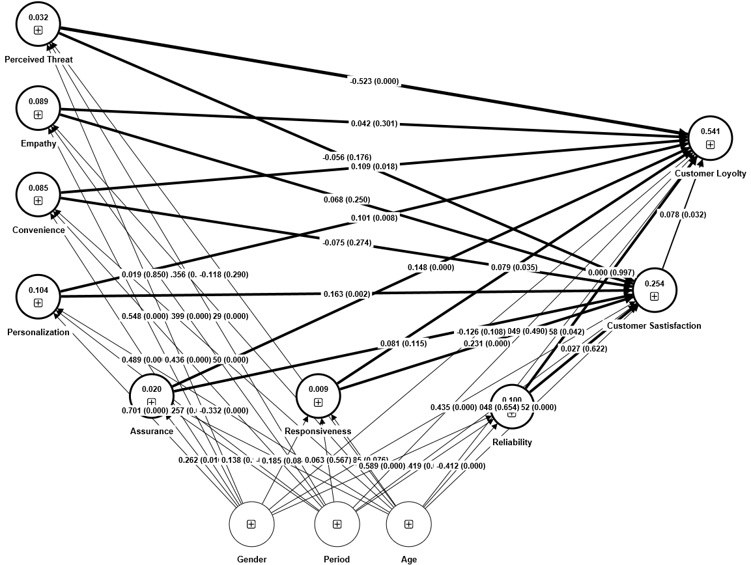
Note: P-Value of Path Co-efficients are given in parantheses.
Table 5: Structural Model Results
Outcome | R Sq. | Predictor | Direct Paths and Hypotheses | β | CI | Significance? | f² | VIF
Responsiveness (REP) | 0.009 | CV | Age -> REP | -0.185 | [-0.388; 0.020] | No | 0.006 | 1.329
 |  | CV | Gender -> REP | 0.185 | [-0.022; 0.393] | No | 0.006 | 1.248
 |  | CV | Period of Use -> REP | 0.063 | [-0.155; 0.283] | No | 0.001 | 1.144
Reliability (REL) | 0.1 | CV | Age -> REL | -0.412 | [-0.581; -0.240] | Yes | 0.034 | 1.329
 |  | CV | Gender -> REL | 0.589 | [0.418; 0.761] | Yes | 0.067 | 1.248
 |  | CV | Period of Use -> REL | 0.419 | [0.238; 0.596] | Yes | 0.033 | 1.144
Empathy (EMP) | 0.089 | CV | Age -> EMP | -0.429 | [-0.597; -0.260] | Yes | 0.036 | 1.329
 |  | CV | Gender -> EMP | 0.548 | [0.368; 0.722] | Yes | 0.057 | 1.248
 |  | CV | Period of Use -> EMP | 0.399 | [0.202; 0.592] | Yes | 0.029 | 1.144
Assurance  (ASS) | 0.02 | CV | Age -> ASS | -0.274 | [-0.463; -0.081] | Yes | 0.014 | 1.329
 |  | CV | Gender -> ASS | 0.262 | [0.059; 0.458] | Yes | 0.012 | 1.248
 |  | CV | Period of Use -> ASS | 0.138 | [-0.053; 0.329] | No | 0.003 | 1.144
CON | 0.085 | CV | Age -> CON | -0.45 | [-0.620; -0.277] | Yes | 0.04 | 1.329
 |  | CV | Gender -> CON | 0.489 | [0.314; 0.661] | Yes | 0.045 | 1.248
 |  | CV | Period of Use -> CON | 0.436 | [0.246; 0.617] | Yes | 0.035 | 1.144
Personalisation (PER) | 0.104 | CV | Age -> PER | -0.332 | [-0.516; -0.147] | Yes | 0.022 | 1.329
 |  | CV | Gender -> PER | 0.701 | [0.514; 0.882] | Yes | 0.095 | 1.248
 |  | CV | Period of Use -> PER | 0.257 | [0.061; 0.452] | Yes | 0.012 | 1.144
Perceived Threat (PT) | 0.032 | CV | Age -> PT | -0.118 | [-0.333; 0.097] | No | 0.003 | 1.329
 |  | CV | Gender -> PT | 0.019 | [-0.175; 0.212] | No | 0 | 1.248
 |  | CV | Period of Use -> PT | -0.356 | [-0.553; -0.157] | Yes | 0.022 | 1.144
Customer Satisfaction  (CS) | 0.254 | RES | REP -> CS | 0.079 | [0.006; 0.152] | Yes | 0.048 | 1.487
 |  | PER | PER -> CS | 0.101 | [0.027; 0.178] | Yes | 0.025 | 1.429
 |  | ASS | ASS -> CS | 0.081 | [-0.022; 0.18] | No | 0.006 | 1.575
 |  | CON | CON -> CS | -0.075 | [-0.206; 0.059] | No | 0.004 | 2.072
 |  | EMP | EMP -> CS | 0.068 | [-0.048; 0.185] | No | 0.003 | 1.798
 |  | PT | PT - > CS | -0.056 | [-0.137; 0.026] | No | 0.004 | 1.155
 |  | REL | REL -> CS | 0.027 | [-0.076; 0.135] | No | 0.001 | 1.522
 |  | CV | Age -> CS | -0.552 | [-0.717; -0.378] | Yes | 0.068 | 1.424
 |  | CV | Gender -> CS | 0.435 | [0.266; 0.601] | Yes | 0.039 | 1.423
 |  | CV | Period of Use -> CS | 0.048 | [-0.165; 0.257] | No | 0 | 1.231
Customer Loyalty (CL) | 0.541 | CS | CS -> CL | 0.078 | [0.008; 0.151] | Yes | 0.01 | 1.341
 |  | RES | RES -> CL | 0.079 | [0.141; 0.326] | Yes | 0.009 | 1.558
 |  | PER | PER -> CL | 0.101 | [0.027; 0.178] | Yes | 0.015 | 1.464
 |  | ASS | ASS -> CL | 0.148 | [0.07; 0.222] | Yes | 0.03 | 1.584
 |  | CON | CON -> CL | 0.109 | [0.018; 0.197] | Yes | 0.012 | 2.08
 |  | EMP | EMP -> CL | 0.042 | [-0.037; 0.124] | No | 0.002 | 1.804
 |  | PT | PT -> CL | -0.523 | [-0.582; -0.457] | Yes | 0.515 | 1.159
 |  | REL | REL -> CL | 0 | [-0.069; 0.066] | No | 0 | 1.523
 |  | CV | Age -> CL | -0.158 | [-0.311; -0.003] | Yes | 0.009 | 1.521
 |  | CV | Gender -> CL | -0.126 | [-0.281; 0.030] | No | 0.005 | 1.478
 |  | CV | Period of Use -> CL | 0.049 | [-0.09; 0.188] | No | 0.001 | 1.232

Source: Primary Data

References:
[1] Bughin, J., Hazan, E., & Ramaswamy, S. (2017). Artificial intelligence: The next digital frontier? McKinsey Global Institute.
[2] Agarwal, R. (2021). Artificial intelligence in banking: Opportunities and challenges. Journal of Banking and Finance, 3(1), 23-38.
[3] Davenport, T., Guha, A., Grewal, D., & Bressgott, T. (2020). How artificial intelligence will change the future of marketing. Journal of the Academy of Marketing Science, 48(1), 24-42.
[4] Rai, A. (2019). Customer experience and business performance: The mediating role of customer satisfaction. European Journal of Marketing, 53(10), 2003-2024.
[5] Gupta, R. (2021). Artificial intelligence in the banking sector – Challenges and opportunities. Journal of Banking and Financial Technology, 5, 57–66.
[6] Bughin, J., Hazan, E., Ramaswamy, S., Chui, M., Allas, T., Dahlström, P., ... & Trench, M. (2022). Artificial intelligence–The next digital frontier?. McKinsey Global Institute.
[7] Bostrom, N., Dafoe, A., & Flynn, C. (2021). Public policy toward artificial intelligence. AI and Society, 1-17.
[8] Castelvecchi, D. (2020). Can we open the black box of AI? Nature, 538(7623), 20.
[9] Zhang, Y., Lai, I.K., Lu, L., & Liu, Z. (2022). Understanding customer service experience using a text mining approach: An investigation of a ride-hailing platform. Journal of Business Research, 134, 187-200. https://doi.org/10.1016/j.jbusres.2021.08.032
[10] Chen, H. (2016). The WealthTech Book: The Fintech Handbook for Investors, Entrepreneurs, and Finance Visionaries. Wiley.
[11] Tang, Z., Shao, Y., & Wu, Z. (2023). Artificial intelligence in banking: A literature review and avenues for future research. International Journal of Information Management, 56, 102127. https://doi.org/10.1016/j.ijinfomgt.2022.102127
[12] Yablonsky, S.A. (2020). AI-driven digital platform innovation. Technology Innovation Management Review, 10(10), 4-15. https://doi.org/10.22215/timreview/1394
[13] Bharati, P., Zhang, W., & Chaudhury, A. (2022). Better Investment Decisions with AI. MIS Quarterly Executive, 21(1), 67-81.
[14] Morosan, C., and DeFranco, A. (2016). It's about time: Revisiting UTAUT2 to examine consumers’ intentions to use NFC mobile payments in hotels. International Journal of Hospitality Management, 53, 17-29.
[15] Dubey, V. (2019). FinTech innovations in digital banking. International Journal of Engineering Research and Technology (IJERT), 8(10), 597-601.
[16] Huang, M. H., & Rust, R. T. (2021). Artificial intelligence in service. Journal of Service Research, 24(1), 5-22.
[17] Pham, T. & Ho, J. (2020). The effects of product recommendations on consumer decision making and loyalty in social commerce. Information and Management, 57(6), 103228.
[18] Davis, F. D. (1989). Perceived usefulness, perceived ease of use, and user acceptance of information technology. MIS Quarterly, 13(3), 319–340.
[19] Oliver, R. L. (1980). A Cognitive Model for the Antecedents and Consequences of Satisfaction. Journal of Marketing Research (17), 460-469.
[20] Parasuraman, A., Zeithaml, V. A., & Berry, L. L. (1988). SERVQUAL: A Multiple-Item Scale for Measuring Consumer Perceptions of Service Quality. Journal of Retailing, 64(1), 12-40.
[21] Hair, J. F., Risher, J. J., Sarstedt, M., & Ringle, C. M. (2019). When to use and how to report the results of PLS-SEM. European business review, 31(1), 2-24.
[22] Saari, U. A., Damberg, S., Frömbling, L., & Ringle, C. M. (2021). Sustainable consumption behavior of Europeans: The influence of environmental knowledge and risk perception on environmental concern and behavioral intention. Ecological Economics, 189, 107155.

